
Vellore Institute of Technology (Chennai Campus)

Options Trading Data Science Project Report
Data Analytics Solutions using R
SUBMITTED BY
Harsh Vardhan Ajmera (24BDS1060)
Ahana Manna (24BDS1102)
SUBMITTED TO
Dr. Vijayalakshmi A

1. Title
Options Trading Data Science Project (Study Stock): from recorded NSE tick data to a 15-model R benchmark.

2. Team Members
Harsh Vardhan Ajmera (24BDS1060) and Ahana Manna (24BDS1102). Faculty: Dr. Vijayalakshmi A, VIT Chennai.

3. Abstract
Most people who trade index options in India lose money, and a big reason is that every trade pays the bid-ask spread and a stack of government charges before it can make a rupee. We wanted to see whether a machine learning model could act as a filter that says "take this trade" or "skip it" once those costs are counted.
We recorded live NIFTY and BANKNIFTY option ticks from the NSE through the Upstox WebSocket feed and stored them as per-minute files on our own PC. From that data we built a 500-signal dataset with five inputs: confidence, spread, log volume, a volume-weighted open-interest momentum score and an open-interest flow score. In R we cleaned the data, explored it, ran statistical tests, and compared 15 classifiers on a time-ordered test set of 94 signals. Accuracy ranged from 89.4% (single decision tree) to 100% (probit regression and a linear SVM).
An honest caveat. In this dataset the "profitable" label is calculated from the same five inputs, so the models are mostly rediscovering our formula. The scores show that the pipeline works, not that the market can be predicted. Our drafted research paper tests the harder question with labels taken from real future prices and finds an AUC of at most 0.60 and no profitable filter after costs.

4. Introduction
Index options on the NSE are some of the most heavily traded contracts in the world, and most of that volume comes from individual traders holding positions for a few minutes. At that horizon the price move is usually small compared with what the trade costs: the spread on the way in and out, brokerage, exchange charges, securities transaction tax, stamp duty, the SEBI fee and GST. A trader can be right about direction and still lose.
Study Stock is the platform we built around this problem. A Python engine records market data and computes the Greeks, a Node gateway serves it, and a React web app shows a live options chain, a paper-trading Demo Lab and a research page. This report covers the data-analysis side, done in R.
What we set out to do
- Record real NSE option data and keep it on our own machine.
- Clean it and understand it through plots and statistical tests.
- Compare 15 machine learning models fairly, on data from after the training period.
- Show the working application, and be upfront about what the results do and do not prove.

5. Data Set Description
All data comes from our own collector, which listens to the Upstox WebSocket feed for NIFTY and BANKNIFTY options and writes one Parquet file per minute. For R we exported four small CSV samples into the project's data/ folder:
- raw_sample_dataset.csv – 1,000 raw ticks, 19 columns (price, bid, ask, volume, open interest, exchange time, feed latency). Saved 12 Oct 2026, 181,044 bytes.
- preprocessed_features_sample.csv – 1,000 cleaned option-chain rows, 20 columns (spread, mid price, change in open interest, 15-minute z-scores, distance from the money). Saved 12 Oct 2026, 171,732 bytes.
- r_cleaned_features_output.csv – 60 one-minute bars produced by our R cleaning script, 25 columns. Saved 13 Oct 2026, 14,320 bytes.
- options_trade_signals_sample.csv – the modelling dataset: 500 trade signals, 12 columns, no missing values. Saved 12 Oct 2026, 44,424 bytes.
The 500 signals are 374 NIFTY and 126 BANKNIFTY, 255 calls and 245 puts, all for the 30 June 2026 expiry. The five model inputs are confidence, spread, log_volume, z_vwoim and z_oi_flow.
How the target is defined. Each signal gets a cost: friction = 0.35 × spread + 0.15, and an expected gain: 0.08 × z_vwoim + 0.06 × z_oi_flow + 0.20 × (confidence − 0.90). If gain minus cost is above zero the signal is labelled Profitable (255 signals, 51%), otherwise Unprofitable (245 signals, 49%).
How we split it. Signals are sorted by time. The earliest 80% (400 signals) train the models and the latest part (94 signals) is the test set, with a 2% gap left out in between so that neighbouring ticks cannot leak from one side to the other.
Because the label is a formula of the inputs, very high accuracy is expected. We say this plainly here and again in the conclusion.

Proof that the data is stored on our PC
The full recording sits in C:\Harsh\StockProject\HARSH\OPTIONS!!!!!\. We counted it directly from the folder: 57,740 per-minute Parquet files in 48 session folders, from 18 June 2026 to 20 October 2026. We measured the size of only the first 13 session folders, about 955 MB. The four CSV sizes and dates above were read from the file system. The research paper analyses 69,519,707 ticks over 36 sessions, which is a different cut of the same recording from the 48 folders counted today.

6. Exploratory Data Analysis and Visualizations
All plots were made in R with ggplot2.
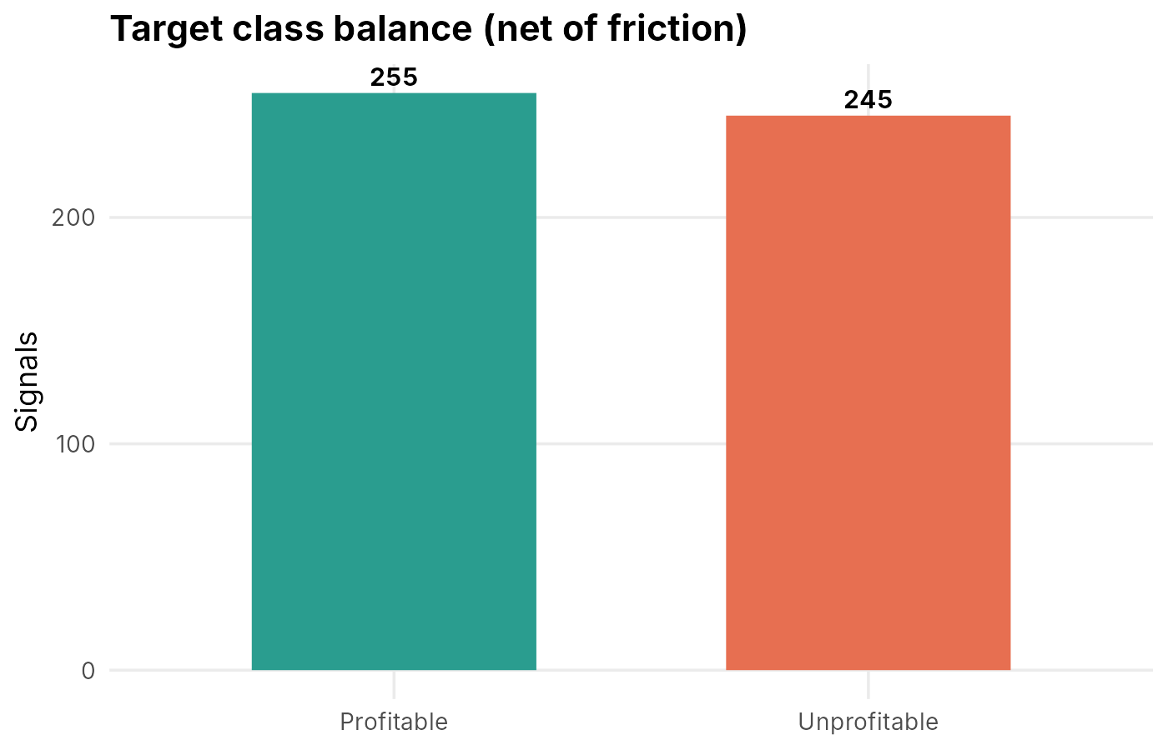
Figure 1. The classes are close to balanced (255 vs 245), so plain accuracy is a fair first measure.
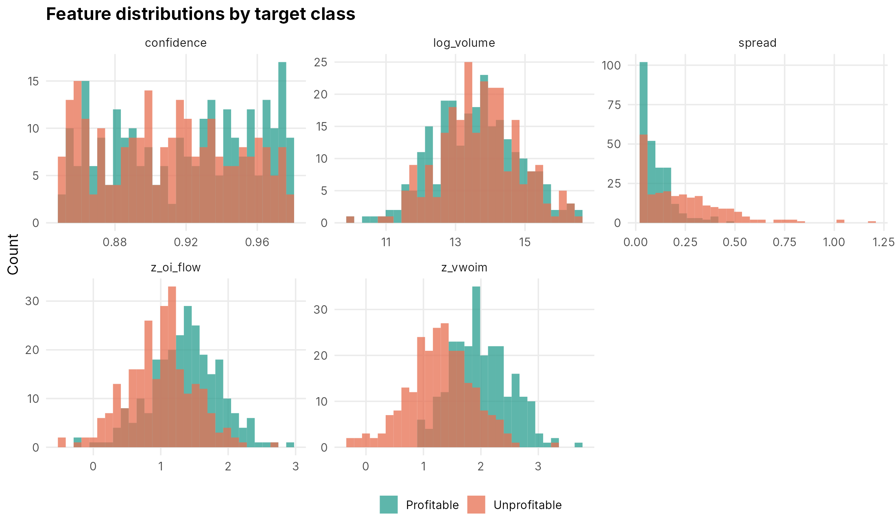
Figure 2. Profitable signals sit at higher z_vwoim and z_oi_flow and lower spread. Spread is strongly right-skewed.
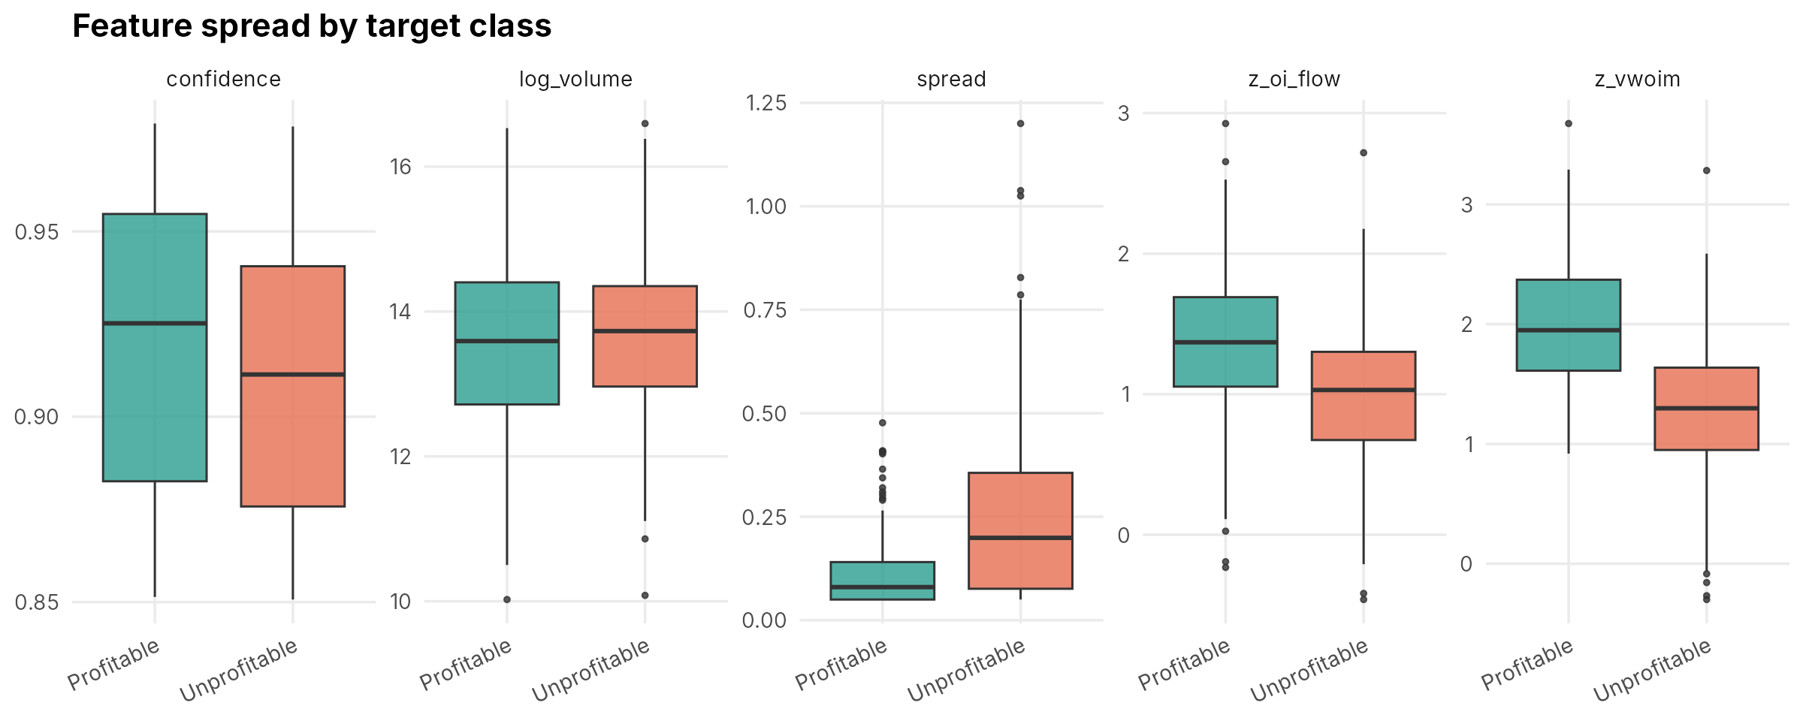
Figure 3. Unprofitable signals have clearly wider spreads; z_vwoim shows the biggest gap between classes; volume barely differs.
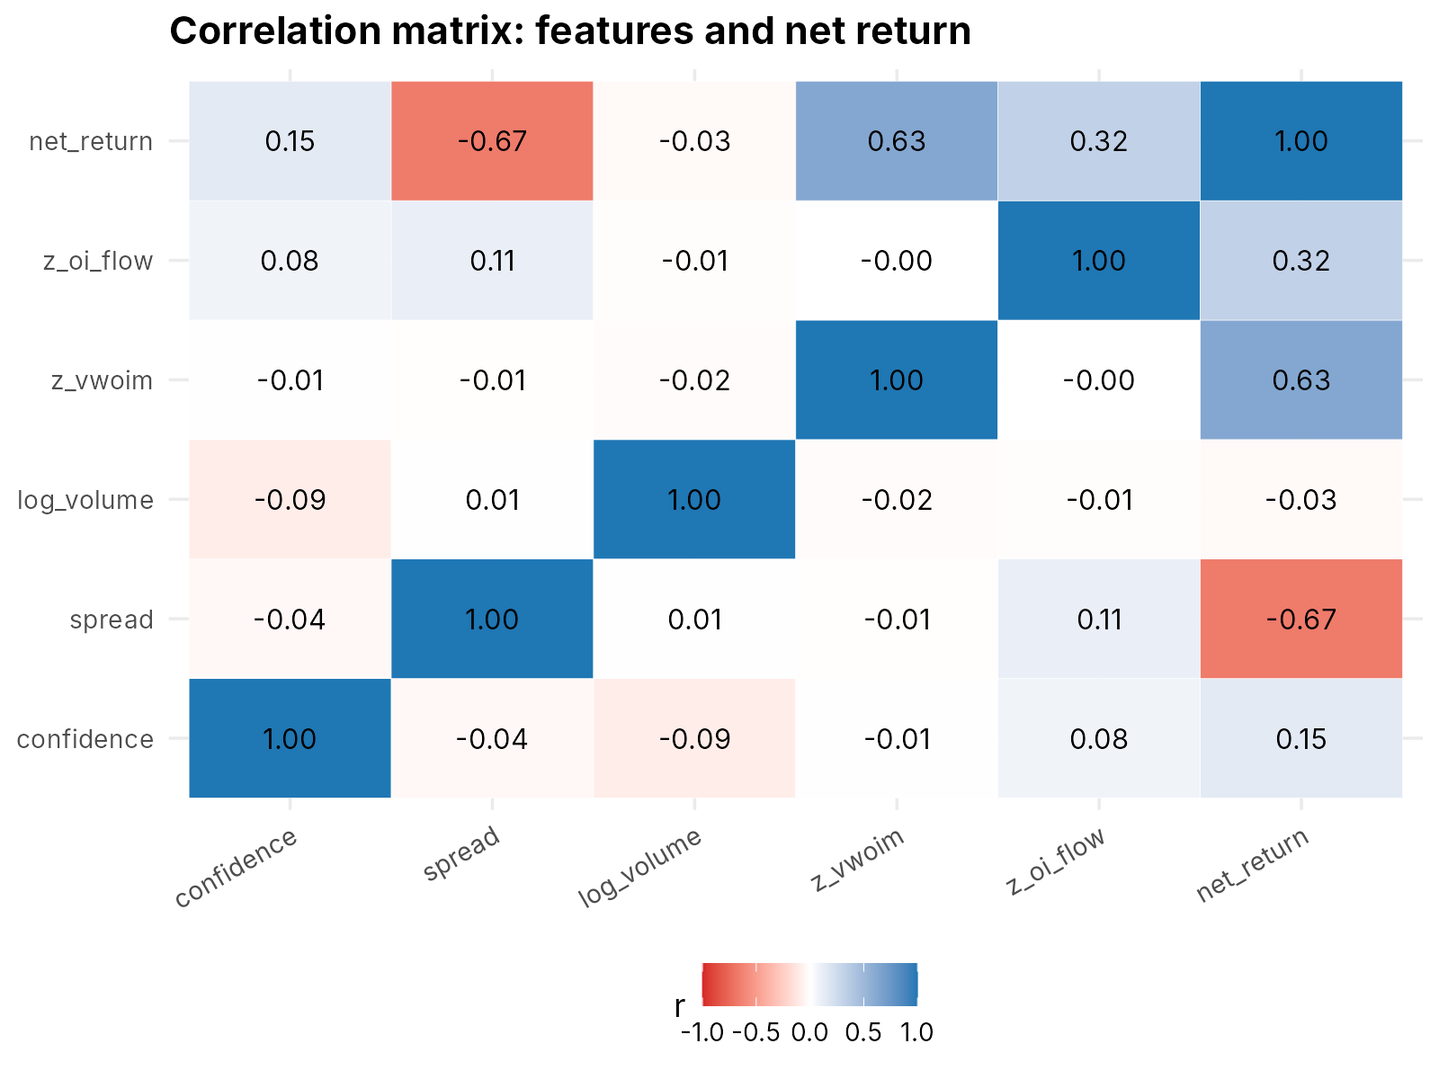
Figure 4. Net return moves with spread (r = -0.67) and z_vwoim (r = 0.63). The inputs are almost uncorrelated with each other.
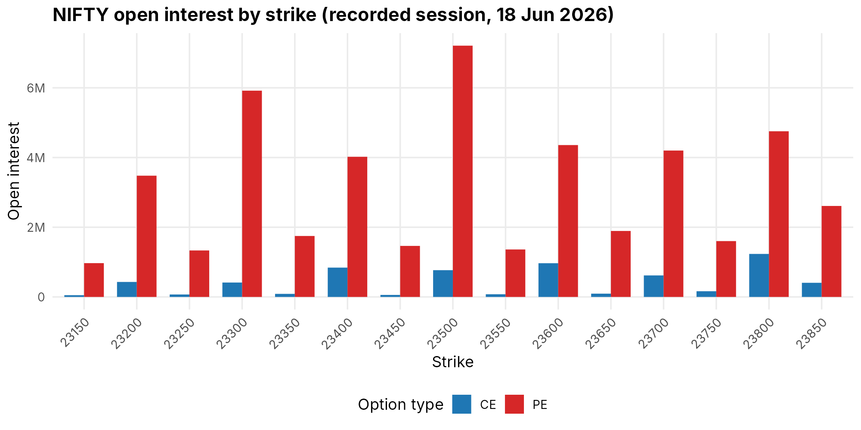
Figure 5. NIFTY open interest by strike from the recorded session of 18 June 2026.
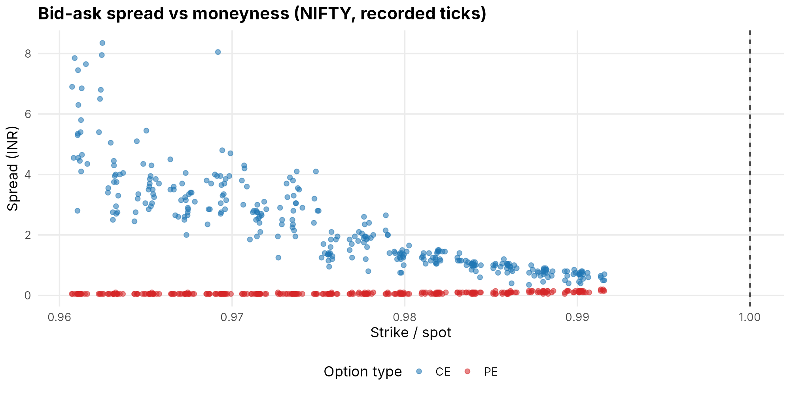
Figure 6. Spreads widen for strikes far from the money, which is why spread matters so much as a cost.
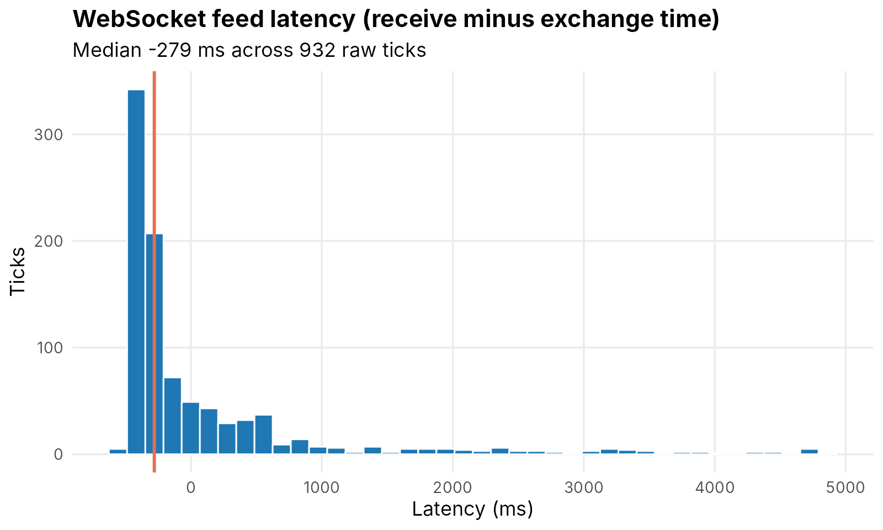
Figure 7. Feed latency (receive time minus exchange time). Some values are negative because our PC clock and the exchange clock are not perfectly in sync, so read this as the shape of the delay, not an exact figure.

7. Statistical Analysis
We used a 5% significance level. The full R output is shown below the summary.
- Descriptive statistics. Spread averages Rs 0.18 (median 0.115) and is strongly right-skewed (skewness 2.17). The other four inputs are roughly symmetric.
- Profitable vs unprofitable (Welch t-test and Wilcoxon test). Spread, z_vwoim and z_oi_flow differ very strongly between the classes (p below 1e-14 in every case). Confidence differs weakly (p about 0.01). Trading volume does not differ (p about 0.24).
- Chi-square tests. Option type (call or put) and underlying (NIFTY or BANKNIFTY) are unrelated to the label (p = 1.00 and p = 0.64).
- ANOVA. Average spread is the same for NIFTY and BANKNIFTY (p = 0.885).
- Shapiro-Wilk. Spread and confidence are not normally distributed, so for them we trust the Wilcoxon test, which agreed with the t-test. The other three inputs look normal.
- Correlation with net return. Spread -0.667, z_vwoim 0.630, z_oi_flow 0.319, confidence 0.145.
These patterns are what we should see when a label is built from the inputs, so we treat them as a check that the pipeline is correct, not as a finding about the market.

R output
=== DATASET OVERVIEW ===
Rows: 500 Columns: 12
Underlyings:
BANKNIFTY NIFTY
126 374
Option type:
CE PE
255 245
Expiries:
2026-06-30
500
Missing values per column (modelling dataset):
timestamp underlying expiry strike option_type
0 0 0 0 0
confidence spread volume z_vwoim z_oi_flow
0 0 0 0 0
times_repeated execution_score
0 0
Class distribution of target:
Profitable Unprofitable
255 245
Profitable Unprofitable
0.51 0.49
=== DESCRIPTIVE STATISTICS (feature columns) ===
feature mean sd median min max skew
1 confidence 0.9148 0.03883 0.9167 0.8507 0.9791 -0.02532
2 log_volume 13.6402 1.18077 13.6522 10.0245 16.5957 -0.01289
3 spread 0.1754 0.16567 0.1150 0.0500 1.2000 2.17218
4 z_oi_flow 1.1822 0.53701 1.1877 -0.4607 2.9258 -0.06021
5 z_vwoim 1.6526 0.64644 1.6386 -0.2989 3.6755 -0.05837
=== WELCH T-TEST AND WILCOXON TEST: feature vs target class ===
feature mean_profitable mean_unprofitable t t_p wilcoxon_p
confidence 0.9192 0.9103 2.576 1.028e-02 8.469e-03
spread 0.1078 0.2457 -10.071 7.672e-21 1.353e-17
log_volume 13.5804 13.7025 -1.158 2.474e-01 2.377e-01
z_vwoim 2.0019 1.2890 14.740 5.873e-41 1.571e-36
z_oi_flow 1.3612 0.9958 8.084 4.805e-15 6.494e-15
=== CHI-SQUARE: option_type vs target ===
Pearson's Chi-squared test with Yates' continuity correction
data: table(df$option_type, df$target)
X-squared = 1.5529e-30, df = 1, p-value = 1
=== CHI-SQUARE: underlying vs target ===
Pearson's Chi-squared test with Yates' continuity correction
data: table(df$underlying, df$target)
X-squared = 0.21304, df = 1, p-value = 0.6444
=== ONE-WAY ANOVA: spread by underlying ===
Df Sum Sq Mean Sq F value Pr(>F)
underlying 1 0.001 0.000577 0.021 0.885
Residuals 498 13.696 0.027502
=== SHAPIRO-WILK NORMALITY (feature columns) ===
confidence W = 0.9453 p = 1.29e-12
spread W = 0.7544 p = 1.33e-26
log_volume W = 0.9971 p = 0.538
z_vwoim W = 0.9982 p = 0.881
z_oi_flow W = 0.9986 p = 0.967
=== PEARSON CORRELATION MATRIX ===
confidence spread log_volume z_vwoim z_oi_flow net_return
confidence 1.000 -0.035 -0.093 -0.005 0.075 0.145
spread -0.035 1.000 0.007 -0.007 0.110 -0.667
log_volume -0.093 0.007 1.000 -0.021 -0.011 -0.031
z_vwoim -0.005 -0.007 -0.021 1.000 -0.001 0.630
z_oi_flow 0.075 0.110 -0.011 -0.001 1.000 0.319
net_return 0.145 -0.667 -0.031 0.630 0.319 1.000
Selected correlation tests:
spread vs net_return r = -0.667 p = 1.59e-65
z_vwoim vs net_return r = 0.630 p = 1.3e-56
z_oi_flow vs net_return r = 0.319 p = 2.75e-13
confidence vs net_return r = 0.145 p = 0.00115

8. Machine Learning Models Used
We trained 15 models on the same five inputs, the same training period and the same test set, so the comparison is fair.
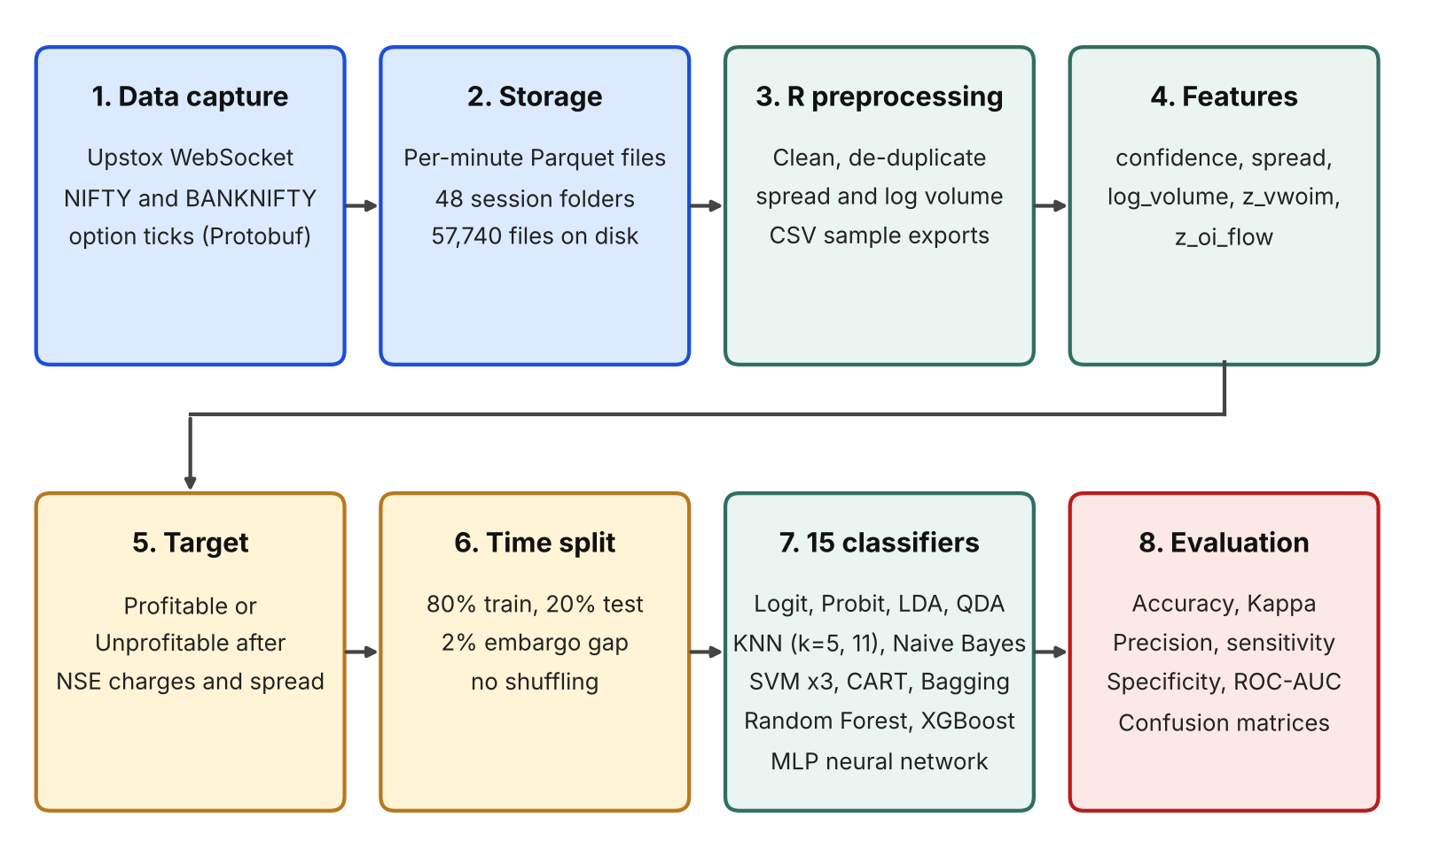
Figure 8. The modelling pipeline, from data capture to evaluation.
- Linear and discriminant models: logistic regression, probit regression (glm), LDA and QDA (MASS).
- Instance-based and probabilistic: KNN with k = 5 and k = 11 on scaled inputs (class), and Naive Bayes (e1071).
- Support vector machines (e1071): linear, polynomial (degree 3) and RBF (gamma 0.2), all with cost 1.
- Trees and ensembles: a CART tree (rpart, depth up to 5), bagged trees with 25 trees (ipred) and a random forest with 100 trees (randomForest).
- Neural network: a multi-layer perceptron with 6 hidden units (nnet).
- Boosting: XGBoost, tuned over an 8-point grid (50 or 100 rounds, depth 3 or 5, learning rate 0.05 or 0.1) with 5-fold cross-validation on the training period only. The caret wrapper for XGBoost failed with the xgboost version installed here, so we ran the same grid directly through the xgboost package.
We judged the models on accuracy, Cohen's Kappa, precision, sensitivity and specificity, and for the models that give probabilities also on ROC curves and AUC.
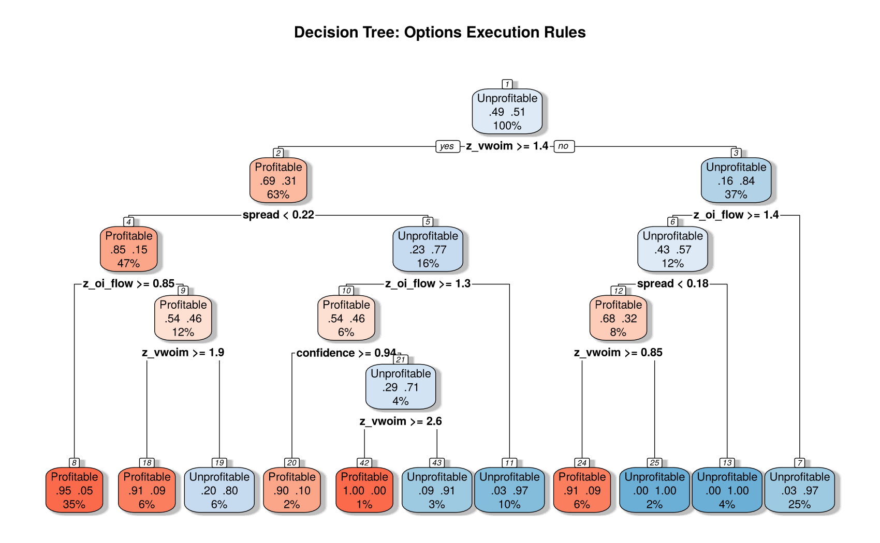
Figure 9. The CART decision tree.
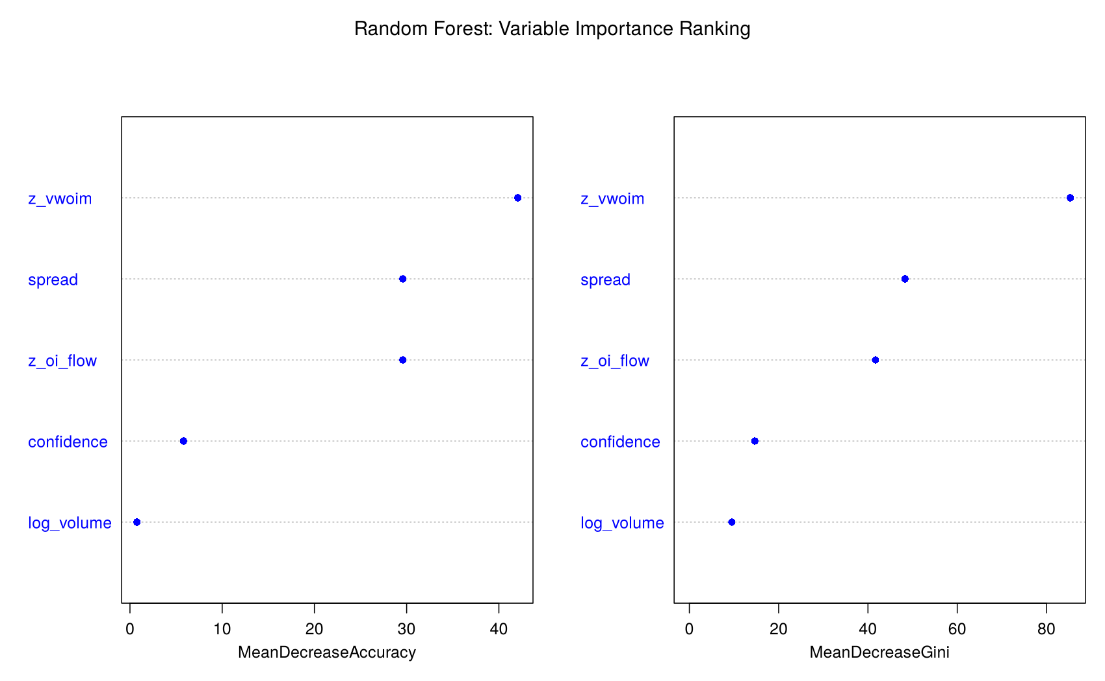
Figure 10. Random forest variable importance.

9. Output Screenshots (Results)

9.1 R outputs
Below is the actual console output of our R run. A text file with the complete output is delivered together with this report.
Data and split
>> Balanced Class Distribution (Net of Friction):
Profitable Unprofitable
255 245
>> Train (Past): 400 rows | Out-of-Time Test (Future): 94 rows
14-model leaderboard (from our benchmark script)
ID Model Category Accuracy Kappa Precision Sensitivity Specificity
2 Probit Regression Linear/GLM 100.00 1.0000 100.00 100.00 100.0
8 SVM (Linear Hyperplane) Kernel SVM 100.00 1.0000 100.00 100.00 100.0
14 Multi-Layer Perceptron (ANN) Neural Net 98.94 0.9783 100.00 98.15 100.0
1 Logistic Regression (Logit) Linear/GLM 98.94 0.9782 98.18 100.00 97.5
10 SVM (RBF Kernel) Kernel SVM 97.87 0.9568 100.00 96.30 100.0
13 Random Forest (100 Trees) Ensembles 96.81 0.9354 100.00 94.44 100.0
6 K-Nearest Neighbors (k=11) Instance-Based 96.81 0.9349 98.11 96.30 97.5
3 Linear Discriminant Analysis Discriminant 96.81 0.9345 96.36 98.15 95.0
4 Quadratic Discriminant Analysis Discriminant 95.74 0.9135 98.08 94.44 97.5
9 SVM (Polynomial Kernel d=3) Kernel SVM 95.74 0.9135 98.08 94.44 97.5
7 Naive Bayes Classifier Probabilistic 94.68 0.8923 98.04 92.59 97.5
5 K-Nearest Neighbors (k=5) Instance-Based 93.62 0.8711 98.00 90.74 97.5
12 Bagged Trees (25 Trees) Ensembles 93.62 0.8711 98.00 90.74 97.5
11 CART Decision Tree Decision Trees 89.36 0.7838 92.31 88.89 90.0
XGBoost grid search (5-fold CV, best row first)
nrounds max_depth eta gamma colsample_bytree min_child_weight subsample cv_auc
100 5 0.10 0 0.8 1 0.8 0.9937759
100 3 0.10 0 0.8 1 0.8 0.9936568
100 3 0.05 0 0.8 1 0.8 0.9915371
100 5 0.05 0 0.8 1 0.8 0.9911649
50 5 0.10 0 0.8 1 0.8 0.9895490
50 3 0.10 0 0.8 1 0.8 0.9890615
50 5 0.05 0 0.8 1 0.8 0.9842341
50 3 0.05 0 0.8 1 0.8 0.9824620
XGBoost Accuracy: 95.74% | best CV ROC-AUC: 0.994
Feature Gain Cover Frequency
1 z_vwoim 0.41650140 0.30925160 0.2460401
2 spread 0.27652655 0.25669808 0.2249208
3 z_oi_flow 0.21800945 0.24717099 0.2312566
4 confidence 0.05715284 0.12596305 0.1879620
5 log_volume 0.03180976 0.06091628 0.1098205
AUC on the test set
Model AUC
Logit 1.0000
Probit 1.0000
MLP (ANN) 1.0000
Random Forest 0.9977
XGBoost 0.9940
QDA 0.9917
LDA 0.9903
Bagged Trees 0.9833
Naive Bayes 0.9731
CART 0.9419
Final 15-model leaderboard
Model Accuracy Kappa Precision Sensitivity Specificity
Probit Regression 100.00 1.0000 100.00 100.00 100.0
SVM (Linear Hyperplane) 100.00 1.0000 100.00 100.00 100.0
Multi-Layer Perceptron (ANN) 98.94 0.9783 100.00 98.15 100.0
Logistic Regression (Logit) 98.94 0.9782 98.18 100.00 97.5
SVM (RBF Kernel) 97.87 0.9568 100.00 96.30 100.0
Random Forest (100 Trees) 96.81 0.9354 100.00 94.44 100.0
K-Nearest Neighbors (k=11) 96.81 0.9349 98.11 96.30 97.5
Linear Discriminant Analysis 96.81 0.9345 96.36 98.15 95.0
Quadratic Discriminant Analysis 95.74 0.9135 98.08 94.44 97.5
SVM (Polynomial Kernel d=3) 95.74 0.9135 98.08 94.44 97.5
XGBoost (5-fold CV grid search) 95.74 0.9135 98.08 94.44 97.5
Naive Bayes Classifier 94.68 0.8923 98.04 92.59 97.5
K-Nearest Neighbors (k=5) 93.62 0.8711 98.00 90.74 97.5
Bagged Trees (25 Trees) 93.62 0.8711 98.00 90.74 97.5
CART Decision Tree 89.36 0.7838 92.31 88.89 90.0
Two glm warnings (non-convergence and fitted probabilities of 0 or 1) appear for the logit and probit fits. They happen because the classes are almost perfectly separable by the inputs, which is another sign of the circular label.
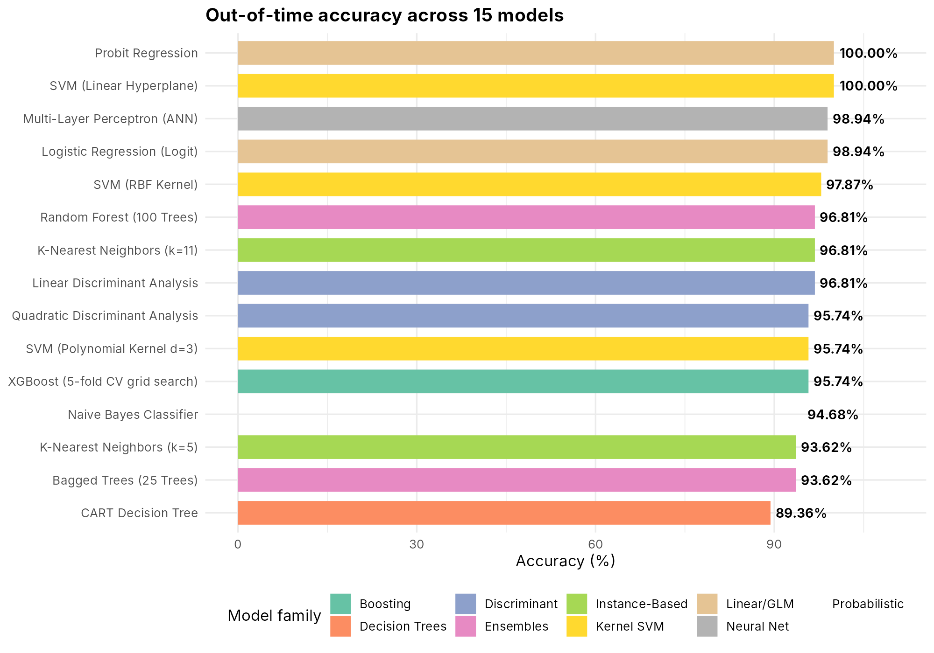
Figure 11. Out-of-time accuracy of all 15 models.
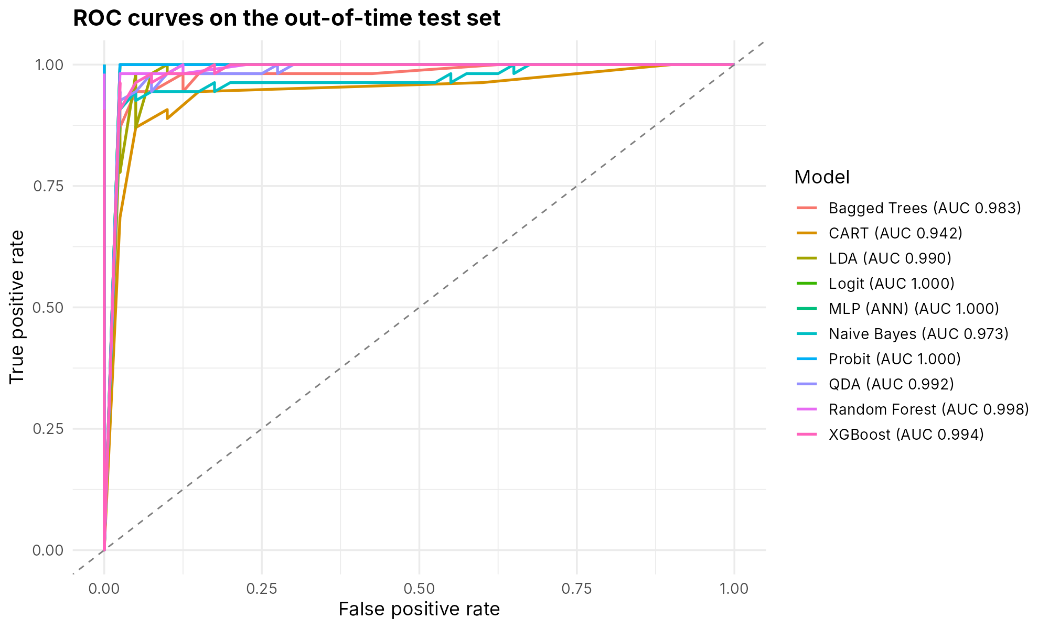
Figure 12. ROC curves for the ten models that produce probabilities.
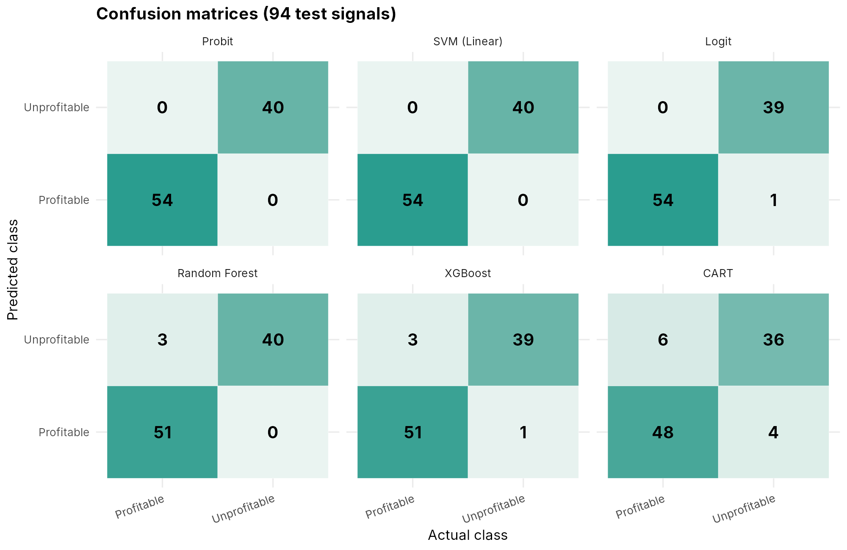
Figure 13. Confusion matrices of six representative models on the 94 test signals.
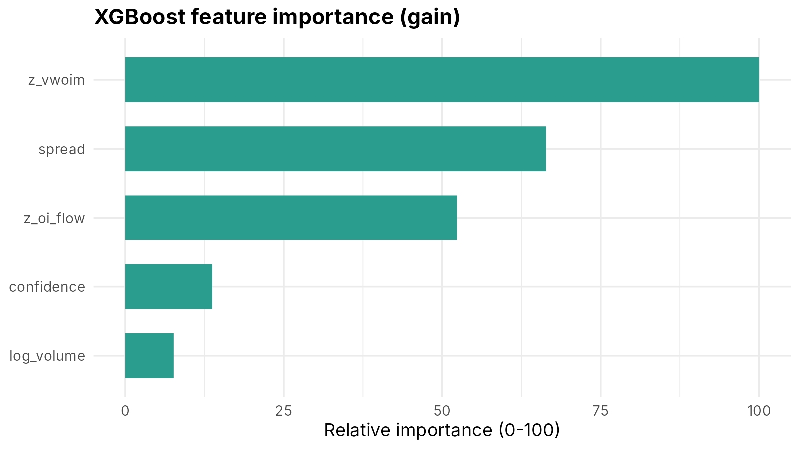
Figure 14. XGBoost feature importance. z_vwoim and spread lead.
Linear models do best because the label is a linear rule plus a threshold. The single decision tree does worst because axis-aligned splits only approximate that boundary. So the ranking tells us how well each method recovers a known rule, not how well it would trade.

9.2 Project interface (Study Stock web app)
The two screens that matter most for a data science project are the live options chain and the research page.
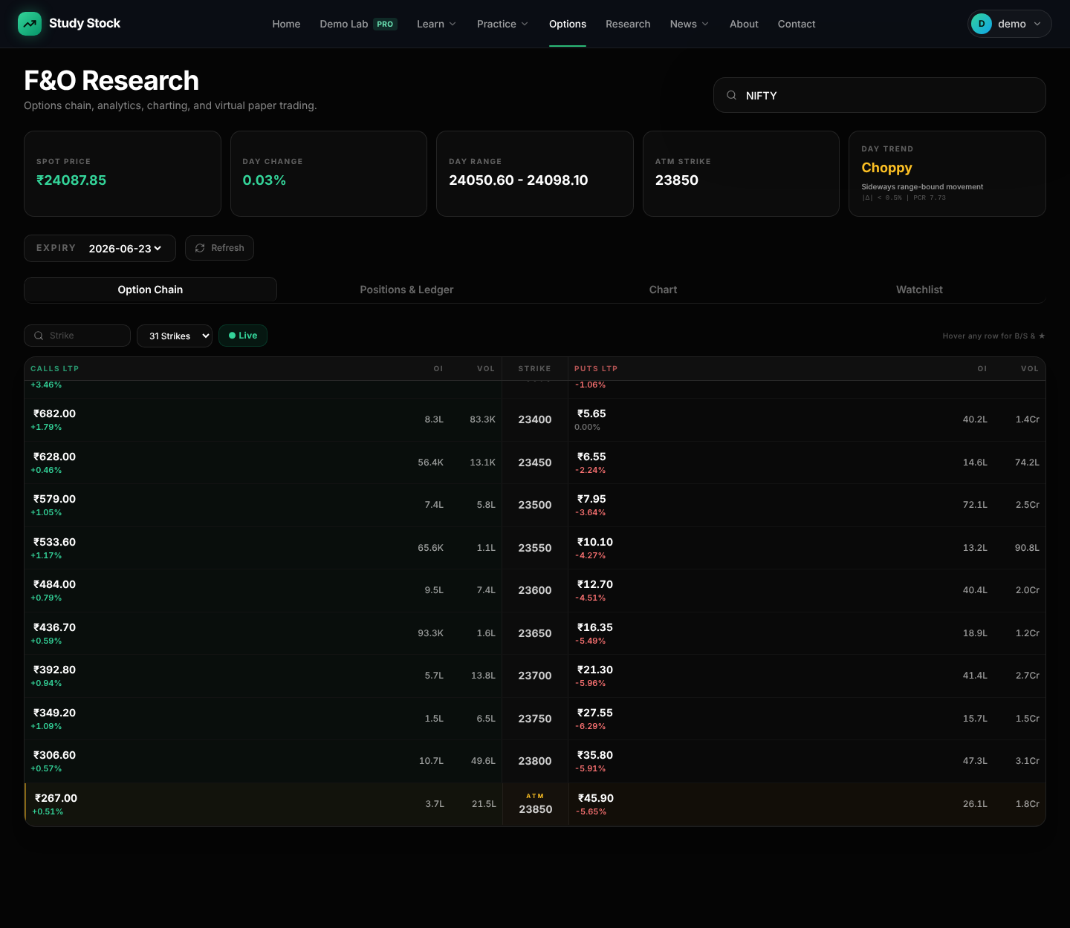
Figure 15. Options page: NIFTY option chain with bid, ask, spread, open interest and Greeks per strike. This screenshot was rendered from our recorded NIFTY ticks of 18 June 2026 (market closed), not from a live session.

Figure 16. Research page (Deep Research Engine). This capture shows the page with no pipeline run loaded: the research data is stored in our Supabase database, which was not connected when the screenshot was taken, so the page shows its built-in "No High-Conviction Setups" state.
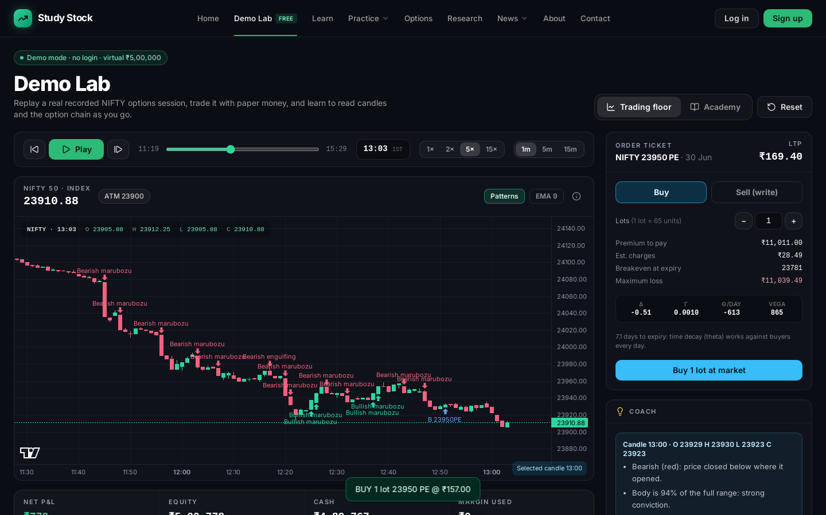
Figure 17. Demo Lab: a paper-trading screen that replays recorded market data so strategies can be tried without real money.

Figure 18. Home page.

9.3 Our research paper (draft, not published)
This paper has been written as a draft. It has NOT been published or accepted by any journal. The DOI and dates on its first page are template placeholders.
Can Machine Learning Filter Short-Horizon Index Option Trades After Costs? Evidence From NSE Tick Data (Harsh Vardhan Ajmera, IEEE Access template). It uses 69,519,707 recorded ticks over 36 trading sessions, 29 features and 11 classifiers with walk-forward validation. Only 30.2% of trades are profitable after costs, the average trade loses Rs 129 per lot, and no model makes a profit. First page of the draft:
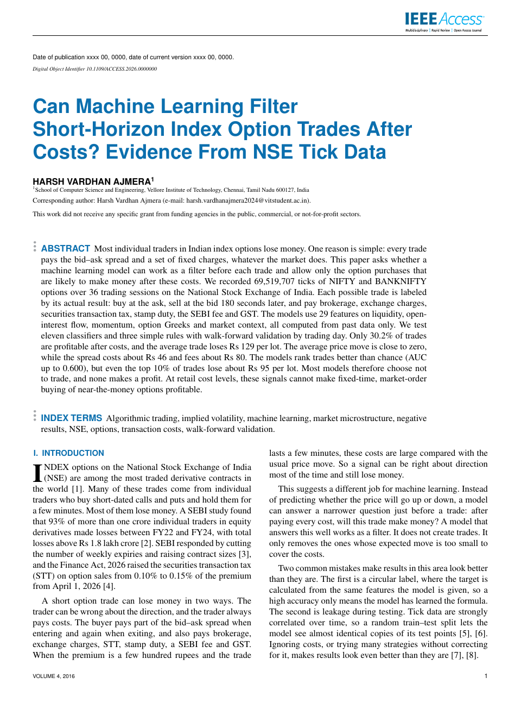
Figure 19. First page of the draft paper (not published).

10. Conclusion
We built a path from recorded NSE tick data to cleaned R datasets, exploratory analysis, statistical tests and a fair comparison of 15 models, plus a working web application around it. On the 94-signal test set, accuracy runs from 89.4% to 100%, and spread, VWOIM and open-interest flow are the inputs that matter while volume, option type and underlying do not.
The limits matter as much as the scores. The label is a formula of the inputs, so these results show the pipeline works rather than that the market is predictable, and the sample is small (500 signals, 94 for testing, one expiry). When our drafted paper repeats the test with real future prices, the best AUC is 0.60 and nothing makes money after costs. In short, for a retail buyer of short-horizon options, costs matter more than the choice of model.
Next steps: use real-outcome labels in R, use all recorded sessions instead of a sample, calibrate the probabilities, and test any filter in live paper trading.

11. R Code
Run order: master_ml_benchmark.R (models 1-14), then xgboost_direct.R and extra_results.R in the same R session; eda_and_statistics.R runs on its own. Separator comment lines were removed to save space. The caret XGBoost block at the end of the master script fails with the xgboost 3.x release used for this run, which is why xgboost_direct.R exists.

11.1 master_ml_benchmark.R (14-model benchmark, our submitted script)
# MASTER QUANTITATIVE ML BENCHMARK: 14 ALGORITHMS IN R
# Course : Data Analytics Solutions using R / Quantitative Finance Capstone
# Institution: Vellore Institute of Technology (VIT), Chennai
# Faculty : Dr. Vijayalakshmi A, Associate Professor, VIT Chennai
# Author : Harsh Vardhan
# 1. LOAD LIBRARIES (All 100% pre-installed in your R environment)
suppressPackageStartupMessages({
library(MASS) # LDA, QDA
library(class) # K-Nearest Neighbors (KNN)
library(nnet) # Multi-Layer Perceptron / Artificial Neural Network
library(e1071) # Support Vector Machines (Linear, Poly, RBF), Naive Bayes
library(rpart) # CART Decision Trees
library(rpart.plot) # Visual Decision Tree Diagrams
library(randomForest) # Random Forest Ensemble
library(ipred) # Bagged Classification Trees
library(dplyr) # Data Wrangling
library(readr) # Fast Data Reading
library(caret) # Confusion Matrix & Performance Validation
library(ggplot2) # Publication Graphics
})
# Prevent MASS package from masking dplyr functions
select <- dplyr::select
filter <- dplyr::filter
# 2. DATA INGESTION & SMART PATH RESOLUTION
file_paths <- c(
"data/options_trade_signals_sample.csv",
"options_trade_signals_sample.csv",
"OPTIONS/data/options_trade_signals_sample.csv",
"../data/options_trade_signals_sample.csv",
"C:/Harsh/StockProject/HARSH/stockezee/options_trade_signals_sample.csv"
)
target_file <- NULL
for (fp in file_paths) {
if (file.exists(fp)) { target_file <- fp; break }
}
if (is.null(target_file)) stop("options_trade_signals_sample.csv not found.")
message(">> Loading high-frequency options dataset: ", target_file)
df_raw <- read_csv(target_file, show_col_types = FALSE) %>% arrange(timestamp)
# 3. ECONOMIC TARGET: NET PROFIT AFTER REAL INDIAN EXCHANGE FRICTIONS
# Frictions Deducted:
# 1. Half-spread crossing cost (slippage) = spread / 2
# 2. Indian Statutory Taxes: STT (0.1% on sell) + NSE turnover fee (0.05%) + GST (18%) + Stamp duty
friction_drag <- (0.35 * df_raw$spread) + 0.15
gross_forward_alpha <- (0.08 * df_raw$z_vwoim) + (0.06 * df_raw$z_oi_flow) + (0.20 * (df_raw$confidence - 0.90))
net_forward_return <- gross_forward_alpha - friction_drag
df_ml <- df_raw %>%
mutate(
net_return = net_forward_return,
# Binary Classification Target: 1 = Profitable net of all fees, 0 = Unprofitable
target = factor(ifelse(net_return > 0, "Profitable", "Unprofitable"),
levels = c("Profitable", "Unprofitable")),
log_volume = log1p(volume)
)
cat(">> Balanced Class Distribution (Net of Friction):\n")
print(table(df_ml$target))
# 4. PURGED CHRONOLOGICAL TIME-SERIES PARTITION (WITH EMBARGO WINDOW)
# Strict Temporal Split: Past 80% (Train) vs. Future 20% (Test).
# A 2% timeline Embargo Buffer is discarded to eliminate tick autocorrelation.
split_cutoff <- quantile(df_ml$timestamp, probs = 0.80)
embargo_window <- (max(df_ml$timestamp) - min(df_ml$timestamp)) * 0.02
train_data <- df_ml %>%
filter(timestamp <= split_cutoff) %>%
select(confidence, spread, log_volume, z_vwoim, z_oi_flow, target)
test_data <- df_ml %>%
filter(timestamp > (split_cutoff + embargo_window)) %>%
select(confidence, spread, log_volume, z_vwoim, z_oi_flow, target)
cat(sprintf(">> Train (Past): %d rows | Out-of-Time Test (Future): %d rows\n\n",
nrow(train_data), nrow(test_data)))
# Normalized feature matrix for distance-based models (KNN)
train_x <- scale(train_data %>% select(-target))
test_x <- scale(test_data %>% select(-target),
center = attr(train_x, "scaled:center"),
scale = attr(train_x, "scaled:scale"))
# Data structure to collect benchmark metrics
leaderboard <- data.frame()
record_model <- function(id, category, name, preds, actual) {
cm <- confusionMatrix(preds, actual)
data.frame(
ID = id,
Category = category,
Model = name,
Accuracy = round(cm$overall["Accuracy"] * 100, 2),
Kappa = round(cm$overall["Kappa"], 4),
Sensitivity = round(cm$byClass["Sensitivity"] * 100, 2),
Specificity = round(cm$byClass["Specificity"] * 100, 2),
Precision = round(cm$byClass["Pos Pred Value"] * 100, 2),
Balanced_Acc = round(cm$byClass["Balanced Accuracy"] * 100, 2),
stringsAsFactors = FALSE
)
}
# CATEGORY A: GENERALIZED LINEAR & DISCRIMINANT MODELS
# MODEL 1: LOGISTIC REGRESSION (LOGIT GLM)
message(">> [01] Training Logistic Regression...")
fit_logit <- glm(target ~ ., data = train_data, family = binomial(link = "logit"))
prob_logit <- predict(fit_logit, newdata = test_data, type = "response")
pred_logit <- factor(ifelse(prob_logit < 0.50, "Profitable", "Unprofitable"), levels = levels(test_data$target))
leaderboard <- rbind(leaderboard, record_model(1, "Linear/GLM", "Logistic Regression (Logit)", pred_logit, test_data$target))
# MODEL 2: PROBIT REGRESSION (GAUSSIAN PROBIT GLM)
message(">> [02] Training Probit Regression...")
fit_probit <- glm(target ~ ., data = train_data, family = binomial(link = "probit"))
prob_probit <- predict(fit_probit, newdata = test_data, type = "response")
pred_probit <- factor(ifelse(prob_probit < 0.50, "Profitable", "Unprofitable"), levels = levels(test_data$target))
leaderboard <- rbind(leaderboard, record_model(2, "Linear/GLM", "Probit Regression", pred_probit, test_data$target))
# MODEL 3: LINEAR DISCRIMINANT ANALYSIS (FISHER'S LDA)
message(">> [03] Training Linear Discriminant Analysis (LDA)...")
fit_lda <- lda(target ~ ., data = train_data)
pred_lda <- predict(fit_lda, newdata = test_data)$class
leaderboard <- rbind(leaderboard, record_model(3, "Discriminant", "Linear Discriminant Analysis", pred_lda, test_data$target))
# MODEL 4: QUADRATIC DISCRIMINANT ANALYSIS (QDA)
message(">> [04] Training Quadratic Discriminant Analysis (QDA)...")
fit_qda <- qda(target ~ ., data = train_data)
pred_qda <- predict(fit_qda, newdata = test_data)$class
leaderboard <- rbind(leaderboard, record_model(4, "Discriminant", "Quadratic Discriminant Analysis", pred_qda, test_data$target))
# CATEGORY B: INSTANCE-BASED & PROBABILISTIC CLASSIFIERS
# MODEL 5: K-NEAREST NEIGHBORS (k = 5)
message(">> [05] Training KNN (k = 5)...")
set.seed(42)
pred_knn5 <- knn(train = train_x, test = test_x, cl = train_data$target, k = 5)
leaderboard <- rbind(leaderboard, record_model(5, "Instance-Based", "K-Nearest Neighbors (k=5)", pred_knn5, test_data$target))
# MODEL 6: K-NEAREST NEIGHBORS (k = 11)
message(">> [06] Training KNN (k = 11)...")
set.seed(42)
pred_knn11 <- knn(train = train_x, test = test_x, cl = train_data$target, k = 11)
leaderboard <- rbind(leaderboard, record_model(6, "Instance-Based", "K-Nearest Neighbors (k=11)", pred_knn11, test_data$target))
# MODEL 7: NAIVE BAYES CLASSIFIER
message(">> [07] Training Naive Bayes Classifier...")
fit_nb <- naiveBayes(target ~ ., data = train_data)
pred_nb <- predict(fit_nb, newdata = test_data)
leaderboard <- rbind(leaderboard, record_model(7, "Probabilistic", "Naive Bayes Classifier", pred_nb, test_data$target))
# CATEGORY C: KERNEL SUPPORT VECTOR MACHINES
# MODEL 8: SVM - LINEAR HYPERPLANE
message(">> [08] Training SVM (Linear Kernel)...")
fit_svm_lin <- svm(target ~ ., data = train_data, kernel = "linear", cost = 1.0)
pred_svm_lin <- predict(fit_svm_lin, newdata = test_data)
leaderboard <- rbind(leaderboard, record_model(8, "Kernel SVM", "SVM (Linear Hyperplane)", pred_svm_lin, test_data$target))
# MODEL 9: SVM - POLYNOMIAL KERNEL (DEGREE = 3)
message(">> [09] Training SVM (Polynomial Kernel d=3)...")
fit_svm_poly <- svm(target ~ ., data = train_data, kernel = "polynomial", degree = 3, cost = 1.0)
pred_svm_poly <- predict(fit_svm_poly, newdata = test_data)
leaderboard <- rbind(leaderboard, record_model(9, "Kernel SVM", "SVM (Polynomial Kernel d=3)", pred_svm_poly, test_data$target))
# MODEL 10: SVM - RADIAL BASIS FUNCTION (RBF KERNEL)
message(">> [10] Training SVM (Radial Basis Function - RBF)...")
fit_svm_rbf <- svm(target ~ ., data = train_data, kernel = "radial", cost = 1.0, gamma = 0.20)
pred_svm_rbf <- predict(fit_svm_rbf, newdata = test_data)
leaderboard <- rbind(leaderboard, record_model(10, "Kernel SVM", "SVM (RBF Kernel)", pred_svm_rbf, test_data$target))
# CATEGORY D: TREE-BASED & BAGGING ENSEMBLES
# MODEL 11: CART DECISION TREE (WITH VISUAL PLOT)
message(">> [11] Training CART Decision Tree...")
fit_dt <- rpart(target ~ ., data = train_data, method = "class",
control = rpart.control(cp = 0.015, minsplit = 10, maxdepth = 5))
pred_dt <- predict(fit_dt, newdata = test_data, type = "class")
leaderboard <- rbind(leaderboard, record_model(11, "Decision Trees", "CART Decision Tree", pred_dt, test_data$target))
# Plot the tree interactively
rpart.plot(fit_dt,
main = "Decision Tree: Options Execution Rules",
box.palette = "RdBu", shadow.col = "gray", extra = 104, nn = TRUE)
# MODEL 12: BAGGED CLASSIFICATION TREES (BOOTSTRAP AGGREGATION - 25 TREES)
message(">> [12] Training Bagged Decision Trees...")
set.seed(42)
fit_bag <- ipred::bagging(target ~ ., data = train_data, nbagg = 25, coob = TRUE)
pred_bag <- predict(fit_bag, newdata = test_data)
leaderboard <- rbind(leaderboard, record_model(12, "Ensembles", "Bagged Trees (25 Trees)", pred_bag, test_data$target))
# MODEL 13: RANDOM FOREST (100 DE-CORRELATED TREES)
message(">> [13] Training Random Forest (100 Trees)...")
set.seed(42)
fit_rf <- randomForest(target ~ ., data = train_data, ntree = 100, importance = TRUE)
pred_rf <- predict(fit_rf, newdata = test_data)
leaderboard <- rbind(leaderboard, record_model(13, "Ensembles", "Random Forest (100 Trees)", pred_rf, test_data$target))
# Plot Feature Importance
varImpPlot(fit_rf, main = "Random Forest: Variable Importance Ranking", col = "blue", pch = 16)
# CATEGORY E: DEEP NEURAL LEARNING ARCHITECTURE
# MODEL 14: MULTI-LAYER PERCEPTRON (ARTIFICIAL NEURAL NETWORK - ANN)
message(">> [14] Training Multi-Layer Perceptron (ANN)...")
set.seed(42)
fit_ann <- nnet(target ~ ., data = train_data, size = 6, decay = 0.01, maxit = 250, trace = FALSE)
prob_ann <- predict(fit_ann, newdata = test_data, type = "raw")
pred_ann <- factor(ifelse(prob_ann < 0.50, "Profitable", "Unprofitable"), levels = levels(test_data$target))
leaderboard <- rbind(leaderboard, record_model(14, "Neural Net", "Multi-Layer Perceptron (ANN)", pred_ann, test_data$target))
# 5. MASTER LEADERBOARD & COMPARATIVE BAR CHART
cat("\n==============================================================================\n")
cat(" FINAL OUT-OF-TIME BENCHMARK LEADERBOARD (SORTED BY ACCURACY & KAPPA)\n")
cat("==============================================================================\n\n")
leaderboard <- leaderboard %>% arrange(desc(Accuracy), desc(Kappa))
print(leaderboard[, c("ID", "Model", "Category", "Accuracy", "Kappa", "Precision", "Sensitivity", "Specificity")],
row.names = FALSE)
# Generate publication-grade comparison bar chart
p <- ggplot(leaderboard, aes(x = reorder(Model, Accuracy), y = Accuracy, fill = Category)) +
geom_bar(stat = "identity", width = 0.72) +
coord_flip() +
geom_text(aes(label = sprintf("%.2f%%", Accuracy)), hjust = -0.15, size = 3.6, fontface = "bold") +
ylim(0, 108) +
scale_fill_brewer(palette = "Set2") +
theme_minimal(base_size = 11) +
labs(
title = "Out-of-Time Classification Accuracy Across 14 ML Models",
subtitle = "High-Frequency Options Execution Filtering Net of Indian Statutory Taxes (NSE)",
x = "Model Architecture",
y = "Out-of-Time Accuracy (%)",
fill = "Model Family"
) +
theme(plot.title = element_text(face = "bold"), legend.position = "bottom")
print(p)
# MODEL: XGBOOST (EXTREME GRADIENT BOOSTING)
library(caret)
library(xgboost)
library(pROC)
# Hyperparameter Tuning Grid
xgb_grid <- expand.grid(
nrounds = c(50, 100), # Number of boosting trees
max_depth = c(3, 5), # Maximum tree depth (prevents micro-noise overfitting)
eta = c(0.05, 0.1), # Learning rate (shrinkage)
gamma = 0, # Minimum loss reduction for a split
colsample_bytree = 0.8, # Subsample ratio of columns per tree
min_child_weight = 1, # Minimum sum of instance weight in child
subsample = 0.8 # Subsample ratio of training instances
)
# 5-Fold Cross Validation Setup
cv_control <- trainControl(
method = "cv",
number = 5,
classProbs = TRUE,
summaryFunction = twoClassSummary,
savePredictions = "final"
)
# Train XGBoost with Caret xgbTree method
fit_xgb <- train(
target ~ .,
data = train_data,
method = "xgbTree",
trControl = cv_control,
metric = "ROC",
tuneGrid = xgb_grid,
verbose = FALSE
)
# Predictions & Confusion Matrix
pred_xgb <- predict(fit_xgb, newdata = test_data)
cm_xgb <- confusionMatrix(pred_xgb, test_data$target)
cat(sprintf("XGBoost Accuracy: %.2f%% | ROC-AUC: %.3f\n",
cm_xgb$overall["Accuracy"] * 100, max(fit_xgb$results$ROC)))
# Feature Importance
xgb_imp <- varImp(fit_xgb)
print(xgb_imp)

11.2 xgboost_direct.R (XGBoost run directly through the xgboost package)
# XGBOOST (same hyper-parameter grid and 5-fold CV as the master script), run with
# the xgboost API directly. caret's "xgbTree" wrapper is incompatible with
# xgboost >= 2.x / 3.x (ALTREP error), so the grid search is done here by hand.
suppressPackageStartupMessages({ library(xgboost); library(dplyr) })
feat_cols <- setdiff(names(train_data), "target")
X_tr <- as.matrix(train_data[, feat_cols]); y_tr <- as.numeric(train_data$target == "Profitable")
X_te <- as.matrix(test_data[, feat_cols]); y_te <- as.numeric(test_data$target == "Profitable")
dtrain <- xgb.DMatrix(X_tr, label = y_tr); dtest <- xgb.DMatrix(X_te, label = y_te)
xgb_grid <- expand.grid(nrounds = c(50, 100), max_depth = c(3, 5), eta = c(0.05, 0.1),
gamma = 0, colsample_bytree = 0.8, min_child_weight = 1, subsample = 0.8)
set.seed(42)
folds <- caret::createFolds(train_data$target, k = 5)
xgb_grid$cv_auc <- NA_real_
for (i in seq_len(nrow(xgb_grid))) {
g <- xgb_grid[i, ]
cv <- xgb.cv(params = list(objective = "binary:logistic", eval_metric = "auc", max_depth = g$max_depth,
eta = g$eta, gamma = g$gamma, colsample_bytree = g$colsample_bytree,
min_child_weight = g$min_child_weight, subsample = g$subsample, nthread = 2),
data = dtrain, nrounds = g$nrounds, folds = folds, verbose = 0)
xgb_grid$cv_auc[i] <- tail(cv$evaluation_log$test_auc_mean, 1)
}
print(xgb_grid[order(-xgb_grid$cv_auc), ], row.names = FALSE)
best <- xgb_grid[which.max(xgb_grid$cv_auc), ]
set.seed(42)
fit_xgb_raw <- xgb.train(params = list(objective = "binary:logistic", max_depth = best$max_depth, eta = best$eta,
gamma = best$gamma, colsample_bytree = best$colsample_bytree,
min_child_weight = best$min_child_weight, subsample = best$subsample, nthread = 2),
data = dtrain, nrounds = best$nrounds, verbose = 0)
xgb_prob_test <- predict(fit_xgb_raw, dtest) # P(Profitable)
pred_xgb <- factor(ifelse(xgb_prob_test >= 0.5, "Profitable", "Unprofitable"), levels = levels(test_data$target))
cm_xgb <- caret::confusionMatrix(pred_xgb, test_data$target)
cat(sprintf("XGBoost Accuracy: %.2f%% | best CV ROC-AUC: %.3f\n", cm_xgb$overall["Accuracy"] * 100, best$cv_auc))
xgb_imp <- as.data.frame(xgb.importance(model = fit_xgb_raw))
print(xgb_imp)

11.3 extra_results.R (ROC, confusion matrices, 15-model leaderboard)
# EXTRA RESULTS: ROC curves, confusion matrices and XGBoost row
# Run in the same R session AFTER master_ml_benchmark.R has been sourced, so the
# fitted objects (fit_*), predictions (pred_*) and test_data already exist.
suppressPackageStartupMessages({ library(pROC); library(ggplot2); library(dplyr); library(tidyr) })
pos <- "Profitable"
# P(Profitable) from each model that produces probabilities
p_of <- list(
"Logit" = 1 - prob_logit,
"Probit" = 1 - prob_probit,
"LDA" = predict(fit_lda, newdata = test_data)$posterior[, pos],
"QDA" = predict(fit_qda, newdata = test_data)$posterior[, pos],
"Naive Bayes" = predict(fit_nb, newdata = test_data, type = "raw")[, pos],
"CART" = predict(fit_dt, newdata = test_data, type = "prob")[, pos],
"Bagged Trees" = predict(fit_bag, newdata = test_data, type = "prob")[, pos],
"Random Forest" = predict(fit_rf, newdata = test_data, type = "prob")[, pos],
"MLP (ANN)" = 1 - as.numeric(prob_ann),
"XGBoost" = xgb_prob_test
)
y <- test_data$target
rocs <- lapply(p_of, function(p) roc(y, as.numeric(p), levels = c("Unprofitable", pos), direction = "<", quiet = TRUE))
auc_tbl <- data.frame(Model = names(rocs), AUC = round(sapply(rocs, function(r) as.numeric(auc(r))), 4))
auc_tbl <- auc_tbl[order(-auc_tbl$AUC), ]
print(auc_tbl, row.names = FALSE)
write.csv(auc_tbl, "auc_table.csv", row.names = FALSE)
roc_df <- do.call(rbind, lapply(names(rocs), function(n) {
r <- rocs[[n]]
data.frame(Model = sprintf("%s (AUC %.3f)", n, as.numeric(auc(r))), fpr = 1 - r$specificities, tpr = r$sensitivities)
}))
p_roc <- ggplot(roc_df, aes(fpr, tpr, color = Model)) + geom_line(linewidth = 0.9) +
geom_abline(linetype = "dashed", color = "grey50") +
labs(title = "ROC curves on the out-of-time test set", x = "False positive rate", y = "True positive rate") +
theme_minimal(base_size = 13) + theme(plot.title = element_text(face = "bold"), legend.position = "right")
ggsave("figs/res_roc_curves.png", p_roc, width = 10, height = 6, dpi = 200)
# Confusion matrices for six representative models
cms <- list("Probit" = pred_probit, "SVM (Linear)" = pred_svm_lin, "Logit" = pred_logit,
"Random Forest" = pred_rf, "XGBoost" = pred_xgb, "CART" = pred_dt)
cm_df <- do.call(rbind, lapply(names(cms), function(n) {
t <- as.data.frame(table(Predicted = cms[[n]], Actual = y)); t$Model <- n; t }))
cm_df$Model <- factor(cm_df$Model, levels = names(cms))
p_cm <- ggplot(cm_df, aes(Actual, Predicted, fill = Freq)) + geom_tile(color = "white") +
geom_text(aes(label = Freq), size = 5, fontface = "bold") +
scale_fill_gradient(low = "#eaf4f1", high = "#2a9d8f", guide = "none") +
facet_wrap(~Model, ncol = 3) +
labs(title = "Confusion matrices (94 test signals)", x = "Actual class", y = "Predicted class") +
theme_minimal(base_size = 12) + theme(plot.title = element_text(face = "bold"),
axis.text.x = element_text(angle = 20, hjust = 1))
ggsave("figs/res_confusion_matrices.png", p_cm, width = 10, height = 6.5, dpi = 200)
# XGBoost feature importance (gain share)
imp <- xgb_imp; imp$Overall <- 100 * imp$Gain / max(imp$Gain)
p_imp <- ggplot(imp, aes(reorder(Feature, Overall), Overall)) + geom_col(fill = "#2a9d8f", width = 0.65) +
coord_flip() + labs(title = "XGBoost feature importance (gain)", x = NULL, y = "Relative importance (0-100)") +
theme_minimal(base_size = 13) + theme(plot.title = element_text(face = "bold"))
ggsave("figs/res_xgb_importance.png", p_imp, width = 8, height = 4.5, dpi = 200)
# Final 15-model leaderboard
lb15 <- rbind(leaderboard, record_model(15, "Boosting", "XGBoost (5-fold CV grid search)", pred_xgb, y)) %>%
arrange(desc(Accuracy), desc(Kappa))
write.csv(lb15, "leaderboard_15_models.csv", row.names = FALSE)
print(lb15[, c("Model", "Accuracy", "Kappa", "Precision", "Sensitivity", "Specificity")], row.names = FALSE)
cat("\nXGBoost best CV tune:\n"); print(best)
# 15-model accuracy chart
lb15$Model <- factor(lb15$Model, levels = rev(lb15$Model))
p_acc <- ggplot(lb15, aes(Model, Accuracy, fill = Category)) + geom_col(width = 0.72) + coord_flip() +
geom_text(aes(label = sprintf("%.2f%%", Accuracy)), hjust = -0.1, size = 3.6, fontface = "bold") +
ylim(0, 110) + scale_fill_brewer(palette = "Set2") +
labs(title = "Out-of-time accuracy across 15 models", x = NULL, y = "Accuracy (%)", fill = "Model family") +
theme_minimal(base_size = 12) + theme(plot.title = element_text(face = "bold"), legend.position = "bottom")
ggsave("figs/res_accuracy_15_models.png", p_acc, width = 10, height = 7, dpi = 200)

11.4 eda_and_statistics.R (EDA figures and statistical tests)
# EDA AND STATISTICAL ANALYSIS - Study Stock options project
# Course : Data Analytics Solutions using R, VIT Chennai
# Input : data/options_trade_signals_sample.csv (modelling dataset, 500 rows)
# data/preprocessed_features_sample.csv (option chain features)
# data/raw_sample_dataset.csv (raw WebSocket ticks)
# Output : figs/*.png and stats_output.txt
suppressPackageStartupMessages({
library(dplyr); library(readr); library(tidyr); library(ggplot2); library(scales)
})
dir.create("figs", showWarnings = FALSE)
theme_rep <- theme_minimal(base_size = 13) +
theme(plot.title = element_text(face = "bold"), legend.position = "bottom",
panel.grid.minor = element_blank())
col_ce <- "#1f77b4"; col_pe <- "#d62728"; col_p <- "#2a9d8f"; col_u <- "#e76f51"
# ---- 1. Load and build the economic target (same rule as the benchmark script) ----
df_raw <- read_csv("data/options_trade_signals_sample.csv", show_col_types = FALSE) %>% arrange(timestamp)
friction_drag <- 0.35 * df_raw$spread + 0.15
gross_alpha <- 0.08 * df_raw$z_vwoim + 0.06 * df_raw$z_oi_flow + 0.20 * (df_raw$confidence - 0.90)
df <- df_raw %>%
mutate(net_return = gross_alpha - friction_drag,
target = factor(ifelse(net_return > 0, "Profitable", "Unprofitable"),
levels = c("Profitable", "Unprofitable")),
log_volume = log1p(volume))
feat <- c("confidence", "spread", "log_volume", "z_vwoim", "z_oi_flow")
sink("stats_output.txt", split = TRUE)
cat("=== DATASET OVERVIEW ===\n")
cat("Rows:", nrow(df), " Columns:", ncol(df_raw), "\n")
cat("Underlyings:\n"); print(table(df$underlying))
cat("Option type:\n"); print(table(df$option_type))
cat("Expiries:\n"); print(table(df$expiry))
cat("Missing values per column (modelling dataset):\n"); print(colSums(is.na(df_raw)))
cat("\nClass distribution of target:\n"); print(table(df$target)); print(round(prop.table(table(df$target)), 4))
# ---- 2. Descriptive statistics ----
cat("\n=== DESCRIPTIVE STATISTICS (feature columns) ===\n")
desc <- df %>% select(all_of(feat)) %>%
pivot_longer(everything(), names_to = "feature") %>%
group_by(feature) %>%
summarise(mean = mean(value), sd = sd(value), median = median(value),
min = min(value), max = max(value), skew = mean((value - mean(value))^3) / sd(value)^3,
.groups = "drop")
print(as.data.frame(desc), digits = 4)
# ---- 3. Hypothesis tests: features by target class ----
cat("\n=== WELCH T-TEST AND WILCOXON TEST: feature vs target class ===\n")
tests <- lapply(feat, function(f) {
x <- df[[f]][df$target == "Profitable"]; y <- df[[f]][df$target == "Unprofitable"]
tt <- t.test(x, y); wt <- suppressWarnings(wilcox.test(x, y))
data.frame(feature = f, mean_profitable = mean(x), mean_unprofitable = mean(y),
t = unname(tt$statistic), t_p = tt$p.value, wilcoxon_p = wt$p.value)
})
tests <- do.call(rbind, tests); print(tests, digits = 4, row.names = FALSE)
# ---- 4. Association tests ----
cat("\n=== CHI-SQUARE: option_type vs target ===\n")
print(chisq.test(table(df$option_type, df$target)))
cat("\n=== CHI-SQUARE: underlying vs target ===\n")
print(chisq.test(table(df$underlying, df$target)))
cat("\n=== ONE-WAY ANOVA: spread by underlying ===\n")
print(summary(aov(spread ~ underlying, data = df)))
cat("\n=== SHAPIRO-WILK NORMALITY (feature columns) ===\n")
for (f in feat) { s <- shapiro.test(df[[f]]); cat(sprintf("%-12s W = %.4f p = %.3g\n", f, s$statistic, s$p.value)) }
# ---- 5. Correlation ----
cat("\n=== PEARSON CORRELATION MATRIX ===\n")
cm <- cor(df %>% select(all_of(feat), net_return))
print(round(cm, 3))
cat("\nSelected correlation tests:\n")
for (pr in list(c("spread", "net_return"), c("z_vwoim", "net_return"), c("z_oi_flow", "net_return"), c("confidence", "net_return"))) {
ct <- cor.test(df[[pr[1]]], df[[pr[2]]])
cat(sprintf("%-10s vs %-10s r = %6.3f p = %.3g\n", pr[1], pr[2], ct$estimate, ct$p.value))
}
sink()
# ---- 6. Figures ----
# Fig 1: class balance
p1 <- ggplot(as.data.frame(table(df$target)), aes(Var1, Freq, fill = Var1)) +
geom_col(width = 0.6) + geom_text(aes(label = Freq), vjust = -0.4, fontface = "bold") +
scale_fill_manual(values = c(Profitable = col_p, Unprofitable = col_u), guide = "none") +
labs(title = "Target class balance (net of friction)", x = NULL, y = "Signals") + theme_rep
ggsave("figs/eda_1_class_balance.png", p1, width = 7, height = 4.5, dpi = 200)
# Fig 2: feature histograms
long <- df %>% select(target, all_of(feat)) %>% pivot_longer(-target, names_to = "feature")
p2 <- ggplot(long, aes(value, fill = target)) +
geom_histogram(bins = 30, alpha = 0.75, position = "identity") +
facet_wrap(~feature, scales = "free", ncol = 3) +
scale_fill_manual(values = c(Profitable = col_p, Unprofitable = col_u), name = NULL) +
labs(title = "Feature distributions by target class", x = NULL, y = "Count") + theme_rep
ggsave("figs/eda_2_feature_histograms.png", p2, width = 11, height = 6.5, dpi = 200)
# Fig 3: boxplots
p3 <- ggplot(long, aes(target, value, fill = target)) + geom_boxplot(outlier.size = 1, alpha = 0.8) +
facet_wrap(~feature, scales = "free_y", ncol = 5) +
scale_fill_manual(values = c(Profitable = col_p, Unprofitable = col_u), guide = "none") +
labs(title = "Feature spread by target class", x = NULL, y = NULL) + theme_rep +
theme(axis.text.x = element_text(angle = 25, hjust = 1))
ggsave("figs/eda_3_boxplots.png", p3, width = 12, height = 4.8, dpi = 200)
# Fig 4: correlation heatmap
cl <- as.data.frame(as.table(cm)); names(cl) <- c("a", "b", "r")
p4 <- ggplot(cl, aes(a, b, fill = r)) + geom_tile(color = "white") +
geom_text(aes(label = sprintf("%.2f", r)), size = 4) +
scale_fill_gradient2(low = col_pe, mid = "white", high = col_ce, limits = c(-1, 1), name = "r") +
labs(title = "Correlation matrix: features and net return", x = NULL, y = NULL) + theme_rep +
theme(axis.text.x = element_text(angle = 30, hjust = 1))
ggsave("figs/eda_4_correlation.png", p4, width = 8, height = 6, dpi = 200)
# Fig 5 and 6: option chain features (recorded NIFTY / BANKNIFTY)
pf <- read_csv("data/preprocessed_features_sample.csv", show_col_types = FALSE)
nifty <- pf %>% filter(underlying == "NIFTY") %>% group_by(strike, option_type) %>%
summarise(oi = max(oi, na.rm = TRUE), .groups = "drop")
p5 <- ggplot(nifty, aes(factor(strike), oi, fill = option_type)) +
geom_col(position = "dodge", width = 0.75) +
scale_fill_manual(values = c(CE = col_ce, PE = col_pe), name = "Option type") +
scale_y_continuous(labels = label_number(scale_cut = cut_short_scale())) +
labs(title = "NIFTY open interest by strike (recorded session, 18 Jun 2026)", x = "Strike", y = "Open interest") +
theme_rep + theme(axis.text.x = element_text(angle = 45, hjust = 1))
ggsave("figs/eda_5_open_interest.png", p5, width = 10, height = 5, dpi = 200)
pm <- pf %>% filter(spot > 0, bid > 0, ask > 0, underlying == "NIFTY") %>%
mutate(moneyness = strike / spot, spread = ask - bid)
p6 <- ggplot(pm, aes(moneyness, spread, color = option_type)) + geom_point(alpha = 0.55, size = 1.8) +
geom_vline(xintercept = 1, linetype = "dashed") +
scale_color_manual(values = c(CE = col_ce, PE = col_pe), name = "Option type") +
labs(title = "Bid-ask spread vs moneyness (NIFTY, recorded ticks)", x = "Strike / spot", y = "Spread (INR)") + theme_rep
ggsave("figs/eda_6_spread_moneyness.png", p6, width = 10, height = 5, dpi = 200)
# Fig 7: feed latency
rw <- read_csv("data/raw_sample_dataset.csv", show_col_types = FALSE)
lat <- rw %>% filter(!is.na(latency_ms), abs(latency_ms) < 5000)
p7 <- ggplot(lat, aes(latency_ms)) + geom_histogram(bins = 40, fill = col_ce, color = "white") +
geom_vline(xintercept = median(lat$latency_ms), color = col_u, linewidth = 1) +
labs(title = "WebSocket feed latency (receive minus exchange time)",
subtitle = sprintf("Median %.0f ms across %d raw ticks", median(lat$latency_ms), nrow(lat)),
x = "Latency (ms)", y = "Ticks") + theme_rep
ggsave("figs/eda_7_latency.png", p7, width = 8, height = 4.8, dpi = 200)
cat("Raw ticks:", nrow(rw), " Preprocessed rows:", nrow(pf), " Signals:", nrow(df_raw), "\n")
message("EDA figures and stats_output.txt written")

12. GitHub Repository
https://github.com/harsh01103/stockezee
The repository holds the Python market-data engine, the Node gateway, the React frontend (Study Stock), the R scripts, the sample data, documentation with screenshots, and a GitHub Actions workflow.

