Abstract:

In the last few years, there has been a significant change in the sea level of Alaska by the melting of glaciers due to which the flora and fauna in the coastal region have been endangered. Accurate prediction and analysis of change in sea level is crucial for the policymakers and protective agencies to take proper measures against the change. Existing studies don’t provide a proper prediction about the changes in the glacier mass, glacier health or the changes in the sea level. The main problem lies in the unavailability of data. This research provides a deep analysis of glacier mass change from 1985-2021 extracted from a remote sensing timelapse video and it predicts the changes in glacier health and sea level from 2021-2026. This solution uses various image processing techniques to extract data from the image sequence from the video and it also uses the LSTM and RNN models ensembled together to predict future changes with an accuracy of 80%. This prediction provides a solution for various policy-building organizations to be ready for a change in habitat.

Introduction:

Glaciers appear as fundamental cryospheric components that function as climate change indicators. The variations in glacier size and weight cause direct impacts on global sea level elevation together with freshwater proportions and ecosystem health. Global sea level rise is a pressing concern, with projections indicating a substantial increase in the coming decades. The Intergovernmental Panel on Climate Change (IPCC) has projected a likely global mean sea level rise of between 0.43 m and 0.84 m by 2100 under a high emission scenario (RCP 8.5) (IPCC, 2021). This rise poses significant threats to coastal communities, infrastructure, and ecosystems worldwide. A major contributor to this sea level rise is the melting of glaciers and ice sheets. Global glaciers experienced a mass change of -331.68 ± 59.07 Gt/yr between 2019 and 2023, which alone equates to a sea level rise of 0.916 ± 0.163 mm/yr [1]. Glaciers, in particular, are highly sensitive to changes in temperature and precipitation, making them excellent indicators of climate change. While a comprehensive global assessment of glacier change is ideal, data availability often presents a challenge. For this study, the focus is on glaciers in Alaska, as this region represents a significant portion of global glacier ice mass outside of the ice sheets, accounting for approximately 10% of the global total [6], and, importantly, this was the most comprehensive and readily available dataset for the analysis. Alaskan glaciers have experienced substantial changes, including a 12 ± 3% shrinkage in area between 1986 and 2016 [3]. Understanding the dynamics of Alaskan glaciers, which contributed a mass balance loss of -57.11 ± 7.68 Gt/yr between 2019 and 2023 [1], is crucial not only for regional assessments but also for contributing to global sea level rise projections.

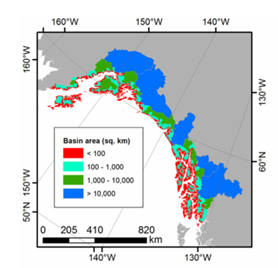

Figure 1. Map of the individual coastal watersheds in the GOA, color-coded by area.

The Gulf of Alaska (GOA) stands as an ideal research site because it contains diverse terrain features together with both heavy rainfall and significant ice coverage, which is visualized in Figure 1 [4]. The glaciated area in the GOA constitutes a substantial segment of worldwide glacier ice beyond polar ice sheets which contributes substantially to worldwide sea-level alterations [6]. Accurate climate impact assessments depend on a thorough understanding of glacier dynamics throughout this specific region because predictions about global effects on regional systems need Glacier tracking in the Gulf of Alaska.

Figure 2.Mass balance trends of Alaskan glaciers (1952-2023)

The current state of GOA glaciers reflects a complex interaction of various factors. While globally, glacier mass loss is accelerating [1], with Alaska playing a substantial role for whose a historical trend pattern is plotted for the 4 Major Glaciers of Alaska; regional studies have revealed a more similar data. Some research suggests a deceleration in mass loss rates within Alaska [1], even as the state remains a significant contributor to overall global ice loss. This apparent paradox highlights the importance of regional-scale investigations and illustrates the uneven distribution in glacier response to climate forcing. Furthermore, a broad range of mass balance estimates exists within the literature [3], emphasizing the challenges inherent in accurately measuring and modeling glacier dynamics, the major runoff sequences for GOA is shown in Figure 3[6]. These challenges arise from the complex interactions of climatic drivers such as temperature, precipitation and wind currents, the influence of glacier morphology (e.g., terminus type: land-terminating, lake-terminating, tidewater) [7], and the difficulties in quantifying processes like calving, subglacial melt, and rain-on-snow events[4][6]. For instance, Yang et al. (2020) observed significant differences in flow speeds between different glacier terminus types, with lake-terminating and tidewater glaciers exhibiting considerably higher velocities than land-terminating glaciers [7].

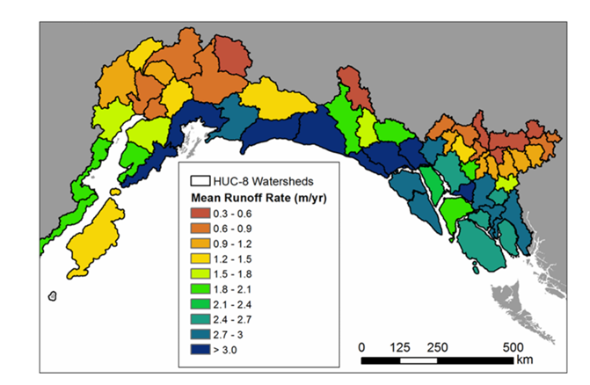

Figure 3.Map of mean annual runoff rate (in m yr21

This study addresses the critical need for improved projections of future glacier mass balance and associated hydrological fluxes within the GOA. Accurate predictions are crucial for understanding the potential impacts on sea-level rise, regional water resources, coastal ecosystems, and local communities. Previous studies have employed various methodologies, including remote sensing analysis [3], hydrological modeling [4][6], and statistical approaches, to examine glacier changes in the GOA. For instance, Beamer et al. (2016) quantified the various components of freshwater flux into the GOA, highlighting the substantial contribution from glacier melt [6]. However, further research is needed to develop more sophisticated and comprehensive models that can fully capture the complex interactions between climate change, glacier dynamics, and hydrological processes. Moreover, many previous studies have focused on specific sub-regions or limited timeframes, hindering the development of a holistic understanding of glacier change across the entire GOA. For instance, studies focusing on the Kenai Peninsula have documented significant glacier area reduction (e.g., a 12 ± 3% decrease between 1986 and 2016 ) and accelerated mass loss (e.g., -0.94 ± 0.12 m w.e. a⁻¹ between 2005 and 2014 )[3].

To overcome these limitations, this research proposes an integrated approach that synthesizes information from multiple sources, including remotely sensed data , climate model projections , and findings from previous studies , to develop a more robust framework for projecting future glacier evolution in the GOA. Specifically, this work harnesses existing studies of glacier mass balance, area change, and ice velocity, in conjunction with climate projections under various emission scenarios, to train and validate advanced predictive models. This work proposes state-of-the-art statistical and machine learning techniques to identify the key drivers of glacier change and to develop models capable of accurately representing these complex relationships. By integrating data from multiple studies, including those focusing on specific regions and time periods, to construct a more comprehensive and spatially explicit understanding of glacier change across the entire GOA. This multifaceted approach will enable to address the limitations of individual datasets and models, ultimately leading to more reliable and generalizable projections.

The process begins with extracting frames from glacier timelapse and segmented into 300 individual frames, which then undergo image processing to enhance quality and identify key features through segmentation. 9 Statistical features are derived from these processed frames, complementing data acquired from existing research, including geographical facts about the glaciers. The dataset represents the glacier's characteristics over the 36-year period, with each row corresponding to a specific year from 1986 to 2021. This combined dataset is then pre-processed, analyzed, and normalized to prepare it for modeling. Two hybrid models, a Long Short-Term Memory (LSTM) network and a Recurrent Neural Network (RNN), are trained and their outputs ensembled for improved prediction. The results from these two models were then ensembled to obtain optimized forecasts for the years 2022 to 2026. Additionally, linear regression is utilized to establish a relationship between the extracted statistical features and real-world glacier trends. estimate the glacier's mass balance and sea level contribution, which are crucial indicators of the glacier's health and the region's environmental changes.

The novelty and strength of this research lie in its integrated and data-driven approach. The statistical and machine learning techniques finds complex relationships between glacier changes and change in sea level. Furthermore, our focus on future projections will provide critical information for climate change adaptation and mitigation strategies in the GOA region. This prediction provides a solution for various policy-building organizations to be ready for a change in habitat.

Literature Study:

Recent studies highlight the alarming rate of glacier mass loss, significantly contributing to global sea level rise. From 2019 to 2023, global glaciers lost approximately −331.68 ± 59.07 Gt/yr, equating to a sea level rise of 0.916 ± 0.163 mm/yr. Alaska was the foremost contributor, with a mass balance loss of −57.11 ± 7.68 Gt/yr [1].

Four main methods are used to quantify glacier mass changes: glaciological, digital elevation model (DEM) differencing, altimetry, and gravimetry. The IPCC’s sixth assessment report (AR6) complemented glaciological observations with global glacier mass balance from DEM differencing, using gravimetry for evaluation [1].

Alaska has been a significant focus due to its substantial contribution to global sea level rise. The region-wide mass-balance rate between 2005 and 2014 was −0.94 ± 0.12 m w.e. a−1, indicating an acceleration in glacier mass loss. Alaskan glaciers account for approximately 12% of the total global glacierized area, excluding the Greenland and Antarctica ice sheets [3].

The Kenai Peninsula experienced a 12% area shrinkage between 1986 and 2016. The region-wide mass-balance rate between 2005 and 2014 was −0.94 ± 0.12 m w.e. a−1, indicating an acceleration in glacier mass loss [3]. The glaciers have experienced widespread recession since the Little Ice Age [7].

Glacier mass loss in Alaska impacts global sea level rise and freshwater resources. Annual runoff is partitioned into 63% snowmelt, 17% glacier ice melt, and 20% rainfall. Glacier runoff was 38% of the total seasonal runoff [4].

Climate models predict that the Gulf of Alaska (GOA) will become warmer and wetter, leading to significant reductions in snowpack and glacier extent. For RCP 4.5, reductions in glacier volume and area resulted in a 30% decrease in annual glacier runoff between 2003–2022 and 2080–2099 [6].

Ice flow plays a fundamental role in glacier dynamics and hazards. In Alaska, glacier speeds are 50% greater in spring than the annual mean. Lake-terminating and tidewater glaciers flow faster than land-terminating glaciers. Glacier Lake Outburst Floods (GLOFs) can cause significant speed-ups in glacier flow [7].