**Modelling Glacier Dynamics and Sea Level Rise for Future Projections in the Gulf of Alaska**

|  |  |  |
| --- | --- | --- |
| **Harsh Mahanti**  *Amity Institute of Information Technology*  *Amity University Jharkhand*  *Ranchi, India*  **mahantiharsh@gmail.com** | **Swayam Gupta**  *Amity Institute of Information Technology*  *Amity University Jharkhand*  *Ranchi, India*  **swayamgupta5698@gmail.com** | **Roumo Kundu**  *SAP TLL VT India BLR*  *SAP Labs BLR*  *Bangalore, India*  **rjroumo@gmail.com** |
| **Tannisha Kundu**  *Amity Institute of Information Technology*  *Amity University Jharkhand*  *Ranchi, India*  **tkundu@rnc.amity.edu** |  |  |

**Abstract**

In the last few years, there has been a significant change in the sea level of Alaska by the melting of glaciers due to which the flora and fauna in the coastal region have been endangered. Accurate prediction and analysis of change in sea level is crucial for the policymakers and protective agencies to take proper measures against the change. Existing studies don’t provide a proper prediction about the changes in the glacier mass, glacier health or the changes in the sea level. The main problem lies in the unavailability of data. This research provides a deep analysis of glacier mass change from 1985-2021 extracted from a remote sensing timelapse video and it predicts the changes in glacier health and sea level from 2021-2026. This solution uses various image processing techniques to extract data from the image sequence from the video and it also uses the LSTM and RNN models ensembled together to predict future changes with an accuracy of 80%. This prediction provides a solution for various policy-building organizations to be ready for a change in habitat.

**Introduction**

Glaciers play a crucial role in the Earth's climate system and significantly contribute to global sea level rise. Recent studies have highlighted the alarming rate of glacier mass loss worldwide, with substantial implications for sea level rise, freshwater resources, and regional hydrology. The Intergovernmental Panel on Climate Change (IPCC) has projected a likely global mean sea level rise of between 0.43 m and 0.84 m by 2100 under a high emission scenario (RCP 8.5) (IPCC, 2021) [2]. This rise poses significant threats to coastal communities, infrastructure, and ecosystems worldwide.

From 2019 to 2023, global glaciers experienced a significant mass loss of approximately −331.68 ± 59.07 Gt/yr, contributing to a sea level rise of 0.916 ± 0.163 mm/yr [1]. Notably, Alaska emerged as the foremost contributor to global glacier mass change, with a substantial mass balance loss of approximately −57.11 ± 7.68 Gt/yr [1]. This deceleration in mass loss contrasts with the accelerated mass loss observed in other regions, such as the southern Canadian Arctic and the southern Greenland Periphery. The Gulf of Alaska (GOA) stands as an ideal research site because it contains diverse terrain features together with both heavy rainfall and significant ice coverage, which is visualized in **Figure 1** [4].

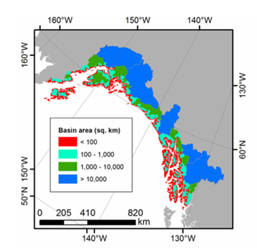

Figure 1. Map of the individual coastal watersheds in the GOA, color-coded by area.

To understand and quantify changes in glacier mass, four main methods are commonly used: glaciological, digital elevation model (DEM) differencing, altimetry, and gravimetry. Repeat observations from optical and radar DEMs provide detailed glacier elevation data at high temporal and spatial resolution. The IPCC’s sixth assessment report (AR6) complemented glaciological observations with global glacier mass balance from DEM differencing, using results from gravimetry for evaluation [2]. Furthermore, a broad range of mass balance estimates exists within the literature, emphasizing the challenges inherent in accurately measuring and modeling glacier dynamics, the major runoff sequences for GOA is shown in **Figure 2** [6].

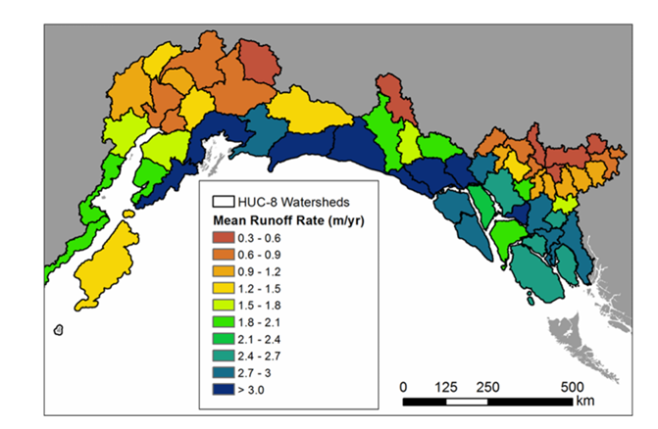

Figure 2. .Map of mean annual runoff rate (in m yr21)

The Kenai Peninsula in south-central Alaska has experienced significant glacier mass loss, with a 12% area shrinkage between 1986 and 2016. The region-wide mass-balance rate between 2005 and 2014 was −0.94 ± 0.12 m w.e. a−1, indicating an acceleration in glacier mass loss.[3] This region's glaciers contribute significantly to global sea level rise and freshwater input into the Gulf of Alaska. The current state of GOA glaciers reflects a complex interaction of various factors. While globally, glacier mass loss is accelerating [1], with Alaska playing a substantial role for whose a historical trend pattern is plotted for the 4 Major Glaciers of Alaska in **Figure 3** [10].

Figure 3. Mass balance trends of Alaskan glaciers (1952-2023)

This research aims to develop a robust pipeline for processing images, extracting meaningful features, generating datasets, analyzing data, and deploying models to study glacier mass balance changes. The research begins with extracting frames from glacier timelapse and segmented into 300 individual frames, which then undergo image processing to enhance quality and identify key features through segmentation. 9 Statistical features are derived from these processed frames, complementing data acquired from existing research, including geographical facts about the glaciers. The dataset represents the glacier's characteristics over 36 years, with each row corresponding to a specific year from 1986 to 2021. This combined dataset is then pre-processed, analyzed, and normalized to prepare it for modelling.

Following image processing, the extracted features are used to generate datasets for training and testing machine learning models. Data analytics is performed to gain insights into the datasets and prepare them for model training. Different machine learning models, including ensemble models, Long Short-Term Memory (LSTM) networks, and Recurrent Neural Networks (RNNs), are tested to evaluate their performance and suitability for the given task. The best-performing models are then prepared for deployment.

The results from these two models were then ensembled to obtain optimized forecasts for the years 2022 to 2026. Additionally, linear regression is utilized to establish a relationship between the extracted statistical features and real-world glacier trends. estimate the glacier's mass balance and sea level contribution, which are crucial indicators of the glacier's health and the region's environmental changes.

This comprehensive workflow showcases the integration of image processing, machine learning, and data analytics to solve complex problems effectively. By providing a detailed methodology for developing and deploying machine learning models for image processing tasks, this research aims to contribute to the field and serve as a valuable reference for future studies and applications in related domains.

**Literature Study**

Recent studies highlight the alarming rate of glacier mass loss, significantly contributing to global sea level rise. From 2019 to 2023, global glaciers lost approximately −331.68 ± 59.07 Gt/yr, equating to a sea level rise of 0.916 ± 0.163 mm/yr. Alaska was the foremost contributor, with a mass balance loss of −57.11 ± 7.68 Gt/yr [1].

Four main methods are used to quantify glacier mass changes: glaciological, digital elevation model (DEM) differencing, altimetry, and gravimetry. The IPCC’s sixth assessment report (AR6) complemented glaciological observations with global glacier mass balance from DEM differencing, using gravimetry for evaluation [1].

Alaska has been a significant focus due to its substantial contribution to global sea level rise. The region-wide mass-balance rate between 2005 and 2014 was −0.94 ± 0.12 m w.e. a−1, indicating an acceleration in glacier mass loss. Alaskan glaciers account for approximately 12% of the total global glacierized area, excluding the Greenland and Antarctica ice sheets [3].

The Kenai Peninsula experienced a 12% area shrinkage between 1986 and 2016. The region-wide mass-balance rate between 2005 and 2014 was −0.94 ± 0.12 m w.e. a−1, indicating an acceleration in glacier mass loss [3]. The glaciers have experienced widespread recession since the Little Ice Age [7].

Glacier mass loss in Alaska impacts global sea level rise and freshwater resources. Annual runoff is partitioned into 63% snowmelt, 17% glacier ice melt, and 20% rainfall. Glacier runoff was 38% of the total seasonal runoff [4].

Climate models predict that the Gulf of Alaska (GOA) will become warmer and wetter, significantly reducing snowpack and glacier extent. For RCP 4.5, reductions in glacier volume and area resulted in a 30% decrease in annual glacier runoff between 2003–2022 and 2080–2099 [6].

Ice flow plays a fundamental role in glacier dynamics and hazards. In Alaska, glacier speeds are 50% greater in spring than the annual mean. Lake-terminating and tidewater glaciers flow faster than land-terminating glaciers. Glacier Lake Outburst Floods (GLOFs) can cause significant speed-ups in glacier flow [7].

**Methodology**

The workflow structure and implementations of the study have been mentioned below in the sections discussed in the sections ahead. The procedure starts with the extraction of frames from glacial timelapse, followed by the segmentation into 300 distinct frames, which subsequently undergo image processing to improve quality and discover essential elements using segmentation. Statistical characteristics are extracted from these processed frames, augmenting data obtained from prior studies, including geographical information on the glaciers.

The integrated dataset is subsequently pre-processed, analysed, and normalised to facilitate modelling. Two hybrid models, a Long Short-Term Memory (LSTM) network and a Recurrent Neural Network (RNN), are trained and their outputs are ensembled for improved prediction. The results from these two models are then ensembled to obtain optimized forecasts for the years 2022 to 2026. Additionally, linear regression is utilized to establish a relationship between the extracted statistical features and real-world glacier trends, estimating the glacier's mass balance and sea level contribution. The proposed architecture is described in **Figure 4**.

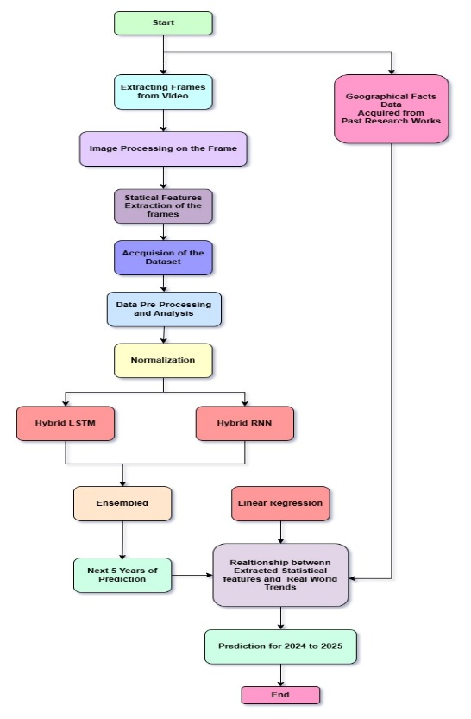

Figure 4. Workflow Algorithm of the Proposition

**Data Acquisition and Analysis**

The numerical and statistical features of the dataset, used for projections were extracted over from the Timelapse footage of 300 frames, Constituting 300 rows and 9 features respectively. The details of the extracted features are described as follows,

* Feature_1 - Processes an image to compute the percentage of pixels that have a high intensity, based on a dynamic threshold and the frequency of pixel intensities
* Feature_2 - The Frobenius norm is calculated for the grayscale version of an image, providing a numerical value that represents the overall intensity magnitude of the image.
* Feature_3 - Detects the largest region, computes its convex hull, crops the image, and applies Frobenius Norm on it.
* Feature_4 – Calculates the diagonal length of the cropped image by applying the Pythagorean theorem.
* Feature_5 – Calculates the Width of the cropped image by applying the Pythagorean theorem.
* Feature_6 – Calculates the Height of the cropped image by applying the Pythagorean theorem.
* Feature_7 - Compute the percentage of pixels that have the lowest intensity, based on a dynamic threshold and the frequency of pixel intensities.
* Feature_8 - Calculate the ratio of white family pixels to black family pixels.
* Feature_9 – Calculates Pixel rate Change with Subsequence Subtraction of Images.

These 9 features’ characteristics are computed in Table 1, the data reveals that Feature 1 and Feature 8 exhibit small ranges together with minimal standard deviations indicating small variations. The large values combined with higher standard deviations of Feature 2 and Feature 3 indicate notable variations across the study parameters. Data from Feature 4, Feature 5, and Feature 6 demonstrate average size values while containing significant variations of moderate scope. Feature7 demonstrates stability across a narrow range yet Feature9 reveals substantial differences between its lowest point (0) and highest point (11.55) along with high standard deviation levels due to occasional extreme fluctuations.

Table 1. Characteristics of the Features

|  | **min** | **max** | **mean** | **std** |
| --- | --- | --- | --- | --- |
| **Feature1** | 0.1121 | 0.190300 | 0.152698 | 0.020580 |
| **Feature2** | 83528.1779 | 108193.522600 | 96826.305201 | 6497.177463 |
| **Feature3** | 80950.3309 | 103158.110500 | 92651.430769 | 5500.413412 |
| **Feature4** | 1156.8513 | 1293.431100 | 1215.729927 | 42.300775 |
| **Feature5** | 412.0000 | 592.000000 | 466.726667 | 37.045465 |
| **Feature6** | 1080.0000 | 1174.000000 | 1122.213333 | 34.962682 |
| **Feature7** | 0.7294 | 0.789700 | 0.758105 | 0.012816 |
| **Feature8** | 0.1298 | 0.239900 | 0.184671 | 0.028877 |
| **Feature9** | 0.0000 | 11.550129 | 0.752736 | 2.131414 |

The Interquartile Range (IQR) detects outliers by locating values that exceed 1.5 times the IQR above Q1 and below Q3. The outlier box plot is shown in Figure 5, except Feature 9. Outlier analysis reveals substantial outlier numbers in Feature3 (12), Feature5 (52) and Feature9 (44) which could represent unusual data points or distribution variation. The distribution patterns for all other features remain within standard ranges which indicates their relative stability. Feature5 and Feature9 display high outlier numbers which suggests distribution anomalies or extreme values that warrant further examination.

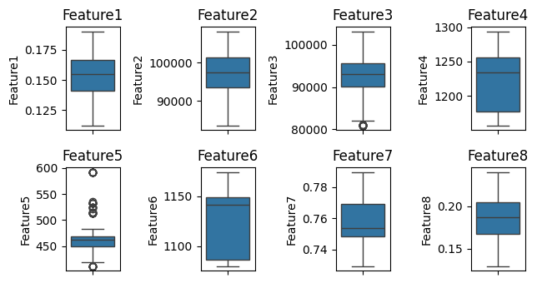

Figure 5. Probable Outlier Detection for the Dataset

The correlation matrix in Figure 6, reveals strong positive relationships among many features, especially between Features 1, 2, and 8, indicating they likely capture similar patterns. Features 3 and 4 also show a strong positive correlation. Feature 7, however, exhibits moderate negative correlations with several other features, suggesting an inverse relationship or a unique role in the dataset. Feature 9 remains largely uncorrelated with different features, indicating it varies independently. Overall, the dataset appears to have highly interrelated features, with some, like Feature 7, displaying contrasting behaviour. These insights suggest potential redundancy among features.

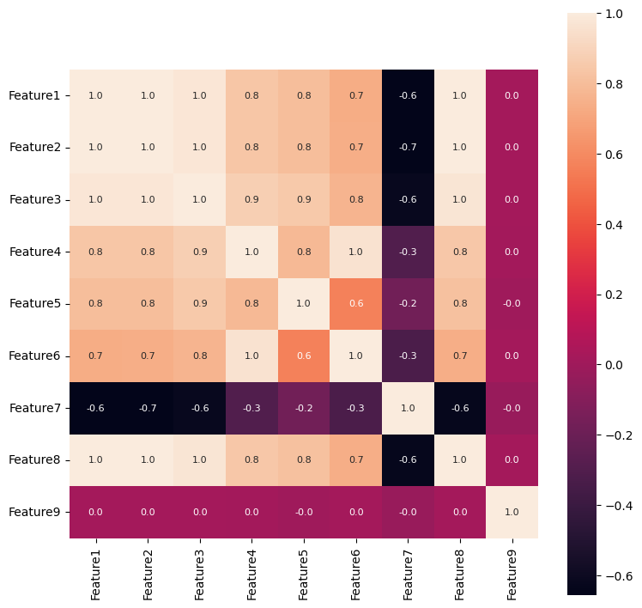

Figure 6. Correlation Matrix for the Features

To test the variability and use case One Way ANOVA was implemented, to determine if there are significant differences between multiple groups of data in the dataset,

|  |  |
| --- | --- |
|  | (1) |

The p-value and t-value are both used to assess statistical significance. The t-value measures the difference between group means in relation to variability within the groups, whereas the p-value indicates the probability of observing such a difference (or more extreme) under the null hypothesis. The alpha value (typically **0.05**) sets the threshold for significance: if the p-value is less than alpha, the null hypothesis is rejected, suggesting a significant difference between groups.

In this case ANOVA test for all the Features results in an **F-value** of **63114.40** and a **p-value** of **0.0000**, the result is highly significant, indicating strong evidence against the null hypothesis and suggesting that there are significant differences between the groups. All pairs of features demonstrate statistically meaningful differences according to the pairwise ANOVA test whose **p-values** amount to **0.000000e+00** which surpasses the standard alpha value of **0.05**. Statistical results show that researchers should reject the null hypothesis for each feature pair comparison thereby confirming significant differences between the feature means.

To validate the study that found that the glacial melt and runoff decelerated between 2019 and 2023 than in the previous decade. To validate the claim of deceleration in glacial melt and runoff from 2019 to 2023, we analyze the year-over-year changes for the chosen features (representing glacial melt and runoff) over two periods: 2009-2018 and 2019-2023. The year-over-year change for any given feature *F(t)* is computed as,

|  |  |
| --- | --- |
|  | (2) |

Where ΔF(t) represents the year-over-year difference for the feature at year t. Next, we calculate the average annual rate of change for both periods as follows;

For the previous decade (2009 to 2018),

|  |  |
| --- | --- |
|  | (3) |

For the recent period (2019 to 2023) ,

|  |  |
| --- | --- |
|  | (4) |

For this analysis Features 1 and 8 were selected as these two resonate closely with Glacial Health overall. The change of average annual rate of change in Feature1 and Feature8 from 2002-2019 to 2019-2021 is analyzed and it is found that both features grew from **-0.0002 to 0.0008** for **Feature 1** and from **-0.0003 to 0.0010** for **Feature 8**. A Feature termed *“****Health of the Glacier****”* was formulated for ease of study which was mean value corresponded with **Feature 1 and 8 ,** shown in Figure 7.

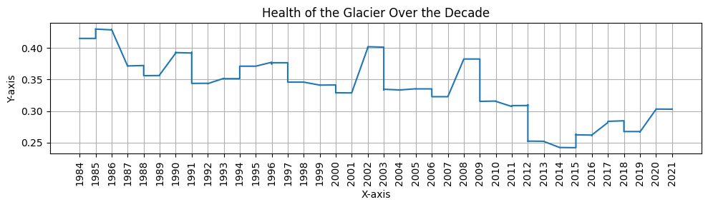

Figure 7. Glacier Health over The Decade

On *“****Health of the Glacier****”* it Calculates the rate of change (slope) of a glacial health metric over two periods, 2002-2019 and 2019-2021, by fitting a linear regression model to the data for each period. The slope of the regression line represents the rate of change.

|  |  |
| --- | --- |
|  | (5) |
|  | (6) |
|  |  |

Where x are the years, y are the corresponding glacial health values, xˉ and yˉ​ are the means of the years and glacial health values, respectively, and n is the number of data points. The slope mmm indicates whether the glacial health metric is improving or declining over the period in (6) .

In the rate of change in glacial pixels, two distinct trends are seen between the two periods. The negative rate of change **−0.0016** from **2002 to 2019** is indicative of a decreasing trend in glacial pixels (degradation in glacier health) likely owing to an increase in melt and loss of ice. Yet, from **2019 to 2021**, the rate of change **0.0089** is positive, implying that glacial pixels are increasing and possibly indicating stabilization or even improvement in glacier health in this latter period.

A t-test is then performed to compare the slopes of the two periods to determine if there is a statistically significant difference. If the p-value from the t-test is less than 0.05, the difference in slopes is significant, indicating a change in the glacial health metric between the two periods.

|  |  |
| --- | --- |
|  | (7) |

Both **Feature1** and **Feature8** show significant changes between 2002-2019 and 2019-2021, as indicated by the results of the t-test. The **t-statistic** of **3.8126** and the **p-value** of **0.0003** for **Feature1** imply a strong statistical difference in the slopes, indicating a sharp change in glacial health within these two periods. **Feature8** has also shown a **t-statistic** of **3.9771** and **p-value** of **0.0002**, indicating a significant shift between the two period. The observed deceleration in glacial melt and runoff is therefore corroborated by the change in glacial dynamics, as quantified by both features, between earlier and more recent years. Combined with these highly significant p values (far below the usual bar of 0.05), the results do not suggest random variation through time, but rather indicate real changes in the glacial processes. A similar test was opted for the entire Feature set of the Extraction Shown in **Figure 8** ,

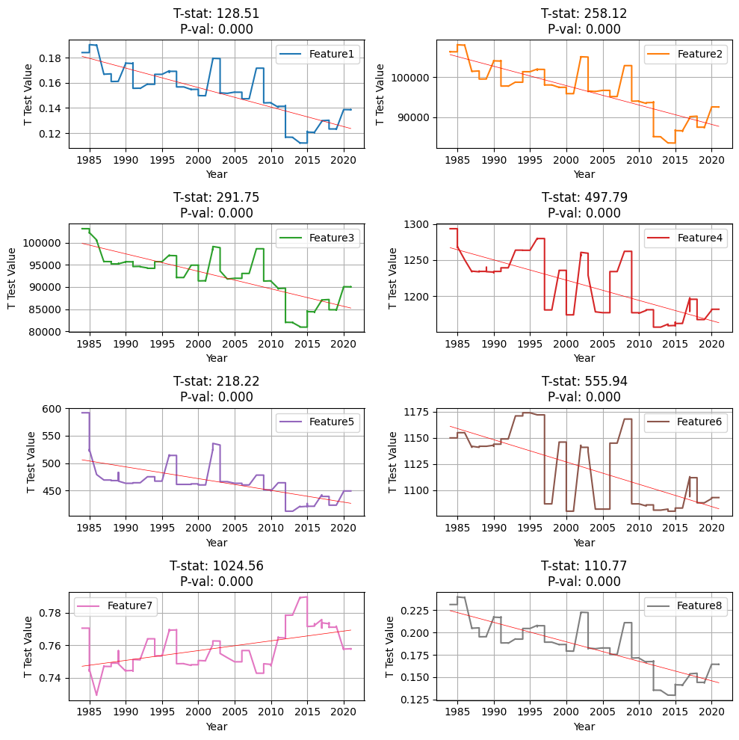

Figure 8. t-tests for each feature against a hypothetical population mean

Results of the t test strongly reject the null hypothesis, each feature is statistically significantly different from hypothetical population mean, with p values extremely small. Feature7 with the highest t statistics shows the most substantial deviation from the mean, while other’s such as Feature1 and Feature8 although have lower t statistics still have strong significances. The results indicate that all features are meaningful and that they include a lot of information which is not centered on the population mean of 0. Validating the acquisition of the Feature Extraction.

**Mathematical Implementation**

**Phase 1 (Image Processing Techniques for Segmentation)**

The first step begins by extracting individual frames from time-lapse video of glacier. These frames serve as the primary data source for analysing glacier dynamics and surface characteristics. The initial processing step involves a Gray Scale Transform, converting the imported colour frames into grayscale images. This reduction in dimensionality simplifies the subsequent image processing operations while still retaining essential information about image intensity and structure.

(1)

Here in equation (1), Igray(x,y) is the grayscale intensity at pixel (x,y), IR(x,y), .IG(x,y) and IB(x,y) are the red, green and blue channel intensities at (x,y) respectively. The coefficient 0.2989, 0.5870 and 0.1140 are the standard luminance conversion factors from RGB to grayscale. This transformation ensures that human-perceived brightness is perceived in the grayscale image.

(2)

Following the grayscale conversion, a Gaussian Blur is applied to the image. This convolution operation smooths the image by reducing high-frequency noise and subtle variations, allowing for a clearer focus on more prominent features. The blurring effect is achieved by convolving the image with a Gaussian kernel, effectively averaging pixel values in a neighborhood weighted by the Gaussian distribution. Here in (2) Idenoised(x,y) is the denoised intensity at pixel (x,y) Igray(x,y) is the grayscale intensity at pixel (x,y)

(3)

G(i,j) is the Gaussian kernel defined as (3), σ is the standard deviation of the Gaussian function, k is the kernel size parameter, where the kernel has dimensions (2k+1)x(2k+1). This convolution operation smooths the image by averaging pixel intensities weighted by the Gaussian kernel, effectively reducing noise.

To enhance the contrast and emphasize edges within the image, a **Sharpening Filter** is employed. This filter amplifies the intensity differences between neighbouring pixels, resulting in a more defined and crisp appearance of features such as crevasses, glacier boundaries, and other textural elements. The sharpening process enhances the visual clarity of the image, making feature extraction more accurate.

Here in equation (4) Isharp(x,y) is the sharpened pixel intensity at (x,y). Idenoised(x,y) is the intensity of the denoised image at (x,y). K(i,j) is the sharpening kernel. This kernel enhances edges by amplifying the centre pixel value while subtracting the surrounding pixel values, making edges more prominent.

In parallel with the sharpening, Canny Edge Detection is performed. This technique identifies edges in the image by detecting abrupt changes in pixel intensity. The Canny Edge Detector operates through a multi-stage process, including Gaussian blurring, Sobel filtering to find gradient magnitudes and orientations, non-maximum suppression to thin edges, and hysteresis thresholding to link edge segments. The results from the sharpening filter and the Canny Edge Detector are then combined using an Add Resultants operation. This step integrates the enhanced contrast from the sharpening with the precise edge information from the Canny detection, providing a comprehensive representation of the image's structural features. This combined image is then subjected to a Thresholded Original Image step.

Here, a threshold value is applied to the original grayscale image, segmenting the image into distinct regions based on pixel intensity. This thresholding creates a binary image where pixels above the threshold are assigned one value (e.g., white) and those below are assigned another (e.g., black). Simultaneously, a Thresholded Resultant Image operation is performed on the combined image from the sharpening and edge detection steps. This thresholding highlights the enhanced edges and features identified earlier.

The binary images resulting from both thresholding operations are then combined using another Add Resultants step. This integration merges the segmented regions from the original image with the enhanced edge information from the processed image, creating a more complete and accurate segmentation mask. To further refine the segmented image and reduce any remaining noise or irregularities, a Gaussian Blur and a Median Blur are sequentially applied. The Gaussian blur provides additional smoothing, while the median blur replaces each pixel with the median value of its neighboring pixels, effectively removing isolated noise and preserving edges.

(5)

The mathematical formulation for applying the median filter is given in equation (5). Given an image I(x, y), the median filter replaces each pixel with the median value of the pixels in its neighborhood. Where Imedian(x, y) is the pixel value at position (x, y) after the median filter is applied. represents the set of pixel values in a neighborhood around pixel (x, y). k is the radius of the neighborhood (in this case, the kernel size is 25x25, so k = 12).

Finally, another Add Resultants operation combines the outputs from the Gaussian and Median blurs, yielding the Obtained Segmented Image. This image represents the culmination of the image processing steps, providing a clean and well-defined segmentation of the glacier features. From this segmented image, 9 Statistical Features are extracted. These features, which quantify various aspects of the glacier's texture, shape, and structure, form the basis for subsequent statistical analysis and modelling for this study.

**Phase 2 ( Ensembled Hybrid {LSTM + RNN} )**

**Results and Discussions**

**Phase 1 (Image Processing Techniques for Segmentation)**

**Phase 2 ( Ensembled Hybrid {LSTM + RNN} )**