CA3 – AGENTIC AI
Course / Subject: Agentic AI
Student Name: Harsh Mate
Project: Pune Restaurant Discovery Agent – a budget-aware AI agent
Course Title: [TO FILL – title(s) of your completed course(s)]
Course Duration (minimum 45 hours): [TO FILL – total hours from your own certificates]
Faculty: [TO FILL]
Division: [TO FILL]

1. Introduction to Agentic AI

Objective
The objective of this CA3 work is to understand how agentic AI systems differ from ordinary chatbots, and to show that understanding by building, testing and explaining a working agent. The agent built for this report, the Pune Restaurant Discovery Agent, takes a natural-language request such as “veg birthday dinner for 4 in Wakad under ₹3000”, works out what the user needs, decides which tools to call, checks the results, changes its plan when the results are not good enough, and returns a ranked shortlist with an explanation for every choice.

Key Concepts Understood
The table below lists the agentic-AI concepts used in this project and where each one appears in the implementation.
Table 1: Agentic AI concepts and how this project applies them
Concept | Meaning | Where it appears in this project
Perception / understanding | Turning unstructured input into structured information the agent can act on. | agent/extractor.py converts the request into a Preferences object (area, budget, party size, diet, cuisine, occasion, rating, features).
Goal and constraints | The agent works towards the user’s goal while respecting limits. | Diet and budget are hard constraints that are never relaxed; cuisine, rating, features and area are soft.
Planning | Choosing a sequence of actions before acting. | agent/planner.py decides whether to reject, decline, clarify or search, and lists the tool calls for the search.
Tool use | Calling external functions or data sources instead of answering from memory. | Five tools in agent/tools.py: search_restaurants, get_nearby_areas, estimate_cost, check_budget, filter_candidates.
Observe and re-plan loop | Looking at tool results and changing the plan when they are not good enough. | If fewer than 3 restaurants match, the agent widens the area or relaxes one preference and runs the tools again.
Memory / state | Keeping context across turns. | ConversationState stores partial preferences while the agent waits for an answer to its question.
Human-in-the-loop | Asking the user instead of guessing when information is missing. | One clarifying question per turn for a missing area or budget (maximum 3 rounds).
Guardrails and validation | Checking inputs and model outputs before trusting them. | LLM JSON is validated against known values; LLM summaries are rejected if they name unknown restaurants or unverified prices.
Transparency | Making the agent’s decisions visible. | Every stage writes to a trace shown in the CLI (--trace) and in the web UI.

2. Understanding of Agentic AI

What is an AI Agent?
An AI agent is a software system that pursues a goal by repeatedly perceiving its situation, deciding what to do, acting through tools, and observing the result before deciding again. A large language model (LLM) can be one component of an agent, typically for understanding language, but the agent is the whole loop: the decision rules, the tools, the state it keeps and the checks it applies. Russell and Norvig describe an agent as anything that perceives its environment and acts upon it; modern LLM agents follow the same idea, with the ReAct pattern (Yao et al., 2023) interleaving reasoning steps with tool actions.
A useful practical distinction, also made in Anthropic’s guidance on building agents (2024), is between fixed workflows, where the steps are decided in advance, and agents, which decide their own next step based on what they observe. Good systems use the simplest design that solves the problem. This project is therefore deliberately a single agent with a small set of tools and a bounded re-planning loop, rather than several cooperating agents.
Table 2: A chatbot compared with the agent built in this project
Aspect | Typical chatbot | This agent
Missing information | Guesses or answers generically | Asks one targeted question and remembers the partial request
Data | Answers from the model’s memory | Calls tools that read a dataset; no restaurant is ever invented
Budget | Approximate wording | Exact arithmetic: cost per person × party size × 1.05 tax, checked against the budget
When results are poor | Returns whatever it has | Observes the result, re-plans, and reports every compromise
Explanation | Free text, may not match the data | Reasons and trade-offs generated from the same numbers as the score
Failure | May hallucinate or crash | Falls back to rules, retries tools, or states clearly that it cannot answer

3. Courses Completed (multiple courses as applicable)

Course Details
Note to self: fill this section from your own course certificates only. Each certificate’s name, number and URL must match you. Make sure the total meets the 45-hour minimum.
- Course Title: [TO FILL]
Platform / Provider: [TO FILL]
Course Duration (minimum 45 hours): [TO FILL]
Completion Evidence: [TO FILL – certificate number / URL and screenshot of YOUR certificate]
- Course Title: [TO FILL]
Platform / Provider: [TO FILL]
Course Duration (minimum 45 hours): [TO FILL]
Completion Evidence: [TO FILL – certificate number / URL and screenshot of YOUR certificate]

4. Problem Statement

Problem Statement
Problem Statement: Students and young professionals in Pune and Pimpri-Chinchwad often need to choose a restaurant for a group with a fixed total budget and specific needs, for example a pure-vegetarian birthday dinner for four in Wakad under ₹3,000. Existing discovery apps present long lists and leave the user to apply each filter, multiply cost per person by group size, allow for tax, and judge trade-offs between rating, distance and suitability on their own. They do not ask for missing details, do not explain why a place fits, and do not say what was compromised when nothing fits exactly.
The goal is an AI agent that understands such a request in plain language, asks only for essential missing information, treats budget and dietary needs as strict limits, searches nearby areas when the chosen area has too few options, and returns a short, ranked, explained recommendation.

Why this problem is worth solving
- Group budgets are total, listings are per person. The user has to do the multiplication and allow for tax, and an error means overspending at the table.
- Dietary needs are non-negotiable. For many users in Pune, “veg” means a pure-vegetarian restaurant, and Jain or vegan needs are strict. A recommendation that ignores this is useless.
- Trade-offs are invisible. A higher-rated place 6 km away may be better than a weaker one nearby, but users rarely see this comparison laid out.
- It suits an agent, not a single prompt. Solving it needs extraction, clarification, tool calls, exact arithmetic, re-planning and explanation, which is exactly the loop described in Section 2.

Objectives and scope
- Extract area, budget (total or per person), party size, diet, cuisine, occasion, minimum rating and features from free text.
- Ask one clarifying question at a time when the area or budget is missing or the area is not covered.
- Never recommend a restaurant that breaks the budget or dietary requirement.
- Re-plan when fewer than three restaurants match, preferring the smallest compromise, and report it.
- Rank results with a transparent score and explain reasons and trade-offs for each.
- Handle invalid input, off-topic requests, tool failures and LLM failures without crashing or inventing results.
- Run fully offline in a demo mode, with an optional real LLM.
Out of scope: live restaurant data, bookings, payments and real-time opening hours. The project uses a clearly labelled sample dataset of 42 fictional restaurants across 12 real Pune localities, because live listings could not be verified and inventing real businesses would be misleading.

5. Proposed Solution

Project Title
Pune Restaurant Discovery Agent: a budget-aware, explainable AI agent for group dining decisions

Project Description
The Pune Restaurant Discovery Agent is a Python application with a Streamlit chat interface and a command-line interface. The user types a request in everyday language. The agent extracts structured preferences, using an LLM when one is configured and a rule-based extractor otherwise. It then decides whether it can proceed. If essential information is missing it asks a single question and remembers the partial request. Once it has enough, it plans and executes tool calls to fetch restaurants, estimate each bill for the group including tax, and filter out anything that breaks the hard constraints. It then observes how many restaurants survived; if too few, it re-plans by widening the search to nearby areas or, only when nothing matches, by relaxing one stated preference. Finally it ranks the candidates with a transparent weighted score, writes reasons and trade-offs for each, and produces a summary that is fact-checked before being shown.
Three earlier ideas were considered: a restaurant finder, a rental-flat finder and a combined “discovery” agent. The restaurant finder was chosen because it can be demonstrated live without unreliable external services, its constraints (budget, diet, location) are easy to test exactly, and it still needs every part of the agent loop. The combined option was rejected because two half-built domains would be harder to test and defend than one complete domain.

Agent Workflow
Figure 1 shows the complete workflow. Blue stages use the LLM when available, grey stages are deterministic Python, the green stage is tool execution, and orange boxes are the possible outcomes.
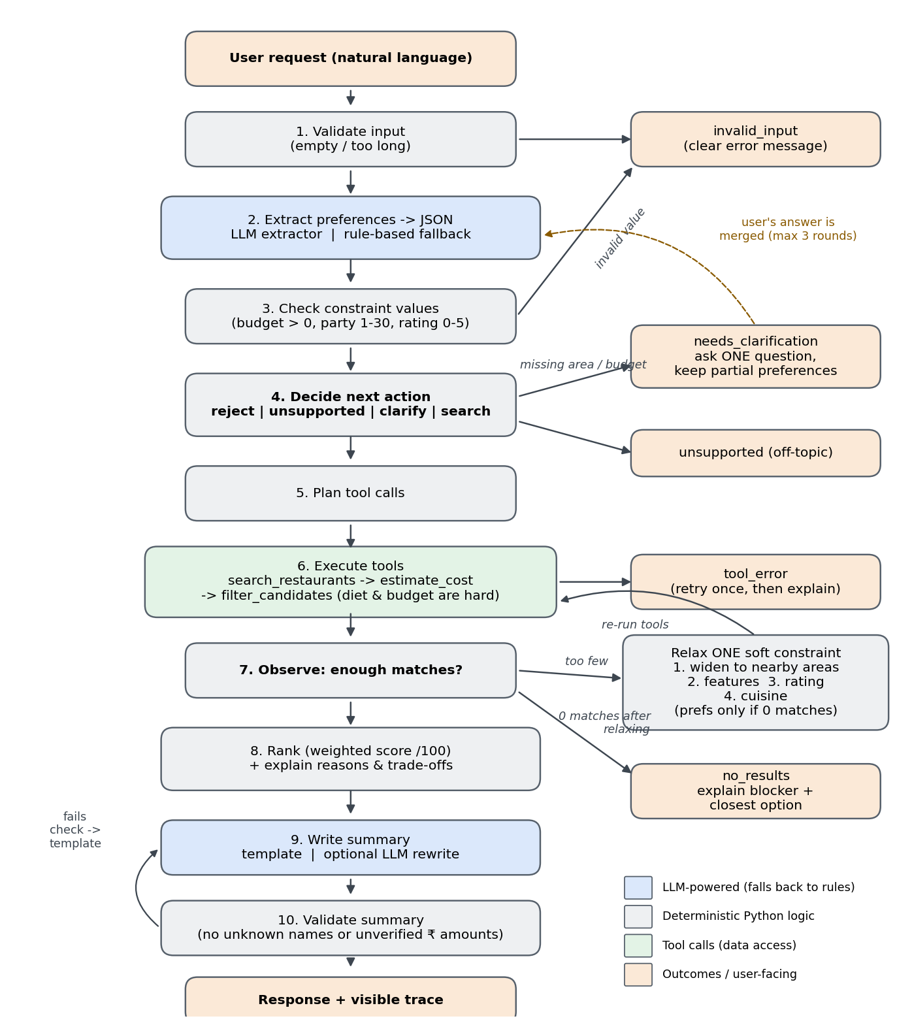
Figure 1: Agent workflow, from request to validated response (docs/agent_workflow.png)

Agent and Tool Responsibilities
The system uses one agent with five tools. A multi-agent design was considered but rejected: each step depends directly on the previous one, so splitting them across agents would add coordination overhead without adding capability.
Table 3: Tools available to the agent
Tool | Input | Output | Why the agent needs it
search_restaurants | List of areas | Restaurants in those areas | Only way to obtain candidates; keeps data access in one replaceable place
get_nearby_areas | Area, max km (8) | [(area, km)] by shortest road distance (Dijkstra) | Lets the agent widen the search sensibly when one area has too few options
estimate_cost | Restaurant, party size | Estimated bill in ₹ incl. 5% tax, rounded to ₹10 | Converts per-person prices into the group total that the budget refers to
filter_candidates | Restaurants, preferences, costs, relaxed set | Kept list + count of rejections by reason | Applies hard and soft constraints; the rejection counts tell the planner what to relax
check_budget | Estimated total, budget | Within budget?, headroom, share used | Final safety check before anything is recommended

Table 4: Stage responsibilities and what powers each stage
Stage | Module | Powered by | Failure handling
Validate input | extractor.validate_text | Python | Empty or >500 characters → invalid_input
Extract preferences | extractor.HybridExtractor | LLM, with rule-based fallback | LLM error or bad JSON → rule-based extractor; trace records it
Validate LLM output | LLMExtractor.validate_llm_output | Python | Unknown areas/cuisines/features are dropped, not trusted
Check values | extractor.check_constraints | Python | Budget ≤ 0, party > 30, rating outside 0–5 → invalid_input
Decide | planner.decide | Python rules | Off-topic → unsupported; missing area/budget → clarify
Plan and execute | planner.initial_plan, ToolBox | Python + tools | Tool failure retried once, then tool_error
Observe and re-plan | planner.next_relaxation | Python rules | Nothing left to relax → no_results with explanation
Rank and explain | recommender.rank | Python weighted score | Deterministic tie-breaking
Summarise and verify | response_generator | Template or LLM | LLM text mentioning unknown names or prices → template

Decision Rules
- Hard constraints (never relaxed): budget and diet. “Vegetarian” means a pure-veg restaurant; vegan and Jain require confirmed options, and unknown values count as not confirmed.
- Clarification: if the area is missing or not covered, ask for it; then, if the budget is missing, ask for it. One question per turn, at most three rounds, after which the agent proceeds and lists its assumptions.
- Re-planning: widening the search to areas within 8 km keeps every preference intact, so it is allowed whenever fewer than three restaurants match. Changing a stated preference (features, then rating, then cuisine) is allowed only when zero restaurants match, and only for a preference that actually rejected candidates.
- Ranking score (out of 100): rating 30%, occasion fit 20%, cuisine match 15%, distance 15%, value for money 10%, requested features 10%. The weights were set so that occasion fit outweighs cheapness. An earlier version gave value for money 20%, which ranked a ₹500 chaat stall above a birthday venue for a birthday request, so the weights were changed.

6. Implementation

Technologies Used
Programming Language: Python 3.10+ (developed and tested on Python 3.12.3)
LLM / AI Model: Optional and configurable. Any OpenAI-compatible chat model (e.g. OpenAI, Groq, Google Gemini’s OpenAI-compatible endpoint) or an Anthropic Claude model, selected with LLM_PROVIDER and LLM_MODEL. Demo mode uses no model. [State the model you actually used, if any]
Agent Framework: Custom, lightweight agent loop written in plain Python (no LangChain / LangGraph), chosen so every decision is visible and testable
Tools / APIs: Five Python tools (search_restaurants, get_nearby_areas, estimate_cost, check_budget, filter_candidates); LLM chat-completion API via the standard library (urllib)
Database / Storage: JSON files: data/restaurants.json (42 sample restaurants) and data/areas.json (12 Pune areas with an approximate distance graph); session state in memory
Frontend: Streamlit chat UI (app.py) and a command-line interface (main.py)
Backend: Python agent package (agent/) with pytest test suite

Project Structure
Table 5: Project files and their purpose
Path | Purpose
app.py / main.py | Streamlit web UI / command-line interface (both call the same DiscoveryAgent)
config.py | Reads LLM_PROVIDER, LLM_API_KEY, LLM_MODEL, LLM_BASE_URL from the environment or .env; no keys in code
agent/core.py | DiscoveryAgent orchestrator, ConversationState, visible trace
agent/extractor.py | Input validation, rule-based / LLM / hybrid preference extraction
agent/planner.py | Decide, plan, choose next relaxation
agent/tools.py | The five tools and ToolBox (retry, logging)
agent/recommender.py | Weighted scoring, reasons, trade-offs
agent/response_generator.py | Template summary, optional LLM summary, hallucination check
agent/llm.py | Minimal OpenAI-compatible and Anthropic client
data/ | Sample restaurants and area graph (clearly labelled as sample data)
tests/ | 64 automated pytest tests
scripts/ | generate_evidence.py (builds docs/test_evidence.md from real runs), make_diagram.py
docs/ | Workflow explanation, test evidence, screenshots, diagram

Implementation Steps
- Defined the data model (agent/models.py): Preferences, Restaurant, Recommendation, TraceStep and AgentResponse, so that every stage has an explicit input and output.
- Created the sample data: 42 fictional restaurants across 12 real Pune areas, with cost per person, rating, diet flags, occasions and features. Some features are deliberately unknown (null) to test missing-information handling. Area distances form a graph for shortest-path search.
- Built the preference extractor: first a rule-based extractor (regular expressions and synonym lists), then an LLM extractor that requests JSON and validates it against the same vocabulary, and finally a hybrid extractor that falls back to rules on any LLM error.
- Implemented the tools with one responsibility each, wrapped in a ToolBox that logs every call and retries a failing data source once.
- Wrote the planner: the decide step (reject / unsupported / clarify / search), the initial plan, and the relaxation policy driven by the rejection counts from filter_candidates.
- Implemented ranking and explanations from the same score components, so that the text always matches the numbers.
- Added the response generator with a deterministic template and an optional LLM rewrite, checked for unknown restaurant names and unverified ₹ amounts.
- Built two interfaces: a CLI with --trace and --json options, and a Streamlit chat UI with example prompts, score breakdowns and an expandable trace.
- Wrote and ran 64 automated tests, fixed the bugs they and manual runs revealed (Section 7), and generated the evidence document from real runs.

Key Code: Hard Constraints and Re-planning
The excerpt below is the core of the observe-and-re-plan loop in agent/core.py. The agent filters, observes how many restaurants remain, asks the planner what to relax, and repeats until it has enough results or nothing more may be relaxed.
while True:
kept, rejected = tools.call("filter_candidates", candidates=candidates,
prefs=prefs, costs=costs, relaxed=relaxed)
run.log("observe", f"{len(kept)} match; rejected by ...")
step = next_relaxation(prefs, relaxed, rejected, len(kept), wanted)
if step is None:
break
relaxed.add(step)
if step == "nearby_areas":
nearby = tools.call("get_nearby_areas", area=prefs.area, max_km=8)
extra = tools.call("search_restaurants", areas=[a for a, _ in nearby])
... # estimate costs for the new candidates, then loop again

Data Sources and Limitations
- Restaurant data is fictional sample data. Names, prices, ratings and features were created for this project and are labelled as such in the data file, the UI and the CLI output. Area names are real; distances are approximate and are not navigation data.
- Cost is an estimate: average cost per person × party size × 1.05, assuming 5% GST. Drinks, service charges and menu choices can change the real bill, so the agent warns when an option uses more than 90% of the budget.
- Live LLM calls were not executed while building this version because no API key was available in the build environment. The LLM code paths are verified with a scripted fake provider (TC-50 to TC-58). [If you test with your own key, record the result here]

7. Final Project Demonstration

Prototype / Application Link
Runs locally: streamlit run app.py (then open http://localhost:8501). Not deployed online. [Add a hosted link here if you deploy it, e.g. on Streamlit Community Cloud]

GitHub Repository
[TO FILL – your GitHub repository URL after you upload the smart_discovery_ai_agent folder (the .gitignore already excludes .env and logs)]

Demonstration

Scenario 1: complete request with re-planning
Input: “veg birthday dinner for 4 in Wakad under 3000”. The agent extracted every preference in one step, so no question was needed. Wakad alone produced only 2 pure-veg match(es) within budget, fewer than the target of three, so the agent called get_nearby_areas, searched 4 nearby areas and filtered again. Every recommendation is pure-vegetarian and within ₹3,000; the top pick is in Wakad itself and is tagged for birthdays. The trade-off that it uses over 90% of the budget is stated openly. The output below is copied from an actual run.
[extract] Preferences extracted by rule-based extractor: area=Wakad, budget=3000.0, party=4,
diet=vegetarian, occasion=birthday
[decide] search: All essential information is available.
[plan] search_restaurants - Fetch restaurants in Wakad.
[plan] estimate_cost - Estimate each bill for 4 people incl. 5% tax.
[plan] filter_candidates - Apply diet and budget (hard) plus cuisine/rating/feature (soft)
constraints.
[plan] check_budget - Confirm each shortlisted bill is within ₹3,000.
[tool] search_restaurants(Wakad) -> 5 restaurants
[tool] estimate_cost x5 for party of 4
[observe] 2 match; rejected by diet=3
[replan] Too few matches (2/3). Expanded the search beyond Wakad to areas within 8 km.
[tool] get_nearby_areas -> Hinjewadi (5 km), Chinchwad (6 km), Baner (6 km), Pimpri (7 km)
[tool] search_restaurants(nearby) -> 16 more restaurants
[observe] 7 match; rejected by diet=14
[tool] check_budget confirmed all 7 candidates are within ₹3,000
[rank] Rooftop Rasoi=67.9; Wakad Chaat Corner=49.3; Morning Misal House=48.9
[respond] Template summary (demo mode).

1. Rooftop Rasoi (Wakad) | rating 4.3 | est. ₹2,730 | score 67.9/100
+ Estimated ₹2,730 for 4, leaving ₹270 of your ₹3,000 budget.
+ Rated 4.3/5 in the sample data.
+ Pure-vegetarian restaurant.
+ Suited to a birthday outing.
+ Located in Wakad, the area you asked for.
- Uses over 90% of your budget, so extras (drinks, dessert) may push you over.
2. Wakad Chaat Corner (Wakad) | rating 3.9 | est. ₹500 | score 49.3/100
+ Estimated ₹500 for 4, leaving ₹2,500 of your ₹3,000 budget.
+ Rated 3.9/5 in the sample data.
+ Pure-vegetarian restaurant.
+ Located in Wakad, the area you asked for.
- Not specifically tagged as good for a birthday outing.
3. Morning Misal House (Chinchwad) | rating 4.5 | est. ₹630 | score 48.9/100
+ Estimated ₹630 for 4, leaving ₹2,370 of your ₹3,000 budget.
+ Rated 4.5/5 in the sample data.
+ Pure-vegetarian restaurant.
- Not specifically tagged as good for a birthday outing.
- In Chinchwad, about 6 km from Wakad.

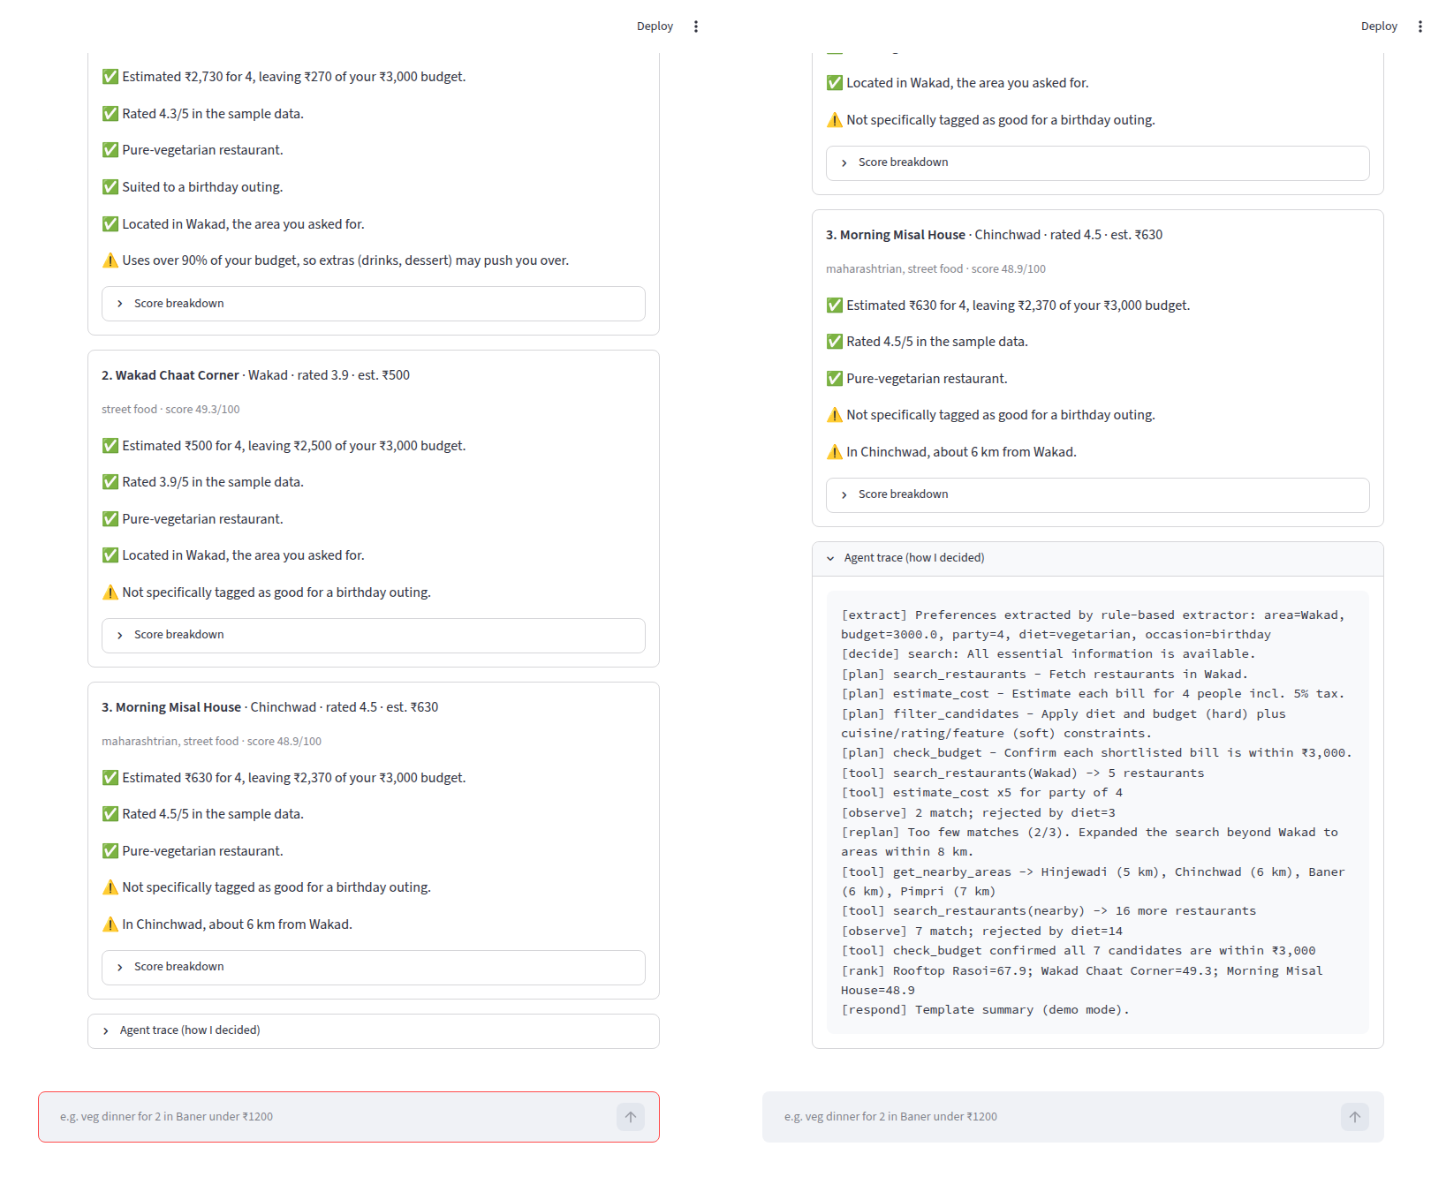
Figure 2: Streamlit UI for Scenario 1: ranked recommendations with reasons (✅) and trade-offs (⚠️) on the left, the expanded agent trace on the right

Scenario 2: missing information and clarification
Input: “find me a good place to eat for my family”. The area and budget were missing, so the agent asked for them one at a time and stored the partial request (occasion = family) between turns. The answer “1500 total, we are 4” was merged with the earlier turns, and the agent then searched. Final status: ok, with 3 recommendations within ₹1,500 for 4.
User: find me a good place to eat for my family
Agent: Which area of Pune should I search? For example: Pimpri, Chinchwad, Akurdi, Wakad,
Hinjewadi, Baner, ...
User: Kothrud
Agent: What's your budget? You can give a total (e.g. 'under ₹1500') or per person (e.g. '₹400 per
person').
User: 1500 total, we are 4
Agent: I found 3 options near Kothrud within ₹1,500 for 4 people. My top pick is Kothrud Sweet Mart
& Snacks (Kothrud, rated 4.1, about ₹550). To find enough options I had to compromise:
Expanded the search beyond Kothrud to areas within 8 km.
1. Kothrud Sweet Mart & Snacks (Kothrud) | rating 4.1 | est. ₹550 | score 70.3/100

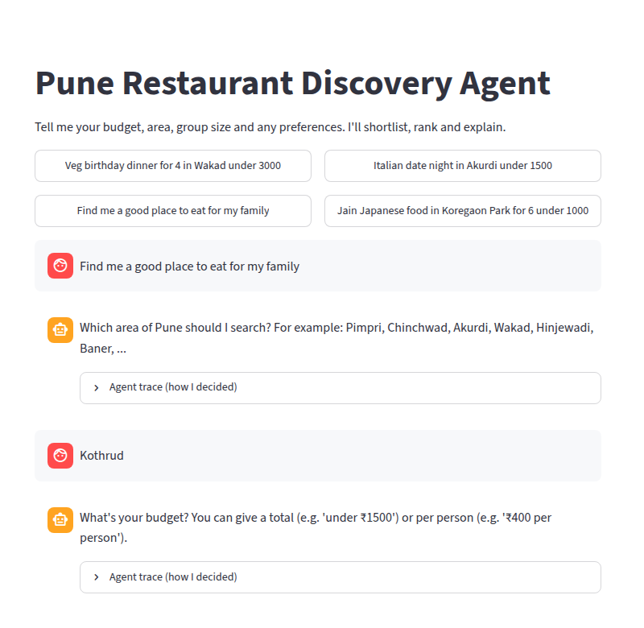
Figure 3: Clarification dialogue in the UI: the agent asks for the area, then the budget

Scenario 3: no exact match and an impossible request
“italian date night in Akurdi under 1500”: no Italian restaurant exists in Akurdi, so the agent widened the search and found Crust & Crumb in Chinchwad (3 km away). It kept the Italian preference, because one exact match is better than three compromises. “jain japanese food in Koregaon Park for 6 under 1000” cannot be satisfied, and the agent says so honestly: “No restaurant meets all your requirements, even after relaxing the flexible ones. The closest option is Udupi Grand (Viman Nagar) at about ₹1,450, which is ₹450 over your ₹1,000 budget. Few places nearby have confirmed jain options in the data. Try a higher budget, a different area, or fewer requirements.”

Testing and Evidence

Testing methodology
Testing used pytest with 64 automated tests in five files, covering each stage on its own (unit tests) and the whole agent end to end. LLM behaviour was tested with a scripted fake provider, so the tests need no network and no key. The UI was tested with Streamlit’s built-in AppTest, and real screenshots were taken of the running application. The document docs/test_evidence.md is produced by scripts/generate_evidence.py from actual runs, so it can be regenerated on any machine.
Table 6: Test coverage by area
File | What it verifies
tests/test_extractor.py | Preference extraction, aliases, per-person budgets, ‘non-veg’ vs ‘veg’, invalid input
tests/test_tools.py | Cost estimate, shortest-path nearby areas, hard constraints over the whole dataset (16 combinations), data-source failure and retry, corrupt data
tests/test_recommender.py | Score range, ranking order, explanations match data, unknown features, determinism
tests/test_agent.py | End-to-end scenarios: valid, strict budget, clarification, no results, invalid, off-topic, re-planning, tool failure, trace
tests/test_llm.py | LLM JSON validation, fallback on API error / bad JSON, blocking invented names and prices, both API formats, demo mode
tests/test_app.py | Streamlit UI loads and returns the expected top pick

Key test cases and results
Table 7: Selected test cases (all 64 results are in docs/test_evidence.md)
ID | Objective | Input | Expected | Actual observed | Result
TC-30 | Valid request | veg birthday dinner for 4 in Wakad under 3000 | ≤3 pure-veg options ≤ ₹3,000, ranked | 3 options; top Rooftop Rasoi ₹2,730; all veg, all ≤ ₹3,000 | PASS
TC-31 | Strict budget | dinner for two in Baner under ₹400 | Only options ≤ ₹400 | 1 option: Wakad Chaat Corner at ₹250 | PASS
TC-32 | Missing information | find me a good place… → Kothrud → 1500 total, we are 4 | Ask area, then budget, then recommend | 2 questions, then status ok with merged preferences | PASS
TC-34 | No results | jain japanese… Koregaon Park for 6 under 1000 | no_results + reason + closest option | status no_results; closest option and amount over budget stated | PASS
TC-35 | Invalid input | under -500 / party of 50 / empty | invalid_input, clear message | “The budget must be a positive amount in rupees.” | PASS
TC-36 | Off-topic | what's the weather tomorrow | unsupported | unsupported | PASS
TC-37 | Uncovered city | pizza in Mumbai under 800 for 2 | Ask, don’t guess | needs_clarification listing the 12 covered areas | PASS
TC-38 | Re-planning | italian date night in Akurdi under 1500 | Widen area, keep Italian | Crust & Crumb (Chinchwad); cuisine kept | PASS
TC-13 | Hard constraints never broken | All 42 restaurants × 4 diets × 4 budgets | No over-budget or wrong-diet result | 0 violations in 16 combinations | PASS
TC-40 | Tool failure | Data file missing | Retry once, then tool_error | Retried once; honest ‘unavailable’ message; no results invented | PASS
TC-51 | LLM API failure | Fake provider returns HTTP 503 | Fall back to rules; still answer | Rule-based extractor and template used; status ok | PASS
TC-53 | LLM hallucination | Fake summary names a non-shortlisted place | Reject summary | Rejected; template summary shown | PASS
TC-54 | Invented price | Fake summary quotes ₹999 | Reject summary | Rejected as unverified amount | PASS
TC-60 | UI | Request entered in Streamlit AppTest | Top pick shown, no exception | Rooftop Rasoi shown | PASS

Result: 64 of 64 tests passed (latest run: “64 passed in 0.42s”).

Do the tests actually catch bugs?
A test suite that always passes proves little unless it fails when the code is wrong. Three bugs were deliberately introduced, the suite was run, and the code was then restored:
Table 8: Deliberate fault injection (mutation check)
Injected fault | Tests that failed
Budget filter disabled | 17 tests failed
LLM summary check disabled (hallucinations allowed through) | 2 tests failed (TC-53, TC-54)
Preferences relaxed even when matches exist | 2 tests failed (TC-38, TC-39)

Bugs found and fixed during testing
- Follow-up answers were not understood. The reply “1500 total, we are 4” was not parsed, so the agent ran out of questions and searched without a budget. Fixed by extending budget and party-size patterns and by reading a bare number as the budget when the agent has just asked for one (TC-32, TC-33).
- “2k budget, 4 of us” was read as a ₹4 budget. Fixed by ignoring small positive numbers as budgets while still passing zero and negative amounts to validation (TC-06).
- Ranking favoured cheapness over suitability (see Decision Rules); the weights were rebalanced (TC-21).
- Cuisine was relaxed just to fill three slots, overriding what the user asked for. The policy was changed so stated preferences are relaxed only when nothing matches (TC-38).
- An empty CLI query made the program wait for keyboard input, and a display bug in the UI dumped Streamlit’s help text into the chat history. Both were found in manual runs and screenshots and fixed.

Discussion and limitations
- The agent behaves predictably: identical inputs give identical rankings (TC-24), which makes it easy to demonstrate and defend.
- The rule-based extractor covers common phrasing but will miss unusual wording. This is exactly where the optional LLM helps, and its output is still validated.
- With only 42 sample restaurants, some requests legitimately return one result. The agent states this rather than padding the list.
- The LLM integration is tested against fake responses only; real provider behaviour (latency, model-specific JSON quirks) has not been measured.

8. Conclusion
This project produced a working, tested AI agent rather than a chatbot. The Pune Restaurant Discovery Agent understands a free-text request, asks for missing essentials, calls tools, applies exact budget and diet constraints, observes its results and re-plans, and explains every recommendation and compromise. All 64 automated tests pass, deliberate fault injection showed that the tests detect real errors, and the demonstration outputs in this report were produced by the code itself. The main lesson is that an agent’s value comes from the loop around the model: decision rules, tools, validation and transparency. The LLM is a useful component, but the system stays correct even when the LLM is unavailable.

Individual Reflection
Draft: rewrite this in your own words, and add your personal experience where highlighted. Evaluators may ask you about any of it.
What I learned about agent design. The most important design decision was deciding what the LLM should and should not do. Using it to understand language makes sense, but budget arithmetic, filtering and ranking have to be exact, so they are written as normal Python. This also made the system testable: almost every behaviour can be checked automatically.
Why the agent asks before acting. Recommending restaurants without knowing the area or budget would produce confident but useless answers. Limiting the agent to one question per turn, and three rounds in total, keeps the conversation short while still avoiding guesses.
What testing taught me. Several of the most important fixes came from tests and screenshots, not from writing the code: the follow-up answer that was not understood, the ‘2k budget’ misreading, and a ranking that put a chaat stall first for a birthday. Deliberately breaking the code to confirm the tests failed showed me that passing tests are only meaningful if they can fail.
Honesty about data. Using fictional sample data, labelling it everywhere, and having the agent say “no results” instead of inventing an option were deliberate choices. A recommendation system that fabricates options is worse than one that admits it cannot help.
[ADD YOUR OWN: which part was hardest for you to understand or build, and how you worked through it]
[ADD YOUR OWN: what you would do differently if you started again, and how the course content helped]

Future Improvements
- Connect a licensed live data source behind search_restaurants (only this tool would change), with timestamps showing how fresh the data is.
- Measure the LLM extractor against the rule-based one on a labelled set of real user requests.
- Add opening hours and travel time, and let users refine results (“something cheaper”, “closer”) in follow-up turns.
- Deploy the Streamlit app and add simple usage logging to learn which constraints are relaxed most often.

References
- Russell, S. and Norvig, P. (2021) Artificial Intelligence: A Modern Approach. 4th edn. Pearson.
- Yao, S. et al. (2023) ‘ReAct: Synergizing Reasoning and Acting in Language Models’, International Conference on Learning Representations (ICLR).
- Anthropic (2024) ‘Building effective agents’. Available at: https://www.anthropic.com/engineering/building-effective-agents.
- Streamlit documentation. Available at: https://docs.streamlit.io.
- pytest documentation. Available at: https://docs.pytest.org.

Appendix A: Rubric Coverage
Table 9: Mapping of the marking criteria to this report and the project
Criterion (marks) | Where in this report | Evidence in the project | Remaining gap
Problem Statement (5) | Section 4: statement, justification, objectives, scope | README, data notice | None known
Agent Workflow (8) | Section 5: Figure 1, tool and stage tables, decision rules, single-agent justification | agent/planner.py, agent/core.py, docs/agent_workflow.md | Be ready to explain the re-planning loop live
Implementation (10) | Section 6: technologies, structure, steps, key code, data limitations | agent/, app.py, main.py; runs with no API key | Live LLM not tested; GitHub link to be added
Testing and Evidence (7) | Section 7: methodology, test table, mutation check, bugs fixed, screenshots | tests/ (64 tests), docs/test_evidence.md, scripts/generate_evidence.py | Re-run on your own machine before submission
Individual Reflection (5) | Section 8: Individual Reflection | Design decisions and fixes recorded in this report | Highlighted paragraphs must be written by you
Report Quality (10) | Whole document: numbered sections, figures, tables, references | This .docx | Fill highlighted fields; check page breaks in Word

Appendix B: How to Run
cd smart_discovery_ai_agent
python -m venv .venv
Windows: .venv\Scripts\activate macOS/Linux: source .venv/bin/activate
pip install -r requirements.txt
streamlit run app.py
python main.py -q "veg birthday dinner for 4 in Wakad under 3000" --trace
python -m pytest -v
python scripts/generate_evidence.py

