ABSTRACT

Huffman Coding is an approach to text compression

originally developed by [David A. Huffman](http://en.wikipedia.org/wiki/David_A._Huffman) while he was

a [Ph.D.](http://en.wikipedia.org/wiki/Doctor_of_Philosophy) student at [MIT,](http://en.wikipedia.org/wiki/Massachusetts_Institute_of_Technology) and published in the 1952 paper "A

Method for the Construction of Minimum-Redundancy

Codes". In [computer science](http://en.wikipedia.org/wiki/Computer_science) and [information theory,](http://en.wikipedia.org/wiki/Information_theory) it is

one of many lossless data compression algorithms. It is a

statistical compression method that converts characters into

variable length bit strings and produces a prefix code. Most-

frequently occurring characters are converted to shortest bit

strings; least frequent, the longest.

CONTENTS

• Certificate

• Abstract

• Acknowledgement

1.

2.

3.

Introduction to Huffman Codes

Basic Techniques

Implementation of Huffman Coding

a. Program

b. Output

4.

5.

6.

Variations

Applications

References

**1.** **Introduction to Huffman Coding:**

Let us suppose, we need to store a string of length 1000 that comprises

characters a, e, n, and z. To storing it as 1-byte characters will require

1000 byte (or 8000 bits) of space. If the symbols in the string are

encoded as (00=a, 01=e, 10=n, 11=z), then the 1000 symbols can be

stored in 2000 bits saving 6000 bits of memory.

The number of occurrence of a symbol in a string is called its frequency.

When there is considerable difference in the frequencies of different

symbols in a string, variable length codes can be assigned to the symbols

based on their relative frequencies. The most common characters can be

represented using shorter codes than are used for less common source

symbols. More is the variation in the relative frequencies of symbols, it is

more advantageous to use variable length codes for reducing the size of

coded string.

Since the codes are of variable length, it is necessary that no code is a

prefix of another so that the codes can be properly decode. Such codes

are called [prefix code](http://en.wikipedia.org/wiki/Prefix_code) (sometimes called "prefix-free codes", that is, the

code representing some particular symbol is never a prefix of the code

representing any other symbol). Huffman coding is so much widely used

for creating prefix codes that the term "Huffman code" is sometimes

used as a synonym for "prefix code" even when such a code is not

produced by Huffman's algorithm.

Huffman was able to design the most efficient compression method of

this type: no other mapping of individual source symbols to unique

strings of bits(i.e. codes) will require lesser space for storing a piece of

text when the actual symbol frequencies agree with those used to create

the code.

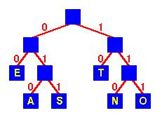

**2.** **Basic Technique:**

In Huffman Coding , the complete set of codes can be represented as a

binary tree, known as a **Huffman tree**. This Huffman tree is also a

**coding tree** i.e. a full binary tree in which each [leaf](http://www.itl.nist.gov/div897/sqg/dads/HTML/leaf.html) is an encoded symbol

and the [path](http://www.itl.nist.gov/div897/sqg/dads/HTML/path.html) from the [root](http://www.itl.nist.gov/div897/sqg/dads/HTML/root.html) to a leaf is its codeword. By convention, bit '0'

represents following the left child and bit '1' represents following the

right child. One code bit represents each level. Thus more frequent

characters are near the [root](http://www.itl.nist.gov/div897/sqg/dads/HTML/root.html) and are coded with few bits, and rare

characters are far from the root and are coded with many bits.

**Huffman Tree**

First of all, the source symbols along with their frequencies of

occurrence are stored as leaf nodes in a regular array, the size of which

depends on the number of symbols, n. A finished tree has up to n leaf

nodes and n − 1 internal nodes.

**PROBLEM DEFINITION:-**

**Given**

A set of symbols and their weights (usually [proportional](http://en.wikipedia.org/wiki/Proportionality_(mathematics)) to

probabilities or equal to their frequencies).

**Find**

A [prefix-free binary code](http://en.wikipedia.org/wiki/Prefix_code) (a set of codewords) with

minimum [expected](http://en.wikipedia.org/wiki/Expected_value) codeword length (equivalently, a tree with

minimum [weighted path length from the root).](http://en.wikipedia.org/w/index.php?title=Weighted_path_length_from_the_root&action=edit&redlink=1)

**The simplest construction algorithm uses a** [**priority queue**](http://en.wikipedia.org/wiki/Priority_queue) **where**

**the node with lowest probability is given highest priority:**

Step 1:- Create a leaf node for each symbol and add it to the priority

queue (i.e.Create a min heap of Binary trees and heapify it).

Step 2:- While there is more than one node in the queue (i.e. min heap):

i. Remove the two nodes of highest priority (lowest probability or

lowest frequency ) from the queue.

ii. Create a new internal node with these two nodes as children

and with probability equal to the sum of the two nodes'

probabilities (frequencies).

iii. Add the new node to the queue.

Step 3:- The remaining node is the root node and the Huffman tree is

complete.

Joining trees by frequency is the same as merging sequences by length

in [optimal merge.](http://www.itl.nist.gov/div897/sqg/dads/HTML/optimalMerge.html) Since a node with only one child is not optimal, any

Huffman coding corresponds to a [full binary tree.](http://www.itl.nist.gov/div897/sqg/dads/HTML/fullBinaryTree.html)

**Definition of optimal merge:** Let D={n1, ... , nk} be the set of lengths of

sequences to be merged. Take the two shortest sequences, ni, nj∈ D, such

that n≥ ni and n≥ nj∀ n∈ D. Merge these two sequences. The new set D is

D' = (D - {ni, nj}) ∪ {ni+nj}. Repeat until there is only one sequence.

Since efficient priority queue data structures require O(log n) time per

insertion, and a tree with n leaves has 2n−1 nodes, this algorithm

operates in O(n log n) time.

The [worst case](http://www.itl.nist.gov/div897/sqg/dads/HTML/worstcase.html) for Huffman coding (or, equivalently, the longest

Huffman coding for a set of characters) is when the distribution of

frequencies follows the [Fibonacci numbers.](http://www.itl.nist.gov/div897/sqg/dads/HTML/fibonacciNumber.html)

If the estimated probabilities of occurrence of all the symbols are same

and the number of symbols are a power of two, Huffman coding is same

as simple binary [block encoding,](http://en.wikipedia.org/wiki/Block_code) e.g., [ASCII](http://en.wikipedia.org/wiki/ASCII) coding.

Although Huffman's original algorithm is optimal for a symbol-by-

symbol coding (i.e. a stream of unrelated symbols) with a known input

probability distribution, it is not optimal when the symbol-by-symbol

restriction is dropped, or when the [probability mass functions](http://en.wikipedia.org/wiki/Probability_mass_function) are

unknown, not [identically distributed,](http://en.wikipedia.org/wiki/Independent_and_identically-distributed_random_variables) or not [independent](http://en.wikipedia.org/wiki/Independence_(probability_theory)) (e.g., "cat" is

more common than "cta").

**3.** **Implementation of Huffman Coding**

**a)** **PROGRAM**

#include <iostream>

#include <cmath>

using namespace std;

struct node

{

char info;

int freq;

char *code;

node *Llink;

node *Rlink;

};

class BinaryTree // Coding Tree

{

private:

node *root;

public:

BinaryTree() { root=NULL; }

void print();

void assign_code(int i);

void print_code(char c);

void encode(const char str[]);

void print_symbol(char cd[], int &f, int length);

void decode(char cd[], int size);

friend class minHeap;

friend class HuffmanCode;

};

class minHeap

{

private:

BinaryTree *T; // Array of Binary Trees

int n; // Number of symbols

public:

minHeap();

void heapify(int i);

BinaryTree dequeue(); // Returns the first Binary Tree of the min heap and

// then heapify the array of Binary trees in order of the

//frequencies of their root nodes.

void enqueue(BinaryTree b); // To insert another Binary tree

// and then heapify the array of Binary trees

void print();

friend class HuffmanCode;

};

class HuffmanCode

{

private:

BinaryTree HuffmanTree; // (a minimum weighted external path length tree)

public:

HuffmanCode();

};

HuffmanCode::HuffmanCode()

{

minHeap Heap;

// Huffman Tree is build from bottom to top.

// The symbols with lowest frequency are at the bottom of the tree

// that leads to longer codes for lower frequency symbols and hence

// shorter codes for higher frequency symbol giving OPTIMAL code length.

while (Heap.T[0].root->freq>1)

{

// The first two trees with min. priority (i.e. frequency) are taken and

BinaryTree l=Heap.dequeue();

cout<<"\nAfter dequeueing "<<l.root->freq<<endl;

Heap.print();

BinaryTree r=Heap.dequeue();

cout<<"\nAfter dequeueing "<<r.root->freq<<endl;

Heap.print();

// a new tree is constructed taking the above trees as left and right sub-trees

// with the frequency of root node as the sum of frequencies of left & right child.

HuffmanTree.root=new node;

HuffmanTree.root->info='\0';

HuffmanTree.root->freq=l.root->freq + r.root->freq;

HuffmanTree.root->Llink=l.root;

HuffmanTree.root->Rlink=r.root;

// then it is inserted in the array and array is heapified again.

// Deletion and Insertion at an intermediate step is facilitated in heap-sort.

Heap.enqueue(HuffmanTree);

cout<<"\nAfter

enqueueing

"<<l.root->freq<<"+"<<r.root->freq<<"=

"<<HuffmanTree.root->freq<<endl;

Heap.print();

}

//The process continues till only one tree is left in the array of heap.

cout<<"\nThe process is completed and Huffman Tree is obtained\n";

HuffmanTree=Heap.T[1]; // This tree is our HuffmanTree used for coding

delete []Heap.T;

cout<<"Traversal of Huffman Tree\n\n";

HuffmanTree.print();

cout<<"\nThe symbols with their codes are as follows\n";

HuffmanTree.assign_code(0); // Codes are assigned to the symbols

cout<<"Enter the string to be encoded by Huffman Coding: ";

char *str;

str=new char[30];

cin>>str;

HuffmanTree.encode(str);

cout<<"Enter the code to be decoded by Huffman Coding: ";

char *cd;

cd=new char[50];

cin>>cd;

int length;

cout<<"Enter its code length: ";

cin>>length;

HuffmanTree.decode(cd,length);

delete [ ]cd;

delete [ ]str;

}

minHeap::minHeap()

{

cout<<"Enter no. of symbols:";

cin>>n;

T= new BinaryTree [n+1];

T[0].root=new node;

T[0].root->freq=n; //Number of elements in min. Heap at any time is stored in the

// zeroth element of the heap

for (int i=1; i<=n; i++)

{

T[i].root=new node;

cout<<"Enter characters of string :- ";

cin>>T[i].root->info;

cout<<"and their frequency of occurence in the string:- ";

cin>>T[i].root->freq;

T[i].root->code=NULL;

T[i].root->Llink=NULL;

T[i].root->Rlink=NULL;

// Initially, all the nodes are leaf nodes and stored as an array of trees.

}

cout<<endl;

int i=(int)(n / 2);// Heapification will be started from the PARENT element of

//the last ( 'n th' ) element in the heap.

cout<<"\nAs elements are entered\n";

print();

while (i>0)

{

heapify(i);

i--;

}

cout<<"\nAfter heapification \n";

print();

}

int min(node *a, node *b)

{if (a->freq <= b->freq) return a->freq;

void swap(BinaryTree &a, BinaryTree &b)

else return b->freq;}

{BinaryTree c=a;

a=b;

b=c;}

void minHeap::heapify(int i)

{

while(1)

{

if (2*i > T[0].root->freq)

return;

if (2*i+1 > T[0].root->freq)

{

if (T[2*i].root->freq <= T[i].root->freq)

swap(T[2*i],T[i]);

return;

}

int m=min(T[2*i].root,T[2*i+1].root);

if (T[i].root->freq <= m)

return;

if (T[2*i].root->freq <= T[2*i+1].root->freq)

{swap(T[2*i],T[i]);

else

i=2*i; }

{swap(T[2*i+1],T[i]); i=2*i+1;}

}

}

BinaryTree minHeap::dequeue()

{

BinaryTree b=T[1];

T[1]= T[T[0].root->freq];

T[0].root->freq--;

if (T[0].root->freq!=1)

heapify(1);

return b;

}

void minHeap::enqueue(BinaryTree b)

{

T[0].root->freq++;

T[T[0].root->freq]=b;

int i=(int) (T[0].root->freq /2 );

while (i>0)

{

heapify (i);

i=(int) (i /2 );

}

}

int isleaf(node *nd)

{ if(nd->info=='\0') return 0; else return 1;}

void BinaryTree::assign_code(int i)

{

if (root==NULL)

return;

if (isleaf(root))

{

root->code[i]='\0';

cout<<root->info<<"\t"<<root->code<<"\n";

return;

}

BinaryTree l,r;

l.root=root->Llink;

r.root=root->Rlink;

l.root->code=new char[i+1];

r.root->code=new char[i+1];

for (int k=0; k<i; k++)

{

l.root->code[k]=root->code[k];

r.root->code[k]=root->code[k];

}

l.root->code[i]='0';

r.root->code[i]='1';

i++;

}

l.assign_code(i);

r.assign_code(i);

void BinaryTree::encode(const char str[])

{

if (root==NULL)

return;

int i=0;

cout<<"Encoded code for the input string '"<<str<<"' is\n";

while (1)

{

if (str[i]=='\0')

{

cout<<endl;

return;

}

print_code(str[i]);

i++;

}

}

void BinaryTree::print_code(char c)

{

int f=0;

if (isleaf(root))

{

if (c==root->info)

{f=1; cout<<root->code;}

return ;

}

BinaryTree l,r;

l.root=root->Llink;

if (f!=1)

l.print_code(c);

r.root=root->Rlink;

if (f!=1)

r.print_code(c);

}

int isequal(const char a[], const char b[], int length)

{

int i=0;

while (i<length)

{

if(b[i]!=a[i])

return 0;

i++;

}

if (a[i]!='\0')

return 0;

return 1;

}

void BinaryTree::decode(char cd[], int size)

{

if (root==NULL)

return;

int i=0;

int length=0;

int f;

char *s;

cout<<"Decoded string for the input code '"<<cd<<"' is\n";

while (i<size)

{

f=0;

s=&cd[i];

while (f==0)

{

length++;

}

print_symbol(s,f,length);

}

i=i+length;

length=0;

cout<<endl;

}

void BinaryTree::print_symbol(char cd[], int &f, int length)

{

if (isleaf(root))

{

if (isequal(root->code, cd, length))

{

f=1; cout<<root->info;

}

return;

}

BinaryTree l,r;

l.root=root->Llink;

if (f!=1)

l.print_symbol(cd,f,length);

r.root=root->Rlink;

if (f!=1)

r.print_symbol(cd,f,length);

}

void BinaryTree::print()

{

if (root==NULL)

return;

cout<<root->info<<"\t"<<root->freq<<"\n";

if (isleaf(root))

return;

BinaryTree l,r;

l.root=root->Llink;

r.root=root->Rlink;

l.print();

r.print();

}

int power(int i, int j)

{

int n=1;

for (int k=1; k<=j; k++)

n=n*i;

return n;

}

int ispowerof2(int i)

{

if (i==1)

return 0;

if (i==0)

return 1;

while (i>2)

{

if (i%2!=0)

return 0;

i=i/2;

}

return 1;

}

int fn(int l)

{

if (l==1||l==0)

return 0;

return 2*fn(l-1)+1;

}

void minHeap::print()

{

cout<<"The Heap showing the root frequencies of the Binary Trees are:\n";

if (T[0].root->freq==0)

{

cout<<endl;

return;

}

int level=1;

while( T[0].root->freq >= power(2,level) ) // 2^n-1 is the max. no. of nodes

///in a complete tree of n levels

level++;

if(level==1)

{

cout<<T[1].root->freq<<”\n”;

return;

}

for (int i=1; i<=T[0].root->freq; i++)

{

if (ispowerof2(i))

{cout<<”\n”; level--;}

for (int k=1; k<=fn(level); k++)

cout<<” “;

cout<<T[i].root->freq<<” “;

for (int k=1; k<=fn(level); k++)

cout<<” “;

}

cout<<endl;

}

int main()

{

HuffmanCode c;

system (“pause”);

return 0;}

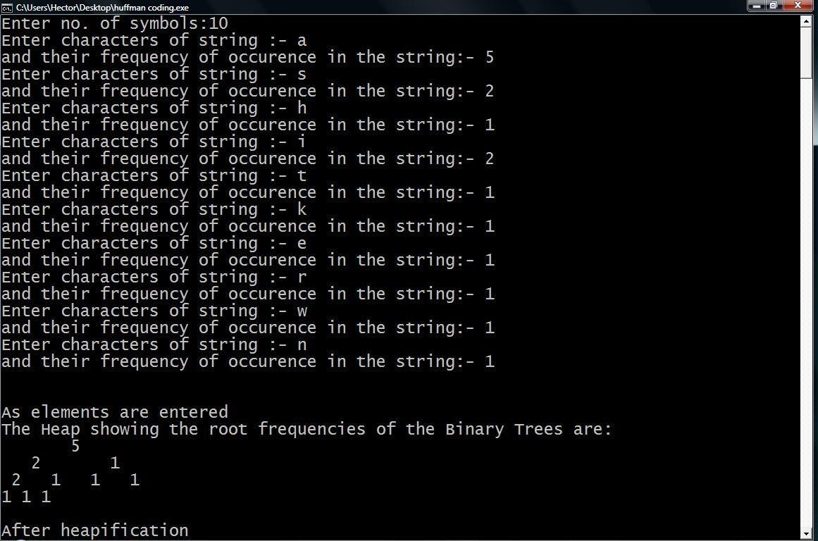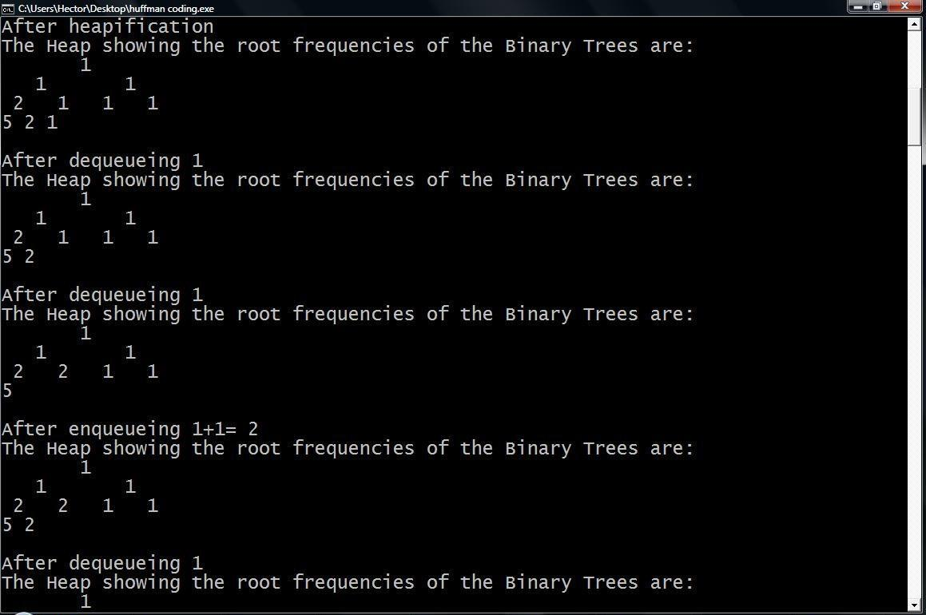

**Output**

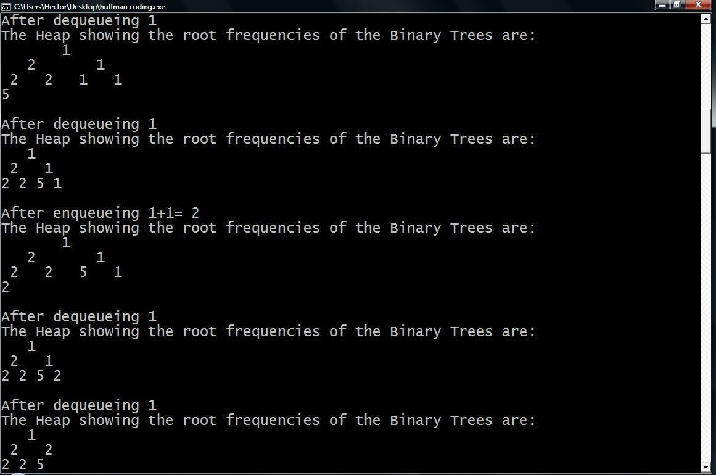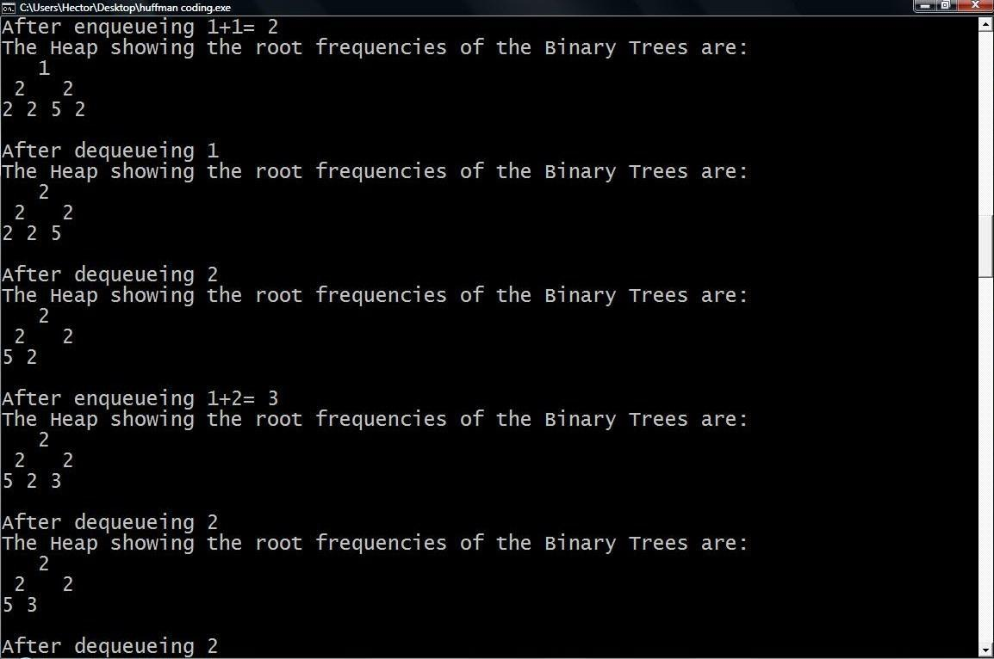

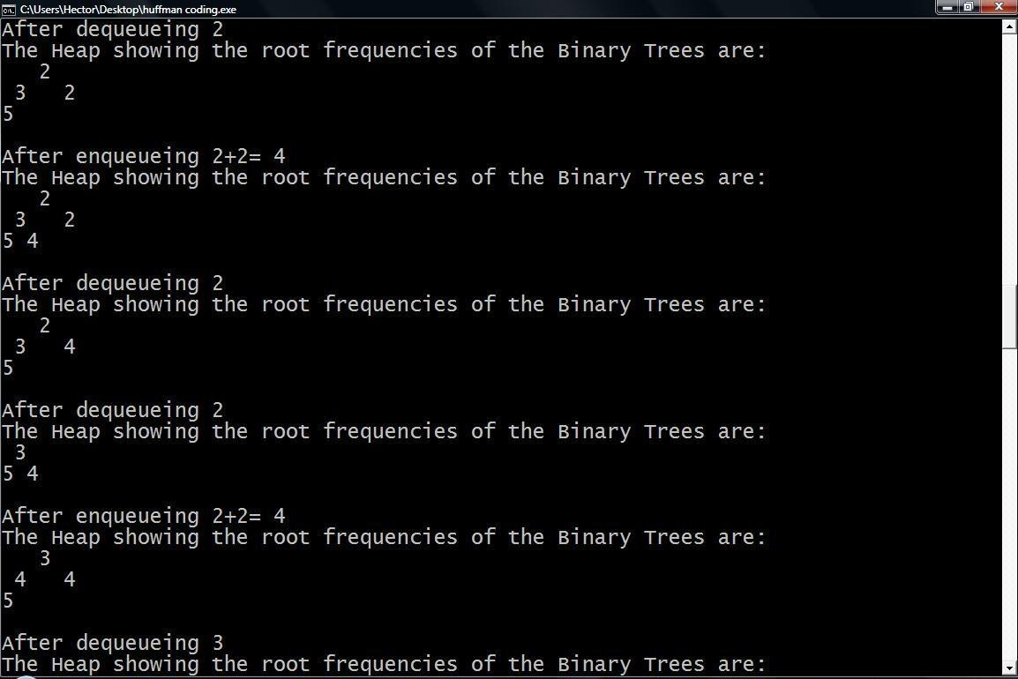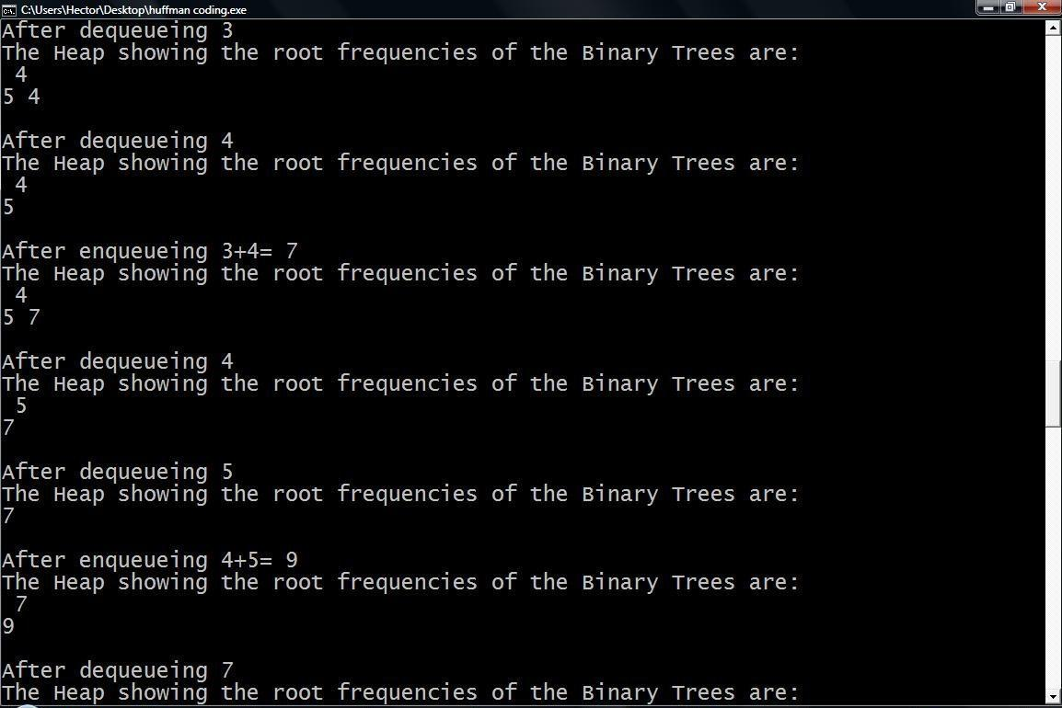

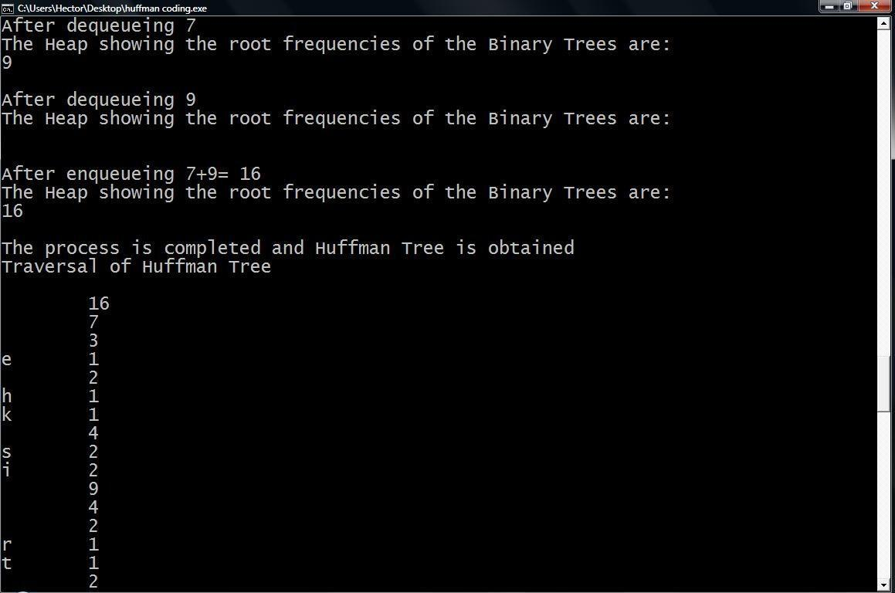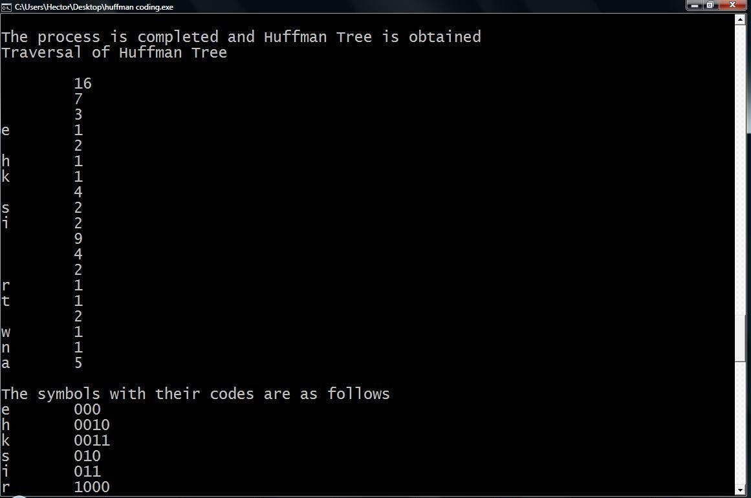

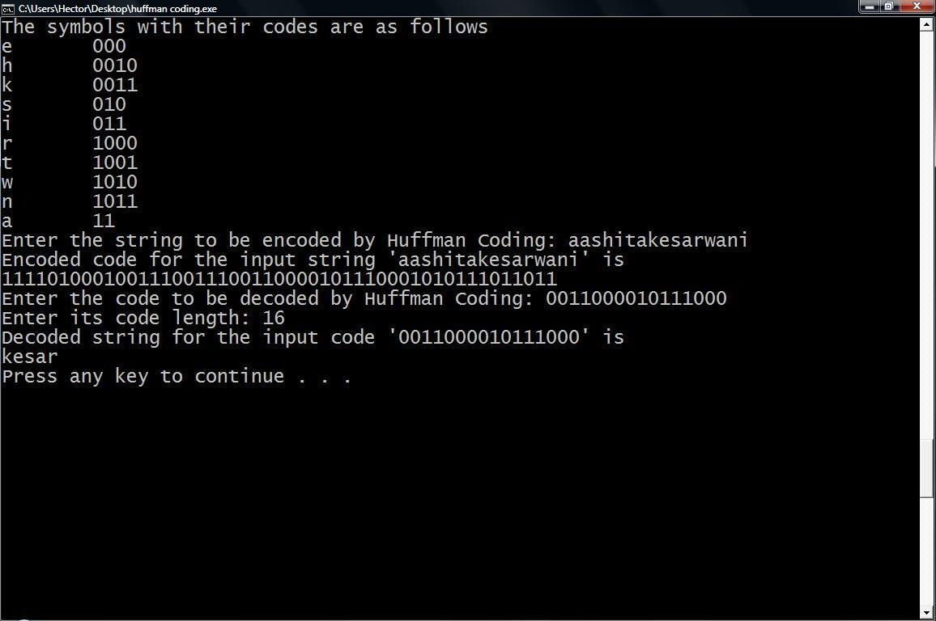

**4.** **Variations of Huffman Coding:**

**a)** **n-ary Huffman coding**

The **n-ary Huffman** algorithm uses the {0, 1, ... , n − 1} alphabet to

encode message and build an n-ary tree.

**b)** **Adaptive Huffman coding**

It calculates the probabilities dynamically based on recent actual

frequencies in the source string. This is somewhat related to

the [LZ](http://en.wikipedia.org/wiki/LZ77) family of algorithms.

**c)** **Huffman template algorithm**

The **Huffman template algorithm** enables one to use any kind of

weights (costs, frequencies, pairs of weights, non-numerical

weights) and one of many combining methods (not just addition).

**d)** **Optimal alphabetic binary trees (Hu-Tucker coding)**

In the alphabetic version, the alphabetic order of inputs and

outputs must be identical.This is also known as the **Hu-**

**Tucker** problem, after the authors of the paper presenting the

first [linearithmic](http://en.wikipedia.org/wiki/Linearithmic) solution to this optimal binary alphabetic

problem, which has some similarities to Huffman algorithm, but is

not a variation of this algorithm. These optimal alphabetic binary

trees are often used as [binary search trees.](http://en.wikipedia.org/wiki/Binary_search_tree)

**e)** **The canonical Huffman code**

If weights corresponding to the alphabetically ordered inputs are

in numerical order, the Huffman code has the same lengths as the

optimal alphabetic code, which can be found from calculating these

lengths, rendering Hu-Tucker coding unnecessary. The code

resulting from numerically (re-)ordered input is sometimes called

the [canonical Huffman code](http://en.wikipedia.org/wiki/Canonical_Huffman_code) and is often the code used in practice,

due to ease of encoding/decoding. The technique for finding this

code is sometimes called **Huffman-Shannon-Fano coding**, since it

is optimal like Huffman coding, but alphabetic in weight

probability, like [Shannon-Fano coding.](http://en.wikipedia.org/wiki/Shannon-Fano_coding)

**5.** **Applications:**

[Arithmetic coding](http://en.wikipedia.org/wiki/Arithmetic_coding) can be viewed as a generalization of Huffman

coding; indeed, in practice arithmetic coding is often preceded by

Huffman coding, as it is easier to find an arithmetic code for a binary

input than for a nonbinary input. Also, although arithmetic coding

offers better compression performance than Huffman coding,

Huffman coding is still in wide use because of its simplicity, high

speed and lack of encumbrance by [patents.](http://en.wikipedia.org/wiki/Patent)

Huffman coding today is often used as a "back-end" to some other

compression method. [DEFLATE](http://en.wikipedia.org/wiki/DEFLATE_(algorithm)) [(PKZIP's](http://en.wikipedia.org/wiki/PKZIP) algorithm) and

multimedia [codecs](http://en.wikipedia.org/wiki/Codec) such as [JPEG](http://en.wikipedia.org/wiki/JPEG) and [MP3](http://en.wikipedia.org/wiki/MP3) have a front-end model

and [quantization](http://en.wikipedia.org/wiki/Quantization_(signal_processing)) followed by Huffman coding.

**6.** **References**

• Sartaj Sahani: Data structures, Algorithms and Applications

in C++

• [http://www.itl.nist.gov/div897/sqg/dads/HTML/codingTree.ht](http://www.itl.nist.gov/div897/sqg/dads/HTML/codingTree.html)

[ml](http://www.itl.nist.gov/div897/sqg/dads/HTML/codingTree.html)

• <http://encyclopedia2.thefreedictionary.com/Huffman+tree>

• <http://en.wikipedia.org/wiki/Huffman_coding>