How to run:

The zip file contains the jar files to both client and server. Run the client jar file from seperate cmd line as

Java -jar “filename.jar”

And the webservice war from glassfish.

The source file for both are included in the zip.

The application requires a mongoDB database named test running on the system.

Working:

The client starts by generating a unique id for a session which is not known by the user. The client then asks for the user name and the operation to be performed from the following

1.Search Book by Year 2.Rent Book by id 3. EXIT

- If the user selects the operation 1(initially or after the illegal operation), the client asks for the year to search the list of books. The server makes a note of this session id from the client side and performs the operation. The server sends the list of books which are not already rented for the queried year.

- If the user selects operation 2, the client asks for the id of the book to rent. The server matches the session id of the user to its maintained list of session ids. If the session id is not present it is an illegal sequence of operation, the server sends a message accordingly and notifies the user to query the book availablity first. If the session id is recorded earlier at the server, the server process the query. The server creates a new record if there isnt one for the given user in a user collection(MongoDB collection) and sets the MaxRent value to 5 and BooksRented value to 1. If the user exists in the collection it simply updates the BooksRented value by 1. If the BooksRented values reaches MaxRent, a error is thrown to the user. If it is a success the client application closes and the server removes the respective session id.

The screengrab below shows the user making an illegal call which fails and then a correct sequence of operation. Since the session id is mainted the user can go on to make any number of operations thereafter but I limit it to one for demonstration.

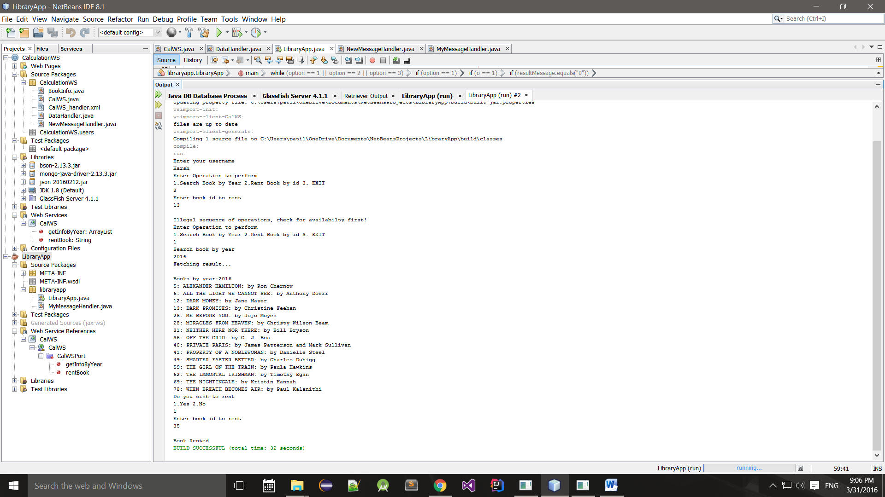

**Multiple client same User:** Since a unique session id is mainted for each client, the server will consider both as a different user and comply with the above protocol for both of them. With a simple addition of new field password(or any other id known only to a user), both these sessions can be coordinated.

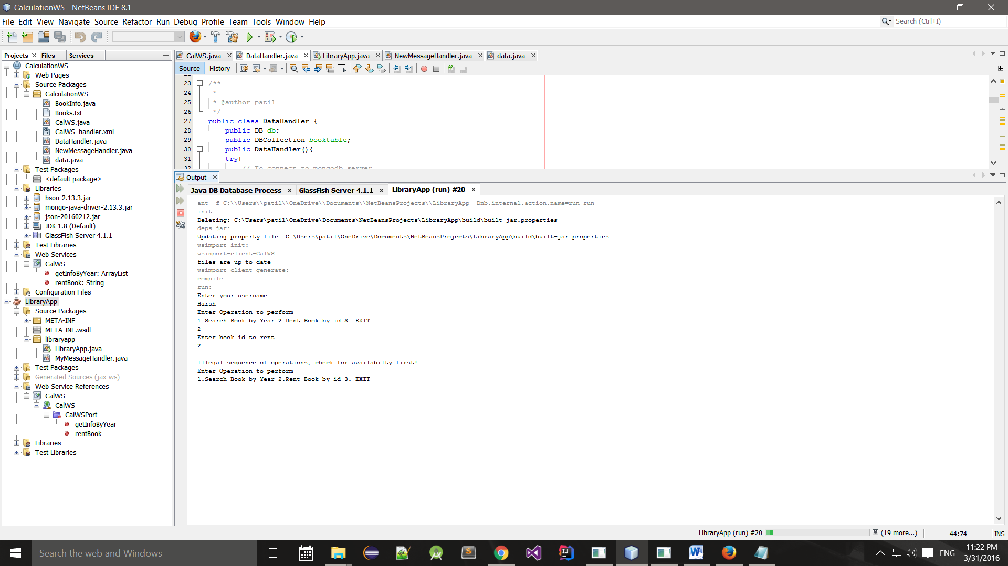

**MongoDB snapshot.**

