BIO DATA
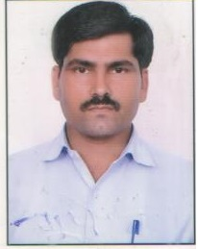
BHUPENDRA SINGH
Ward No.8, 33AMP
KALWASIA SADULSHAHAR
SRIGANGANAGAR (Rajasthan)
Mobile No.: 8875080464,
9636639448
E-Mail ID: bhuppipunni1@gmail.com

Objective:

To work in challenging atmosphere which provides an opportunity for growth within the management environment by continuous efforts towards develop and success of the organization.

Experience:
- Organization: SAMRUDDHA JEEVAN MULTI STATE MULTI PURPOSE Co-OPERATIVE SOCIETY (SRIGANGANAGAR)
- Designation: DATA ENTRY OPERATOR
- Duration: Six Year (10-06-2010 to 20-10-2016)

Academic Qualification:
- Completed Graduate diploma in Business Administration from Vivekanand Institute of Management & Technology
- Completed Senior Secondary Education From Ajmer Board, Ajmer
- Completed Secondary Education From Ajmer Board, Ajmer

Professional Qualification :
- Diploma in RSCIT
- Basic Knowledge of Computer Hardware
- Typing Speed 25-30wpm with 90 % accuracy
- Basic Knowledge in M.S. Office 2007
- INTERNET , E- mail, Online search and shop
Personal Details:
- Date of Birth: 01 November 1981
- Father’s Name: Sh. Sukhdev Singh
- Nationality: Indian
- Marital Status: Married
- Hobbies: Computer Savvy & Reading Books
- Language Known: English, Hindi and Punjabi
- Mailing Address: Ward No.8, 33AM
KALWASIA SADULSHAHAR
SRIGANGANAGAR (Rajasthan)

[ BHUPENDRA SINGH ]

