

Dharmsinh Desai University, Nadiad

Faculty of Technology, Department of Computer Engineering

B.Tech. CE Semester – V

Subject: (CE-515) Advanced Technologies

Project Title:

CarPooling System

By:

Harsh Moradiya ( Roll No: CE073 Id:17CEUOG056 )

Guided By:

Prof. Prashant M. Jadav

Prof. Parth R. Dave



Dharmsinh Desai University, Nadiad

Faculty of Technology, Department of Computer Engineering

**CERTIFICATE**

This is to certify that Advanced Technologies project entitled “Carpooling System” is the bonafide report of work carried out by

1. **Harsh Moradiya (17CEUOG056)**

Of Department of Computer Engineering, Semester V, academic year 2019-20, under our supervision and guidance.

|  |  |  |
| --- | --- | --- |
| Guide | Guide | HOD |
|  |  |  |
| **Prof. Prashant M. Jadav** | **Prof. Parth R. Dave** | **Dr. C. K. Bhensdadia** |
| Associate Professor of | Assistant Professor of | Head of the Department of |
| Department of Computer | Department of Computer | Department of Computer |
| Engineering, Dharmsinh Desai University, Nadiad. | Engineering, Dharmsinh Desai University, Nadiad. | Engineering, Dharmsinh Desai University, Nadiad. |
|  |  |  |
|  |  |  |

TABLE OF CONTENTS

**Content Page**

1. Abstract …………………………………………………………………….4
2. Introduction…………………………………………………………….…..5
   * + 1. Brief introduction…………….…………………………….…..5
       2. Tools/Technologies use……………………………..…………..5
3. Software Requirement Specification……………………………………….6
   * + 1. Types of User……………………………………………………6
       2. System functional requirement………………………………….6
4. ER-Diagram………………………………………………………………...9
5. Data Dictionary Format…………………………………………………...10
6. Data Flow Diagram……………………………………………………….12
7. Flowchart………………………………………………………………….14
8. XML………………………………………………………………………15
9. XSD……………………………………………………………………….16
10. XSLT…………………………………………………………………….18
11. Screenshot………………………………………………………………20
12. Limitation and Future Extension………………………………………...25
13. Testing…………………………………………………………………..26
14. Conclusion……………………………………………………………….27
15. Bibliography……………………………………………………………..28
16. Abstract

Carpooling (also known as car-sharing, ride-sharing and lift sharing), is the sharing of car journeys so that more than one person travels in a car. Carpooling reduces each person’s travels costs such as fuel costs, tolls, and the stress of driving. Carpooling is one method that can be easily instituted and can help resolve a variety of problems that continue to plague urban areas, ranging from energy demands and traffic congestion to environmental pollution. Authorities often encourage carpooling, especially during high pollution periods and high fuel prices. We intent on making an angular,node and mongoDB based web application that will enable to let people know if vehicles are available for carpool in their desired path they can sign in for it. This will enable people using this application to share expense, not worry about hiring a cab and making new connections. People having this application on their cell phone with advance facilities can easily carpool with unacquainted people without worrying about security. It will show the date to reach at particular location. It gives a better way for pooling a car with a very efficient environment that is easy to use. This is a Web-based collaboration, communications, and content delivery framework.

# 2.Introduction

**2.1 Brief Introduction**

Car Pooling is shared use of a car in particular for commuting to work, often by people who each have a car but travel together to save costs and in the interest of other social-environmental benefits.The objective of the project is to present a web based application which provides a communication platform between car owners and passengers. Car owners will be able to post a notice announcing that (s)he has been traveling between some particular locations regularly or just once, to search a travel-mate in order to reduce the ride costs.Traveller can find list of all live ride and can confirm ride by just clicking button.It also shows a list of your past ride and your offered ride.

**2.2 Tools/Technologies used**

**Technologies:**

1. HTML 5
2. Cascading Style Sheets (CSS 3)
3. Bootstrap 4
4. Angular CLI
5. Typescript
6. Node Js
7. Express Js
8. Mongo Db

**Tools:**

Visual Studio Code

Postman

**Platform:**

Localhost:4200 For Angular (ClientSide)

Localhost:7762 For NodeJs (ServerSide)

Localhost:27017 for MongoDB (Database)

# 3.Software Requirement Specifications

**3.1 Types of User**

1. Admin

2. End-User

**3.2 System Function Requirement**

**R.1 Admin Functionality**

**R.1.1** **Delete User Account**

**Description**:Using this functionality admin is able to delete user by user id

**Input**:User Id of user whose account will be deleted

**R.1.2 View User Account**

**Description**:Using this functionality admin is able to view user

**Input**:User Id of user whose account will be displayed

**Output**:Display user information

**R.1.2 Update User Account**

**Description**:Using this functionality admin can update the user detail

**Input**:User Id of user whose account will be displayed

**Output**:Display user information

**R.1.3** **Check History of booking**

**Description:**The admin will be able to check the history of booking .

**Input:**Admin Selection

**Output**:Admin can view history of whole booking system

**R.2 End-User Functionality**

**R.2.1 Login**

**Description**:Login operation. Check the user id and Password whether it is true or not if it is right then success message otherwise alert will be display with error message.

**Input**:User credential of user whose account will be verify

**Output**:Display user account with welcome message

**R.2.2.Register**

**Description** :User can register if he want to find ride

**Input**: User details

**Output**:Display message if wrong detail is entered by user

**R.2.3 Offer Ride**

**Description** :User can offer ride by selecting source and destination from map or manually entering on textbox.

**Input**: Ride details

**Output**:Ride details will be entering in database

**R.2.4 Find Ride**

**Description** :User can find ride from list of all live ride

**Input**: Ride selection by user

**Output**:Ride details will be entering in database

**R.2.9.Past Booked Ride**

**Description**: User can view his past journey with details of source,destination,date and fare

**Input:**User selection

**Output**:All the past ride which is booked by current user will be display

**R.2.9.Past offered Ride**

**Description**: User can view his offered ride with details of source,destination,date and fare

**Input:**User selection

**Output**:All the past offered ride which is offered by current user will be display

**R.2.9 About Us**

**Description** :User can see details about website and other info

**Input**: User selection

**Output**:Details will be display

# 4.ER-Diagram

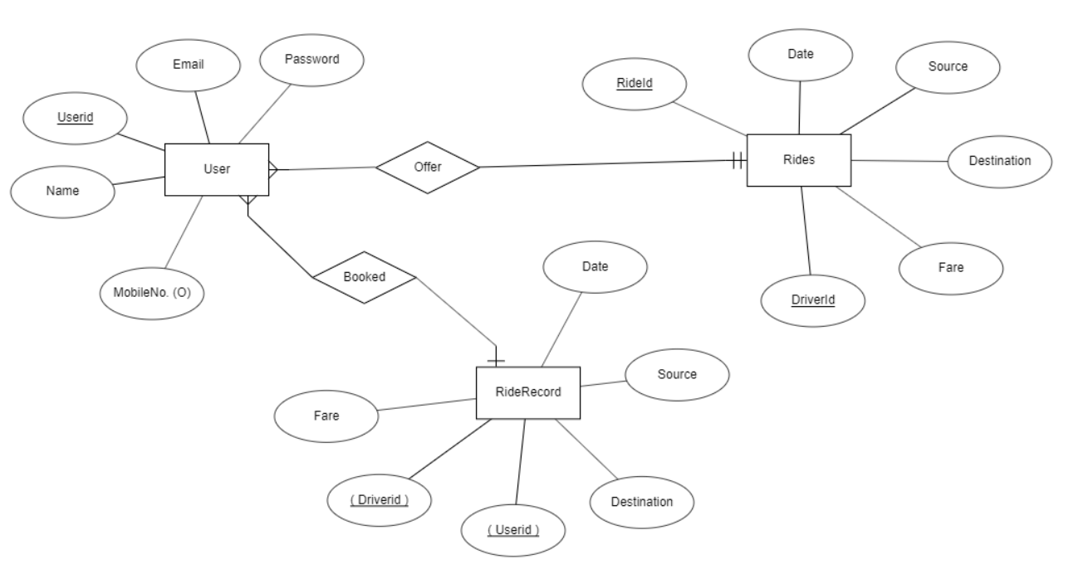

# 5.Data Dictionary Format

**User**

|  |  |  |  |  |  |  |  |
| --- | --- | --- | --- | --- | --- | --- | --- |
| **Sr. No** | **Field No.** | **Data Type** | **Size** | **Required** | **Unique** | **Pk/Fk** | **Referenced Table** |
| 1 | Uid | Varchar | 10 | Yes | Yes | Pk |  |
| 2 | Name | Varchar | 20 | Yes | Yes |  |  |
| 3 | Email | Varchar | 10 | Yes | Yes |  |  |
| 4 | Password | Varchar | 20 | Yes | Yes |  |  |
| 5 | Mobile No | String |  |  | No |  |  |

**Ride Record (History of booking)**

|  |  |  |  |  |  |  |  |
| --- | --- | --- | --- | --- | --- | --- | --- |
| **Sr. No** | **Field No.** | **Data Type** | **Size** | **Required** | **Unique** | **Pk/Fk** | **Referenced Table** |
| 1 | Rid | varchar | 10 | Yes | Yes | Pk |  |
| 2 | Userid | varchar | 20 | Yes | No | Fk | User |
| 3 | Driverid | varchar | 20 | Yes | No | Fk | User |
| 3 | Source | varchar | 10 | Yes | No |  |  |
| 4 | Destination | varchar | 1 | Yes | No |  |  |
| 5 | Date of journey | Date | - | Yes | No |  |  |

**Live Ride**

|  |  |  |  |  |  |  |  |
| --- | --- | --- | --- | --- | --- | --- | --- |
| **Sr. No** | **Field No.** | **Data Type** | **Size** | **Required** | **Unique** | **Pk/Fk** | **Referenced Table** |
| 1 | Id | Varchar | 20 | Yes | Yes | Pk |  |
| 2 | Source | Varchar | 10 | Yes | No |  |  |
| 3 | Destination | Varchar | 1 | Yes | No |  |  |
| 4 | Date of journey | Date | - | Yes | No |  |  |
| 5 | Fare | Number | 10 | Yes | No |  |  |
| 6 | Driverid | Varchar | 20 | Yes | No | Fk | User |

# 6.Data Flow-Diagram

**Zero Level Diagram**

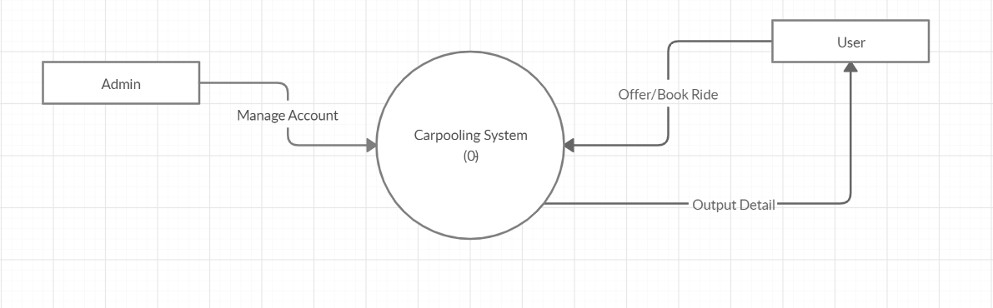

**First Level Diagram**

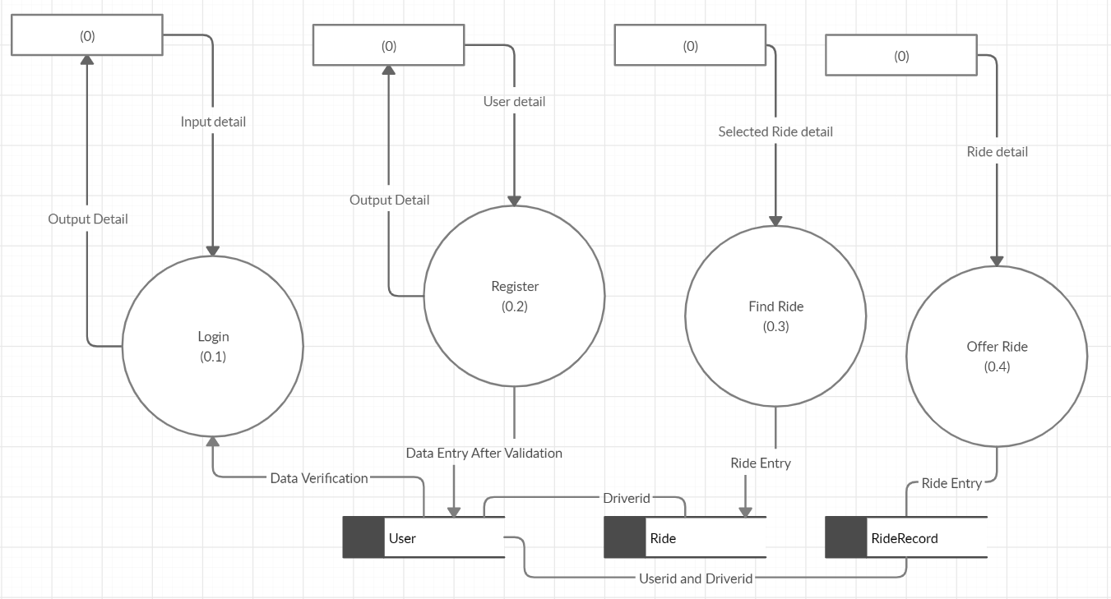

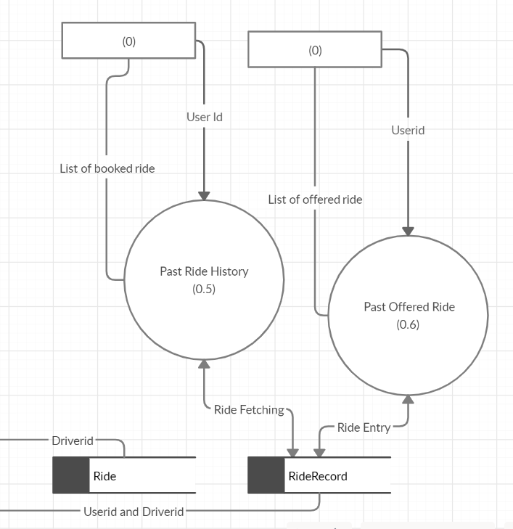

**Second Level Diagram**

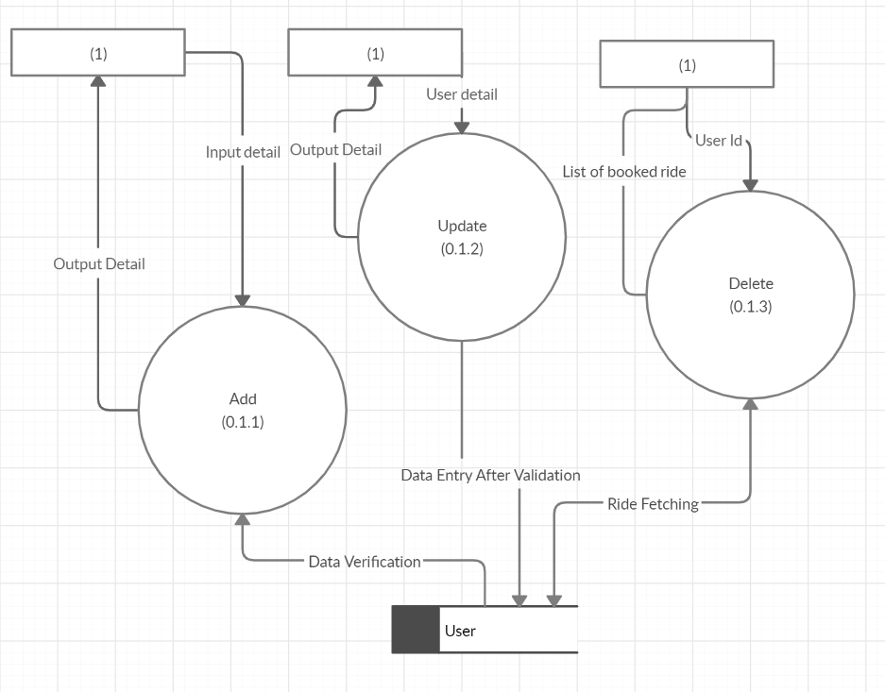

# 7.Flowchart

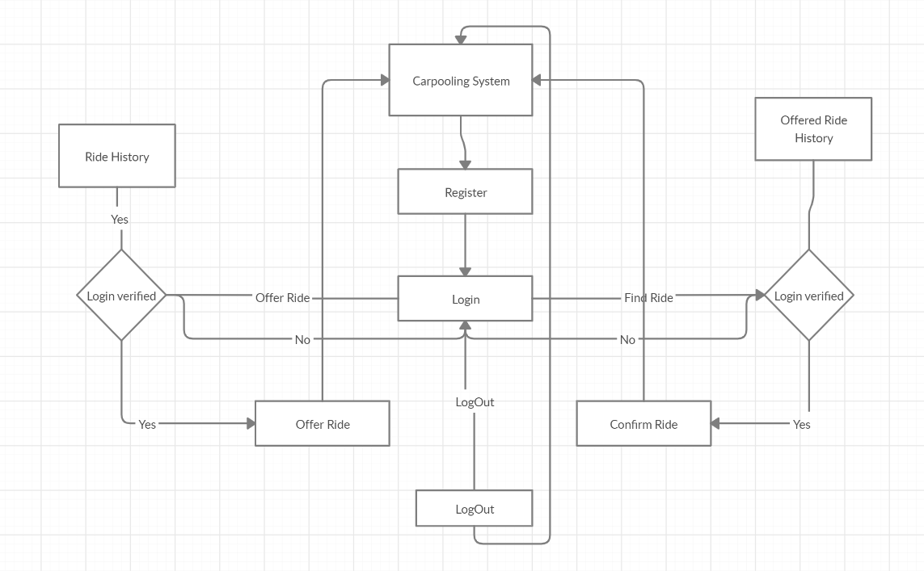

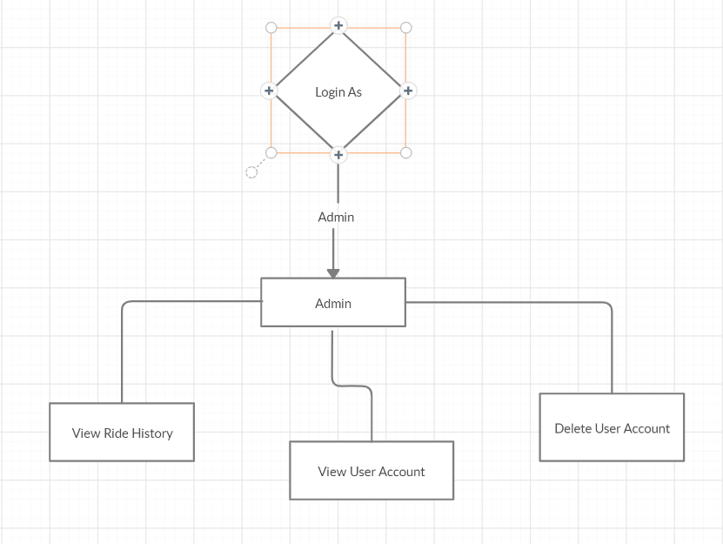

# 8.XML

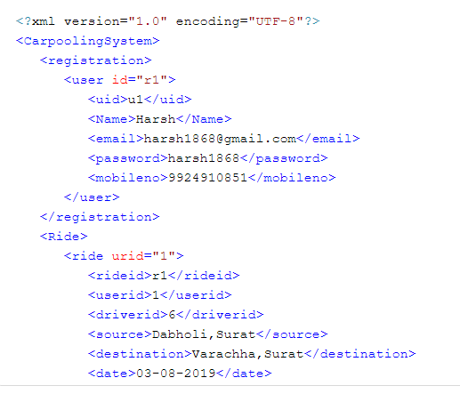

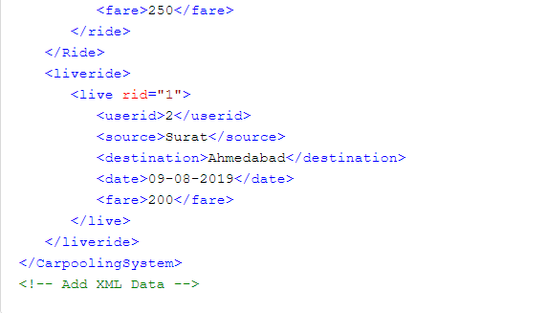

# 9.XSD

# 

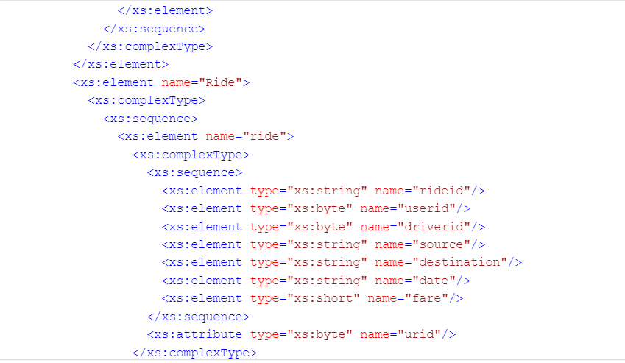

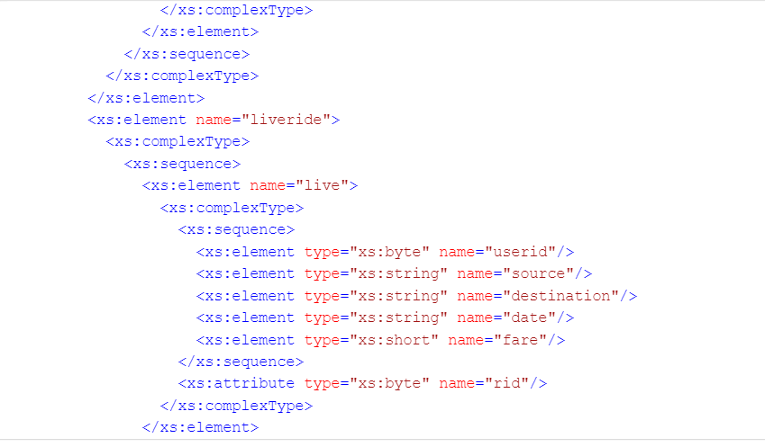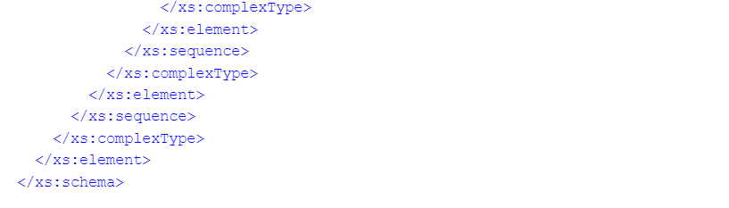

# 10.XSLT

# 

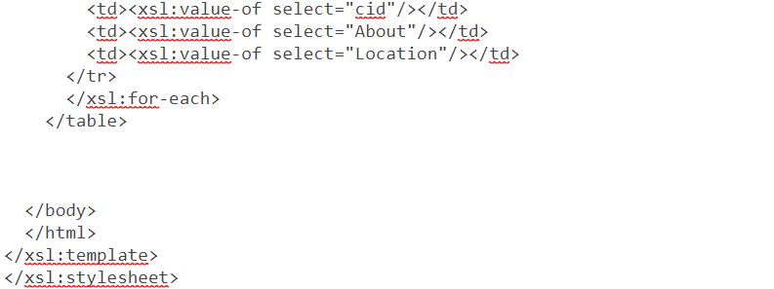

# 11.Screenshot

1. Homepage



1. Register/Login page

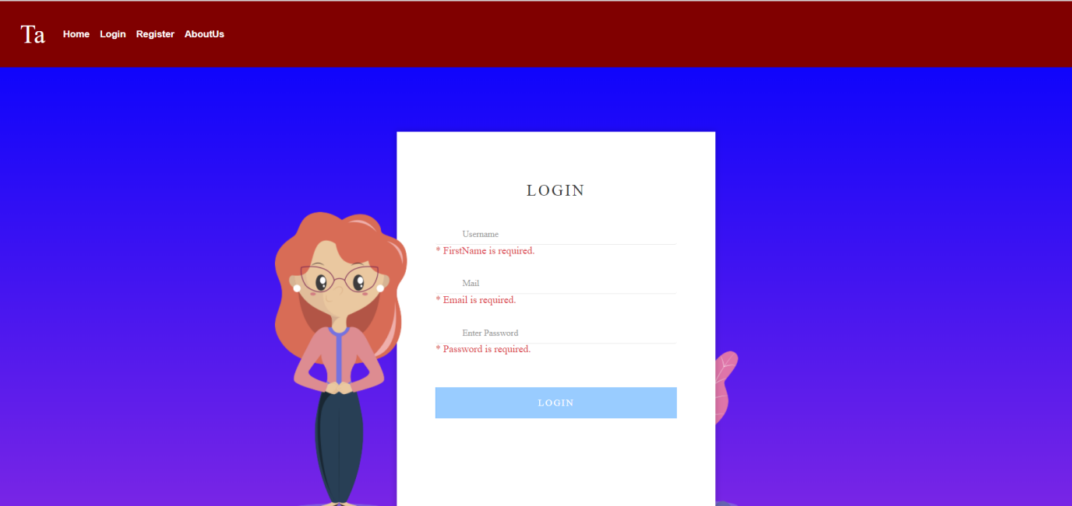

1. Offer Ride

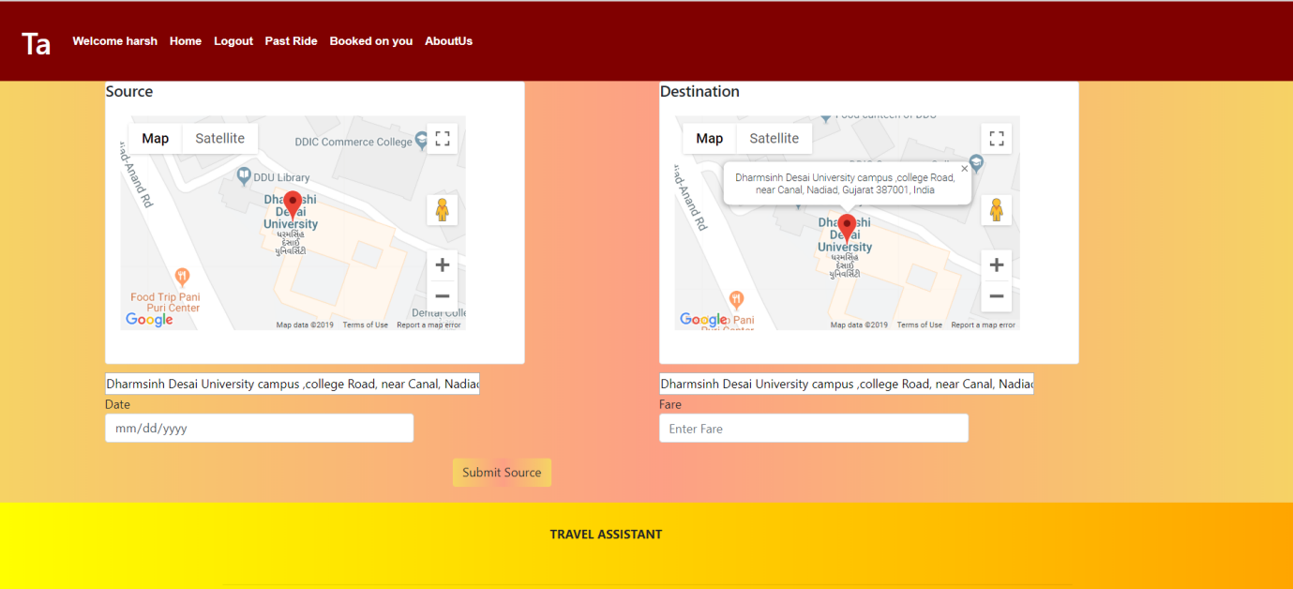

1. Find Ride and Confirm

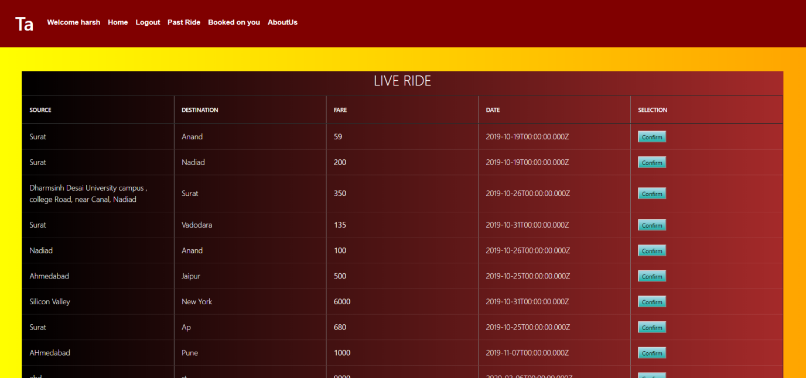

1. Past Booked Ride

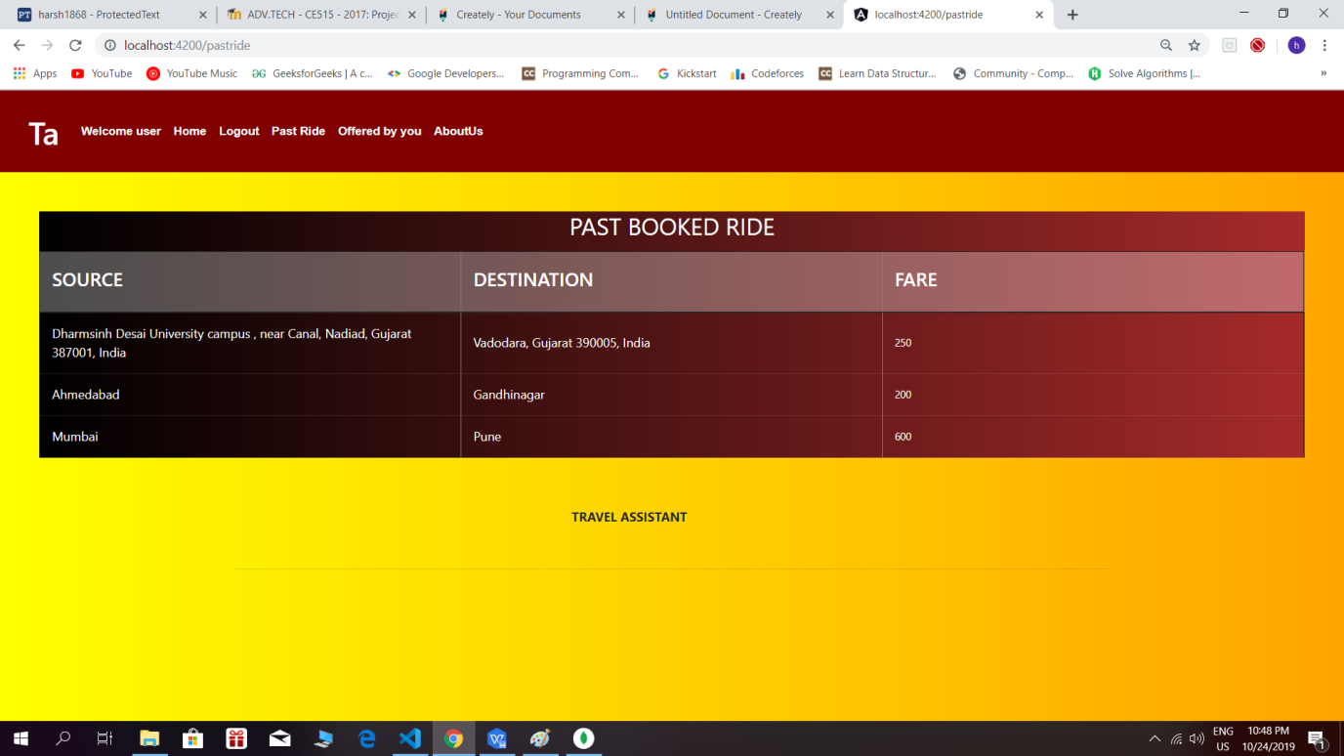

1. Ride Offered by you

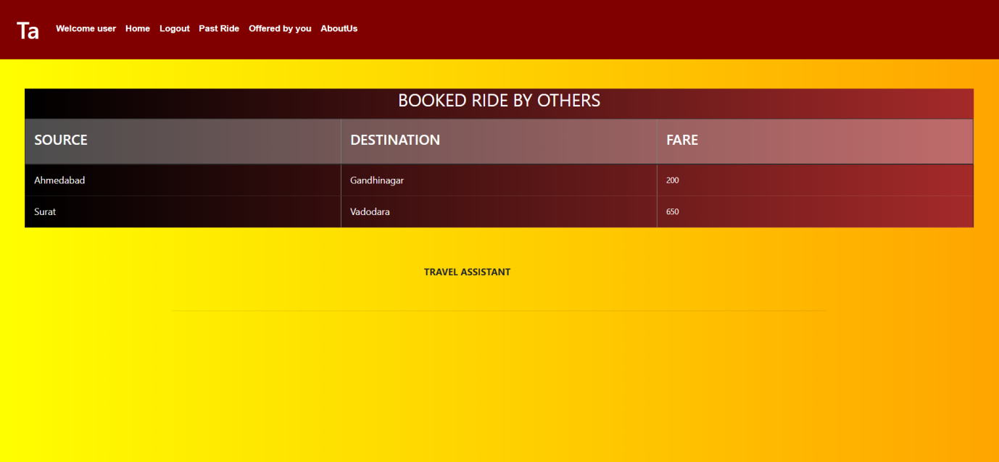

1. Famouse Ride

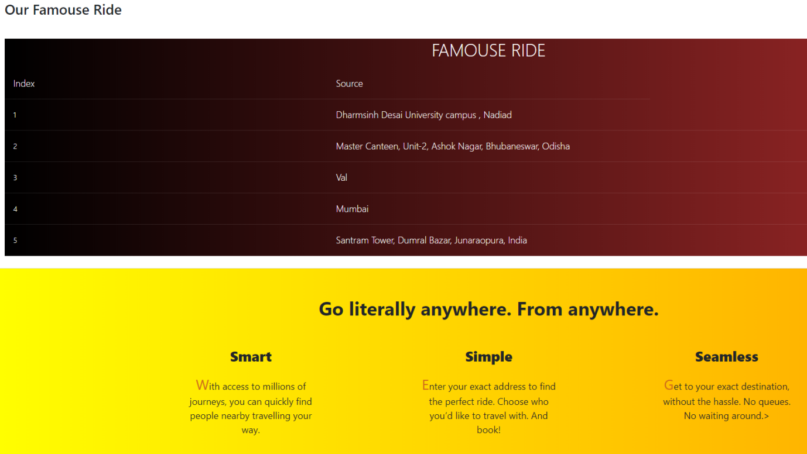

1. Admin page

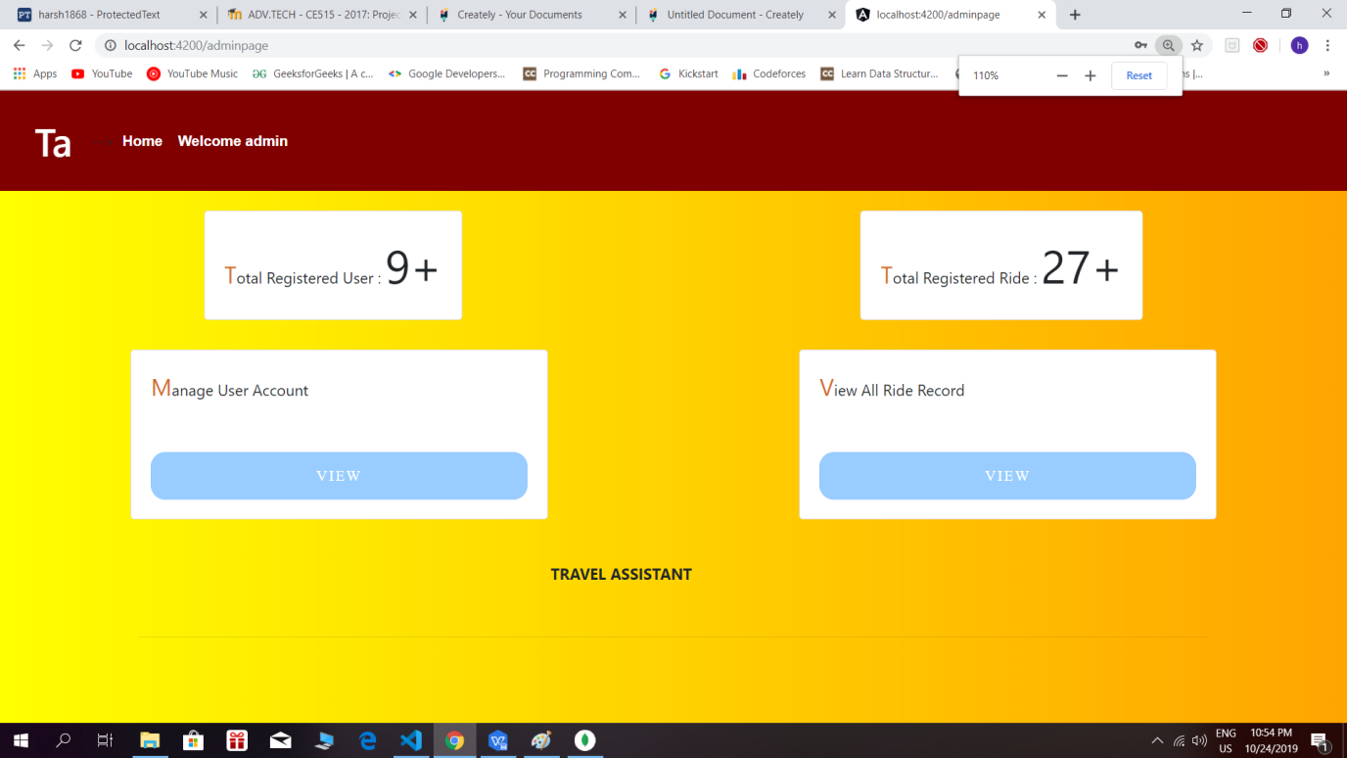

1. Manage User

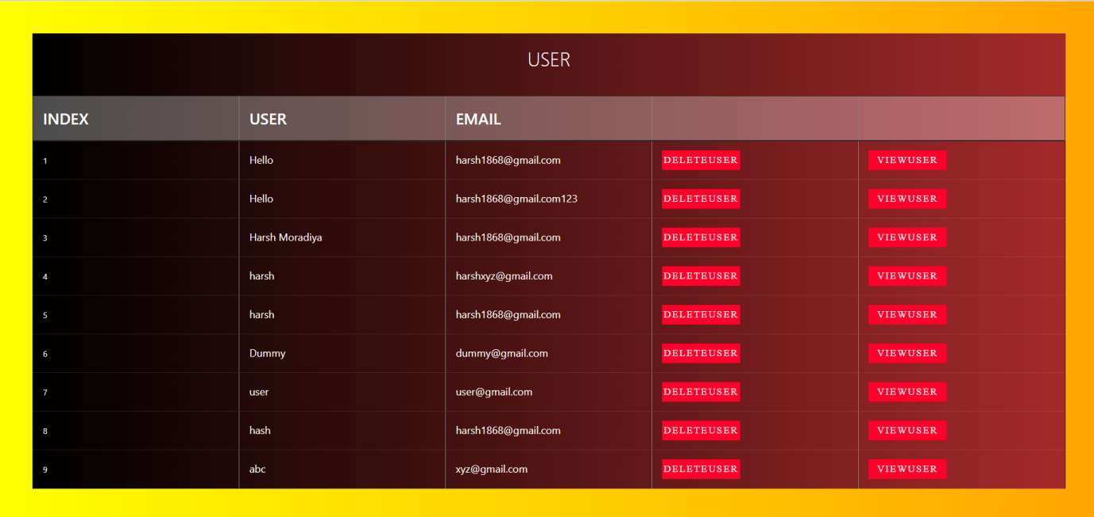

1. 10.View all ride history

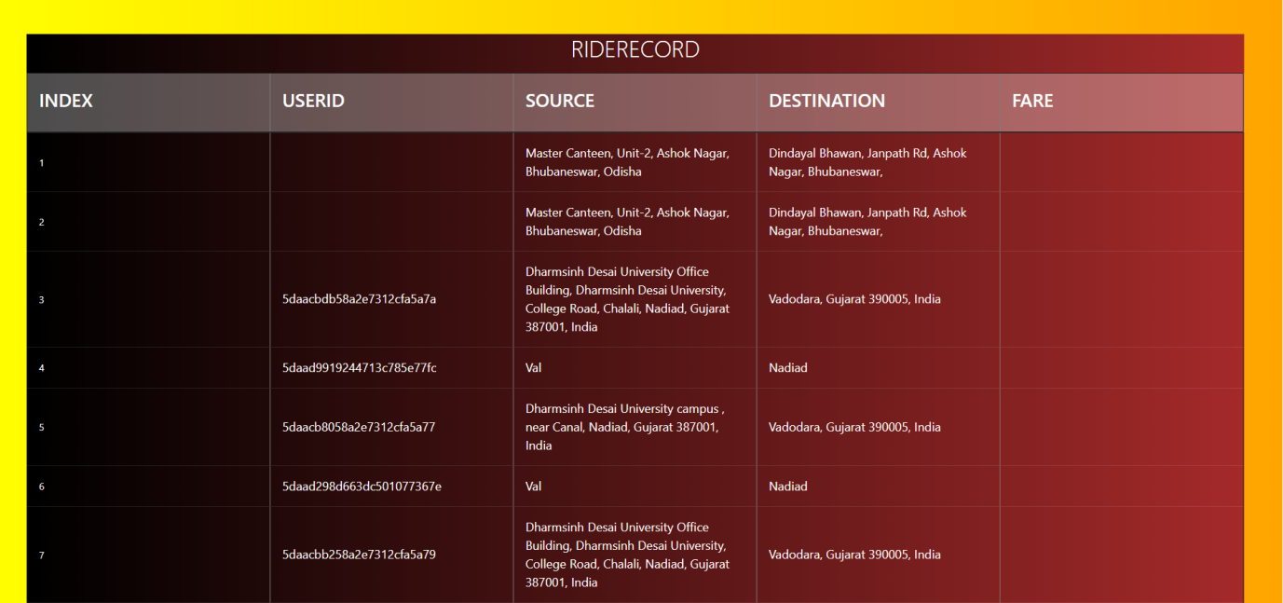

# 12.Limitation and Future Extension

**Limitations**

* + - 1. User can not filter Ride by distance of their location or specific source to destination.So user need to check all the records
      2. Once the request is made to the driver by the user,driver needs to communicate with customer by contact number which will be provided by help team. They can not further communicate via application.
      3. At time of offering ride,it is possible that you can not get exact label by marker on map so some time we need to type manually Source and destination
      4. No options available in application for the online payment.

**Future Extension**

* + - 1. Filter operation will be improved to provide best GUI to user
      2. Map facility will be created accurately and using distance matrix we will provide distance between source and destination
      3. Provide functionality that allows user to track booked car based on gps and for online payment.
      4. Provide Platform for communication between customer and workers.
      5. Allow user to cancel or update request even after it has been confirmed and notify respective driver about changes
      6. 6.Implement Rating And Review mechanism to allow user to add reviews and ratings to respective driver and ride.

# 13.Testing

After the implementation and coding of system,comprehensive testing was performed on the system to determine possible flaws in system and loopholes of system. The testing was performed using postman as Tool,Through which we can directly pass data in JSON format as Request Data in URL.Post request can not be directly send to server but using postman we can also send a POST request.

# 14.Conclusion

The functionality of this system is developed after understanding whole system flow and all module and it is as per requirement.

The functionality which were successfully implemented :

1. Registration/Login
2. Offer Ride : based on google map or manually entering source and destination
3. Find Ride : Confirm ride by confirming from display list
4. View past booked ride
5. View Offered ride
6. Manage user account
7. View full profile in admin site

# 15.Bibliography

1. https://nodejs.org‐For NodeJS Installation.
2. <https://angular.io‐For> Angular Installation.
3. <https://www.w3school.com/-> For Html,Css,Bootstrap.
4. <https://www.mongodb.com/-> For Mongodb installation