**SpringBoot Configuration with CI/CD(Using GitHub Action)**

Srep-1 Create Simple SpringBoot Application.

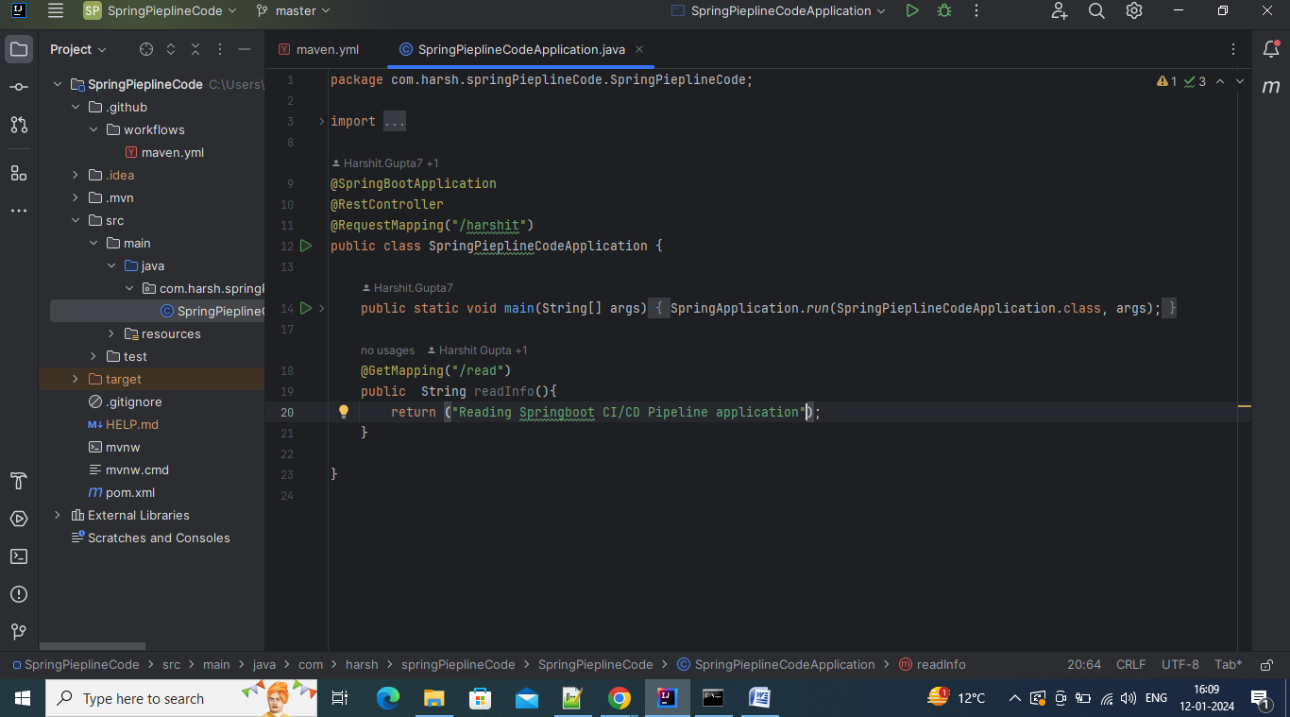

Step-2 Now Create the Github Repository where we will push Spring Code

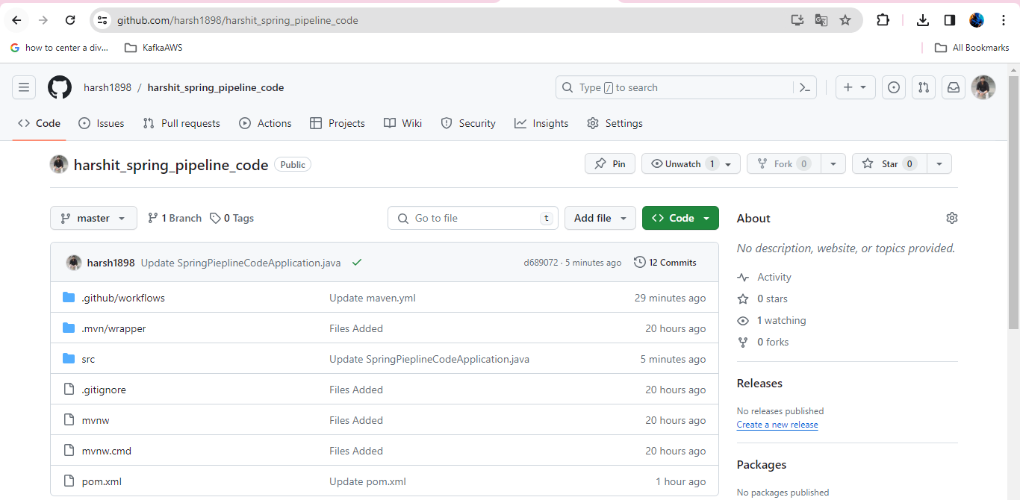

Step-3 Now, From Actions tab, Select Java with Maven Workflow to integrate the CI/CD Piepline with spring application that will automate the build and test.

