# Practical-1

**Name of Experiment: To design all logic gate with help of Logisim Tools required: Logisim**

**Theory:** Computer architecture is the organisation of the components which make up a computer system. A logic gate is a device that acts as a building block for digital circuits. They perform basic logical functions that are fundamental to digital circuits.

## NOT

**BLOCK DAIGRAM:**

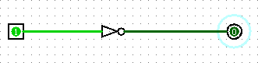

**Result:**

