**APPLIED ARTIFICIAL INTELLIGENCE**

**MASTER OF SCIENCE**

**(INFORMATION TECHNOLOGY)**

**BY**

**Name: Mali Pranjal Krishna**

**Seat No: 2295009**



N.B. MEHTA (VALWADA) SCIENCE COLLEGE BORDI

MAHARASHTRA - 401701

DEPARTMENT OF INFORMATION TECHNOLOGY

Master of Science (INFORMATION TECHNOLOGY)

Semester-III

Academic year 2023-2024



**Certificate**

Class: M.Sc. Information Technology (Semester III) Year: 2023-2024

This is to certify that the work entered in this journal is the work of

Kumari Prajapti Preeti Mangal Prasad of M.Sc. Part-1 division Information Technology Roll No. 10 Uni. Exam No. has satisfactorily completed the required number of practical and worked for the 1st term / 2nd term/ both the terms of the Year 2022-23 in the college laboratory as laid down by the university.

**Index**

|  |  |  |
| --- | --- | --- |
| Sr. No. | Practical Name | Sign |
| 1 | 1. Design a simple machine learning model to train the training instances and test the same using Python 2. Implement and demonstrate the FIND-S algorithm for finding the most specific hypothesis based on a given set of training data samples. Read the training data from a .CSV file |  |
| 2 | 1. Perform Data Loading, Feature selection (Principal Component analysis) and Feature Scoring and Ranking 2. For a given set of training data examples stored in .CSV file, implement and demonstrate the CandidateElimination algorithm to output a description of the set of all hypotheses consistent with the training examples |  |
| 3 | Write a program to implement Decision Tree and Random forest with Prediction, Test Score and Confusion Matrix |  |
| 4 | 1. For a given set of training data examples stored in a .CSV file implement Least Square Regression algorithm. (Use Univariate dataset) 2. For a given set of training data examples stored in a .CSV file implement Logistic Regression algorithm. (Use Multivariate dataset) |  |
| 5 | 1. Write a program to demonstrate the working of the decision tree based ID3 algorithm. Use an appropriate data set for building the decision tree and apply this knowledge to classify a new sample 2. Write a program to implement k-Nearest Neighbour algorithm to classify the iris data set |  |
| 6 | 1. Implement the different Distance methods (Euclidean, Manhattan   Distance, Minkowski Distance) with Prediction, Test Score and Confusion Matrix   1. Implement the classification model using clustering for the following techniques with K means clustering with Prediction, Test Score and Confusion Matrix |  |
| 7 | Implement the classification model using clustering for the following techniques with hierarchical clustering with Prediction, Test Score and Confusion Matrix |  |
| 8 | 1. Write a program to construct a Bayesian network considering medical data. Use this model to demonstrate the diagnosis of heart patients using standard Heart Disease Data Set 2. Implement the non-parametric Locally Weighted Regression algorithm in order to fit data points. Select appropriate data set for your experiment and draw graphs |  |

# Practical-01

A. Design a simple machine learning model to train the training instances and test the same using Python.

import numpy as np

class SVM: def init_(self, learning_rate=0.001, lambda_param=0.01, n_iters=1000):

self.lr = learning_rate self.lambda_param = lambda_param self.n_iters = n_iters self.w = None

self.b - None

def fit(self, x, y): n_samples, n_features - X. shape

y_ - np.where(y <- 0, -1, 1)

self.w = np.zeros(n_features) self.b = 0

for _in range(self.n_iters): for idx, x_i in enumerate(X): condition = y_[idx] * (np.dot(x_i, self.w) - self.b) >= 1 if condition: self.w -= self.lr * (2 " self.lambda_param * self.w) def predict(self, x): approx = np.dot(X, self.w) - self.b return np.sign(approx)

# Testing if _name # Imports from sklearn import datasets

import matplotlib.pyplot as plt

x, y = datasets.make_blobs(

n_samples=50, n_features=2, centers=2, cluster_std=1.05, random_state=40

y = np.where(y == 0, -1, 1)

clf = SVM() clf.fit(x, y)

# predictions - clf.predict(x)

" main

)

print(clf.w, clf.b)

def visualize_svm():

def get_hyperplane_value(x, w, b, offset): return (-w[0] * x + b + offset) / w[1]

fig = plt.figure() ax = fig.add_subplot(1, 1, 1)

plt.scatter(x[:, 0], x[:, 1], marker-"o", c-y)

x0_1 = np.amin(X[:, 0])

x0_2 = np.amax(X[:, 0])

x1_1 - get_hyperplane_value(x0_1, clf.w, clf.b, 0) x1_2 - get_hyperplane_value(x0_2, clf.w, clf.b, 0)

x1_1_m = get_hyperplane_value(x0_1, clf.w, clf.b, -1) x1_2_m = get_hyperplane_value(x0_2, clf.w, clf.b, -1)

x1_1_p - get_hyperplane_value(x0_1, clf.w, clf.b, 1)

x1_2_p = get_hyperplane_value(x0_2, clf.w, clf.b, 1)

ax.plot([x0_1, x0_2], [x1_1, x1_2], "y -- ") ax.plot([x0_1, x0_2], [x1_1_m, x1_2_m], "k") ax.plot([x0_1, x0_2], [x1_1_p, x1_2_p], "k") x0_1 - np.amin(X[:, 0])

x0_2 = np.amax(x[:, 0])

x1_1 = get_hyperplane_value(x0_1, clf.w, clf.b, 0) x1_2 = get_hyperplane_value(x0_2, clf.w, clf.b, 0)

x1_1_m = get_hyperplane_value(x0_1, clf.w, clf.b, -1) x1_2_m = get_hyperplane_value(x0_2, clf.w, clf.b, -1)

x1_1_p =get_hyperplane_value(x0_1, clf.w, clf.b, 1) x1_2_p - get_hyperplane_value(x0_2, clf.w, clf.b, 1)

ax.plot([x0_1, x0_2], [x1_1, x1_2], "y -- ") ax.plot([x0_1, x0_2], [x1_1_m, x1_2_m], "k")

ax.plot([x0_1, x0_2], [x1_1_p, x1_2_p], "k")

x1_min = np.amin(X[:, 1]) x1_max = np.amax(X[:, 1])

ax.set_ylim([x1_min - 3, x1_max + 3])

plt. show()

visualize svm()

output:

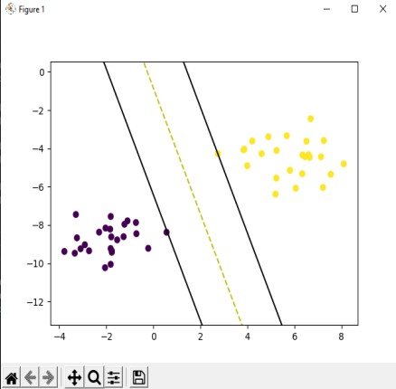

B. Implement and demonstrate the FIND-S algorithm for finding the most specific hypothesis based on a given set of training data samples. Read the training data from a

.CSV file.

Code:

import csv

num_attributes = 5

a - [] print("\n") print("07_Govind Saini")

print("\n The Given Training Data Set \n")

with open('govind.csv', 'r') as csvfile: reader = csv.reader(csvfile) for row in reader: a.append (row)

print(row)

print("\n The initial value of hypothesis: ") hypothesis = ['0'] * num_attributes print(hypothesis)

for j in range(0,num_attributes): hypothesis[j] = a[1][j]

print("\n The a[1] value of hypothesis: ") print(hypothesis) print("\n Find S: Finding a Maximally Specific Hypothesis\n")

for i in range(e,len(a)): if a[i][num_attributes] -- 'Positive': for j in range(0,num_attributes): if a[i][j] != hypothesis[j]: hypothesis[j]='?' else :

hypothesis[j]= a[i][j] print(" For Training instance No:{} the hypothesis is ".format(i), hypothesis) print("\n The Maximally Specific Hypothesis for a given Training Examples :\n", hypothesis)

Output:

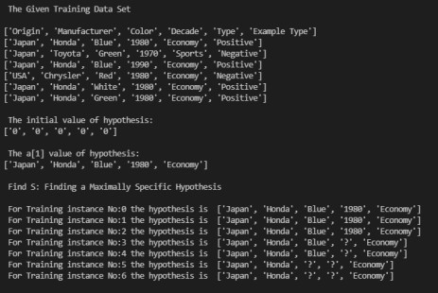

# Practical-02

A. Perform Data Loading, Feature selection (Principal Component analysis) and Feature Scoring and Ranking.

Code: import numpy as np import matplotlib.pyplot as plt import pandas as pd

dataset = pd.read_csv('winequality_red.csv')

# distributing the dataset into two components X and Y X - dataset.iloc[:, 0:13].values

y = dataset.iloc[:, 13].values

from sklearn.model_selection import train_test_split

X_train, X_test, y_train, y_test = train_test_split(X, y, test_size = 0.2, random_state = 0)

# performing preprocessing part

from sklearn.preprocessing import StandardScaler Sc = StandardScaler()

X_train - sc.fit_transforn(X_train)

X_test = sc.transform(X_test)

from sklearn.decomposition import PCA pca - PCA(n_components - 2)

X_train = pca.fit_transform(X_train) X_test - pca.transform(X_test)

explained variance = pca.explained variance ratio

from sklearn.linear_model import LogisticRegression

classifier = LogisticRegression(random_state = 0) classifier.fit(X_train, y_train)

y_pred = classifier.predict(x_test)

from sklearn.metrics import confusion_matrix

cm - confusion_matrix(y_test, y_pred)

print("07_Govind Saini")

from matplotlib.colors import ListedColormap

X_set, y_set - X_train, y_train

X1, X2 - np.meshgrid(np.arange(start - X_set[:, @].min() - 1, stop - X_set[:, 0].max() + 1, step - 0.01), np.arange(start = X_set[:, 1].min() - 1,

stop = X_set[:, 1].max() + 1, step = 0.01))

plt.contourf(X1, X2, classifier.predict(np.array([x1.ravel(), x2.ravel()]).T).reshape(X1.shape), alpha = 0.75, cmap = Listedcolormap(('yellow', 'white', 'aquamarine'))) plt.xlim(X1.min(), X1.max()) plt.ylim(X2.min(), X2.max())

for i, j in enumerate(np.unique(y_set)):

plt.scatter(X_set[y_set == j, 0], x_set[y_set == j, 1],

c - ListedColormap(('red', 'green', 'blue'))(i), label - j)

plt.title('Logistic Regression (Training set)') plt.xlabel('PC1') plt.ylabel('PC2') plt. legend()

plt. show()

# Visualising the Test set results through scatter plot

from matplotlib.colors import ListedColormap

X_set, y_set - X_test, y_test

X1, X2 = np.meshgrid(np.arange(start = X_set[:, e].min() - 1, stop = X_set[:, 0].max() + 1, step = 0.01), np.arange(start = X_set[:, 1].min() - 1,

stop = X_set[:, 1].max() + 1, step = 0.01))

plt.contourf(X1, x2, classifier.predict(np.array([x1.ravel(), X2.ravel()]).T).reshape(X1.shape), alpha - 0.75, cmap = ListedColormap(('yellow', 'white', 'aquamarine'))) plt.xlim(X1.min(), X1.max()) plt.ylim(X2.min(), X2.max())

for i, j in enumerate(np.unique(y_set)): plt.scatter(X_set[y_set == j, 0], X_set[y_set -= j, 1], C = ListedColormap(('red', 'green', 'blue') )(1), label = j)

plt.title('Logistic Regression (Test set)') plt.xlabel('PC1') plt.ylabel('PC2') plt. legend()

plt.show()

Output:

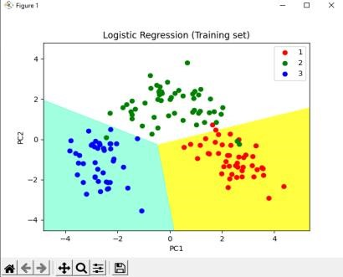

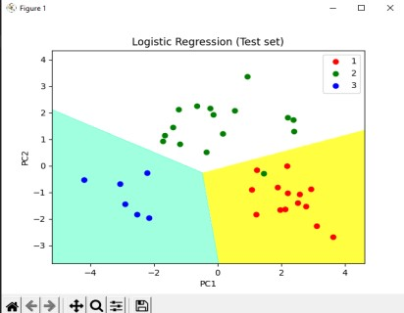

B. For a given set of training data examples stored in .CSV file, implement and demonstrate the CandidateElimination algorithm to output a description of the set of all hypotheses consistent with the training examples.

Code:

import csv import numpy as np import warnings warnings.filterwarnings('ignore')

import matplotlib.pyplot as plt

def g_e(n): return ("?",)n

def s_0(n): return ('0'.)*n

def more_general(h1, h2): more_general_parts = [] for x, y in zip(h1, h2): mg - x -= "?" or (x !- "e" and (x -- y or y -= "e")) more_general_parts.append(mg)

return all(more_general_parts)

11 = [1, 2, 3] 12 = [3, 4, 5]

list(zip(11, 12))

# min_generalizations def fulfills(example, hypothesis):

### the implementation is the same as for hypotheses:

return more_general(hypothesis, example) def min_generalizations(h, x): h_new = list(h) for i in range(len(h)): if not fulfills(x[i:i+1], h[i:i+1]): h_new[i] = '?' if h[i] 1= '0' else x[i] return [tuple(h_new) ] min_generalizations(h-('e', 'e'

x=('rainy', 'windy', 'cloudy'))

def min_specializations(h, domains, x): results - [] for i in range(len(h)):

if h[i] -- "?": for val in domains[i]: if x[i] != val:

h_new = h[:i] + (val, ) + h[i+1:] results.append(h_new) elif h[i] != "0": h_new = h[:i] + ('0', ) + h[i+1:] results.append(h_new) return results min_specializations(h=('?', 'x',), domains-[['a', x-('b', 'x'))

with open('season_dataset.csv') as csvFile: examples - [tuple(line) for line in csv.reader(csvFile)]

, 'sunny"),

'b', 'c'], ['x', 'y']l,

def get_domains(examples): d - [set() for i in examples[0]] for x in examples: for i, xi in enumerate(x): d[i].add(xi)

return [list(sorted(x)) for x in d]

get_domains(examples)

def candidate_elimination(examples): domains - get_domains(examples)[ :- 1]

G = set([g_0(len(domains))]) S = set([s_0(len(domains))]) i-℮

#print("\n G[{0]]:".format(i),G) #print("\n S[{0]]:".format(i),S) for xcx in examples:

1=1+1

x, cx - xcx[ :- 1], xcx[-1] # Splitting data into attributes and decisions if cx -= 'Y': # x is positive example

G - {g for g in G if fulfills(x, g)} S = generalize_S(x, G, S) else: # x is negative example

5 m {s for s in 5 if not fulfills(x, s)} def generalize_S(x, G, S): S_prev = list(S) for s in S_prev: if s not in S: continue if not fulfills(x, s):

S.remove(s)

Splus - min_generalizations(s, x)

## keep only generalizations that have a counterpart in G s.update([h for h in Splus if any([more_general(g,h) for g in G])])

## remove hypotheses less specific than any other in S

5.difference_update([h for h in S if any([more_general(h, h1) for h1 in S if h !- hi])])

return S def specialize_G(x, domains, G, 5): G_prev - list(G) for g in G_prev: if g not in G: continue if fulfills(x, g):

G.remove(g)

Ginus = min specializations(g, domains, x) def specialize_G(x, domains, G, 5): G_prev = list(G) for g in G_prev: if g not in G: continue if fulfills(x, g):

G. remove(g)

Gminus - min_specializations(g, domains, x)

## keep only specializations that have a conuterpart in S G.update([h for h in Gminus if any([more_general(h, s) for s in S])])

ftt remove hypotheses less general than any other in G

G.difference_update([h for h in G if any([more_general(g1, h)

for g1 in G if h !- g1])])

G, S = candidate_elimination(examples) print("G[4] ="

print("s[4] -"

return G class HypothesisNode(object): def _init_(self, h, level-0, parents-None): self.h = h self.level - level if parents is None:

parents = [] self.parents = set(parents) def _repr_(self): return "HypothesisNode({], {), {])".format(self.h, self.level, self.parents)

def build_hypothesis_space(G, S): levels = [[HypothesisNode(x, 0) for x in G]] curlevel = 1

def next_level(h, S):

for s in S: for i in range(len(h)): if h[i] == '?' and s[i] |= '?': yield h[:i] + (s[i], ) + h[i+1:]

nextLv1 - {} while True: for n in levels[-1]:

for hyp in next_level(n.h, 5): if hyp in nextLvl: nextLvl[hyp].parents.add(n) else: pos = 0 ymin = 0.1

ymax = 0.9

for nodes, y in [(levels[0], ymin), (levels[-1], ymax)]: xvals = np.linspace(0, 1, len(nodes)) for x, n in zip(xvals, nodes):

pos[n.h] - [x, y]

pos = nx.layout.fruchterman_reingold_layout(g, pos-pos, fixed-pos.keys())

nx.draw_networkx_edges(g, pos-pos, alpha-0.25) nx.draw_networkx_labels(g, pos-pos)

plt.box(True) plt.xticks([]) plt.yticks([]) plt.xlim(-1, 2)

plt.gcf().set_size_inches((10, 10)) plt.show() print()

draw_hypothesis_space(G, 5)

Output:

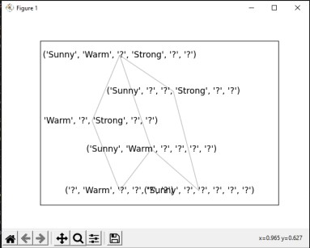

# Practical-03

Write a program to implement Decision Tree and Random forest with Prediction, Test Score and Confusion Matrix.

Code: import pandas as pd

import seaborn as sns

df = pd.read_csv("HR_employee_data.csv") df.head()

sns.countplot(x='Attrition', data=df) df.drop(['EmployeeCount', 'EmployeeNumber', 'Over18', 'StandardHours'], axis-

"columns", inplace-True)

categorical_col = [] for column in df.columns: if df[column].dtype == object and len(df[column].unique()) <= 50:

categorical col annand(column) (variable) df: DataFrame df['Attrition'] = df.Attrition.astype("category").cat.codes

from sklearn.preprocessing import LabelEncoder label = LabelEncoder() for column in categorical_col:

df[column] = label.fit_transform(df[column])

from sklearn.model_selection import train_test_split

X = df.drop('Attrition', axis=1) y - df.Attrition

X_train, X_test, y_train, y_test = train_test_split(X, y, test_size=0.3, random_state=42)

from sklearn.metrics import accuracy_score, confusion_matrix, classification_report def print_score(clf, X_train, y_train, X_test, y_test, train=True):

if train: pred - clf.predict(x_train)

clf_report = pd.DataFrame(classification_report(y_train, pred, output_dict=True)) print("07_Govind Saini \n") print("Train Result:\n ==

print(f"Accuracy Score: {accuracy_score(y_train, pred) * 100 :. 2f}%") print(f"CLASSIFICATION REPORT:\n{clf_report}")

print(f"Confusion Matrix: \n {confusion_matrix(y_train, pred)}\n")

elif train -- False:

pred - clf.predict(x_test)

clf_report = pd.DataFrame(classification_report(y_test, pred, output_dict=True)) print("Test Result:\n ===== print(f"Accuracy Score: {accuracy_score(y_test, pred) * 100 :. 2f}%")

print(f"CLASSIFICATION REPORT:\n{clf_report}") print(f"Confusion Matrix: \n {confusion_matrix(y_test, pred)}\n")

from sklearn.tree import DecisionTreeClassifier tree_clf = DecisionTreeClassifier(random_state=42) tree_clf.fit(x_train, y_train)

print_score(tree_clf, X_train, y_train, X_test, y_test, train=True) print_score(tree_clf, X_train, y_train, X_test, y_test, train=False)

Output:

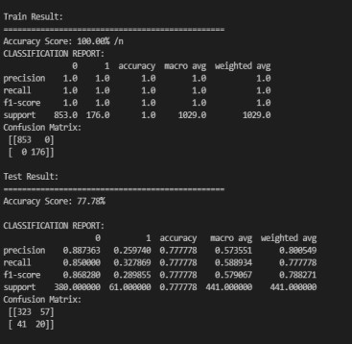

# Practical-04

A. For a given set of training data examples stored in a .CSV file implement Least Square Regression algorithm. (Use Univariate dataset).

Code: import pandas as pd import numpy as np import matplotlib.pyplot as plt plt.rcparams['figure.figsize'] - (12.0, 9.0)

# Preprocessing Input data

data = pd.read_csv('Sample_Salary_Data.csv')

X = data.iloc[:, 0] Y - data. iloc[:, 1] plt.scatter(x, Y)

plt. show()

# Building the model X_mean - np.mean(X)

Y_mean = np.mean(Y)

nun - 0 den = 8 for i in range(len(X)):

num +- (X[i] - x_mean)*(Y[i] - Y_mean) den += (X[i] - X_mean) ** 2 m - num / den C = Y_mean - m*x_mean

print('07_Govind Saini') print (m, c)

# Making predictions Y_pred = m*X + C

plt.scatter(X, Y) # actual

# plt.scatter(X, Y_pred, color='red')

plt.plot([min(X), max(x)], [min(Y_pred), max(Y_pred)], color-'red') # predicted plt.show()

Output:

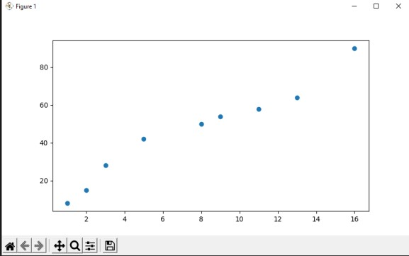

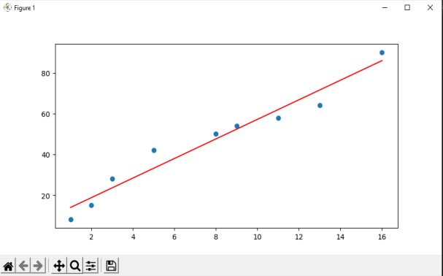

B. For a given set of training data examples stored in a .CSV file implement Logistic

Regression algorithm. (Use Multivariate dataset )

Code: import numpy as np import matplotlib.pyplot as plt import pandas as pd

dataset = pd.read_csv('p4b.csv') X = dataset. iloc[:, [0, 1]].values

y = dataset.iloc[:, 2].values

from sklearn.model_selection import train_test_split

X_train, X_test, y_train, y_test = train_test_split(x, y, test_size = 0.25, random_state = 0)

from sklearn.preprocessing import StandardScaler

5C = StandardScaler()

X_train = sc.fit_transform(X_train) X_test = sc.transform(X_test)

print (X_train[0:10, :])

from sklearn.linear_model import LogisticRegression

classifier = LogisticRegression()

classifier.fit(X_train, y_train)

y_pred = classifier.predict(x_test)

from sklearn.metrics import confusion_matrix cm = confusion_matrix(y_test, y_pred)

print ("Confusion Matrix : \n", cm)

df - pd.DataFrame({'Real Values':y_test, 'Predicted Values':y_pred})

from matplotlib.colors import ListedColormap

X_set, y_set = X_test, y_test

X1, X2 = np.meshgrid(np.arange(start = X_set[:, 0].min() - 1, stop = X_set[:,

0].max() + 1, step = 0.01), np.arange(start - X_set[:, 1].min() - 1, stop - X_set[:, 1].max() + 1, step - 0.01)) plt.contourf(X1, X2, classifier.predict(np.array([x1.ravel(), X2.ravel()]).T).reshape(X1.shape),

alpha = 0.75, cmap = ListedColormap(('red', 'green'))) plt.xlim(X1.min(), X1.max()) plt.ylim(X2.min(), X2.max()) for i, j in enumerate(np.unique(y_set)): plt.scatter(X_set[y_set == j, 0], x_set[y_set == j, 1], C = ListedColormap(('red', 'green'))(i), label = j) plt.title('Logistic Regression') plt.xlabel('X_Test') plt.ylabel('Y_Test') plt. legend()

plt. show()

Output:

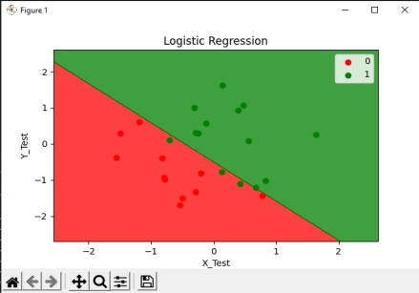

# Practical-05

A. Write a program to demonstrate the working of the decision tree based ID3 algorithm. Use an appropriate data set for building the decision tree and apply this knowledge to classify a new sample.

Code: from chefboost import Chefboost as chet import pandas as pd

df - pd.read_csv("Weekened_data.txt") print("07_Govind Saini") config = {'algorithm': 'ID3'}

model = chef.fit(df, config = config, target_label = 'Decision')

prediction = chef.predict(model, param = ['W1', 'Sunny', 'Yes', 'Rich']) moduleName - "outputs/rules/rules" #this will load outputs/rules/rules.py tree = chef.restoreTree(moduleNane)

prediction = tree.findDecision(['W1', 'Sunny', 'Yes', 'Rich'])

chef. save_model(model, "model.pkl")

model - chef. load_model("model.pk1")

prediction - chef.predict(model, ['W1',85,85, 'Rich'])

config = {'algorithm': 'ID3'} #Set algorithm to ID3, C4.5, CART, CHAID or Regression model - chef.fit(df, config)

Output:

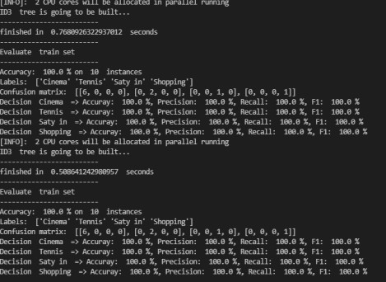

B. Write a program to implement k-Nearest Neighbour algorithm to classify the iris data set.

Code: from sklearn.neighbors import KNeighborsClassifier from sklearn.preprocessing import StandardScaler from sklearn.pipeline import make_pipeline from sklearn import datasets from sklearn.model_selection import train_test_split from sklearn.model_selection import GridSearchCV

iris = datasets. load_iris() X = iris.data

y = iris.target

# print(iris)

# Create train and test split

X_train, X_test, y_train, y_test = train_test_split(

X, y, test_size=0.3, random_state=42, stratify-y)

# Feature Scaling using StandardScaler

SC = StandardScaler() sc.fit(x_train)

X_train_std = sc.transform(x_train)

X_test_std = sc.transform(X_test)

# Fit the model knn = KNeighborsClassifier(

n_neighbors=5, p=2, weights='uniform', algorithm='auto')

knn.fit(X_train_std, y_train)

# Evaluate the training and test score print('07_Govind Saini')

print('Training accuracy score: %.3f' % knn.score(X_train_std, y_train)) print('Test accuracy score: %.3f' % knn.score(X_test_std, y_test))

iris = datasets. load_iris() X - iris.data

y - iris.target

# Create train and test split

X_train, X_test, y_train, y_test = train_test_split(

x, y, test_size=0.3, random_state=42, stratify=y)

# Create a pipeline

pipeline = make_pipeline(StandardScaler(), KNeighborsClassifier())

# Create the parameter grid

naram prid = If param_grid = [{

'kneighborsclassifier_n_neighbors': [2, 3, 4, 5, 6, 7, 8, 9, 10],

'kneighborsclassifier_p': [1, 2],

"kneighborsclassifier_weights': ['uniform', 'distance'],

'kneighborsclassifier_algorithm': ['auto', 'ball_tree', 'kd_tree', 'brute'],

# Create a grid search instance

gs = GridSearchcv(pipeline, param_grid-param_grid, scoring-'accuracy', refit-True,

CV=10, verbose=1,

n_jobs=2)

# Fit the most optimal model

gs.fit(x_train, y_train)

# Print the best model parameters and scores print('Best Score: %.3f' % gs.best_score_, '\nBest Parameters: ', gs.best_params_)

Output:



# Practical-06

A. Implement the different Distance methods (Euclidean, Manhattan Distance, Minkowski Distance) with Prediction, Test Score and Confusion Matrix.

Code: from math import sqrt from sklearn.metrics import confusion_matrix

from sklearn.metrics import classification_report

# calculate euclidean distance def euclidean_distance(a, b): return sqrt(sum((e1-e2) ** 2 for e1, e2 in zip(a, b)))

# calculate manhattan distance def manhattan_distance(a, b): return sum(abs(e1-e2) for e1, e2 in zip(a, b))

# calculate minkowski distance def minkowski_distance(a, b, p): return sum(abs(e1-e2)"*p for e1, e2 in zip(a, b)) ** (1/p)

# define data # actual values actual = [1, 0, 0, 1, 0, 0, 1, 0, 0, 1]

# predicted values predicted - [1, 0, 0, 1, 0, 0, 0, 1, 0, e]

# calculate distance

dist1 - euclidean_distance(actual, predicted)

dist2 - manhattan_distance(actual, predicted)

# calculate distance (p-1) st3 = minkowski distance(actual, predicted,1)

# calculate distance (p-1) dist3 = minkowski_distance(actual, predicted,1)

print(dist3)

# calculate distance (p=2)

dist3 - minkowski_distance(actual, predicted, 2) print(dist3)

# confusion matrix

matrix = confusion_matrix(actual, predicted, labels=[1, 0]) print('Confusion matrix : \n', matrix)

# outcome values order in sklearn tp, fn, fp, tn = confusion_matrix(actual, predicted, labels=[1, 0]).reshape(-

1) print('Outcome values : \n', tp, fn, fp, tn)

# classification report for precision, recall f1-score and accuracy matrix - classification_report(actual, predicted, labels-[1, 0]) print('Classification report : \n', matrix)

Output:

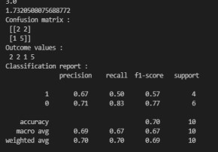

B. Implement the classification model using clustering for the following techniques with K means clustering with Prediction, Test Score and Confusion Matrix.

Code: import pandas as pd from sklearn.preprocessing import StandardScaler from sklearn.model_selection import train_test_split from sklearn.neighbors import KNeighborsClassifier from sklearn.metrics import classification_report from sklearn.metrics import confusion_matrix import warnings

warnings.filterwarnings('ignore')

# Xmatplotlib inline #Import the data set

raw_data - pd.read_csv('classified_data.csv', index_col - 0) print('07_Govind_saini')

print(raw_data)

print(raw_data.columns)

#Import standardization functions from scikit-learn

#Standardize the data set

scaler - StandardScaler() scaler.fit(raw_data.drop('TARGET CLASS', axis-1))

scaled_features - scaler.transform(raw_data.drop('TARGET CLASS', axis-

1))

scaled_data - pd.DataFrame(scaled_features, columns - raw_data.drop('TARGET CLASS', axis-1).columns)

scaler = Standardscaler()

scaler.fit(raw_data.drop('TARGET CLASS', axis=1)) scaled_features - scaler.transform(raw_data.drop('TARGET CLASS', axis-

1))

scaled_data = pd.DataFrame(scaled_features, columns =

raw_data.drop('TARGET CLASS', axis=1).columns)

#Split the data set into training data and test data

x = scaled_data y = raw_data['TARGET CLASS']

x_training_data, x_test_data, y_training_data, y_test_data - train_test_split(x, y, test_size - 0.3)

#Train the model and make predictions model - KNeighborsClassifier(n_neighbors - 1) model.fit(x_training_data, y_training_data)

predictions = model.predict(x_test_data)

#Performance measurement

print(classification_report(y_test_data, predictions))

print(confusion_matrix(y_test_data, predictions))

Output:

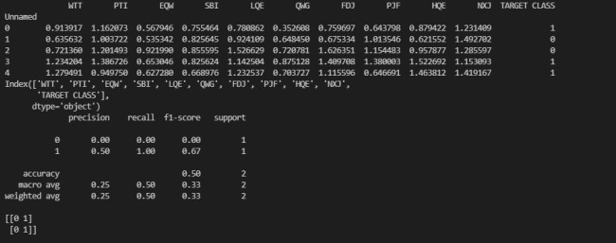

# Practical-07

A. Implement the classification model using clustering for the following techniques with hierarchical clustering with Prediction, Test Score and Confusion Matrix

Code:

import matplotlib.pyplot as plt

import pandas as pd

#2 Importing the Mall_Customers dataset by pandas dataset - pd.read_csv('abalone.csv') X - dataset.iloc[:, [3,4]].values

import scipy.cluster.hierarchy as sch

print("07_Govind Saini") #Lets create a dendrogram variable

dendrogram = sch.dendrogram(sch.linkage(X, method = "ward")) plt. title('Dendrogran') plt.xlabel('Gender') plt.ylabel('Euclidean distances') plt.show()

# algorithm class

from sklearn.cluster import AgglomerativeClustering hc - AgglomerativeClustering(n_clusters - 5, affinity = 'euclidean', linkage ='ward')

# clusters vector that tells for each customer which cluster the customer belongs to. y_hc=hc.fit_predict(x)

print("Prediction Values :",y_hc)

#5 Visualizing the clusters. This code is similar to k-means visualization code. plt.scatter(X[y_hc -- 0, 0], x[y_hc -- 0, 1], s-100, c-'red', label -'Cluster

1') plt.scatter(X[y_hc -= 1, 0], x[y_hc -- 1, 1], 5-100, C='blue', label

='Cluster 2')

pit. ticie( Denurogram ) plt.xlabel('Gender') plt.ylabel('Euclidean distances') plt.show()

# algorithm class

from sklearn.cluster import AgglomerativeClustering hc = AgglomerativeClustering(n_clusters = 5, affinity = 'euclidean', linkage ='ward')

# clusters vector that tells for each customer which cluster the customer belongs to. y_hc-hc.fit_predict(x)

print("Prediction Values :",y_hc)

#5 Visualizing the clusters. This code is similar to k-means visualization code.l plt.scatter(X[y_hc -- 0, 0], x[y_hc -- 0, 1], s-100, c-'red', label -'Cluster

1') plt.scatter(X[y_hc -= 1, 0], x[y_hc -- 1, 1], s-100, c='blue', label

='Cluster 2') plt.scatter(x[y_hc == 2, 0], x[y_hc == 2, 1], s=100, c='green', label

='Cluster 3') plt.scatter(x[y_hc == 3, 0], x[y_hc == 3, 1], s=100, C='cyan', label

='Cluster 4') plt.scatter(X[y_hc == 4, 0], x[y_hc == 4, 1], s=100, C='magenta', label

='Cluster 5')

plt.title('Clusters of Customers (Hierarchical Clustering Model) ') plt.xlabel('Annual Income(k$)') plt.ylabel('Spending Score(1-100') plt.show()

Output:

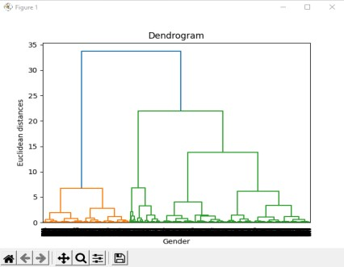

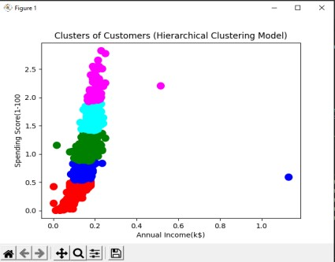

# Practical-08

A. Write a program to construct a Bayesian network considering medical data. Use this model to demonstrate the diagnosis of heart patients using standard Heart Disease Data Set.

Code: import numpy as np import pandas as pd

from pgmpy.estimators import MaximumLikelihoodEstimator from pgmpy.models import BayesianModel

from pgmpy.inference import VariableElimination

heartDisease = pd.read_csv('heart_disease_data.csv') heartDisease - heartDisease.replace('?',np.nan)

print("07_Govind Saini")

print('Sample instances from the dataset are given below') print(heartDisease.head())

print('\n Attributes and datatypes')

print(heartDisease.dtypes)

model- BayesianModel([('age', 'heartdisease'), ('gender',

'heartdisease'), ('exang', 'heartdisease'), ('cp', 'heartdisease'). print('\nLearning CPD using Maximum likelihood estimators') model.fit(heartDisease,estimator=MaximumLikelihoodEstimator)

print('\n Inferencing with Bayesian Network:') HeartDiseasetest_infer - VariableElimination(model)

print('\n 1. Probability of HeartDisease given evidence= restecg') q1=HeartDiseasetest_infer.query(variables=['heartdisease'],evidenc e={'restecg':1}) print(q1) print('\n Inferencing with Bayesian Network: ') HeartDiseasetest_infer = VariableElimination(model)

print('\n 1. Probability of HeartDisease given evidence- restecg') q1-HeartDiseasetest_infer.query(variables['heartdisease'],evidence-{'restecg':1]) print(q1)

print('\n 2. Probability of HeartDisease given evidence- cp ') q2-HeartDiseasetest_infer.query(variables=['heartdisease'], evidence={'cp':2}) print(q2)

Output:

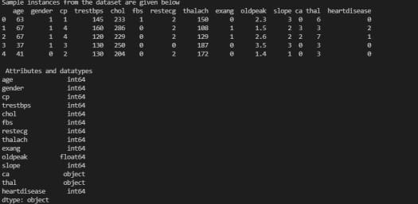

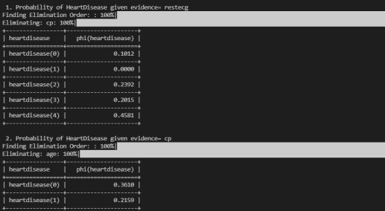

B. Implement the non-parametric Locally Weighted Regression algorithm in order to fit data points. Select appropriate data set for your experiment and draw graphs.

Code:

import matplotlib.pyplot as plt import pandas as pd import numpy as np

def kernel(point, xmat, k): m,n = np.shape(xmat) weights = np.mat(np.eye((m))) for j in range(m): diff = point - x[j] weights[j,j] = np.exp(diff*diff.T/(-2.0"k ** 2)) return weights

def localWeight(point, xmat, ymat, k): wei - kernel(point,xmat,k)

W = (X.T*(wei*X)).I*(X.T*(wei*ymat.T))

return W

def localWeightRegression(xmat, ymat, k): m,n = np.shape(xmat) ypred = np. zeros(m) for i in range(m): ypred[1] = xmat[i]*localWeight(xmat[i],xmat,ymat,k) return ypred

# load data points data = pd.read_csv('user_info.csv') bill - np.array(data.total_user)

tip - np.array(data.tips)

#preparing and add 1 in bill mbill - np.mat(bill)

mtip = np.mat(tip)

m= np.shape(mbill)[1] one - np.mat(np.ones(m)) X - np.hstack((one.T,mbill.T))

#set k here

ypred = localWeightRegression(X,mtip,0.5) SortIndex - X[:,1].argsort(e) xsort = X[SortIndex][:,0] print("07_Govind Saini") fig = plt.figure() ax - fig.add_subplot(1,1,1) ax.scatter(bill, tip, color-'orange')

ax.plot(xsort[:,1],ypred[SortIndex], color = 'blue', linewidth-5) plt.xlabel('Total User') plt.ylabel('Tips')

plt.show()

Output:

