INDIAN INSTITUTE OF ENGNEERING SCIENCE AND TECHNOLOGY , SHIBPUR

DEPARTMENT OF COMPUTER SCIENCE AND TECHNOLOGY



MINI PROJECT REPORT

CELLULAR NETWORK DASHBOARD(CELLNEXUS)

A full-stack, real-time dashboard providing geospatial visualizations and critical telemetry analytics to instantly diagnose cellular network performance.

Submitted By :- Harshit Maurya (2024CSB016)

Akriti Singh (2024CSB083)

AbhikMaurya (2024CSB050)

Project Report: Cellular Network Dashboard

Problem Statement
Modern cellular network infrastructures are vast and highly complex. When a network issue occurs, such as high call drops, latency spikes, or failing towers, network operators and analysts often struggle to visualize the problem geographically in real-time. Without a centralized, interactive dashboard, telecom teams rely on fragmented raw data (CSV logs) and delayed reports, resulting in slower response times to cellular degradation and a poor experience for end-users.

Proposed Solution
The Cellular Network Dashboard was developed as a full-stack, real-time monitoring system. It provides a geographical interface (a map) where network analysts can actively monitor the health of cell towers across different regions. When a tower experiences high traffic or call failures, the dashboard instantly reflects these changes through visual indicators (colors, coverage radii) , allowing for immediate diagnosis and resolution.

How It Was Made (Technology Stack & Architecture)
The project follows a standard decoupled Client-Server architecture.
Frontend (User Interface): Built with React.js and styled using Tailwind CSS. It uses Leaflet.js (react- leaflet) for rendering the interactive geographical map and Recharts to plot live telemetry graphs.
Backend (Server & Simulation): Built using Node.js and Express.js. It features a Socket.io integration that establishes a persistent WebSocket connection with the frontend, pushing fresh telemetry data every 3 seconds to simulate live network traffic.
Database: MySQL is used to store tower metadata, locations, and historical telemetry data.

Data Sourcing and Mechanics
Data simulation drives the dashboard, ensuring realistic visualization without needing a physical connection to an actual telecom ISP layout.
Raw Historical Data: The database is initially populated using an administrative script (seed.js), which reads massive telecom logs from a local CallStats.csv file and batch-inserts historical records into the MySQL database.
Live Telemetry Engine: An additional dataset (callstats_900.csv) is piped into the Node.js server. A custom "Geographical Data Slicing" algorithm maps chunks of this CSV row-data to specific towers. The server mathematically calculates answering, blocking, and dropping probabilities, and then broadcasts these via WebSocket to the frontend every 3 seconds.

Benefits of Dashboard

How This Helps the User (Network Analyst / Engineer)
- Real-time Visualization: Analysts no longer need to parse spreadsheets. They simply look at the map; if a tower icon is red, they know there's an outage.

- Predictive Monitoring: By viewing the live area charts for "Answered vs Blocked" calls, analysts can see traffic spikes while they are happening.
- Geographical Context: Seeing exactly where a tower is helps operators dispatch physical repair crews faster.

How This Helps the Admin (System Maintainer)
- Database Simplicity: The Admin can wipe and repopulate the entire simulated history across thousands of rows instantly by running the seed.js script.
- Scalability: The backend automatically adjusts the data slicing depending on how many towers are entered in the database; it dynamically adapts without hardcoding.

System Thresholds
To make the dashboard readable at a glance, several critical visual thresholds have been implemented programmatically:
- Tower Status Colors (Based on Database State): GOOD (Green)
DEGRADED (Orange)
OFFLINE (Red)

Geographical Coverage Radius mapping:
If GOOD: Radius = 100% of defined coverage size. If DEGRADED: Radius conditionally shrinks to 60%. If OFFLINE: Radius conditionally shrinks to 15%.

Critical Call Drop Limit (CallStatsChart.jsx):
If the Drop Probability (Failed Handoffs vs Total Incoming) exceeds 10%, the system triggers a
Red Alert Pulse, flashing the KPI box red to indicate a critical service failure.

System Flowcharts

User Flow Diagram
Shows the interaction path of a network analyst using the frontend application.

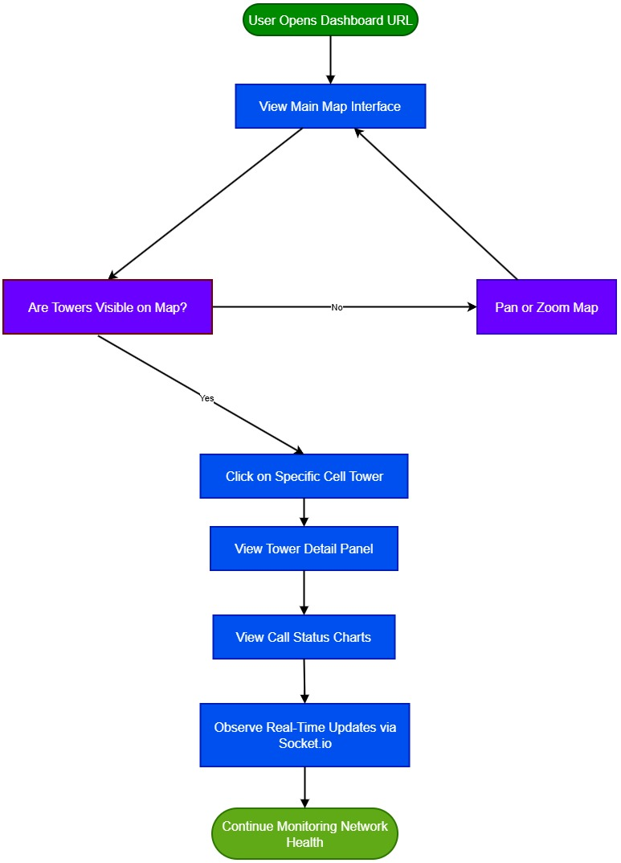

Administrator / System Flow Diagram
Shows the backend initialization and live simulation cycle.

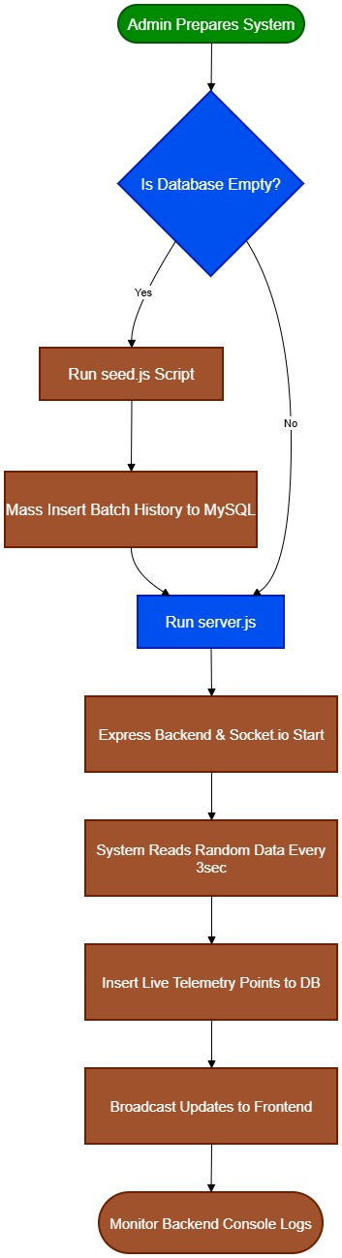

Annexures

Annexure A: System Architecture Diagram(Software Engineer’s)

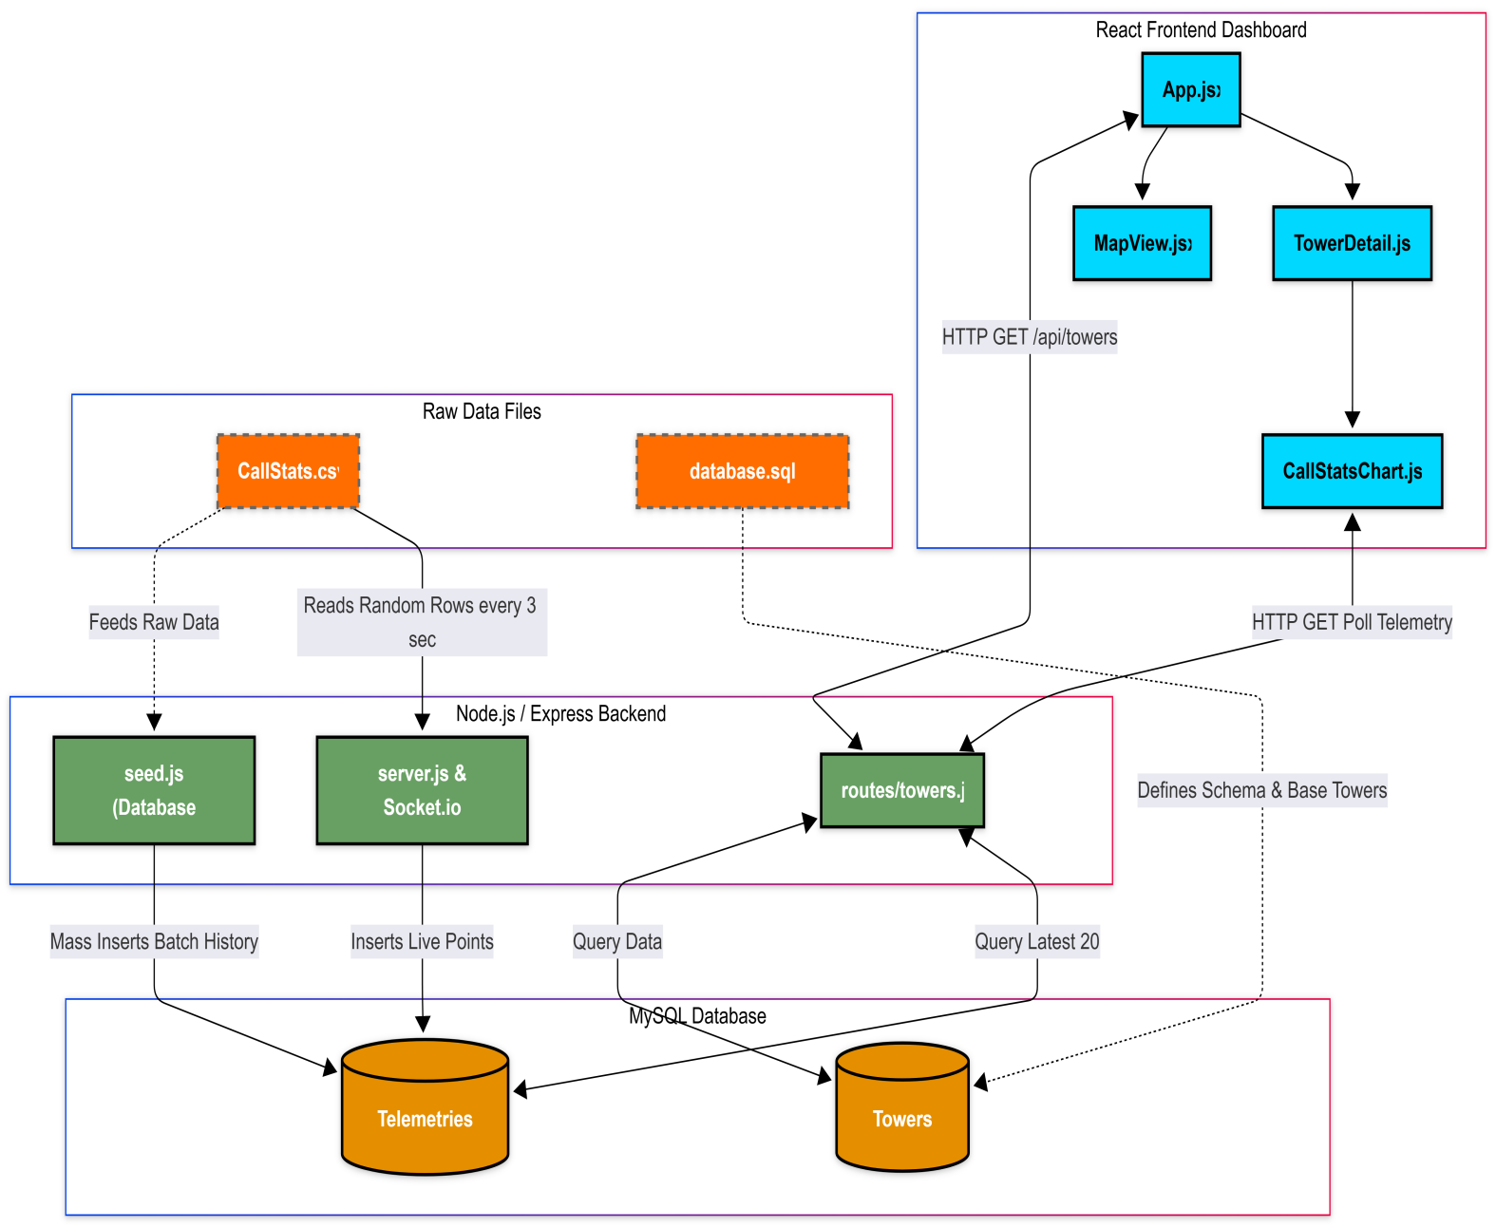

Annexure B: Dashboard Visuals

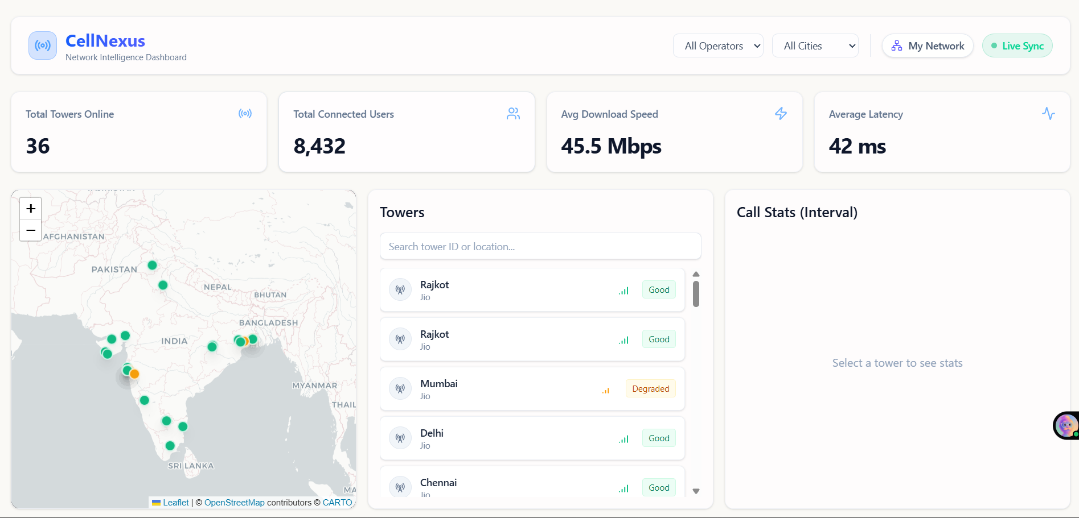

Navigation Bar of Dashboard

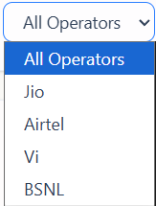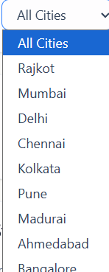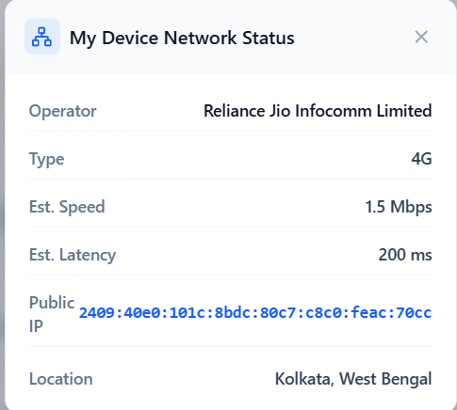

Tower Visuals( On clicking tower what it show )

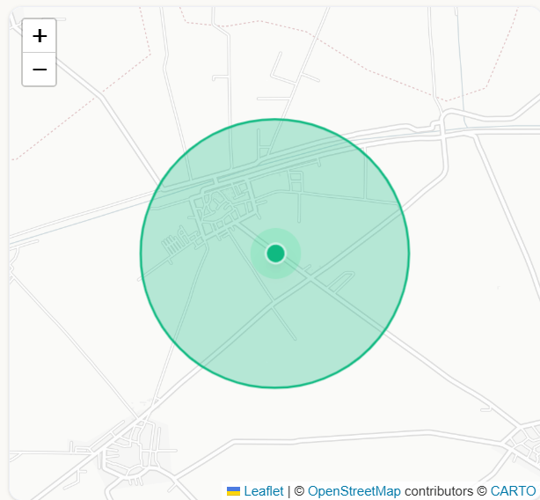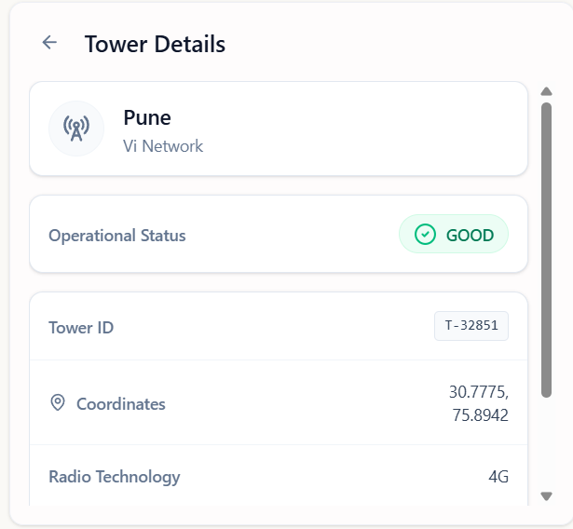

Tower Radius Tower Details

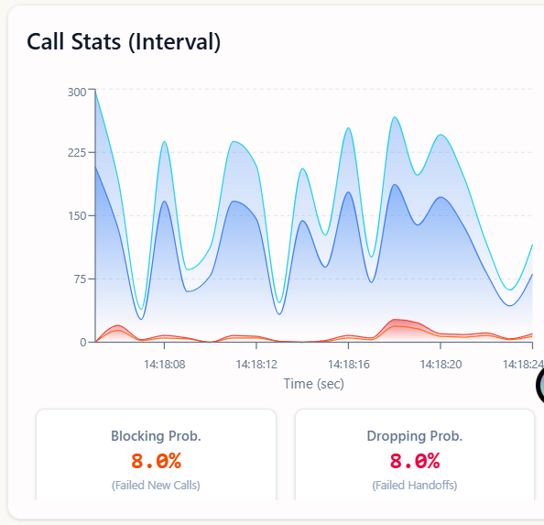

Call Stats
Annexure C: Core Source Code

File: server.js (Backend)

const express = require('express'); const http = require('http');
const cors = require('cors');
const { Server } = require('socket.io'); const fs = require('fs');
const path = require('path');
const csv = require('csv-parser'); require('dotenv').config();

const csvDataList = [];
fs.createReadStream(path.join( dirname, 'callstats_900.csv'))
.pipe(csv())
.on('data', (row) => csvDataList.push(row))
.on('end', () => console.log('Loaded new 900-row CSV for live simulation.'));

// Global states for Geographical Data Slicing engine let towerMappingInitialised = false;
const towerCursors = {};

const { initializeDatabase, pool } = require('./config/db');
// Removed: require('./models') since we dropped Sequelize

const app = express();
const server = http.createServer(app); const io = new Server(server, {
cors: {
origin: '*',
methods: ['GET', 'POST']
}
});

app.use(cors());
app.use(express.json({ limit: '50mb' }));
app.use(express.raw({ type: 'application/octet-stream', limit: '50mb' }));

// Import Routes
const towerRoutes = require('./routes/towers');
const speedTestRoutes = require('./routes/speedTests');
// Removed: const { Tower, Telemetry } = require('./models');

app.use('/api/towers', towerRoutes);
app.use('/api/speed-tests', speedTestRoutes);

// Basic health check
app.get('/api/health', (req, res) => {
res.json({ status: 'API is running' });
});

// Socket.io connection handling & Real-time Telemetry Simulator

io.on('connection', (socket) => {
console.log('New client connected:', socket.id);

// Real-time wow factor: Every 3 seconds, we broadcast random fluctuations
// for a random subset of towers to simulate live network traffic. const interval = setInterval(async () => {
try {
// Update all towers synchronously every 3 seconds so individual graphs tick perfectly seamlessly
const [towers] = await pool.query('SELECT * FROM Towers');

// 1. Array Slicing Initialization
if (!towerMappingInitialised && csvDataList.length > 0 && towers.length > 0)
{
const sliceSize = Math.floor(csvDataList.length / towers.length); let mappingText = "Network Architecture: Geographical Data Slicing
Map\n";
mappingText +=
"===================================================\n\n";
mappingText += "| Tower ID | Location | Operator | CSV Assigned Range |\n";
mappingText += "|----------|------------------|---------------|---------
- |\n";

towers.forEach((tower, i) => { const start = i * sliceSize;
// The last tower absorbs any remainder rows
const end = (i === towers.length - 1) ? csvDataList.length - 1 : (i
+ 1) * sliceSize - 1;
towerCursors[tower.id] = { startIndex: start, endIndex: end, currentOffset: 0 };

const tid = String(tower.id).padEnd(8);
const loc = String(tower.locationName).padEnd(16); const op = String(tower.operatorName).padEnd(13); const range = `[${start} to ${end}]`.padEnd(18);

mappingText += `| ${tid} | ${loc} | ${op} | ${range} |\n`;
});

fs.writeFileSync(path.join( dirname, 'tower_data_mapping.txt'), mappingText);
console.log("Successfully generated tower_data_mapping.txt for academic verification!");
towerMappingInitialised = true;
}

const updates = await Promise.all(towers.map(async (tower) => {
// 2. Localized Traversal let targetRow;
if (towerMappingInitialised && towerCursors[tower.id]) { const cursor = towerCursors[tower.id];
const absoluteIndex = cursor.startIndex + cursor.currentOffset; targetRow = csvDataList[absoluteIndex];

limit
// Advance the cursor for this specific tower; Loop seamlessly if hit

cursor.currentOffset++;
if (cursor.startIndex + cursor.currentOffset > cursor.endIndex) { cursor.currentOffset = 0;

}
} else {
targetRow = { 'Incoming Calls': 100, 'Answered Calls': 80 }; // Loading fallback
}

const incomingCalls = parseInt(targetRow['Incoming Calls'], 10) || 0; const callAccepted = parseInt(targetRow['Answered Calls'], 10) || 0; const callTotal = incomingCalls;
const callBlocked = Math.max(0, callTotal - callAccepted); const connectedUsers = 8432; // System default fixed amount

let responseTimeSecs = 0;
const speedStr = targetRow['Response Time'] || targetRow['Response Time ']
|| targetRow['Answer Speed (AVG)'];
if (speedStr && typeof speedStr === 'string') {
const p = speedStr.split(':').map(n => Number(n) || 0);
if (p.length === 3) responseTimeSecs = p[0]*3600 + p[1]*60 + p[2]; else if (p.length === 2) responseTimeSecs = p[0]*60 + p[1];
else responseTimeSecs = p[0];
}
if (responseTimeSecs <= 0) responseTimeSecs = Math.floor(Math.random() *
25) + 5; // fallback so it never shows 0s if CSV fails

// Save strictly required data to DB via raw SQL const [result] = await pool.execute(
`INSERT INTO Telemetries (towerId, callTotal, callAccepted, latency,
timestamp)
VALUES (?, ?, ?, ?, NOW())`,
[tower.id, callTotal, callAccepted, responseTimeSecs]
);

return {
towerId: tower.id, telemetry: {
id: result.insertId, towerId: tower.id, connectedUsers,
callTotal,
callAccepted, callBlocked,
timestamp: new Date()
}
};
}));

// Broadcast to all connected clients
socket.emit('telemetry_update', updates);

} catch (err) {
console.error('Simulation error:', err.message);
}
}, 3000);

socket.on('disconnect', () => {
console.log('Client disconnected:', socket.id); clearInterval(interval);
});
});
const PORT = process.env.PORT || 5000; async function startServer() {
// 1. Initialize DB (create it if missing) await initializeDatabase();

// Note: Table creation / syncing is now handled by seed.js, not Sequelize

// 3. Start Express
server.listen(PORT, () => {
console.log(`Server running on port ${PORT}`);
});
}

startServer();

module.exports = { app, io };

File: seed.js (Backend)

const fs = require('fs');
const path = require('path');
const csv = require('csv-parser');
const { pool } = require('./config/db');

async function importCSVFromLaptop() { const csvData = [];
const filepath = path.join( dirname, 'CallStats.csv'); console.log('Reading CallStats.csv file...');
fs.createReadStream(filepath)
.pipe(csv())
.on('data', (row) => { csvData.push(row);
})
.on('end', async () => {
console.log(`Successfully read ${csvData.length} rows. Pushing to Database...`);

try {
// Fetch valid tower IDs to map the stats realistically
const [towers] = await pool.query('SELECT id FROM Towers'); if (towers.length === 0) {
console.error('❌ No towers found in the database. Please insert
towers into database.sql first.');
process.exit(1);
}
const towerIds = towers.map(t => t.id);

rerun
// Clear the telemetries table so we don't have infinite duplicate rows on await pool.query('TRUNCATE TABLE Telemetries');

for (const row of csvData) {
// Parse values from CSV headers (CallStats.csv)
const incomingCalls = parseInt(row['Incoming Calls'], 10) || 0; const answeredCalls = parseInt(row['Answered Calls'], 10) || 0;
const abandonedCalls = parseInt(row['Blocked Calls'] || row['Abandoned Calls'], 10) || 0;

// Parse "Response Time " (e.g., "0:00:17") into total seconds for response time
const speedStr = row['Response Time '] || row['Answer Speed (AVG)'] ||

'0:00:00';

const speedParts = speedStr.split(':'); let responseTimeSecs = 0;
if (speedParts.length === 3) {
responseTimeSecs = parseInt(speedParts[0], 10) * 3600 +

parseInt(speedParts[1], 10) * 60 + parseInt(speedParts[2], 10);
}

// Pick a valid random tower ID
const towerId = towerIds[Math.floor(Math.random() * towerIds.length)];

await pool.execute(
`INSERT INTO Telemetries (towerId, callTotal, callAccepted, latency) VALUES (?, ?, ?, ?)`,
[towerId, incomingCalls, answeredCalls, responseTimeSecs]
);
}

console.log('✅ All CallStats.csv data cleanly imported!'); process.exit(0);
} catch (error) {
console.error('❌ Database Error:', error.message); process.exit(1);
}
});
}

importCSVFromLaptop();

File: App.jsx (Frontend)

import React, { useState, useEffect } from 'react'; import axios from 'axios';
import io from 'socket.io-client';

import Header from './components/Header'; import MapView from './components/MapView';
import MetricsGrid from './components/MetricsGrid'; import TowerList from './components/TowerList';
import TowerDetail from './components/TowerDetail';
import CallStatsChart from './components/CallStatsChart'; import SpeedTestModule from './components/SpeedTestModule';

const API_URL = import.meta.env.VITE_API_URL || 'http://localhost:5000'; const socket = io(API_URL);

function App() {
const [towers, setTowers] = useState([]);
const [selectedTower, setSelectedTower] = useState(null);
const [operatorFilter, setOperatorFilter] = useState('All Operators'); const [cityFilter, setCityFilter] = useState('All Cities');
const [globalMetrics, setGlobalMetrics] = useState({ onlineTowers: 0,
connectedUsers: 0,
avgDownload: 0,
avgUpload: 0,
avgLatency: 0
});

const fetchTowers = () => {
axios.get(`${API_URL}/api/towers`).then(res => { setTowers(res.data);
setGlobalMetrics(prev => ({ ...prev, onlineTowers: res.data.length }));

// Update selected tower if it exists if(selectedTower) {
const updatedSelected = res.data.find(t => t.id === selectedTower.id); if(updatedSelected) setSelectedTower(updatedSelected);
}
});
};

useEffect(() => {
// 1. Fetch initial towers fetchTowers();

// 2. Listen for real-time telemetry updates to dynamically evaluate logic socket.on('telemetry_update', (updates) => {
setTowers(prevTowers => {
const newTowers = [...prevTowers];

let needsUpdate = false;

updates.forEach(update => {
const towerIndex = newTowers.findIndex(t => t.id === update.towerId); if (towerIndex !== -1) {
const tel = update.telemetry;
const totalIncoming = tel.callTotal || 0;
const totalAnswered = tel.callAccepted || 0;

// Re-use our mathematical split
const answerRate = totalIncoming > 0 ? totalAnswered / totalIncoming :
1;
const incomingHandoff = totalIncoming * 0.3;
const answeredHandoff = Math.round(incomingHandoff * answerRate); const droppedHandoff = Math.max(0, Math.round(incomingHandoff) -
answeredHandoff);
const droppingProb = Math.min(1, Math.max(0, incomingHandoff > 0 ? droppedHandoff / incomingHandoff : 0));

// Dynamic Threshold Logic (Updated to User requirements) let newStatus = 'GOOD';
if (droppingProb > 0.10) newStatus = 'OFFLINE';
else if (droppingProb > 0.07) newStatus = 'DEGRADED';

newStatus };
// Check if status actually flipped
if (newTowers[towerIndex].status !== newStatus) {
newTowers[towerIndex] = { ...newTowers[towerIndex], status: needsUpdate = true;

// If the user happens to have this specific tower open, refresh their UI detail box immediately
setSelectedTower(currentSelected => {
if (currentSelected && currentSelected.id === update.towerId) { return { ...currentSelected, status: newStatus };
}
return currentSelected;
});
}
}
});

return needsUpdate ? newTowers : prevTowers;
});
});

// 3. Fake initial global metrics for design setGlobalMetrics({
onlineTowers: 30,
connectedUsers: 8432,
avgDownload: 45.5,
avgUpload: 12.2,
avgLatency: 42

});

return () => {
socket.off('telemetry_update');
};
}, []);

// Clear selection if it gets filtered out useEffect(() => {
if (selectedTower) {
const matchOp = operatorFilter === 'All Operators' || selectedTower.operatorName === operatorFilter;
const matchCity = cityFilter === 'All Cities' || selectedTower.locationName
=== cityFilter;
if (!matchOp || !matchCity) { setSelectedTower(null);
}
}
}, [operatorFilter, cityFilter, selectedTower]);

// Compute filtered towers for Map and List
const filteredTowers = towers.filter(tower => {
const matchOperator = operatorFilter === 'All Operators' || tower.operatorName
=== operatorFilter;
const matchCity = cityFilter === 'All Cities' || tower.locationName === cityFilter;
return matchOperator && matchCity;
});

return (
<div className="min-h-screen flex flex-col p-4 gap-4">
<Header
towers={towers}
operatorFilter={operatorFilter}
setOperatorFilter={setOperatorFilter} cityFilter={cityFilter}
setCityFilter={setCityFilter}
/>

<MetricsGrid metrics={globalMetrics} />

<div className="grid grid-cols-1 lg:grid-cols-3 gap-4 mb-4">

{/* Left Column: Map */}
<div className="glass-panel overflow-hidden relative h-[400px] lg:h- [450px]">
<MapView
towers={filteredTowers}
selectedTower={selectedTower}
onSelectTower={setSelectedTower}
/>
</div>

{/* Middle Column: Tower List or Details */}

<div className="glass-panel p-4 h-[400px] lg:h-[450px] flex flex-col">
{selectedTower ? (
<TowerDetail
tower={selectedTower}
onBack={() => setSelectedTower(null)}
/>
) : (
<>
<h2 className="text-xl font-semibold mb-4 text-white">Towers</h2>
<div className="flex-1 overflow-hidden">
<TowerList
towers={filteredTowers}
selectedTower={selectedTower}
onSelectTower={setSelectedTower}
/>
</div>
</>
)}
</div>

{/* Right Column: Tower Details / Call Stats */}
<div className="glass-panel p-4 h-[400px] lg:h-[450px] flex flex-col">
<h2 className="text-xl font-semibold mb-2 text-white">Call Stats (Interval)</h2>
<div className="flex-1 overflow-hidden">
{selectedTower ? (
<CallStatsChart towerId={selectedTower.id} />
) : (
<div className="h-full flex items-center justify-center text-

slate-500">

Select a tower to see stats
</div>
)}

</div>
</div>

</div>

{/* Bottom Full-width Row: Speed Test */}
<div className="w-full h-48 mb-4">
<SpeedTestModule />
</div>
</div>
);
}

export default App;
- References

Project Overview :-

# Cloud-Integrated Network Monitoring Dashboards Using IoT and Edge Analytics ,

International Journal of Scientific Research and Engineering Development-– Volume 8 Issue 5, Sep-Oct 2025 (2298 -2307)

# A Network Monitoring Systemfor High Speed Network Trafﬁc , Engin Zeyden , 2018

(https://www.researchgate.net/publication/309687688_A_Network_Monitoring_System_for_High_Speed_Network_Traffic)

# https://www.kaggle.com/datasets/satvicoder/call-center-data - Call stat dataset

# https://www.opencellid.org/ - Cell tower location

# https://react.dev/ - Frontend tool

THANK YOU !!

