Azure Cloud Fundamentals and Data Pipeline Implementation using ADF
Submission — Screenshots & Execution Summary
Name: Harsh Wardhan | Data Factory: week4adf | Resource Group: WEEK4-HKW | Storage Account: week4taskstorage
Objective
To understand Azure cloud concepts and build a complete data pipeline using a Storage Account and Azure Data Factory — moving Sample - Superstore.csv from Blob Storage through ADF into a destination file, with metadata validation and IAM access control.

Task 1: Explore Azure Portal & Create a Resource Group
- Explored the Azure Portal (search bar, service categories, Marketplace).
- Created resource group WEEK4-HKW under the Azure for Students subscription.
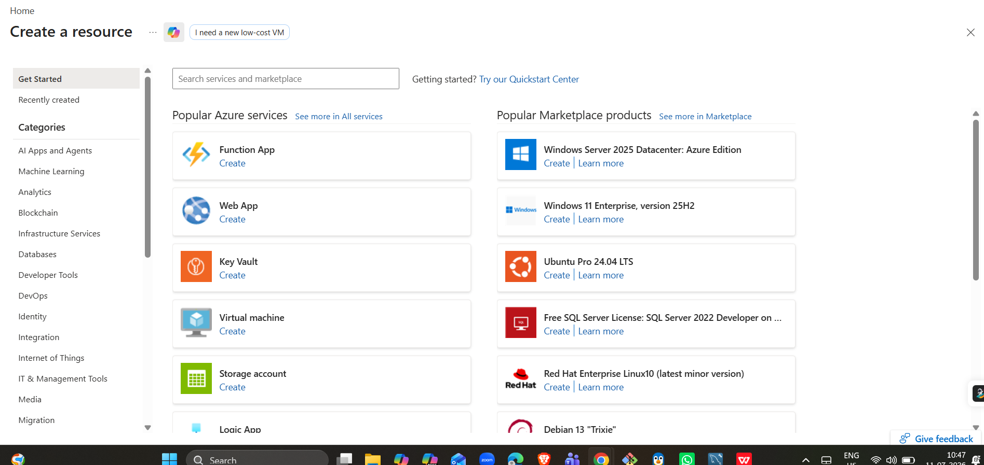
Exploring the Azure Portal's "Create a resource" screen and service catalog.
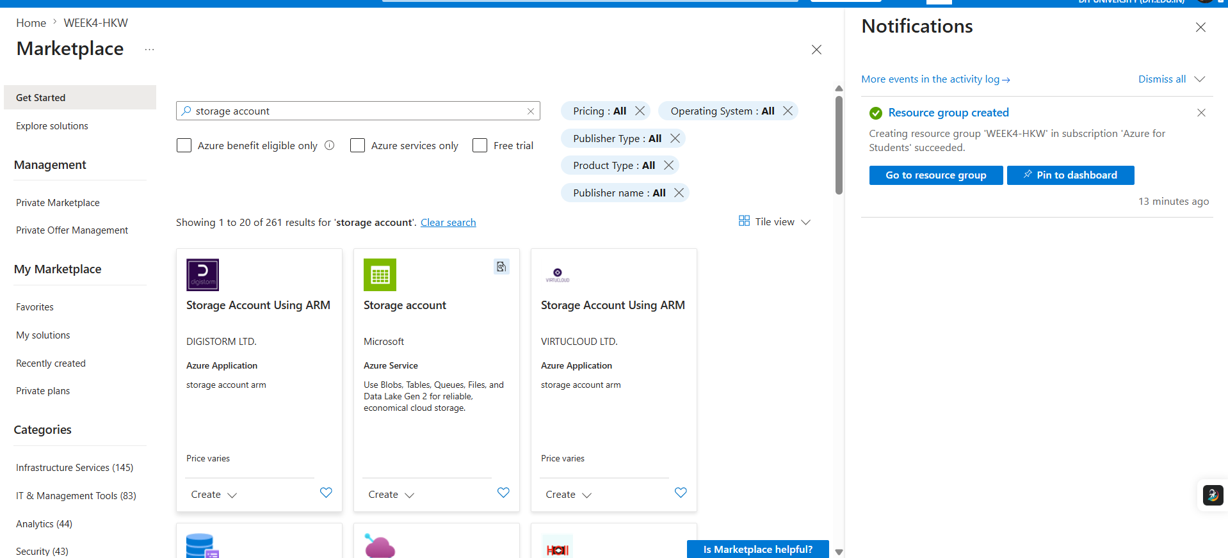
Resource group creation confirmed via the notifications panel.
✔ Deliverable: Screenshot of Resource Group
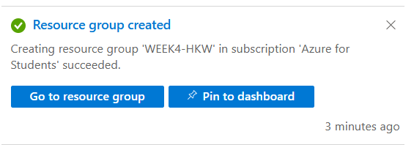
Resource group "WEEK4-HKW" created successfully in subscription "Azure for Students".

Task 2: Storage Setup
- Created storage account week4taskstorage (Standard performance, LRS redundancy, Central India region).
- Created blob container superstore.
- Uploaded Sample - Superstore.csv to the container.
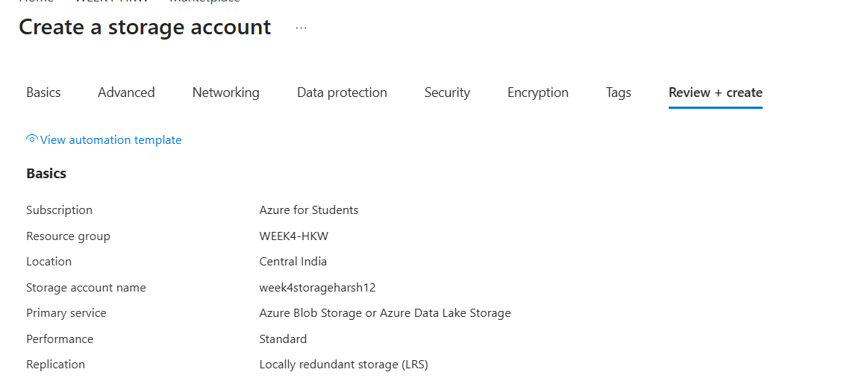
Storage account configuration reviewed before creation.
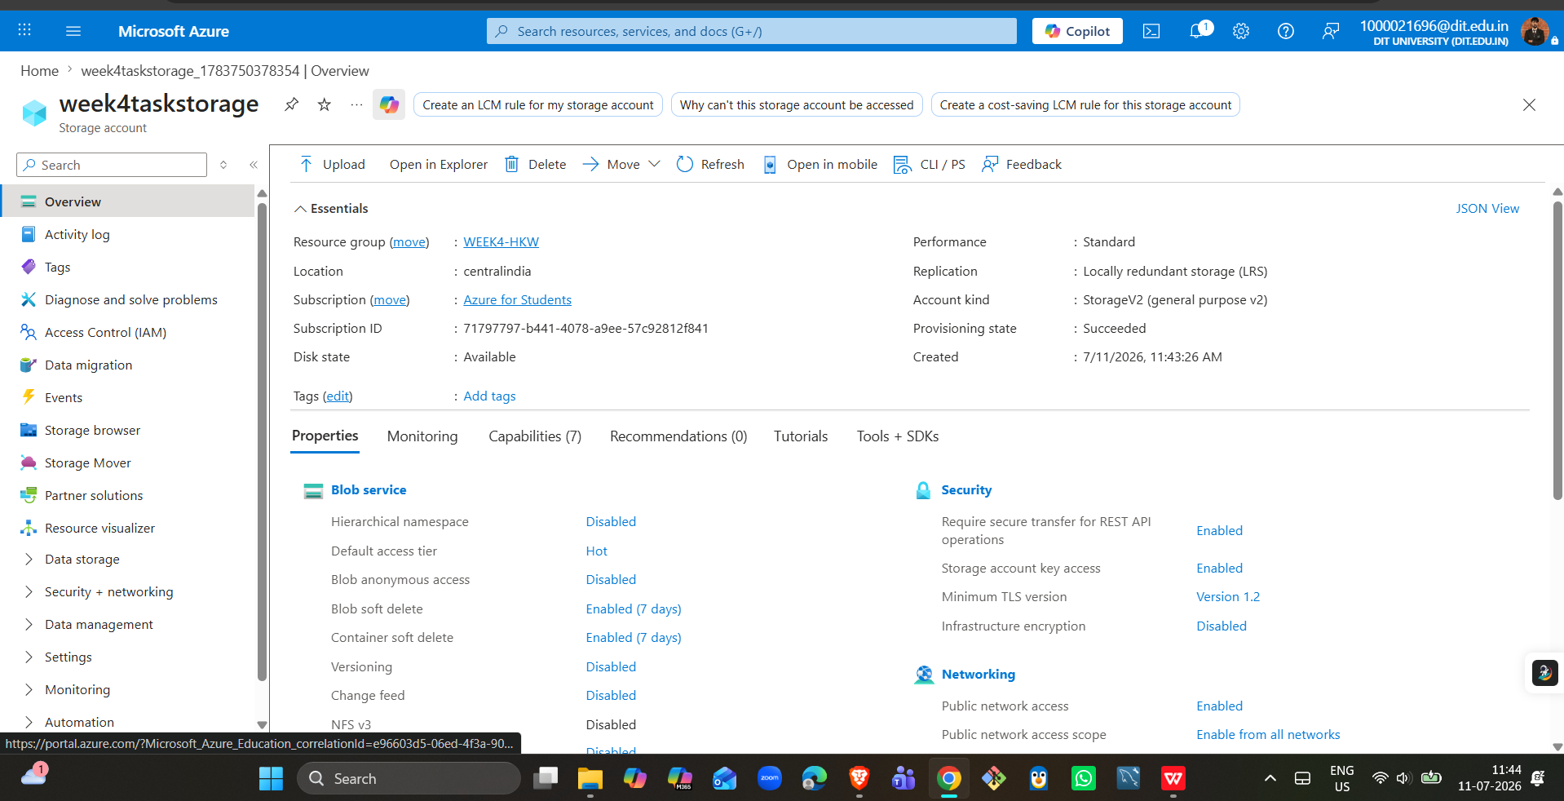
week4taskstorage overview - Standard performance, LRS replication, Central India.
✔ Deliverable: Screenshot of container with uploaded file
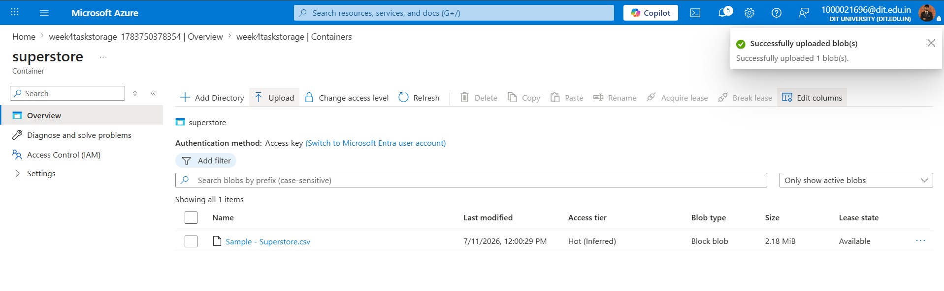
superstore container showing Sample - Superstore.csv successfully uploaded (2.18 MiB).

Task 3: ADF Basics
- Created Azure Data Factory week4adf (V2) in resource group WEEK4-HKW.
- Explored the ADF Studio UI (Author, Monitor, Manage).
- Created a Linked Service (AzureBlobStorage1) to connect ADF to Blob Storage.
- Created SourceDataset and DestinationDataset (DelimitedText / CSV).
- Configured a Get Metadata activity to validate file properties before copying.
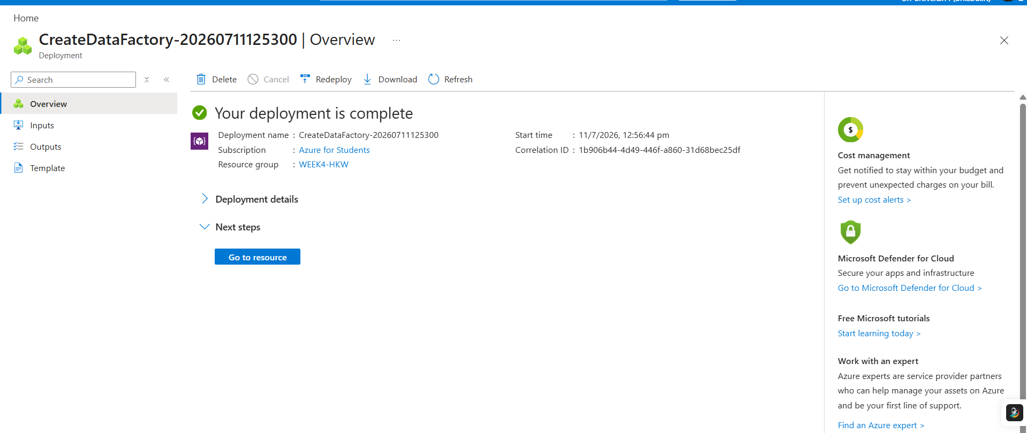
Azure Data Factory "week4adf" deployment completed successfully.
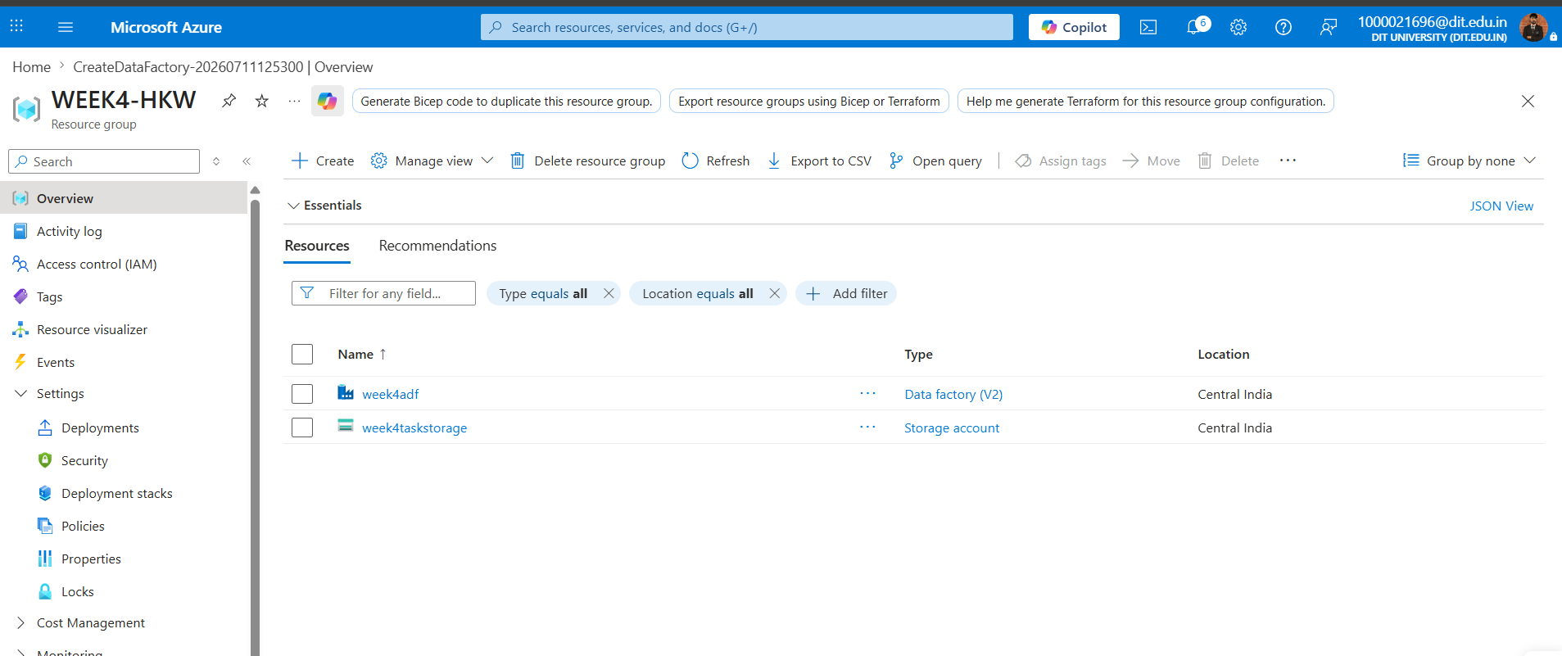
Resource group WEEK4-HKW showing both week4adf (Data factory V2) and week4taskstorage.
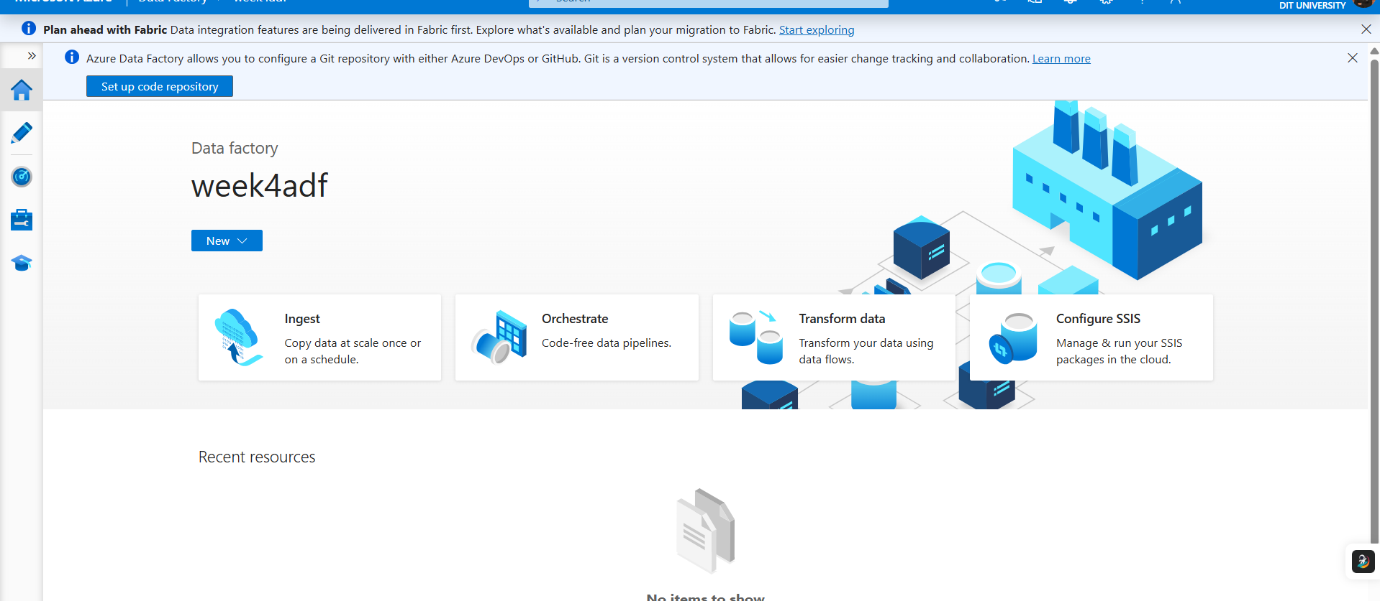
ADF Studio landing page for week4adf, showing Ingest, Orchestrate, Transform data, and Configure SSIS options.
✔ Deliverable: Screenshot of Linked Service
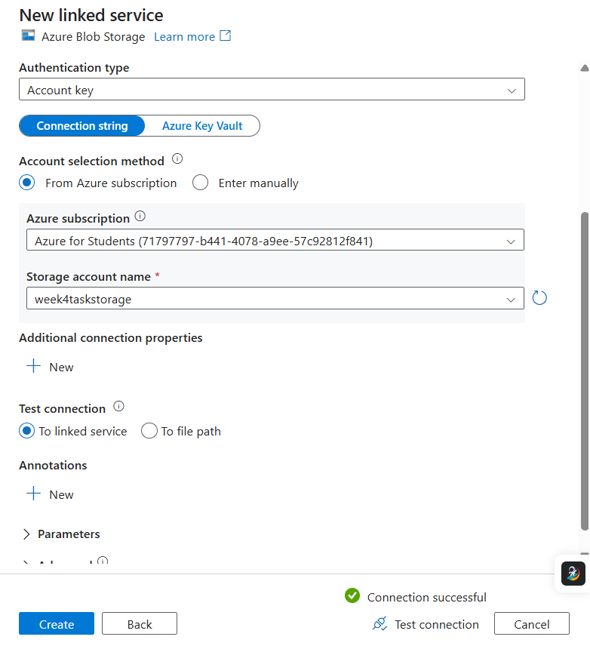
Azure Blob Storage linked service configured against week4taskstorage - connection test succeeded.
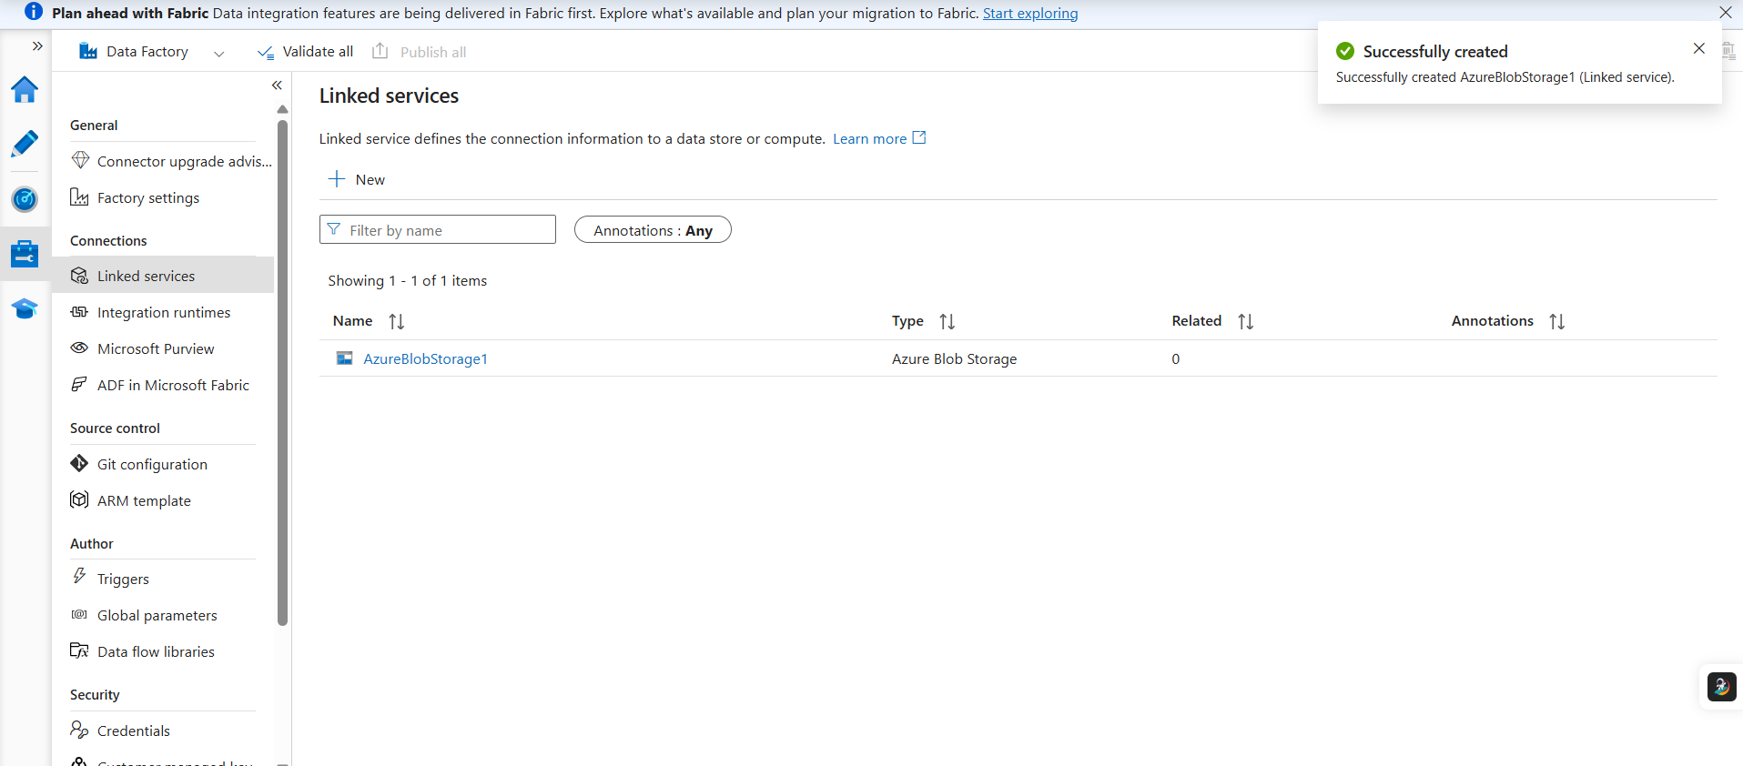
AzureBlobStorage1 linked service successfully created and listed under Manage > Linked services.
✔ Deliverable: Screenshot of dataset
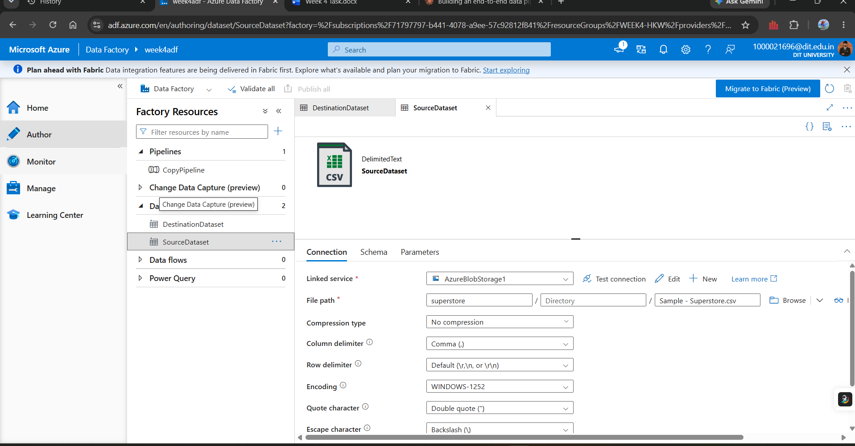
SourceDataset configured against container superstore, file Sample - Superstore.csv, with delimiter and quote/escape character settings.
✔ Deliverable: Screenshot of Get Metadata activity
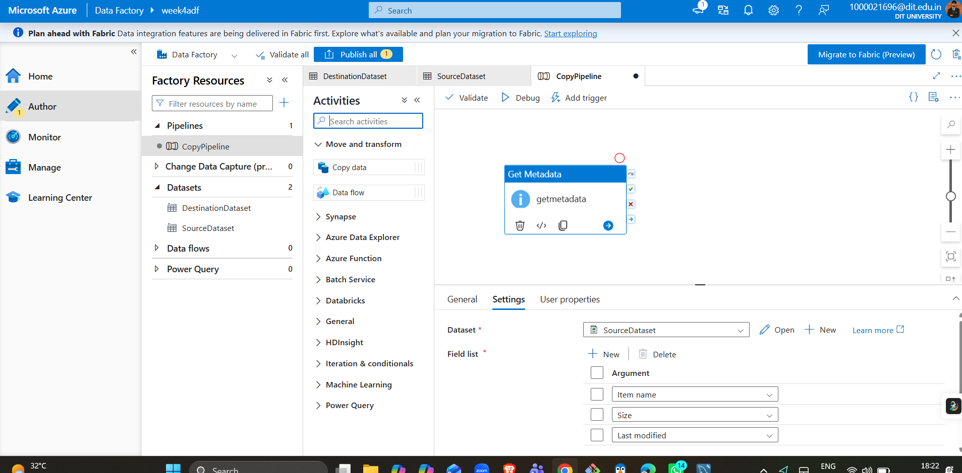
Get Metadata activity bound to SourceDataset, retrieving Item name, Size, and Last modified fields.

Task 4: Pipeline Development
- Built pipeline CopyPipeline using a Copy data activity.
- Connected Get Metadata -> Copy data with an On Success dependency.
- Configured Source = SourceDataset and Sink = DestinationDataset.
- Imported schema mapping for all 21 Superstore columns.
✔ Deliverable: Screenshot of pipeline design
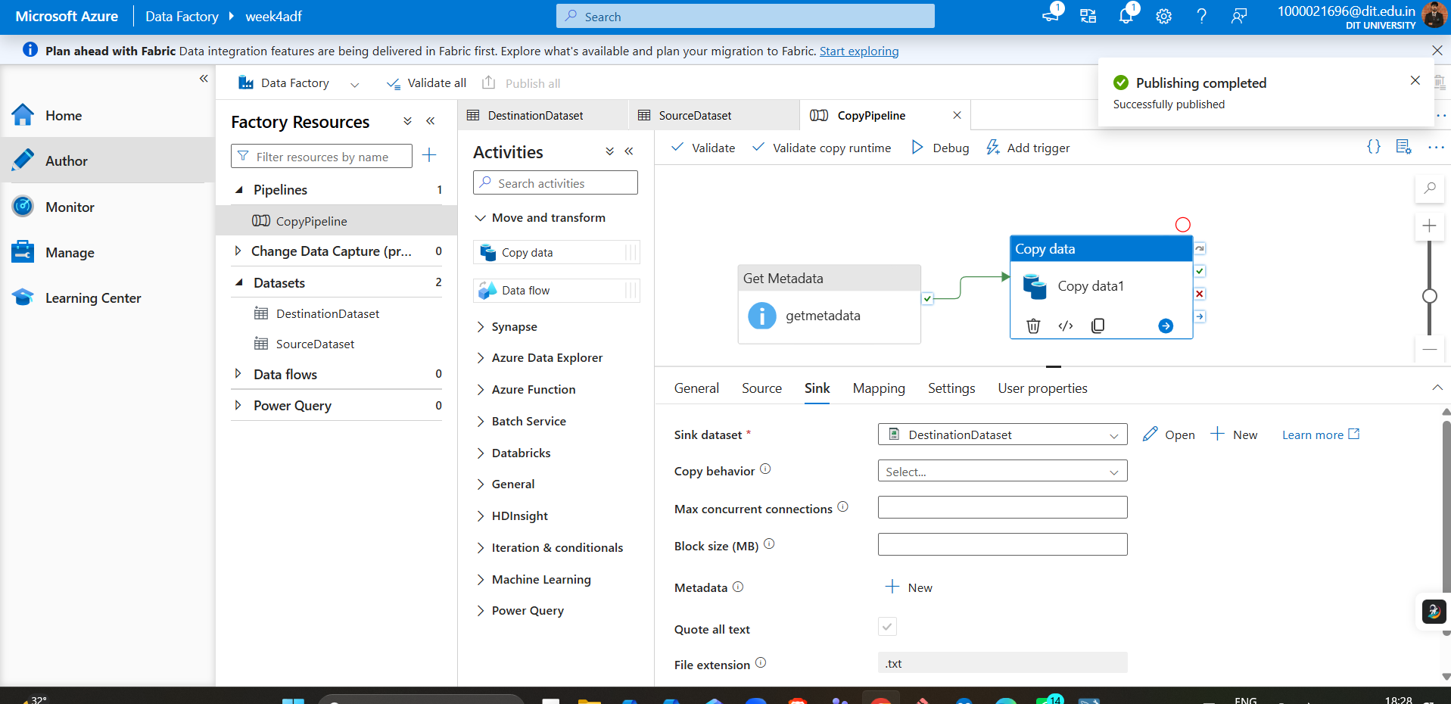
CopyPipeline canvas: Get Metadata connected to Copy data, Sink dataset = DestinationDataset, published successfully.
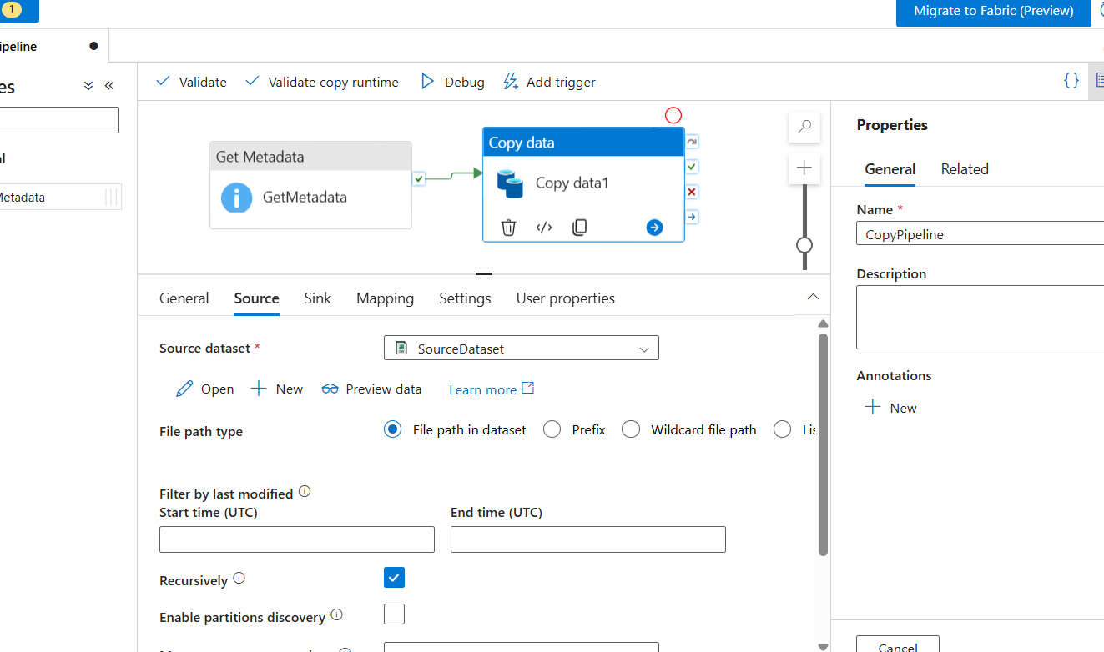
Copy data activity Source tab, bound to SourceDataset.
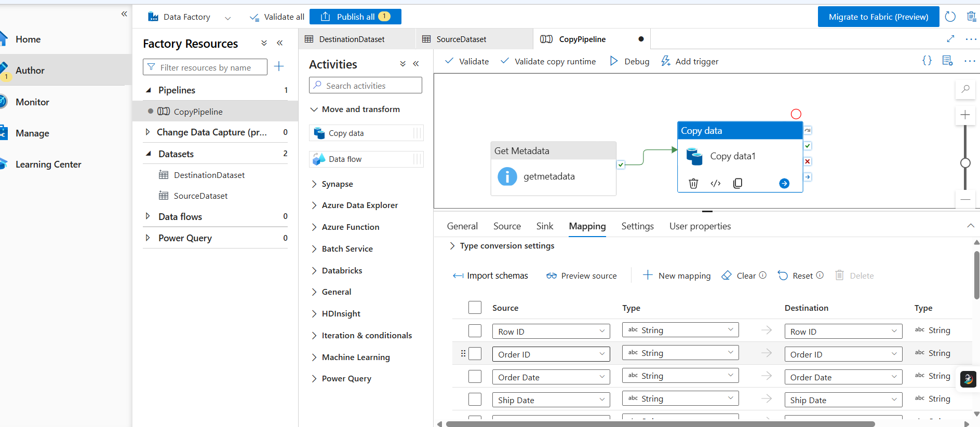
Column mapping auto-generated via Import schemas, aligning all Superstore fields (Row ID, Order ID, Order Date, etc.) between source and destination.

Task 5: Pipeline Execution
- Ran the pipeline in Debug mode.
- Encountered and resolved a DelimitedTextMoreColumnsThanDefined parsing error (see Troubleshooting note below).
- Confirmed successful execution in both the pipeline Output panel and the Monitor tab.
✔ Deliverable: Screenshot showing pipeline execution (Succeeded)
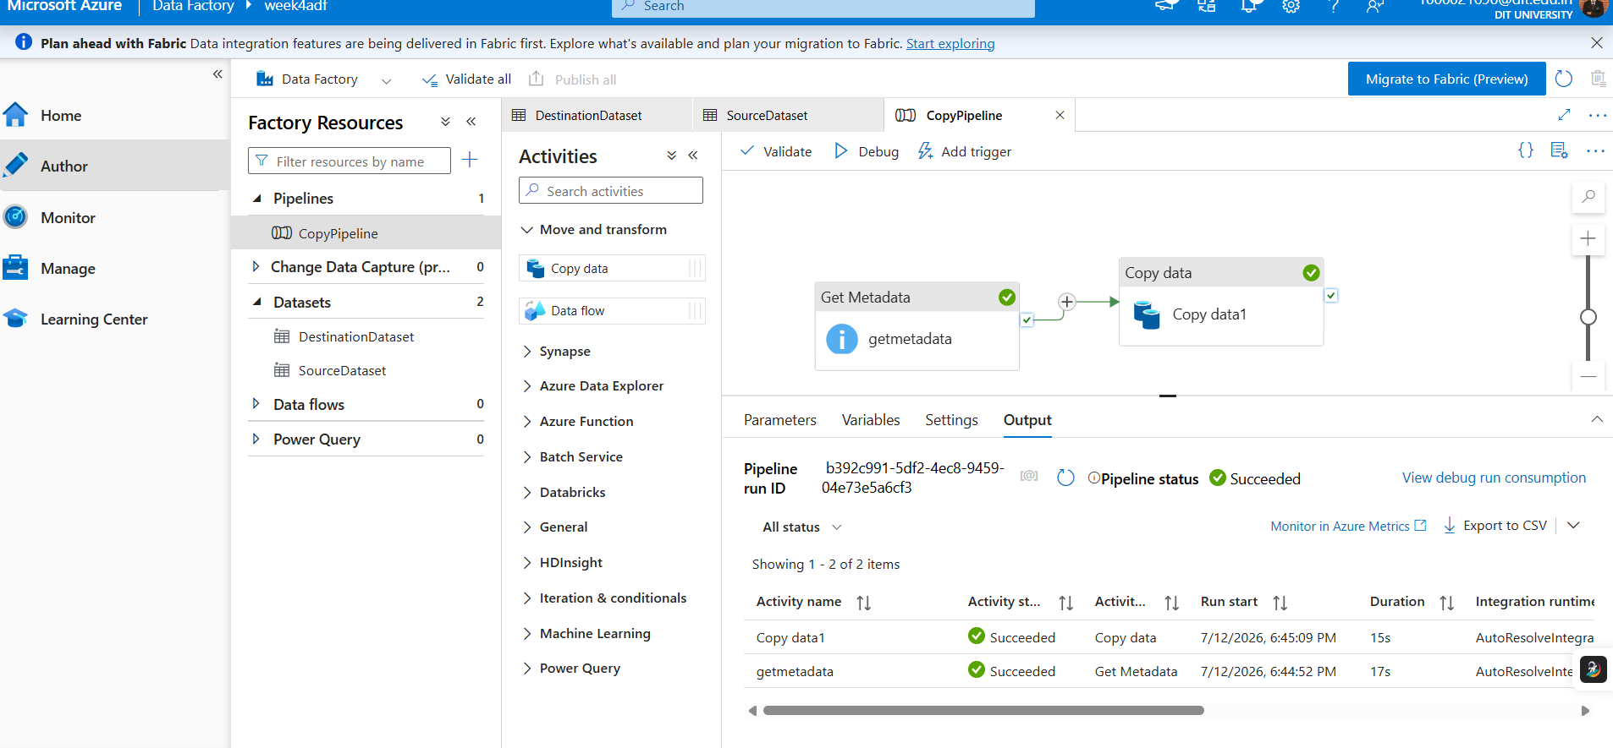
Pipeline run output: getmetadata and Copy data1 both Succeeded; overall Pipeline status = Succeeded.
Monitor > Pipeline runs confirming CopyPipeline completed in 41s via manual trigger, Status = Succeeded.
Troubleshooting note: The first pipeline run failed with ErrorCode=DelimitedTextMoreColumnsThanDefined at row 34, because several product names in the CSV contain escaped double quotes (e.g. 14 7/8"" x 11""). The fix was setting the SourceDataset's Escape character to "Quote character (\")" instead of "No escape character" or "Backslash", matching the file's standard CSV quoting convention. After republishing, the pipeline ran successfully.

Task 6: IAM Roles
- Assigned Reader role to my account on week4taskstorage.
- Assigned Contributor role to my account on week4taskstorage.
- Granted the week4adf managed identity the Storage Blob Data Contributor role, enabling keyless access between ADF and Storage.
✔ Deliverable: Screenshot of role assignment
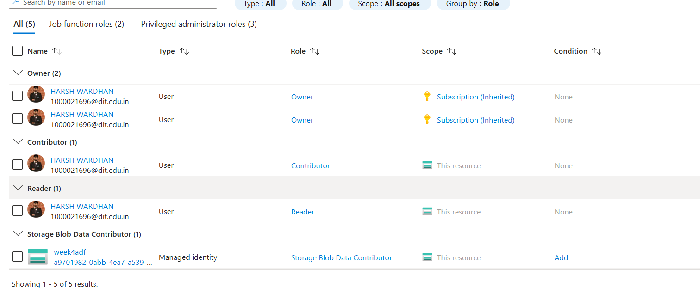
Access Control (IAM) > Role assignments on week4taskstorage - Owner (inherited), Contributor, Reader for Harsh Wardhan, and Storage Blob Data Contributor for the week4adf managed identity, all in one view.
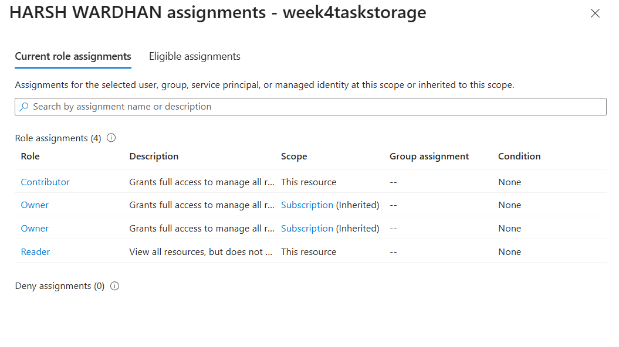
Per-user view confirming Harsh Wardhan holds Contributor and Reader (plus inherited Owner) on week4taskstorage.
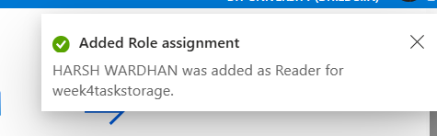
Reader role assignment confirmed for Harsh Wardhan on week4taskstorage.
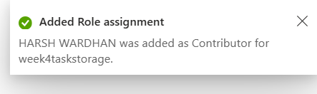
Contributor role assignment confirmed for Harsh Wardhan on week4taskstorage.
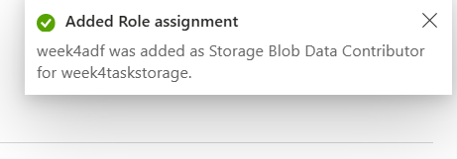
Storage Blob Data Contributor role assigned to the week4adf managed identity, granting ADF secure access to Blob Storage.

Mini Project: End-to-End CSV Pipeline
Problem Statement
Build a complete pipeline that reads Sample - Superstore.csv from Blob Storage and processes it using Azure Data Factory.
Requirements met
- Source: Sample - Superstore.csv in the superstore blob container.
- Linked Service + Dataset + Pipeline: AzureBlobStorage1, SourceDataset/DestinationDataset, CopyPipeline.
- Process: Get Metadata (validation) followed by Copy Data.
- Destination: output.csv written to the same container.
✔ Deliverable: Pipeline executed successfully; data copied to destination; metadata validated
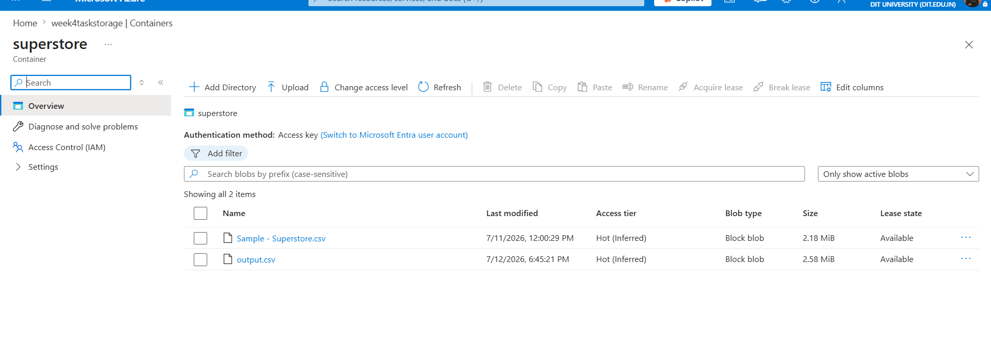
superstore container after pipeline execution, showing the original Sample - Superstore.csv alongside the newly created output.csv.

Summary
In this lab, I provisioned a resource group (WEEK4-HKW) and storage account (week4taskstorage), uploaded Sample - Superstore.csv to a blob container, and built an Azure Data Factory pipeline (CopyPipeline in week4adf) using a Get Metadata activity followed by a Copy Data activity. I connected ADF to Storage via a linked service and, for least-privilege access, granted ADF's managed identity the Storage Blob Data Contributor role. During execution I diagnosed and fixed a delimited-text parsing error caused by escaped quotes in product names, after which the pipeline validated the source file's metadata and successfully copied it to output.csv in the destination container. I also assigned Reader and Contributor IAM roles to practice Azure access control end-to-end.

