WEEK 3 INTERNSHIP REPORT
Exploratory Data Analysis and Visualization
Virtual Data Analysis Intern – E-Governance & Digital Services
Submitted by: Harsh Kirar
Datasets: Government of India eTaal – NSAP and Sarathi
Project Repository: github.com/harsh25-web/e-governance-data-analysis

This report presents a structured exploratory analysis of publicly available e-governance transaction data. The work continues the data collection and cleaning activities completed in Week 2.

Table of Contents
1. Executive Summary
2. Task Objective and Scope
3. Background: E-Governance and Digital Services
4. Dataset Description
5. Data Preparation and Quality Checks
6. EDA Methodology
7. Descriptive Statistics
8. Visualization 1 – NSAP Top 10
9. Visualization 2 – Sarathi Top 10
10. Visualization 3 – NSAP vs Sarathi
11. Visualization 4 – Mean vs Median
12. Comparative Analysis
13. Key Findings and Interpretation
14. Limitations and Assumptions
15. Recommendations for Further Analysis
16. Reproducibility and Tools
17. Conclusion
18. References

1. Executive Summary
This Week 3 project performs Exploratory Data Analysis (EDA) and visualization on two public e-governance datasets collected and cleaned during Week 2. The selected datasets are National Social Assistance Programme (NSAP) and Sarathi. The primary variable used for analysis is the State/UT-level electronic transaction count.
The analysis has four major purposes: understand the overall distribution of the data, identify States/UTs with higher and lower recorded transaction activity, compare the two services, and communicate observations through clear visualizations. The work uses descriptive statistics, ranking, a common-State/UT comparison and a simple correlation analysis.
The results show substantial variation in transaction activity across States/UTs. The highest transaction values are concentrated in a smaller number of records, which also causes the mean to be higher than the median. The NSAP and Sarathi rankings are not identical, showing that usage patterns can differ by digital service.
An important interpretation rule is followed throughout this report: transaction count is treated as a measure of recorded electronic activity only. It is not independently sufficient to measure service quality, efficiency, citizen satisfaction or adoption rate because population, service coverage, reporting practices and time dimensions are not included in these tables.

2. Task Objective and Scope
The Week 3 task asks for exploratory analysis of a suitable public e-governance dataset and at least four distinct visualizations.

2.1 Objectives
- Understand the structure and distribution of the selected data.
- Calculate descriptive statistics such as mean, median, minimum and maximum.
- Identify high-activity and low-activity State/UT records.
- Compare electronic transaction activity across two digital government services.
- Create four distinct visualizations that communicate patterns clearly.
- Document assumptions, limitations and the analysis workflow.

2.2 Scope
The scope is limited to the cleaned State/UT transaction tables prepared from public eTaal data. No personal information, citizen-level records or confidential government records are used.

2.3 Expected Deliverable
The deliverable is a structured DOCX report containing the EDA process, statistics, visualizations, interpretation, limitations and reproducibility information.

3. Background: E-Governance and Digital Services
E-governance refers broadly to the use of digital technologies and information systems to deliver, manage and monitor public services. Digital transaction records can provide useful operational evidence because they show the volume of recorded electronic activity associated with a service.
For this project, State/UT-level transaction counts are useful for exploratory comparison. A high count can indicate that a large amount of electronic activity was recorded for a service in the selected table. However, the number may also be influenced by population size, number of eligible users, service availability, administrative processes and the way transactions are recorded.

3.1 Why EDA is useful
- EDA helps detect unusual or extreme values before deeper analysis.
- It provides a quick understanding of central tendency and spread.
- Visualizations make large State/UT tables easier to interpret.
- Comparisons can generate questions for later investigation.
- EDA helps decide which additional variables or datasets should be collected.

3.2 Analytical Question
The central question for this report is: What patterns of recorded electronic transaction activity can be observed across States/UTs in the NSAP and Sarathi datasets, and how do the two services compare?

4. Dataset Description

4.1 NSAP Dataset
The NSAP working dataset contains 30 State/UT records. The main analytical field is `NSAP Transactions`, representing recorded electronic transaction activity in the collected table.

4.2 Sarathi Dataset
The Sarathi working dataset contains 37 State/UT records. The main analytical field is `Sarathi Transactions`, representing recorded electronic transaction activity in the collected table.

4.3 Data Dictionary
Field | Type | Meaning | Use in EDA
State/UT | Text | Name of State or Union Territory | Grouping and comparison
NSAP Transactions | Integer | Recorded NSAP electronic transactions | Ranking/statistics
Sarathi Transactions | Integer | Recorded Sarathi electronic transactions | Ranking/statistics

4.4 Data Source
The datasets were collected from publicly available Government of India eTaal service information and organized into CSV working files during Week 2. The project repository contains the cleaned CSV files and documentation.

5. Data Preparation and Quality Checks
Before performing EDA, the working tables were checked for basic data quality. These checks reduce the risk of incorrect statistics caused by formatting problems.
- State/UT names were treated as text labels and unnecessary whitespace was removed.
- Transaction fields were treated as numeric values.
- Blank key values were checked.
- Exact duplicate records were checked.
- Negative transaction counts were checked and were not expected in the working data.
- Both datasets were reviewed for consistent column structure.
- Common State/UT names were matched before the cross-service comparison.

5.1 Quality-check result
The working tables used for this report contain valid State/UT labels and non-negative transaction counts. The analysis uses the cleaned versions prepared for the internship workflow.

5.2 Analytical caution
A cleaned dataset can still contain contextual limitations. Data cleaning improves technical consistency, but it does not automatically resolve differences in service coverage, reporting period, population size or administrative practice.

6. EDA Methodology
The analysis followed a simple and reproducible sequence:
1. Load the cleaned NSAP and Sarathi CSV tables.
2. Inspect record counts and column types.
3. Calculate mean, median, minimum and maximum transaction values.
4. Rank State/UT records by transaction count.
5. Select the top ten records for service-specific visualizations.
6. Merge the two datasets using common State/UT names.
7. Create a scatter plot to examine the relationship between the two transaction variables.
8. Compare mean and median to understand skewness.
9. Document observations without treating correlation as causation.

6.1 Tools
- Python
- Pandas
- Matplotlib
- Microsoft Word
- CSV files
- GitHub
- Government of India eTaal public data

7. Descriptive Statistics
Measure | NSAP | Sarathi
Records | 30 | 37
Mean | 19,045,304 | 5,959,751
Median | 11,109,492 | 2,906,320
Minimum | 249 | 12,001
Maximum | 102,266,664 | 31,645,210
NSAP mean: 19,045,304; median: 11,109,492. Sarathi mean: 5,959,751; median: 2,906,320.
For both datasets, the mean is affected by relatively high transaction values. This is why the median is also important when describing a distribution with large differences between States/UTs.

7.1 Highest and lowest observations
- NSAP highest recorded value: Bihar (102,266,664).
- NSAP lowest recorded value: Goa (249).
- Sarathi highest recorded value: Maharashtra (31,645,210).
- Sarathi lowest recorded value: Lakshadweep (12,001).

8. Visualization 1 – NSAP Top 10
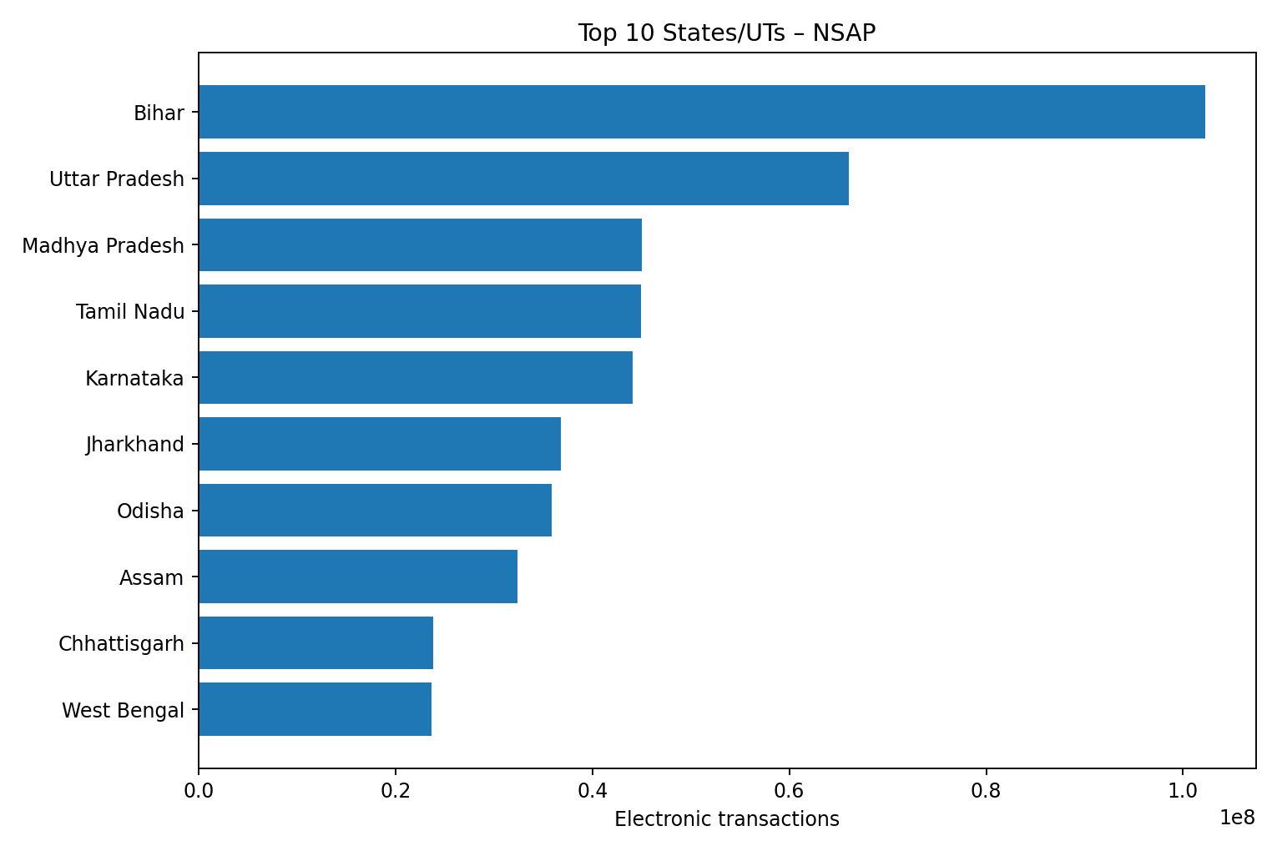
Figure 1: Top ten State/UT records by NSAP electronic transaction count.
This visualization ranks the ten largest NSAP transaction counts. Ranking is useful because it immediately identifies the records contributing the largest observed transaction activity in the table. The chart also makes the difference between the largest values easier to see than a raw table.

8.1 Interpretation
- The top group contains a relatively small number of high-activity records.
- The largest NSAP observation is Bihar in the collected working table.
- Uttar Pradesh, Karnataka, Madhya Pradesh and Tamil Nadu also appear among the high-activity records.
- The ranking should not be interpreted as a ranking of service quality or citizen satisfaction.

9. Visualization 2 – Sarathi Top 10
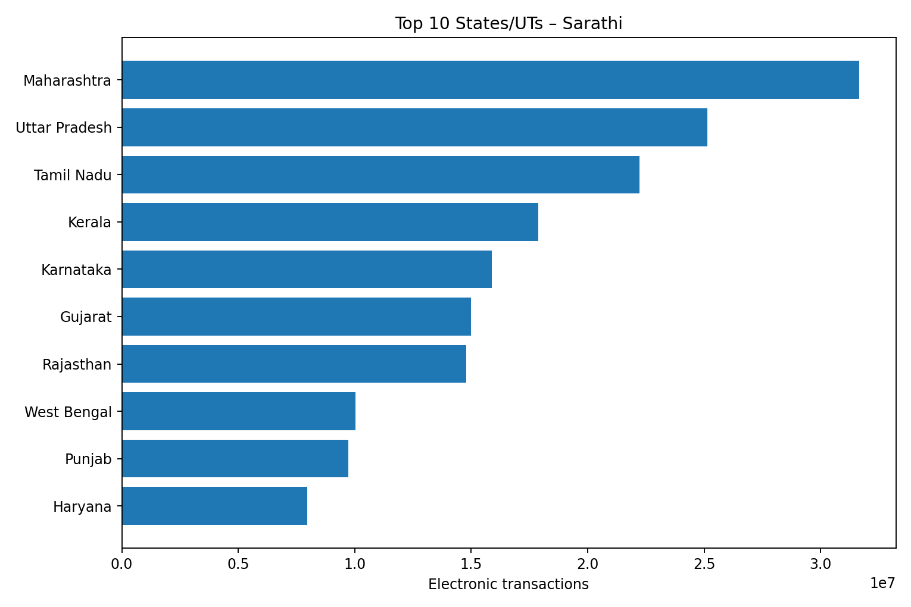
Figure 2: Top ten State/UT records by Sarathi electronic transaction count.
The Sarathi chart applies the same ranking method to the second service. Comparing the two ranking charts helps show that different government digital services can have different geographic patterns of recorded activity.

9.1 Interpretation
- Maharashtra has the largest Sarathi transaction count in the collected table.
- Karnataka, Tamil Nadu, Uttar Pradesh and Kerala are also among the higher-activity records.
- The Sarathi ranking differs from the NSAP ranking.
- Different service requirements and user groups can contribute to different transaction patterns.

10. Visualization 3 – NSAP vs Sarathi
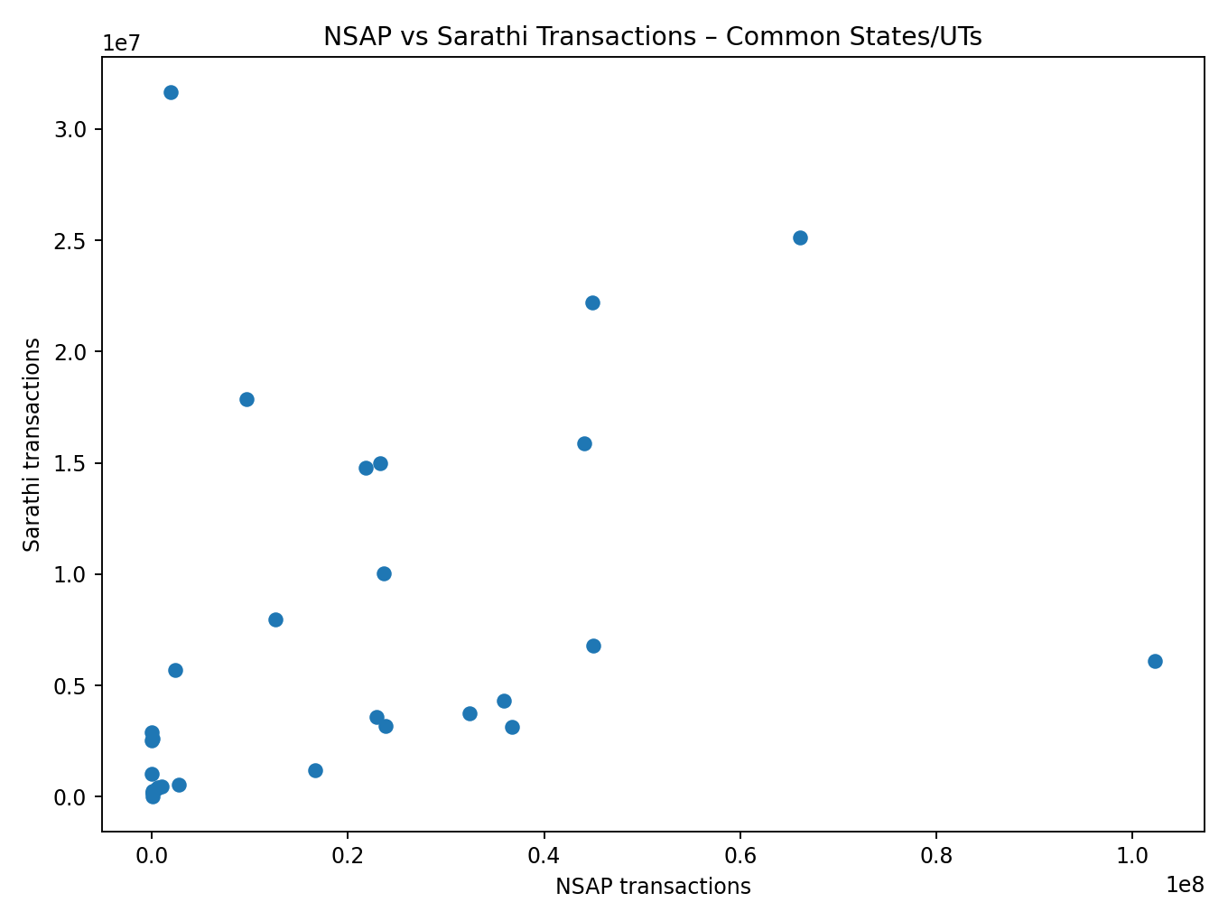
Figure 3: Scatter plot of NSAP and Sarathi transaction counts for State/UTs present in both datasets.
The two tables were merged using State/UT as the common key. The resulting comparison contains 30 common State/UT records. The Pearson correlation calculated from these observations is approximately 0.36.

10.1 Interpretation
A positive correlation would indicate that higher NSAP counts tend to be associated with higher Sarathi counts in these observations. The correlation value is descriptive only. It does not prove that one service causes the other, and it may be influenced by factors such as population size or the overall scale of a State/UT.

10.2 Why a scatter plot was selected
A scatter plot is appropriate for comparing two numeric variables across the same observations. It helps identify whether the observations generally move together and whether some records appear far from the overall pattern.

11. Visualization 4 – Mean vs Median
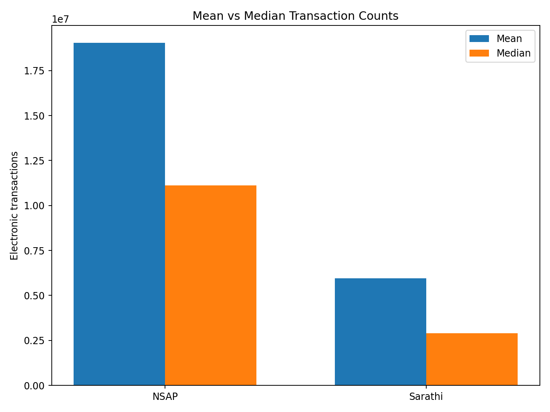
Figure 4: Comparison of mean and median transaction counts for the two datasets.
The mean is sensitive to very large observations, whereas the median represents the middle observation after sorting. The gap between the two measures provides a simple indication that the distributions are not perfectly symmetric.

11.1 Interpretation
- High transaction values increase the mean.
- The median provides a more robust description of the typical middle observation when the distribution is skewed.
- Both measures should be reported together for this type of State/UT transaction data.
- Further distribution plots such as histograms or box plots could provide additional detail.

12. Comparative Analysis
The following observations emerge when NSAP and Sarathi are considered together.

12.1 Difference in ranking
The highest-activity States/UTs are not identical for the two services. This means a single service-level pattern should not automatically be generalized to all e-governance services.

12.2 Difference in scale
The numerical scale of transaction activity is different across the datasets. Therefore, direct comparison of raw counts should be made carefully and within the context of each service.

12.3 Common-State comparison
The merged analysis includes 30 State/UT records that occur in both working tables. The correlation of approximately 0.36 provides a compact summary of association between the two variables.

12.4 Need for normalization
For a stronger geographic comparison, future work could divide transaction counts by population, number of eligible users, service centers, or another relevant denominator. Such normalization is outside the current dataset.

13. Key Findings and Interpretation
- The NSAP dataset contains 30 State/UT records, while Sarathi contains 37 records.
- The largest NSAP transaction count in the working table is Bihar with 102,266,664.
- The largest Sarathi transaction count in the working table is Maharashtra with 31,645,210.
- Transaction activity varies substantially between State/UT records.
- The mean is higher than the median in both datasets, consistent with the presence of high-value observations.
- The top ten rankings differ between NSAP and Sarathi, indicating service-specific geographic patterns.
- The common-State/UT correlation is approximately 0.36; this is an association, not a causal result.
- Raw transaction counts should not be used alone to judge efficiency, quality or citizen experience.

13.1 Questions generated by EDA
- Are higher transaction counts mainly explained by population size?
- Do transaction counts change significantly over time?
- Are there differences between rural and urban service usage?
- Do service processing times vary across States/UTs?
- Are there regional differences after population normalization?
- What additional service-level KPIs are available for a deeper evaluation?

14. Limitations and Assumptions
- The analysis uses State/UT-level aggregate transaction counts rather than citizen-level records.
- Population and eligible-user denominators are not included.
- Time-series information is not the main focus of the current tables.
- Different services may have different coverage, workflows and user groups.
- Transaction volume is not equivalent to service quality.
- Correlation does not demonstrate causation.
- External factors can influence transaction activity and should be investigated before operational decisions are made.

14.1 Assumptions
- Transaction fields are interpreted as recorded electronic transaction counts.
- State/UT names are treated as the geographic grouping key.
- The cleaned Week 2 datasets are suitable for descriptive analysis.
- Missing contextual variables are not estimated or invented.

15. Recommendations for Further Analysis
The current EDA can be extended when additional public variables become available.
- Add time-series data to study monthly or yearly trends.
- Normalize transaction counts by population or eligible beneficiaries/users.
- Compare service processing time and transaction volume.
- Add district-level data where appropriate and publicly available.
- Create interactive dashboards in Power BI or Tableau.
- Use box plots and histograms to study distribution and outliers.
- Perform service-wise segmentation and cluster States/UTs using multiple indicators.
- Validate important findings against official documentation and metadata.

15.1 Suggested dashboard indicators
- Total electronic transactions
- Median transaction count
- Top and bottom activity records
- Service-wise comparison
- State/UT filters
- Time trend, if date fields become available
- Population-normalized transaction rate, if population data is added

16. Reproducibility and Tools
The report is designed so another learner can reproduce the analysis using the cleaned CSV files stored in the project repository. The basic process is to load the CSV files, calculate descriptive statistics, rank the values, merge common State/UT records, and recreate the four charts.

16.1 Repository contents
- README.md – project overview.
- nsap_data.csv – cleaned NSAP working data.
- sarathi_data.csv – cleaned Sarathi working data.
- data_cleaning_log.md – Week 2 cleaning notes.
- Week 2 report – documentation of collection and cleaning.

16.2 Software
- Python with Pandas for data handling
- Matplotlib for charts
- Microsoft Word for report preparation
- GitHub for project documentation

16.3 Reproduction sequence
1. Download the two CSV files from the repository.
2. Read the files into a data-analysis environment.
3. Check data types and missing values.
4. Calculate mean, median, minimum and maximum.
5. Sort each dataset and select the top ten records.
6. Merge on State/UT for the common comparison.
7. Generate the four visualizations.
8. Review interpretations together with dataset limitations.

17. Conclusion
This Week 3 exploratory analysis demonstrates how cleaned public e-governance data can be converted into useful descriptive information through statistics and visualization. The NSAP and Sarathi datasets show considerable variation in recorded electronic transaction activity across States/UTs.
The four visualizations provide complementary perspectives: two rankings identify high-activity records, the scatter plot compares the two services, and the mean-versus-median chart highlights distribution characteristics. Together, these views help transform a basic transaction table into an interpretable analytical story.
The analysis also demonstrates the importance of responsible interpretation. Transaction volume alone cannot establish service quality or citizen experience. Future work should incorporate time, population, service coverage and other relevant indicators before drawing stronger conclusions.

18. References
1. Government of India – eTaal, Electronic Transaction Aggregation & Analysis Layer: https://etaal.gov.in/
2. Project GitHub repository: https://github.com/harsh25-web/e-governance-data-analysis
3. Week 2 cleaned NSAP and Sarathi working datasets prepared for this internship.

Appendix A – Selected Data Snapshot
State/UT | NSAP | Sarathi
Bihar | 102,266,664 | 6,102,187
Uttar Pradesh | 66,085,063 | 25,137,454
Madhya Pradesh | 45,034,149 | 6,791,134
Tamil Nadu | 44,907,865 | 22,213,272
Karnataka | 44,117,830 | 15,891,777
Jharkhand | 36,758,460 | 3,148,613
Odisha | 35,879,879 | 4,329,644
Assam | 32,355,652 | 3,740,675
Chhattisgarh | 23,857,156 | 3,194,308
West Bengal | 23,667,320 | 10,022,528
Gujarat | 23,272,474 | 14,984,435
Andhra Pradesh | 22,877,647 | 3,592,560

Appendix B – Interpretation Note
All numerical findings in this report describe the supplied working tables. They should be read together with the source metadata and reporting context. The report intentionally avoids treating raw transaction counts as standalone measures of effectiveness.

