WEEK 4: STATISTICAL ANALYSIS OF E-GOVERNANCE PERFORMANCE
Virtual Data Analysis Internship – E-Governance & Digital Services
Prepared by: Harsh Kirar
Dataset: Simulated educational dataset (30 observations)

1. Introduction and Objectives
This report demonstrates statistical analysis of digital public service performance using three indicators: service efficiency, user satisfaction, and access equity. The goal is to summarize the data, examine relationships, and discuss possible operational implications.

2. Performance Indicators
Indicator | Definition | Higher score means
Service Efficiency | Illustrative 0–100 score for timeliness and ease of completing a service. | More efficient service
User Satisfaction | Illustrative 0–100 score for overall user experience. | More positive experience
Access Equity | Illustrative 0–100 score for broad and fair access. | More equitable access

3. Data Source and Simulation
The CSV contains 30 observations. All values are simulated for educational purposes and are NOT official government or eTaal measurements. Efficiency scores range from 20 to 95. Satisfaction and access-equity scores were generated using a positive linear pattern plus random noise, with fixed random seed 42 for reproducibility. Public transaction dashboards such as eTaal may provide transaction-volume context, but transaction counts do not directly measure satisfaction or equitable access.

4. Methodology: Step by Step
- Create one row per observation and one numeric column per indicator.
- Check missing values, data types, and score ranges.
- Calculate mean, sample standard deviation, minimum, median, and maximum.
- Calculate Pearson correlation coefficients for each pair of indicators.
- Fit ordinary least squares regression with satisfaction as the outcome and efficiency as the predictor.
- Interpret slope and R-squared; correlation and regression do not prove causation.

5. Descriptive Statistics
Indicator | Mean | Std dev | Min | Median | Max
Service Efficiency | 57.50 | 22.77 | 20.00 | 57.50 | 95.00
User Satisfaction | 70.72 | 15.00 | 45.00 | 71.27 | 95.62
Access Equity | 68.17 | 11.30 | 48.81 | 68.44 | 90.59

6. Pearson Correlation Analysis
Indicator pair | Pearson r | Interpretation
Efficiency – Satisfaction | 0.979 | Positive
Efficiency – Access Equity | 0.935 | Positive
Satisfaction – Access Equity | 0.906 | Positive
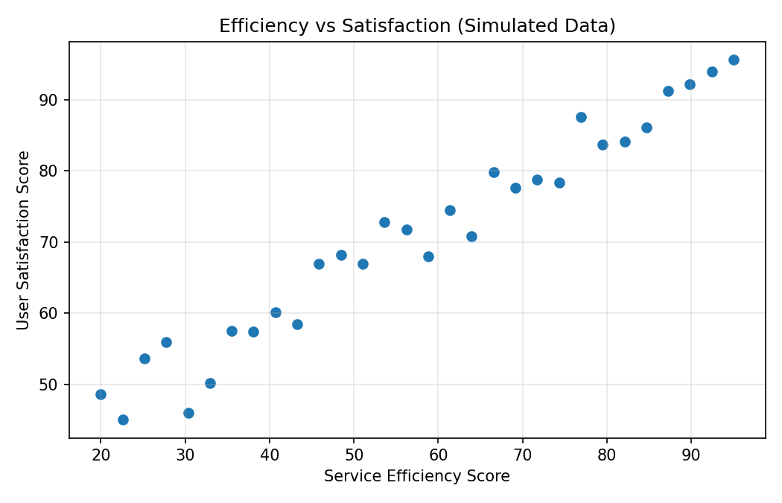
Efficiency and satisfaction have Pearson r = 0.979 in this simulated sample, indicating a positive linear association. This is an educational example, not a finding about actual government service users.

7. Simple Linear Regression
Model: User Satisfaction = intercept + slope × Service Efficiency.
Estimated equation: Satisfaction = 33.616 + (0.645 × Efficiency). R-squared = 0.959.
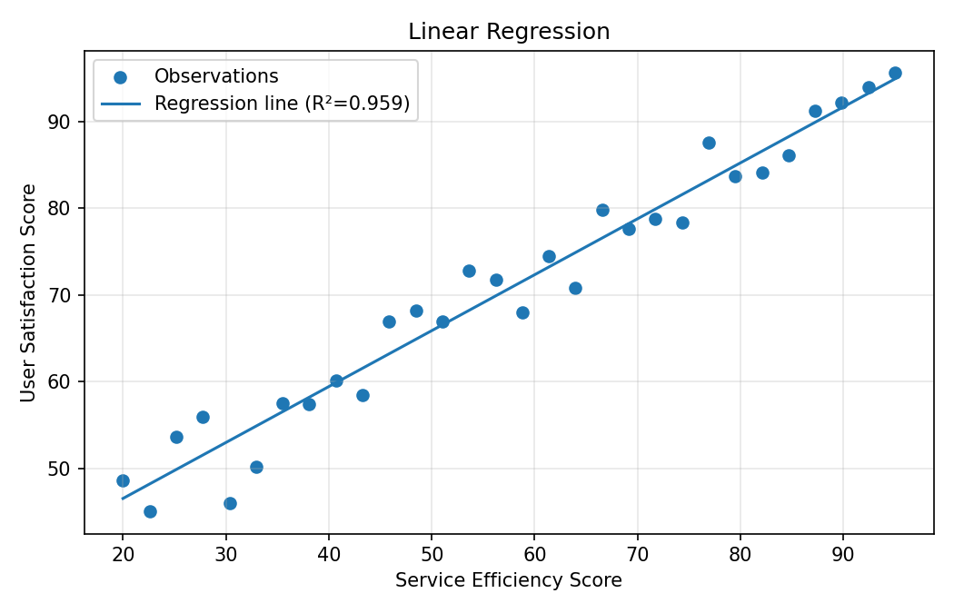
The slope (0.645) estimates the average satisfaction-score difference associated with a one-point efficiency increase in this simulated dataset. R-squared (0.959) describes the proportion of in-sample satisfaction variation accounted for by the model. Do not generalize these simulated estimates to real services.

8. Access Equity and Indicator Comparison
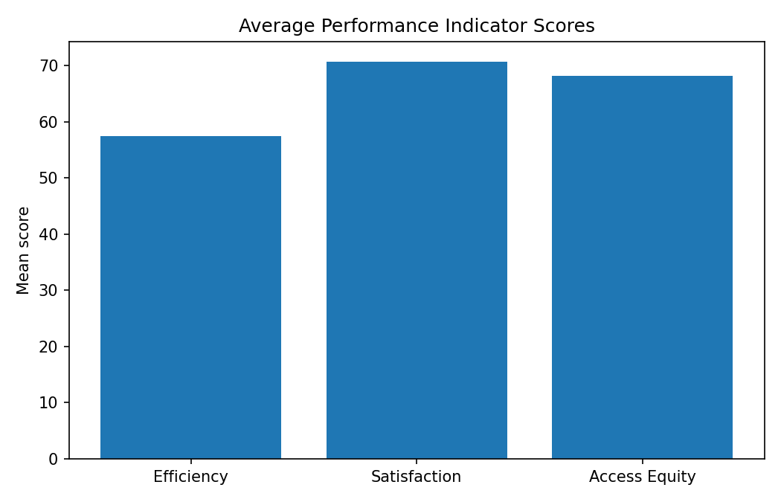
Average scores provide an overview, but the indicators measure different concepts. Real equity analysis should examine relevant groups and barriers such as rural/urban location, disability access, language, age, and connectivity, while protecting privacy.

9. Validation and Quality Checks
- Dataset size: 30 observations.
- Missing indicator values: 0.
- All indicator values are numeric and within intended score ranges.
- Fixed random seed and documented method support reproducibility.
- For real data, examine outliers, residuals, uncertainty, and subgroup differences.

10. Policy and Operational Implications
- Simplify unnecessary steps and monitor processing times alongside user feedback.
- Collect satisfaction feedback and check whether respondents represent different user groups.
- Measure equity across geography, disability access, language, and connectivity.
- Define indicators consistently and document changes in data collection.
- Evaluate pilots with real pre/post or comparison-group data before attributing changes to policy.

11. Limitations
- The dataset is simulated and is not official government data.
- Thirty observations cannot represent all services and users.
- A single score can hide subgroup differences.
- Correlation and simple regression do not prove causality or control for confounding variables.
- A real study should report uncertainty and appropriate hypothesis tests.

12. Reproducibility and Conclusion
Use the CSV to recalculate descriptive statistics, pairwise Pearson correlations, and an ordinary least squares model with satisfaction as y and efficiency as x. The charts use the same data. This exercise illustrates how statistical methods can support e-governance monitoring; real decisions require validated administrative and survey data, uncertainty assessment, privacy protection, and equity checks.

References
1. eTaal, Government of India: https://etaal.gov.in/ (transaction-statistics context only; simulated scores are not sourced from eTaal).
2. NIST/SEMATECH e-Handbook of Statistical Methods: https://www.itl.nist.gov/div898/handbook/
3. OpenIntro Statistics: https://www.openintro.org/book/os/

