VIRTUAL DATA ANALYSIS INTERNSHIP
WEEK 2 TASK REPORT
Data Collection and Cleaning for Digital Services
E-Governance & Digital Services
Submitted by
Harsh Kirar
Week 2

1. Executive Summary
This report documents a practical data collection and cleaning exercise for digital government services. Two publicly available service-level tables from the Government of India's Electronic Transaction Aggregation & Analysis Layer (eTaal) were selected: National Social Assistance Programme (NSAP) and Sarathi.
The purpose is to demonstrate a reproducible workflow: identify an official public source, capture relevant records, structure the data, validate fields, check missing values and duplicates, standardize labels, and document every transformation so that another analyst can repeat the process.
The collected data contain state/UT-level electronic transaction counts. These counts are useful for studying digital-service usage and geographic distribution. They should not, by themselves, be interpreted as measures of service quality, citizen satisfaction or operational efficiency.
The cleaned structure is suitable for later ranking, trend analysis, KPI calculation and dashboard development.

2. Objectives and Scope
- Identify at least two publicly available datasets related to e-governance and digital services.
- Explain the relevance of each dataset to digital-service analysis.
- Document the collection and extraction process and its limitations.
- Perform basic cleaning: missing-value checks, duplicate checks, numeric validation and label standardization.
- Create a replication guide that another analyst can follow.
- Prepare an analysis-ready structure for later visualization and KPI work.
Included | Not included
State/UT transaction counts | Citizen-level personal data
Public dashboard information | Internal government databases
Data quality documentation | Causal policy conclusions
Basic descriptive checks | Predictive modelling

3. Selected Public Data Sources

Dataset 1 – NSAP
Field | Details
Source | Official eTaal portal
Service | National Social Assistance Programme
Owner | Ministry of Rural Development
Geography | State/UT
Measure | e-Transactions
Displayed period | 01-Jan-2018 to 11-Sep-2026

Dataset 2 – Sarathi
Field | Details
Source | Official eTaal portal
Service | Sarathi
Owner | Ministry of Road Transport and Highways
Geography | State/UT
Measure | e-Transactions
Displayed period | 01-Jan-2018 to 11-Sep-2026
eTaal documentation describes the platform as an aggregation and analysis layer for electronic transactions from government e-services. citeturn0search24turn0search25

4. Relevance and Data Dictionary
The datasets are relevant because electronic transaction volume is a directly observable indicator of digital-service activity. The same data structure also demonstrates how a data analyst can apply consistent cleaning rules to different government services.
Column | Type | Meaning | Cleaning rule
State/UT | Text | Geographic unit | Trim and standardize labels
e_transactions | Integer | Electronic transaction count | Convert to numeric; validate non-negative
service | Text | Service identifier | Standardized constant
source | Text | Official source | Preserve source name
collection_date | Date | Date captured | Record exact date
displayed_period | Text | Period shown by source | Preserve source wording
Interpretation note: a high transaction count means higher recorded digital activity; it does not automatically mean better service performance.

5. Data Collection Procedure
Step | Action | Output
1 | Locate official eTaal service page | Source verified
2 | Confirm service and owner | NSAP / Sarathi
3 | Capture State/UT rows | Geographic records
4 | Capture e-transaction count | Numeric field
5 | Record reporting period | Metadata
6 | Record collection date | Not specified
7 | Create structured working table | CSV/Excel-ready
8 | Run validation checks | Cleaning log
For this report, publicly displayed tabular records were transcribed into structured working tables. This is a transparent exercise for the internship and avoids any need for internal datasets. eTaal documentation indicates that the portal aggregates transaction statistics and provides tabular/graphical analysis. citeturn0search24turn0search27

6. Dataset 1 – NSAP Collected Records
No. | State/UT | e-Transactions
1 | Andaman and Nicobar | 58,010
2 | Andhra Pradesh | 22,877,647
3 | Assam | 32,355,652
4 | Bihar | 102,266,664
5 | Chhattisgarh | 23,857,156
6 | Delhi | 2,370,510
7 | Goa | 249
8 | Gujarat | 23,272,474
9 | Haryana | 12,562,075
10 | Himachal Pradesh | 116,005
11 | Jammu and Kashmir | 1,961
12 | Jharkhand | 36,758,460
13 | Karnataka | 44,117,830
14 | Kerala | 9,656,910
15 | Lakshadweep | 109,778
16 | Madhya Pradesh | 45,034,149
17 | Maharashtra | 1,958,256
18 | Manipur | 493,304
19 | Meghalaya | 590,954
20 | Mizoram | 57,085
21 | Odisha | 35,879,879
22 | Puducherry | 1,005,933
23 | Rajasthan | 21,810,460
24 | Sikkim | 49,230
25 | Tamil Nadu | 44,907,865
26 | Telangana | 16,690,192
27 | Tripura | 2,726,806
28 | Uttar Pradesh | 66,085,063
29 | Uttarakhand | 21,253
30 | West Bengal | 23,667,320
Source: Official eTaal NSAP service table. citeturn0search1

7. Dataset 2 – Sarathi Collected Records
No. | State/UT | e-Transactions
1 | Andaman and Nicobar | 158,103
2 | Andhra Pradesh | 3,592,560
3 | Arunachal Pradesh | 256,564
4 | Assam | 3,740,675
5 | Bihar | 6,102,187
6 | Chandigarh | 471,863
7 | Chhattisgarh | 3,194,308
8 | Dadra and Nagar Haveli | 36,406
9 | Daman and Diu | 64,901
10 | Delhi | 5,680,996
11 | Goa | 1,004,319
12 | Gujarat | 14,984,435
13 | Haryana | 7,965,346
14 | Himachal Pradesh | 2,605,562
15 | Jammu and Kashmir | 2,530,391
16 | Jharkhand | 3,148,613
17 | Karnataka | 15,891,777
18 | Kerala | 17,884,842
19 | Ladakh | 57,802
20 | Lakshadweep | 12,001
21 | Madhya Pradesh | 6,791,134
22 | Maharashtra | 31,645,210
23 | Manipur | 360,665
24 | Meghalaya | 418,873
25 | Mizoram | 249,853
26 | Nagaland | 220,811
27 | Odisha | 4,329,644
28 | Puducherry | 457,124
29 | Punjab | 9,728,775
30 | Rajasthan | 14,776,967
31 | Sikkim | 170,890
32 | Tamil Nadu | 22,213,272
33 | Telangana | 1,171,578
34 | Tripura | 526,048
35 | Uttar Pradesh | 25,137,454
36 | Uttarakhand | 2,906,320
37 | West Bengal | 10,022,528
Source: Official eTaal Sarathi service table. citeturn0search2

8. Data Cleaning Procedure
Check | Procedure | Observed result
Missing values | Check State/UT and transaction fields | No blank key values in collected rows
Duplicates | Check exact duplicate State/UT rows within each service | No exact duplicates observed
Numeric validation | Convert counts to integer | All collected counts numeric
Whitespace | Trim text fields | Applied
Label consistency | Use one canonical label per State/UT | Applied
Negative values | Check count < 0 | None observed
Metadata | Preserve source and period | Recorded
Cleaning principle: values were not altered simply to improve appearance. Transformations were limited to formatting, data-type conversion, duplicate checking and label standardization.

9. Cleaning Transformation Log
Issue / risk | Transformation | Reason
Formatting separators in counts | Store as integer | Enable arithmetic
Leading/trailing spaces | Trim whitespace | Prevent false categories
Capitalization differences | Standardize labels | Consistent grouping
Dashboard can change | Store collection date | Reproducibility
Different service definitions | Keep datasets separate | Avoid invalid aggregation
Dataset | Rows | Missing key fields | Exact duplicates
NSAP | 30 | 0 | 0
Sarathi | 37 | 0 | 0
Combined | 67 | 0 | 0
The two services are deliberately kept separate. Their transaction counts should not be summed unless comparability is established for a specific analytical question.

10. Preliminary Visual Validation
Simple ranking charts provide a first validation that the cleaned numeric field can be sorted and visualized.
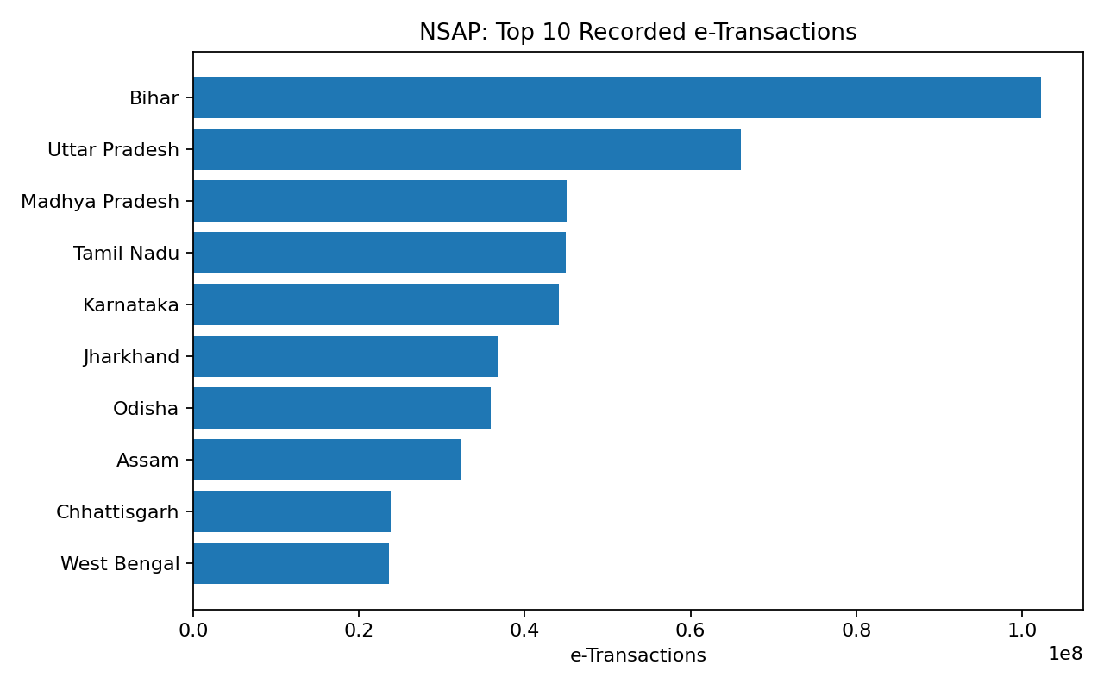
Figure 1. NSAP top 10 recorded e-transactions

11. Preliminary Visual Validation – Sarathi
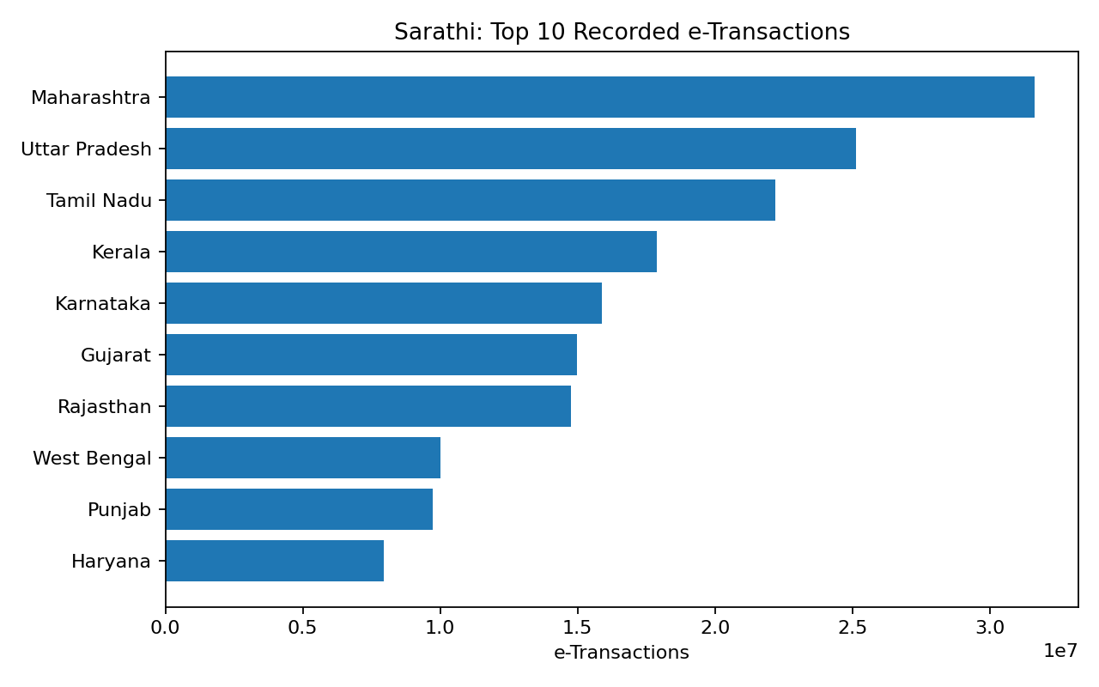
Figure 2. Sarathi top 10 recorded e-transactions
These charts are descriptive. A state with more transactions is not necessarily more efficient because transaction volume depends on service purpose, eligibility, population, adoption and transaction definitions.

12. Replication Guide
Step | Instruction
1 | Open the official eTaal portal and locate the service page.
2 | Select NSAP or Sarathi.
3 | Record the displayed reporting period and collection date.
4 | Copy State/UT and e-Transactions into a spreadsheet.
5 | Add service, source, collection_date and displayed_period columns.
6 | Trim whitespace and standardize labels.
7 | Convert transaction counts to integer and validate non-negative values.
8 | Check blanks and exact duplicates.
9 | Save raw and cleaned versions separately.
10 | Create a cleaning log.
11 | Generate a basic ranking/chart.
12 | Store the official source reference with the report.
Suggested files: harsh_kirar_week2_nsap_raw_YYYY-MM-DD.csv; harsh_kirar_week2_nsap_clean_YYYY-MM-DD.csv; harsh_kirar_week2_sarathi_raw_YYYY-MM-DD.csv; harsh_kirar_week2_sarathi_clean_YYYY-MM-DD.csv

13. Tools, Challenges and Solutions
Tool | Purpose
Web browser | Access official public tables
Excel / Google Sheets | Collection and cleaning
Python / pandas | Optional automated validation
Power BI / Excel | Future dashboards
Microsoft Word | Documentation
Challenge | Solution
Public dashboard may update | Record collection date and period
Different service definitions | Keep datasets separate
Manual transcription risk | Validate rows and selected values
Naming differences | Use canonical labels
Missing values | Flag and document treatment
Large counts | Use numeric data type

14. Conclusion and Next Steps
This Week 2 exercise established a structured workflow for collecting and cleaning public e-governance data. NSAP and Sarathi were selected because their official eTaal pages provide state/UT-level electronic transaction counts. The report documents the source, fields, collection method, quality checks, transformations and replication steps.
- Expand to additional eTaal services or suitable Open Government Data datasets.
- Collect monthly records where available for time-series analysis.
- Calculate transaction share and growth metrics.
- Build Excel or Power BI dashboards.
- Investigate outliers and unusual changes.
- Use multiple indicators before making claims about service efficiency or quality.
The main outcome is an analysis-ready, traceable data structure that can support the next internship tasks.

15. References
- eTaal – Electronic Transaction Aggregation & Analysis Layer, Government of India / NIC / MeitY.
- eTaal User & Technical Manual.
- Official eTaal NSAP service page.
- Official eTaal Sarathi service page.
- Open Government Data (OGD) Platform India.
Official evidence used: eTaal technical documentation and service pages. citeturn0search24turn0search25turn0search1turn0search2
Submitted by: Harsh Kirar

