Week 5: Predictive Modeling for Digital Service Demand Forecasting
Virtual Data Analysis Internship – E-Governance & Digital Services
Prepared by: Harsh Kirar

1. Introduction
This report develops and evaluates a simple predictive model to forecast future demand for digital public services. Demand forecasting can help service managers estimate incoming requests, plan staffing, allocate server capacity, and reduce delays in public-facing digital platforms.

2. Problem Definition and Objective
The forecasting problem is to estimate the monthly number of digital service requests using historical demand observations. The target variable is Digital_Service_Requests. Time_Index is used as the primary predictor to capture the overall trend. The aim is to demonstrate a transparent baseline model and explain its usefulness and limitations.

3. Dataset and Variables
A simulated dataset of 30 monthly observations from January 2024 through June 2026 was created for educational purposes. It includes Month, Time_Index, Digital_Service_Requests, and a binary Promotion_or_Policy_Change indicator. The baseline model in this report uses Time_Index only; the policy-change indicator is included as a possible variable for future model improvement.
Variable | Role | Description
Month | Time label | Calendar month of observation
Time_Index | Predictor | Sequential monthly index from 1 to 30
Digital_Service_Requests | Target | Simulated count of monthly digital service requests
Promotion_or_Policy_Change | Potential predictor | Simulated flag for a month with a possible service/policy change

4. Data Preparation
The data were generated as simulated monthly observations with an upward trend, mild annual seasonality, and random variation. The dataset was checked for missing values and duplicate month labels. The first 24 observations were used for model training, and the final 6 observations were held out for validation. This chronological split is more appropriate for forecasting than a random split because it preserves time order.

5. Model Selection and Justification
A simple linear regression trend model was selected as a baseline. The model estimates demand as a linear function of Time_Index. It is easy to interpret, computationally inexpensive, and provides a useful starting point when only a small history is available. However, it does not explicitly model seasonality, sudden policy changes, or nonlinear growth.
Estimated training model: Demand = 20.52 × Time_Index + 867.81.
Model tuning in this baseline consists of estimating the slope and intercept from the training data using least squares. For a production system, candidate models could be compared using rolling-origin validation, and seasonal regression or time-series methods could be tested.

6. Model Validation and Evaluation
The model was evaluated on the final six months, which were not used for fitting. Mean Absolute Error (MAE) measures the average absolute difference between actual and predicted demand. Root Mean Squared Error (RMSE) penalizes larger errors more heavily.
Validation MAE: 62.76 service requests.
Validation RMSE: 66.63 service requests.
These scores are illustrative and apply only to the simulated dataset. They should not be interpreted as the expected accuracy of a real government service forecasting system.
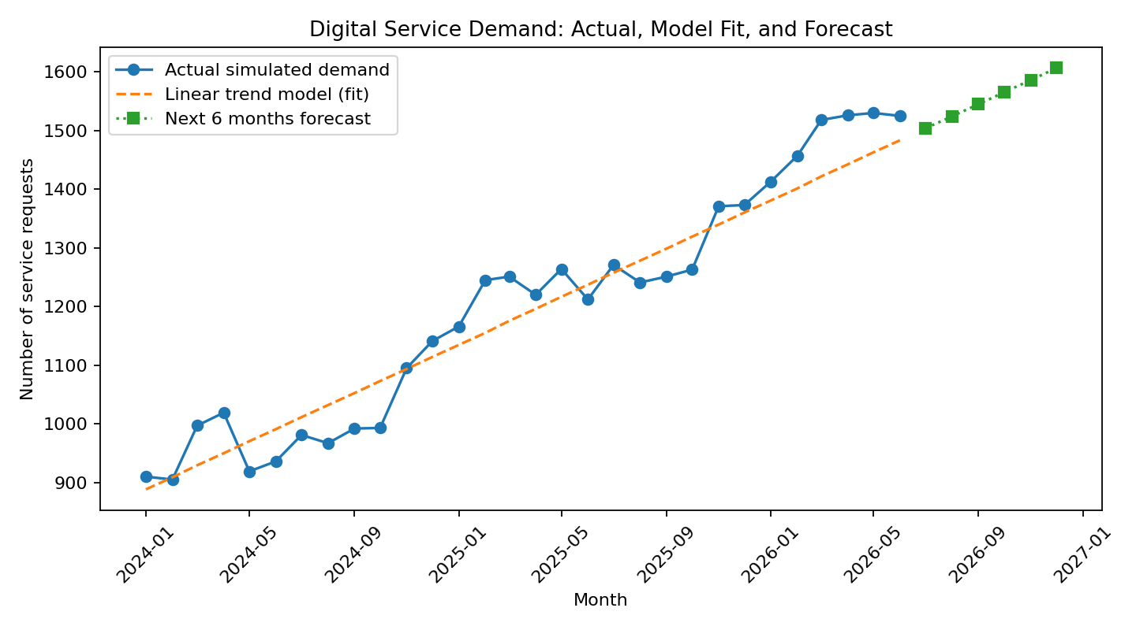
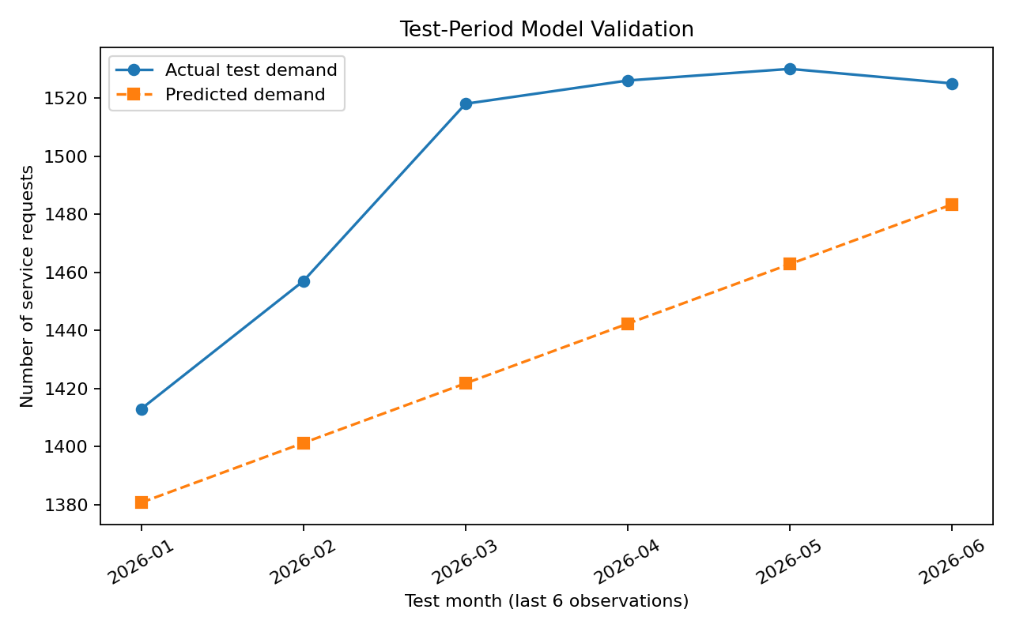
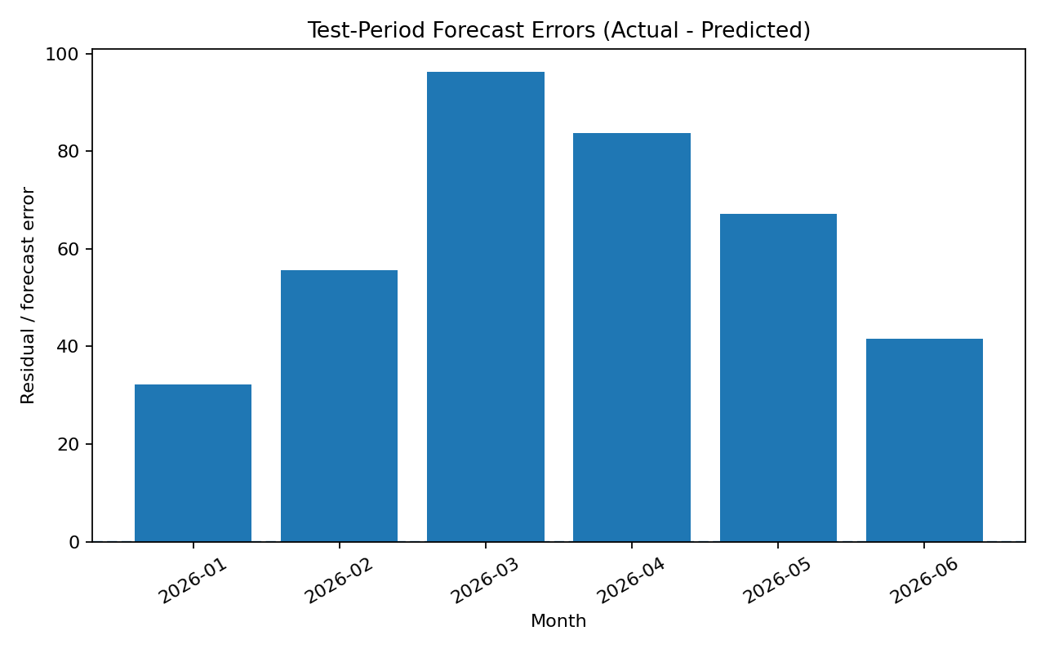

7. Six-Month Forecast
The fitted trend was extended six months beyond the observed period to produce a demonstration forecast. The forecast is a planning illustration, not an official estimate. The CSV file week5_demand_forecast.csv contains the month-by-month forecast values.
Forecast month | Forecast service requests
2026-07 | 1504
2026-08 | 1524
2026-09 | 1545
2026-10 | 1565
2026-11 | 1586
2026-12 | 1606

8. Practical Implications for E-Governance
A demand forecast can help digital service managers prepare staff schedules, plan infrastructure capacity, anticipate busy periods, and prioritize service improvements. Forecasts should be reviewed regularly against actual demand. If requests rise faster than expected, managers can investigate policy announcements, application deadlines, outages, or changes in user adoption.

9. Limitations and Future Improvements
The dataset is simulated and small. The baseline uses only a time trend and therefore cannot reliably capture seasonal patterns, holidays, local events, sudden system changes, or differences between service categories. Future work should use validated real-world data where authorized, add relevant predictors such as weekday/month effects, service type, campaign dates, outages, and policy changes, and compare linear regression with seasonal naïve, exponential smoothing, ARIMA, or machine-learning models. Rolling-origin validation and prediction intervals should be used before operational deployment.

10. Conclusion
This task demonstrates an end-to-end predictive modeling workflow: defining the forecasting problem, preparing data, selecting a baseline model, training it, validating it on a later time segment, measuring errors with MAE and RMSE, and discussing practical implications. The main learning is that forecasts can support better planning, but model assumptions, data quality, and uncertainty must be considered before using predictions for real decisions.

Reproducibility Note
All data and results in this report are simulated for learning purposes. The charts and forecast CSV are generated from the same dataset and baseline model described above. No official government transaction, satisfaction, or access dataset was used.

