College Transport Reservation System
Project Report – Python Essentials
Submitted by: Harsh
Faculty : Dr. Sandeep Monga

1. Introduction
The College Transport Reservation System is a Python Essentials project designed to provide an efficient, user-friendly solution for booking intercity and interstate transportation for students. The system is fully modular, uses JSON-based storage, follows a clean architecture, and includes realistic long distance travel data designed specifically for college environments.

2. Statement
College students often need to travel long distances for holidays, semester breaks, festivals, and emergencies. Public transportation is often overcrowded or misaligned with academic timings. Students require a simple, reliable, and accessible bus/train reservation system managed by the college.

3. Scope of the Project
This project implements a fully functional text based reservation system using ONLY Python Essentials modules.
The scope includes:
• Student registration & login
• Admin route/trip creation
• Searching for intercity/interstate routes
• Seat booking & cancellation
• JSON persistence
• Modular architecture
• Realistic vehicle & trip data

4. Target Users
• College Students – Primary users booking long distance transport
• Admin / Transport Office – Manages routes, bookings, and logs
• Hostel Wardens – Can use logs for student exit/entry tracking

5. High-Level Features
• Student authentication
• Admin authentication
• Search trips by origin, destination, date
•Seat availability checking
• Booking & cancellation
• View reservation history
•JSON-based database ,modular Python code (auth, db, reservation, search, models)

7. Implementation Details
The system is built according to Python Essentials (Modules 1–13):
• Variables, data types , Operators ,Input/Output , Control Flow (if/else, loops) ,Data structures (lists, dicts, arrays) , Functions, modular code ,JSON file handling ,Basic OOP

8. Sample Data
The project includes:
• 20 sample student accounts , 15 realistic interstate/intercity trips , 8 buses/trains , 10 preloaded reservations Stored in: data/users.json, trips.json, vehicles.json, reservations.json
9. Screenshots & Program Output

Student Registration
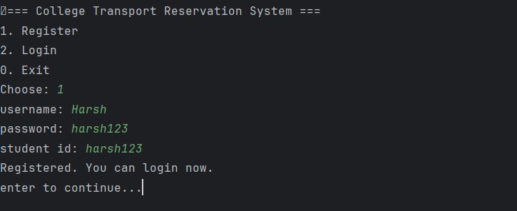

Student Login
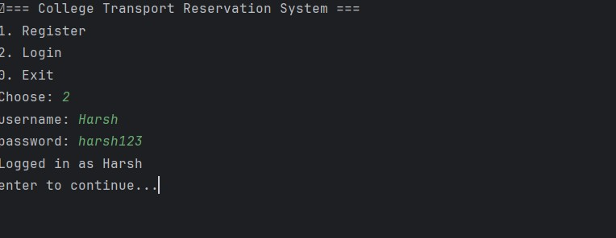

Searching & Booking Trip
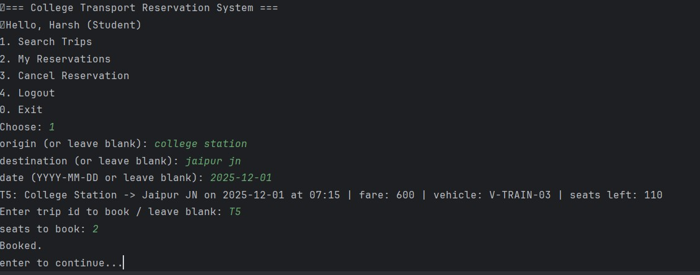

Viewing Reservations
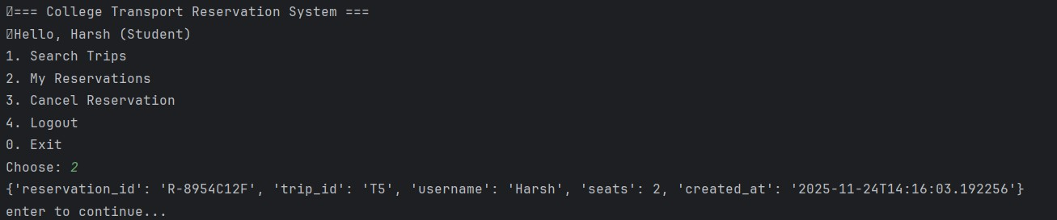

Canceling Reservation
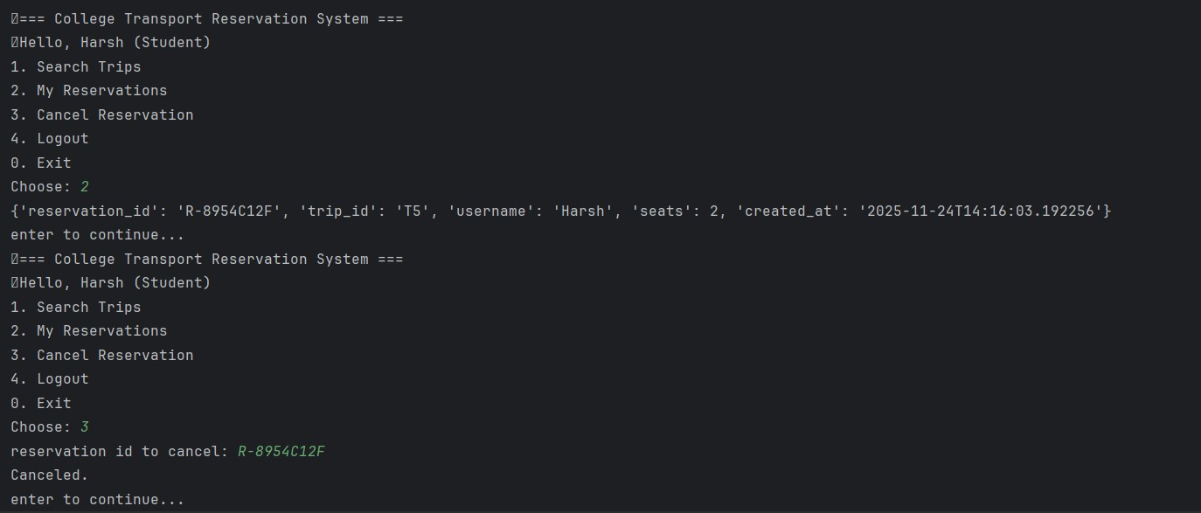

10. Testing
Testing includes: Authentication tests ,Trip search tests , Seat availability tests Reservation booking/cancellation tests Using Python's built in unittest framework.

11. Future Enhancements
• Web based interface
• Mobile app integration
• Real time seat tracking
• Payment gateway
• OTP verification

12. Conclusion
This project demonstrates a complete end to end Python application using only fundamental programming concepts. It solves a real world problem for college students and showcases the use of modular programming, file handling, system design, and practical application of logic.

