SMARTASSIST
IoT-Based Health Monitoring and Emergency Communication System
for Paralysis Patients
Project Documentation
Hardware Prototype • ESP32 • Multi-Sensor Monitoring • OLED Display • Web-Based Alert/Demand Interface
Prepared from the supplied prototype photographs and implementation screenshots

1. Project Overview
SmartAssist is an IoT-based assistive monitoring prototype designed to support a person with paralysis by combining basic physiological/environmental sensing with a simple local communication interface. The prototype uses an ESP32 as the central controller and connects sensors, an OLED display, visual/audible indicators, and a browser-based interface. The system is intended as an engineering prototype for monitoring and assistance; it is not a certified medical device and should not be used as a substitute for clinical equipment.

Project Title Meaning
“SmartAssist” combines Smart (connected sensing and processing) with Assist (helping a patient communicate a need and allowing a caregiver to observe important readings).

2. Problem Statement
A person with limited movement may have difficulty communicating discomfort, requesting medicine, or attracting a caregiver's attention. The project therefore focuses on a compact system that can continuously read selected sensors, present values locally, and provide a simple demand/communication mechanism over a Wi-Fi-connected web page.

3. Objectives
- Monitor selected patient-related and environmental parameters using sensors.
- Use an ESP32 to collect, process, and communicate sensor data.
- Display readings locally on an OLED screen.
- Provide visual and audible indication for selected conditions or events.
- Provide a browser-based patient-demand interface, including a medicine request shown in the supplied prototype.
- Create a practical, low-cost proof-of-concept suitable for academic demonstration and further development.

4. Hardware and Main Modules
Module | Purpose | Role in Prototype
ESP32 development board | Main controller and Wi-Fi connectivity | Reads sensors, drives outputs and hosts/serves the web interface
Flex sensors (2 shown in code/prototype) | Detect bending/movement | Can be used to detect assisted hand/finger movement or patient input
Thermistor | Temperature-related sensing | Provides an analog reading used for temperature estimation
DHT sensor | Humidity and temperature sensing | Provides humidity and temperature values
OLED display (SSD1306-type appearance) | Local visual feedback | Shows live values such as temperature and humidity
LED indicators | Visual status indication | Provides simple normal/alert/status feedback
Buzzer | Audible alert | Can attract caregiver attention during an event
Web browser interface | Remote/local communication | Displays patient demand such as “MEDICINE” in the supplied demonstration
Breadboard, jumper wires and power module | Prototype interconnection | Used to assemble and power the demonstration circuit

5. Prototype Hardware
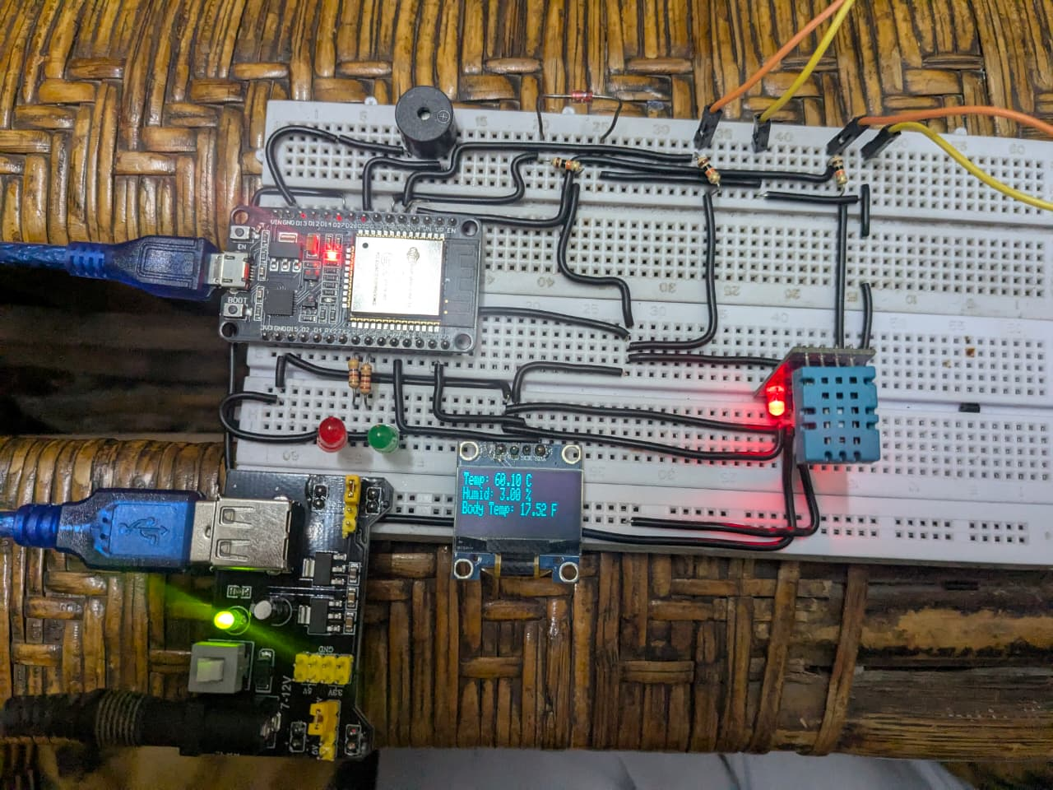
Figure 1. ESP32-based prototype with sensor, indicators, OLED display and power arrangement.

6. System Working Principle
The ESP32 acts as the central processing unit. Sensor values are acquired through the ESP32 inputs, processed into usable readings, and then presented through the OLED display and serial monitor. The Wi-Fi capability is also used to provide a browser-accessible page for a patient demand/communication function.

Operational Flow
1. Power on the ESP32 and connected modules.
2. Initialize the sensors, OLED display and network/web-server functions.
3. Read the two flex-sensor channels and the thermistor analog channel.
4. Read temperature and humidity from the DHT sensor.
5. Process the sensor readings and update the local display.
6. Monitor for defined patient-input or alert conditions.
7. Serve a simple web page that can communicate a patient demand to a caregiver on the local network.
8. Continue the sensing and display cycle while the system is powered.

7. Software Logic Observed in the Implementation
The supplied Arduino IDE screenshot shows an ESP32 web-server implementation. The visible code includes web-server route handling and a loop that handles incoming clients before reading sensor values. The implementation also uses analogRead() for the flex sensors and thermistor, and DHT functions for humidity and temperature. The code itself is intentionally not reproduced in this report.
The serial-monitor screenshot shows flex-sensor values, thermistor values and temperature output. The OLED photographs show temperature/humidity information being presented locally. A browser page labeled “Patient Demand” demonstrates a medicine-demand message.

8. Prototype Evidence and Demonstration
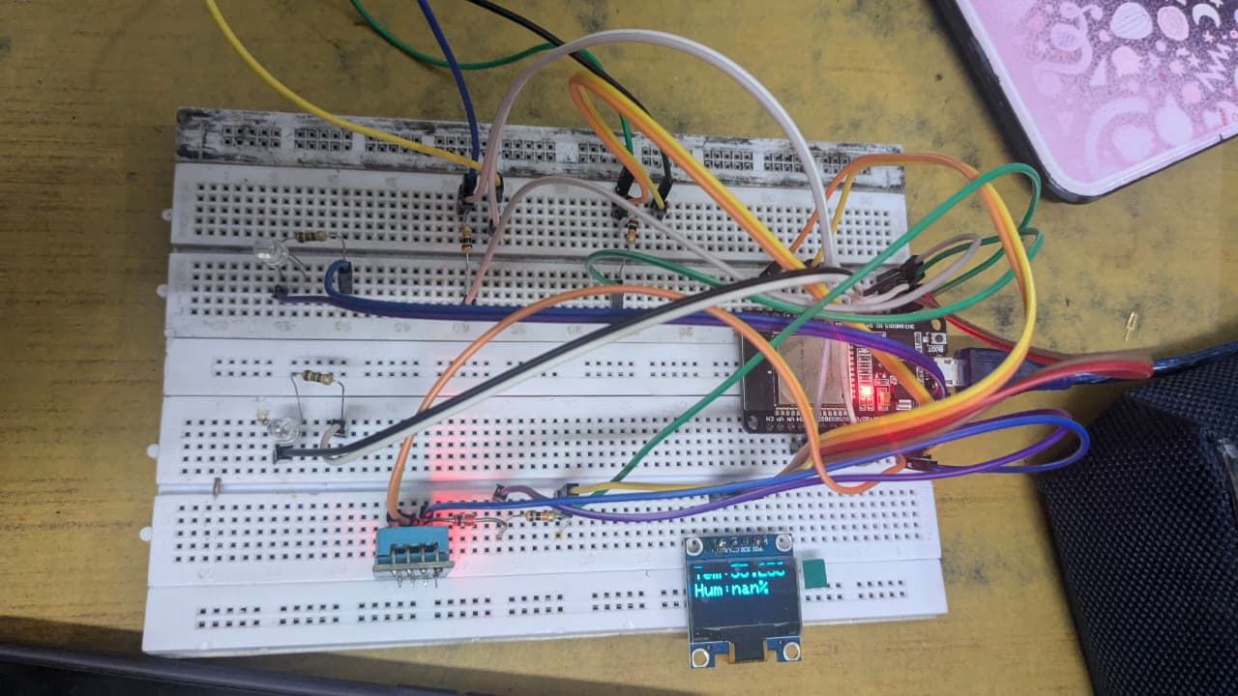
Figure 2. Breadboard prototype showing the ESP32, OLED and connected sensing/indicator circuitry.
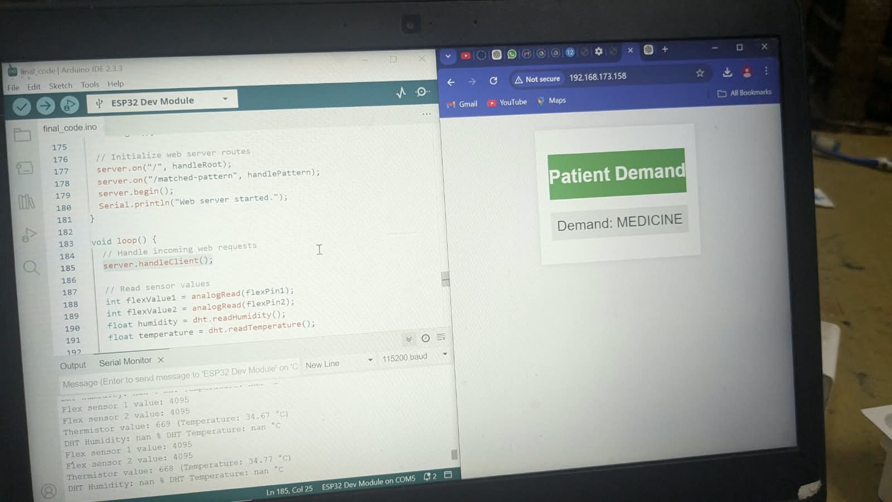
Figure 3. Arduino IDE, serial-monitor readings and browser-based “Patient Demand” demonstration.

9. Local Display Demonstration
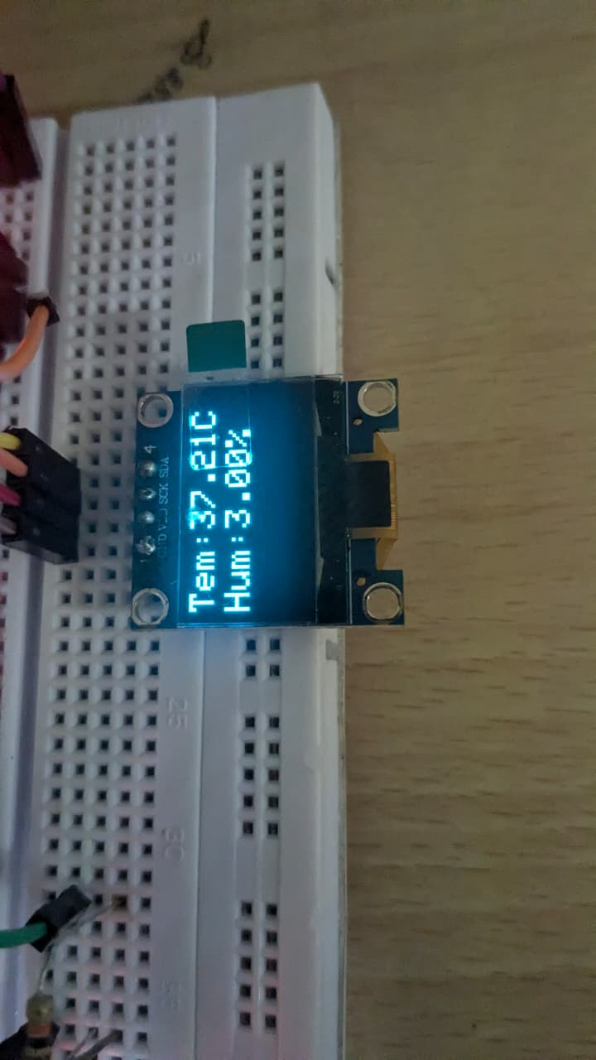
Figure 4. OLED display showing temperature and humidity values in the prototype.

10. Patient Demand / Communication Feature
The supplied computer screenshot demonstrates a browser page titled “Patient Demand” with a visible message, “Demand: MEDICINE”. This feature provides a simple communication channel for a patient who may have difficulty speaking or physically reaching a conventional call button. In a complete deployment, the demand should be transmitted to a caregiver dashboard, phone notification, or other approved alert mechanism.
For an academic prototype, the current local-network web page is sufficient to demonstrate the concept. For real-world use, authentication, reliable notification delivery, data privacy, fail-safe behavior and medical-device validation would be required.

11. System Architecture
Layer | Function
Patient / Assisted Input | Flex sensors or other patient-operated input
Sensing Layer | Flex sensors + thermistor + DHT sensor
Controller | ESP32: acquisition, processing, decision logic and Wi-Fi
Local Feedback | OLED + LEDs + buzzer
Communication Layer | ESP32 web server / local browser interface
Caregiver Interaction | Patient demand such as medicine request

12. Expected Benefits
- Hands-free or low-movement communication concept for a person with restricted mobility.
- Local visual feedback through the OLED display.
- Audible/visual alert capability for caregiver attention.
- Wireless connectivity through the ESP32.
- Modular design that allows additional sensors and communication services to be added later.
- Useful as a low-cost academic demonstration of embedded systems, IoT, sensors and human-assistance technology.

13. Testing and Observations
Test Area | Observed in Supplied Prototype | Status
ESP32 operation | ESP32 development board powered and running the application | Demonstrated
Flex sensor acquisition | Serial monitor shows changing/raw flex-sensor channel values | Demonstrated
Thermistor acquisition | Serial monitor shows an analog thermistor value and temperature-related output | Demonstrated
DHT sensing | Humidity/temperature functions are visible in the implementation; some screenshot readings show NaN | Needs calibration/debugging
OLED display | OLED displays temperature/humidity-style information | Demonstrated
Web interface | Browser shows Patient Demand with MEDICINE request | Demonstrated
Indicators | LED/buzzer hardware is present in the prototype | Demonstrated at prototype level

14. Important Technical Note
The supplied serial-monitor screenshot contains “nan” for the DHT humidity/temperature line while other sensor readings are present. This indicates that the DHT reading was not valid at that moment. Common engineering checks include verifying the DHT sensor type, data pin, power and ground, pull-up resistor where required, initialization timing, and sensor-read timing. The system should not interpret a NaN reading as a real medical measurement.

15. Future Enhancements
- Add a dedicated caregiver dashboard with patient status and event history.
- Send alerts through a secure notification service rather than relying only on a local browser.
- Add heart-rate/SpO₂ sensing only with appropriately validated hardware and algorithms.
- Add a reliable emergency/call-for-help button or configurable patient gesture input.
- Store timestamped sensor data for trend analysis.
- Add sensor-failure detection, watchdog recovery and power-failure handling.
- Improve enclosure, cable management and electrical isolation for a more robust prototype.
- Add authentication and encrypted communication before exposing the system beyond a trusted local network.
- Calibrate each sensor and validate readings against appropriate reference instruments.
- Perform safety, usability and medical-device validation before any real patient deployment.

16. Conclusion
SmartAssist demonstrates a practical IoT approach to assistive monitoring for a person with paralysis. The prototype integrates an ESP32, multiple sensors, an OLED display, indicators and a web-based patient-demand interface. The supplied photographs and implementation screen show the core functions operating as an embedded-system proof of concept. The next stage should focus on sensor reliability, caregiver notifications, safety, secure communication and validation before considering any real-world clinical application.

17. Components at a Glance
- ESP32 development board
- Two flex sensors
- Thermistor
- DHT temperature/humidity sensor
- OLED display
- LED indicators
- Buzzer
- Breadboard and jumper wires
- Power supply/module
- Wi-Fi-enabled browser interface

