PCB DESIGN & DEVELOPMENT
555 Timer Based AC Interface and Control Board
Schematic Design • PCB Layout • 3D Verification • Prototype Development
Designed in KiCad
Project Documentation

1. Project Overview
This project documents the design and PCB development of a compact electronic control board based on a 555 timer circuit, an optocoupler interface, transistor switching stages and an isolated AC/DC power module. The supplied schematic and KiCad PCB/3D-view photographs were used to document the design workflow.
The design is intended as a low-voltage control interface for an AC-powered application. The control circuitry is separated from the AC input using an isolated power module and optocoupler, while transistor stages provide switching/control outputs.

2. Project Objectives
- Convert the circuit concept into a manufacturable PCB.
- Create a compact and organized component placement.
- Route electrical connections with practical trace paths.
- Use optocoupler-based electrical isolation.
- Use a 555 timer as the timing/control element.
- Use transistor stages for output switching.
- Verify component placement using KiCad 3D Viewer.

3. Main Circuit Blocks
Block | Main Component | Function
Timing/control | 555 timer (U1) | Generates the timing/control waveform.
Timing network | R3, RV1, C1 and associated parts | Sets/adjusts timing characteristics.
Indicator | LED D2 + resistor | Provides visual status indication.
Isolation | PC817 (U2) | Transfers control signal with galvanic isolation.
Switching | Q1 and Q2 | Provides output switching/control.
Power conversion | HLK-10M12 (PS1) | Provides isolated low-voltage DC power from AC input.
External interface | J1 terminal connector | Connects the board to the external circuit/load.

4. Schematic Design Process
The schematic is the electrical foundation of the project. It defines the relationships between the timing circuit, power supply, isolation stage and output switching circuitry before PCB layout.
- The 555 timer is the central timing/control IC.
- Resistors, capacitors and a potentiometer form the timing network.
- An LED provides visual indication of operation.
- The PC817 provides an isolated signal path.
- Q1 and Q2 form transistor switching stages.
- The HLK-10M12 module provides isolated DC power from the AC input.
- J1 provides external input/output connections.

5. PCB Design Workflow
1. Schematic capture — create and verify the electrical circuit and component references/values.
2. Footprint assignment — select suitable footprints for ICs, passives, optocoupler, transistors, connector and power module.
3. Board outline — create the rectangular PCB boundary.
4. Component placement — position components for compactness and practical connections.
5. Routing — route copper tracks while maintaining appropriate clearances.
6. Interface organization — separate AC/input and low-voltage/control sections.
7. Silkscreen — add reference designators and labels such as A.C, 1R.IN2 and 1R.OUT2.
8. 3D verification — inspect orientation, spacing and overall board appearance.
9. Fabrication preparation — complete ERC/DRC and manufacturing checks before release.

6. PCB Layout
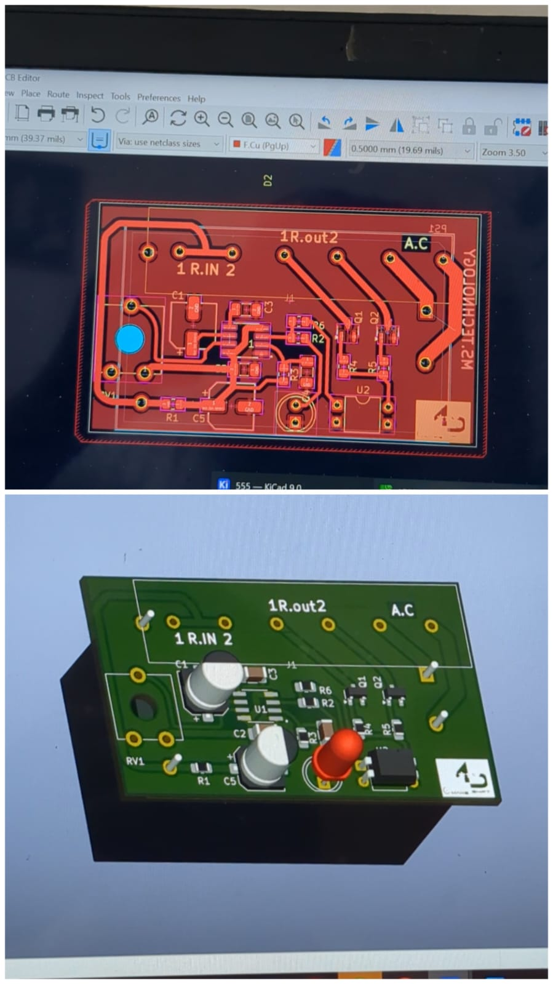
Figure 1. KiCad PCB layout showing board outline, component placement, copper routing and interface labels.
The layout shows a compact rectangular board with the timing/control circuitry concentrated in the center. Power/input/output connection areas are positioned around the perimeter. Copper tracks connect the component pads, while the silkscreen identifies important references and connection labels.

7. Component Placement Strategy
- Group the 555 timer and timing components to keep timing connections short.
- Place the optocoupler between the control and isolated interface sections.
- Position transistor stages close to their associated control networks.
- Keep the AC/power section organized toward one side of the board.
- Place the external terminal connector at the PCB edge for easy wiring.
- Position the indicator LED where it remains visible after assembly.

8. PCB Routing Considerations
- Maintain adequate separation between AC/mains paths and low-voltage control circuitry.
- Select trace widths according to expected current, especially for power/load paths.
- Maintain appropriate creepage and clearance for the actual AC voltage.
- Keep sensitive 555 timing-node connections short and organized.
- Check track-to-pad, track-to-edge and isolation clearances.
- Run KiCad DRC before fabrication.

9. 3D PCB Verification
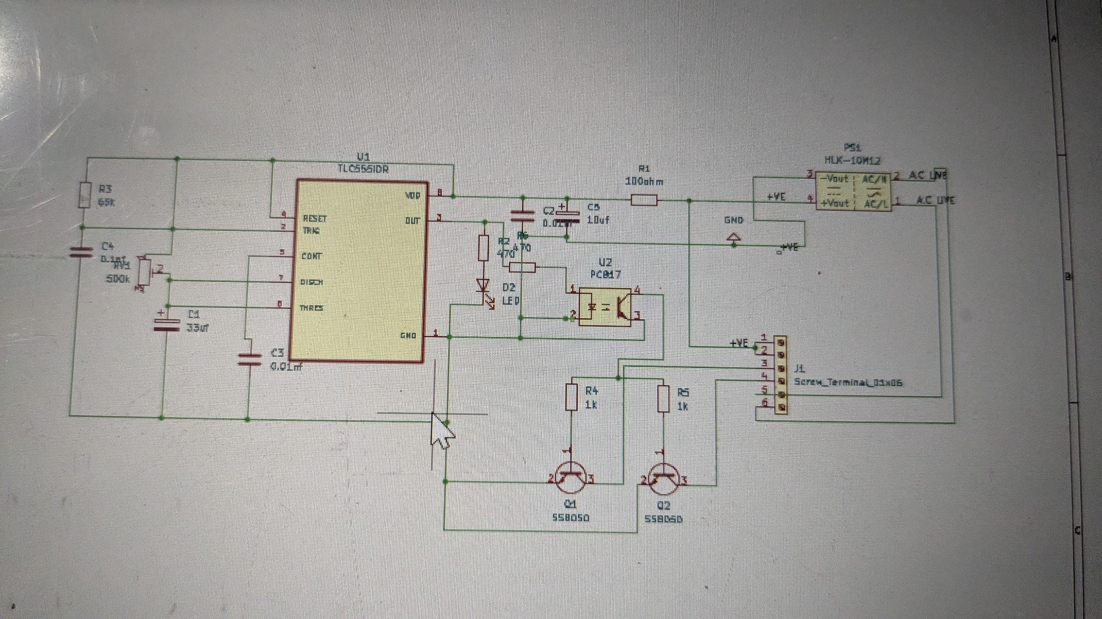
Figure 2. KiCad 3D Viewer representation of the PCB with components placed on the board.
The 3D view provides a physical design check before fabrication. It helps verify component orientation, approximate spacing, connector accessibility, board proportions and the suitability of selected footprints.

10. Design Verification Checklist
Check | Purpose | Action
Schematic ERC | Find electrical-rule problems | Run and resolve errors/warnings.
PCB DRC | Check clearances and unconnected items | Run before fabrication.
Footprints | Confirm real component dimensions/pin mapping | Verify against datasheets.
Polarity/orientation | Prevent incorrect assembly | Check LEDs, capacitors, ICs and modules.
AC safety spacing | Reduce risk of arcing | Validate for actual mains voltage.
Trace width | Support expected current | Calculate for actual load.
3D review | Check physical arrangement | Review all major components.
Prototype test | Confirm operation safely | Test before deployment.

11. Skills Demonstrated
- Electronic schematic interpretation and design
- KiCad schematic capture and PCB layout
- Component footprint selection
- SMD and through-hole component placement
- PCB track routing and board organization
- 555 timer circuit design
- Optocoupler-based isolation
- Transistor switching
- Isolated power-module integration
- KiCad 3D PCB visualization

12. Project Outcome
The project progressed from schematic design to component placement, PCB routing and 3D verification. The supplied KiCad views demonstrate the practical PCB development workflow, including board layout, copper routing, labeling and physical visualization.

13. Safety and Engineering Note
Because the schematic contains an AC input/power section, the finished board must be treated as a potentially hazardous mains-connected circuit. Before fabrication or live testing, the final design should be checked for the actual mains voltage, load current, creepage/clearance, protection, fusing, enclosure and applicable safety requirements. A 3D view is only a visual verification and does not certify electrical safety.

14. Conclusion
This PCB project demonstrates the core workflow of electronic product development: schematic creation, component selection, footprint assignment, PCB placement, routing, labeling and 3D inspection. The design combines a 555 timer control circuit, optocoupler isolation, transistor switching and an isolated power module in a compact PCB implementation.

15. Resume / Portfolio Description
Designed and developed a compact PCB in KiCad for a 555-timer-based AC interface and control circuit. Created the schematic, selected footprints, performed component placement and PCB routing, integrated optocoupler-based signal isolation and transistor switching stages, and verified the final board using KiCad 3D Viewer.

