***Online Book store Management System***

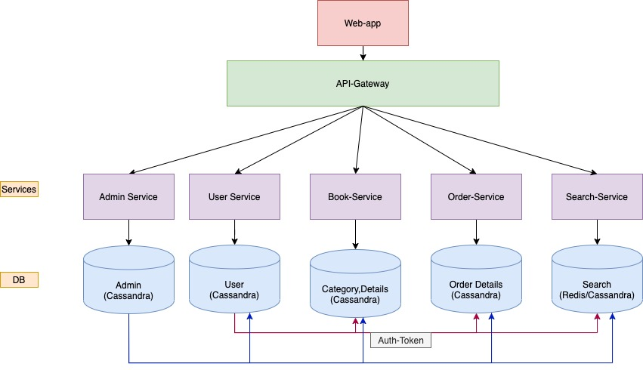

**Services**

* **User-Service:** Responsible for handle authentication process of the system, auth-user retrieve , auth-user store. It connects with User, Role, Permission db tables.
* **Book-Service**: Responsible for book store for all kind users.
* **Order-Service:** Responsible for handling orders which placed by buyers for the products.
* **Search-Service:** Responsible for searching books, users, categories.

**Gateway**

* **API-Gateway: Netflix Zuul API Gateway** (Load balancing also done)

**DB**

* **Cassandra**
* **Redis** *(Maybe)*

**Service Discovery**

* **Eureka *(Host on GitHub repository , endpoints):*** Created on LocalHost.

**Admin-Service:**

**User-Service:**

Usage: Oauth2 **(Tried).** Used : Spring Security Authorization filter.

**User:** UserID *(PK)* ,Username *(Unique)* , Name, DOB, Email, Password, PhoneNo.,

**Book-Service**:

**Category :** CategoryID *(PK)* , Category *(unique) .*

**Details :** BookID *(PK) ,* Name , Description , Price, Year, ISBN, AuthorName.

**Category to Details** : *(CategoryID , RoleID)*

**Order-Service:**

**OrderDetails :** OrderID *(PK)* , DateOfOrder , UserID, BookID

**Search-Service:**

**Endpoints:**

/Users/Login  
/Users/Signup

/Users  
  
/Books/Search  
/Books/{id}

/Books

/Orders/{id}

/Orders

/Search/Users/ (name)  
/Search/Order/ (id)  
/Search/Books/ (name)  
/Search/Books/Author/ (name)  
/Search/Books/Category/ (name)

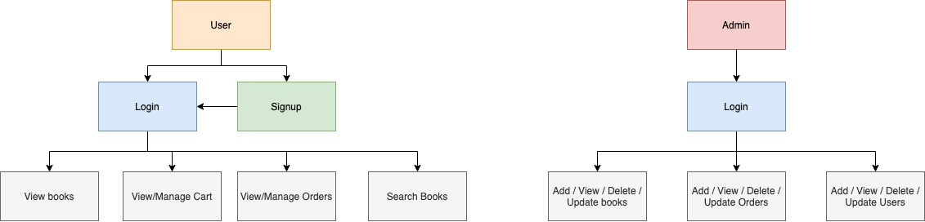

**Front end**

- HTML  
- CSS  
- JS  
- React

**AWS**Created an account on AWS.

Use of elastic beanstalk to host the WebApp.