**Reshape2**

* http://seananderson.ca/2013/10/19/reshape.html
* Data transformation between wide and long formats

|  |  |
| --- | --- |
| **Wide-Format** | **Long-Format** |

* ***melt*** = takes wide-format data and melts it into long-format data.
* ***cast*** = takes long-format data and casts it into wide-format data.
* Think of working with metal: if you melt metal, it drips and becomes long. If you cast it into a mould, it becomes wide.

**Melt**

For each month and day. We can do that with melt by telling it that we want month and day to be “ID variables”. ID variables are the variables that identify individual rows of data.

Ex: melt(airquality, id.vars = c("month", "day"), variable.name = "climate_variable", value.name = "climate_value")

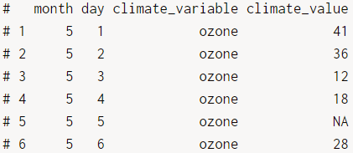

**Cast**

dcast uses a formula to describe the shape of the data. The arguments on the left refer to the ID variables and the arguments on the right refer to the measured variables. Coming up with the right formula can take some trial and error at first.

Ex: dcast(aql, month+day ~ climate_variable, value.var=”climate_value”)

Ex: dcast(aql, month ~ variable, ***fun.aggregate = mean***, na.rm = TRUE)

