**Name :** Harsh Solanki

**PRN :** 2019033800128221

**Batch : B**

**Roll No. :** 512071

**Assignment - 2**

**Numbers , Branches and Loops**

**GitHub Link :** [**https://github.com/harsh391/dot-net-2**](https://github.com/harsh391/dot-net-2)

1. **Numbers**

**Code:**

using System;

namespace Code_1

{

class Program

{

static void Main(string[] args)

{

int a = 18;

int b = 6;

int c = 2;

int d = 3;

double e = 5;

double f = 4;

double g = 2;

decimal h = 1.0M;

decimal i = 3.0M;

Pro_1.add(a,b);

Pro_1.sub(a,b);

Pro_1.mul(a,b);

Pro_1.div(a,b);

Pro_1.complex(a,b,c);

Pro_1.complex2(a,b,c,d);

Pro_1.findMinMax();

Pro_1.dbAdd(e,f,g);

Pro_1.findMinMaxDb();

Pro_1.findMinMaxDec();

Pro_1.decOp(h,i);

double radius = 2.50;

double area = Math.PI * radius * radius;

Console.WriteLine($"Area : {area}");

}

}

static class Pro_1 {

public static void add(int a, int b) {

Console.WriteLine("Output of add...");

int c = a + b;

Console.WriteLine(c);

}

public static void sub(int a, int b) {

Console.WriteLine("Output of sub...");

int d = a - b;

Console.WriteLine(d);

}

public static void mul(int a, int b) {

Console.WriteLine("Output of mul...");

int e = a * b;

Console.WriteLine(e);

}

public static void div(int a, int b) {

Console.WriteLine("Output of div...");

int f = a / b;

Console.WriteLine(f);

}

public static void complex(int a, int b, int c) {

Console.WriteLine("Output of complex...");

int g = a + b * c;

Console.WriteLine(g);

}

public static void complex2(int a, int b, int c, int d) {

Console.WriteLine("Output of complex2...");

int e = (a + b) / c;

int f = (a + b) % c;

Console.WriteLine($"quotient : {e}");

Console.WriteLine($"remainder : {f}");

}

public static void findMinMax() {

Console.WriteLine("Output of findMinMax...");

int max = int.MaxValue;

int min = int.MinValue;

Console.WriteLine($"The range of integers is {min} to {max}");

}

public static void dbAdd(double a, double b, double c) {

Console.WriteLine("Output of dbAdd...");

double d = (a + b) / c;

Console.WriteLine(d);

}

public static void findMinMaxDb() {

Console.WriteLine("Output of findMinMaxDb...");

double max = double.MaxValue;

double min = double.MinValue;

Console.WriteLine($"The range of double is {min} to {max}");

}

public static void findMinMaxDec() {

Console.WriteLine("Output of findMinMaxDec...");

decimal min = decimal.MinValue;

decimal max = decimal.MaxValue;

Console.WriteLine($"The range of the decimal type is {min} to {max}");

}

public static void decOp(decimal a, decimal b) {

Console.WriteLine("Output of decOp...");

Console.WriteLine(a / b);

}

}

}

**Output:**

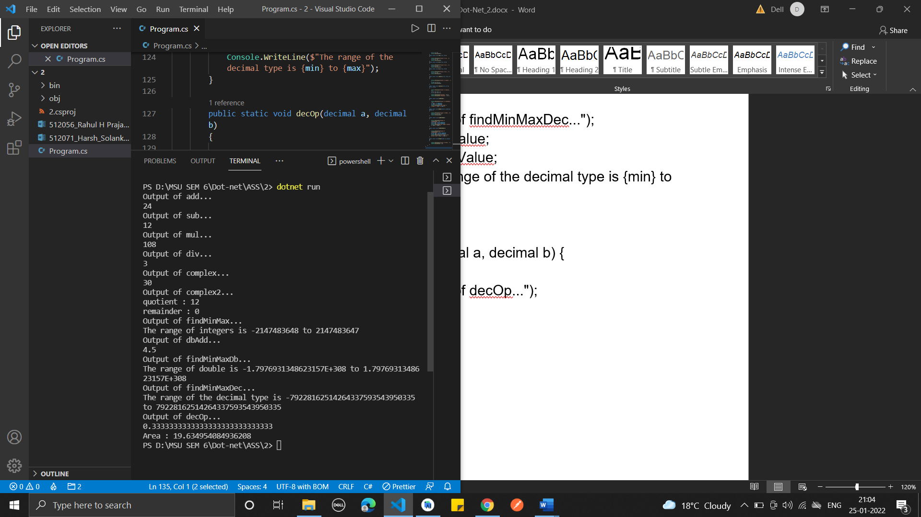

1. **Branches and Loops**

**Code:**

using System;

namespace Code_2

{

class Program

{

static void Main(string[] args)

{

int a = 5;

int b = 6;

int c = 4;

if(a + b > 10) {

Console.WriteLine("This answer is greater than 10. ");

} else {

Console.WriteLine("This answer is greater than 10. ");

}

Pro_2.complexIf(a,b,c);

// loops

int counter = 0;

Pro_2.whileLoop(counter);

Pro_2.doWhileLoop(counter);

Pro_2.forLoop();

Pro_2.nestLoops();

Pro_2.challenge1();

}

}

static class Pro_2 {

public static void complexIf(int a, int b, int c) {

Console.WriteLine("Output of complexIf...");

if ((a + b + c > 10) && (a == b)) {

Console.WriteLine("The answer is greater than 10");

Console.WriteLine("And the first number is equal to the second");

}

else {

Console.WriteLine("The answer is not greater than 10");

Console.WriteLine("Or the first number is not equal to the second");

}

if ((a + b + c > 10) || (a == b)) {

Console.WriteLine("The answer is greater than 10");

Console.WriteLine("And the first number is equal to the second");

}

else {

Console.WriteLine("The answer is not greater than 10");

Console.WriteLine("Or the first number is not equal to the second");

}

}

public static void whileLoop(int counter) {

Console.WriteLine("Output of whileLoop...");

while(counter < 5) {

Console.WriteLine($"Hello World! USING While Loop The counter is {counter}");

counter++;

}

}

public static void doWhileLoop(int counter) {

Console.WriteLine("Output of dowWhileLoop...");

do {

Console.WriteLine($"Hello World! USING Do While Loop The counter is {counter}");

counter++;

} while(counter < 5);

}

public static void forLoop() {

Console.WriteLine("Output of forLoop...");

for(int counter = 0; counter < 10; counter++) {

Console.WriteLine($"Hello World! USING For Loop The counter is {counter}");

}

}

public static void nestLoops() {

Console.WriteLine("Output of nestLoops...");

for (int row = 1; row < 11; row++) {

for (char column = 'a'; column < 'k'; column++) {

Console.WriteLine($"The cell is ({row}, {column})");

}

}

}

public static void challenge1() {

Console.WriteLine("Output of challenge1...");

int sum = 0;

for (int number = 1; number <= 20; number++) {

if (number % 3 == 0) {

sum = sum + number;

}

}

Console.WriteLine($"The sum is {sum}");

}

}

}

**Output :**

