**Name :** Harsh Solanki

**PRN :** 2019033800128221

**Batch : B**

**Roll No. :** 512071

**Assignment - 4**

**GitHub Link : https://github.com/harsh391/dot-net-4**

**Code:**

using System;

namespace Code_1

{

    class Program

    {

        static void Main(string[] args)

        {

            TimePeriod t = new TimePeriod();

            // The property assignment causes the 'set' accessor to be called.

            t.Hours = 24;

            // Retrieving the property causes the 'get' accessor to be called.

            Console.WriteLine($"Time in hours: {t.Hours}");

            var person = new Person("Harsh", "Solanki");

            Console.WriteLine(person.Name);

            var item = new SaleItem { Name = "Shoes", Price = 19.95m };

            Console.WriteLine($"{item.Name}: sells for {item.Price:C2}");

        }

    }

    class TimePeriod

    {

        private double _seconds;

        public double Hours

        {

            get { return _seconds / 3600; }

            set

            {

                if (value < 0 || value > 24)

                {

                    throw new ArgumentOutOfRangeException($"{nameof(value)} must be between 0 and 24.");

                }

                _seconds = value * 3600;

            }

        }

    }

    public class Person

    {

        private string _firstName;

        private string _lastName;

        public Person(string first, string last)

        {

            _firstName = first;

            _lastName = last;

        }

        public string Name => $"{_firstName} {_lastName}";

    }

    public class SaleItem

    {

        public string Name

        { get; set; }

        public decimal Price

        { get; set; }

    }

}

**Output:**

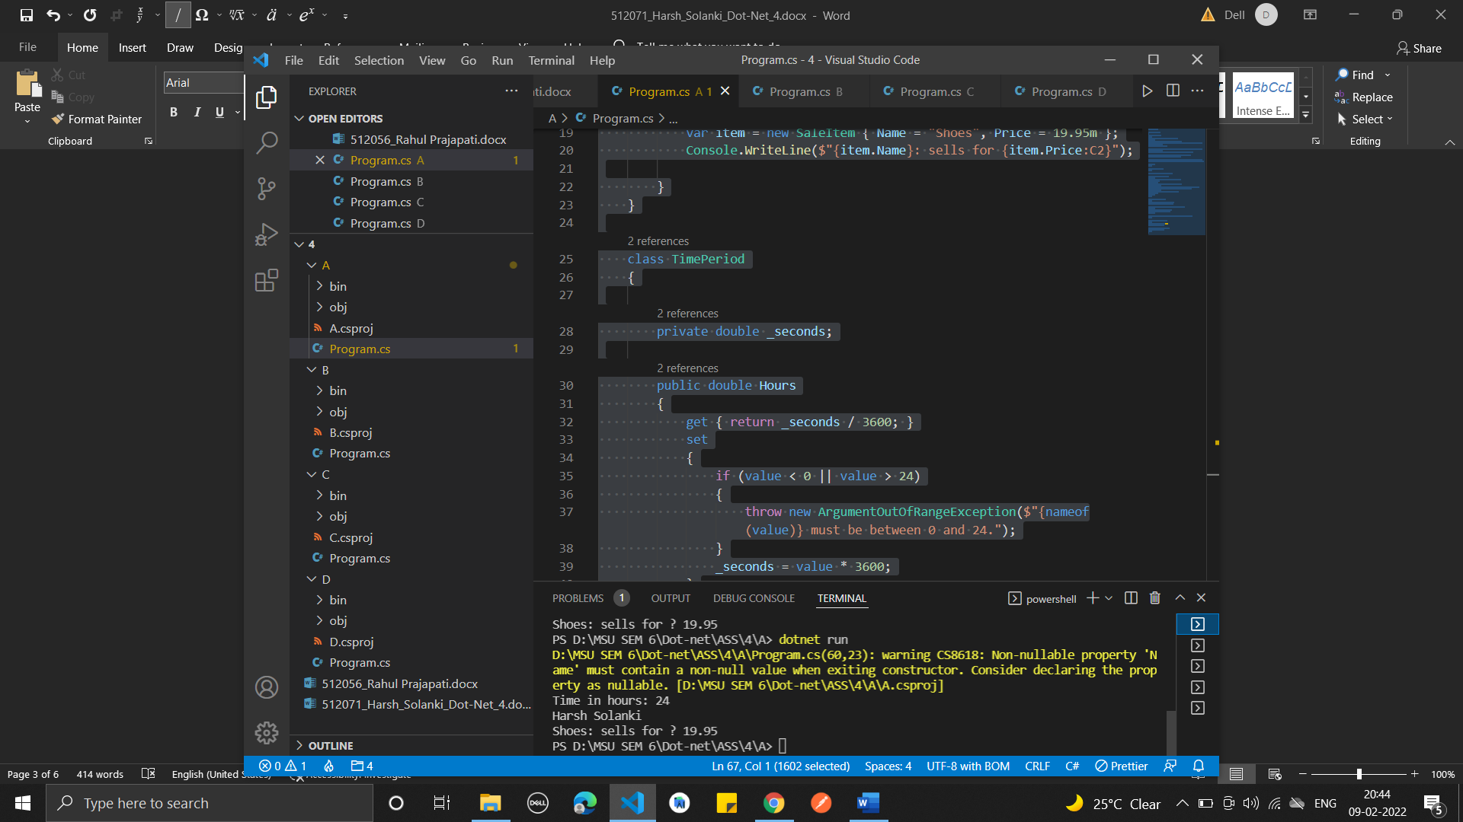

**Code:**

using System;

using Day = System.DayOfWeek;

namespace Code_2

{

    class Program

    {

        static void Main(string[] args)

        {

            //  Example 1

            var tempRecord = new TempRecord();

            // Use the indexer's set accessor

            tempRecord[3] = 58.3F;

            tempRecord[5] = 60.1F;

            // Use the indexer's get accessor

            for (int i = 0; i < 10; i++)

            {

                Console.WriteLine($"Element #{i} = {tempRecord[i]}");

            }

            // Keep the console window open in debug mode.

            Console.WriteLine("Press any key to exit.");

            Console.ReadKey();

            // Example 2

            var week = new DayCollection();

            Console.WriteLine(week["Fri"]);

            try

            {

                Console.WriteLine(week["Made-up day"]);

            }

            catch (ArgumentOutOfRangeException e)

            {

                Console.WriteLine($"Not supported input: {e.Message}");

            }

            // Example 3

        }

    }

    public class TempRecord

    {

        // Array of temperature values

        float[] temps = new float[10]

        {

            56.2F, 56.7F, 56.5F, 56.9F, 58.8F,

            61.3F, 65.9F, 62.1F, 59.2F, 57.5F

        };

        // To enable client code to validate input

        // when accessing your indexer.

        public int Length => temps.Length;

        // Indexer declaration.

        // If index is out of range, the temps array will throw the exception.

        public float this[int index]

        {

            get => temps[index];

            set => temps[index] = value;

        }

    }

    class DayCollection

    {

        string[] days = { "Sun", "Mon", "Tues", "Wed", "Thurs", "Fri", "Sat" };

        // Indexer with only a get accessor with the expression-bodied definition:

        public int this[string day] => FindDayIndex(day);

        private int FindDayIndex(string day)

        {

            for (int j = 0; j < days.Length; j++)

            {

                if (days[j] == day)

                {

                    return j;

                }

            }

            throw new ArgumentOutOfRangeException(

                nameof(day),

                $"Day {day} is not supported.\nDay input must be in the form \"Sun\", \"Mon\", etc");

        }

    }

}

**Output :**

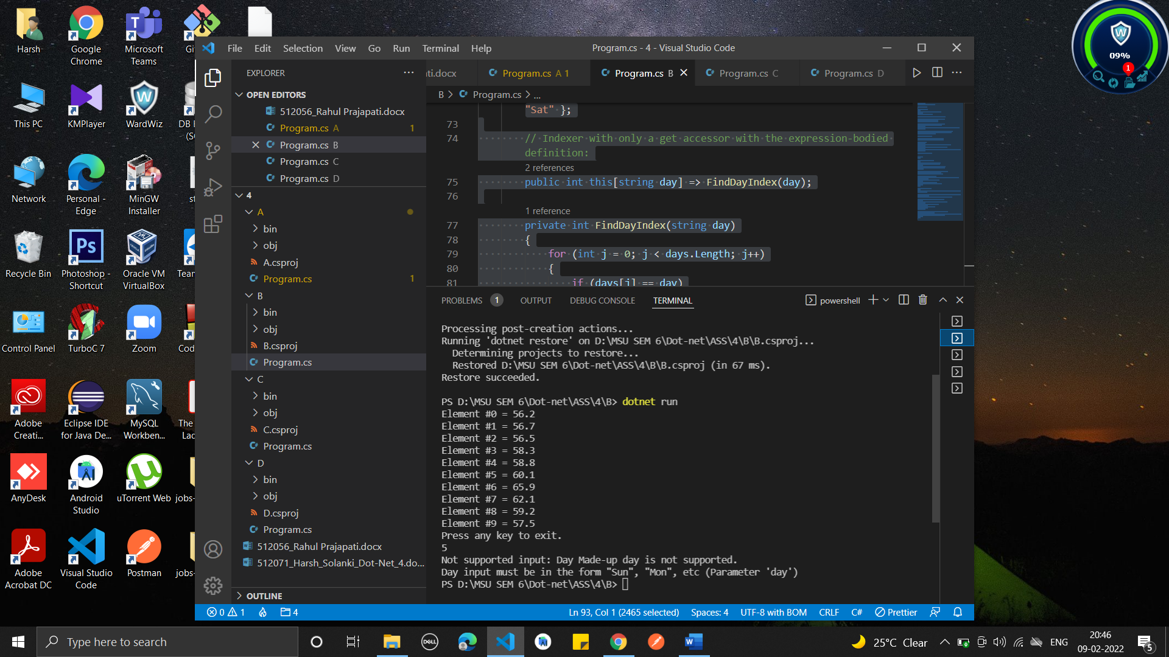

**3.**

**Code:**

using System;

namespace Code_3

{

    class Program

    {

        static void Main(string[] args)

        {

            Employee e1 = new Employee("Harsh", "Solanki", 45000);

            Employee e2 = new Employee("Jaya", "Patel", 23000);

            Console.WriteLine("Before Increament...");

            Console.WriteLine(e1.ToString());

            Console.WriteLine(e2.ToString());

            Console.WriteLine("After Increament...");

            e1.giveRaise(10.0);

            e2.giveRaise(10.0);

            Console.WriteLine(e1.ToString());

            Console.WriteLine(e2.ToString());

            Console.WriteLine("----------- Permanent Employee ---------");

            PermanentEmployee pe1 = new PermanentEmployee("Harsh", "Solanki", 45000, 2000, 1000, 4500, "01-02-2022", "10-05-2022");

            PermanentEmployee pe2 = new PermanentEmployee("Jaya", "Patelc", 23000, 2789, 500, 9500, "01-01-2022", "18-12-2022");

            Console.WriteLine("Before Increament...");

            Console.WriteLine(pe1);

            Console.WriteLine(pe2);

            pe1.giveRaise(10.0);

            pe2.giveRaise(10.0);

            Console.WriteLine("After Increament...");

            Console.WriteLine(pe1.ToString());

            Console.WriteLine(pe2.ToString());

        }

    }

    public class Employee

    {

        private String _firstName;

        private String _lastName;

        private double _monSalary;

        public Employee(String first, String last, double sal)

        {

            _firstName = first;

            _lastName = last;

            _monSalary = sal;

        }

        public String First

        {

            get => _firstName;

            set => _firstName = value;

        }

        public String Last

        {

            get => _lastName;

            set => _lastName = value;

        }

        public double MonSalary

        {

            get => _monSalary;

            set

            {

                if (value < 0.0)

                {

                    _monSalary = 0.0;

                }

                else

                {

                    _monSalary = value;

                }

            }

            // 2nd way

            // set => _monSalary = value < 0.0 ? 0.0 : value;

        }

        public virtual void giveRaise(double inc)

        {

            _monSalary = _monSalary + (_monSalary * inc / 100);

        }

        public override string ToString()

        {

            return "Employee Details : " + _firstName + " " + _lastName + " Yearly Salary : " + (_monSalary) * 12;

        }

    }

    public class PermanentEmployee : Employee

    {

        private double _hra;

        private double _da;

        private double _pf;

        private String _joiningDate;

        private String _retirementDate;

        public PermanentEmployee(String first, String last, double sal, double hra, double da, double pf, String joiningDate, String retirementDate) : base(first, last, sal)

        {

            this._hra = hra;

            this._da = da;

            this._pf = pf;

            this._joiningDate = joiningDate;

            this._retirementDate = retirementDate;

            this.MonSalary = this.MonSalary + _hra + _da;

        }

        public double Hra

        {

            get => _hra;

        }

        public double Da

        {

            get => _da;

        }

        public double Pf

        {

            get => _pf;

        }

        public String JoiningDate

        {

            get => _joiningDate;

            set => _joiningDate = value;

        }

        public String RetirementDate

        {

            get => _retirementDate;

            set => _retirementDate = value;

        }

        public override void giveRaise(double inc)

        {

            this.MonSalary = this.MonSalary + (this.MonSalary * inc) / 100 + _da + _hra;

        }

        public override string ToString()

        {

            return "Permanent Employee Details : " + this.First + " " + this.Last + " Joining Date : " + _joiningDate + " Retirement Date : " + _retirementDate + " Yearly Salary : " + (this.MonSalary) * 12;

        }

    }

}

**Output :**

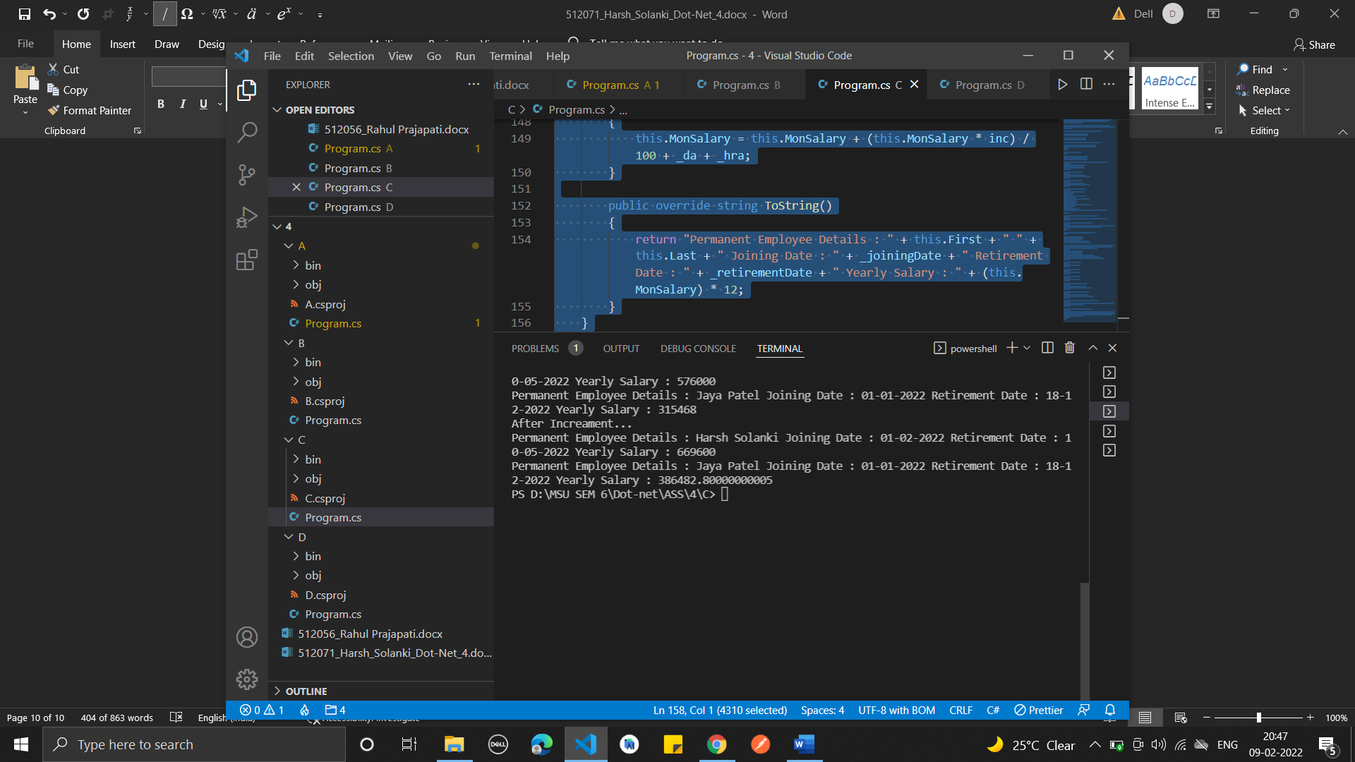

**4.**

**Code:**

using System;

using System.Reflection;

namespace SimpleClassExample

{

    class Program

    {

        static void Main(string[] args)

        {

            Type t = typeof(SimpleClass);

            BindingFlags flags = BindingFlags.Instance | BindingFlags.Static | BindingFlags.Public |

            BindingFlags.NonPublic | BindingFlags.FlattenHierarchy;

            MemberInfo[] members = t.GetMembers(flags);

            Console.WriteLine($"Type {t.Name} has {members.Length} members: ");

            foreach (var member in members)

            {

                string access = "";

                string stat = "";

                var method = member as MethodBase;

                if (method != null)

                {

                    if (method.IsPublic)

                        access = " Public";

                    else if (method.IsPrivate)

                        access = " Private";

                    else if (method.IsFamily)

                        access = " Protected";

                    else if (method.IsAssembly)

                        access = " Internal";

                    else if (method.IsFamilyOrAssembly)

                        access = " Protected Internal ";

                    if (method.IsStatic)

                        stat = " Static";

                }

                var output = $"{member.Name} ({member.MemberType}): {access}{stat}, Declared by {member.DeclaringType}";

                Console.WriteLine(output);

            }

        }

    }

    public class SimpleClass

    {

    }

}

**Output :**

