**QUESTION 1**

What is Random Forest Classifier?

A random forest classifier is the machine learning algorithm which takes the output from various **decision tree** and combine them to give to single result.

Now what is decision tree?

A decision tree basically has some set of rules to make the decision, that’s how humans make decision too. The decision tree starts by splitting the dataset’s features in way that it develops the YES/NO questions and this process is continued until each data belong to one of the classes.

**Observations**

1. Number of base learners = 10

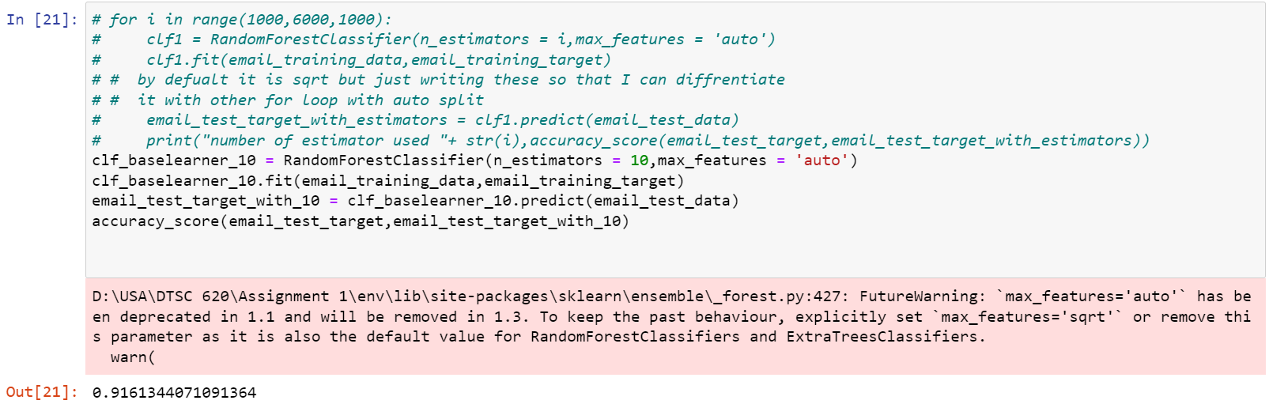

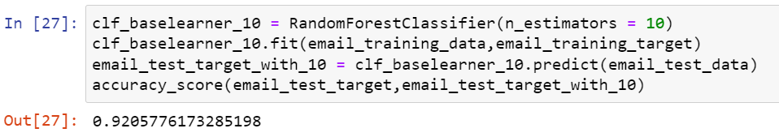

As we can observe that if we use 10 base learner with ‘sqrt’ feature split has slightly more accuracy compared to ‘auto’ feature split.

1. Number of base learners = 50

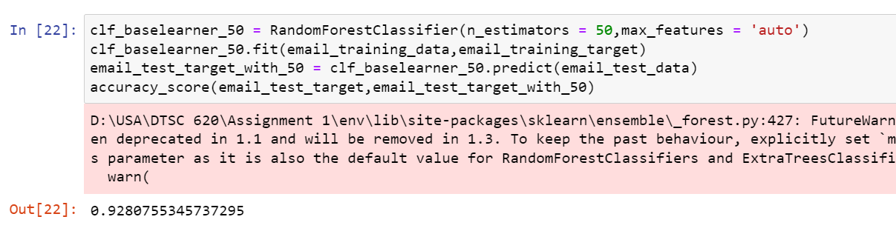

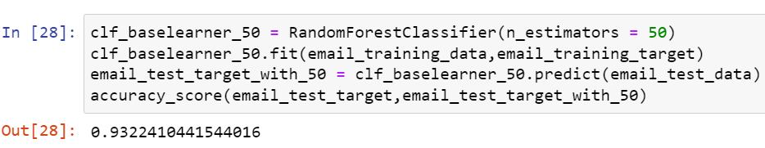

Here we can observe same result as above.

1. Number of base learners = 100

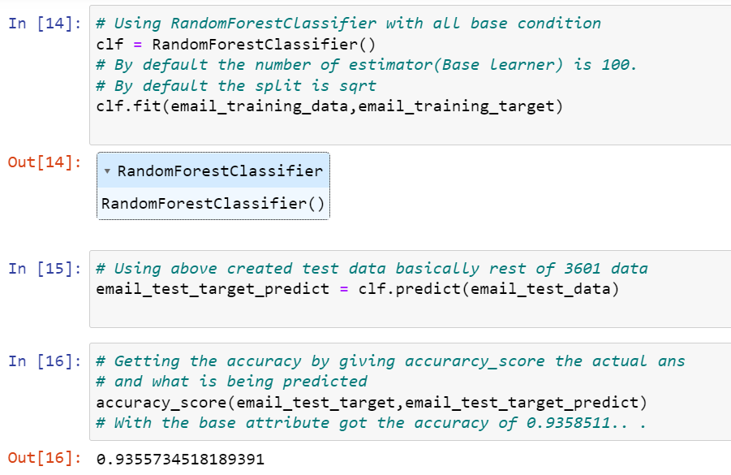

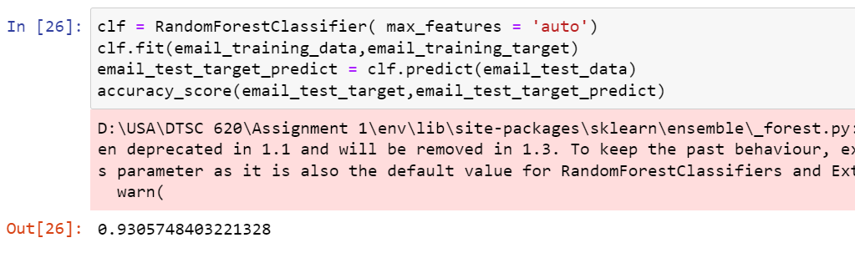

We can observe best accuracy of random forest classifier when we use all default parameter which are number of base learners is 100 and feature split is ‘sqrt’.

1. Number of base learners = 500

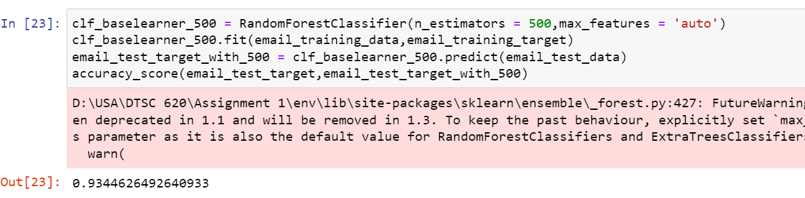

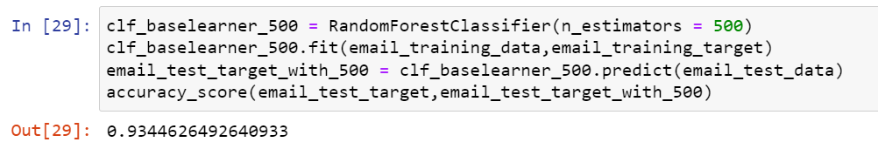

For 500 base learners we got same accuracies for both type of features split.

1. Number of based learners = 1000

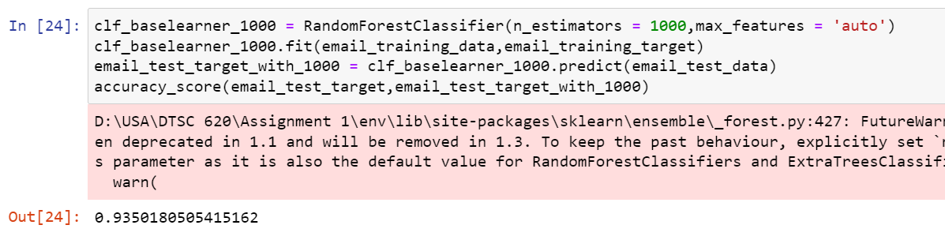

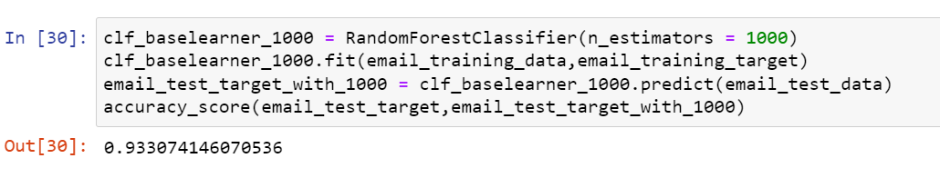

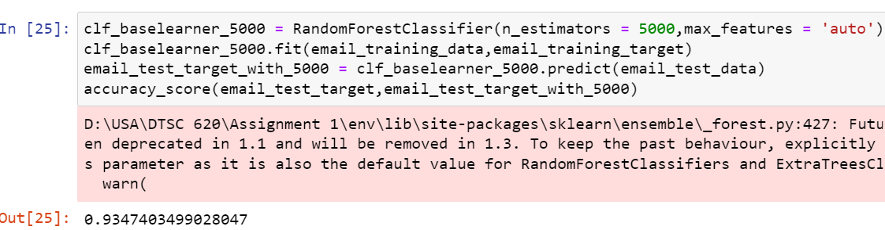

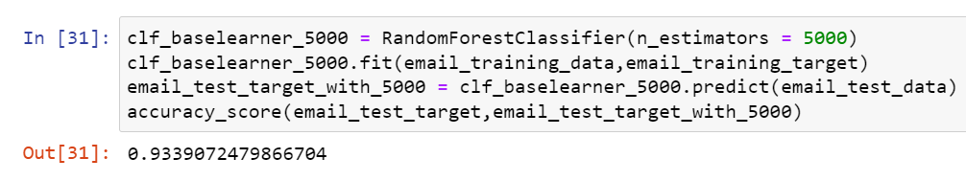

From 500 base learners accuracy for both features split are getting close to 0.02%

**Summary**

|  |  |  |
| --- | --- | --- |
| Number of Base Learners | Features split = ‘auto’ | Features split = ‘sqrt’ |
| 10 | 0.9161344071091364 | 0.9205776173285198 |
| 50 | 0.9280755345737295 | 0.9322410441544016 |
| 100 | 0.9305748403221328 | 0.9355734518189391 |
| 500 | 0.9344626492640933 | 0.9344626492640933 |
| 1000 | 0.9350180505415162 | 0.933074146070536 |
| 5000 | 0.9347403499028047 | 0.9339072479866704 |

The classification accuracy with 10 base learners irrespective to feature split has the lowest accuracy which has average of 91.8%.

The below Screenshot uses Random Forest Classifier with base learner 10 and max_features of auto has the accuracy 91.6%.

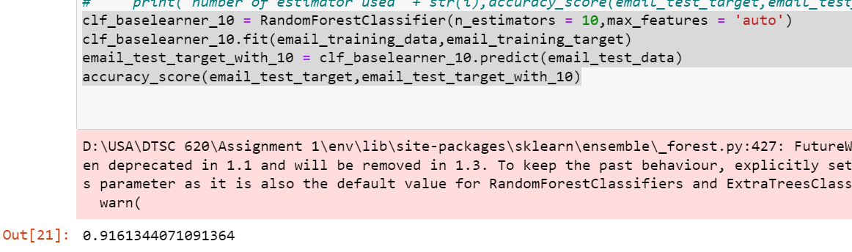

Below Classifier has 10 base learners and max_features of sqrt which has slightly high accuracy.

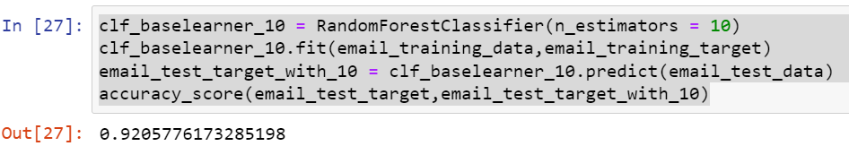

There is not much difference in accuracy if we take number of base learners from 100 to 5000 no matter how we split the data but through experimenting I can conclude that the execution time increases as the number of base learners increases and while increasing the base learner there no much difference in accuracies.

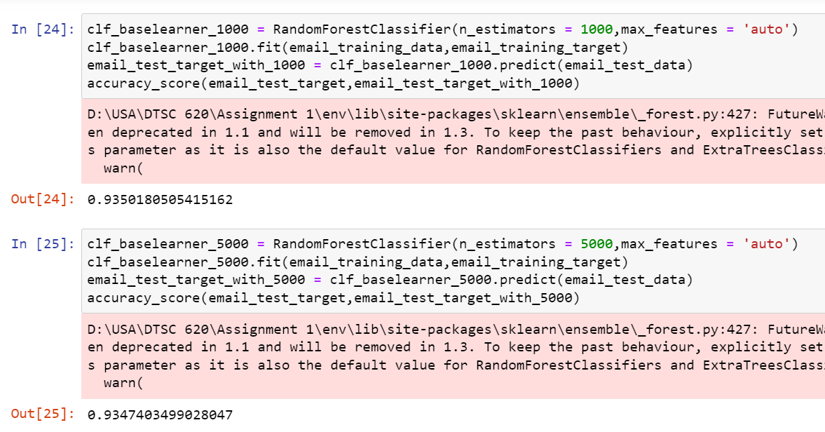

In summary, the classification accuracy increases as number of base learners increase no matter how we split the features ‘auto’ or ‘sqrt’. Also, as number of base learners increases the accuracies get closer to each other. According to me it will be efficient to use feature split of ‘sqrt’ because with a smaller number of base learners it has achieved the highest accuracy. The best parameter for random forest classification is the default one which is 100 base learner and feature split ‘sqrt’. We can also get similar accuracy with 1000 base learners and auto feature split but then the execution time will increase.

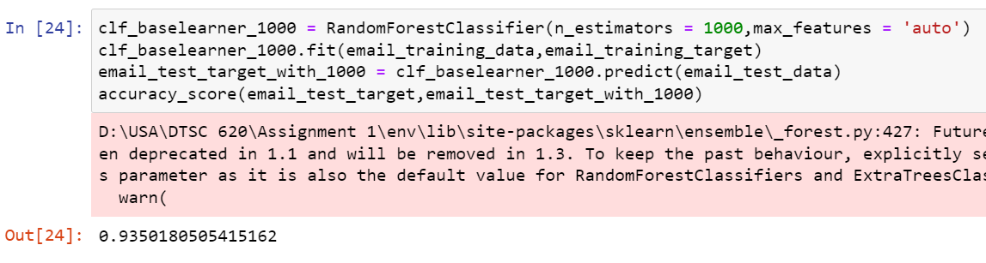

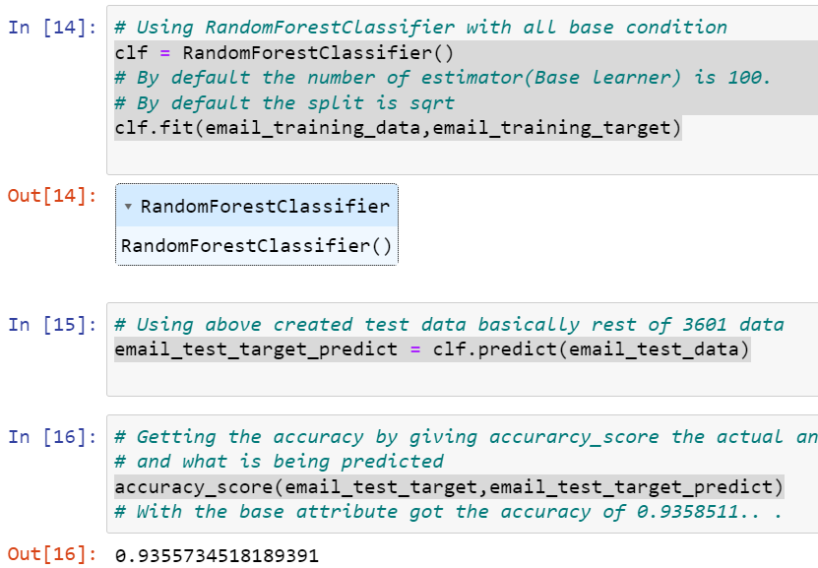

**QUESTION 2**

The decision Tree classifier has classification accuracy of 0.8869758400444321 Random Forest classifier has accuracy has 0.9355734518189391 with the best parameters set for it.

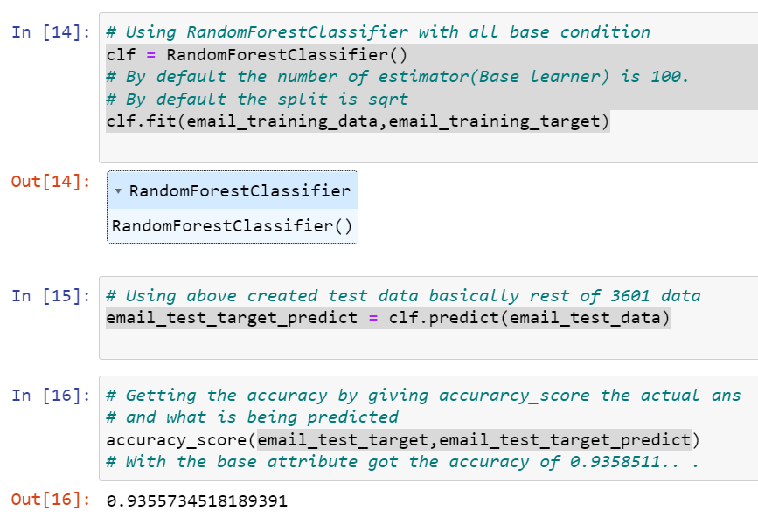

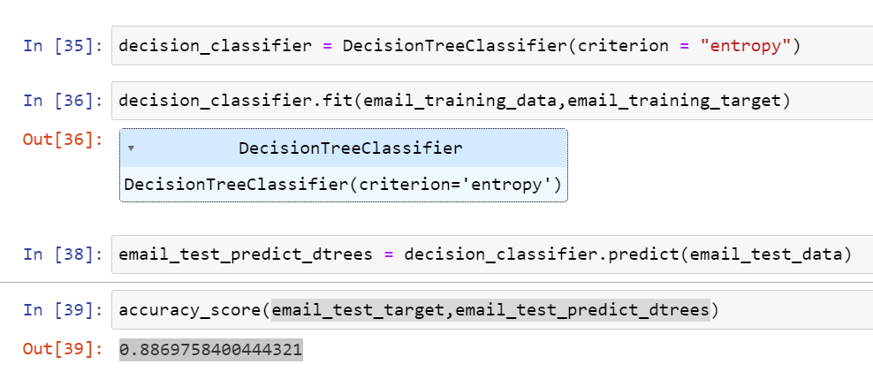

Confusion matrix for Decision Tree classifier is:

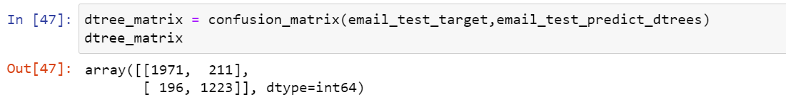

Per class classification accuracy is

(Class ham ,Class spam)

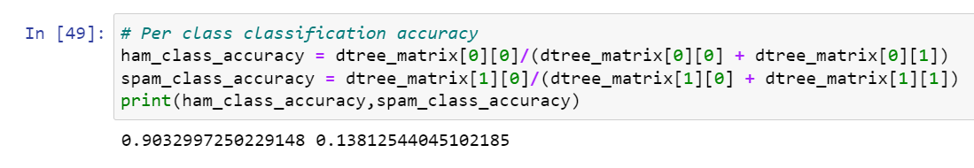

Confusion matrix for Random Forest classifier is:

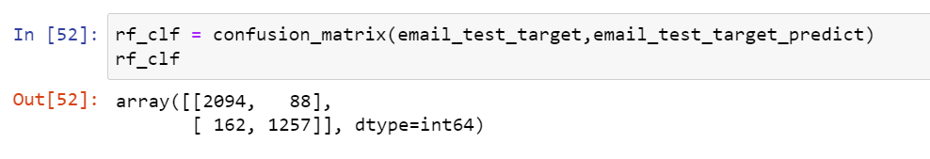

Per class classification accuracy

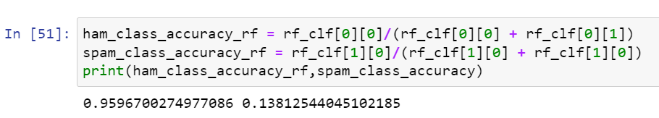

In summary if we see the per class classification accuracy then random forest classifier is best classifier because its classification accuracy for correctly classifying ham class is 95% where as in decision Tree classification the accuracy is 90% which is 5% less.