RAG Chunking Strategy Benchmarking and Recommendation System
Project Documentation

1. Objectives
- To take a single source document and a set of test questions, and run the full RAG pipeline through eight different chunking strategies, so that every method is evaluated under identical conditions rather than being judged in isolation.
- To score each chunking method on multiple dimensions that actually matter in a production RAG system — answer quality, retrieval quality, faithfulness to the source, latency, and token usage — instead of relying on a single proxy metric such as chunk count or average chunk size.
- To combine these dimensions into one ranked leaderboard with a clear top recommendation, along with the reasoning behind it, so that a developer can pick a chunking strategy for their own document without having to repeat this experiment from scratch.

2. Methodology
The system is built as a single Streamlit application (app.py) that runs the entire benchmarking pipeline end-to-end. The methodology follows six stages, described below in the order they execute.

2.1 Document and Question Ingestion
The document is uploaded as a PDF, DOCX, or TXT file. PDF text is extracted page by page using pypdf, DOCX paragraphs are extracted using python-docx, and plain text files are read directly. All extracted text is normalised (collapsing repeated whitespace) before chunking begins. Test questions are supplied either by typing them directly into the interface or by uploading a CSV, TXT, or JSON file; the system auto-detects question and ID columns where possible and removes duplicate questions.

2.2 Chunking
The core of the system is a set of eight independent chunking functions. Each one takes the same raw document text and produces its own separate set of chunks, with its own parameters:
- Fixed Size — splits the text into chunks of a fixed number of words, with no overlap.
- Fixed Overlap — same as fixed size, but consecutive chunks share a configurable number of overlapping words to preserve context across chunk boundaries.
- Sentence Based — groups a fixed number of sentences into each chunk, using sentence-boundary regex splitting.
- Paragraph Based — splits on blank lines (paragraph breaks) and merges paragraphs that fall below a minimum word count, so that very short paragraphs are not left as their own chunk.
- Semantic Chunking — embeds each sentence individually and groups consecutive sentences together as long as their embedding similarity stays above a threshold, falling back to sentence-based chunking if embeddings are unavailable.
- Sliding Window — moves a fixed-size window across the document with a smaller step size than the window itself, so that adjacent chunks overlap by design.
- Recursive Character Splitter — recursively splits text using an ordered list of separators (paragraph breaks, line breaks, sentence breaks, spaces, and finally raw characters) until every chunk is below a maximum character length.
- Hybrid Chunking — combines paragraph splitting, sentence-level splitting of any paragraph that is too long, and a semantic-similarity merge step that joins adjacent segments which are topically related, before a final pass that merges any segments still under the minimum word count.
Every method runs on the same document, producing eight independent chunk sets. Basic statistics (chunk count, average size, minimum and maximum size, standard deviation) are recorded for each set at this stage.

2.3 Embedding and Indexing
Each chunk set is embedded separately using a sentence-transformer model (all-MiniLM-L6-v2 by default). The resulting vectors are L2-normalised so that inner-product search is equivalent to cosine similarity. A separate FAISS index (IndexFlatIP) is built for each of the eight chunking methods, so retrieval for one method never touches the chunks produced by another.

2.4 Retrieval and Answer Generation
For every test question, the question text is embedded with the same model and used to search each method’s FAISS index independently, returning the top-k most similar chunks (k is configurable, default 5). The retrieved chunks are concatenated into a context block and passed into a generation prompt that instructs the model to answer strictly from the given context, or to state that the context is insufficient if the answer is not present. Answer generation supports two backends: a local Flan-T5 model (sequence-to-sequence, runs entirely on CPU/GPU without an external API), or any OpenAI-compatible chat completion API for higher-quality generation. This step is repeated for every question against every chunking method, so the same question is answered eight times — once per method — using only the context that method’s retrieval step produced.

2.5 Evaluation
Each generated answer is scored against its question and its retrieved context using one of two evaluators. The default is a heuristic judge, which uses lexical overlap between the question, the answer, and the context to estimate relevance, faithfulness, completeness, context sufficiency, and hallucination risk, without requiring any external API call. When an API key is supplied, an LLM-as-judge evaluator can be used instead: it sends the question, context, and answer to a language model with instructions to return structured numeric scores in JSON, falling back to the heuristic judge if the response cannot be parsed.

2.6 Ranking
Once every method has been run against every question, the per-question scores are averaged into one summary record per chunking method. Each summary metric is then min-max normalised across the eight methods, so that the best-performing method on any given metric scores 1.0 and the worst scores 0.0 on that metric, regardless of the metric’s original scale. Metrics where a lower value is better — total pipeline time, average context tokens, hallucination risk, and total chunk count — are inverted after normalisation so that a higher normalised value always means a better outcome. These normalised metrics are grouped into six categories: answer quality, retrieval quality, faithfulness, speed efficiency, token efficiency, and chunk quality. Each category is combined into a single final score using a configurable set of weights, which default to 40% answer quality, 25% retrieval quality, 15% faithfulness, 10% speed efficiency, 5% token efficiency, and 5% chunk quality. The eight methods are sorted by this final score to produce the leaderboard, and each method is automatically annotated with a short list of strengths and weaknesses based on threshold rules applied to its own metrics.

3. System Architecture and Working
The diagram below shows how a document and a set of questions move through the system, from raw input to the final ranked leaderboard. The left-hand path shows the document being chunked eight different ways and each chunk set being embedded and indexed on its own. The questions join the pipeline at the retrieval step, where each question is run against all eight indexes independently. From there, every method’s retrieved chunks pass through answer generation and evaluation separately, and the resulting per-method metrics are combined at the ranking step to produce the final leaderboard.
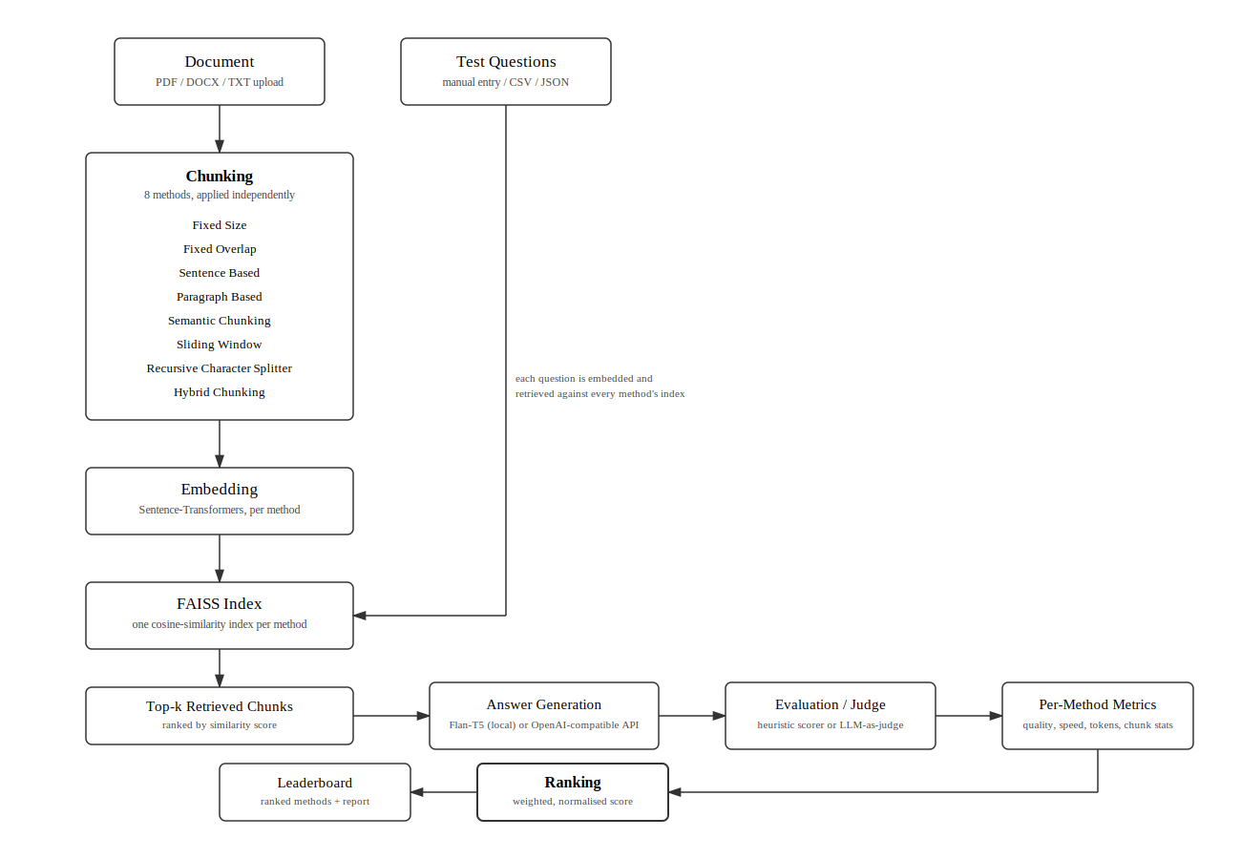
Figure 1. End-to-end pipeline of the chunking benchmark system, from document and question ingestion through chunking, embedding, retrieval, generation, evaluation, and ranking.
A few points about how the architecture is actually implemented, beyond what the diagram shows directly:
- The eight chunking methods are not alternatives selected by the user one at a time — they all run in the same execution, on the same document, so their outputs can be directly compared.
- Each method’s embedding index is completely independent of the others. There is no shared index and no cross-method retrieval; this is what makes it possible to isolate the effect of the chunking strategy itself from everything downstream of it.
- The generation step is interchangeable between a local model and an API-based model without changing anything else in the pipeline, since both paths return the same (answer text, latency) format to the rest of the system.
- The evaluation step is similarly interchangeable between the heuristic judge and the LLM judge, and the LLM judge silently falls back to the heuristic judge if its output cannot be parsed as valid JSON, so the pipeline does not break if the judging model misbehaves.
- The ranking step is the only place where the eight methods are compared against each other directly. Up to that point, every method is scored only against its own retrieved context and its own generated answers.
The application itself is organised as a tabbed Streamlit dashboard, with separate tabs for configuration, the leaderboard, per-question answer comparison, a retrieved-chunk viewer, detailed metric tables, charts, and export options (JSON, CSV, and a generated Markdown report).

4. Results
The system was run on two documents that differ substantially in structure: the National Education Policy 2020 (a 65-page formal government policy document, organised into numbered parts, chapters, and clauses) and Atomic Habits by James Clear (a 256-page narrative non-fiction book, organised into short chapters with frequent headers, footnotes, and front matter). Both runs used the same set of eight chunking methods, the local Flan-T5 generation model, and the heuristic evaluator, with twenty test questions per document. Running both documents through the same pipeline makes it possible to ask not just which chunking method performed best, but whether the answer to that question stays the same across different kinds of documents.

4.1 Leaderboard — National Education Policy 2020
Rank | Method | Score | Relev. | Correct. | Faithf. | Latency (ms) | Ctx. Tokens | Chunks
1 | semantic_chunking | 0.744 | 0.157 | 0.566 | 0.975 | 19227 | 616 | 469
2 | recursive_character_splitter | 0.665 | 0.173 | 0.559 | 0.975 | 26218 | 838 | 317
3 | sliding_window | 0.643 | 0.205 | 0.550 | 0.925 | 27682 | 1966 | 265
4 | sentence_based | 0.542 | 0.093 | 0.537 | 0.980 | 22118 | 877 | 327
5 | fixed_size | 0.503 | 0.162 | 0.506 | 0.850 | 27416 | 1964 | 133
6 | hybrid_chunking | 0.431 | 0.140 | 0.464 | 0.848 | 23978 | 1302 | 191
7 | paragraph_based | 0.407 | 0.176 | 0.433 | 0.750 | 23759 | 1804 | 147
8 | fixed_overlap | 0.391 | 0.073 | 0.536 | 1.000 | 25255 | 1952 | 159
On this document, semantic_chunking ranked first by a clear margin, followed by recursive_character_splitter and sliding_window. The top-ranked method used far fewer context tokens per question (616, against 1300–2000 for most other methods) while still matching or beating them on correctness and faithfulness, which is what drove its final score under the default weighting. fixed_overlap ranked last, despite having perfect faithfulness (1.000); its relevance score (0.073) was the lowest of any method on this document, indicating that its answers, while strictly grounded in the retrieved context, were frequently not addressing what the question actually asked.

4.2 Leaderboard — Atomic Habits
Rank | Method | Score | Relev. | Correct. | Faithf. | Latency (ms) | Ctx. Tokens | Chunks
1 | sentence_based | 0.740 | 0.277 | 0.613 | 0.950 | 19246 | 534 | 944
2 | semantic_chunking | 0.655 | 0.254 | 0.626 | 0.998 | 28798 | 670 | 880
3 | recursive_character_splitter | 0.477 | 0.172 | 0.485 | 0.798 | 25421 | 1037 | 510
4 | paragraph_based | 0.398 | 0.139 | 0.487 | 0.865 | 23680 | 1578 | 263
5 | sliding_window | 0.397 | 0.098 | 0.499 | 0.900 | 31982 | 1976 | 521
6 | fixed_size | 0.308 | 0.193 | 0.513 | 0.893 | 32008 | 2007 | 261
7 | fixed_overlap | 0.304 | 0.191 | 0.485 | 0.840 | 27034 | 2023 | 312
8 | hybrid_chunking | 0.240 | 0.103 | 0.421 | 0.800 | 27353 | 1659 | 328
On this document, the ranking changes considerably. sentence_based moves from fourth place on the policy document to first place here, and semantic_chunking — the top method on the policy document — drops to second. hybrid_chunking, which placed mid-table on the policy document, ranks last here, with the lowest correctness (0.421) and faithfulness (0.800) of any method on either document.

4.3 Comparison Across Documents
The table below lines up each method’s chunk count and average chunk size across both documents, since the underlying document length and structure directly shape how each method behaves.
Method | NEP Chunks | NEP Avg Words | Habits Chunks | Habits Avg Words
semantic_chunking | 469 | 84.7 | 880 | 88.7
recursive_character_splitter | 317 | 125.4 | 510 | 153.0
sliding_window | 265 | 299.3 | 521 | 299.3
sentence_based | 327 | 121.5 | 944 | 82.7
fixed_size | 133 | 298.8 | 261 | 299.0
hybrid_chunking | 191 | 208.0 | 328 | 237.9
paragraph_based | 147 | 270.3 | 263 | 296.8
fixed_overlap | 159 | 299.6 | 312 | 300.0
Two findings stand out from comparing the two leaderboards directly.
First, no single chunking method was best on both documents. semantic_chunking won on the National Education Policy 2020 but only placed second on Atomic Habits; sentence_based won on Atomic Habits but only placed fourth on the policy document. This suggests that the right chunking strategy depends on the structure of the document being chunked, rather than there being one strategy that is generally superior. The policy document is written in long, formally structured paragraphs with consistent terminology, which appears to suit semantic grouping well — sentences on the same topic tend to stay together and the similarity-based grouping has clean boundaries to work with. Atomic Habits is written in much shorter, more conversational sentences with frequent topic shifts within a single paragraph, which appears to suit straightforward sentence-grouping better than similarity-based grouping.
Second, hybrid_chunking was the only method whose rank dropped sharply between the two documents (sixth on the policy document, last on Atomic Habits), and its lowest scores of any method on either document both occurred on Atomic Habits. Tracing this through the retrieved-chunk output for that run showed that hybrid_chunking’s semantic-merge step, which is designed to combine short segments that are topically related, sometimes failed to merge short chapter titles, footnotes, and front-matter lines (such as the table of contents) into surrounding body text, because their embeddings were not similar enough to neighbouring sentences to trigger a merge. These short, low-information segments occasionally surfaced as top-ranked retrieved chunks for ordinary content questions. Atomic Habits, as a published book, contains considerably more of this kind of short structural text — chapter headers, footnotes, a table of contents — than a continuous policy document does, which is consistent with hybrid_chunking underperforming specifically on this document and not on the other.

4.4 Summary
Across both documents, semantic_chunking and sentence_based were consistently the two strongest performers, while fixed_overlap and hybrid_chunking were consistently among the weakest, though for different reasons in each case — fixed_overlap for low relevance despite high faithfulness, and hybrid_chunking for retrieving short, low-information segments on documents with significant structural front matter. paragraph_based and recursive_character_splitter sit in the middle on both documents, neither standing out nor failing outright. The overall finding is that chunking strategy selection should be informed by document structure rather than fixed in advance, and that a system such as this one — which runs every candidate strategy against the same document and the same questions before deciding — is a more reliable way to make that choice than picking a strategy by convention.

