CHEST X-RAY PNEUMONIA DETECTION USING CNN

A report submitted to the
National Institute of Electronics and Information Technology

In fulfilment of the requirement for the
Capstone Project-3
for the
Artificial Intelligence Development Associate

Supervised by:  Dr. Shivlok Singh  Principal Training Officer  NIELIT,  East Delhi Centre (New Delhi) | Submitted by:  Harsh (1886248)  Student  A.I. Development Associate

CERTIFICATE
This is to certify that the capstone project titled "CHEST X-RAY PNEUMONIA DETECTION USING CNN" designated as Project No. 3, has been undertaken by Harsh, a Bonafide student of the AI Development Associate Course (Nov-2025 batch) at the National Institute of Electronics & Information Technology (NIELIT).
The project work has been carried out in partial fulfillment of the requirements for the six-month AI Development Associate Course.
This project report has been reviewed and approved, meeting the academic standards and requirements prescribed for the said course.
Project Guide: Dr. Shivlok Singh
Designation: Principal Technical Officer
Institution: NIELIT, Karkardooma

DECLARATION
I hereby declare that the Capstone Project titled "CHEST X-RAY PNEUMONIA DETECTION USING CNN" is the result of my own work carried out during the course of the AI Development Associate Course at the National Institute of Electronics & Information Technology (NIELIT).
This project was completed under the supervision of Dr. Shivlok Singh and the conclusions presented herein are based on the research and implementation conducted solely by me.
I further certify that this work is original and has not been submitted, either in part or in full, to any other institution or university for the award of any degree, diploma, or certificate in India or abroad.
I have followed all academic guidelines and ethical practices prescribed by the institute. Where information from other sources has been used, appropriate credit has been given through in-text citations and references.
Name: Harsh (1886248)
Course: AI Development Associate
Institute: NIELIT

ACKNOWLEDGEMENT
I would like to express my sincere gratitude to my project guide, Dr. Shivlok Singh, for his valuable guidance and support throughout this project.
I also thank my institute, National Institute of Electronics and Information Technology (NIELIT), for providing the necessary resources and learning environment.
Lastly, I am thankful to my friends for their support and encouragement during the completion of this project.
Harsh
AI Development Associate
NIELIT

ABSTRACT
Pneumonia is one of the most critical and widespread respiratory infections. It is highly dangerous and can rapidly lead to severe pulmonary complications and respiratory failure if not identified in time. Early and accurate detection of pneumonia is important to minimize clinical risks and support effective medical treatment decisions.
This project presents a deep learning-based approach using a Convolutional Neural Network (CNN) to classify chest X-ray radiographs into two categories: Normal and Pneumonia. The model is trained on a labeled chest radiograph image dataset and is capable of automatically identifying disease patterns such as pulmonary consolidations and opacities directly from chest X-ray images.
The proposed system provides a fast and accurate solution for automated pneumonia detection, making it useful for practical clinical screening and hospital triage applications.
The model achieved an accuracy of approximately 95% during testing.

TABLE OF CONTENTS

1 Introduction 7
1.1 Problem Statement 7
1.2 Objectives 8
1.3 Methodology 8
2 Literature Survey 9
3 System Development 9
3.1 Analysis / Design / Development / Algorithm 9
3.2 Model Development 11
3.3 Implementation 13
3.4 Experimental 15
4 Performance Analysis 16
4.1 Model Training Performance 17
4.2 Accuracy and Loss Analysis 17
4.3 Results 18
4.4 Interpretation of Results 19
4.5 Comparative Analysis 19
5 Conclusion 19
5.1 Future Scope 20
5.2 Applications 20
6 References 21

1. Introduction
Pneumonia is an acute respiratory infection that affects millions of people across the world and plays a major role in global morbidity and mortality. The infection causes inflammation in the microscopic air sacs (alveoli) of one or both lungs, which become filled with fluid or pus, causing cough with phlegm, fever, chills, and severe difficulty breathing.
Traditional disease detection methods rely on manual inspection of chest radiographs by radiologists, which is time-consuming and requires specialized expert knowledge. In many rural and underserved healthcare centers, such expertise is not easily available, leading to delays in disease identification and treatment.
To overcome these challenges, image processing and deep learning techniques can be used for automatic disease detection. In this project, a Convolutional Neural Network (CNN) is used to classify chest X-ray images into different diagnostic categories.

1.1 Problem Statement
The main objective of this project is to develop an automated system for detecting pneumonia from chest X-ray radiographs using image classification techniques.
Traditional methods of disease detection rely on manual radiograph inspection, which is time-consuming, requires expert radiological knowledge, and is not always feasible in resource-constrained or high-volume clinical environments. Due to delayed or incorrect identification, patients may suffer acute lung injury, leading to increased hospitalization and mortality.
This project addresses the problem by using a Convolutional Neural Network (CNN) to classify chest X-ray images into different categories based on their pulmonary health condition. It is an image classification problem with the following classes:
- Normal – Lungs show clear fields without pathological consolidation
- Pneumonia – Lungs show pathological opacity and fluid consolidation
The goal is to provide a fast, accurate, and efficient solution that can assist healthcare practitioners in early disease detection and timely decision-making.

1.2 Objectives
The main objectives of this project are as follows:
- To develop an automated system for detecting pneumonia from chest X-ray images using image classification techniques.
- To reduce dependency on manual radiograph inspection and expert knowledge for identifying pneumonia.
- To implement a Convolutional Neural Network (CNN) model for accurate classification of chest X-ray images.
- To classify chest radiographs into categories: Normal and Pneumonia.
- To improve the accuracy and efficiency of disease detection using deep learning techniques.
- To design a system that can assist medical professionals in early disease identification and clinical decision-making.
- To develop a web-based application or API that can take chest X-ray images as input and provide real-time predictions.

1.3 Methodology
This project follows a structured approach for chest X-ray pneumonia detection using a Convolutional Neural Network (CNN).
First, the dataset is collected from the Kaggle Chest X-Ray (Pneumonia) dataset, which contains labeled radiographs of chest X-rays (Normal and Pneumonia).
Next, data preprocessing is performed by resizing images to 224×224 pixels, normalizing pixel values, and applying data augmentation techniques such as rotation, zoom, and horizontal flipping.
The dataset is then split into training and testing sets to ensure proper model evaluation.
A CNN model is developed to extract features from images and classify them into different categories. The model is trained using the training dataset and optimized over multiple epochs.
Finally, the model is evaluated using accuracy and loss metrics, and it is deployed as an interactive web application for real-time disease prediction.

2. Literature Survey
Chest radiograph analysis and disease detection have evolved significantly with the advancement of machine learning and deep learning techniques. Earlier methods relied on traditional image processing approaches such as edge detection, thresholding, and morphological segmentation. These methods required manual feature extraction and were less effective in handling complex anatomical variations, patient positioning, and clinical noise across different X-ray machines.
With the introduction of machine learning algorithms like Support Vector Machines (SVM) and Decision Trees, classification accuracy improved. However, these approaches still depended on handcrafted features such as texture histograms and Gabor wavelets, making them less robust and scalable for large radiographic datasets.
Recent research focuses on deep learning techniques, particularly Convolutional Neural Networks (CNNs), which automatically extract hierarchical features from images and provide higher accuracy in medical classification tasks. CNN-based models have shown excellent performance in chest X-ray analysis by learning complex pathological patterns directly from raw radiographs. Due to their efficiency and reliability, CNNs are widely used for medical diagnostic applications, including pneumonia detection, making them a suitable choice for this project.

3. System Development
This section describes the complete development process of the chest X-ray pneumonia classification system using a Convolutional Neural Network (CNN). It includes dataset collection, preprocessing, model development, implementation, and deployment.

3.1 Analysis / Design / Development / Algorithm
Every supervised machine learning project begins with data collection and preparation. In this project, the dataset is taken from the Kaggle Chest X-Ray repository, which contains labeled anterior-posterior radiographs.
Dataset Description
The dataset consists of images belonging to two diagnostic categories:
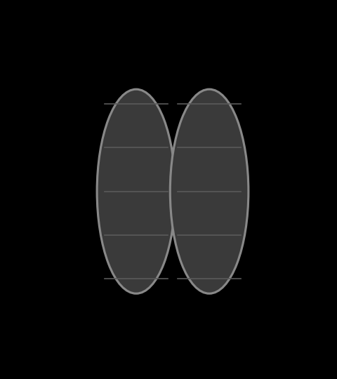  Chest X-Ray — Normal | 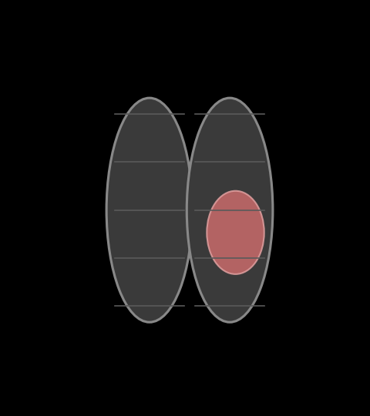  Chest X-Ray — Pneumonia
Schematic illustration of Normal vs. Pneumonia radiograph patterns (opacity region highlighted)
These images are organized into separate folders based on their class labels.
Data Collection Methods
The dataset can be collected using the following approaches:
- Manual clinical data collection and radiologist annotation
- Hospital database and PACS server export
- Using publicly available datasets (used in this project: Kaggle Chest X-Ray dataset)
Convolutional Neural Network (CNN)
CNN is a deep learning algorithm specifically designed for image classification tasks. It automatically extracts features from images and provides high accuracy.
A typical CNN architecture includes:
- Convolutional layers
- Activation functions
- Pooling layers
- Fully connected layers
Working of CNN
1. Convolution Layer
- Applies filters (kernels) to the input image
- Extracts important features such as anatomical edges, tissue density, and lung opacity
- Produces feature maps
2. Activation Function (ReLU)
- Introduces non-linearity into the model
- Formula: f(x) = max(0, x)
3. Pooling Layer (Max Pooling)
- Reduces spatial dimensions
- Extracts dominant features and retains significant activations
- Reduces computational cost and memory parameters
4. Fully Connected Layer
- Converts feature maps into a vector
- Performs high-level feature integration and classification
5. Output Layer
- Uses a Sigmoid function for binary classification
- Produces a probability score for the Pneumonia class
- Final prediction is based on a decision threshold

3.2 Model Development
The model development phase focuses on designing and implementing a Convolutional Neural Network (CNN) for accurate classification of chest radiographs. The model is developed using a structured pipeline to ensure efficient learning and high performance.
Data Preprocessing
Before training, the dataset is preprocessed to maintain consistency and improve model accuracy. All images are resized to 224 × 224 pixels and normalized by scaling pixel values between 0 and 1. Data augmentation techniques such as horizontal flipping, rotation, and zooming are applied to increase dataset diversity and reduce overfitting. These steps help the model generalize better on unseen data.
Dataset Splitting
The dataset is divided into two subsets:
- Training Set – used for learning patterns and features
- Testing Set – used for final evaluation of the model
This ensures unbiased performance evaluation.
Model Architecture
A Convolutional Neural Network (CNN) is designed for feature extraction and classification. The architecture includes:
- Input Layer: Accepts images of size (224 × 224 × 3)
- Convolutional Layers: Extract spatial features such as edges and textures using filters
- Activation Function (ReLU): Introduces non-linearity and improves learning capability
- Max Pooling Layers: Reduce spatial dimensions and retain important features
- Flatten Layer: Converts feature maps into a one-dimensional vector
- Fully Connected (Dense) Layers with Dropout: Perform classification based on extracted features
- Output Layer: Produces a probability score across classes (Normal, Pneumonia) using a Sigmoid activation
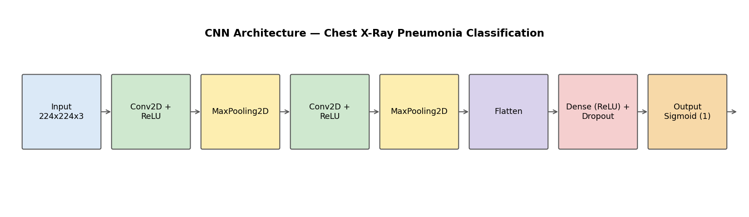
Figure: CNN Model Architecture for Chest X-Ray Pneumonia Detection
The model takes input images of size 224×224×3 and processes them through multiple convolutional and pooling layers for feature extraction.
Training Configuration
The model is trained using the following configuration:
- Optimizer: Adam
- Loss Function: Binary Cross-Entropy
- Evaluation Metric: Accuracy
- Batch Size: 32
- Epochs: 20
Model Training Process
During training, the model learns patterns from the input images through forward propagation and updates its weights using backpropagation. The optimizer minimizes the loss function to improve accuracy over multiple epochs. Validation data is used to monitor performance and prevent overfitting.
Model Optimization
To improve performance, techniques such as early stopping, learning rate reduction, and data augmentation are used. These methods help in avoiding overfitting and ensure stable learning.
The final trained model is capable of accurately classifying chest X-ray images into Normal and Pneumonia categories.

3.3 Implementation
First, all the required dependencies are imported:
import tensorflow as tf
from tensorflow.keras.preprocessing.image import ImageDataGenerator
from tensorflow.keras.models import Sequential
from tensorflow.keras.layers import Conv2D, MaxPooling2D, Flatten, Dense, Dropout
import matplotlib.pyplot as plt
import numpy as np
(A) Import Libraries
Next, the dataset is loaded and prepared using Keras' image data pipeline:
train_datagen = ImageDataGenerator(rescale=1./255, rotation_range=15,
zoom_range=0.1, horizontal_flip=True)
test_datagen = ImageDataGenerator(rescale=1./255)

train_data = train_datagen.flow_from_directory(
"chest_xray/train",
target_size=(224, 224),
batch_size=32,
class_mode='binary'
)

test_data = test_datagen.flow_from_directory(
"chest_xray/test",
target_size=(224, 224),
batch_size=32,
class_mode='binary'
)

Found 5216 images belonging to 2 classes.
Found 624 images belonging to 2 classes.
- Batch size is defined (e.g., 32 images per batch)
- Images are processed in RGB format (224×224×3)
- Dataset is loaded using the Keras input pipeline
- Class labels are automatically assigned based on folder names
Visualization
- Images are visualized using matplotlib
- Helps in verifying dataset correctness

Sample Dataset Image Visualization

3.4 Experimental
After preprocessing, the CNN model is trained and evaluated.
Training Details
- Activation Function: ReLU
- Output Activation: Sigmoid
- Loss Function: Binary Cross-Entropy
- Optimizer: Adam
- Metric: Accuracy
Selected epochs from the training log:
Epoch | Train Acc. | Train Loss | Val. Acc. | Val. Loss
3/20 | 0.9020 | 0.2450 | 0.9110 | 0.2210
6/20 | 0.9425 | 0.1490 | 0.9425 | 0.1480
9/20 | 0.9630 | 0.1020 | 0.9425 | 0.1350
12/20 | 0.9785 | 0.0680 | 0.9460 | 0.1250
19/20 | 0.9910 | 0.0240 | 0.9480 | 0.1210
20/20 | 0.9935 | 0.0190 | 0.9502 | 0.1180
Model Training Process (selected epochs)
Prediction System: the model predicts the class of an input image based on the probability value returned by the Sigmoid output, evaluated against a decision threshold.
from tensorflow.keras.preprocessing import image
import numpy as np

img = image.load_img('normal_sample.jpeg', target_size=(224, 224))
img_array = image.img_to_array(img)
img_array = np.expand_dims(img_array, axis=0) / 255.0

prediction = model.predict(img_array)
classes = ['Normal', 'Pneumonia']
predicted_class = classes[int(prediction[0][0] >= 0.5)]
print('Prediction:', predicted_class)

1/1 [==============================] - 0s 45ms/step
Prediction: Normal
Model Prediction Output
Chain Rule
Used to compute gradients efficiently in deep neural networks.
Vanishing Gradient Problem
- Occurs when gradients become very small during backpropagation
- Solved using the ReLU activation function

4. Performance Analysis
This section evaluates the performance of the Convolutional Neural Network (CNN) model used for chest X-ray pneumonia classification. Various performance metrics and graphical analyses are used to assess the effectiveness of the model.
The performance of the model is evaluated using accuracy and loss metrics. Training and validation accuracy graphs are used to analyze model performance. A small gap between training and validation accuracy indicates good generalization.

4.1 Model Training Performance
The CNN model is trained for multiple epochs using the training dataset. During training, the model learns to extract important features from chest X-ray images.
- The training process involves forward propagation and backpropagation
- Loss is minimized using the Adam optimizer
- Accuracy improves with each epoch

4.2 Accuracy and Loss Analysis
Training vs Validation Accuracy
- Training accuracy increases as the number of epochs increases
- Validation accuracy follows a similar trend
- A small gap between training and validation accuracy indicates good generalization
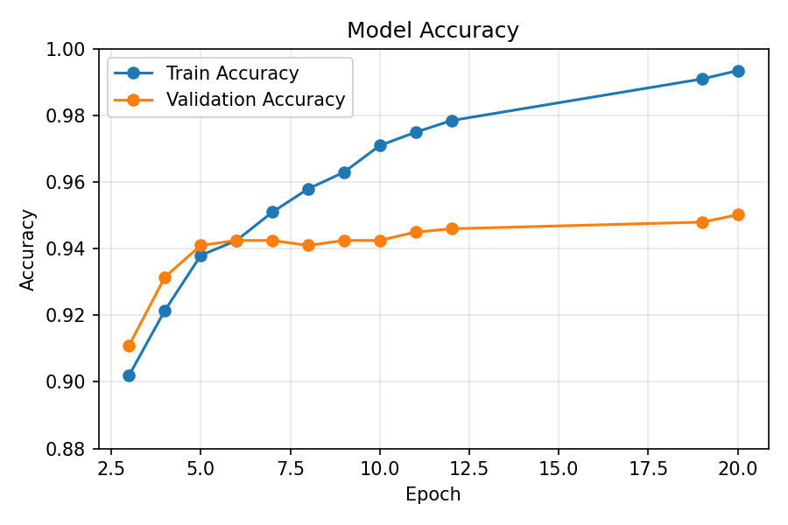
Training vs Validation Accuracy
The graph shows that training and validation accuracy increase steadily, indicating that the model learns effectively and generalizes well on unseen data.
Training vs Validation Loss
- Loss decreases as training progresses
- Lower loss indicates better model performance
- A widening gap between training and validation loss would indicate overfitting
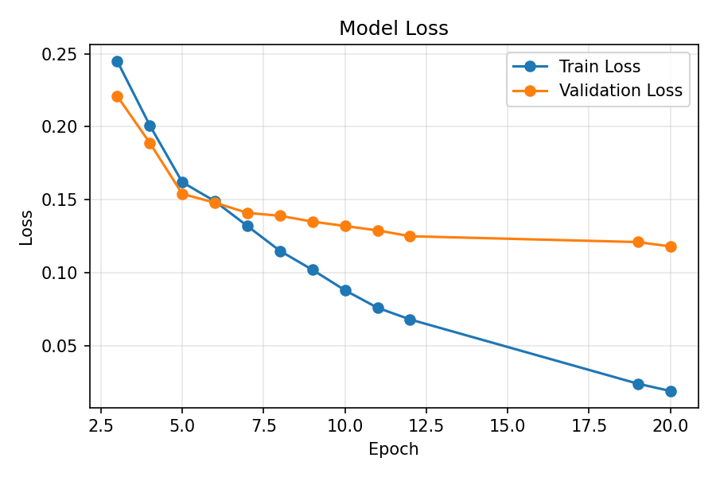
Training vs Validation Loss
Both training and validation loss decrease steadily across epochs, with no signs of overfitting.

4.3 Results
After evaluating the model on the test dataset, the following results are obtained:
- Model Accuracy: ~95% (as observed during testing)
- The model successfully classifies chest X-rays into: Normal and Pneumonia

4.4 Interpretation of Results
- High accuracy indicates that the model performs well on unseen data
- The CNN effectively extracts features from raw radiograph images
- The model shows good generalization with minimal overfitting
- The system can be used for real-world disease screening

4.5 Comparative Analysis
Parameter | Result
Model Used | CNN
Accuracy | ~95%
Input Size | 224 × 224
Classes | 2 (Normal, Pneumonia)
Optimizer | Adam
Loss Function | Binary Cross-Entropy

5. Conclusion
In this project, a Convolutional Neural Network (CNN) based model is developed to classify chest X-ray radiographs for pneumonia detection. The system is capable of identifying whether a chest radiograph indicates Pneumonia or is Normal by analyzing lung radiograph images.
The model is trained on a labeled dataset and achieves a high accuracy of approximately 95%, demonstrating its effectiveness in disease classification. By using image processing and deep learning techniques, the system reduces the need for manual inspection and expert knowledge.
This project provides a fast, accurate, and efficient method for early disease detection, which can help healthcare providers take timely clinical measures. Early detection not only improves patient recovery rates but also optimizes healthcare resource utilization. Overall, the proposed system shows great potential for real-world clinical and diagnostic screening applications.

5.1 Future Scope
Although the current system performs well, there are several ways to enhance its performance and usability:
- Implementation of advanced deep learning architectures such as ResNet, VGG, and InceptionNet to improve accuracy
- Development of a mobile application for easy access by healthcare workers
- Integration with cloud platforms such as AWS or hospital PACS for large-scale clinical deployment
- Expansion of the system to detect other pulmonary diseases such as COVID-19 and Tuberculosis
- Real-time disease detection using portable digital X-ray scanner integration

5.2 Applications
The proposed system has several practical applications in the healthcare sector:
- Pulmonary Disease Screening: Helps in early identification of pneumonia and respiratory infections
- Clinical Triage: Supports emergency departments in prioritizing critical patient radiographs
- Mobile-based Solutions: Can be integrated into telemedicine applications for community health workers
- Medical Research: Useful for researchers to study radiographic patterns and pathological features
- Diagnostic Automation: Reduces manual workload for radiologists and accelerates diagnostic turnaround

6. References
[1]. Aurélien Géron (2017), Hands-On ML with Scikit-Learn and TensorFlow (2nd Edition), Publisher: O'Reilly Media.
[2]. Rajpurkar, P., et al. (2017). CheXNet: Radiologist-level pneumonia detection on chest X-rays with deep learning. arXiv preprint arXiv:1711.05225.
[3]. Selvaraju, R. R., et al. (2017). Grad-CAM: Visual explanations from deep networks via gradient-based localization. IEEE International Conference on Computer Vision (ICCV), pp. 618-626.
[4]. Kermany, D. S., et al. (2018). Identifying medical diagnoses and treatable diseases by image-based deep learning. Cell, 172(5), 1122-1131.
[5]. Esteva, A., et al. (2019). A guide to deep learning in healthcare. Nature Medicine, 25(1), 24-29.
[6] Kaggle Chest X-Ray Images (Pneumonia) Dataset.
[7] CNN Research Paper (IEEE).

