Third Year Industrial Training - 7CSTR Report
Bold Font 12

Python and Machine Learning , Deep Learning
Bold Font 16

Font 12

Submitted in
partial fulfillment of the degree of Bachelor of Technology
Rajasthan Technical University



Font 12
By
Bold Font 12

Harsh Soni
(PCE17CS062)

Bold Font 12

Department of Computer Engineering
Font size 18
Poornima College of Engineering, Jaipur
(Academic Year 2019-20)

CERTIFICATE BY COMPANY/ INDUSTRY / INSTITUTE



Sample sheet -Declaration
CANDIDATE'S DECLARATION
I “Harsh Soni” hereby declare that I have undertaken 45 days industrial at “Adhoc Networks Pvt. Ltd.” during a period from 1 July to 15 July in partial fulfillment of requirements for the award of degree of B.Tech (Computer Science & Engineering) at POORNIMA COLLEGE OF ENGINEERING, JAIPUR. The work which is being presented in the training report submitted to Department of Computer Science and Engineering at POORNIMA COLLEGE OF ENGINEERING, JAIPUR is an authentic record of training work.
It has not been submitted anywhere else for the award of any degree, diploma and fellowship of any University or Institution.

Signature of the Student

The 45 Days industrial training Viva–Voce Examination of________Student Name Harsh Soni has been held on ____________ and accepted.

Signature of Internal Examiner Signature of External Examiner

ACKNOWLEDGEMENT

A project of such a vast coverage cannot be realized without help from numerous sources and people in the organization. I am thankful to Mr. Shashikant Singhi, Chairman, PGC and Prof(Dr.) Mahesh M. Bundele, Director, PCE for providing me a platform to carry out such a training successfully.

I am also very grateful to Dr. Surendra Yadav (HOD,CE) for his kind support.

I would like to take this opportunity to show my gratitude towards Dr Sunil Phatak & Prof (Dr) Sunil Gupta (Practical Training Seminar- 7CSTR) who helped me in successful completion of my Final Year Practical Training. They have guided, motivated & were source of inspiration for me to carry out the necessary proceedings for the training to be completed successfully.

I am also grateful to the Ms. Swati kalia for his/her guidance and support.

I am thankful toMr. Ashutosh Singh for his/her kind support and providing me expertise of the domain to develop the project.

I am also privileged to have Mr. Ashutosh Singh who has/have flourished me with his/her/their valuable facilities without which this work cannot be completed.

I would also like to express my hearts felt appreciation to all of my friends whose direct or indirect suggestions help me to develop this project [and to entire team members for their valuable suggestions.

Lastly, thanks to all faculty members of Computer Engineering department for their moral support and guidance.

ABSTRACT
The objective of this briefing is to present an overview of the python and machine learning , Deep learning techniques currently in use or in consideration at s worldwide.Chap1 tells in brief about what is python , its history , why to use python and python syntax in compare to other languages. And also about machine learning and types of machine learning, Deep learning’s introduction. The chap2 tells about the face detector which is part of machine learning’s computer vision field. Chap3 tells about motion detector which is also part of computer vision. Chap4 performs the twitter sentiment analysis which is part of deep learning which is done on the basis of the twitter api and Tweepy library . Chap5,6 are for human count and lips checking whether they are open or close on the basis of opencv and haarcascade files.

TABLE OF CONTENTS
CHAPTER
1 :INTRODUCTION 7
1.1 Python 7
1.2 machine learning………………………………………………………………………8
1.3 deep learning………………………………………………………………………….10
CHAPTER 2: Face Detector 13
2.1 Introduction 13
2.2 Algo & Conclusions 14
CHAPTER 3: Motion Detector 15
3.1 Introduction 15
3.2 Algo & Conclusions 16
CHAPTER 4: Twitter sentiment Analysis 17
4.1 Introduction 17
4.2 Algo & Conclusion 18
CHAPTER 5: Human Count 19
5.1 Introduction 19
5.2 Algo & Conclusions 20
CHAPTER 6: lips open or close 21
6.1 Introduction 21
6.2 Algo & Conclusions 22

LIST OF FIGURES
Figure Number Caption Page No
Figure 1. Machine Learning and Types 10
Figure 2. Face Detector 14
Figure 3. Motion Detector 16
Figure 4. Twitter Sentiment Analysis 19
Figure 5. Human Count 21
Figure 6. Lips checking 23

CHAPTER I
INTRODUCTION

Introduction

Python
Python is a popular programming language. It was created by Guido van Rossum, and released in 1991.
It is used for:
--web development (server-side),
--software development,
--mathematics,
--system scripting.
Why Python?
Python works on different platforms (Windows, Mac, Linux, Raspberry Pi, etc).
Python has a simple syntax similar to the English language.
Python has syntax that allows developers to write programs with fewer lines than some other programming languages.
Python runs on an interpreter system, meaning that code can be executed as soon as it is written. This means that prototyping can be very quick.
Python can be treated in a procedural way, an object-orientated way or a functional way.
A list of publications and references is placed towards the end of the Training Report.

Python Syntax compared to other programming languages :-
Python was designed for readability, and has some similarities to the English language with influence from mathematics.
Python uses new lines to complete a command, as opposed to other programming languages which often use semicolons or parentheses.
Python relies on indentation, using whitespace, to define scope; such as the scope of loops, functions and classes. Other programming languages often use curly-brackets for this purpose.

1.1.2 Machine-Learning :
Machine Learning is the field of study that gives computers the capability to learn without being explicitly programmed. ML is one of the most exciting technologies that one would have ever come across. As it is evident from the name, it gives the computer that which makes it more similar to humans: The ability to learn. Machine learning is actively being used today, perhaps in many more places than one would expect.
The term Machine Learning was coined by Arthur Samuel in 1959, an American pioneer in the field of computer gaming and artificial intelligence and stated that “it gives computers the ability to learn without being explicitly programmed”.
And in 1997, Tom Mitchell gave a “well-posed” mathematical and relational definition that “A computer program is said to learn from experience E with respect to some task T and some performance measure P, if its performance on T, as measured by P, improves with experience E.

Machine Learning is a latest buzzword floating around. It deserves to, as it is one of the most interesting subfield of Computer Science. So what does Machine Learning really mean?

Let’s try to understand Machine Learning in layman terms. Consider you are trying to toss a paper to a dustbin.

After first attempt, you realize that you have put too much force in it. After second attempt, you realize you are closer to target but you need to increase your throw angle. What is happening here is basically after every throw we are learning something and improving the end result. We are programmed to learn from our experience.
Classification of Machine Learning:--
Machine learning implementations are classified into three major categories, depending on the nature of the learning “signal” or “response” available to a learning system which are as follows:-
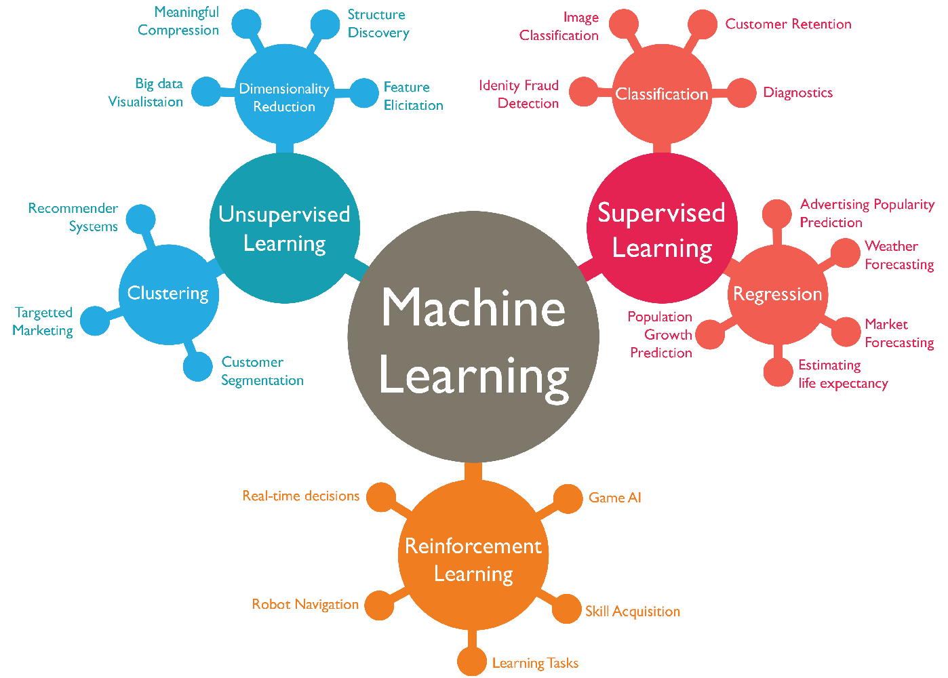

Supervised learning : When an algorithm learns from example data and associated target responses that can consist of numeric values or string labels, such as classes or tags, in order to later predict the correct response when posed with new examples comes under the category of Supervised learning. This approach is indeed similar to human learning under the supervision of a teacher. The teacher provides good examples for the student to memorize, and the student then derives general rules from these specific examples.
Unsupervised learning :Whereas when an algorithm learns from plain examples without any associated response, leaving to the algorithm to determine the data patterns on its own. This type of algorithm tends to restructure the data into something else, such as new features that may represent a class or a new series of un-correlated values. They are quite useful in providing humans with insights into the meaning of data and new useful inputs to supervised machine learning algorithms.
As a kind of learning, it resembles the methods humans use to figure out that certain objects or events are from the same class, such as by observing the degree of similarity between objects. Some recommendation systems that you find on the web in the form of marketing automation are based on this type of learning.
Reinforcement learning : When you present the algorithm with examples that lack labels, as in unsu-pervised learning. However, you can accompany an example with positive or negative feedback according to the solution the algorithm proposes comes under the category of Reinforcement learning, which is connected to applications for which the algorithm must make decisions (so the product is prescriptive, not just descriptive, as in unsupervised learning), and the decisions bear consequences. In the human world, it is just like learning by trial and error.
Errors help you learn because they have a penalty added (cost, loss of time, regret, pain, and so on), teaching you that a certain course of action is less likely to succeed than others. An interesting example of reinforcement learning occurs when computers learn to play video games by themselves.
In this case, an application presents the algorithm with examples of specific situations, such as having the gamer stuck in a maze while avoiding an enemy. The application lets the algorithm know the outcome of actions it takes, and learning occurs while trying to avoid what it discovers to be dan-gerous and to pursue survival. You can have a look at how the company Google DeepMind has created a reinforcement learning program that plays old Atari’s videogames. When watching the video, notice how the program is initially clumsy and unskilled but steadily improves with training until it becomes a champion.

1.1.3Deep-Learning :-
The “deep” part of deep learning refers to creating deep neural networks. This refers a neural network with a large amount of layers — with the addition of more weights and biases, the neural network improves its ability to approximate more complex functions.
The fundamental building block of Deep Learning is the Perceptron which is a single neuron in a Neural Network.
Given a finite set of m inputs (e.g. m words or m pixels), we multiply each input by a weight (theta 1 to theta m) then we sum up the weighted combination of inputs, add a bias and finally pass them through a non-linear activation function. That produces the output Yhat.
The bias theta 0 allows to add another dimension to the input space. Thus, the activation function still provide an output in case of an input vector of all zeros. It is somehow the part of the output that is independent of the input.
The purpose of activation functions is to introduce non-linearities into the network. In fact, linear activation functions produce linear decisions no matter the input distribution. Non-linearities allow us to better approximate arbitrarily complex functions. Here some examples of common activation functions:
Deep Neural Networks are no more than a stacking of multiple perceptrons (hidden layers) to produce an output.
Now,we have understood the basic architecture of a deep neural network.
Chapter2:Face Detector:-- Here we will detect face direct from live camera. This works on computer vision field of machine learning. It works on OpenCV’s latest library cv2 .
Chapter3:Motion Detector :-- It will detect motion motion in the camera if any object moves even slightly. It will show live motion on another window directly.
Chapter4: Twitter Sentiment Analysis:-- It will access twitter on basis of api using acces key and tokens . it will give output on any topic that the tweets related to that topic on your feed are positive or negative or neutral with the percentage.
Chapter5:Human Count:-- it will count no of humans direct from accessing camera of the laptop using the face detection with the help of haar cascade xml file.
Chapter6:Lips checking :-- it will check whether the lips are open or close in the frame that it will get direct from the camera. It will also use opencv for getting the face then in the lower area of the face it will search for the lips that whether they are open or close.

CHAPTER 2
Face Detector

Introduction
In this section, we will detect face direct from live camera. This works on computer vision field of machine learning. It works on OpenCV’s latest library cv2 .
When it detects face it will show a square on it
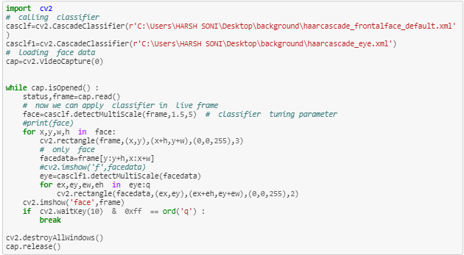

Conclusions.
In this chapter using opencv face detection is done. The Cascade classifier is used for accessing the haar cascade files which are in xml format . these files are already trained files we have no need to train them . haar features are the features of human body that it will detect from using xml file

CHAPTER 3
Motion Detector
3.1 Introduction

It will show motion or movement in any objects instantly on the screen in the frame .
It used opencv library of python for accesing camera .on the another window if any motion is going on then it will be shown.

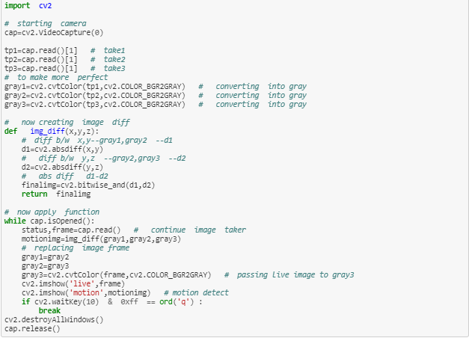

3.2 Conclusion

Here the difference between the three continuos frames is taken then the abslute difference is taken the it is shown on the another window that shows the difference

CHAPTER 4
Twitter Sentiment Analysis

4.1 Introduction

In this the analysis on of the posts in someone’s feed on the certain topic will be done .
This uses tweepy library for extracting the tweets from twitter.
Which will be done on the basis of twitter api .this will shoe that the whther the posts are positive,neagative or neutral.
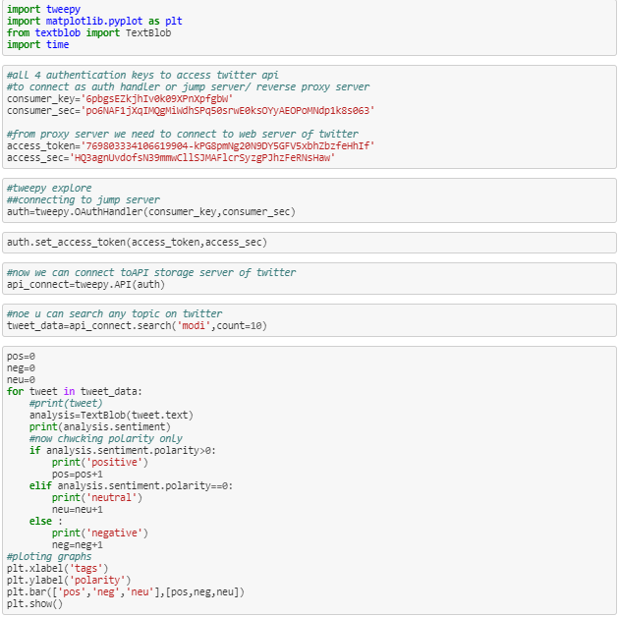

4.2 Conclusion

This uses text blob library pf python for converting the tweets into texts .then using access key and acces token,consumer key and consumer token it will accesstwiiter for the tweets.
Then the polarity is calculated for the tweets that the tweets are positive or negative or neutral
.

CHAPTER5

Human Count

5.1 Introduction:--

It will count no of humans direct from accessing camera of the laptop using the face detection with the help of haar cascade xml file. Haar features are the features of the human face that are trained in this xml file.. it uses cascade classifier to access the haar cascade file for face that is called forntal face file.
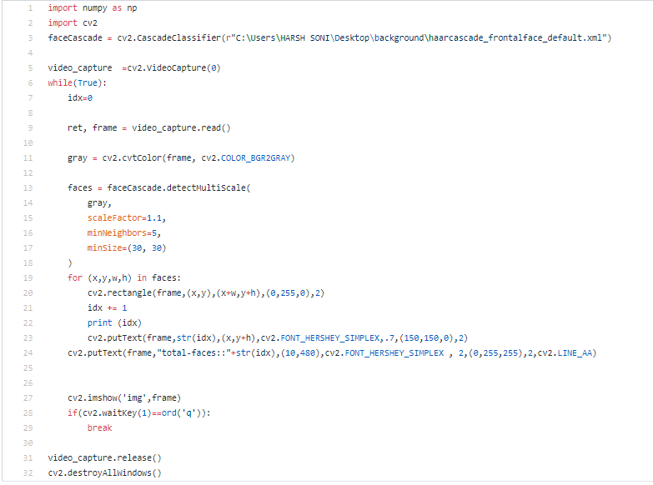

5.2 Conclusion

This counts face on the basis of face detection using haar cascade file.
As it detects any face it increses the no of faces that are refreshed continuously.
It also uses numpy library of python that uses frame as an array and give the exact no of faces in a frame on the window.

CHAPTER 6

Lips Checking

6.1 Introduction

it will check whether the lips are open or close in the frame that it will get direct from the camera. It will also use opencv for getting the face then in the lower area of the face it will search for the lips that whether they are open or close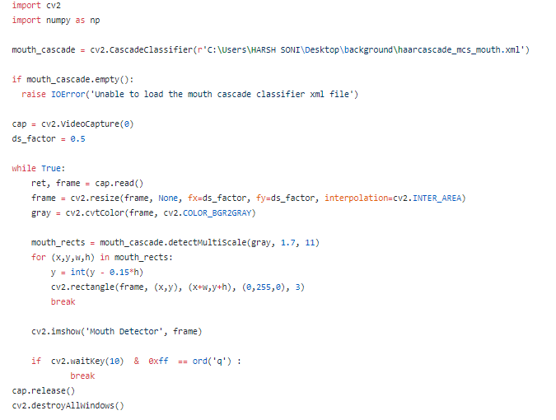

6.2 Conclusion :--
On the basis of haar cascade file for mouth it detects whether the lips are open or close
Whenever the lips are close it will show the area where the lips are by making a rectangle on the lips with written lips close

References:-
HaarCascade File for Face:-
https://github.com/opencv/opencv/blob/master/data/haarcascades/haarcascade_frontalface_default.xml
-GitHub
-OpenCv.org
-W3schools

