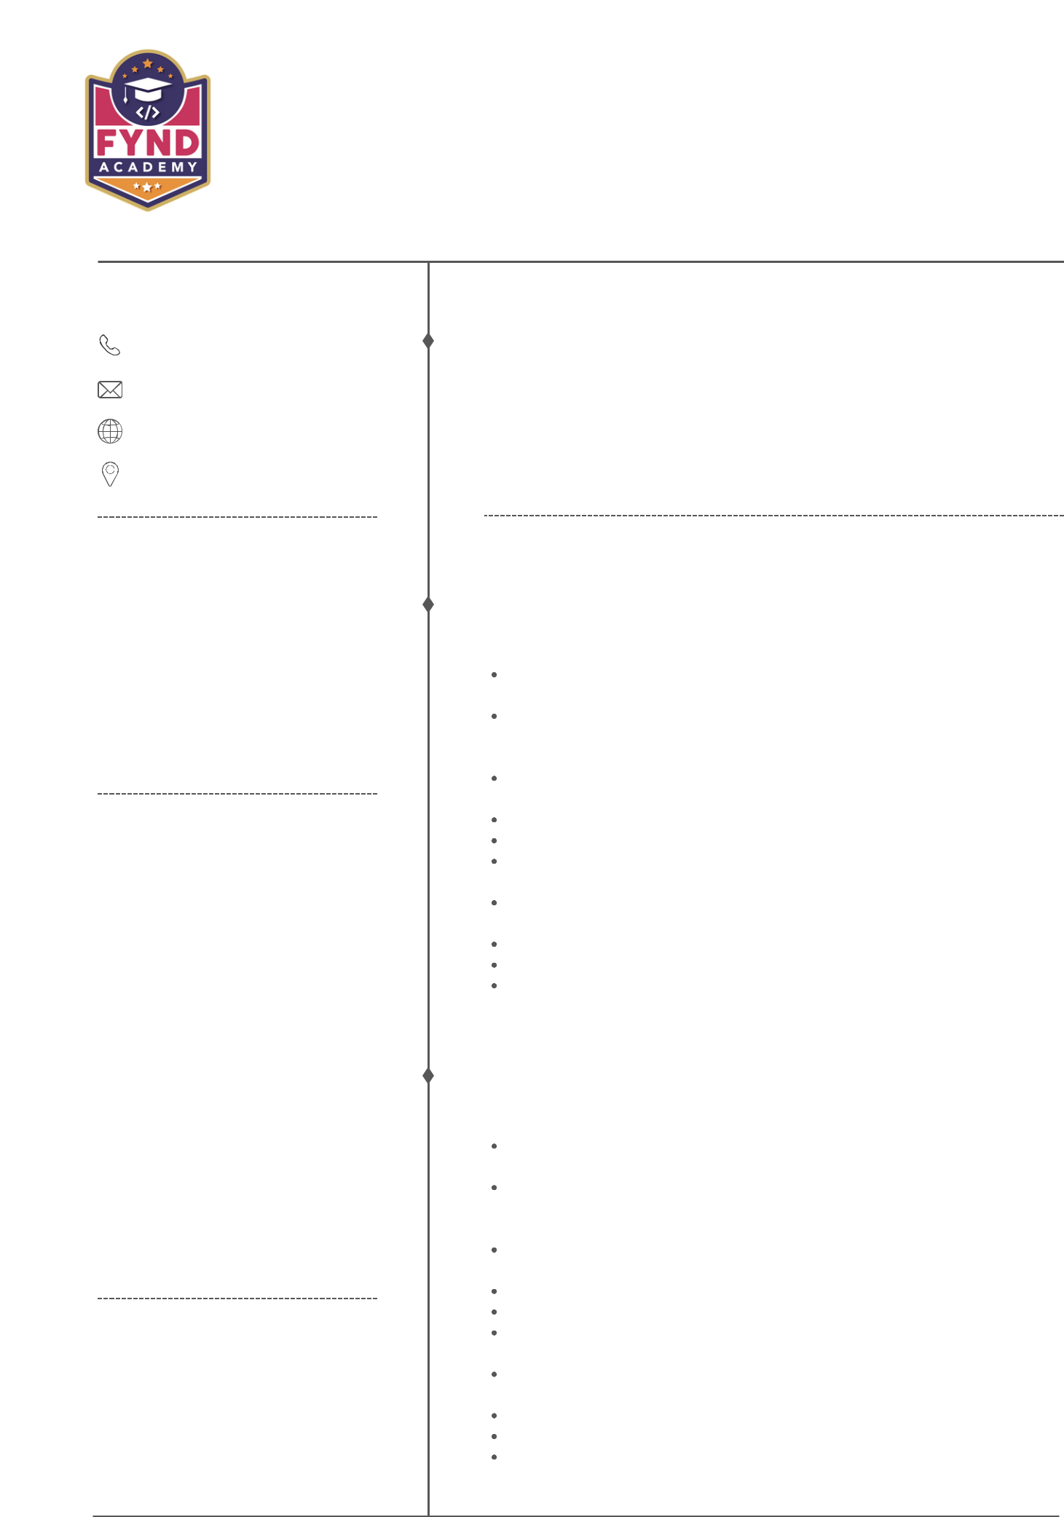HARSHAD VELE

CUSTOM SOFTWARE ENGINEERING ANALYST

**PERSONAL INFO**

8237172969

harshadvele538@gmail.com

<https://www.linkedin.com/in/harshad-vele-9b66b616b>

Location- (Mumbai, Maharashtra)

**SKILLS**

JSE, J2EE, Spring Boot, SQL, Pl/SQL, Intellij,

Eclipse, Agile, HTML, CSS, JSON, Oracle Sqldeveloper

**EDUCATION**

**Electronics and Telecommunication Engineering**

Dr. Babasaheb Ambedkar Technological University, Lonere

2017 - 2021

**PROFILE**

1.5 years of IT experience as Custom Software Engineering Analyst in Software Design, development, debugging and Implementation.

Establish and maintain productive working relationship with management, Clients, and team members.

Adaptability to all working condition, hardworking, can efficiently work independently and within the team.

A dedicated team player with excellent organizational an Interpersonal skill.

**WORK EXPERIENCE**

**Accenture Solutions Private LTD**

Custom Software Engineer Analyst | 2021-2023

Working as developer as to build package and write the code logic to load the data.

Debug and update the code as per requirement.