

# MAHARASHTRA STATE BOARD OF TECHNICAL EDUCATION,

**Mumbai**.

A MICRO PROJECT PROPOSAL ON

“Airline Reservation System”

UNDER THE SUBJECT

“Advance Java Programming”

### COMPUTER ENGINEERING DEPARTMENT ACADEMIC YEAR

2023-2024

### UNDER THE GUIDANCE OF

Mr. B. P. Mulla

**GOVERNMENT POLYTECHNIC, MIRAJ.**

**Certificate**

This is to certify that, as part of the partial fulfilment of the Second Years Diploma Course for the semester forth, the Bonafede students studying in Second Year Diploma (Computer), I Scheme **Harshvardhan Subhash Patil** have completed the project report titled as “Airline Reservation System”– AJP (Advance Java Programming) under the guidance of Mr. B. P. Mulla and submitted it to Government Polytechnic, Miraj. The information presented in this project report has not been submitted earlier.

Place: Govt. Polytechnic, Miraj Date: / / 2023

|  |  |  |
| --- | --- | --- |
| Mr. B. P. Mulla | Dr. Prof. V. R. Falmari | Capt. Dr. N. P. Sonje |
| **(GUIDE)** | **( HOD )** | **(PRINCIPAL)** |

# ACKNOWLEDGEMENT

We take it is an opportunity to thank all those who have directly and indirectly inspired, directed and assisted us towards successful completion of this project report. We express our sincere thanks to the Prof. Nitin Sonje & the Head of Department, Mr. V. R. Falmari for having us allowed to submit this report as part of our academics learning. We express our sincere thanks to Mr. B. P. Mulla, Lecturer in Computer Department, Government Polytechnic, Miraj for encouragement throughout the project report and guideline in designing & working out this project.

Place: Govt. Polytechnic, Miraj Date: / / 2023

Yours Sincerely -

**Harshvardhan Subhash Patil**

Part I Annexure I

**Title of Micro-project:** -

**Micro-Project Proposal**

# “Airline Reservation System”

#### (1.0) Aim of Micro-project: -

Some of the Benefits of the micro-project are as follows:

* The major purpose of this AJP Project to Give Information about acquiring knowledge about Advance java.
* This project also give knowledge about the Application and use of Advance Java in developing a Reservation system.
* State Importance of Advance Java & it’s features in platform independency.

#### (2.0) Course Outcomes addressed: -

* Develop programs using Object Oriented Methodology in java.
* Use AWT Component.
* Use SWING Component.
* Apply Event Handling Concepts.

#### (3.0) Proposal Methodology:

The steps involved in the proposed methodology are:

#### Selection and finalization of topic.

In this step we are searching different topics for micro-project,

* + Hotel Management System
  + Hospital Management System
  + Airline Reservation System
  + The Bank Management System

From this we selected The Airline Reservation System for micro-project also we have taken the approval from the subject Teacher.

#### Information Gathering:

In this step we are going to search the various information about bills & their calculation we are going to visit various websites for this information gathering.

#### Creating functions & User defined Exception

In this step we are going to design various functions to build a source code. Here we are going to use various methods of predefined packages and various attributes for Airplane and also other necessary tools for completion of system development.

#### Execution & debugging the source code:

In this step we are going to compile & interpret the code.

#### Preparation of report:

In this step we are going to prepare micro-project report part A and Part B as per given guidelines.

#### (4.0) Resources Required: -

|  |  |  |
| --- | --- | --- |
| **Sr No.** | **Software** | **Hardware** |
| 1) | JDK (Java Development Kit) | Device name LAPTOP- |
| 6G2BT0A4 |
| Processor:11th Gen Intel(R) |
| Core (TM) i3- |
| Installed RAM:8.00 GB (7.75 |
| 2) | Microsoft word | GB usable) |

**(5.0) Action Plan: -**

|  |  |  |  |
| --- | --- | --- | --- |
| **Sr No.** | **Details Of Activity** | **Plan Start date** | **Plan end date** |
| 1) | Selection Of topic for Micro-project |  |  |
| 2) | Creating the Proposal |  |  |
| 3) | Literature review of micro-project |  |  |
| 4) | Collection of Information About Airline System |  |  |
| 5) | The development of project i.e., Coding (Source code) |  |  |
| 6) | Record-keeping &Documentation tasks |  |  |
| 7) | Creating a micro-project report |  |  |
| 8) | Evaluating the microproject with teacher guidance. |  |  |

**Output:**

**Home Page:**

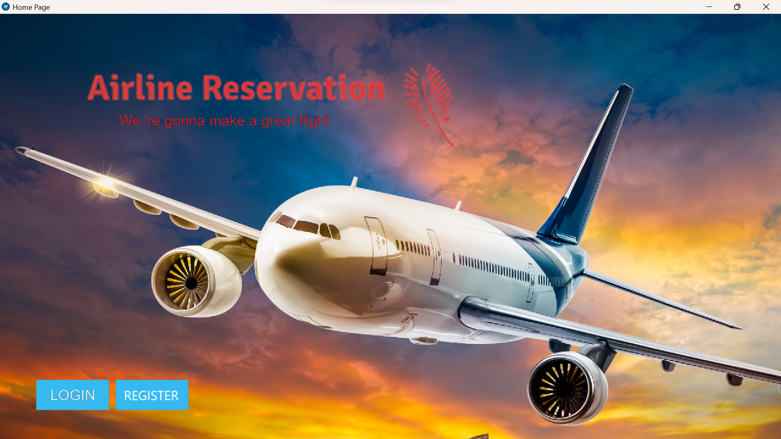

**Login Page:**

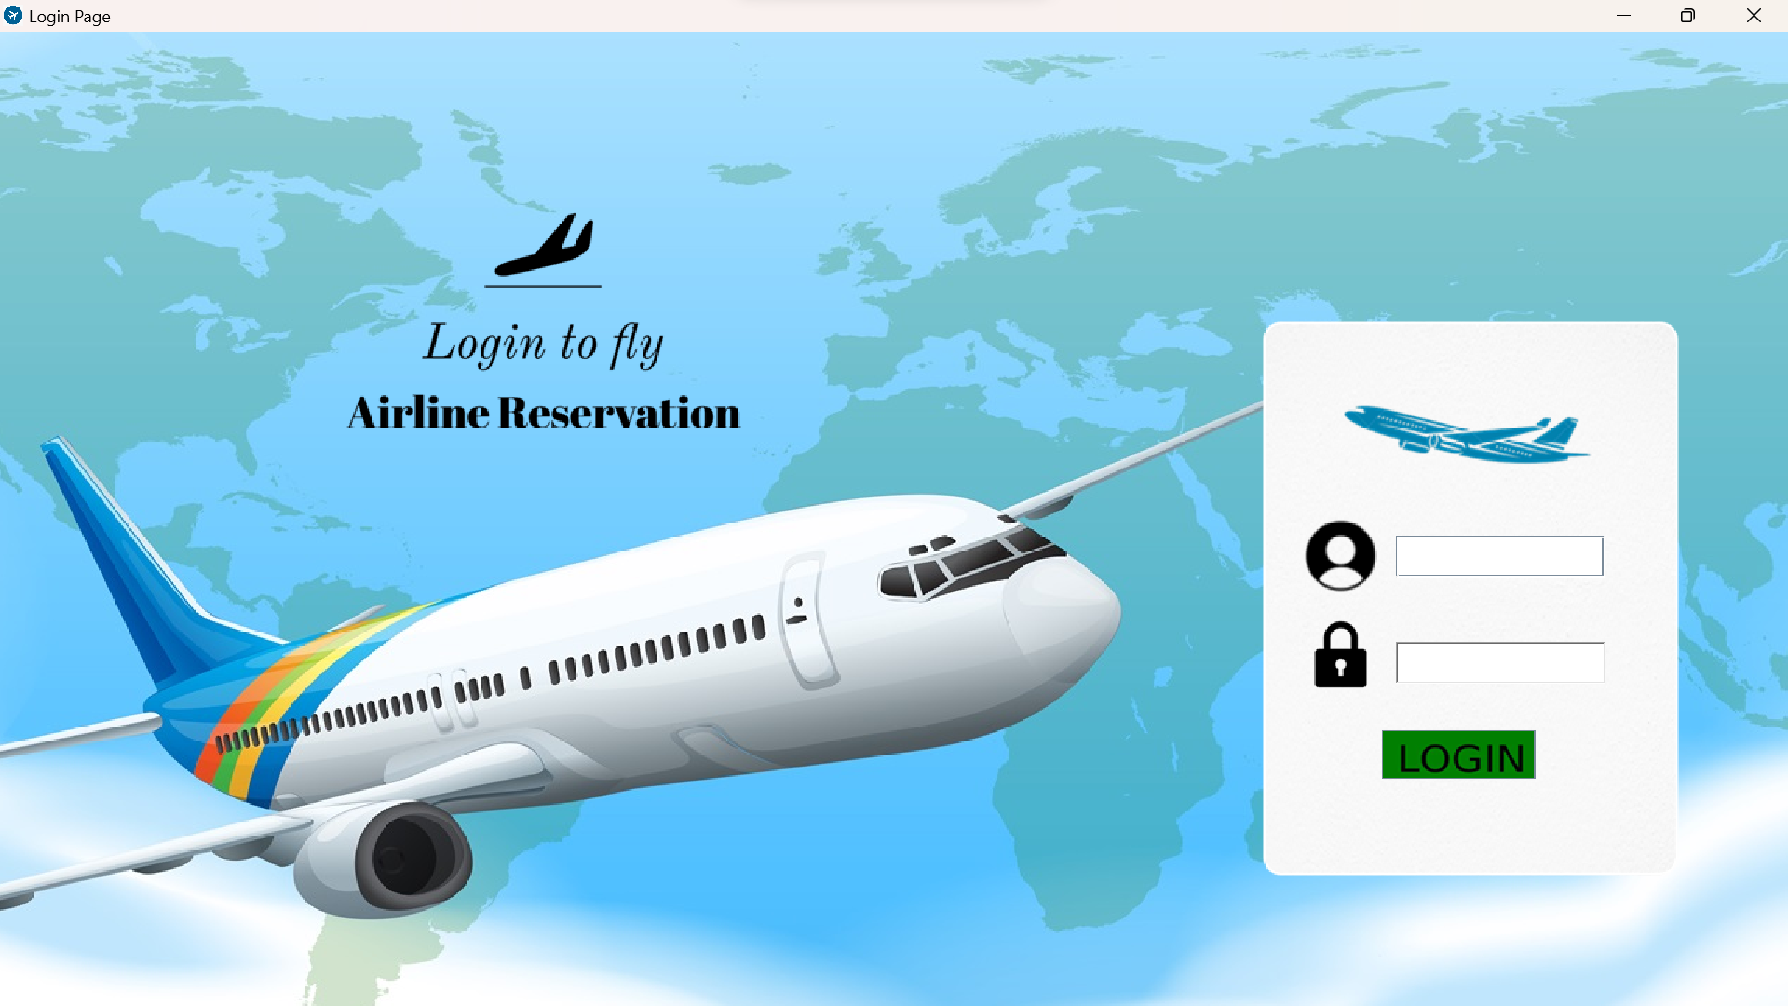

**Registration Page:**

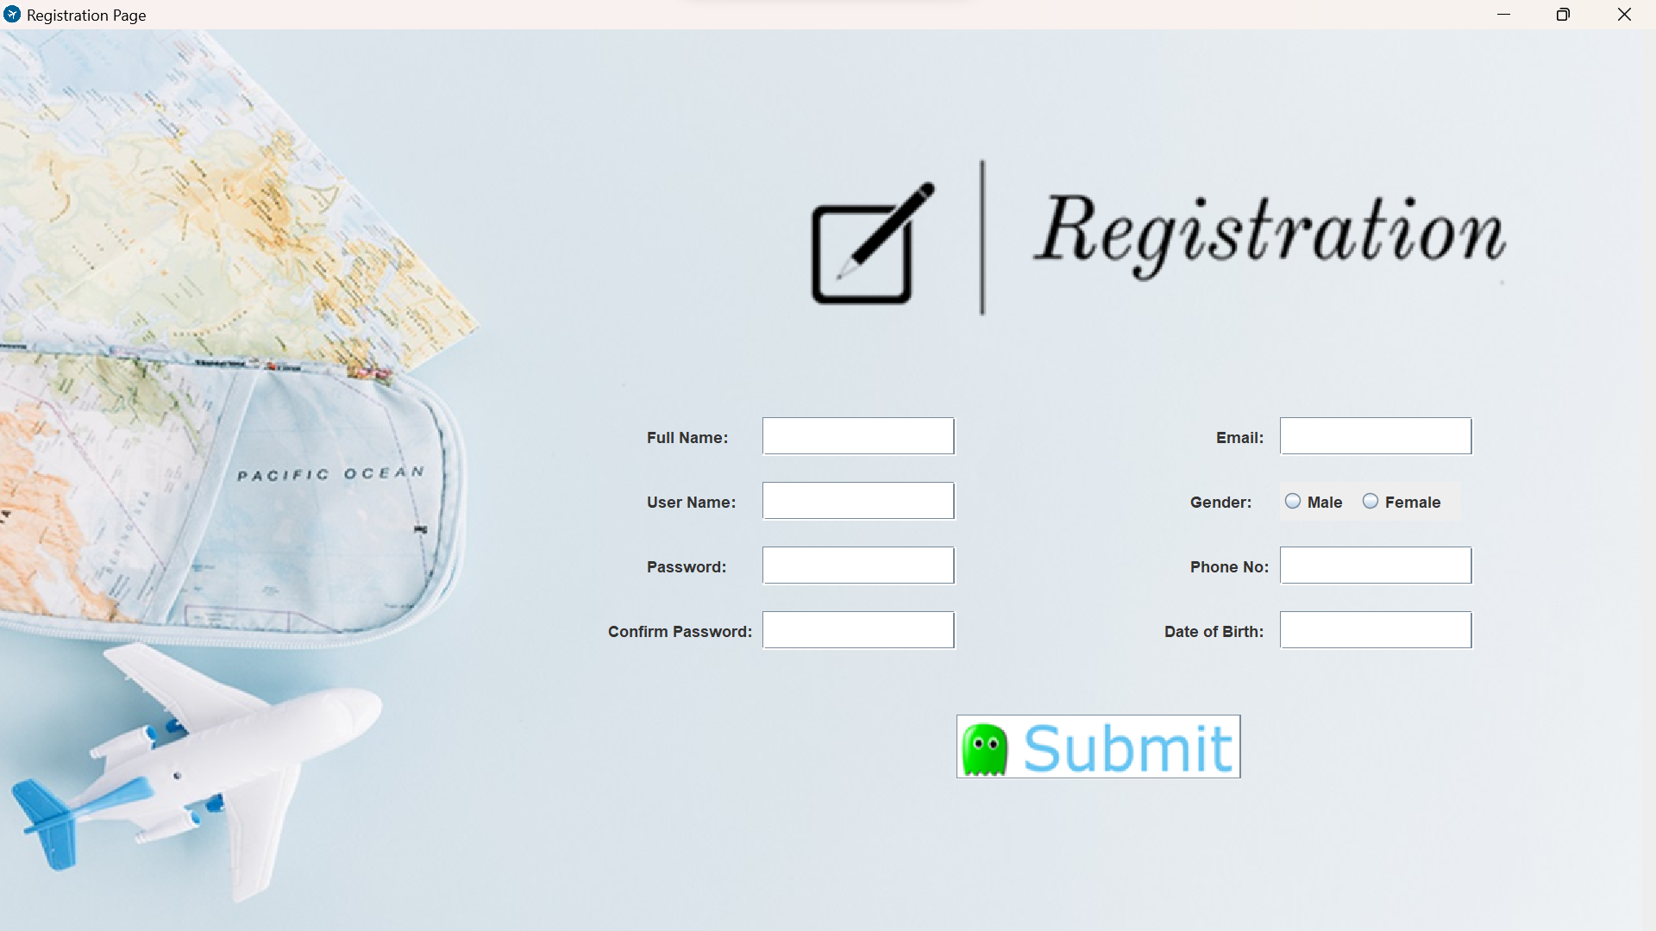

**Reservation Page:**

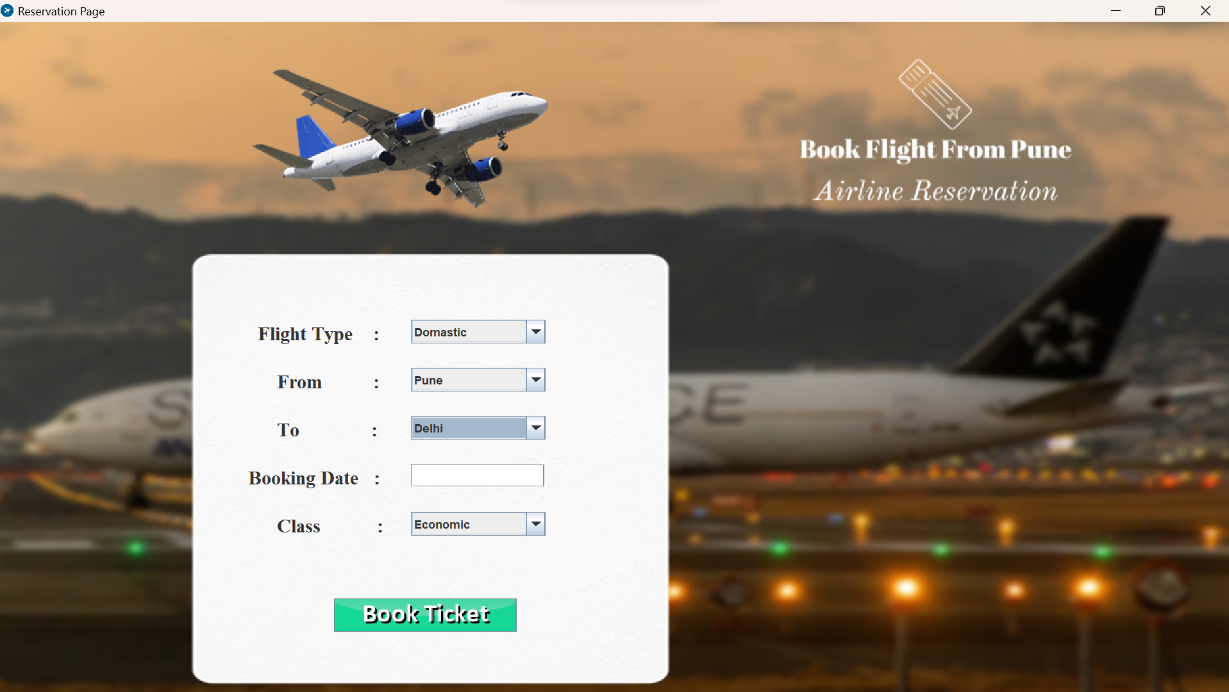

**Part II Annexure II**

## Micro-Project Report

**Title of micro-project:**

**1.0 Rationale:**

# “Airline Reservation System.”

Advance Java is platform independent, open-source object-oriented programming language enriched with free & open-source libraries. In current industrial scenarios Advance Java has the broad industry support and is prerequisite with many allied technologies like Java server Pages, Android Application development. Thus, current industrial trends necessitated acquiring Java knowledge for Computer Engineering & Information Technology graduates. This course develops necessary skills in students to apply object-oriented programming techniques in Java so that students will be able to develop complete applications using core Java.

#### Aims /Benefits of the micro-project:

Some of the Benefits of the micro-project are as follows:

* + - The major purpose of this AJP Project to Give Information about acquiring knowledge about Advance java
    - This project also give knowledge about the Application and use of Java in developing a Reservation system.
    - State Importance of Java & it’s features in platform independency.

#### Course outcomes related micro-project:

* + - Develop programs using Object Oriented Methodology in Advance java.
    - Use AWT Component.
    - Use Swing Component.
    - Apply Event Handling Concepts.

#### 4.0 Literature review:

Advance Java provides us the facility to create our own exceptions which are basically derived classes of Exception. Creating our own Exception is known as a custom exception or user- defined exception. Basically, Java custom exceptions are used to customize the exception according to user needs. In simple words, we can say that a User-Defined

Exception and custom exception is creating your own exception class and throwing that exception using the ‘throw’ keyword. reservation systems. This literature review aims to explore the existing literature on airline reservation systems developed using Java.

**5.0 Actual Resources Used:**

|  |  |  |
| --- | --- | --- |
| **Sr No.** | **Software** | **Hardware** |
| 1) | JDK (Java Development Kit) | Device name LAPTOP-  6G2BT0A4  Processor:11th Gen Intel(R) Core (TM) i3-  Installed RAM:8.00 GB (7.75 GB usable) |
| 2) | Microsoft word |

**6.0 Actual methodology followed-**

The steps involved in the proposed methodology are:

#### Selection and finalization of topic.

In this step we have searched different topics for micro-project,

* + Hotel Management System
  + Hospital Management System
  + Airline Reservation System
  + The Bank Management System

From this we selected The Airline Reservation System for micro-project also we have taken the approval from the subject Teacher.

#### Information Gathering:

In this step we searched the various information about reservation & their ticket we are going to visit various websites for this information gathering.

#### Creating functions & User defined Exception

In this step we designed various functions to build a source code. Here we used various methods of predefined packages and various attributes for Reservation and also other necessary tools for completion of system development.

#### Execution & debugging the source code:

In this step, we compiled & interpreted the code.

#### Preparation of report:

In this step we prepared micro-project report part A and Part B as per given guidelines.

#### Skill developed /learning outcomes:

* + - The concept of project understood.
    - Implementation of the self-development process.
    - The structure and requirement of proposal and report understood.
    - How to search information and use of different online tools come to know.

#### Application of Project:

* + - Login
    - Ticket Booking
    - Find My Flight
    - Reservation

 **Conclusion** 

Thus, we have successfully developed Airline Reservation System using Advance Component in Java And also use Event handling Concept.