**Instructions on how to run the code(equivalent to makefile):**

* Firstly the **Client.java** file needs changes to the following variable:
* At line 34, change the **file_path** value to any random file path from which this client will send the file.

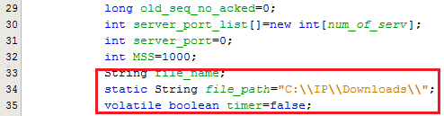

* Secondly the **Server.java** file needs the following changes:
* At line 27, change the **file_path** value to any random file path in which the file will be stored by server.

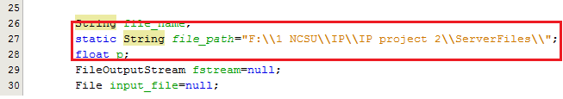

**Now perform the following steps to Compile and Execute the code.**

**Step 1:** Compile and execute the **Client.java**ie the Sender by typing in Command Prompt:

**javac Client.java**

**java Client**

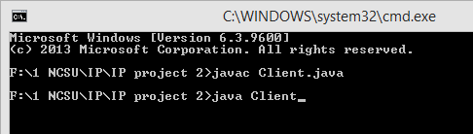

**Step 2:**Secondly run the server after making the necessary changes as defined by compiling and executing Server.java by typing in the command prompt:

**javac Server.java**

**java Server**

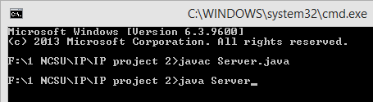

**Run Time scenario:**

**Client:**

* When the client runs, it asks for the number of servers to send the file, the hostname(IP address) of each server, port number on which server are running, the file name to be sent and the MSS Size(in bytes).
* Enter the hostname for servers as an IP Addresss.

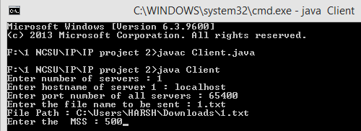

* It then starts sending the file to all the servers specified.

**Server:**

* When the server runs, it asks for the file name in which the incoming data will be written. The file name should be in format of "file_name.extension". In the next line, it asks for the packet loss probability which should be in between 0 & 1.

