**Instructions on how to run the code(equivalent to makefile):**

Firstly make sure the Java Develeopment Kit (JDK) is installed and the environment variables, PATH and CLASSPATH, are set.

**To run LinkState Algorithm**

**Step 1:** Compile and execute the **LinkState.java** file by typing in Command Prompt:

**javac LinkState.java**

To run the file after compiling, provide command line arguments as

**java LinkState file-name node1 node2**

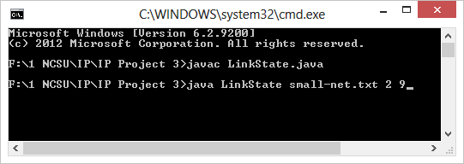

**To run DistanceVector Algorithm**

**Step 1**: Compile and execute the DistanceVector.java file by typing in Command Prompt:

**javac DistanceVector.java**

To run the file after compiling, provide command line arguments as

**java DistanceVector initial-node file-name node1 node2**

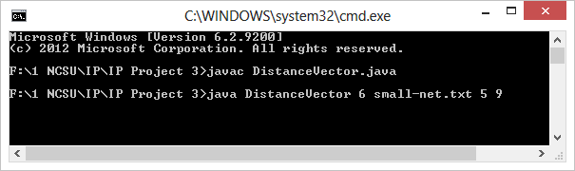

**To run the DistanceVector over UDP program (extra-credit)**

**Step 1**: Compile and execute the UDPDistanceVector.java file by typing in Command Prompt:

**javac UDPDistanceVector.java**

To run the file after compiling, provide command line arguments as

**java UDPDistanceVector file-name my-node-number**

where, ***file-name*** is the file that contains the graph instance or define edge costs between nodes (e.g. the small-net.txt file provided in the project), ***my-node-number*** is the node number of the current program which is being run to inform the program its node value in the graph/network.

