**Instructions on how to run the code (equivalent to makefile):**

* Firstly the **Client.java** file needs changes to the following variables:
* At line 10, change the **client_port** value to any random port number on which this "client's RFC server" will run.
* At line 11, change the **rs_server_ip** value to the IP address on which the main Registeration sever will be running.
* At line 12, change the **file_path** value to any folder path in the computer on which the Client would be running. Make sure the last folder the hierarchy of file_path doesn't contain any files other than the required RFC's.

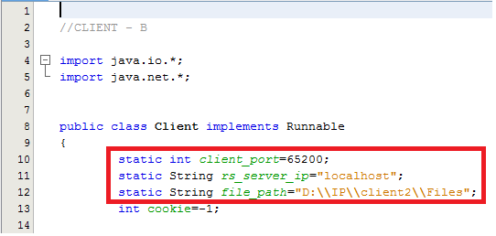

* The filename of the RFC's should be in the form of

"RFCNo_RFCName.txt"

Secondly, the name shouldn’t contain any underscore ( _ ).

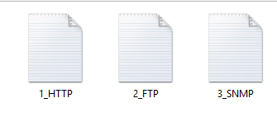

* The main RS Server is running on port no:65423.

**Now perform the following steps to Compile and Execute the code.**

**Step 1:** Compile and execute the **RSTest.java** ie the Registration Server by typing in Command Prompt:

**javac RSTest.java**

**java RSTest**

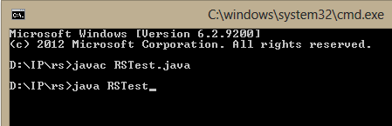

**Step 2:** Secondly run the 2 clients (you need to duplicate the client code once to make the second client) after making the necessary changes as defined.

**Step 3:** Now Compile and execute the Client.java by typing in the command prompt:

javac Client.java

java Client

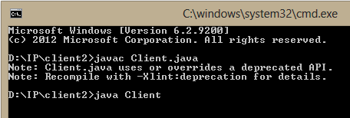

**Run Time scenario:**

* When the client runs, it asks for a hostname from the user.
* Enter the hostname for a client in String format.

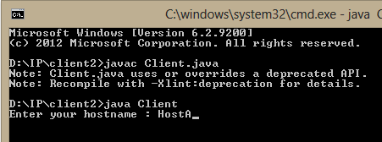

* It displays a menu driven set of following options on the screen or command prompt:

1) Register

2) Leave

3) GetRFC

Enter any of the above options in the numeric format of 1,2 or 3.

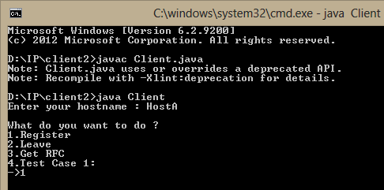

* Once we enter one of the above options, a required processing is performed and the following statement is displayed:

"Do you want to continue ? (yes/no)"

Enter any of the one options "yes" or " no".

* **GetRFC:** Once you hit GetRFC option(3), it will ask you for the RFC Number that you require,once u enter the required RFC Number in numeric format eg: 1,20,100 etc.

