Student Name: Harsh Sharma
Programme: BBA Aviation
Year: 2nd Year | Semester: 3
DAY 5
EXPLORING IMAGE GENERATING TOOLS & PROMPTING

ACTIVITY 1
PROMPT
Create a photorealistic image of a female airline customer-service executive standing at a modern international airport check-in counter. She is wearing a professional navy-blue uniform and looking directly at the camera. Soft natural light is entering from camera-left. The airport background is clean and modern, with passengers visible in soft focus. Use realistic skin texture, natural facial features, professional commercial photography, shallow depth of field and a 16:9 aspect ratio. Do not include any airline logo or readable text.
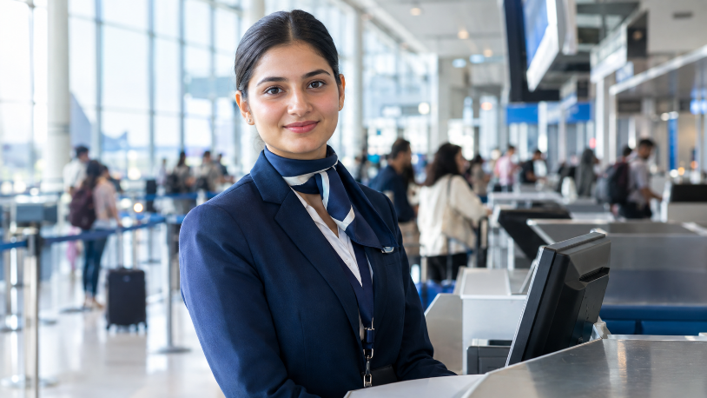
CHATGPT

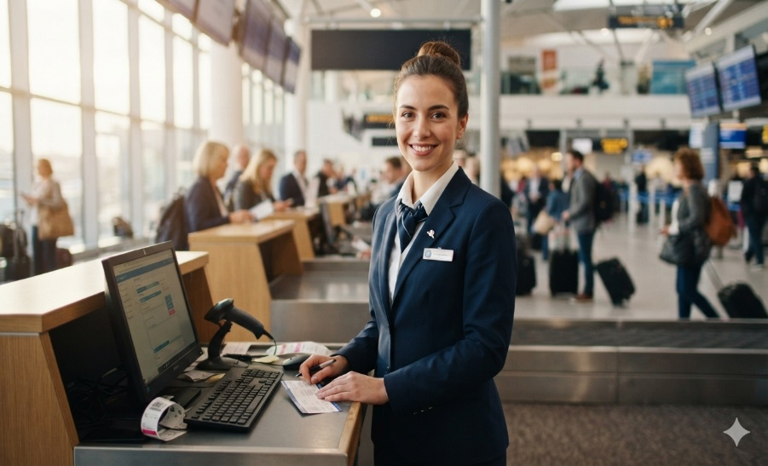
GEMINI

ACTIVITY 2
Evaluation Criterion | Tool 1 – ChatGPT | Tool 2 – Gemini
Name of AI tool | ChatGPT Image Generation | Google Gemini
Prompt followed correctly? | Yes – closely follows the requested airport check-in scene, navy uniform, female executive, camera-facing pose, natural lighting and 16:9 format. | Mostly yes – follows the airport, female executive, navy uniform and professional photography requirements, but adds some extra elements such as a visible name badge and workstation details.
Human face appears realistic? | 9/10 – natural facial proportions and expression. | 9/10 – realistic facial appearance and expression.
Skin texture appears natural? | 9/10 – realistic but slightly polished/commercial. | 8.5/10 – natural-looking, though somewhat smooth.
Eyes and hands are correct? | 9/10 – eyes look natural; hands are less prominent, so fewer opportunities for visible errors. | 8/10 – eyes look realistic; hands are visible and generally correct, although fine finger details are slightly less convincing.
Airport environment is realistic? | 9/10 – modern check-in counters, passengers and airport infrastructure look convincing. | 9/10 – convincing airport environment with check-in desks, passengers and luggage.
Light comes from camera-left? | 9/10 – strong natural light is clearly coming from the left side of the image. | 9/10 – visible natural light from the left through the large airport windows.
Uniform is professional? | 9/10 – clean navy-blue professional uniform with coordinated accessories. | 9/10 – professional navy-blue airline-style uniform with scarf and badge.
Unwanted text or logos present? | 10/10 – no obvious readable airline logos or unwanted text. | 7/10 – some visible text-like elements on the workstation/monitor and name-badge area, despite the instruction to avoid readable text.
Image looks AI-generated? Why? | Slightly – extremely clean facial appearance and highly controlled background blur give it a polished AI/commercial look. | Slightly – some background details, screens and small objects have an overly clean/synthetic appearance.
Overall score out of 10 | 9.1/10 | 8.5/10
Based on the two generated images and the evaluation above:

1. Which tool followed the prompt more accurately?
ChatGPT followed the prompt more accurately. It closely matched the requested female customer-service executive, navy-blue uniform, camera-facing pose, natural lighting from the left, shallow depth of field, and avoided noticeable readable text or logos.

2. Which image appeared more realistic?
Both were highly realistic, but ChatGPT appeared slightly more realistic overall because of the natural facial features, skin texture, and controlled background blur.

3. What differences did you observe in lighting?
- ChatGPT: Soft, bright natural light clearly enters from the camera-left, giving the subject an evenly lit professional appearance.
- Gemini: Also uses strong natural light from the left, but the overall scene appears slightly warmer and brighter, with more visible ambient airport lighting.

4. Did either image contain distorted eyes, hands or facial features?
Neither image had major distortions.
- ChatGPT: Eyes and facial proportions look natural; hands are less prominently visible.
- Gemini: Face and eyes look realistic, while the visible hands have minor imperfections in fine finger details.

5. Which image would you use on an airline’s website?
ChatGPT's image would be my choice for an airline website based specifically on prompt adherence and visual consistency. It has a clean commercial-photography appearance and keeps attention on the customer-service executive.

6. What is the “visual accent” of each model?
Model | Visual Accent
ChatGPT | Clean, polished & corporate — strong focus on the person, professional presentation, controlled depth of field and realistic commercial photography.
Gemini | Cinematic, detailed & environmental — gives more attention to the airport surroundings, workstation, passengers and overall scene.

ACTIVITY 3

Prompt A — Camera-Left
Create a photorealistic image of an airport ground-staff executive standing beside a check-in counter. Soft morning light must enter from camera-left and illuminate the left side of the image. The executive should hold a tablet. Include a modern airport background in soft focus. Professional photography, realistic facial features, 16:9 aspect ratio, no logos and no readable text.
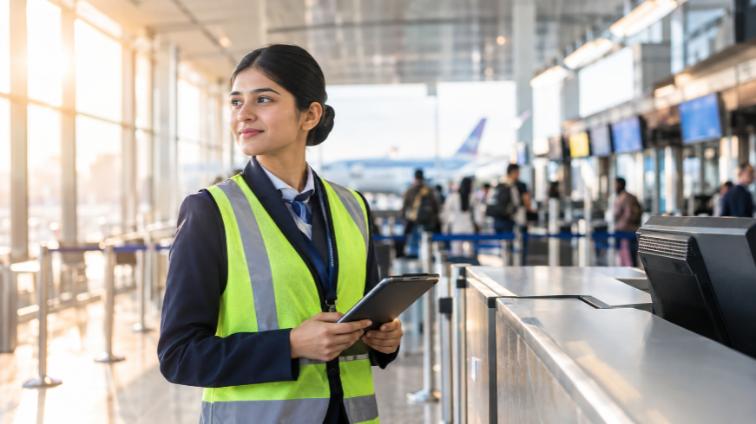

Prompt B — Camera-Right
Create a photorealistic image of an airport ground-staff executive standing beside a check-in counter. Soft morning light must enter from camera-right and illuminate the right side of the image. The executive should hold a tablet. Include a modern airport background in soft focus. Professional photography, realistic facial features, 16:9 aspect ratio, no logos and no readable text.
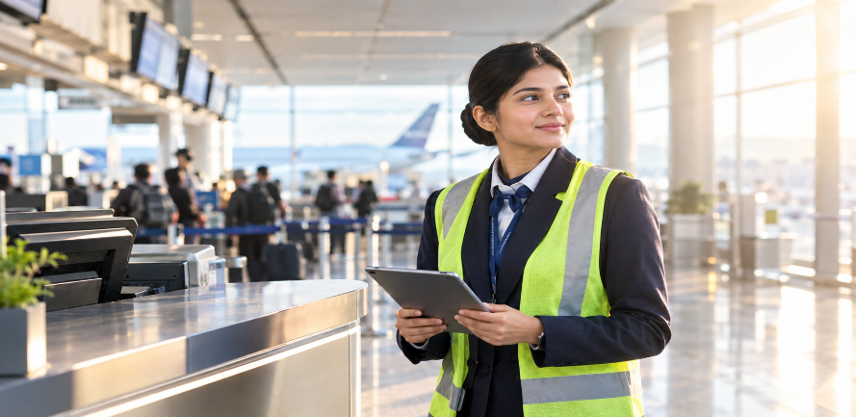

Question | Observation
Did the lighting direction change? | Yes. Prompt A shows the strongest light coming from the camera-left, while Prompt B shows the strongest light coming from the camera-right.
Was camera-left followed correctly? | Yes. In Prompt A, the bright windows and warm illumination are clearly concentrated on the left side of the image.
Was camera-right followed correctly? | Yes. In Prompt B, the strongest sunlight and highlights appear on the right side of the image.
Did the background remain consistent? | Mostly yes. Both images show a modern airport check-in area with passengers, counters, monitors, and an aircraft in the background, although the composition and positioning of elements changed.
Did the person’s appearance change? | Very slightly. The same general character appears in both images, with similar uniform, reflective vest, hairstyle, tablet, and professional appearance. Her pose and exact positioning changed.
Which instruction was ignored, if any? | No major instruction was ignored. Both images followed the main requirements, including the lighting direction, tablet, airport setting, soft-focus background, photorealistic style, and 16:9 format. Some background screens contain visual shapes, but there is no clearly readable text or obvious logo.

