# A

**Project Report On**

# "PARKING MANAGEMENT SYSTEM"

## Prepared by

Ankur Kapuriya(20DCE049)

Prins Mathukiya(20DCE057) Namra Mehta(20DCE059)

## Under the guidance of

Dhruvi Gosai Urvashi Chaudhari Assistant Professor

A Report Submitted to

Charotar University of Science and Technology for Partial Fulfillment of the Requirements for the 3rd Semester Software Group Project-I (CE244)

**Submitted at**

**CE DEPSTAR**

**At: Changa, Dist: Anand – 388421 November 2021**



This is to certify that the report entitled “Parking Management System” is a bonafied work carried out by Ankur Kapuriya (20DCE049), PRINS Mathukiya(20DCE057), Namra Mehta(20DCE059) under the guidance and supervision of Assistant Prof. Dhruvi Gosai, Urvashi Chaudhari for the subject CE244-Software Group Project-I (CE) of 3rd Semester of Bachelor of Technology in DEPSTAR at Faculty of Technology & Engineering – CHARUSAT, Gujarat.

To the best of my knowledge and belief, this work embodies the work of candidate himself, has duly been completed, and fulfills the requirement of the ordinance relating to the B.Tech. Degree of the University and is up to the standard in respect of content, presentation and language for being referred to the examiner.

|  |
| --- |
| Dhruvi Gosai  Urvashi Chaudhari Assistant Professor Branch Name (CE)  DEPSTAR, Changa, Gujarat. |
| Dr. Amit Ganatra Principal, DEPSTAR Dean, FTE  CHARUSAT, Changa, Gujarat.  Shape |

**Devang Patel Institute of Advance Technology And Research At: Changa, Ta. Petlad, Dist. Anand, PIN: 388 421. Gujarat.**

# ABSTRACT

The Simple Parking Lot project is simply in HTML, CSS, and JavaScript. Taking about the features of this system, it just contains the admin section. Also, you can view all users and manage the parking area details. You just have to type the details and click on the add button to add the parking information on the record. This project includes a lot of javascript for making the functioning of the project.

# ACKNOWLEDGEMENT

We, the developers of a website “Parking Management System”, with immense pleasure and commitment would like to present the project assignment. The development of this project has given us wide opportunity to think, implement and interact with various aspects of management skills as well as to learn new topics.

Every work that one completes successfully stands on the constant encouragement, good will and support of the people around. We hereby avail this opportunity to express our gratitude to number of people who extended their valuable time, full support and cooperation in developing the project.

We express deep sense of gratitude towards our Head of the CE Department, Dr. Amit Ganatra and project guides Prof. Dhruvi Gosai and Prof. Urvashi Chaudhari for the support during the whole session of study and development. It is because of them, that we were prompted to do hard work, adopting new technologies.

The University altogether provided us favourable environment, and without that it would not have been possible to achieve our goal.

Thanks, Ankur Kapuriya

Prins Mathukiya Namra Mehta

# TABLE OF CONTENTS

Title Page 1

Certificate 2

Abstract 3

Acknowledgement 4

Table of contents 5

|  |  |  |
| --- | --- | --- |
| **Chapter No.** | **Chapter Names** | **Page No.** |
| **1** | Project Definition | 6 |
| **2** | Project Description | 7 |
| **3** | Software and Hardware Specifications | 8 |
| **4** | Major Functionality | 9 |
| **5** | System Flow Chart | 10 |
| **6** | Screenshots of Project | 11 |
| **7** | Limitations of Project | 18 |
| **8** | Project Outcomes | 19 |
| **9** | Future Enhancements | 20 |
| **10** | References | 21 |

**CHAPTER 1: PROJECT DEFINITION**

**A Parking Management System Project in javascript is used to manage and solve the Parking Problems of any company, institute or organisation.**

**CHAPTER 2: PROJECT DESCRIPTION**

The website which we will be developing is the best solution for all the above mentioned limitations.

It will be time saving, productive and helpful to every single company. Simultaneously maintaing a proper record of all the vehicles parked in the past or parked currently.

**CHAPTER 3: SOFTWARE AND HARDWARE SPECIFICATIONS**

* **SOFTWARE USED:**
* Visual Studio for coding.
* Pre-installed browser for testing the website.
* **SYSTEM CONFIGURATION ON WHICH THE PROJECT WAS DEVELOPED:**
* Min. 256GB Hard drive storage for application data storage
* Min. 4 GB RAM, Intel i3 10th generation processor.
* Internet connectivity**.**

**CHAPTER 4: MAJOR FUNCTIONALITY**

* Owner Name
* Car Name
* License Plate Number
* Entry Date
* Exit Date
* Other Actions

**CHAPTER 5: SYSTEM FLOWCHART**

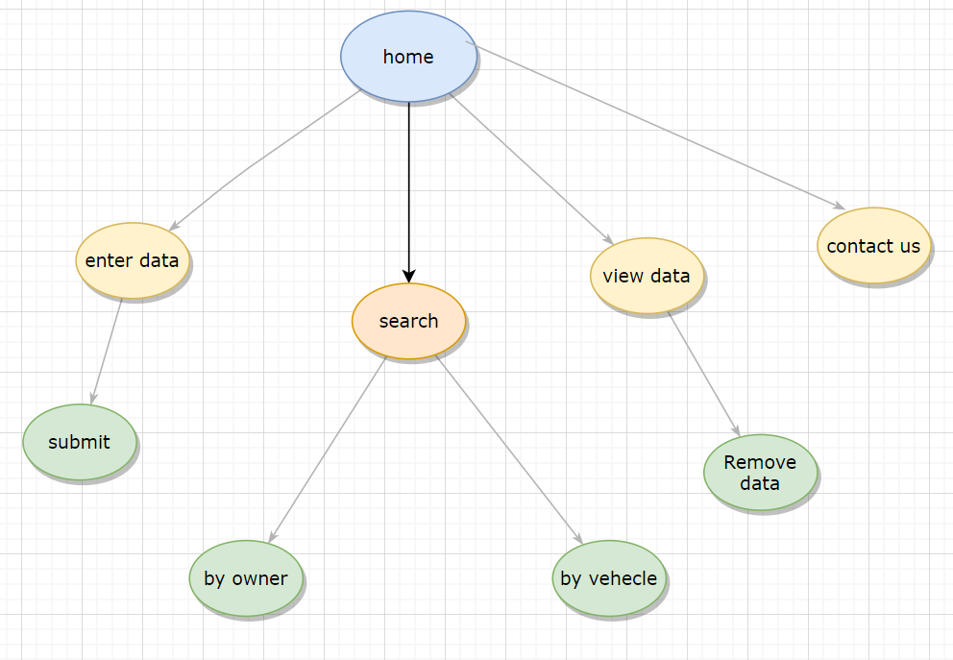

* The runtime flow of the website is that first the home page will be seen in the main screen , it has six boxes 1st is the capacity of the parking which is enters only one time.
* Every time we want to enter vehicle we have to enter owner’s name in 1st box, vehicle model in 2nd box, License plate with proper format in 3rd box, we have to enter entry date and exit date and then add car.
* After adding the vehicle details, we can show data in lower portion.
* There is a search bar where we can search the vehicle info. By owner name or Licence plate.

**CHAPTER 6: SCREENSHOTS OF PROJECT**

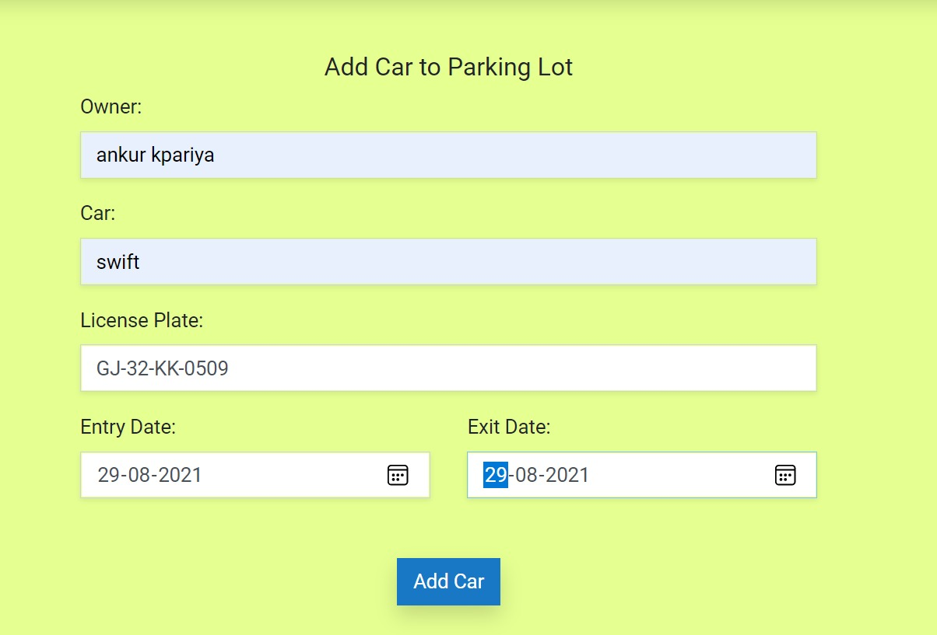

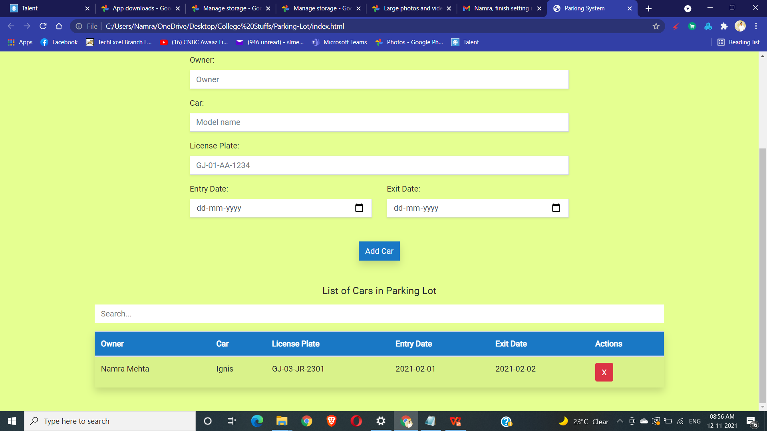

**CHAPTER 7: LIMITATIONS OF PROJECT**

* We can’t print bill or receipt for the vehicles are parked in parking lot.
* We can’t count the charges of the vehicles which are parked in parking lot.
* Can’t book parking slot online earlier.
* User can’t use online method for payment or any else.
* There is no mobile application is available.

**CHAPTER 8: PROJECT OUTCOMES**

* We learnt HTML 5, CSS 3 and java script.
* We learnt how to perform a proper teamwork in a real scenario.
* We learnt the importance of management and their requirements.
* We learnt to have a proper positive approach towards the problem while solving the problem.
* We learnt to divide the work amongst the team and encourage our team members to do something new.

**CHAPTER 9: FUTURE ENHANCEMENTS**

* We can add the amount of the parking space and then the owner can make the payment online through debit card.
* We can generate the e-receipt of the payment done by the user which they can download later.
* We can book online slot earlier.
* We can make mobile application for easy to use.

**CHAPTER 10: REFERENCES**

* [https://youtu.be/nXZ-J-CDrLU](https://www.nourishwelfarefoundation.org/)
* [https://www.tutorialspoint.com/javascript/index.htm](https://www.nourishwelfarefoundation.org/)
* https://www.w3schools.com/js/
* https://stackoverflow.com/
* https://www.javatpoint.com/css-tutorial
* https://youtube.com/playlist?list=PL0b6OzIxLPbx-BZTaWu_AF7hsKo_Fvsnf
* **OUR GITHUB CODE LINK….**