Electronics Store

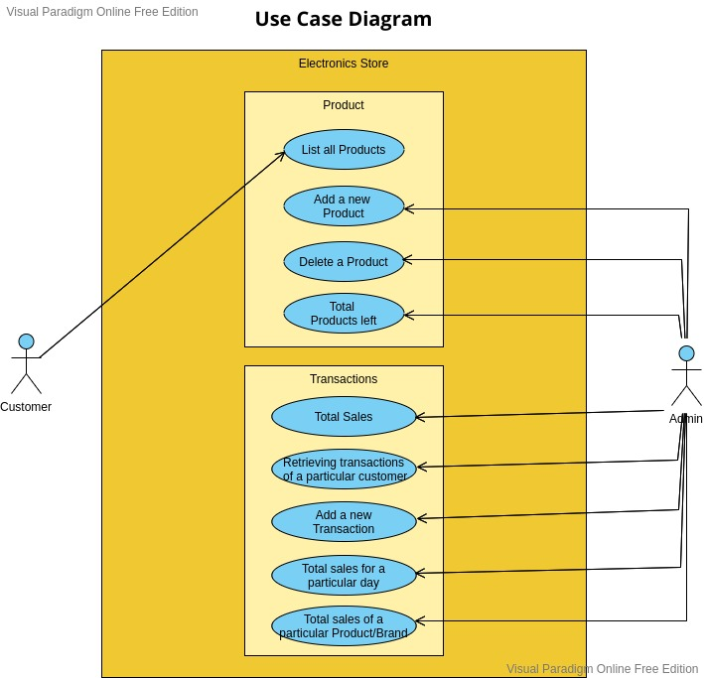

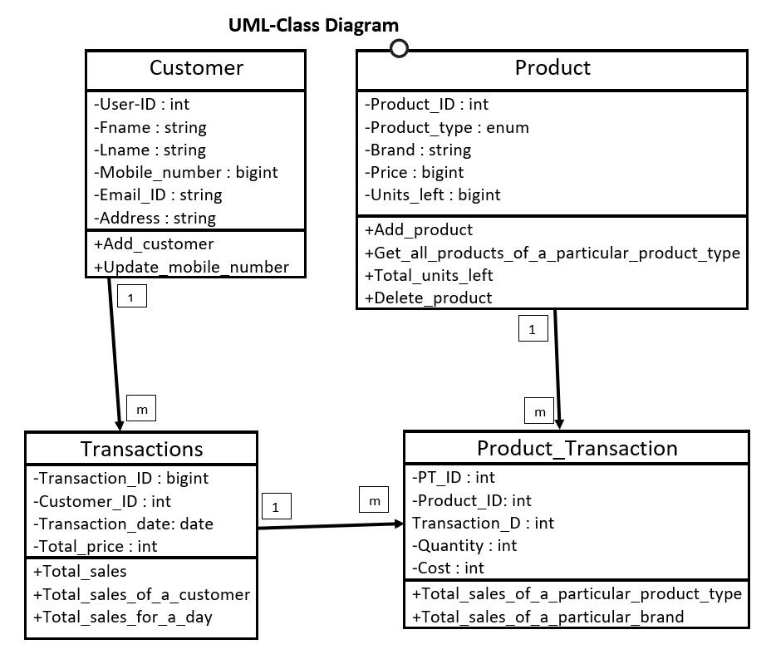

OR-Mapping

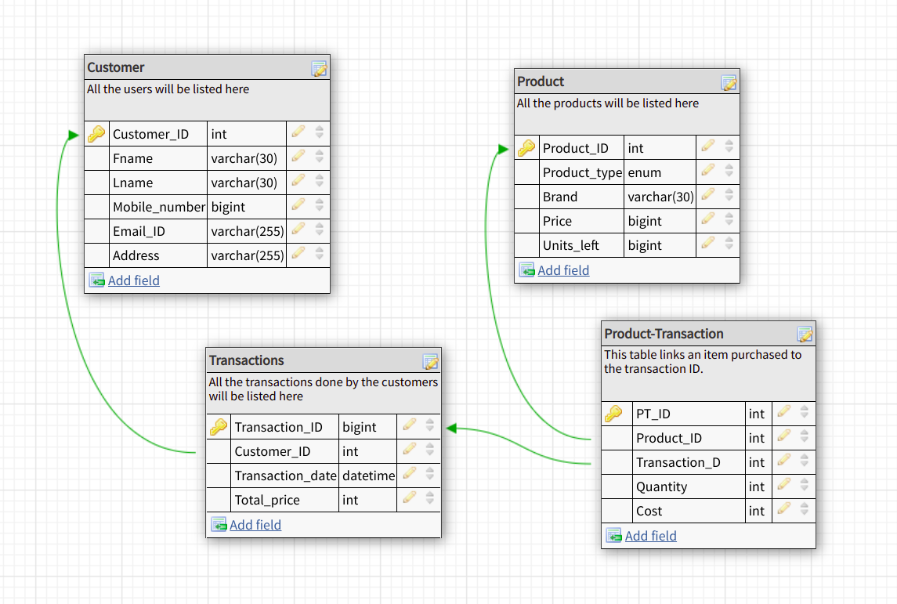

Instructions to Run

- For creating and populating the database, open the mysql command prompt:
- For creating the database, run `source Create_database.sql` command
- For altering the database, run `source Alter_database.sql` command
- For populating the database, run `source Insert_database.sql` command

-Now, for strating the menu driven program, open terminal:
- Run `javac Electronics_store.java` command for compiling the program
- Run `java Electronics_store` command for strating the menu driven program
- A user has two choices, either to login as a Customer or as an Admin.
- Corresponding to both the choices, there are several functionalities, depicted by the menu-driven program.

Output ScreenShots

1.) Customer Menu
Customer can get the list of all the Brands of the product type they have entered and also it’s pricing.
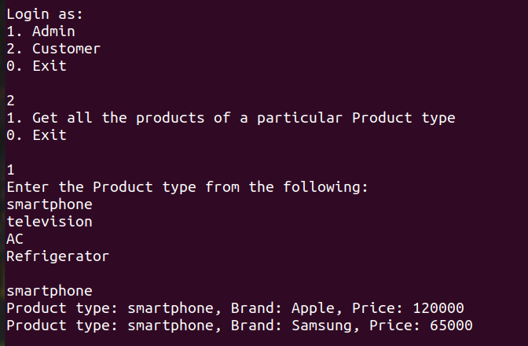

2.) Admin/Owner Menu

Admin can perform the folllowing operations (Every operation’s screenshot attached)
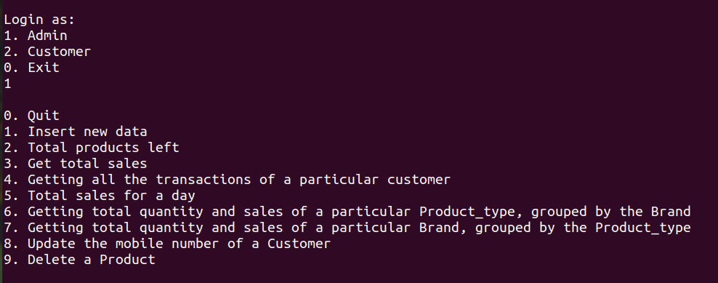

3.) Adding a new Customer

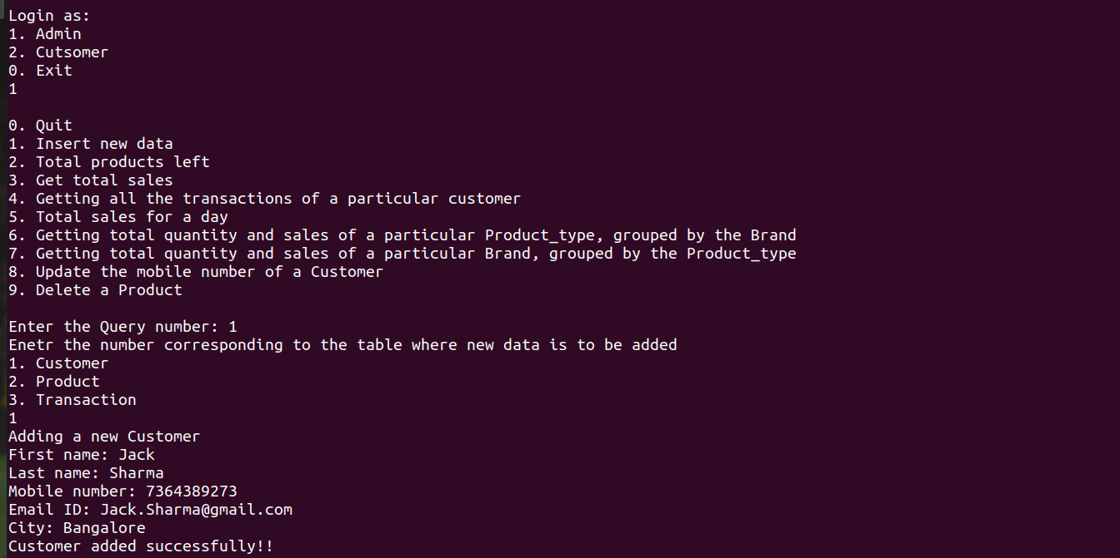

4.)Adding a new Product
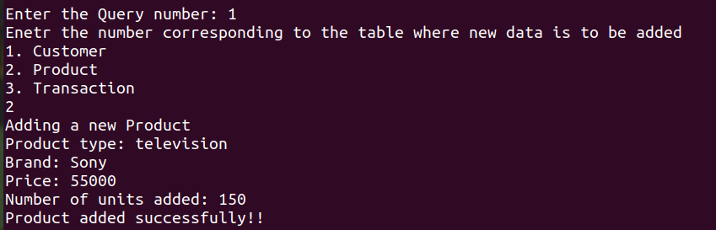

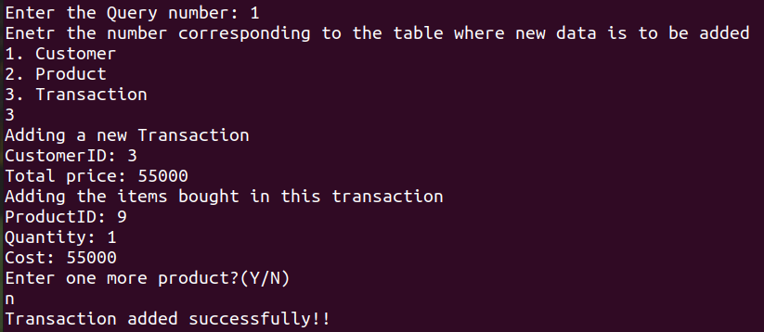
5.) Adding a new Transaction

6.) Total number of products left and Total sales till date

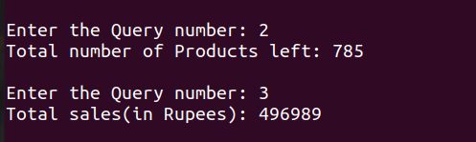

7.) Getting all the transactions made by a particular Customer

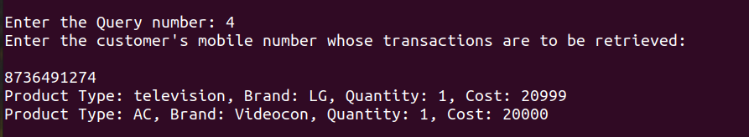

8.) Total sales generated for any given day
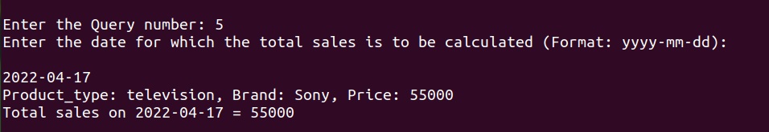

9.) Quantity of product sold and sales generated by a particular Product type

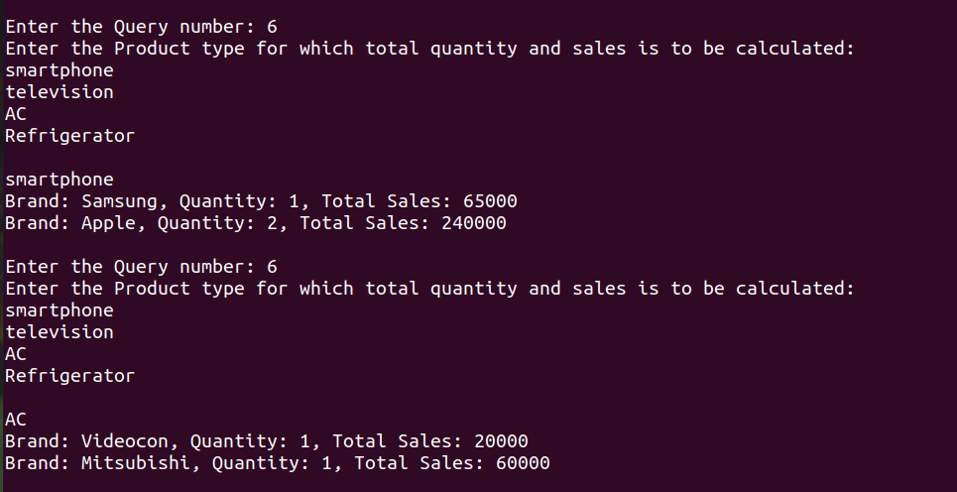
10.) Quantity of product sold and sales generated by a particular Brand
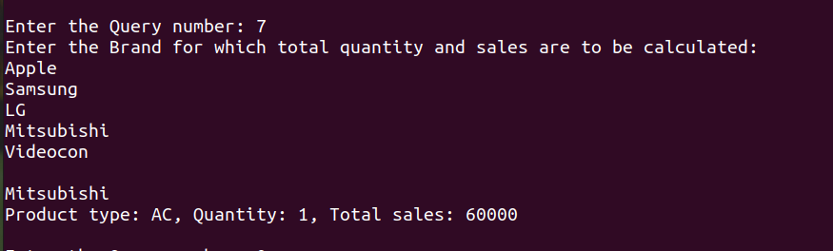

11.) Update a cutsomer’s mobile number
Delete a particular Product’s record

