

**DSP Lab 5**

**Topic : Linear convolution of two sequences using FFT**

**Name: Chris Parmar**

**PRN:20220802034**

**Batch: A1**

—

**AIM : To Plot linear convolution of two sequencies using FFT**

**SOFTWARE : MATLAB**

**THEORY :**

A fast Fourier transform (FFT) is an [algorithm](https://en.wikipedia.org/wiki/Algorithm) that computes the [Discrete Fourier Transform](https://en.wikipedia.org/wiki/Discrete_Fourier_Transform) (DFT) of a sequence, or its inverse (IDFT). [Fourier analysis](https://en.wikipedia.org/wiki/Fourier_analysis) converts a signal from its original domain (often time or space) to a representation in the [frequency domain](https://en.wikipedia.org/wiki/Frequency_domain) and vice versa. The DFT is obtained by decomposing a [sequence](https://en.wikipedia.org/wiki/Sequence) of values into components of different frequencies.This operation is useful in many fields, but computing it directly from the definition is often too slow to be practical. An FFT rapidly computes such transformations by f[actorizing](https://en.wikipedia.org/wiki/Matrix_decomposition) the [DFT matrix](https://en.wikipedia.org/wiki/DFT_matrix) into a product of [sparse](https://en.wikipedia.org/wiki/Sparse_matrix) (mostly zero) factor**s.**

**CODE :**

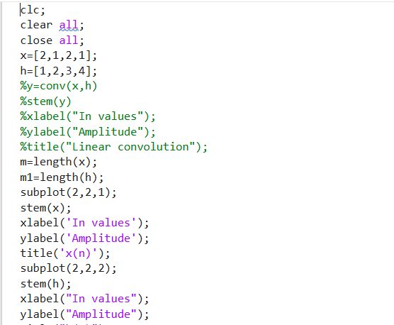

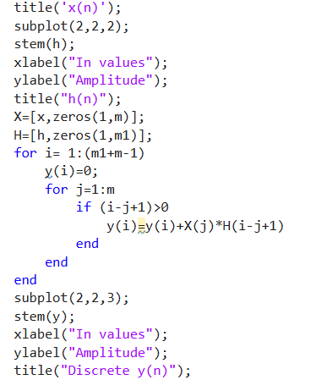

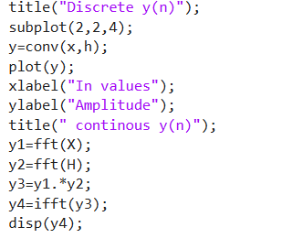

**Result:**

