

**DSP Lab 7**

**Topic : Power spectrum of signal**

**Name: Chris Parmar**

**PRN:20220802034**

**Batch: A1**

—

**AIM : Determination of Power Spectrum of given signal**

**SOFTWARE : MATLAB**

**THEORY : A Power Spectral Density (PSD) is the measure of signal's power content versus frequency. A PSD is typically used to characterize broadband random signals. The amplitude of the PSD is normalized by the spectral resolution employed to digitize the signal.**

**CODE :**

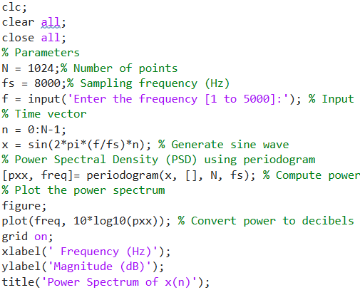

**Result:**

