**Name: - Chris Parmar**

**PRN: - 20220802034**

# EXPERIMENT - 6 ____________________________________________________________________________

**Aim: -** To design ECG signal using MATLAB

**Requirements:** MATLAB, CSV file

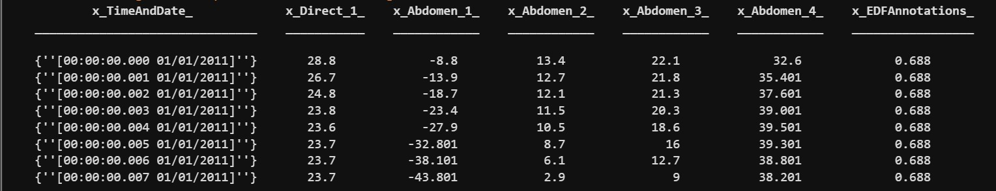**Theory: -** An Electrocardiogram (ECG) is a test that records the electrical activity of the heart over a period of time using electrodes placed on the skin. The resulting signal, known as an ECG waveform, represents the heart's electrical activity. The primary components of an ECG waveform are the P wave, QRS complex, and T wave. The QRS complex represents the rapid depolarization of the right and left ventricles. The P wave represents atrial depolarization, and the T wave represents ventricular repolarization. To simulate an ECG signal in MATLAB, we can use predefined functions to generate these components and combine them to form a complete ECG signal.

# Program-

% Load CSV file data = readtable('samples.csv');

% Display the first few rows to understand the structure disp(head(data));

ECGsignal = data{:, 3}; % Adjust index as necessary based on your CSV structure Fs = 360; % Set appropriate sampling frequency t = (0:length(ECGsignal)-1) / Fs; % Plot the ECG signal figure; plot(t, ECGsignal); xlabel('Time (seconds)'); ylabel('Amplitude (mV)'); title('ECG Signal'); grid on;

# Output: -

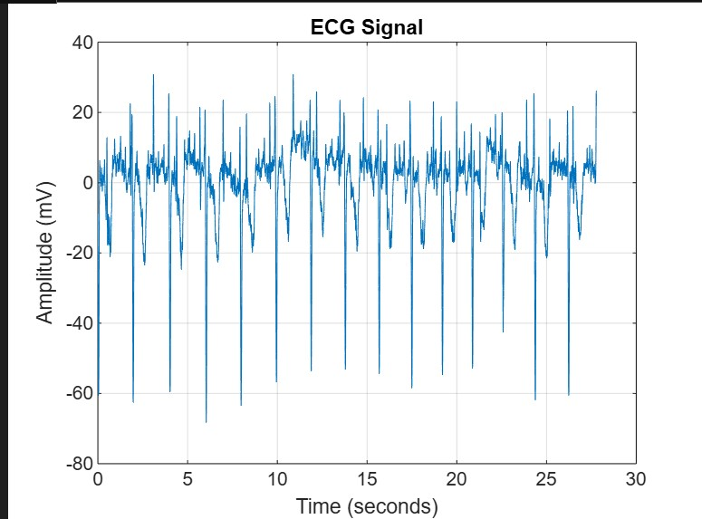

# Observation: -

The synthetic ECG signal was generated successfully using a combination of sinusoidal functions. Noise was added to the signal to simulate real-world conditions. The ECG signal was saved to a CSV file and successfully reloaded and plotted, demonstrating data persistence and retrieval.

# Conclusion: -

The experiment generated a synthetic ECG signal using MATLAB. Sinusoidal functions created a realistic ECG waveform, and added noise simulated actual conditions. Saving and reloading the signal from a CSV file ensured data persistence and easy analysis. This method provides a foundation for advanced ECG signal processing and biomedical applications.