**Dec Lab Exam DT-05.12.2020**

**Aim** :

To design and implement circuit of full adder and verify

**Apparatus required :**

1) Tinkercad Software

2) Breadboard

3) Power Supply

4) Slideswitch

5) IC of Logic gates(74HC86,74HC08,74HC32)

6) Resistor(1 KILO OHM)

7) Led bulb for signal

8) Connecting Wires

**Theory :**

The full adder is used to add three 1-bit binary numbers A, B, and carry C. The full adder has three input states and two output states i.e., sum and carry.

In the truth table,

1. 'A' and' B' are the input variables. These variables represent the two significant bits which are going to be added
2. 'Cin' is the third input which represents the carry. From the previous lower significant position, the carry bit is fetched.
3. The 'Sum' and 'Carry' are the output variables that define the output values.
4. The eight rows under the input variable designate all possible combinations of 0 and 1 that can occur in these variables.

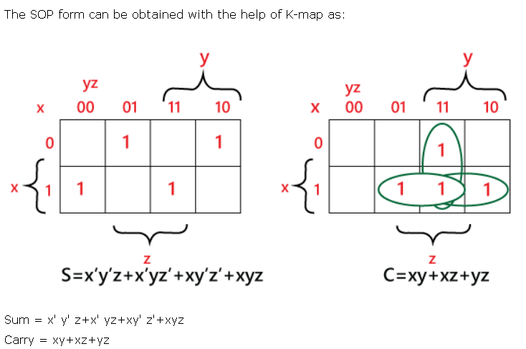

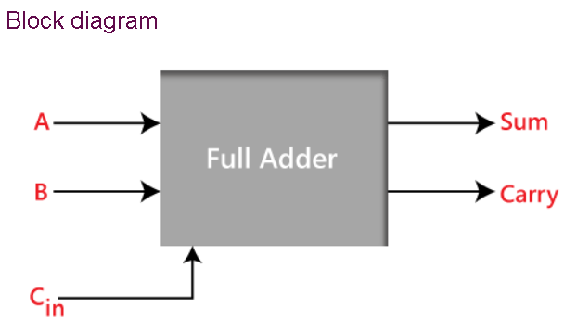

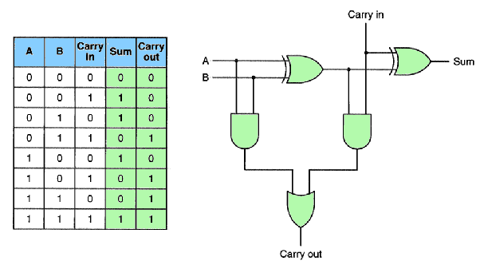

**P.T.O**

**Observation :**

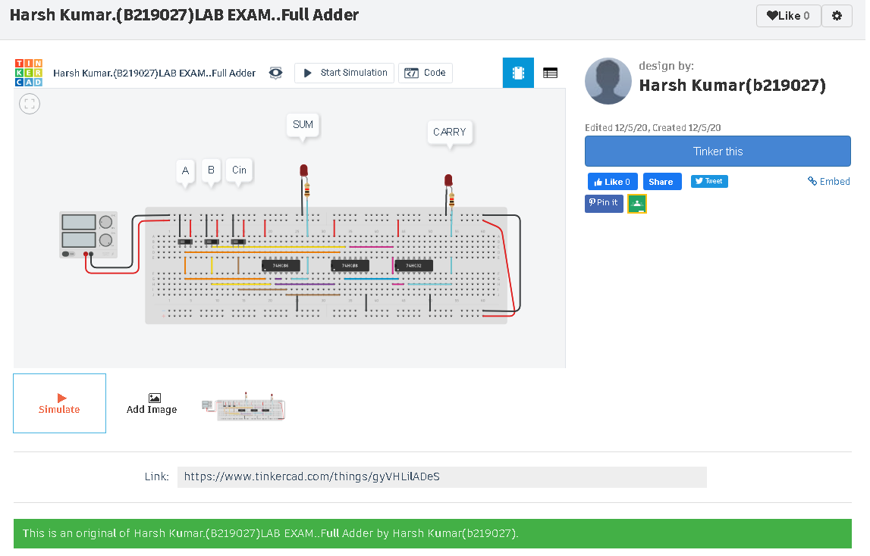

**LINK-**

https://www.tinkercad.com/things/gyVHLilADeS

**Conclusion :**

**Full adder circuit was designed and verified for all inputs and output**

**Name: Harsh Kumar**

**Branch: CE – 3 RD Sem.**

**ID- B219027(branch change)**