**NAME---HARSH KUMAR**

**ID---B219027**

**BRANCH---CE-4TH SEM.**

**DATE--- 15-01-2021**

LAB-1

**1. Use of CREATE command.**

A. Create a table whose details are given below.

i. Name of Table: COLLEGE

ii. Attributes are: CNAME(char), LOCATION(char)

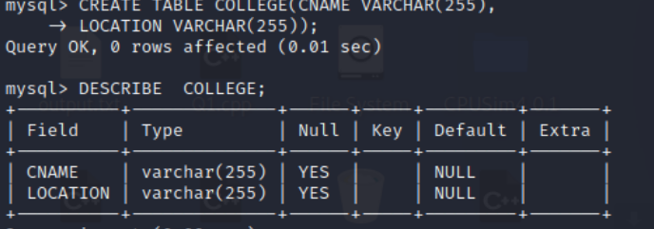

B. Create a table whose details are given below.

i. Name of Table: FACULTIES

ii. Attributes are: FNAME(char), DEPT(char),DESGN(char)

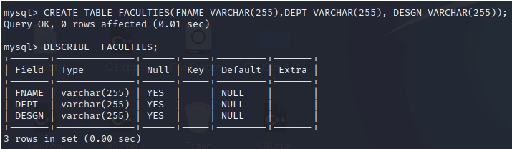

C. Create a table whose details are given below.

i. Name of Table: CUSTOMER

ii. Attributes are: CNAME(char), CID(int), ITEMNAME(char),PRICE(int)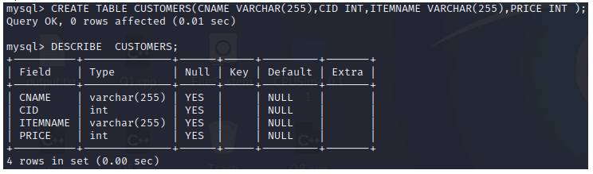

D. Create a table whose details are given below.

i. Name of Table: STUDENTS

ii. Attributes are: SNAME (char), ROLL(char), BRANCH(char),SUBJ1(int), SUBJ2(int). 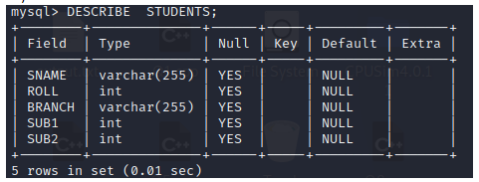

**2. Use of INSERT command.**

Syntax: INSERT INTO Custs (CustomerName, ContactName, Address, City, PostalCode, Country)

VALUES ('Cardinal', 'Tom B. Erichsen', 'Skagen 21', 'Stavanger', '4006', 'Norway');

B. INSERT into a table whose details are given below.

i. Name of Table: COLLEGE

ii. Attributes are: CNAME(IIIT), LOCATION(Bhubaneswar)

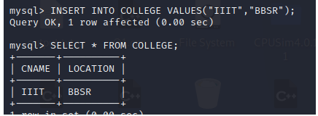

C. INSERT into a table whose details are given below.

i. Name of Table: FACULTIES

ii. Attributes are: FNAME(A Kalam), DEPT(CSE),DESGN(Professor)

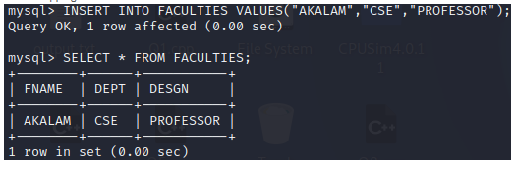

D. INSERT into a table whose details are given below.

i. Name of Table: CUSTOMER

ii. Attributes are: CNAME(Dhruv Rathee), CID(700), ITEMNAME(Camera),PRICE(50000)

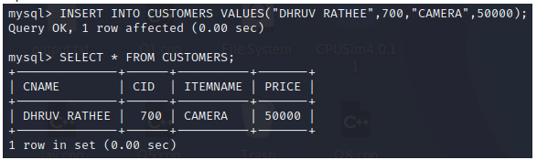

E. INSERT into a table whose details are given below.

i. Name of Table: STUDENTS

ii. Attributes are: SNAME (ADITYA), ROLL(b1111), BRANCH(CSE),SUBJ1(75), SUBJ2(85).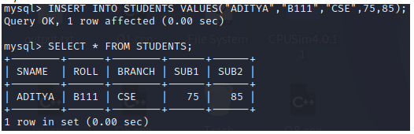

**3. Use of ALTER command**

a. ADD Column to a table using following details

i. Name of Table: COLLEGE

ii. Column name: CTYPE (char)

iii. Syntax: ALTER TABLE *table_name* ADD *column_name* datatype;

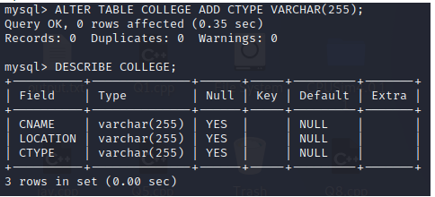

b. DROP COLUMN of a table using following details

i. Name of Table: FACULTIES

ii. Column name: DESGN

iii. Syntax: ALTER TABLE *table_name* DROP COLUMN *column_name*;

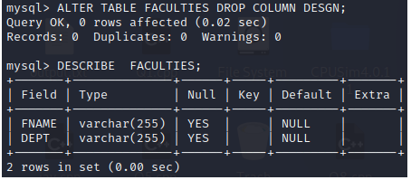

c. MODIFY COLUMN of a table using following details

i. Name of Table: COLLEGE

ii. Column name: CTYPE (int)

iii. Syntax: ALTER TABLE *table_name* MODIFY COLUMN *column_name* datatype; .

