**Experiment 6 DEC lab**

**Date- 3.11.2020**

**Aim**

To design SR , JK and D Flip flops and test them for ouputs.

**Apparatus required**

1) Tinkercad Software

2) Breadboard

3) Power Supply

4) DIP SPST x6 switch

5) NAND IC 7400,7410

6) HEX INVERTER IC 7404

7) Resistors-(1 kilo ohm).

8) LEDs.

9) Connecting wires.

**Theory**

A flip flop is an electronic circuit with two stable states that can be used to store binary data. The stored data can be changed by applying varying inputs. Flip-flops and latches are fundamental building blocks of digital electronics systems used in computers, communications, and many other types of systems. Flip-flops and latches are used as data storage elements. It is the basic storage element in sequential logic. But first, let’s clarify the difference between a latch and a flip-flop.

Flip flop are also known as gated or clocked latches. Flip flops are synchronous and data is only changed when the gated/clocked signal is active.

SR Flip flops:

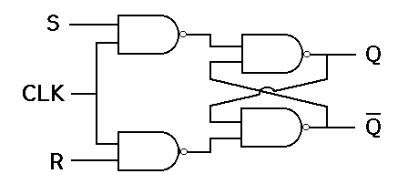

There are majorly 4 types of flip flops, with the most common one being SR flip flop. This simple flip flop circuit has a set input (S) and a reset input (R). In this circuit when you Set “S” as active the output “Q” would be high and “Q**’** ” will be low. Once the outputs are established, the wiring of the circuit is maintained until “S” or “R” go high, or power is turned off. As shown above, it is the simplest and easiest to understand. The two outputs, as shown above, are the inverse of each other. The truth table of SR Flip Flop is highlighted below.

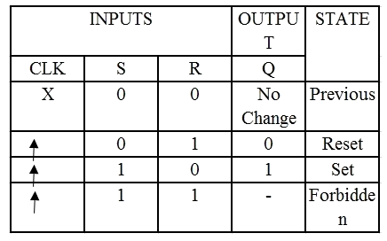

JK Flip flops:-

Due to the undefined state in the SR flip flop, another flip flop is required in electronics. The JK flip flop is an improvement on the SR flip flop where S=R=1 is not a problem.

The input condition of J=K=1, gives an output inverting the output state. However, the outputs are the same when one tests the circuit practically.

In simple words, If J and K data input are different (i.e. high and low) then the output Q takes the value of J at the next clock edge. If J and K are both low then no change occurs. If J and K are both high at the clock edge then the output will toggle from one state to the other. JK Flip Flop can function as Set or Reset Flip flop

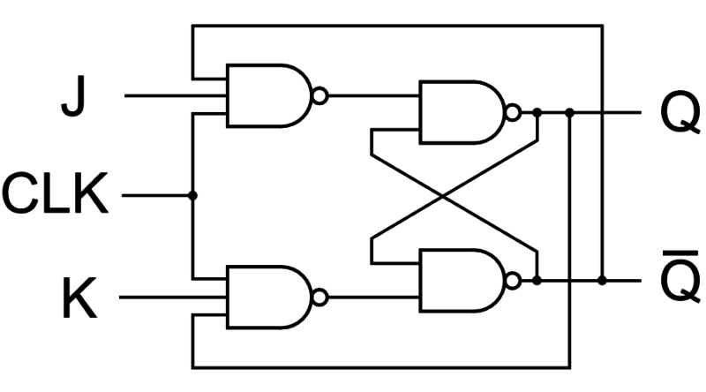

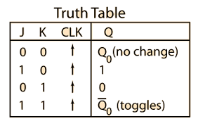

D Flip Flop:

D flip flop is a better alternative that is very popular with digital electronics. They are commonly used for counters and shift-registers and input synchronisation.

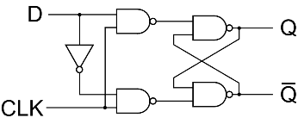

In a D flip flop, the output can be only changed at the clock edge, and if the input changes at other times, the output will be unaffected.

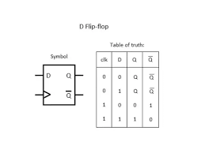

**Observation**

JK Flip Flop

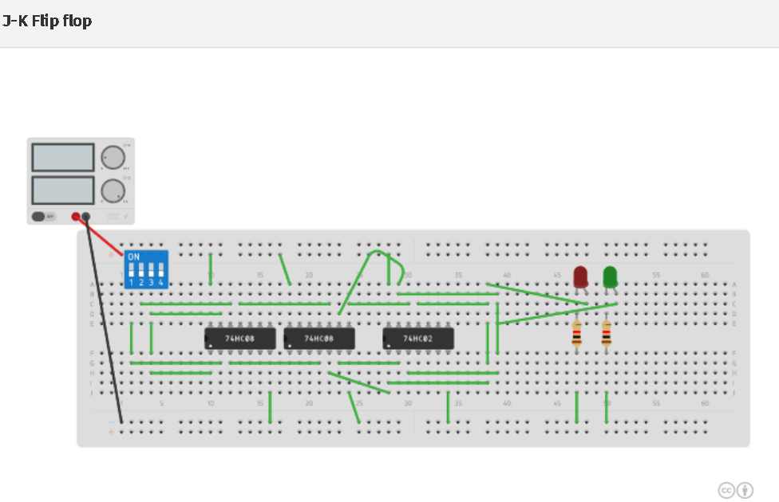

D Flip Flop

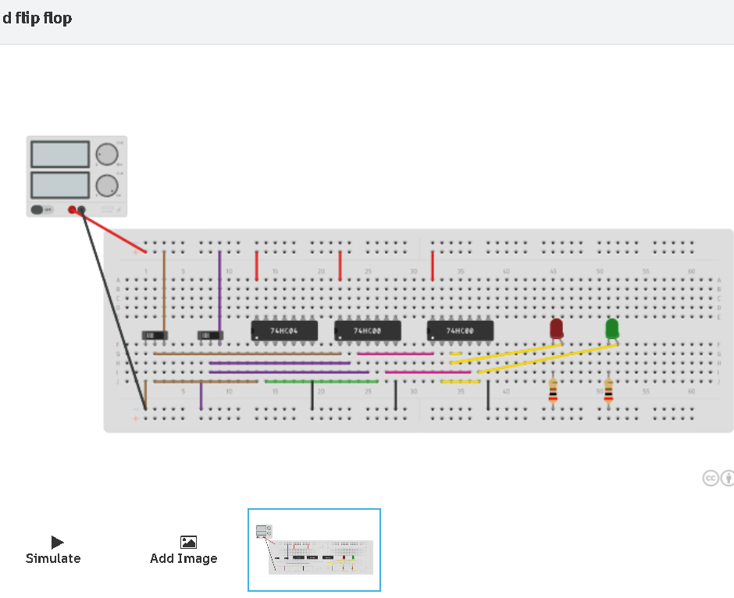

SR Flip Flop

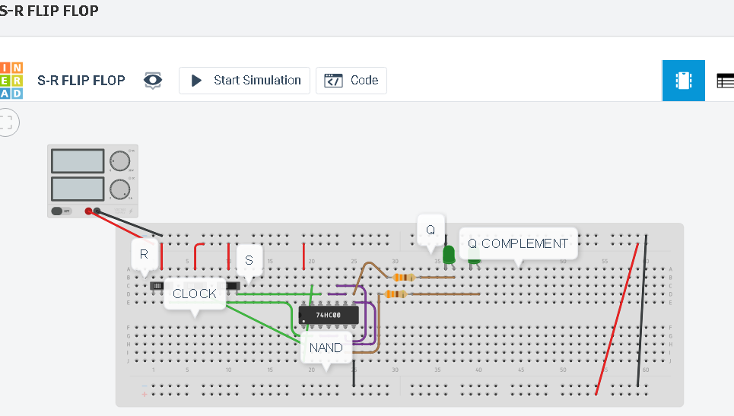

**Conclusion**

All the circuits were designed and verified for all inputs.

**Name - Harsh Kumar**

**Branch - CE 3rd semester**

**ID- B219027**