Business Entity Resolution
Amazon ML Challenge 2026: the complete workflow, explained step by step with real examples
Result: out-of-fold macro F0.5 = 0.9682 on all 2,206,821 training businesses (precision 99.4%, recall 93.1%). Submission files pass the official validator.

How to read this document
Every step of the solution is explained in three layers: (1) what the step does in plain words, (2) exactly how it is computed, and (3) a real example taken from the training data, with the numbers the pipeline actually produced. One business, Maure Williams Colombier Inc, is followed through every stage so you can see how the pieces connect.
Part | Content
1 | The problem
2 | The dataset, with a real example
3 | The evaluation metric (macro F0.5), with worked examples
4 | The workflow at a glance
5 | Step 1: Data analysis: what the data told us
6 | Step 2: Cleaning (normalisation)
7 | Step 3: Shortlisting candidates (blocking), with the full calculation
8 | Step 4: Pre-filter model
9 | Step 5: Clues (features)
10 | Step 6: Round-1 model and how it is trained
11 | Step 7: Round-2 model (context)
12 | Step 8: Final decision: one owner per record and how many matches to return
13 | Results
14 | End-to-end example summary
15 | Files, code and how to run
16 | Limitations and ideas
17 | Glossary

1. The problem
A business such as a shop, a factory or a consultancy is recorded in many places: an official registry, websites, directories, apps. Each place writes it differently: typos, abbreviations, different word order, a website name instead of the business name, a missing address, or the name written in Hindi instead of English. Entity resolution means working out which of these records are really the same business.
The challenge gives three sources:
- Source 1 (S1): a clean reference list. Each business appears exactly once.
- Source 2 (S2) and Source 3 (S3): messy lists. A business may appear several times, or not at all, and some records belong to no Source-1 business (decoys).
The task: for every Source-1 business, list all the Source-2 and Source-3 records that are the same business. If it has none, return an empty list.

Rules that shaped the solution
- No external data: we cannot look up businesses on the internet or in other databases.
- Models must be MIT or Apache licensed and at most 8 billion parameters. We use LightGBM (MIT), a small tree model of a few MB. No language model is used.
- The test set contains France, which never appears in training. The solution must work on a country it has never seen.
- Two output files are required: matching_results.tsv (the final matches) and candidate_pairs.tsv (the shortlist that was considered).

2. The dataset
Every record in every source has only four columns:
Column | Meaning | Example
entity_id | Unique ID. The prefix says the source (S1-, S2-, S3-) | S1-925783039
business_name | Name as written in that source | Orelee's Barbershop
business_address | Address as written (may be empty) | 1795 Westchester Drive, High Point, NC
country | US, India or France | US

File | Training rows | Test rows
Source 1 (clean reference) | 2,206,821 | 1,732,544
Source 2 (messy) | 5,034,616 | 4,887,273
Source 3 (messy) | 5,285,603 | 5,082,316
Ground truth (answer key) | 7,638,365 links | not given: this is what we predict
Countries | US, India | US, India, France

The answer key has one line per Source-1 business, listing its matching records:
source1_entity_id matched_entity_ids
S1-965667 S2-681193310,S2-743505751,S3-775321672,S3-11291185,S3-860443364

A real example: one business and its five copies
Record | Name | Address | What makes it hard
S1-965667 (reference) | Maure Williams Colombier Inc | 85 Wayne Avenue, Ticonderoga, NY | -
S2-681193310 | Maure Wilblims Colombier Inc | (empty) | typo in name, no address
S2-743505751 | Maure Williams Colombier | (empty) | no legal suffix, no address
S3-860443364 | Maure Williams Inc Center | (empty) | word missing, word added
S3-11291185 | maurewilliamscolombier.com | Wayne Ave, Ticonderoga Townshiip, New York | website instead of name, no house number, typo
S3-775321672 | Dréxkor | 85 Wanye Avenue, Ticonderoga Townshiip, New York | invented name, typos in address

And three look-alikes that are NOT this business (decoys the system must reject):
Record | Name | Address | Why it is not a match
S3-114723764 | Maure Williams Colombier Downtown Inc | 96 Wayne Avenue, Ticonderoga, New York | same name and street, different house number: a different branch
S2-101131615 | Williams Colombier Inc. | (empty) | 4 other businesses have this name
S3-84377888 | Williams Inc. Colombier | 738 Fourth St, Henderson, Tennessee | belongs to Williams Colombier Inc., 740 Fourth Street, Henderson, TN

This single example contains nearly every difficulty in the data. We will follow it through every step.

3. The evaluation metric: macro F0.5
Each Source-1 business is scored separately, then the scores are averaged over all businesses ("macro" average: a business with 1 match counts as much as one with 10).

Score for one business
Let G = number of true matches, K = number of matches we predicted, TP = number of our predictions that are correct.
Precision P = TP / K (how many of our answers are right)
Recall R = TP / G (how many of the true matches we found)

F0.5 = (1 + 0.5²) · P · R / (0.5² · P + R)
= 1.25 · TP / (0.25 · G + K) (same thing, simpler form)

Special case: G = 0 and K = 0 (no matches, and we predicted none) → score 1
G = 0 and K > 0 (we predicted something for a loner) → score 0

β = 0.5 means precision is weighted more than recall: a wrong match hurts more than a missed one. So the system should only return matches it is confident about.

Worked examples
Situation | G | K | TP | F0.5
Maure Williams: we return 4, all correct; 5 exist | 5 | 4 | 4 | 0.952
Return all 5, all correct | 5 | 5 | 5 | 1.000
Return 5: 4 correct + 1 wrong | 5 | 5 | 4 | 0.800
Return 3, all correct; 4 exist | 4 | 3 | 3 | 0.938
Return 5: 4 correct + 1 wrong; 4 exist | 4 | 5 | 4 | 0.833
Business with no matches, we return nothing | 0 | 0 | 0 | 1.000
Business with no matches, we return 1 (wrong) | 0 | 1 | 0 | 0.000
Business with 3 matches, we return nothing | 3 | 0 | 0 | 0.000

Two lessons: (1) adding one wrong match costs more than leaving one out (0.833 vs 0.938 in rows 4–5); (2) for the 5.6% of businesses with no matches, returning nothing is worth a full point.

4. The workflow at a glance
The solution is a pipeline of eight steps. Each step reads the previous step's output from disk, so any step can be re-run on its own.
# | Step | What it does | Size after the step (training) | Code
1 | Data analysis | Measure the data; decide the design | - | notebook, analyze.py
2 | Cleaning | Standardise names and addresses | 12.5M records | normalize.py, prepare.py
3 | Shortlisting (blocking) | For each messy record find ~10 likely businesses | 22.8 trillion possible pairs → 102M | blocking.py
4 | Pre-filter | Small model drops hopeless pairs | 102M → 17.5M | stages.py
5 | Clues (features) | 77 numbers describing each pair | 17.5M × 77 | features.py
6 | Round-1 model | Probability that the pair is a match | 17.5M probabilities | run_pipeline.py
7 | Round-2 model | Re-score using context (competition, sibling support) | 17.5M probabilities | model.py
8 | Decision | One owner per record; choose how many matches per business | matching_results.tsv | decision.py

Why a funnel? Comparing every messy record with every business would take 22.8 trillion comparisons. Detailed comparison is slow, so we first use a fast, generous search to get a short list, then spend the expensive work only on that list.

5. Step 1: Data analysis: what the data told us
Before building anything we measured the training data. Each finding changed a design decision.
Finding | Evidence | What we did
A messy record belongs to at most one business | 0 of 7.64M matched records is linked to two businesses | Search from the messy side; each record may go to only one business
About 1 in 4 messy records matches nobody | 74% of S2/S3 records appear in the answer key | Many decoys: precision matters
5.6% of businesses have no matches | 123,247 of 2,206,821 | "Predict nothing" must be a real option
A business has 3.5 matches on average | up to 5 in S2 and 6 in S3 | A business's matches can support each other (Round 2)
Matched records always share the country | 100% of 7.64M links | Search within each country; country is never a model input, so France works
Names reuse a small pool of words | the rarest word of a typical US name appears in ~450 other names; 69 businesses are called exactly "Tirupati Power" | Match on combinations of words
Raw names rarely agree exactly | 4.6% of true pairs; 55.6% after cleaning | Heavy cleaning
Addresses are the steadier field | address similarity ≥ 90% in 84% of true pairs | Address and house-number clues get high weight
Indian names in local scripts | 23% of India S2 names, 13% of S3 names | Romanise, then compare consonant skeletons
Missing addresses | about 3–4% of S2/S3 records | Name-only search channel
Websites / handles as names | about 3–4% of S2/S3 records | Word segmentation

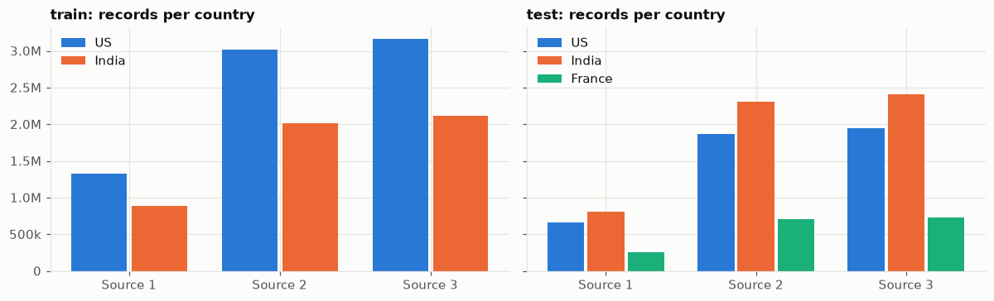
Records per country. France appears only in the test set.
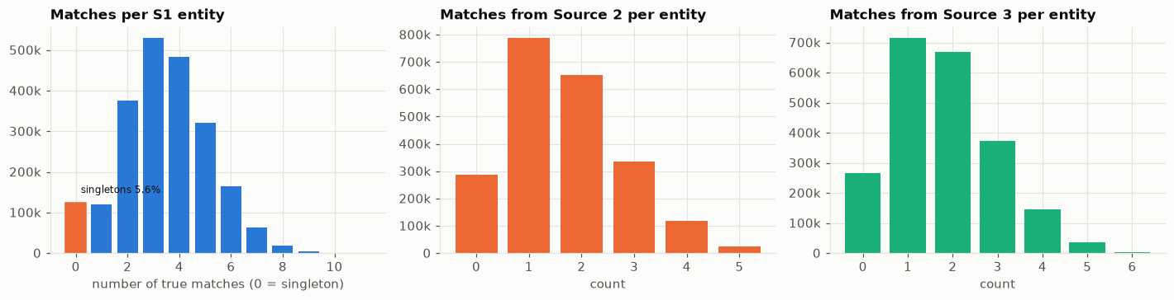
Answer key structure: matches per business and per source.
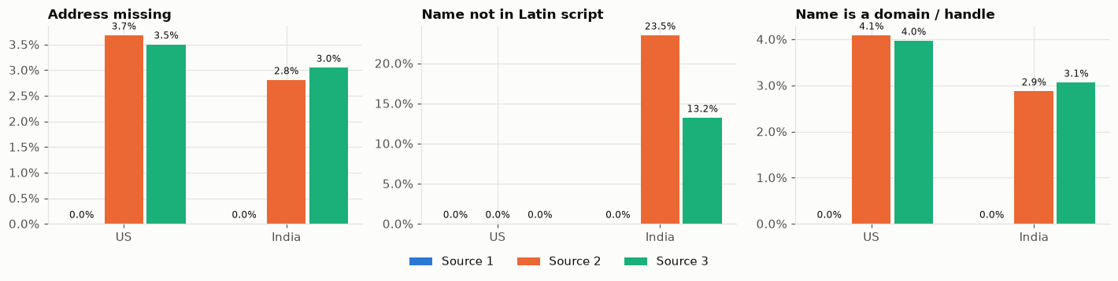
Noise by source and country: missing addresses, non-Latin names, website names.
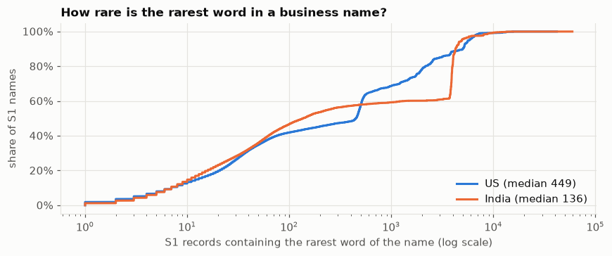
How common is the rarest word of each name? Most names share even their rarest word with hundreds of other businesses.

6. Step 2: Cleaning (normalisation)
Goal: make two spellings of the same thing identical, so later steps can compare them. Every record (all three sources) goes through the same rules. Code: normalize.py; it runs in parallel over 250,000-record slices (prepare.py).

6.1 Name cleaning, rule by rule
1. Transliterate: any non-English script is converted to English letters (unidecode). तिरुपति पावर → tirupti paavr. Accents are removed: ÍNC → inc.
2. Lower-case, remove punctuation: "Tirupati Power-Ltd" → tirupati power ltd; L.L.C → llc; & → and.
3. Website names: "raamvallalarprivate.com" → the .com is removed and the name is flagged as a website (is_dom).
4. Legal form separated: Inc, Incorporated → inc; Private, Pvt, Pte → pvt; Limited, Ltd → ltd; LLC, LLP, SARL, SAS (French) … are moved to a separate field "legal". Legal words written in Indian scripts are recognised by their consonant skeleton (प्राइवेट लिमिटेड → prvt lmtd → pvt ltd).
5. Stop words removed: and, of, the, de, la, le, du, des, et …
6. Duplicates removed: "Group Group" → group (noise often repeats words).
7. Word segmentation: glued words are split using a dictionary learnt from Source-1 names (details in 6.4).
8. Consonant skeleton: each word also gets a sound-based key (details in 6.3).

6.2 Address cleaning
1. Same transliteration / lower-case / punctuation rules as names.
2. Abbreviations unified (English, Indian, French): Avenue, Av, Aven → ave; Street, Str, Saint → st; Road → rd; Nagar → ngr; Sector → sec; Colony → col; Rue → r; Chemin → ch …
3. State extracted: "New York", "NY", "Newyork" → ny, stored separately. Matching is done on the consonant skeleton of the state name, so misspellings still work.
4. Numbers extracted: house / plot numbers go to a "nums" field. Leading zeros are removed (02714 → 2714). Numbers split by - or / are also joined (29-04 → 2904).
5. Empty-like values removed: None, null, N/A, unknown.

6.3 The consonant skeleton
Indian names romanised from a local script, and many typos, differ mainly in vowels and doubled letters. The skeleton keeps only the consonant sounds:
1. Fold similar sounds: ph→f, bh→b, kh→k, gh→g, th→t, dh→d, sh→s, ch→c, ck→k, q→k, c→k, z→j, w→v, x→ks
2. Collapse repeated letters: tt → t
3. Remove vowels and h, y
English spelling | Skeleton | Romanised from Hindi | Skeleton
marketing | mrktng | maarkettiNg | mrktng
tirupati | trpt | tirupti | trpt
power | pvr | paavr | pvr
private | prvt | praaivett | prvt
limited | lmtd | limittedd | lmtd
williams | vlms | wilblims (typo) | vlblms

6.4 Word segmentation
A dictionary of word frequencies is learnt from all Source-1 names. A long unknown word is split into the most likely sequence of known words (Viterbi algorithm: the split with the lowest total "cost", where cost = −log(word frequency)). A split is accepted only if every piece is a known word of at least 3 letters, so ordinary typos are not shredded. Names in Indian scripts are never split.
Input | Result
maurewilliamscolombier(.com) | maure williams colombier
raamvallalarprivate | raam vallalar (+ legal: pvt)
greatmanagementcom | great management
suarezenterprisesgroup | suarez enterprises group
consuihancy (a typo) | kept as is: pieces are not clean known words

6.5 What each record looks like after cleaning
Field | Meaning | Maure Williams (S1) | Website copy (S3-11291185)
nm | core name words | maure williams colombier | maure williams colombier
legal | legal form | inc | (none)
nsk | consonant skeletons | mr vlms klmbr | mr vlms klmbr
ad | address words | 85 wayne ave ticonderoga | wayne ave ticonderoga townshiip
nums | numbers | 85 | (none)
state | state code | ny | ny
is_dom / nonlatin | flags | no / no | yes / no

Raw | After cleaning
ÍNC COYNE INSTITUTE OF TECHNOLOGY | coyne institute technology · legal inc · kn nst tknlg
वन मार्केटिंग एलएलपी | vn maarketting · legal llp · vn mrktng
One Marketing L.L.P. | one marketing · legal llp · n mrktng
503 CLINTON SAINT | 503 clinton st
119 SPANISH BAY PLACE, TX, MONTGOMERY | 119 spanish bay pl montgomery · state tx

Effect measured on true pairs: identical names rise from 4.6% (raw) to 55.6% (cleaned), and 59.6% have identical skeletons.
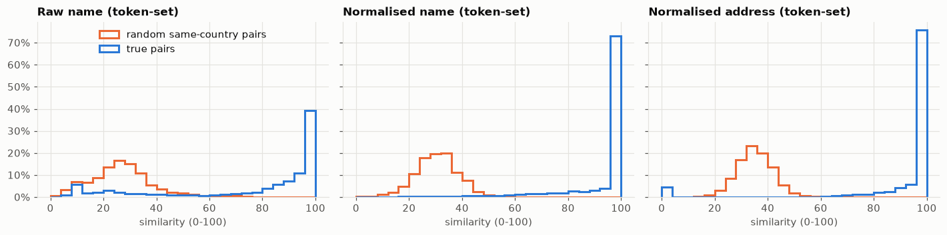
Similarity of true pairs vs random pairs, before and after cleaning. After cleaning the two groups separate much better.

7. Step 3: Shortlisting candidates (blocking)
Goal: for each messy record, quickly find the handful of businesses it could be, without comparing it with all of them. It works like the index at the back of a book: look up a word, jump to the pages that contain it. Code: blocking.py (class Blocker).

7.1 Search per country
One index is built per country from the Source-1 records of that country. A US record is only searched among US businesses. The country itself is never used as a clue, which is why France (unseen in training) works in the same way.

7.2 Turn every record into keys
Twelve kinds of key are produced from the cleaned fields, grouped into three families:
Family | Code | Key kind | Example (Maure Williams, 85 Wayne Ave) | Type weight
Name | n | name word | maure | 1.0
Name | k | consonant word | klmbr | 0.5
Name | p | pair of name words | maure|williams | 1.5
Name | q | pair of consonant words | klmbr|vlms | 0.8
Name | r | pair of 4-letter word beginnings | maur|will | 0.8
Name | t | pair of 3-letter consonant beginnings | klm|vlm | 0.5
Address | a | address word | ticonderoga | 1.0
Address | d | number | 85 | 1.0
Address | b | number + next word | 85 wayne | 1.5
Address | s | adjacent address words | wayne ave | 1.2
Mixed | x | name word # house number | colombier#85 | 1.0
Mixed | y | consonant word # house number | klmbr#85 | 0.6

Why pairs? Single words are shared by thousands of businesses ("williams": 4,873), but combinations are almost unique ("maure|williams": 1). Word-beginning pairs survive typos (Wilblims still gives "will"). The mixed keys tie the name to the address.

7.3 Weight each key by its rarity (IDF)
rarity(key) = ln(N + 1) − ln(df) + 1
N = number of Source-1 businesses in the country (US: 1,323,633)
df = how many of them contain the key

weight(key) = rarity(key) × type weight

Key (US) | Businesses containing it (df) | Rarity | Used for searching?
maure|williams (pair) | 1 | 15.10 (maximum) | yes
colombier|williams (pair) | 5 | 13.49 | yes
maure | 23 | 11.96 | yes
ticonderoga | 65 | 10.92 | yes
wayne ave | 107 | 10.42 | yes
colombier | 512 | 8.86 | no: more than 100
85 | 1,448 | 7.82 | no: more than 100
wayne | 2,884 | 7.13 | no: more than 100
williams | 4,873 | 6.60 | no: more than 100
ave | 184,678 | 2.97 | no: more than 100

Keys used by too many businesses are not used for searching (the limit is 100 for single words and numbers, 300 for pairs and combinations). They would pull thousands of useless candidates into every lookup. They still count in the record's length (next step), so scores stay comparable.

7.4 Score = cosine similarity, computed separately for each family
1. For each record, collect the weights of its keys in one family (e.g. name keys).
2. Divide every weight by the record's length = √(sum of squared weights). After this the squared weights add up to 1, so a record with many keys does not win just by having more.
3. Score between a messy record and a business = sum over shared (searchable) keys of (scaled weight in record × scaled weight in business).
The score is 1.0 when the two records have identical keys and 0 when they share none. This is done three times, giving a name score, an address score and a mixed score. The combined score is their average.

7.5 Worked example A: name score of S2-743505751 "Maure Williams Colombier"
After cleaning, both this record and the business are "maure williams colombier", so they have the same 18 name keys. Length of each key vector = 49.75.
Key | df | Rarity | × type | Weight | Scaled (÷49.75) | Counted? | Product
maure|williams | 1 | 15.10 | 1.5 | 22.64 | 0.455 | yes | 0.207
colombier|maure | 1 | 15.10 | 1.5 | 22.64 | 0.455 | yes | 0.207
colombier|williams | 5 | 13.49 | 1.5 | 20.23 | 0.407 | yes | 0.165
maure | 23 | 11.96 | 1.0 | 11.96 | 0.240 | yes | 0.058
maur|will | 4 | 13.71 | 0.8 | 10.97 | 0.220 | yes | 0.049
klmbr|vlms | 5 | 13.49 | 0.8 | 10.79 | 0.217 | yes | 0.047
colo|maur | 6 | 13.30 | 0.8 | 10.64 | 0.214 | yes | 0.046
klmbr|mr | 11 | 12.70 | 0.8 | 10.16 | 0.204 | yes | 0.042
colo|will | 16 | 12.32 | 0.8 | 9.86 | 0.198 | yes | 0.039
mr|vlms | 43 | 11.33 | 0.8 | 9.07 | 0.182 | yes | 0.033
klm|vlm, klm|mr, mr|vlm | 19–44 | 11.3–12.2 | 0.5 | 5.7–6.1 | 0.11–0.12 | yes | 0.041
colombier | 512 | 8.86 | 1.0 | 8.86 | 0.178 | no (too common) | -
williams | 4,873 | 6.60 | 1.0 | 6.60 | 0.133 | no | -
klmbr, vlms, mr | 512–6,032 | 6.4–8.9 | 0.5 | 3.2–4.4 | 0.06–0.09 | no | -
TOTAL |  |  |  |  |  |  | 0.934

Name score = 0.934. The names are identical, so without the "too common" rule it would be 1.0; the five common keys take away 0.066. The four other "Williams Colombier Inc" businesses share only the keys without "maure" and score 0.465, so the correct business is clearly first. This record has no address, so address score = mixed score = 0, and combined = (0.934 + 0 + 0) / 3 = 0.311.

7.6 Worked example B: address score of S3-11291185 (the website copy)
Key | Business (scaled) | Record (scaled) | Shared & counted? | Adds
85 wayne (df 1) | 0.751 | - (record has no number) | no | 0
wayne ave (df 107) | 0.415 | 0.419 | yes | 0.174
ticonderoga (df 65) | 0.362 | 0.366 | yes | 0.133
85 (df 1,448) | 0.259 | - | no | 0
wayne (df 2,884) | 0.236 | 0.239 | too common | 0
ave (df 184,678) | 0.098 | 0.099 | too common | 0
ticonderoga townshiip (typo) | - | 0.607 | no | 0
townshiip (typo) | - | 0.506 | no | 0
TOTAL |  |  |  | 0.306

Address score 0.306, name score 0.934 (same keys as example A), mixed 0. Combined = (0.934 + 0.306 + 0) / 3 = 0.414. These hand calculations match the values stored by the pipeline exactly (0.9343 and 0.3063).

7.7 Keep a short list
Rule | Kept per messy record
Best by combined score | 8
+ best by name score alone | 3
+ best by address score alone | 3
+ best by mixed score alone | 2

Duplicates are merged, so a record usually ends up with 8–10 candidates (9.9 on average). Taking the best from each family separately protects records where one field is missing or disguised: a record with no address is still found by the name score, and one with an invented name by the address score.

7.8 Short lists for our example records
Messy record | Rank of the true business | Other candidates on its list
S2-743505751 "Maure Williams Colombier" (no address) | 1st (combined 0.311) | 4 × "Williams Colombier Inc/Corp" in TN, CA, VA, WA (0.155); Murray Colombier …
S3-11291185 website copy | 1st (0.414) | 4 × Williams Colombier (0.155); Ballard & Franklin, 15 Wayne Ave, Ticonderoga (0.108)
S3-114723764 decoy "… Downtown Inc, 96 Wayne Ave" | our business ranks 1st (0.319) | Metro Holding Co, 8289 96, Wayne NY (address); Williams Keen, 96 High St (name#number)
S3-775321672 "Dréxkor", 85 Wanye Ave | NOT on the list | 8 other Ticonderoga businesses (0.03–0.05)

The decoy is shortlisted on purpose: the shortlist's only job is not to miss anything. Telling house number 85 from 96 is left to the model. "Dréxkor" is lost: its name shares nothing, the typo "wanye" breaks the unique key "85 wayne", and its only remaining useful key is "ticonderoga", shared by 65 businesses. A pair that is not shortlisted can never be matched, so this is where the 4% recall ceiling comes from.

7.9 How it runs fast
- Keys are stored as 64-bit numbers (hashes), not text, which saves memory.
- For each country the business keys form a sparse matrix (businesses × keys). Messy records are processed 25,000 at a time: their key matrix is multiplied by the business matrix. Only businesses sharing at least one searchable key are touched, like an index lookup.
- Time: about 1 hour per split (US + India training; US + India + France test).

7.10 How well it works
Version (measured on a 1/20 sample) | True matches on the short list | True business ranked 1st
Single words only (name + address) | 78.0% | 65.9%
+ name word pairs, address pairs, name × house number | 94.6% | 89.2%
+ word-beginning pairs, consonant pairs, segmentation, leading-zero fix | 96.2% | 91.6%

Stage | Pairs | Share of true matches still reachable
All possible pairs (same or different country) | 22.8 trillion | 100%
After shortlisting | 102.0 million | 96.19%
After the pre-filter (candidate_pairs.tsv) | 17.5 million | 95.99%
True pairs (for comparison) | 7.64 million | -

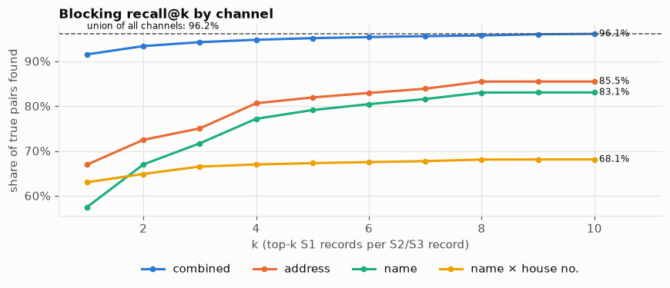
Share of true matches found as the short list grows, per key family.
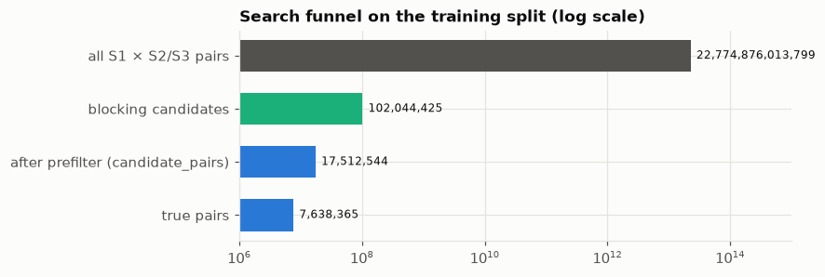
The funnel: from all possible pairs to the final candidate list.

8. Step 4: Pre-filter model
102 million pairs is still a lot to compute 77 clues for. A small, fast LightGBM model looks at only six numbers from the shortlisting step and removes pairs that are clearly hopeless.
Input | Meaning
sc_comb | combined score
sc_name, sc_addr, sc_mix | the three family scores
n_ot | how many candidates this messy record has
margin_ot | how far this candidate is behind or ahead of the record's best candidate

Training: on a 1/10 sample of the training pairs, labelled with the answer key. Threshold: chosen so that at most 0.2% of true matches are dropped. Result: 17.2% of pairs kept (102M → 17.5M). The pre-filter's probability (p0) is kept as a clue for later models. The remaining pairs are written to candidate_pairs.tsv.
Example: for the no-address record S2-743505751 only one of its 8 candidates survives: the true business (p0 = 0.92). The four "Williams Colombier" businesses in other states are dropped because they are far behind the leader and have no address support.

9. Step 5: Clues (features)
For every surviving pair, 77 numbers are computed that describe how the two records compare. A model cannot read text; it learns from these numbers. Code: features.py and stages.py.

9.1 How text similarity is measured
- ratio: edit-based similarity of two strings, 0–100 (how many character edits turn one into the other).
- token_sort_ratio: sort the words first, then compare: word order does not matter.
- token_set_ratio: compare the shared words vs the leftovers: extra words do not hurt much.
- partial_ratio: best match of the shorter string inside the longer one.
- Jaro-Winkler, Levenshtein: character-level similarity / edit distance.
- Jaccard: shared words ÷ all distinct words.
- IDF overlap: the rarity-weighted share of words in common (rare shared words count more).

9.2 The 77 clues, grouped
Group | Clues | What they capture
From shortlisting (22) | sc_name, sc_addr, sc_mix, sc_comb, ranks and gaps per record and per business (rk_ot_*, gap_ot_*, gap_s1_*, margin_ot, margin_s1, n_ot, n_s1), p0 | How strongly the index search linked them and how clear the winner was
Name similarity (12) | nm_ratio, nm_tsort, nm_tset, nm_partial, nm_wratio, cond_jw, cond_lev, cond_partial, sk_ratio, sk_tset, sk_tsort, sk_cond_partial | Name agreement: plain, word-order-free, with spaces removed, on skeletons
Name words (12) | nm_jacc, nm_cont_a, nm_cont_b, sk_jacc, nm_ntok_a/b, nm_first_eq, acro_a, acro_b, nm_eq, sk_eq, oov_b | Shared words, first word equal, acronyms ("IBM"), exact equality, share of words never seen in Source 1 (invented names)
Name rarity (7) | nm_idf_a, nm_idf_b, nm_idf_sum, nm_cnt_s1_a, nm_cnt_s1_b, sk_cnt_s1_b, nm_cnt_ot_b | Are the shared words rare? How many businesses have exactly this name?
Record type (7) | legal_rel, is_dom_b, nonlatin_b, src_s3, len_a, len_b, ad_missing_b | Legal form agrees / conflicts / missing; website name; non-Latin script; which source; length; address missing
Address (15) | ad_ratio, ad_tset, ad_tsort, ad_partial, ad_jacc, ad_cont_a, ad_eq, num_jacc, num_any, hn_eq, hn_lev, ad_idf_a, ad_idf_b, ad_idf_sum, ad_cnt_s1_a | Address agreement, shared numbers, house number equal and its edit distance (10554 vs 70554 = 1), rarity of shared address words
State (1) | state_rel | same state / different / unknown
Combined (2) | nm_ad_min, sk_ad_prod | both name and address agree (min, product)

9.3 Clue values for our example
Record | name tset | skeleton tset | address tset | house no. equal | legal | addr missing | website
A: website copy (true) | 100 | 100 | 93 | n/a | n/a | no | yes
B: "Wilblims" typo (true) | 96 | 93 | - | n/a | same | yes | no
C: "… Inc Center" (true) | 80 | 80 | - | n/a | same | yes | no
D: no suffix (true) | 100 | 100 | - | n/a | n/a | yes | no
E: Downtown, 96 Wayne (decoy) | 100 | 100 | 93 | no (edit 2) | same | no | no
F: Williams Colombier (decoy) | 100* | 100* | - | n/a | same | yes | no
G: 738 Fourth St TN (decoy) | 100* | 100* | 47 | no (edit 3) | same | no | no

* token_set_ratio is 100 when all words of the shorter name appear in the longer one. The rarity and word-coverage clues (nm_cont_a, nm_idf) reveal that "maure" is missing. On names alone the decoy E looks as good as the true copies; the house-number clues separate it.
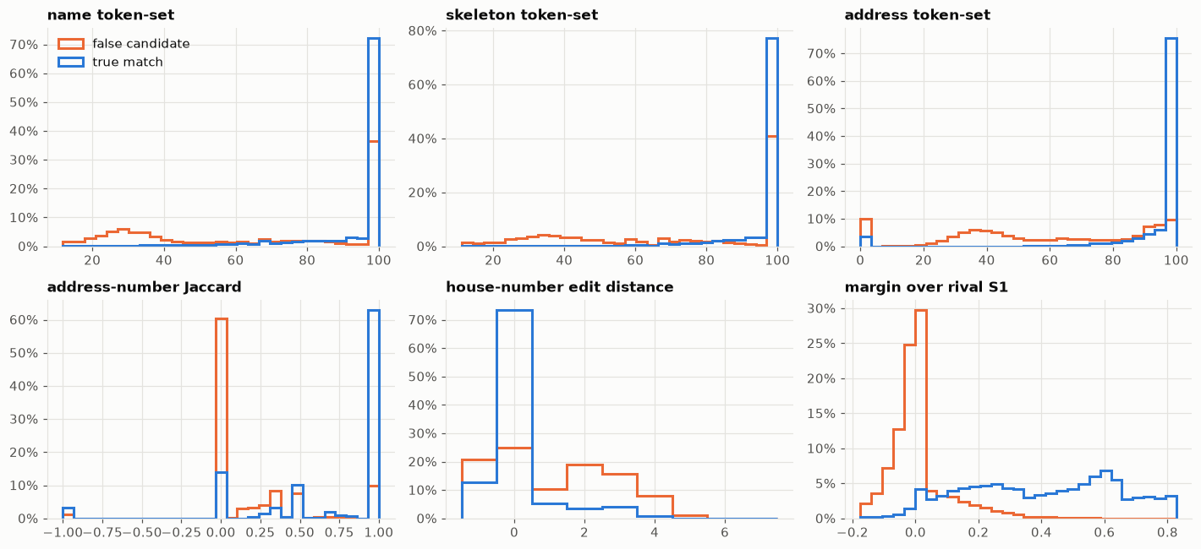
How true and false candidate pairs differ on six important clues (3 million sampled pairs).

10. Step 6: Round-1 model and how it is trained

10.1 Training examples
Each surviving training pair becomes one example: its 77 clues are the input, and the label is 1 if the answer key links the two records, else 0. After the pre-filter, 41.9% of pairs are true matches; the rest are the hard decoys that survived shortlisting, which is exactly what the model needs to learn to reject.

10.2 The model: LightGBM (gradient-boosted decision trees)
A decision tree is a flowchart of yes/no questions, for example:
address similarity ≥ 90 ?
├─ yes → house numbers equal ?
│ ├─ yes → very likely a match
│ └─ no → name similarity ≥ 95 ? …
└─ no → address missing ? …

One tree is weak. Gradient boosting builds hundreds of trees one after another; each new tree is fitted to correct the errors that the trees before it still make. The final answer is the sum of all trees, turned into a probability between 0 and 1.
Setting | Value | Meaning
objective | binary | yes / no prediction with log-loss
learning_rate | 0.05 | each tree corrects only 5% of the remaining error (slow, stable)
num_leaves | 127 | maximum size of each tree
min_child_samples | 200 | a rule must be supported by at least 200 examples
subsample / colsample | 0.8 / 0.7 | each tree sees 80% of rows and 70% of clues (reduces over-fitting)
reg_lambda | 1.0 | penalty on extreme leaf values
n_estimators | up to 3,000 | maximum trees
early stopping | 100 rounds | stop when the score on held-out data has not improved for 100 trees

10.3 Fair testing: two-fold cross-fitting
A model graded on examples it learnt from looks better than it is. So the businesses are split into two halves by ID (even / odd index):
1. Model A learns from half 0 and predicts half 1.
2. Model B learns from half 1 and predicts half 0.
3. Every training pair therefore gets an out-of-fold probability from a model that never saw its business. These are used to train Round 2, to tune the decision rule and to report the score.
4. For the test set, the probabilities of models A and B are averaged.
Memory limit: each model learns from a quarter of its half (about 2.2 million pairs; selected by business ID so all pairs of a business stay together). Early stopping is measured on businesses from the other half. Round-1 training took about 15 minutes per model (2,145 and 2,728 trees).

10.4 What Round 1 relies on
Clue | Share of importance | Meaning
p0 | 38.2% | the pre-filter's probability
margin_ot | 20.1% | how clearly this is the record's best candidate
sk_ad_prod | 5.6% | skeleton name similarity × address similarity
num_jacc | 3.9% | shared numbers
hn_lev | 3.7% | edit distance of house numbers
ad_tset | 3.2% | address similarity
nm_ad_min | 2.7% | both name and address agree
legal_rel | 2.4% | legal form agreement

Round 1 alone scores macro F0.5 = 0.9617 (using probability ≥ 0.5 and one owner per record).

10.5 Round-1 probabilities for our example
Record | True? | Round 1 | Why
A: website copy | yes | 99.996% | full name match + same street
B: "Wilblims" | yes | 99.6% | small typo; rare words "maure", "colombier"
D: no suffix | yes | 99.0% | exact name, even without address
C: "Inc Center" | yes | 98.3% | two rare words match; "center" is filler
E: Downtown, 96 Wayne | no | 0.06% | same street, different house number, extra word
F: Williams Colombier | no | 0.009% | "maure" missing; 4 other businesses share this name
G: 738 Fourth St, TN | no | 0.0003% | wrong state and street

11. Step 7: Round-2 model (context)
Round 1 judges each pair on its own. Round 2 sees Round 1's probabilities for all pairs and adds 15 context clues, then retrains the same kind of model (92 clues in total: 77 + p1 + 14 context). Round-2 training took about 3 minutes per model.

11.1 Competition clues (the one-owner rule)
Clue | Meaning
c_rk_ot | rank of this business among all businesses competing for the same messy record
c_other_max_ot / c_other_sum_ot | strongest / total probability of competing businesses for this record
c_rk_s1 | rank of this record among the business's candidates
c_other_sum_s1, c_n_conf_s1, c_max_s1 | how many confident matches the business already has

11.2 Sibling-support clues
A business's confident matches (Round-1 probability ≥ 0.6, up to 3) are its "siblings". Every candidate is compared with them: sb_ad (address similarity to the best sibling), sb_nm, sb_sk (name / skeleton similarity), sb_num (numbers), weighted versions and the number of siblings. A Hindi-named record or an invented name with the same address as a confident English-named copy gets support even if its own name similarity is low.

11.3 Round 2 on our example
Record | Round 1 | Round 2 | What changed
A | 99.996% | 99.994% | -
B | 99.6% | 99.7% | -
C | 98.3% | 99.4% | raised: its name agrees with 2 confident siblings
D | 99.0% | 98.7% | -
E (decoy) | 0.06% | 0.03% | stays rejected
F (decoy) | 0.009% | 0.006% | 3 other businesses also compete for it
G (decoy) | 0.0003% | 0.0004% | another business (740 Fourth St, TN) wants it with 88%

Round 2's top clue is p1 (80% of importance), followed by p0, margin_ot, sb_num and the rank clues. Round 2 raises the score from 0.9617 to 0.9664 with the same simple rule (probability ≥ 0.5, one owner), and to 0.9682 with the decision step below.
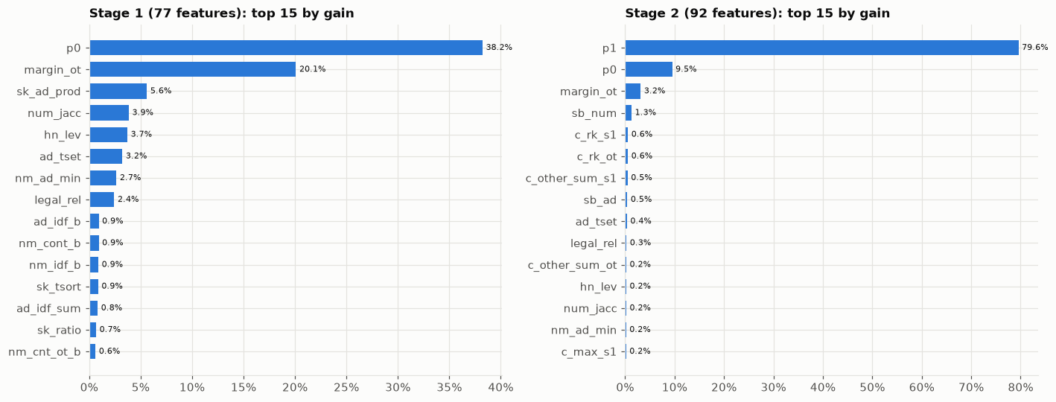
Most important clues of the Round-1 and Round-2 models.

11.4 Can the probabilities be trusted? (calibration)
The decision step needs honest probabilities. Grouping all training pairs by their Round-2 probability and counting how many are really true:
Predicted range | Average predicted | Actually true | Pairs
0.0–0.1 | 0.3% | 0.3% | 9,761,532
0.1–0.2 | 14.5% | 14.6% | 196,569
0.3–0.4 | 34.7% | 34.3% | 87,821
0.5–0.6 | 54.8% | 54.4% | 57,766
0.7–0.8 | 75.3% | 75.3% | 54,792
0.9–1.0 | 99.7% | 99.7% | 7,016,965

"70% sure" really means right about 70% of the time, so the probabilities can be used for expected-score calculations.
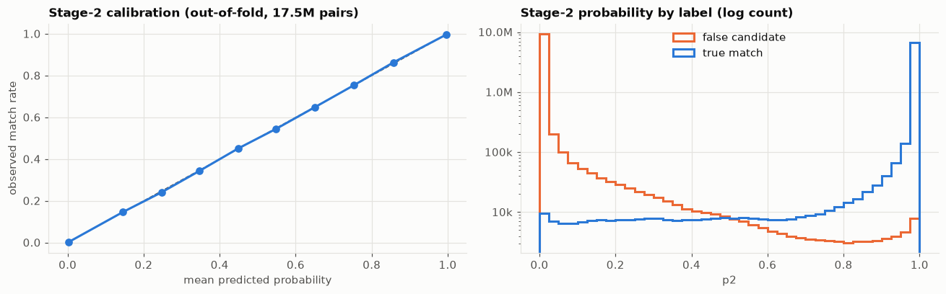
Calibration: predicted probability vs observed share of true matches.

12. Step 8: Final decision

12.1 One owner per messy record
A messy record belongs to at most one business. For each messy record (mode "both"):
1. Renormalise: if the probabilities from all competing businesses add up to more than 1, divide them by the sum.
2. Arg-max: only the business with the highest probability keeps the record; the others get 0.
Example: decoy G has 88% for Williams Colombier Inc. (Henderson, TN) and 0.0004% for our business, so only the Henderson business may claim it.

12.2 How many matches to return for each business
A single global threshold (e.g. 0.5) is not optimal for a per-business F0.5. Instead, for each business, candidates are sorted by probability and for every K = 0, 1, 2, … we compute the expected F0.5 if we return the top K, and pick the best K.
Expected F0.5(K) = Σ over all possible outcomes P(outcome) × F0.5(outcome)
TP = number of true matches among the top K (Poisson-binomial distribution)
U = number of true matches among the rest (Poisson-binomial distribution)
G = TP + U (+ an allowance of 3% for matches the shortlist missed)
F0.5 = 1.25·TP / (0.25·G + K); K = 0 scores 1 only if there are no true matches

The Poisson-binomial distribution gives the exact probability of getting 0, 1, 2 … true matches from candidates with different probabilities; it is computed with a short dynamic programme (decision.py: _pb_dist, expected_f_best_k).

Worked example: Maure Williams Colombier
Return top K | Expected F0.5
0 (predict nothing) | 0.000
1 | 0.617
2 | 0.825
3 | 0.929
4 | 0.989
5 | 0.825

Best K = 4 (expected 0.989). Adding the 5th candidate (the decoy, 0.03%) would almost surely add a wrong match and drop the expected score to 0.825.

Worked example: uncertain businesses
Candidates | Expected F0.5 for each K | Chosen K
best candidate 35%, next 5% | K=0: 0.599, K=1: 0.345, K=2: 0.219 | 0
best candidate 62%, next 5% | K=0: 0.350, K=1: 0.611, K=2: 0.367 | 1
90%, 40%, 5% | K=0: 0.055, K=1: 0.827, K=2: 0.676, K=3: 0.494 | 1

With only a 35% candidate, returning nothing is the better bet (this is how the 5.6% of businesses with no matches get their full point). At 62% it is worth returning one.

12.3 Decision rules compared (all 2.2M training businesses, out-of-fold)
Rule | Macro F0.5
Round 1, probability ≥ 0.5, one owner | 0.96167
Round 2, probability ≥ 0.5, no owner rule | 0.96619
Round 2, probability ≥ 0.5, one owner (arg-max) | 0.96638
Round 2, probability ≥ 0.7, one owner (renormalise) | 0.96765
Round 2, expected-F0.5 K, arg-max | 0.96817
Round 2, expected-F0.5 K, renormalise + arg-max, 3% miss allowance (FINAL) | 0.96819

21 variants were tried; the chosen one is stored in work/models/decision.json. Both halves of the data give the same score (0.96814 and 0.96824), which shows the result is stable.
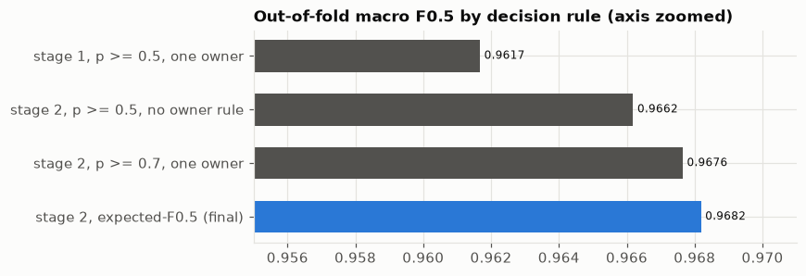
Macro F0.5 of the decision rules.
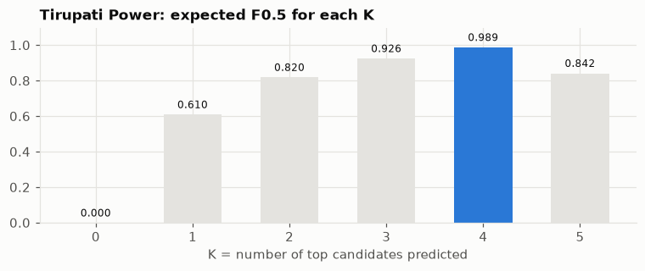
Expected F0.5 against K for the Tirupati Power example.

13. Results
Measure | Value
Macro F0.5 (out-of-fold, all 2,206,821 training businesses) | 0.9682
Precision (share of returned matches that are correct) | 99.38%
Recall (share of true matches returned) | 93.07%
Recall ceiling after shortlisting + pre-filter | 95.99%
US | 0.9742
India | 0.9592
Businesses with no matches (singletons) | 0.9542
Businesses with matches | 0.9690

Where matches are lost
Record type | Share of true matches | On the short list | Finally found
All | 100% | 96.0% | 93.1%
Latin-script name | 92.8% | 96.7% | 93.7%
Non-Latin-script name | 7.2% | 86.3% | 84.6%
Website / handle name | 4.7% | 95.6% | 95.3%
Address present | 95.6% | 96.9% | 95.1%
Address missing | 4.4% | 76.1% | 49.4%

Records with no address are the hardest: with only a common-word name, the model often cannot tell which of several same-named businesses it belongs to, and precision is valued more than recall, so it correctly declines to guess.

Test set (including France)
Country | Businesses | Returned empty | Matches per business
France (never seen in training) | 259,452 | 5.0% | 3.35
India | 809,986 | 6.1% | 3.23
US | 663,106 | 5.8% | 3.33

France behaves like the training countries (training: 5.6% empty, 3.46 matches per business), which suggests the country-agnostic design transfers. Test totals: 101.2M shortlisted pairs → 17.3M candidates → 5,698,901 predicted matches.
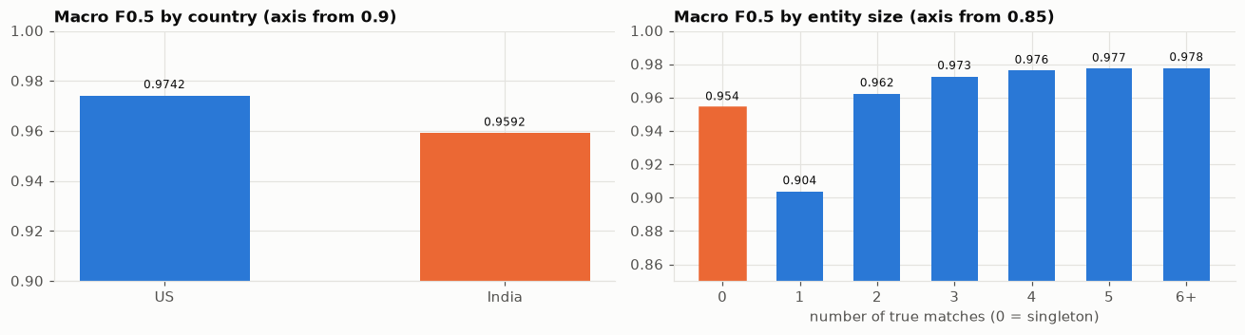
Score by country and by number of true matches.
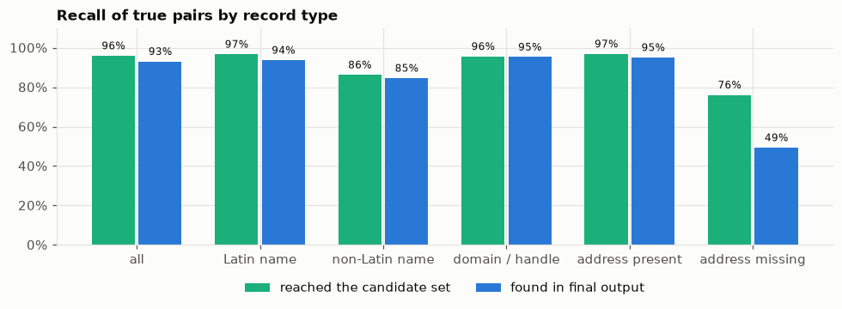
Recall by record type.
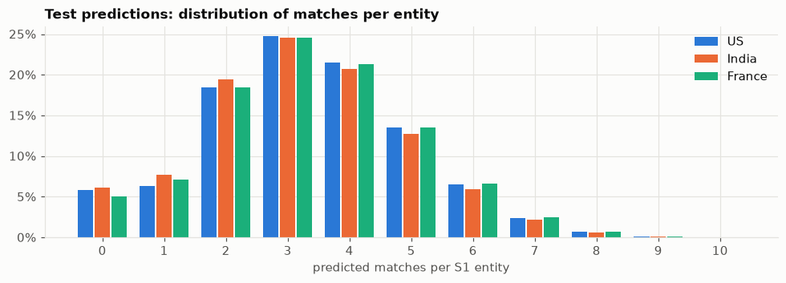
Test predictions per country.

14. End-to-end example summary
Record | Truth | Short-listed? | Pre-filter p0 | Round 1 | Round 2 | Returned? | Correct?
A website copy | match | yes, 1st | 0.71 | 99.996% | 99.99% | yes | ✓
B "Wilblims" | match | yes | 0.77 | 99.6% | 99.7% | yes | ✓
C "Inc Center" | match | yes | 0.64 | 98.3% | 99.4% | yes | ✓
D no suffix | match | yes, 1st | 0.92 | 99.0% | 98.7% | yes | ✓
H "Dréxkor" | match | no | - | - | - | no | ✗ missed
E Downtown, 96 Wayne | decoy | yes | 0.06 | 0.06% | 0.03% | no | ✓
F Williams Colombier | decoy | yes | 0.01 | 0.009% | 0.006% | no | ✓
G 738 Fourth St TN | decoy | yes | 0.006 | 0.0003% | 0.0004% | no | ✓

Score for this business: G = 5 true, K = 4 returned, TP = 4 correct → F0.5 = 1.25 × 4 / (0.25 × 5 + 4) = 0.952. All three decoys were rejected; the only loss is the invented-name copy that the shortlist could not find.

A second example: Tirupati Power (S1-271585788, India)
69 different businesses are called exactly "Tirupati Power". This one has 4 true copies (including one written in Hindi script, तिरुपति पावर → tirupti paavr → skeleton trpt pvr). A decoy "Tirupati Power Limited" sits in the same building (unit c-7d instead of 2d). Round 1 gave the decoy 51%; Round 2, using the context and sibling clues (the business already had confident copies at unit 2d), lowered it to 8.6%. The decision step returned exactly the 4 true copies: F0.5 = 1.000.

15. Files, code and how to run

15.1 Code (code/business_entity_resolution/src)
File | Role
config.py | paths (overridable with BER_ROOT, BER_DATA, BER_WORK, BER_OUT)
normalize.py | all cleaning rules, skeleton, segmenter
prepare.py | runs cleaning in parallel, learns the segmenter, writes work/*.norm.parquet
blocking.py | keys, rarity weights, sparse cosine search, short lists
stages.py | pre-filter training/application, feature building in chunks
features.py | the 77 pair clues
model.py | LightGBM settings, Round-2 context and sibling clues
decision.py | one-owner rule, expected-F0.5 K selection
common.py | loading the answer key, the exact competition metric
run_pipeline.py | entry point: train (all steps + tuning) and test (write outputs)
run_blocking.py, analyze.py | diagnostics and error analysis
notebooks/eda_and_pipeline.ipynb | visual walkthrough of data and every step (18 charts)

15.2 How to run
pip install -r requirements.txt # Python 3.14; numpy, polars, pyarrow, scipy,
# scikit-learn, lightgbm, rapidfuzz, Unidecode
python src/prepare.py # clean all records
python src/run_pipeline.py train # shortlist, features, models (several hours)
python src/run_pipeline.py test # score the test set, write outputs (~2.5 h)

Every step saves its result in work/ and is skipped if the result already exists, so a crashed run resumes where it stopped. Hardware used: 16 GB RAM laptop with only 4–8 GB free, so all large steps stream data in chunks.

15.3 Outputs
File | Content
output/matching_results.tsv | one row per test business: source1_entity_id, matched_entity_ids (comma-separated; empty if none). 1,732,544 rows, 5,698,901 matches.
output/candidate_pairs.tsv | the short list after the pre-filter, per business (17.3M pairs)
work/models/*.pkl, decision.json | pre-filter, Round-1 and Round-2 models (A and B each), chosen decision rule
team_submission.zip | output/, code/business_entity_resolution/{src, notebooks, README.md, requirements.txt}, Documentation_template.md; validated with utils/validate_submission.py --check-ids

16. Limitations and ideas
- Records with no address (4.4% of true matches, 49% found): a name made of common words cannot be tied to one of many same-named businesses. Using Round-2 sibling agreement more aggressively for these could help, at some precision cost.
- Non-Latin names (7.2%, 85% found): romanisation of Indian scripts is imperfect (e.g. vowel marks, "vn" for "one"). A learned transliteration table built from matched training pairs could raise shortlist recall.
- Invented names with broken addresses: like "Dréxkor" with "Wanye": a typo-tolerant address key (e.g. house number + street skeleton) could recover some.
- Same-building decoys: the main source of false matches; unit/flat numbers could be parsed as a separate clue.
- France: no labelled French data exists; the design is country-agnostic, and French legal forms and street words were added to the cleaning dictionaries.

17. Glossary
Term | Meaning
Entity resolution | deciding which records describe the same real-world thing
Source 1 / S2 / S3 | the clean reference list / the two messy lists
Singleton | a Source-1 business with no matches
Decoy / distractor | a messy record that belongs to no Source-1 business, or a look-alike of another
Blocking / shortlisting | a fast search that reduces all possible pairs to a few likely ones
Key / token | a small piece of a record used for searching (a word, a pair of words, …)
df | document frequency: how many businesses contain a key
IDF (rarity) | ln(N+1) − ln(df) + 1: higher for rarer keys
TF-IDF cosine | similarity of two records from their shared rarity-weighted keys, 0–1
Consonant skeleton | a word with vowels removed and similar sounds merged (marketing → mrktng)
Feature / clue | a number describing how a pair compares
LightGBM | a fast gradient-boosted decision-tree library (MIT licence)
Early stopping | stop adding trees when held-out performance stops improving
Cross-fitting / out-of-fold | each example is scored by a model that never saw it
Calibration | whether predicted probabilities match observed frequencies
Precision / Recall | share of returned matches that are right / share of true matches returned
F0.5 | a score combining precision and recall, weighting precision more
Macro average | average of per-business scores; every business counts equally
Poisson-binomial | distribution of the number of successes among events with different probabilities
Recall ceiling | the best possible recall given the short list (true pairs that were not shortlisted can never be found)

