**Supporting Information for: Porosity-Permeability Relationships in Mudstone from Pore-Scale Fluid Flow Simulations using the Lattice Boltzmann Method**

**Harsh Biren Vora1, Brandon Dugan2**

1Department of Earth, Environment and Planetary Sciences, Rice University, Houston, TX 77005

2Department of Geophysics, Colorado School of Mines, Golden, CO 80401

**Contents of this File:**  
Figures S1 and S2  
Tables S1 to S4

**Introduction:**

This supporting information includes six parts:   
(1) Incorporating heterogenous platelet geometry in mudstone models [Fig. S1]   
(2) Compaction data from smectite, kaolinite and intermediate mudstone models [Table S1]   
(3) Compaction data from natural mudstone models, *NM1* and *NM2* [Table S2]  
(4) Evolution of vertical tortuosity (*τv*) during compaction and fluid injection [Fig. S2]  
(5) Microfracture growth data in compacted intermediate mudstone model [Table S3]  
(6) Macrofracture propagation data in compacted intermediate mudstone model [Table S4]

**Figure S1**: Scaled-down model of mudstone pore structure *NM2* (*φ*=0.79), designed after sample 1324B-7H-7. The *NM2* mudstone model consists of 31% smectite, 41% illite and 28% chlorite by volume. (a) Cross sectional view of *NM2* pore structure with bedding layers consisting of smectite, illite and chlorite platelets; (b) Orthogonal view of *NM2*; and (c) Cross sectional view of *NM2* pore structure with platelet rotation (*θ*=10°) and directions of vertical (*qv*) and horizontal flow (*qh*).

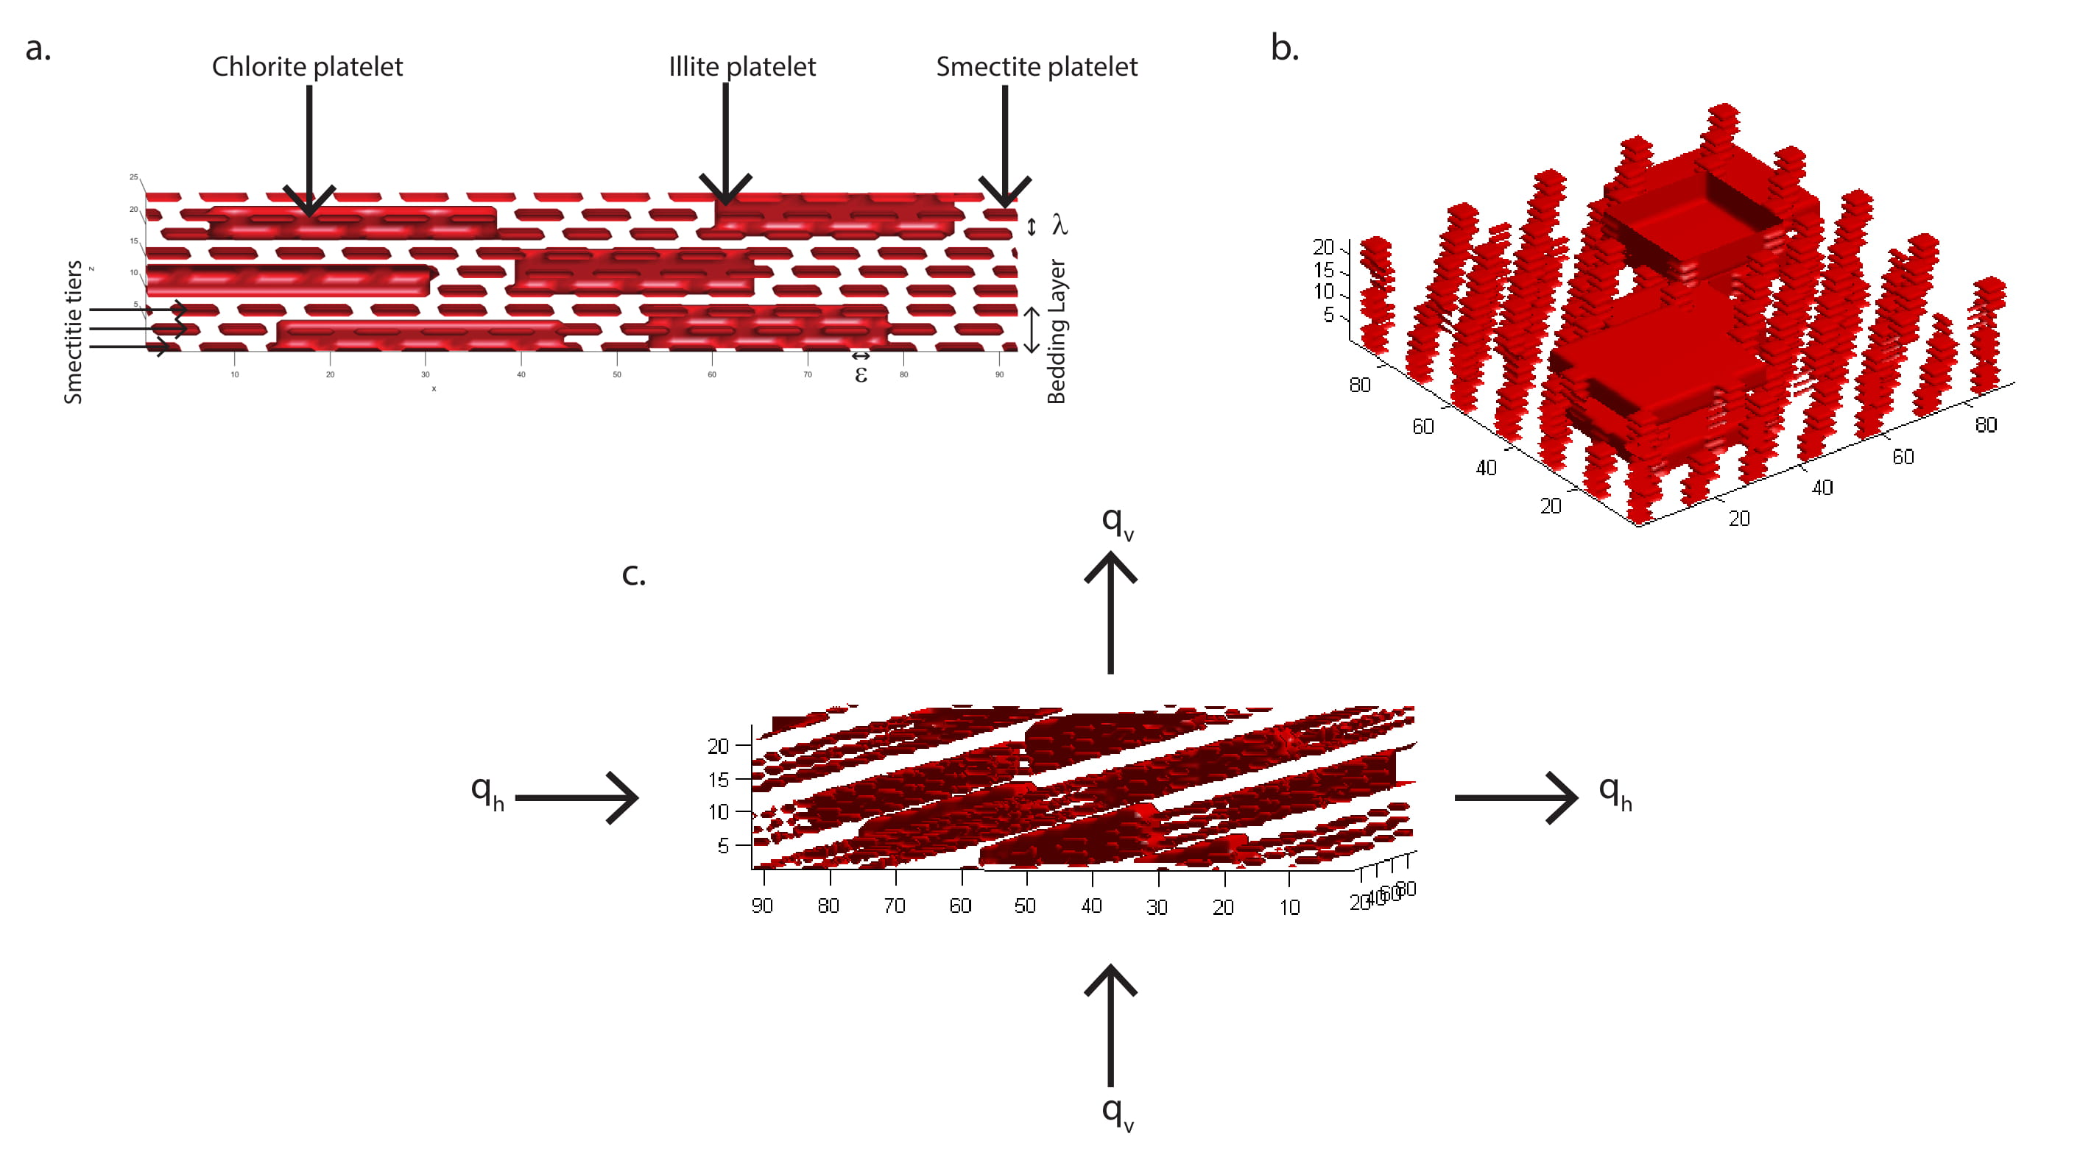

**Table S1**: Vertical (*qv*) and horizontal (*qh*) flux during compaction of kaolinite, smectite and intermediate mudstone models, simulated by step-wise decrease in intrabed (*ξ*), interbed pore throat diameters (*λ*) and orientation (*θ*).

|  |  |  |  |  |  |  |  |  |  |  |  |  |  |
| --- | --- | --- | --- | --- | --- | --- | --- | --- | --- | --- | --- | --- | --- |
| Model | Step | *Porosity*  *φ* | Intrabed Pore Throat Width  *ξ* | Interbed Pore Throat Width  *λ* | Platelet Orientation  Θ | Vertical Flux  *qv* | Reynolds Number Vertical flow  *Rev* | Vertical Permeability  *kv* | Vertical Tortuosity  *τv* | Horizontal Flux  *qh* | Reynolds Number Horizontal flow  *Reh* | Horizontal Permeability  *kh* | Horizontal Tortuosity  *τh* |
|  |  |  | (nm) | (nm) | Degrees | (m/s) |  | (m2) |  | (m/s) |  | (m2) |  |
| Kaolinite | 1 | 0.76 | 3.60 x 102 | 3.60 x 102 | 45 | 7.15 x 10-1 | 2.41 x 100 | 8.31 x 10-15 | 3.98 | 1.12 x 10-1 | 1.88 x 10-2 | 1.10 x 10-14 | 3.98 |
| Kaolinite | 2 | 0.68 | 2.60 x 102 | 2.60 x 102 | 35 | 3.56 x 10-1 | 1.20 x 100 | 3.42 x 10-15 | 5.68 | 5.16 x 10-2 | 8.69 x 10-3 | 4.96 x 10-15 | 4.36 |
| Kaolinite | 3 | 0.58 | 1.80 x 102 | 1.80 x 102 | 25 | 9.81 x 10-2 | 3.31 x 10-1 | 7.84 x 10-16 | 8.15 | 1.77 x 10-2 | 2.99 x 10-3 | 1.68 x 10-15 | 4.53 |
| Kaolinite | 4 | 0.46 | 1.20 x 102 | 1.20 x 102 | 20 | 2.63 x 10-2 | 8.85 x 10-2 | 1.78 x 10-16 | 11.07 | 9.27 x 10-3 | 1.56 x 10-3 | 8.67 x 10-16 | 4.97 |
| Kaolinite | 5 | 0.35 | 8.00 x 101 | 8.00 x 101 | 15 | 5.73 x 10-3 | 1.93 x 10-2 | 3.42 x 10-17 | 14.30 | 2.33 x 10-3 | 3.93 x 10-4 | 2.16 x 10-16 | 5.00 |
| Kaolinite | 6 | 0.28 | 6.00 x 101 | 6.00 x 101 | 10 | 1.92 x 10-3 | 6.49 x 10-3 | 1.07 x 10-17 | 16.61 | 8.69 x 10-4 | 1.47 x 10-4 | 8.02 x 10-17 | 4.29 |
| Kaolinite | 7 | 0.19 | 4.00 x 101 | 4.00 x 101 | 5 | 3.91 x 10-4 | 1.32 x 10-3 | 2.02 x 10-18 | 19.80 | 2.60 x 10-4 | 4.39 x 10-5 | 2.39 x 10-17 | 3.31 |
| Kaolinite | 8 | 0.14 | 4.00 x 101 | 4.00 x 101 | 0 | 1.23 x 10-4 | 4.14 x 10-4 | 6.33 x 10-19 | 21.64 | 1.56 x 10-4 | 2.63 x 10-5 | 1.43 x 10-17 | 1.74 |
| Smectite | 1 | 0.80 | 9.00 x 100 | 9.00 x 100 | 45 | 3.56 x 10-1 | 4.00 x 10-2 | 6.84 x 10-17 | 7.08 | 4.18 x 10-2 | 9.40 x 10-5 | 1.33 x 10-16 | 7.08 |
| Smectite | 2 | 0.76 | 7.00 x 100 | 7.00 x 100 | 35 | 2.10 x 10-1 | 2.36 x 10-2 | 3.61 x 10-17 | 9.31 | 5.08 x 10-2 | 1.14 x 10-4 | 1.60 x 10-16 | 6.88 |
| Smectite | 3 | 0.72 | 5.00 x 100 | 5.00 x 100 | 25 | 1.08 x 10-1 | 1.21 x 10-2 | 1.63 x 10-17 | 12.03 | 4.11 x 10-2 | 9.24 x 10-5 | 1.29 x 10-16 | 6.27 |
| Smectite | 4 | 0.66 | 4.00 x 100 | 4.00 x 100 | 15 | 3.50 x 10-2 | 3.93 x 10-3 | 4.60 x 10-18 | 15.44 | 1.66 x 10-2 | 3.72 x 10-5 | 5.16 x 10-17 | 5.06 |
| Smectite | 5 | 0.58 | 3.00 x 100 | 3.00 x 100 | 10 | 5.02 x 10-3 | 5.64 x 10-4 | 5.59 x 10-19 | 20.10 | 3.18 x 10-3 | 7.15 x 10-6 | 9.85 x 10-18 | 4.63 |
| Smectite | 6 | 0.45 | 2.00 x 100 | 2.00 x 100 | 5 | 3.04 x 10-4 | 3.42 x 10-5 | 2.77 x 10-20 | 27.95 | 2.79 x 10-4 | 6.28 x 10-7 | 8.59 x 10-19 | 3.74 |
| Smectite | 7 | 0.16 | 1.00 x 100 | 1.00 x 100 | 0 | 1.84 x 10-7 | 2.06 x 10-8 | 1.30 x 10-23 | 50.65 | 3.06 x 10-7 | 6.88 x 10-10 | 9.35 x 10-22 | 1.71 |
| Intermediate | 1 | 0.73 | 13.71 x 101 | 13.71 x 101 | 45 | 1.39 x 10-1 | 3.12 x 10-1 | 6.10 x 10-16 | 6.72 | 1.75 x 10-2 | 1.12 x 10-3 | 1.11 x 10-15 | 6.72 |
| Intermediate | 2 | 0.66 | 10.28 x 101 | 10.28 x 101 | 35 | 3.73 x 10-2 | 8.37 x 10-2 | 1.38 x 10-16 | 9.60 | 7.07 x 10-3 | 4.54 x 10-4 | 4.44 x 10-16 | 7.11 |
| Intermediate | 3 | 0.60 | 80.00 x 100 | 80.00 x 100 | 25 | 1.73 x 10-2 | 3.88 x 10-2 | 5.59 x 10-17 | 12.79 | 5.78 x 10-3 | 3.71 x 10-4 | 3.60 x 10-16 | 6.68 |
| Intermediate | 4 | 0.50 | 57.14 x 100 | 57.14 x 100 | 20 | 6.95 x 10-3 | 1.56 x 10-2 | 1.93 x 10-17 | 16.88 | 3.00 x 10-3 | 1.93 x 10-4 | 1.86 x 10-16 | 7.06 |
| Intermediate | 5 | 0.44 | 45.71 x 100 | 45.71 x 100 | 15 | 2.98 x 10-3 | 6.70 x 10-3 | 7.58 x 10-18 | 20.03 | 1.45 x 10-3 | 9.31 x 10-5 | 8.93 x 10-17 | 6.46 |
| Intermediate | 6 | 0.35 | 34.28 x 100 | 34.28 x 100 | 10 | 1.06 x 10-3 | 2.38 x 10-3 | 2.45 x 10-8 | 24.45 | 7.22 x 10-4 | 4.64 x 10-5 | 4.43 x 10-17 | 5.60 |
| Intermediate | 7 | 0.25 | 22.85 x 100 | 22.85 x 100 | 5 | 2.48 x 10-4 | 5.57 x 10-4 | 5.16 x 10-19 | 30.30 | 2.33 x 10-4 | 1.49 x 10-5 | 1.42 x 10-17 | 4.16 |
| Intermediate | 8 | 0.07 | 11.42 x 100 | 11.42 x 100 | 0 | 5.54 x 10-6 | 1.24 x 10-5 | 1.02 x 10-20 | 41.61 | 7.68 x 10-6 | 4.93 x 10-7 | 4.68 x 10-19 | 1.83 |

**Table S2**: Vertical (*qv*) and horizontal (*qh*) flux during compaction of *NM1* (designed after sample 1324C-1H-1) and *NM2* (designed after sample 1324B-7H-7) mudstone models, simulated by step-wise decrease in intrabed (*ξ*), interbed pore throat diameters (*λ*) and orientation (*θ*).

|  |  |  |  |  |  |  |  |  |  |  |  |  |  |
| --- | --- | --- | --- | --- | --- | --- | --- | --- | --- | --- | --- | --- | --- |
| Model | Step | *Porosity*  *φ* | Intrabed Pore Throat Width  *ξ* | Interbed Pore Throat Width  *λ* | Platelet Orientation  Θ | Vertical Flux  *qv* | Reynolds Number Vertical flow  *Rev* | Vertical Permeability  *kv* | Vertical Tortuosity  *τv* | Horizontal Flux  *qh* | Reynolds Number Horizontal flow  *Reh* | Horizontal Permeability  *kh* | Horizontal Tortuosity  *τh* |
|  |  |  | (nm) | (nm) | Degrees | (m/s) |  | (m2) |  | (m/s) |  | (m2) |  |
| NM1 | 1 | 0.72 | 5.05 x 101 | 5.05 x 101 | 15 | 5.03 x 10-2 | 2.71 x 10-2 | 1.54 x 10-16 | 11.30 | 5.08 x 10-2 | 7.42 x 10-4 | 1.39 x 10-15 | 3.91 |
| NM1 | 2 | 0.67 | 3.85 x 101 | 3.85 x 101 | 10 | 1.90 x 10-2 | 1.03 x 10-2 | 5.19 x 10-17 | 13.67 | 2.43 x 10-2 | 3.55 x 10-4 | 6.53 x 10-16 | 3.43 |
| NM1 | 3 | 0.60 | 2.65 x 101 | 2.65 x 101 | 6 | 3.94 x 10-3 | 2.12 x 10-3 | 9.39 x 10-18 | 17.01 | 6.22 x 10-3 | 9.08 x 10-5 | 1.64 x 10-16 | 2.94 |
| NM1 | 4 | 0.49 | 1.45 x 101 | 1.45 x 101 | 3 | 3.36 x 10-4 | 1.81 x 10-4 | 6.86 x 10-19 | 22.45 | 6.70 x 10-4 | 9.78 x 10-6 | 1.73 x 10-17 | 2.47 |
| NM1 | 5 | 0.32 | 2.5 x 100 | 2.5 x 100 | 0 | 4.17 x 10-6 | 2.25 x 10-6 | 7.09 x 10-21 | 32.95 | 1.05 x 10-5 | 1.53 x 10-7 | 2.66 x 10-19 | 1.52 |
| NM2 | 1 | 0.58 | 6.25 x 101 | 6.25 x 101 | 12 | 1.41x10-2 | 7.62 x 10-3 | 3.11 x 10-17 | 12.46 | 8.16 x 10-3 | 1.19 x 10-4 | 2.27 x 10-16 | 3.69 |
| NM2 | 2 | 0.50 | 3.85 x 101 | 3.85 x 101 | 9 | 3.13x10-3 | 1.69 x 10-3 | 6.65 x 10-18 | 15.34 | 2.63 x 10-3 | 3.85 x 10-5 | 7.07 x 10-17 | 3.60 |
| NM2 | 3 | 0.45 | 2.65 x 101 | 2.65 x 101 | 6 | 1.31 x 10-3 | 7.09 x 10-4 | 2.74 x 10-18 | 17.51 | 1.50 x 10-3 | 2.19 x 10-5 | 3.96 x 10-17 | 3.12 |
| NM2 | 4 | 0.37 | 1.45 x 101 | 1.45 x 101 | 3 | 3.16 x 10-4 | 1.71 x 10-4 | 6.46 x 10-19 | 20.76 | 5.06 x 10-4 | 7.39 x 10-6 | 1.30 x 10-17 | 2.50 |
| NM2 | 5 | 0.25 | 2.5 x 100 | 2.5 x 100 | 0 | 2.39 x 10-5 | 1.29 x 10-5 | 4.79 x 10-20 | 26.54 | 5.96 x 10-5 | 8.71 x 10-7 | 1.51 x 10-18 | 1.60 |

**Fig. S2**: Vertical tortuosity increases as porosity declines during compaction (*τv*) in homogenous kaolinite, smectite and intermediate mudstone models, and heterogenous mudstone models, *NM1* (designed after sample 1324C-1H-1) and *NM2* (designed after sample 1324B-7H-7).

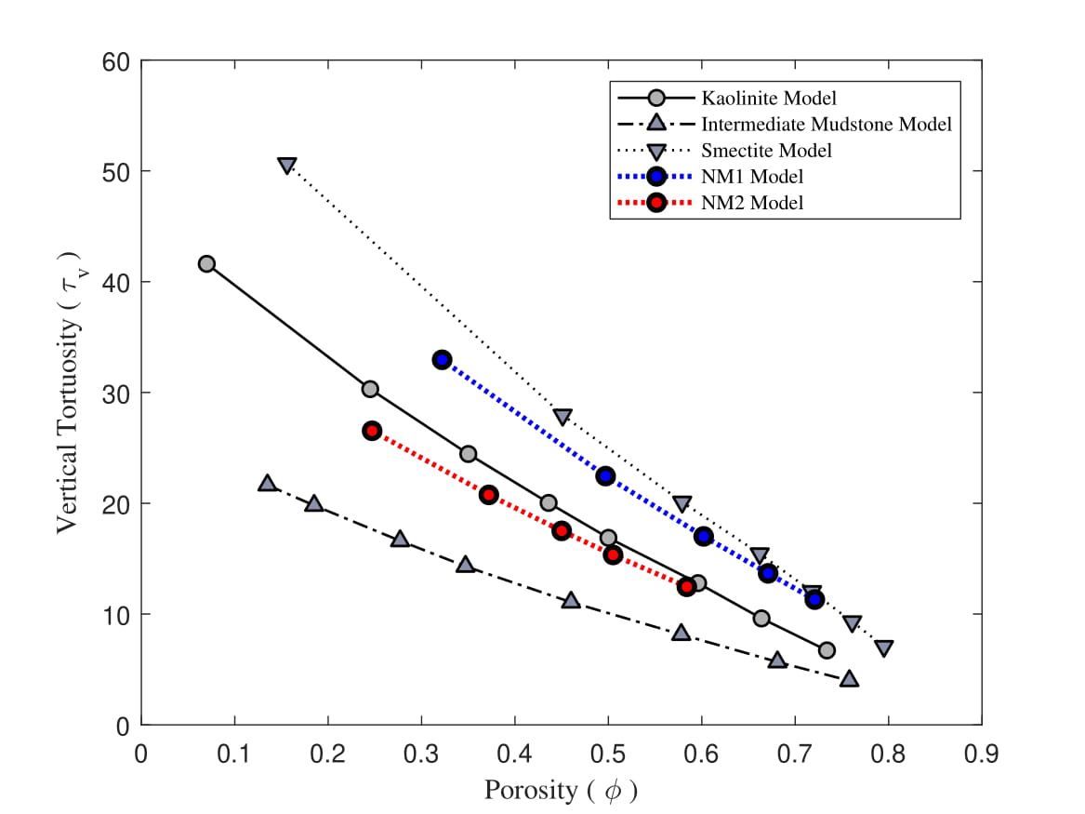

**Table S3**: Vertical flux (*qvmf*) during growth of microfractures through compacted intermediate mudstone, simulated by step-wise increase in microfracture width (*ξmf*).

|  |  |  |  |  |  |  |  |
| --- | --- | --- | --- | --- | --- | --- | --- |
| Step | *Porosity*  *φ* | Micro-fracture Width  *ξmf* | Effective Fracture Width  *εeffmf* | Interbed Pore Throat Width  *λ* | Vertical Flux    *qvmf* | Reynolds Number Vertical flow  *Rev* | Vertical Permeability  *kvmf* |
|  |  | (nm) | (nm) | (nm) | (m/s) |  | (m2) |
| 1 | 0.07 | 11.42 x100 | 0.00 x100 | 11.42 x100 | 5.54 x 10-6 | 1.24 x 10-5 | 1.02 x 10-20 |
| 2 | 0.10 | 57.14 x100 | 1.37 x 102 | 11.42 x100 | 1.56 x 10-4 | 3.52 x 10-4 | 2.89 x 10-19 |
| 3 | 0.13 | 10.20 x101 | 2.74 x 102 | 11.42 x100 | 1.05 x 10-3 | 2.37 x 10-3 | 1.95 x 10-18 |
| 4 | 0.18 | 18.28 x101 | 5.14 x 102 | 11.42 x100 | 7.99 x 10-3 | 1.79 x 10-2 | 1.48 x 10-17 |
| 5 | 0.25 | 29.71 x101 | 8.57 x 102 | 11.42 x100 | 4.68 x 10-2 | 1.05 x 10-1 | 8.66 x 10-17 |
| 6 | 0.29 | 37.70 x101 | 1.10 x 103 | 11.42 x100 | 1.12 x 10-4 | 2.52 x 10-1 | 2.07 x 10-16 |

**Table S4:** Vertical flux (*qvfrac*) during propagation of macrofracture through compacted intermediate mudstone, simulated by step-wise increase in fracture width (*ξfrac*).

|  |  |  |  |  |  |  |  |
| --- | --- | --- | --- | --- | --- | --- | --- |
| Step | *Porosity*  *φ* | Macro-fracture Width  *ξfrac* | Effective Fracture Width  *εefffrac* | Interbed Pore Throat Width*λ* | Vertical Flux  *qvfrac* | Reynolds Number Vertical flow  *Rev* | Vertical Permeability  *kvfrac* |
|  |  | (nm) | (nm) | (nm) | (m/s) |  | (m2) |
| 1 | 0.07 | 11.42 x100 | 0.00 x100 | 11.42 x100 | 5.54 x 10-6 | 1.24 x 10-5 | 1.02 x 10-20 |
| 2 | 0.12 | 37.71 x 101 | 3.66 x 102 | 11.42 x100 | 9.41 x 10-6 | 2.11 x 10-5 | 1.74 x 10-20 |
| 3 | 0.17 | 70.85 x 101 | 6.97 x 102 | 11.42 x100 | 1.17 x 10-5 | 2.64 x 10-5 | 2.17 x 10-20 |
| 4 | 0.21 | 11.09 x 102 | 1.10 x 103 | 11.42 x100 | 3.83 x 10-4 | 8.60 x 10-4 | 7.07 x 10-19 |
| 5 | 0.25 | 14.74 x 102 | 1.46 x 103 | 11.42 x100 | 5.81 x 10-3 | 1.31 x 10-2 | 1.07 x 10-17 |
| 6 | 0.32 | 22.06 x 102 | 2.19 x 103 | 11.42 x100 | 6.64 x 10-2 | 1.49 x 10-1 | 1.22 x 10-16 |