**Supporting Information for: Microscale Characterization of Fracture Growth and associated Energy in Granite and Sandstone Analogs: Insights using the Discrete Element Method**

Harsh Biren Vora and Julia K. Morgan

Department of Earth, Environmental, and Planetary Sciences, Rice University, Houston, TX

**Contents of this File:**

Text S1 to S3

Figures to S3

**Introduction:**

This supporting document includes three parts:

1. Interparticle Contact Forces and Bonding in RICEBAL (Text S1 and Figure S1)
2. Micromechanical Parameters and Calibration of Bulk Rock Behavior (Text S2; Fig. S2; Fig. S3)
3. Calculation of Strain Energy during Biaxial Experiments (Text S3)

**S1: Interparticle Contact Forces and Bonding in RICEBAL**

A detailed description of the DEM code RICEBAL is presented by Morgan (2015), covering interparticle contact forces and resultant particle motions. This study uses the same methodology, but with one difference: tensile failure of interparticle bonds also depends on interparticle moments due to differential particle rotations. Fig. S1a provides a general schematic for particle interactions, Figures S1b and S1c show the force-displacement relationships and interparticle failure criteria.

Particle interactions occur only at contacts and particle motion is determined using Newton’s second law of motion. In this study, we simulate samples for biaxial experiments from assemblages of circular particles of different sizes, connected by elastic bonds. Each bond acts as two elastic springs and an elastic beam that transmit contact normal force *Fn*, shear force *Fs* and moment *M*, respectively (Guo and Morgan, 2007). The force-displacement relationships are governed by elastic-frictional interactions between particles in compression, and elastic bonds that transmit shear stresses, as well as moment and normal stresses between particles in tension (Fig. S1b). In compression, interparticle forces are calculated:

$f_{n}=k_{n}Aδ_{n}$ (Eq. S1)

$f_{s}=k_{s}Aδ_{s}$ (Eq. S2)

$M= k_{n}Iθ$ (Eq. S3)

$A_{b}= πR^{2}$ (Eq. S4)

$I= \frac{1}{4} AR^{2}$ (Eq. S5)

where *fn* is the repulsive normal force, *kn* is the normal interparticle stiffness, *δn* is the amount of overlap between particles in contact, *fs* is the shear force, *ks* is the shear stiffness, *δs* is the shear offset of particle centers, *Ө* is the angular offset of particles, *Ab* is the bond cross-sectional area, and *I* is the moment of inertia. *R* is the effective radius determined from the radii of two contacting particles, *Ra* and *Rb*, given by

$R= \frac{2R_{a}R_{b}}{R_{a}+R_{b}}$ (Eq. S6)

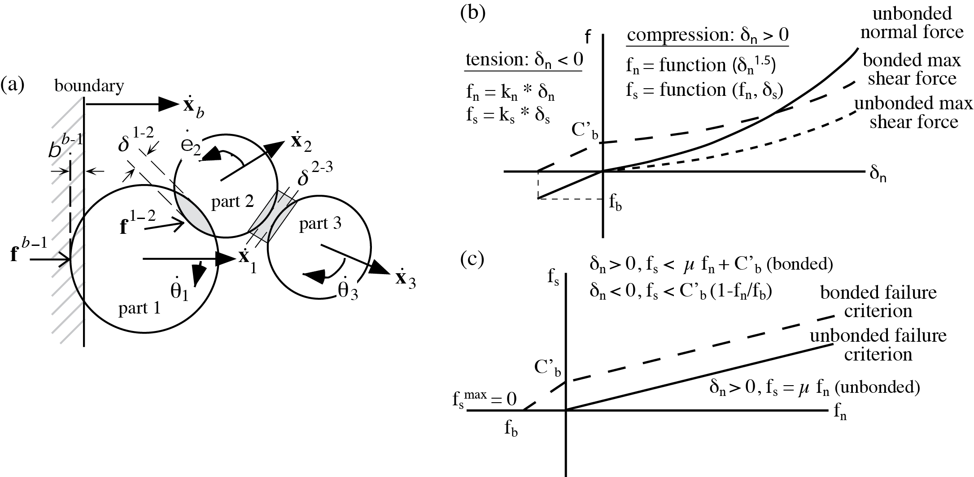

***Figure S1:*** *Implementation of two-dimensional DEM used in this study. (a) Schematic diagram of particle interactions. Lateral velocity of the boundary ẋb causes displacement and overlap with particle 1 of δb-1, imparting a force fb-1 and acceleration of particle 1. The resolved velocity ẋ1 and subsequent displacement of particle 1 cause overlap with particle 2 of δ1-2 imparting a compressional contact force of f1-2­ with both normal and shear components. In contrast, the resolved velocities ẋ2 and ẋ3 lead to separation of particles 2 and 3 of δ2-3, imparting tensile force f2-3. The resultant forces and moments acting on all particles cause both linear and angular accelerations, which are integrated to determine instantaneous velocities and rotations ẋ1, ẋ2, ẋ3, θ̇1, θ̇2 and θ̇3. If the contact shear force between particles 1 and 2 is high enough, sliding can occur. Similarly, the bond between particles 2 and 3 will break if either tensile or shear stress scaled by bond area exceed the bond strengths. See text for details. (b) Force-displacement relationships. Nonlinear (Hertzian) contact relationships operate under compression (δn>0), normal contact (solid line), representative noncohesive maximum shear force for μ=0.5 (short dashes), and cohesive maximum shear force (long dashes). Linear relationships apply to bonded particles in tension (δn<0). (c) Resulting interparticle failure criteria in both compression and tension, in terms of normal and shear forces, defining conditions leading to bond breakage (long dashed line) and interparticle sliding (solid line).*

We implement the non-linear Hertz-Mindlin theory (Johnson, 1985) to calculate normal and shear contact forces (*fn* and *fs* respectively), which are related to the elasticity of the particles the contact area of overlapping particles:

$f_{n}=\left(\frac{2G_{p}\sqrt{2R}}{3(1-v)}\right)δ_{n}^{3/2}$ (Eq. S7)

$f_{s}=\left(\frac{2{(3RG_{p}^{2}\left(1-v\right))}^{1/3}}{(2-v)}\right)f_{n}^{1/3}δ_{s}$ (Eq. S8)

Where *Gp* and *ν* are Shear Modulus and Poisson’s ratio of particles respectively. In RICEBAL, *Gp* is an input parameter, which is related to Youngs Modulus (*Ep*) through the equation:

$E_{P}=G_{P}(1+v)$ (Eq. S9)

Shear forces at unbonded interparticle contacts are limited by frictional resistance along particle surfaces (*fsmax*), as

$f_{s}<μ_{p}f_{n}=f_{s}^{max}$ (Eq. S10)

where *µp* is the coefficient of interparticle friction.

We implement interparticle bonding to impart cohesion into the material assemblage. Each bond has four key mechanical properties: *Eb*, Young’s modulus of the bond, *Gb*, shear modulus of the bond, *Tb*, tensile strength of the bond, and *Cb*, bond cohesion (shear strength of bond at *fn*=0). Bonds connect the centers of particles in contact, and bond forces are set to zero when particles are not displaced relative to each other (*δn*=*δs*=0). When particles are displaced in tension, the bonds support tensile and shear forces below predefined tensile strength and shear strength multiplied by bond area, $A_{b}$, which is equal to the area of the smallest particle in contact. When particles are displaced in compression, the bonds support shear forces below the predefined shear strength multiplied by $A_{b}$. Bond-induced interparticle forces are calculated as

$f_{n}=E_{b}δ_{n}A_{b}$ (Eq. S11)

$f_{s}=G_{b}δ_{s}A_{b}$ (Eq. S12)

Normal and shear forces are related through the following equations (Fig. S1c):

In compression (*δn*>0): $f_{s}<μ_{p}f_{n}+{C'}_{b}=f_{s}^{max}$ (Eq. S13)

In tension (*δn*<0): $f_{s}<{C'}_{b}(1-\frac{f_{n}}{f_{n}^{min}} )$ $=f_{s}^{max}$ (Eq. S14)

where ${C^{'}}_{b}= C_{b} A_{b}$ and *fnmin* is the minimum tensile force required to break the bond. When particles are separated in tension (*δn*<0), bond tensile forces are limited by tensile strength and bond area

$f_{n}^{min}$*= Tb*\**Ab* < - (Eq. S15)

For each time step, net force, displacement, and moment are calculated by summing components of all contact forces acting on a particle. Net force (*Fp*) and net moment (*Mp*) are calculated for each particle by

$F_{p}=m_{p}ẍ_{p}$ (Eq. S16)

$M_{p}=I_{p}Ӫ_{p}$ (Eq. S17)

where *mp* and *Ip* are mass and moment of inertia and *ẍp* and *Ӫp* are the linear and angular accelerations respectively. The particle displacements and rotations are calculated by inverting and integrating Eq. S16 and Eq. S17 twice over each time step, to obtain the new particle positions and orientations. Then, new contact forces are calculated for the new particle configuration and the process is repeated. Particle motions are partially damped at each time step to dissipate energy in the system, to recreate the inelastic deformation in rocks (Potyondy and Cundall, 2004; Hazzard et al., 2000).

**S2: Micromechanical Parameters and Calibration of Bulk Rock Behavior**

For this study, we must develop synthetic analogs for Berea Sandstone and Lac du Bonnet granite. We do so by carrying out simulated numerical experiments using a range of micromechanical properties assigned to assemblage particles, then comparing the responses of the synthetic material to the mechanical responses of the intended physical material. The microparameters are adjusted iteratively to improve fit of the modeled and natural behaviors. We calibrated the macroscopic Young’s Modulus and Unconfined Compressive Strength based on the unconfined mechanical behavior of granite and sandstone observed in the laboratory (Bobich, 2005; Martin and Chandler, 1994). In addition, we calibrated Mohr-Coulomb Cohesion and Angle of Internal Friction of our synthetic materials to replicate the confined mechanical behavior of granite and sandstone observed in the laboratory (Schellart, 2000; Martin and Chandler, 1994).

Sample volume, boundary stresses and particle positions through time are used to calculate bulk scale properties during biaxial experiments. Boundary stresses of the biaxial domain are calculated along the vertical platens and horizontal membranes, by summing the forces of the particles along each surface and scaling that sum by the surface area. Platen and membrane stresses correspond to the maximum and minimum principal stress, *σ1* and *σ3*, respectively. Membrane stresses are maintained at a specified confining pressure. The displacement of the platens is used to calculate axial strain (*εa*).

*Calibration of Young’s Modulus (E)*: Experimental values of Youngs Modulus are 8 GPa for Berea Sandstone and 50 GPa for Lac du Bonnet Granite (Bobich, 2005; Martin and Chandler, 1994). The bulk Young’s Modulus in our models is primarily influenced by the Young’s Modulus of Particles (*Ep*), which is controlled by the input elastic microparameters of particles, *Gp* and *νp*, through Eq. S5. We derive a Young’s Modulus of 5.28x109 Pa for Berea Sandstone (Fig. S2), attained using values of 2.90x1010 Pa and 0.33 for *Gp* and *νp*, respectively (Table 1). Similarly, we derive a Young’s Modulus of 42.07x109 Pa (Fig. S2) for Lac du Bonnet Granite, using values of 2.00x1012 Pa and 0.26 for *Gp* and *νp* respectively (Table 1).

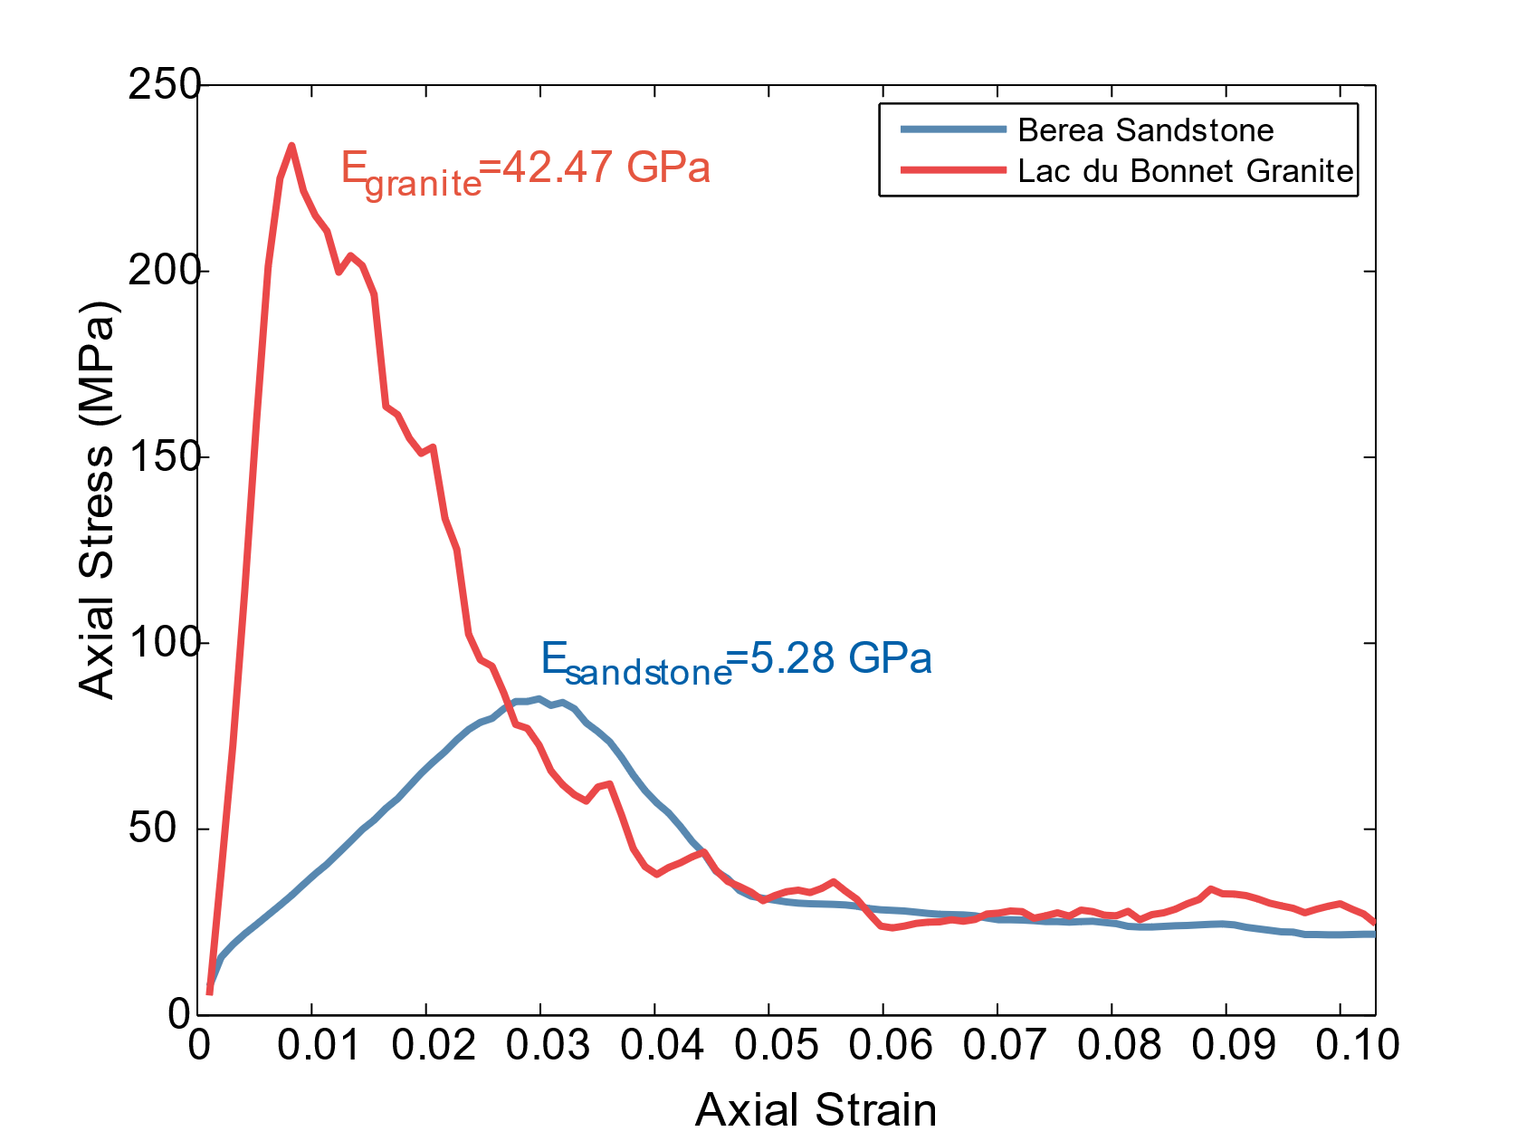

***Figure S2:*** *Unconfined macromechanical properties of calibrated DEM materials used in this study. Berea Sandstone model has a Young’s Modulus of 5.28 GPa and unconfined compressive strength of 85 MPa. Lac du Bonnet granite model has a Young’s Modulus of 42.47 GPa and unconfined compressive strength of 234 MPa.*

*Calibration of Unconfined Compressive Strength (UCS)*: Experimental values of UCS are 85 MPa for Berea Sandstone and 224 MPa for Lac du Bonnet Granite (Bobich, 2005; Martin and Chandler, 1994). The bulk UCS in our models is primarily influenced by the tensile strength of bonds (*Tb*) and Cohesion of bonds (*Cb*). The bond strengths, *Tb* and *Cb* influence the energy required to break bonds in tensile and shear modes, respectively. Scholtès and Donzé (2013) suggest that assigned values of *Tb* and *Cb* must have a ratio equal to bulk *UCS*/*TS*, where *TS* is the tensile strength of the rock, to ensure that micromechanical processes reflect the bulk geomechanical behavior of the rock. In this study, we maintain a *Tb*/*Cb* ratios of 10 for Berea Sandstone (Bobich, 2005), and 20 for Lac du Bonnet Granite (Martin and Chandler, 1994). The *UCS* shows a direct correlation with *Tb* and *Cb*, properties that are adjusted to obtain the best fit to the experimental values, also obeying the guidelines of Scholtès and Donzé, 2013. We attain a UCS of 85.05x106 Pa for Berea Sandstone (Fig. S1) by employing values of 9.00x106 Pa and 9.00x107 Pa for *Tb* and *Cb* respectively (Table 1). Similarly, we attain a UCS of Pa for Lac du Bonnet Granite (Fig. S1) by employing values of 6x108 Pa and 1.2x1010 Pa for *Tb* and *Cb­­* respectively (Table 1).

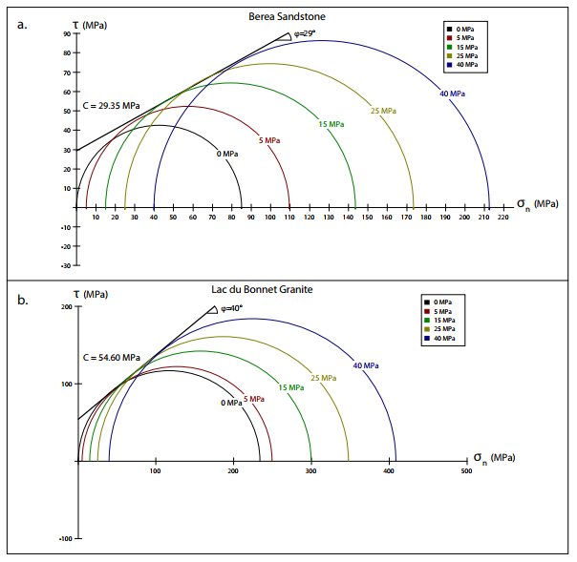

***Figure S3:*** *Mohr-Coulomb properties of calibrated DEM materials used in this study. Berea Sandstone model has a cohesion of 29.3 MPa and an angle of internal friction of 29 degrees. Lac du Bonnet model has a cohesion of 54.6 MPa and an angle of internal friction of 40 degrees.*

*Calibration of Mohr-Coulomb Cohesion (C) and slope (µ)*: After attaining the desired values of bulk Young’s Modulus and UCS through unconfined tests, confined compression tests are conducted to attain the desired Mohr-Coulomb behavior (*C* and *µ*). Experimental values of *C* and *µ* are 29.35 MPa and 0.55 in Berea Sandstone (Schellart, 2000). Experimental values of *C* and *µ* are 46.00 MPa and 1.05 in Lac du Bonnet granite (Martin and Chandler, 1994). The coefficient of interparticle friction is derived from the slope of the Mohr-Coulomb failure envelope. The interparticle friction (*µp*) is adjusted incrementally to attain the best fit to the bulk compressive behavior of Berea Sandstone and Lac du Bonnet Granite. We employ *µp* of 0.3 for Berea Sandstone, and 0.7 Lac du Bonnet Granite (Table 1) to attain desired Mohr-Coulomb behavior (Fig. S3). The Mohr-Coulomb failure envelopes are described by the following equations:

Sandstone: $τ=0.55σ_{n}+29.35$ (Eq. S18)

Granite: $τ=0.83σ_{n}+54.60$ (Eq. S19)

where *τ* is the shear stress (MPa) and *σn* is the normal stress (MPa) on the sample.

Thus, through retroactive adjustment of micromechanical parameters we calibrate the bulk properties of simulated samples of Berea Sandstone and Lac du Bonnet Granite to match experimentally derived geomechanical properties (Table 2).

**S3: Calculation of Strain Energy during Biaxial Experiments**

The work done by external stresses resulting in elastic volumetric changes within the rock is the quantitative measure of the strain energy (*Wint*) (Timoshenko and Goodier, 1951). We implement the methodology presented by Cooke and Murphy, 2004 to calculate the strain energy stored within rock during each biaxial test using the strain energy density function (*V0*):

(Eq. S20)

Where *S1* is the axial stress on rock, *S3* is the confining pressure on rock, *E* is the bulk Young’s Modulus, *υ* is the Poisson’s ratio of the material, and *S13* is the differential stress. The Young’s Modulus (*E*) for a rock during a confined biaxial experiment is the slope of the elastic phase of S1-ε1 curve. We calculate an increase in Young’s Modulus from 5.28 GPa to 7.12 GPa as confining pressure is increased from 0 MPa to 50 MPa on calibrated samples of Berea Sandstone. Similarly, we calculate an increase in Young’s Modulus from 42.47 GPa to 55.07 GPa as confining pressure is increased from 0 MPa to 50 MPa on calibrated samples of Lac du Bonnet granite. The Poisson’s ratio (*υ*) is calculated during the elastic loading phase of each experiment as

$ϑ= {ε_{3}}/{ε_{1}}$ (Eq. S21)

We calculate a decline in Poisson’s Ratio from 0.29 to 0.2 as confining pressure is increased from 0 MPa to 50 MPa on calibrated samples of Berea Sandstone. Similarly, we calculate a decline in Poisson’s Ratio from 0.19 to 0.10 as confining pressure is increased from 0 MPa to 50 MPa on calibrated samples of Lac du Bonnet granite.

The differential stress, *S13* is approximated as

$S_{13}=\frac{S_{1}-S_{3}}{2}$ (Eq. S22)

The total work (*Wint*) is calculated by summing the calculated energy density over the length (*L*) and width of platens (*Wp*) as

$W_{int}= \iint{V_{0}}dL {dW}_{p}$ (Eq. S23)

**References**

Bobich, J. K. (2005), Experimental analysis of the extension to shear fracture transition in Berea sandstone, Texas A&M Univ., (August), 52.

Cooke, M. L., and S. Murphy (2004), Assessing the work budget and efficiency of fault systems using mechanical models, J. Geophys. Res. Solid Earth, 109(10), 1–13, doi:10.1029/2004JB002968.

Guo, Y., and J. K. Morgan (2007), Fault gouge evolution and its dependence on normal stress and rock strength—Results of discrete element simulations: Gouge zone properties, J. Geophys. Res., 112(B10), B10403, doi:10.1029/2006JB004524.

Hazzard, J. F., Young, R. P., & Maxwell, S. C. (2000). Micromechanical modeling of cracking and failure in brittle rocks. Journal of Geophysical Research: Solid Earth, 105(B7), 16683-16697.

Johnson, K. L. (1985), Contact Mechanics, Cambridge Univ. Press, Cambridge.

Martin, C. D., and N. A. Chandler (1994), The progressive fracture of Lac du Bonnet granite, Int. J. Rock Mech. Min. Sci., 31(6), 643–659, doi:10.1016/0148-9062(94)90005-1.

Morgan, J. K. (2015), Journal of Geophysical Research : Solid Earth wedges : Discrete element simulations, , 3870–3896, doi:10.1002/2014JB011455.Received.

Morgan, J. K., and M. S. Boettcher (1999), Numerical simulations of granular shear zones using the distinct element method: 1. Shear zone kinematics and the micromechanics of localization, J. Geophys. Res. Solid Earth, 104(B2), 2703–2719, doi:10.1029/1998JB900056.

Potyondy, D. O., & Cundall, P. A. (2004). A bonded-particle model for rock. *International journal of rock mechanics and mining sciences*, *41*(8), 1329-1364.

Schellart, W. P. (2000), Shear test results for cohesion and friction coefficients for different granular materials: Scaling implications for their usage in analogue modelling, Tectonophysics, 324(1–2), 1–16, doi:10.1016/S0040-1951(00)00111-6.

Scholtès, L., & Donzé, F. V. (2013). A DEM model for soft and hard rocks: role of grain interlocking on strength. *Journal of the Mechanics and Physics of Solids*, *61*(2), 352-369.

Timoshenko, S., Timoshenko, S., & Goodier, J. N. (1951). Theory of Elasticity, by S. Timoshenko and JN Goodier, McGraw-Hill book Company.