**LB New Simulations Plan 2**

In this document, I outline:

1. Updates to LB seeder code to incorporate grain size heterogeneity
2. Reference core data from IODP 308
3. Simulations plan
4. Questions for Brandon
5. **LB Seeder Code**

I have revised my seeder file to incorporate grains of different sizes and aspect ratios. The modified seeder code can handle upto 4 different grain sizes, smectite, illite, kaolinite and chlorite. The dimensions of the grains are inputs into the code.

*Detailed description of the problem*: In the earlier version of the code was built a seeder by concatenating binary 3D matrices, each representing the standard homogenous grain size. While incorporating heterogenous grain sizes, building an accurate seeder became challenging due to grain size scale and resultant seed porosity. Since the lengths of clay platelets vary over an order of magnitude (smectite length = 100 nm and kaolinite length = 3000 nm), the concatenating 3D matrices resulted in disproportionate porosity. Also, the volume fraction of individual mineralogies did not accurately represent real rocks. For example, simply using an input of 3 illite grains and 2 smectite grains (desired volume fraction = 60% illite and 40% smectite) for each bed did not yield the right porosity or accurate volume fraction. Thus, I had to revamp the code significantly to locate void spaces and fill them up with smaller platelets of desired dimensions.

Below is an example a seeder with 3 grain sizes – smectite, illite and chlorite. The dimensions are significantly reduced for plotting purposes. This particular example has a 50% smectite vol%, 25% illite vol% and 25% chlorite vol% and a porosity of 0.79.

X Direction:



Chlorite platelet

Smectite platelet

Illite platelet

Y Direction:



Z Direction:



The revised seeder code also incorporates functionality of compaction and grain rotation.

Rotated X (10 degrees):



Rotated Z (10 degrees):



1. **Reference Core Data from IODP 308**

My primary criteria for selecting cores was high clay fraction. I have found two cores of interest:

1. CRS799 (70.4 wt% clay, 15 wt% quartz, 8.6 wt% plagioclase and 6.0 wt% calcite): Smectite 82.1 wt%, illite 17.9 wt%, trace chlorite, trace quartz). Core top: 51.3 mbsf.
2. CRS015B (68.9 wt% clay, 17.1% quartz, 9.2% plagioclase and 4.8 wt% calcite): Smectite 27.3%, illite 38.8%, chlorite 25% and quartz 8.8%. Core top: 60.62 mbsf.

I digitized their compaction permeability character from Long et al., 2008.

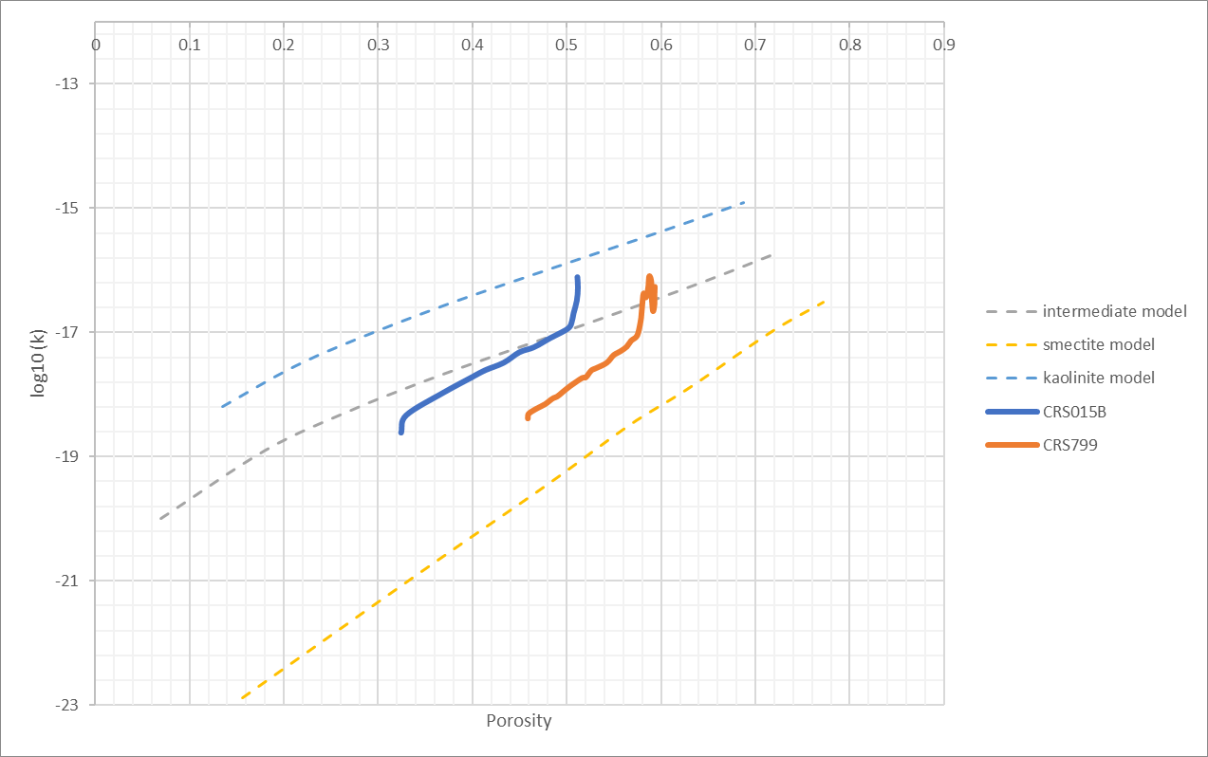

1. **LB Simulations Plan**

I think CRS 799 is a good candidate to reproduce virtually and run LB sims. This is because it is simpler (only 2 grains – smectite and illite) and has trace amounts of quartz. Building the seeder will take some trial and error to match the clay abundances and initial porosity (approximately 60%). Compaction to porosity of 45% can be simulated in two or three compaction steps.

The dimensions of 4 mineralogies:

|  |  |  |  |
| --- | --- | --- | --- |
| Mineralogy | Length (nm) | Thickness (nm) | Aspect Ratio |
| Smectite | 100 | 2 | 50 |
| Illite | 2000 | 58 | 35 |
| Kaolinite | 3000 | 150 | 20 |
| Chlorite | 1000 | 36 | 28 |

I can run simulations while at AGU on my computer at Rice via remote desktop setup.

1. **Questions**
2. Do we incorporate grain rotation while conducting new LB simulations for testing against core data from IODP 308?
3. Do we assume that mineral volume% in our models represents mineral wright% measured in core data? Or do we want to assume different densities associated with each mineralogy?
4. These cores do not have kaolinite mineralogy. Should I look for porosity-permeability data from rock with significant kaolinite fraction? I have spent some time looking but have not found any such published dataset yet.