**Supporting Information for: Microcracking Indicators Predict Critical Failure in Berea Sandstone Analog: Insights using the Discrete Element Method and Machine Learning**

Harsh Biren Vora and Julia K. Morgan

Department of Earth, Environmental, and Planetary Sciences, Rice University, Houston, TX

**Contents of this File:**

Text S1 to S3

Figures S1 to S9

Tables S1 and S2

**Introduction:**

This supporting document includes ten parts:

1. Interparticle Contact Forces and Bonding in RICEBAL (Text S1 and Fig. S1)
2. Geomechanical Calibration of Berea Sandstone (Text S2, Fig. S2, Fig. S3)
3. Calculation of Fractal dimension D-value (Fig. S4)
4. Spatio-temporal clustering of seismic energy (Text S3, Fig. S5)
5. Calculation of seismic b-value (Fig. S6)
6. Relationship between seismic b-value and shear fraction (*SF*) (Fig. S7)
7. Neural Network Architecture (Fig. S8)
8. Damage Indicators from Biaxial test on Berea Sandstone under 25 MPa confining pressure (Fig. S9)
9. Relative Importance of Neural Network Inputs for Stress-to-Failure predictions (Table S1)
10. Relative Importance of Neural Network Inputs for Strain-to-Failure predictions (Table S2)

**S1: Interparticle Contact Forces and Bonding in RICEBAL**

A detailed description of the DEM code RICEBAL is presented by Morgan [2015], covering interparticle contact forces and resultant particle motions. This study uses the same methodology, but with one difference: tensile failure of interparticle bonds also depends on interparticle moments due to differential particle rotations. Fig. S1a provides a general schematic for particle interactions, Figures S1b and S1c show the force-displacement relationships and interparticle failure criteria.

Particle interactions occur only at contacts and particle motion is determined using Newton’s second law of motion. In this study, we simulate samples for biaxial experiments from assemblages of circular particles of different sizes, connected by elastic bonds. Each bond acts as two elastic springs and an elastic beam that transmit contact normal force *Fn*, shear force *Fs* and moment *M*, respectively [Guo and Morgan, 2007]. The force-displacement relationships are governed by elastic-frictional interactions between particles in compression, and elastic bonds that transmit shear stresses, as well as moment and normal stresses between particles in tension (Fig. S1b). In compression, interparticle forces are calculated:

$f_{n}=k_{n}Aδ_{n}$ (Eq. S1)

$f_{s}=k_{s}Aδ_{s}$ (Eq. S2)

$M= k_{n}Iθ$ (Eq. S3)

$A_{b}= πR^{2}$ (Eq. S4)

$I= \frac{1}{4} AR^{2}$ (Eq. S5)

where *fn* is the repulsive normal force, *kn* is the normal interparticle stiffness, *δn* is the amount of overlap between particles in contact, *fs* is the shear force, *ks* is the shear stiffness, *δs* is the shear offset of particle centers, *Ө* is the angular offset of particles, *Ab* is the bond cross-sectional area, and *I* is the moment of inertia. *R* is the effective radius determined from the radii of two contacting particles, *Ra* and *Rb*, given by

$R= \frac{2R_{a}R_{b}}{R_{a}+R_{b}}$ (Eq. S6)

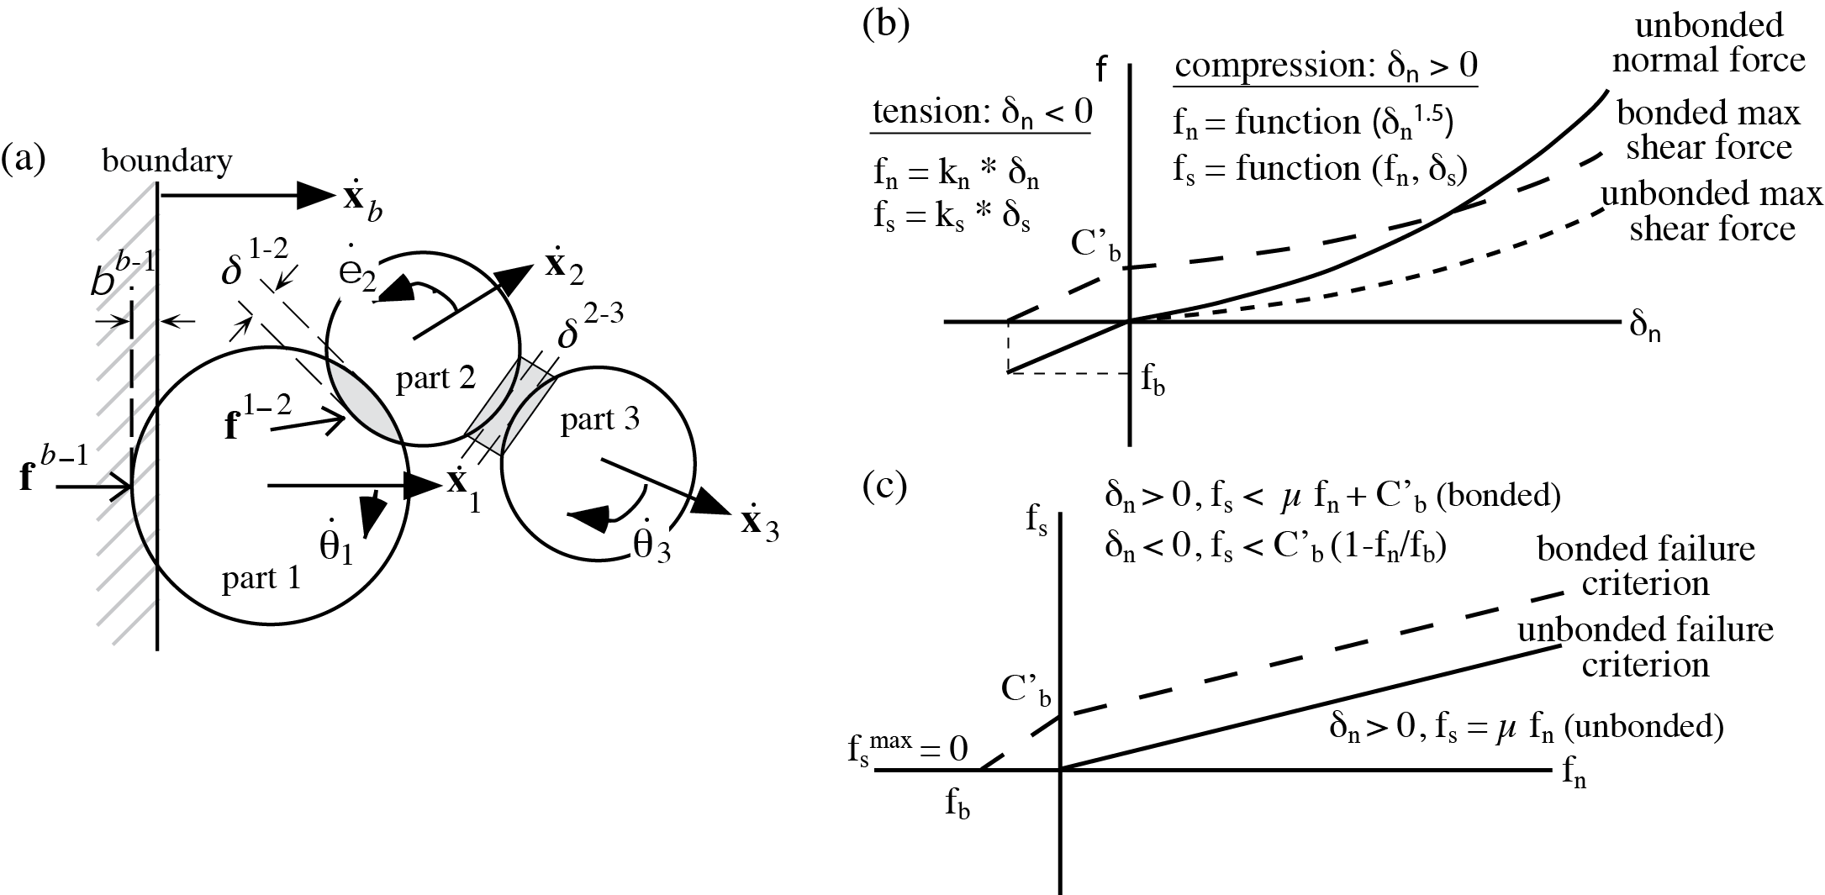

***Figure S1:*** *Implementation of two-dimensional DEM used in this study. (a) Schematic diagram of particle interactions. Lateral velocity of the boundary ẋb causes displacement and overlap with particle 1 of δb-1, imparting a force fb-1 and acceleration of particle 1. The resolved velocity ẋ1 and subsequent displacement of particle 1 cause overlap with particle 2 of δ1-2 imparting a compressional contact force of f1-2­ with both normal and shear components. In contrast, the resolved velocities ẋ2 and ẋ3 lead to separation of particles 2 and 3 of δ2-3, imparting tensile force f2-3. The resultant forces and moments acting on all particles cause both linear and angular accelerations, which are integrated to determine instantaneous velocities and rotations ẋ1, ẋ2, ẋ3, θ̇1, θ̇2 and θ̇3. If the contact shear force between particles 1 and 2 is high enough, sliding can occur. Similarly, the bond between particles 2 and 3 will break if either tensile or shear stress scaled by bond area exceed the bond strengths. See text for details. (b) Force-displacement relationships. Nonlinear (Hertzian) contact relationships operate under compression (δn>0), normal contact (solid line), representative noncohesive maximum shear force for μ=0.5 (short dashes), and cohesive maximum shear force (long dashes). Linear relationships apply to bonded particles in tension (δn<0). (c) Resulting interparticle failure criteria in both compression and tension, in terms of normal and shear forces, defining conditions leading to bond breakage (long dashed line) and interparticle sliding (solid line).*

We implement the non-linear Hertz-Mindlin theory [Johnson, 1985] to calculate normal and shear contact forces (*fn* and *fs* respectively), which are related to the elasticity of the particles the contact area of overlapping particles:

$f_{n}=\left(\frac{2G_{p}\sqrt{2R}}{3(1-v)}\right)δ_{n}^{3/2}$ (Eq. S7)

$f_{s}=\left(\frac{2{(3RG_{p}^{2}\left(1-v\right))}^{1/3}}{(2-v)}\right)f_{n}^{1/3}δ_{s}$ (Eq. S8)

Where *Gp* and *ν* are Shear Modulus and Poisson’s ratio of particles respectively. In RICEBAL, *Gp* is an input parameter, which is related to Youngs Modulus (*Ep*) through the equation:

$E_{P}=G_{P}(1+v)$ (Eq. S9)

Shear forces at unbonded interparticle contacts are limited by frictional resistance along particle surfaces (*fsmax*), as

$f_{s}<μ_{p}f_{n}=f_{s}^{max}$ (Eq. S10)

where *µp* is the coefficient of interparticle friction.

We implement interparticle bonding to impart cohesion into the material assemblage. Each bond has four key mechanical properties: *Eb*, Young’s modulus of the bond, *Gb*, shear modulus of the bond, *Tb*, tensile strength of the bond, and *Cb*, bond cohesion (shear strength of bond at *fn*=0). Bonds connect the centers of particles in contact, and bond forces are set to zero when particles are not displaced relative to each other (*δn*=*δs*=0). When particles are displaced in tension, the bonds support tensile and shear forces below predefined tensile strength and shear strength multiplied by bond area, $A_{b}$, which is equal to the area of the smallest particle in contact. When particles are displaced in compression, the bonds support shear forces below the predefined shear strength multiplied by $A_{b}$. Bond-induced interparticle forces are calculated as

$f_{n}=E_{b}δ_{n}A_{b}$ (Eq. S11)

$f_{s}=G_{b}δ_{s}A_{b}$ (Eq. S12)

Normal and shear forces are related through the following equations (Fig. S1c):

In compression (*δn*>0): $f_{s}<μ_{p}f_{n}+{C'}_{b}=f_{s}^{max}$ (Eq. S13)

In tension (*δn*<0): $f_{s}<{C'}_{b}(1-\frac{f_{n}}{f_{n}^{min}} )$ $=f_{s}^{max}$ (Eq. S14)

where ${C^{'}}_{b}= C_{b} A_{b}$ and *fnmin* is the minimum tensile force required to break the bond. When particles are separated in tension (*δn*<0), bond tensile forces are limited by tensile strength and bond area

$f_{n}^{min}$*= Tb*\**Ab* < - (Eq. S15)

For each time step, net force, displacement, and moment are calculated by summing components of all contact forces acting on a particle. Net force (*Fp*) and net moment (*Mp*) are calculated for each particle by

$F_{p}=m_{p}ẍ_{p}$ (Eq. S16)

$M_{p}=I_{p}Ӫ_{p}$ (Eq. S17)

where *mp* and *Ip* are mass and moment of inertia and *ẍp* and *Ӫp* are the linear and angular accelerations respectively. The particle displacements and rotations are calculated by inverting and integrating Eq. S16 and Eq. S17 twice over each time step, to obtain the new particle positions and orientations. Then, new contact forces are calculated for the new particle configuration and the process is repeated. Particle motions are partially damped at each time step to dissipate energy in the system, to recreate the inelastic deformation in rocks [Potyondy and Cundall, 2004].

**S2: Micromechanical Parameters and Calibration of Bulk Rock Behavior**

For this study, we must develop synthetic analog for Berea Sandstone. We do so by carrying out simulated numerical experiments using a range of micromechanical properties assigned to assemblage particles, then comparing the responses of the synthetic material to the mechanical responses of the intended physical material. The microparameters are adjusted iteratively to improve fit of the modeled and natural behaviors. We calibrated the macroscopic Young’s Modulus and Unconfined Compressive Strength based on the unconfined mechanical behavior of granite and sandstone observed in the laboratory [Bobich, 2005]. In addition, we calibrated Mohr-Coulomb Cohesion and Angle of Internal Friction of our synthetic materials to replicate the confined mechanical behavior of granite and sandstone observed in the laboratory [Schellart, 2000].

Sample volume, boundary stresses and particle positions through time are used to calculate bulk scale properties during biaxial experiments. Boundary stresses of the biaxial domain are calculated along the vertical platens and horizontal membranes, by summing the forces of the particles along each surface and scaling that sum by the surface area. Platen and membrane stresses correspond to the maximum and minimum principal stress, *σ1* and *σ3*, respectively. Membrane stresses are maintained at a specified confining pressure. The displacement of the platens is used to calculate axial strain (*εa*).

*Calibration of Young’s Modulus (E)*: Experimental value of Youngs Modulus is 8 GPa for Berea Sandstone [Bobich, 2005]. The bulk Young’s Modulus in our models is primarily influenced by the Young’s Modulus of Particles (*Ep*), which is controlled by the input elastic microparameters of particles, *Gp* and *νp*, through Eq. S5. We derive a Young’s Modulus of 6.48x109 Pa for Berea Sandstone [Fig. S2], attained using values of 2.90x1010 Pa and 0.33 for *Gp* and *νp*, respectively [Table 1].

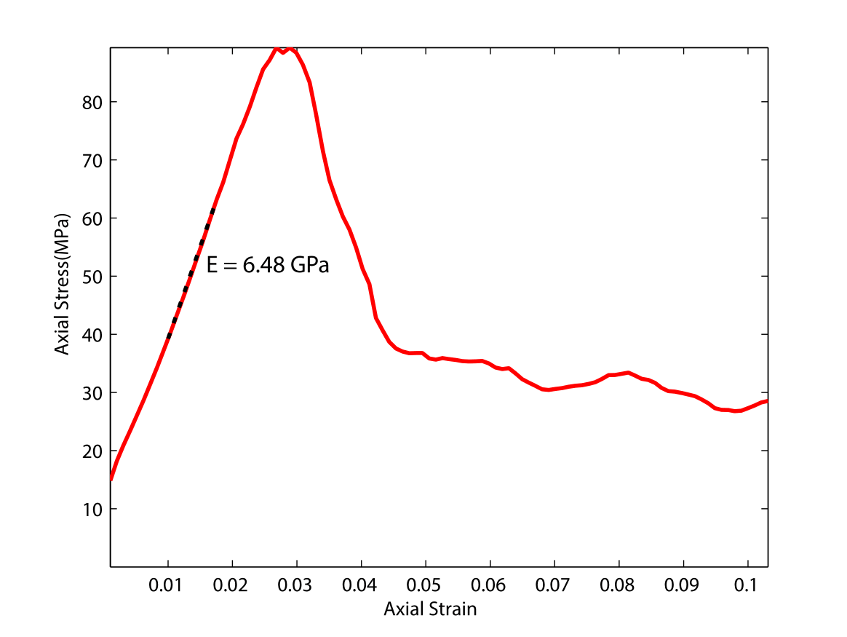

***Figure S2:*** *Unconfined macromechanical properties of calibrated DEM material used in this study. Berea Sandstone model has a Young’s Modulus of 5.28 GPa and unconfined compressive strength of 85 MPa.*

*Calibration of Unconfined Compressive Strength (UCS)*: Experimental value of UCS is 95 MPa for Berea Sandstone [Bobich, 2005]. The bulk UCS in our models is primarily influenced by the tensile strength of bonds (*Tb*) and Cohesion of bonds (*Cb*). The bond strengths, *Tb* and *Cb* influence the energy required to break bonds in tensile and shear modes, respectively. Scholtès and Donzé [2013] suggest that assigned values of *Tb* and *Cb* must have a ratio equal to bulk *UCS*/*TS*, where *TS* is the tensile strength of the rock, to ensure that micromechanical processes reflect the bulk geomechanical behavior of the rock. In this study, we maintain a *Tb*/*Cb* ratios of 10 for Berea Sandstone [Bobich, 2005]. The *UCS* shows a direct correlation with *Tb* and *Cb*, properties that are adjusted to obtain the best fit to the experimental values, also obeying the guidelines of Scholtès and Donzé, 2013. We attain a UCS of 89.37x106 Pa for Berea Sandstone [Fig. S2] by employing values of 3.00x107 Pa and 3.00x108 Pa for *Tb* and *Cb* respectively [Table 1].

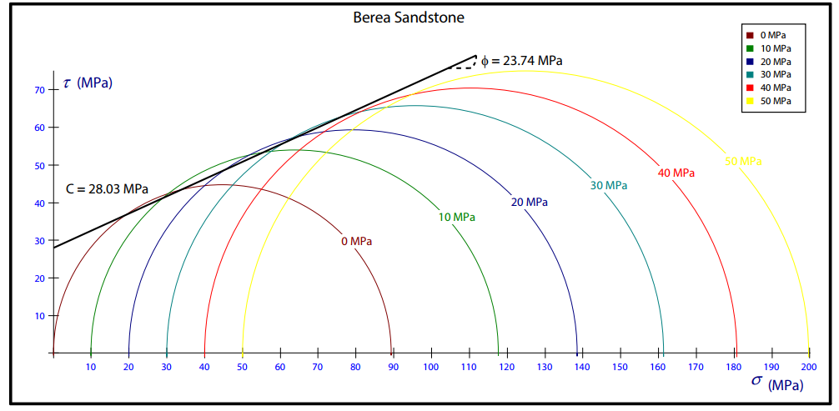

***Figure S3:*** *Mohr-Coulomb properties of calibrated DEM material used in this study. Berea Sandstone model has a cohesion of 28.03 MPa and an angle of internal friction of 23.74 degrees.*

*Calibration of Mohr-Coulomb Cohesion (C) and slope (µ)*: After attaining the desired values of bulk Young’s Modulus and UCS through unconfined tests, confined compression tests are conducted to attain the desired Mohr-Coulomb behavior (*C* and *µ*). Experimental values of *C* and *µ* are 29.35 MPa and 0.55 in Berea Sandstone [Schellart, 2000]. The coefficient of interparticle friction is derived from the slope of the Mohr-Coulomb failure envelope. The interparticle friction (*µp*) is adjusted incrementally to attain the best fit to the bulk compressive behavior of Berea Sandstone and Lac du Bonnet Granite. We employ *µp* of 0.4 for Berea Sandstone [Table 1] to attain desired Mohr-Coulomb behavior [Fig. S3]. The Mohr-Coulomb failure envelope of Berea Sandstone can be described by the following equation:

$τ=0.44σ_{n}+28.03$ (Eq. S18)

where *τ* is the shear stress (MPa) and *σn* is the normal stress (MPa) on the sample. Thus, through retroactive adjustment of micromechanical parameters we calibrate the bulk properties of simulated samples of Berea Sandstone to match experimentally derived geomechanical properties [Table 2].

**S3: Calculation of Fractal Dimension (*D2*)**

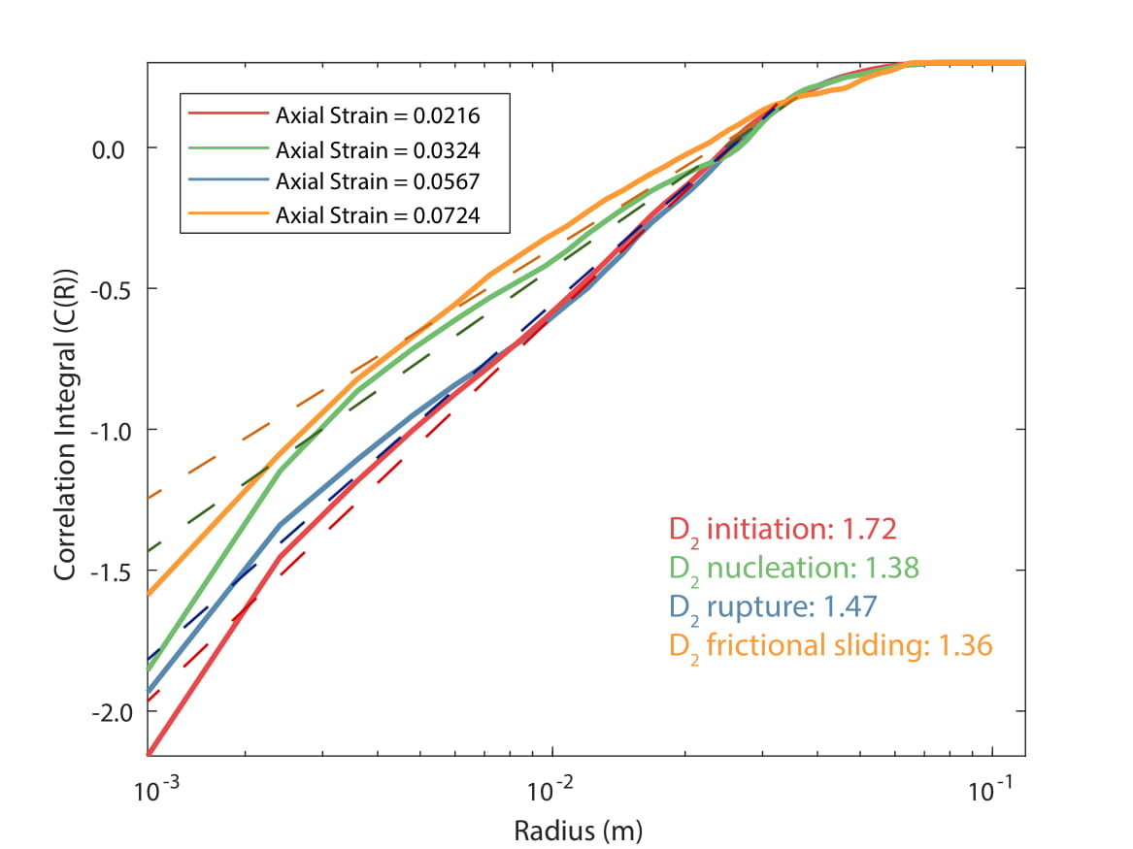

***Figure S4****: D2 calculated during axial strain windows during the initiation, nucleation, rupture and frictional sliding phase of shear fracture growth during biaxial test on Berea Sandstone analog under confining pressure of 10 MPa. Fractal Dimension (D2) calculated as the slope of the correlation integral (C(R)) and radius (R) [Eq. 5]. D2 show strong precursory signatures of critical failure, exhibiting decline during the nucleation phase.*

**S4: Spatio-Temporal clustering of Microcracks**

Each time a bond breaks, energy is released and seismic source information is calculated using Eq. 6. However, bond breakage in our models releases approximately the same amount of energy because of the narrow particle size distribution in our models. This is not the case for real earthquakes and AE, where magnitudes exhibit a larger range that follow a power-law frequency-magnitude distribution [Lockner, 1993]. It is therefore postulated that microcracks occurring close together in space and time may be a part of the same macro rupturing event. This is a realistic assumption as it is known that most seismic events in the field are made up of smaller scale ruptures [Scholz, 1968] and that shear fractures generally grow at a finite velocity [Madariaga, 1976]. Thus, we implement the spatio-temporal clustering algorithm for microcracks developed by Hazzard and Young [2000] for correct moment magnitude calculation of AE events. The algorithm follows the following steps:

1. When a bond breaks, the energy of all microcracks in the source region is summed to calculate the initial energy of the macrorupture event (*E0*). The size of the source region is chosen as 120 μm, which is three times the diameter of the largest particle in our models as recommended by Hazzard and Young [2000].
2. The energy of all new microcracks occurring in the source region (*En*) is monitored for the duration of the macrorupture event and added to the energy of the macrorupture event as

$E_{c}=E^{0}+E^{n}$, (S19)

where *Ec* is the total energy of the a clustered macrorupture event.

1. The event duration is calculated by assuming that each cluster is an expanding shear fracture. Shear fractures propagate as slowly as half the speed of the shear wave velocity of the rock [Madariaga, 1976]. We assume a constant shear wave velocity of 1500 m/s for Berea Sandstone [Mavko et al., 2009], corresponding to a maximum microcrack propagation duration of 1.6x10-6 s. Since we apply a constant strain rate of 0.8x10-7 m/s in our simulations, we calculate an event duration of 2% of axial strain.

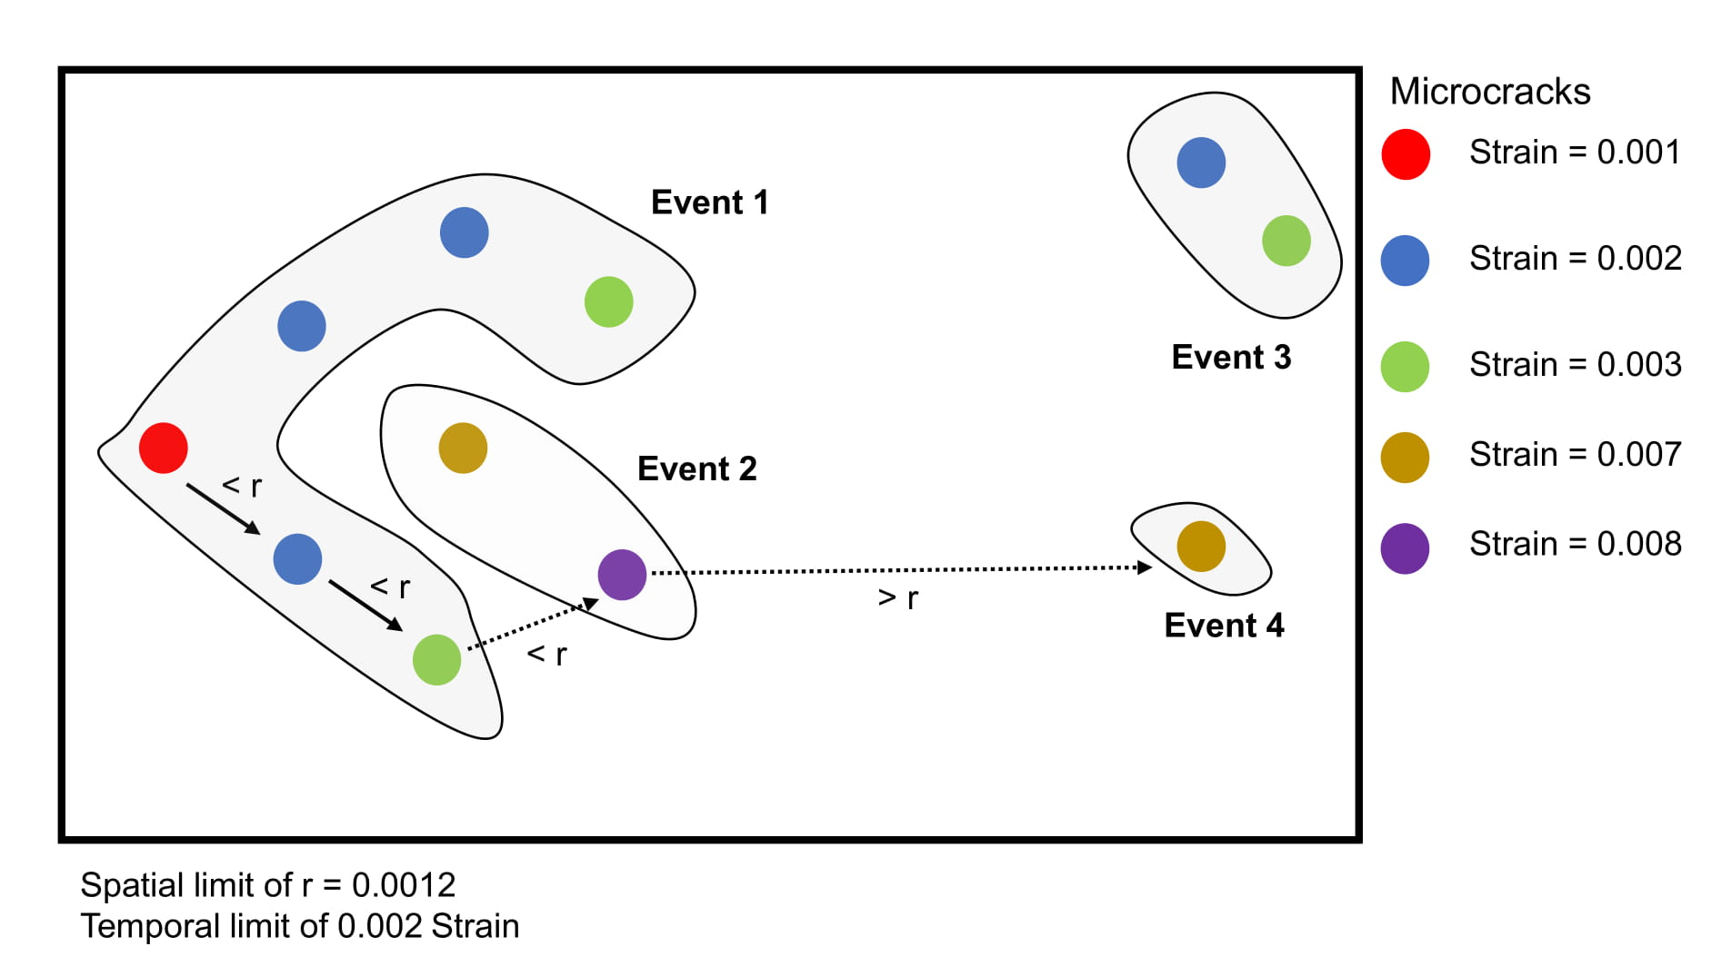

***Figure S5:*** *Schematic of spatio-temporal clustering of microcrack energy implemented from Hazzard and Young, 2000. We employ a source dimension of 0.0012 m and a temporal limit of 0.002 axial strain (εa).*

**S5: Calculation of seismic b-value**

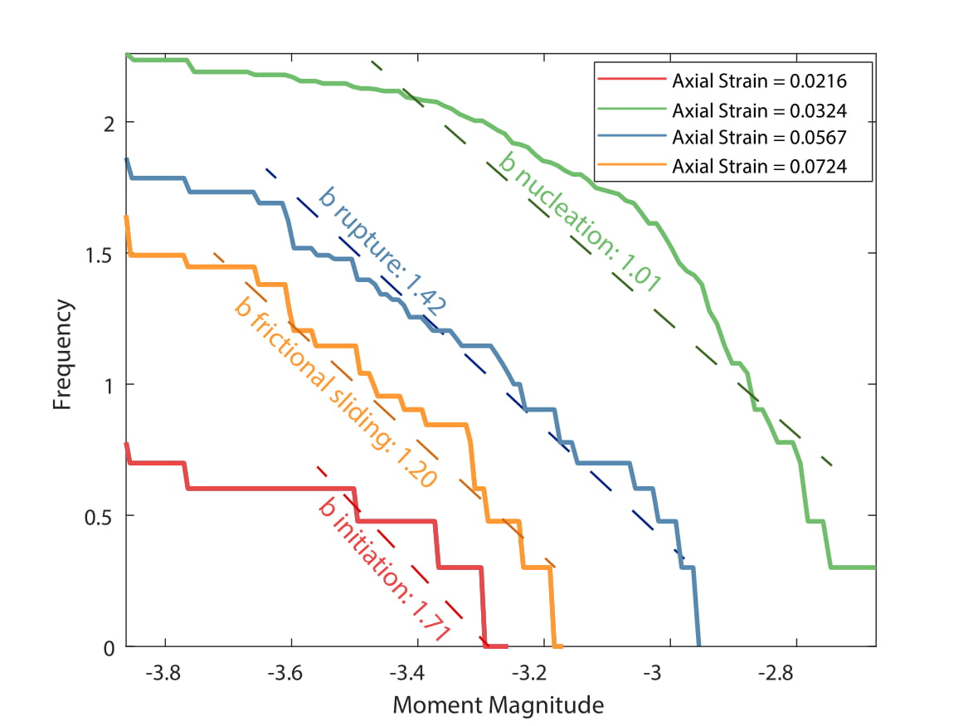

***Figure S6:*** *Seismic b-values calculated during axial strain windows during the initiation, nucleation, rupture and frictional sliding phase of shear fracture growth during biaxial test on Berea Sandstone analog under confining pressure of 10 MPa. Seismic b-value is calculated as the slope of the correlation integral frequency-magnitude distribution of clustered microcrack energy [Eq. 11]. b-values show strong precursory signatures of critical failure, exhibiting decline during the nucleation phase.*

**S6: Relationship between b-value and Shear Fraction**

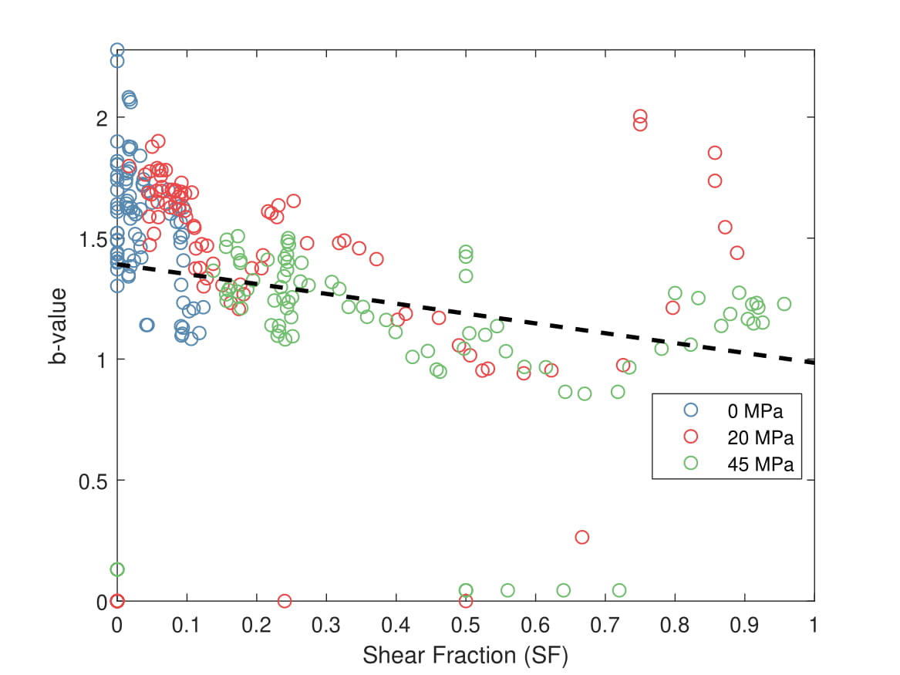

***Figure S7:*** *Seismic b-value exhibits an inverse correlation with shear fraction (SF) indicating the localization of shear stresses in rock results in wider range of moment magnitudes.*

**S7: Neural Network Architecture**

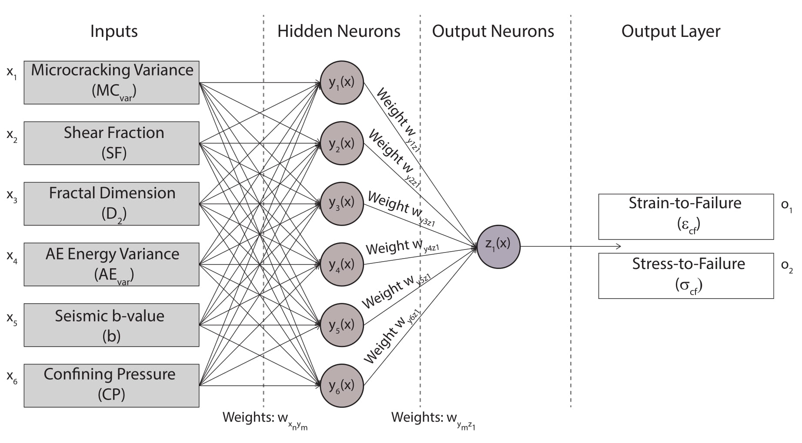

***Figure S8:*** *Architecture of Artificial Neural Network (ANN) employed in our study to predict critical failure in Berea Sandstone during biaxial tests under confining pressures of 0-45 MPa. The ANN predicts output stress-to-failure (σcf) and strain-to-failure (εcf) by correlating input predictors to target values through iteratively applying synaptic weights (wxy and wyz)*

**S8: Damage Indicators from Biaxial test on Berea Sandstone under 25 MPa confining pressure**

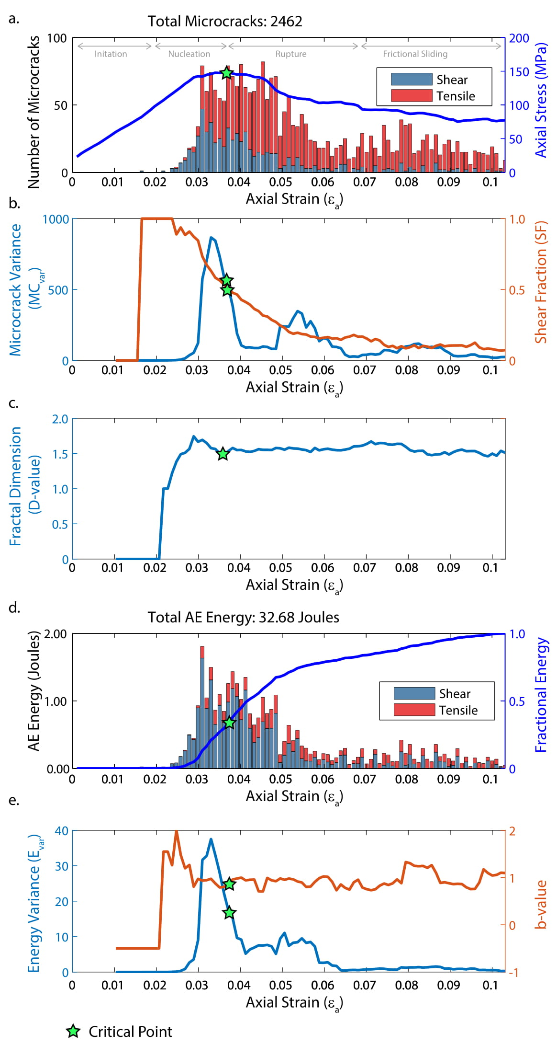

**Figure S9:** *Evolution of microcracking and derived in Berea sandstone during biaxial compression test under confining pressure of 25 MPa. (a) Applied axial stress and microcracking in shear and tensile modes documented as a function of axial strain. (b) Deformation indicators microcrack variance (MCvar) and shear fraction (SF) exhibit an increase in magnitude prior to critical point (c) Deformation indicator fractal dimension (D2) derived from moving axial exhibits a decline prior to critical point. (d) Calculated energy of acoustic emissions (AE) from shear and tensile microcracks documented as a function of axial strain. (e) Deformation indicator AE energy variance (AEvar) exhibits an increase in magnitude while b-value exhibits a decline prior to critical failure.*

**S9: Relative Importance of Neural Network Inputs for Stress-to-Failure predictions**

***Table 1:*** *Relative Importance calculation of input predictors for stress-to-failure prediction using Artificial Neural Network reveals b-value and D2 as primary predictors.*

|  |  |  |  |  |  |  |
| --- | --- | --- | --- | --- | --- | --- |
| **Input Layer-Hidden Layer** | | | | | | |
|  | **Input 1: Confining Pressure (*CP*)** | **Input 2: Microcracking Variance (*MCvar*)** | **Input 3:**  **Shear Fraction (*SF*)** | **Input 4:**  **Fractal Dimension (*D2*)** | **Input 5:**  **AE Energy Variance (*AEvar*)** | **Input 6:**  **Seismic b-value** |
| **Neuron y1** | -12.787 | -5.3654 | 3.3737 | 5.197 | 5.529 | -4.4557 |
| **Neuron y2** | -0.69941 | 0.46166 | 1.7681 | -0.44316 | -0.53642 | 1.3435 |
| **Neuron y3** | -1.3795 | 0.62373 | 1.8093 | -0.96023 | -2.5051 | 2.0473 |
| **Neuron y4** | -0.1906 | -0.80925 | -0.34267 | 1.3237 | -0.93371 | -1.7405 |
| **Neuron y5** | -0.00902 | -0.07215 | -0.00188 | 0.78122 | -0.84251 | -0.45002 |
| **Neuron y6** | -1.1023 | -1.8656 | 2.1003 | 0.65579 | 4.1812 | 1.7924 |
| **Hidden Layer – Output Layer** | | | | | | |
| **Neuron z1** | 0.068337 | -1.127 | 0.39871 | -0.81965 | 0.92711 | 0.81099 |
| **Connection Weights and Relative Importance** | | | | | | |
| **Neuron y1-z1** | 0.34834 | 0.14617 | 0.091906 | 0.14158 | 0.15062 | 0.12138 |
| **Neuron y2-z1** | 0.13316 | 0.087899 | 0.33663 | 0.084376 | 0.10213 | 0.2558 |
| **Neuron y3-z1** | 0.14794 | 0.066886 | 0.19403 | 0.10297 | 0.26863 | 0.21954 |
| **Neuron y4-z1** | 0.035691 | 0.15153 | 0.064166 | 0.24787 | 0.17484 | 0.3259 |
| **Neuron y5-z1** | 0.00418 | 0.03345 | 0.000873 | 0.36221 | 0.39063 | 0.20865 |
| **Neuron y6-z1** | 0.094236 | 0.15948 | 0.17955 | 0.056061 | 0.35744 | 0.15323 |
| **Sum** | 0.76355 | 0.64542 | 0.86715 | 0.99507 | 1.4443 | 1.2845 |
| **Relative Importance (%)** | 12.726 | 10.757 | 14.453 | 16.585 | 24.072 | 21.409 |
| **Rank** | **5** | **6** | **4** | **3** | **1** | **2** |

**S10: Relative Importance of Neural Network Inputs for Strain-to-Failure predictions**

***Table 1:*** *Relative Importance calculation of input predictors for strain-to-failure prediction using Artificial Neural Network reveals microcracking variance (MCvar) and D2 as primary predictors.*

|  |  |  |  |  |  |  |
| --- | --- | --- | --- | --- | --- | --- |
| **Input Layer-Hidden Layer** | | | | | | |
|  | **Input 1: Confining Pressure (*CP*)** | **Input 2: Microcracking Variance (*MCvar*)** | **Input 3:**  **Shear Fraction (*SF*)** | **Input 4:**  **Fractal Dimension (*D2*)** | **Input 5:**  **AE Energy Variance (*AEvar*)** | **Input 6:**  **Seismic b-value** |
| **Neuron y1** | 0.003748 | 0.36396 | 0.97119 | -0.43355 | 1.8287 | 2.9244 |
| **Neuron y2** | 0.70824 | -3.9489 | -1.4084 | -0.67197 | -0.93546 | -3.8996 |
| **Neuron y3** | -0.29575 | 1.9861 | 0.17713 | -0.03881 | -0.01627 | 0.12422 |
| **Neuron y4** | -0.63046 | 0.99101 | 2.5128 | -0.47049 | 0.8302 | 1.778 |
| **Neuron y5** | -0.77788 | -2.9333 | -1.075 | 0.71918 | -0.96588 | 2.2468 |
| **Neuron y6** | -1.3277 | -1.845 | -0.68016 | 1.1911 | -0.97703 | 1.8469 |
| **Hidden Layer – Output Layer** | | | | | | |
| **Neuron z1** | 0.84593 | 0.56068 | 0.53844 | -0.32142 | 1.831 | -3.3834 |
| **Connection Weights and Relative Importance** | | | | | | |
| **Neuron y1-z1** | 0.000574 | 0.055775 | 0.14883 | 0.06644 | 0.28024 | 0.44814 |
| **Neuron y2-z1** | 0.0612 | 0.34123 | 0.1217 | 0.058065 | 0.080835 | 0.33697 |
| **Neuron y3-z1** | 0.1121 | 0.75281 | 0.067138 | 0.014711 | 0.006166 | 0.047082 |
| **Neuron y4-z1** | 0.087407 | 0.13739 | 0.34837 | 0.065229 | 0.1151 | 0.24651 |
| **Neuron y5-z1** | 0.089226 | 0.33646 | 0.12331 | 0.082493 | 0.11079 | 0.25772 |
| **Neuron y6-z1** | 0.16875 | 0.2345 | 0.086448 | 0.15138 | 0.12418 | 0.23474 |
| **Sum** | 0.51926 | 1.8582 | 0.89579 | 0.43832 | 0.71731 | 1.5712 |
| **Relative Importance**  **(%)** | 8.6543 | 30.969 | 14.93 | 7.3054 | 11.955 | 26.186 |
| **Rank** | **5** | **1** | **3** | **6** | **4** | **2** |

**References**

Bobich, J. K. (2005), Experimental analysis of the extension to shear fracture transition in Berea sandstone, Texas A&M Univ., (August), 52.

Guo, Y., and J. K. Morgan (2007), Fault gouge evolution and its dependence on normal stress and rock strength—Results of discrete element simulations: Gouge zone properties, J. Geophys. Res., 112(B10), B10403, doi:10.1029/2006JB004524.

Johnson, K. L. (1985), Contact Mechanics, Cambridge Univ. Press, Cambridge.

Madariaga, R. (1976). Dynamics of an expanding circular fault. *Bulletin of the Seismological Society of America*, *66*(3), 639-666.

Mavko, G., Mukerji, T., & Dvorkin, J. (2009). The rock physics handbook: Tools for seismic analysis of porous media. Cambridge university press.

Morgan, J. K. (2015), Journal of Geophysical Research : Solid Earth wedges : Discrete element simulations, , 3870–3896, doi:10.1002/2014JB011455.Received.

Morgan, J. K., and M. S. Boettcher (1999), Numerical simulations of granular shear zones using the distinct element method: 1. Shear zone kinematics and the micromechanics of localization, J. Geophys. Res. Solid Earth, 104(B2), 2703–2719, doi:10.1029/1998JB900056.

Potyondy, D. O., & Cundall, P. A. (2004). A bonded-particle model for rock. *International journal of rock mechanics and mining sciences*, *41*(8), 1329-1364.

Schellart, W. P. (2000), Shear test results for cohesion and friction coefficients for different granular materials: Scaling implications for their usage in analogue modelling, Tectonophysics, 324(1–2), 1–16, doi:10.1016/S0040-1951(00)00111-6.

Scholtès, L., & Donzé, F. V. (2013). A DEM model for soft and hard rocks: role of grain interlocking on strength. *Journal of the Mechanics and Physics of Solids*, *61*(2), 352-369.

Scholz, C. H. (1968). The frequency-magnitude relation of microfracturing in rock and its relation to earthquakes. *Bulletin of the seismological society of America*, *58*(1), 399-415.