**HOTEL MANAGEMENT SYSYTEM**

**PROJECT**

**SUBJECT : INT -213**



**Submitted by :**

**Suraj kumar**

**Harsh Dwivedi**

**Sumit walia**

**SUBMITTED TO : Mrs. Neha Bagga ,**

**Department of Intelligent Systems , School of Computer Science Engineering**

**Lovely Professional University, Jalandhar**

**STUDENT DECLARATION**

This is to declare that this report has been written by us. No part of the report is copied from other sources. All the information provided here is our own creation. All information included from other sources have been duly acknowledged. This work is totally legit and does not include any kind of copyrighted or Copied material . We aver that if any part of the report is found to be copied, we shall take full responsibility for it.

**NAME : SUMIT WALIA**

**SECTION : K19TG**

**ROLL NUMBER : 63**

**REGISTRATION NUMBER : 11914961**

**NAME : HARSH DWIVEDI**

**SECTION : K19TG**

**ROLL NUMBER : 39**

**REGISTRATION NUMBER : 11915871**

**NAME : SURAJ KUMAR**

**SECTION : K19TG**

**ROLL NUMBER : 47**

**REGISTRATION NUMBER : 11915401**

**TABLE OF CONTENT / MINIATURE**

* LEARNING OBJECTIVE
* A SMALL INTRODUCTION
* ACTUAL CODE AND DESCRIPTION
* DIVISION OF WORK
* REFERENCE FOR PROJECT
* SWOT ANALYSIS
* LEARNING OUTCOME

**LEARNING OBJECTIVE**

* After completing this project we would be able to understand the concepts of tkinter , MySQL and GUI and much more.
* We would be able to learn the concept of combining python code with the database.
* Using tkinter we will be able to make the dynamic and and attractive GUI pages.
* We will be able to connect database with python to store information at the back end.
* We will be able to learn different ways of adding images in gui window using tkinter.
* This project mainly emphasises on the development of an attractive and responsive hotel management website/app.
* The main motive of this project is to make a complete user friendly environment over internet so that the users may face no problems while using it.
* After the completion of this project , we shall become well familiar with the process of inserting images , creating events using buttons.
* We will be come to know how to perform queries on database without even opening the mysql compiler,
* Theory of GUI and MySQL will become much clearer . We will be able to learn the process of making a small app/website and understand the working of backend and frontend of any website.

**INTRODUCTION AND MOTIVATION FOR PROJECT**

**HOTEL MANAGEMENT SYSTEM** is a combination of MySQL and python which make it a complete GUI based website with things happening at the backend. First of all, we would like to thank our teacher Mrs. Neha bagga mam, who provided us with this project. The motivation for making this project comes from the fact that while making reservation in hotels, we need a proper way of storing the information, in an efficient way.. This project is made by keeping in mind the needs for comfort and all best facilities to the customers. The project allows customers to select the type of room they want to stay in and the different facilities they want to opt for. A proper module for check in is made so that the complete information of the user may be collected and stored at the backend using MySQL. There is a separate module called check out which clears the details of customers after they leave the hotel. Moreover, the project also contains a separate module dedicated to the gallery of the hotel, which shows the architecture and facilities inside the hotel. The complete project is divided into small modules/functions which make a complete and ideal hotel reservation system.

**CODE AND DESCRIPTION**

**1.**

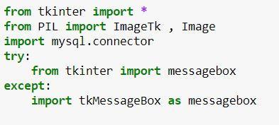

**Here , we are importing the important libraries which are required to make our project work properly.**

**1. tkinter is used for GUI .**

**2. The “from” keyword is used to import some particular or all modules from a library.**

**3. The import options does the actual work of importing the modules.**

**4. By using “*” character , we are importing every module in tkinter library.**

**5. PIL is used for inserting images. Using PIL we are importing only 2 modules namely ImageTK and Image to insert images in gui window.**

**6. mysql.connector is used to import the library which helps in establishing connection and performing queries on the sql using python.**

**7. Message box is imported from tkinter under try and catch block because it may sometimes give error and to avoid that error we have used two different ways of calling the message box module.**

**2. Gallery() function starts**

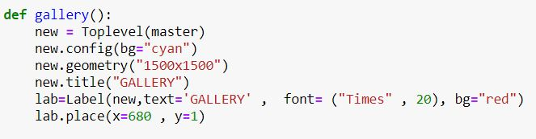

1. **In the above code we have used a function with keyword def , names as “gallery”.**
2. **Then , we have created a Toplevel window on the main window (master) , named as “new” with help of Toplevel() function.**
3. **Then we have configured the “new” window to background color “cyan” using “bg” attribute using the config statement.**
4. **Then we have changed the geometry of new window using “geometry” command to a size of ‘1500x1500’.**
5. **Then we have changed the name of new window using “title” statement as “GALLERY”.**
6. **Then we created a label named as “lab” , on the “new” window , wrote text on it and changed the font to Times and font size to 20 and applied background color as red.**
7. **Then we have placed the label using place function using x and y axis .**

**3.**

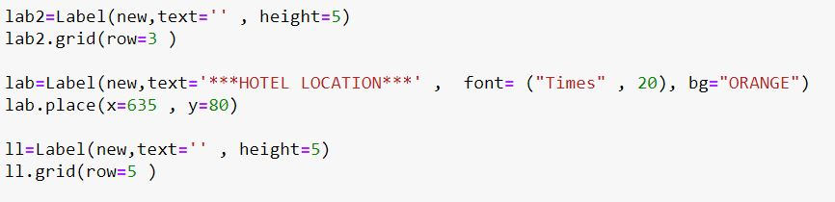

**1. In this code we have used a label named , “lab2” using Label widget and placed it on “new” window and have made the text in it empty , because we want to leave a space , to make program more attractive . The label creates a empty area with a height = 5.**

**2. We have used the grid function to place it on “new ” window using only a row.**

**3. Then we have created another label names as “lab” with some text and change the font to “Times” and font size to 20. We have changed the background color to “orange”.**

**4. Then we have placed the “lab” label on “new” window using place function with x and y coordinates.**

**5. Then , we have again used a label named , “ll” using Label widget and placed it on “new” window and have made the text in it empty , because we want to leave a space , to make program more attractive . The label creates a empty area with a height = 5.**

**6. We have used the grid function to place it on “new ” window using only a row.**

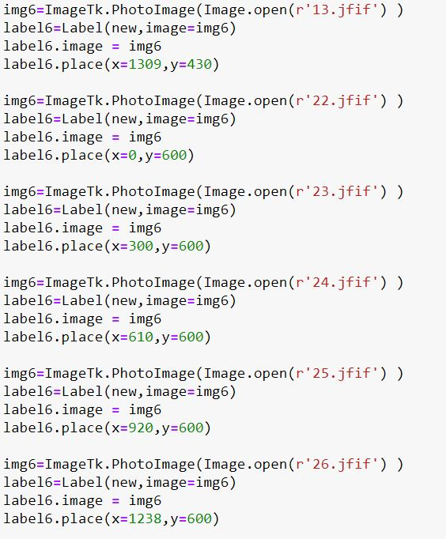 **4.**

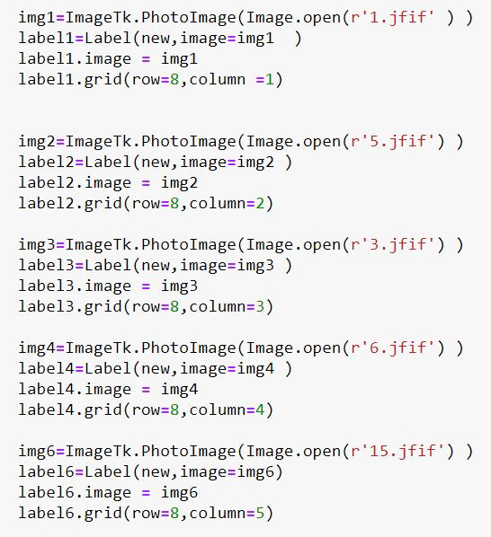

**In the above two codes snippets , we have used the ImageTk and Image module using PhotoImage to open the image in the gui window .**

1. **We have given a variable name to each image and then using “open” method of Image module , we have opened the images.**
2. **We have used a delimiter “r” to open images because sometimes the image may give error and may not open.**
3. **After that we placed the image on a label and have placed the image on the “new” window .We have passed the image we created in the earlier step in to “image” argument inside the label so as to display image on label.**
4. **After that we have created reference to the image which we want to insert into the window to avoid any kind of errors**
5. **After that we simply have used grid function (using rows and columns) and place function (using x and y axis ) to place the label consisting the image on the window.**

**5.**



1. In the above small code we have just made a new label called “lab3” using Label widget and placed it on the “new” window with some text in it using “text” function and we have changed the font using “font” function to Times and font size to 20 .we have also changed the background color of label using “bg” to orange.
2. Finally we have placed the label on “new” window using place method with x and y axis.

**\*\*\*Gallery function ends here\*\*\***

1. **CHECKIN() FUNCTION STARTS**

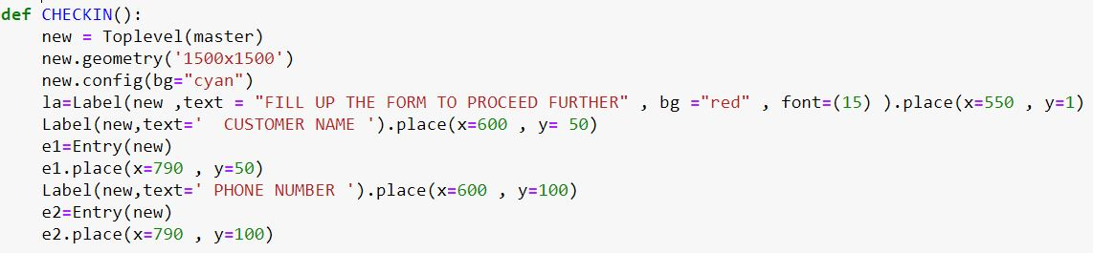

1. In the above code we have created a function named “CHECKIN” using keyword def.
2. Inside the function we have created a new window using Toplevel() function and placed it on master .
3. We have set the geometry of the “new” window to “1500x1500” to get a proper and full view of the window.
4. Then we have configured the new window and changed the background color to cyan using “bg” method.
5. Next, we have made a label called “la” on the new window with some text in it. We have changed its background color to red using “bg” function and also changed its font size to 15 using font function.
6. Then we have placed the label “la” on the “new ” window using place function.
7. Then we have made an entry “e1” ,and placed it on “new” window using place method ,which will take name of customer.
8. Then , we have placed the entry “e1” on the “new” window using place function.
9. After that we created a label with some text and placed it on “new” window using place function.
10. Then we have again created an entry e2 and placed it on “new” window using the place function.

**7.**

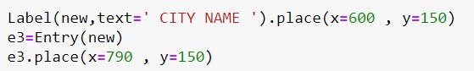

1. In the above code , we have created a new label with some text in it and then place it on “new” window using place method.
2. Then we created a new entry name as “e3” , which will take city name of customer and then placed on the “new” .

**8.**

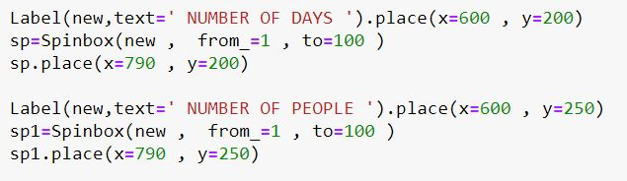

1. In the above code , we have used label placed on “new” window which asks for number of days.

1. Then we have added a spinbox using Spinbox widget which takes values from 1 to 100 using parameters from_ and to .
2. Then ,we have again placed a new label on “new” window which asks for number of customers.

1. Then we have added a spinbox using Spinbox widget which takes values from 1 to 100 using parameters from_ and to .
2. Then we have placed both spinboxes on the window using place() method.

**9.**

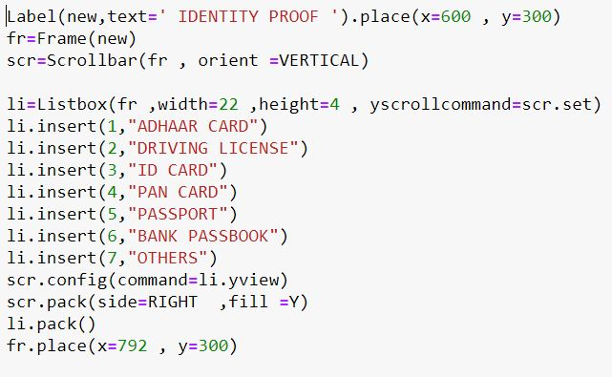

In the above code , we have made a list and attached it with a scrollbar.

1. Firstly , we have created a label with some text and place it on the “new” window.
2. Then we create anew frame using Frame widget and named it as “fr” .
3. Then we created a scrollbar using Scrollbar widget and named it as scr and gave its orient as vertical to make it appear vertically.
4. Then we created a listbox using Listbox widget and placed it on frame “fr” and set its height and width using height and width parameter and also set its yscrollcommand to scr.set .The scrollcomamnd helped us to establish a connection between the list and scrollbar and set it in the y axis of listbox.
5. Then we inserted several values in the listbox using insert function.
6. Syntax of insert function is : listboxname.insert(location , “list item”)

Example list1.insert(1, “hello”) ---- this code will set the 1st option in the list bix as “hello”.

1. Then we configured the scrollbar named as “scr” and set its command to li.yview. This helped in setting the scrollbar with the listbox.
2. Then we packed the scrollbar “scr” to the right side and set fill=Y . This helped in setting the scrollbar towards the right side of the listbox and fill helped to fill the complete y axis of the listbox with scrollbar.
3. After that we packed the listbox “li” on the window using pack function.
4. Finally we placed the frame “fr” on the window using place() method.

**10.**

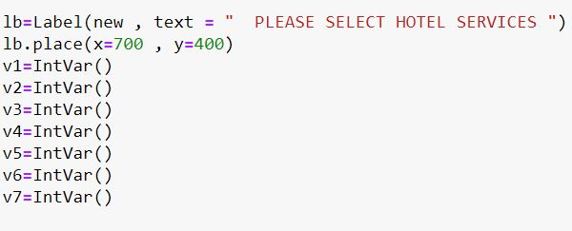

1. In the above code , we have created label named as “lb” and place it on “new” window with some text asking for selecting hotel services.
2. Then we have placed the label “lb” using place function.
3. After this we have created some variables namely v1 ,v2 , v3 , v4 , v5 , v6 , v7 , and gave them values as IntVar() .
4. These variables will be used while using the radiobutton and checkbutton.

**11.**

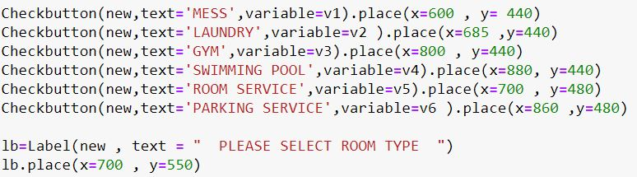

1. In above code with have made some checkbuttons with the help of Checkbutton widget .We have provided some options in the form of checkboxes which user will select .. We have assigned different variables to each of the checkboxes because we don’t want the other check box to be selected if we select one . We have used place() method to place checkbuttons on “new” window.
2. Then we have created a label “lb” with some text and placed it on “new” using place method.

**12.**

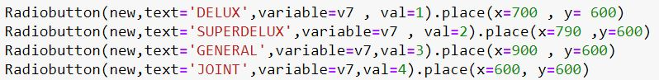

1. In the above code , we have created 4 radiobuttons using Radiobutton widget with some text in it.
2. These radiobuttons allow the user to select only one type of room among 4 options , because we have used only one variable , v7 .
3. We have given 4 different values to each radiobuttons which will further help us in coding in next few modules.
4. Finally we have placed the radiobuttons on “new” window using the place() method.

**13.**

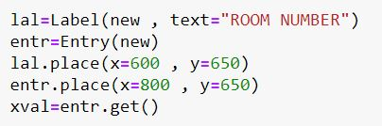

1. In the above code , we have just created a label named as “lal” , which asks for room number .
2. Then we have created an entry , named as “entr” using Entry widget .
3. Then we have placed the “lal” label using place() on “new” window.
4. Then we have also placed the entry using place() method on the “new” window.
5. After that we have created another variable named as xval which will store the value which we will enter into the entry “entr” using the get function.
6. We will use the xval variable in mysql in upcoming modules.

**\*\*\*CHECKIN () FUNCTION ENDS HERE\*\*\***

**14. Checksub() function starts**

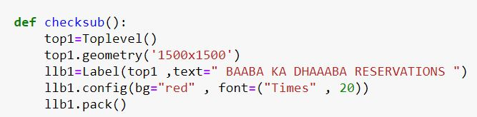

1. In the above code we have created a new function named as checksub().
2. In this function , we have created a toplevel window named as “top1” .
3. We have changed the geometry of “top1” as 1500x1500 to get a proper visuality.
4. We have create a label named as “llb1” using Label widget and placed it on top1
5. Than we changed the background color of label using “bg” and the font size to 20 and font type to “Times”.
6. Then finally we have packed the label inside the “top1”

**15.**

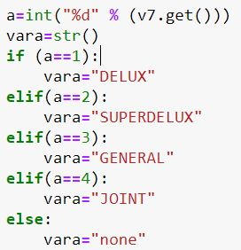

1. In the above code we are fetching the value of v7.get() which was earlier used in step 11 and storing its information in the variable a. We are converting the value of v7.get() into integer first.

This variable corresponds to the radiobutton option selected by the user at time of execution .

1. After that we have declared a variable “vara” to which we have made a string variable.

In next step , we have used if else statement.

1. Here using if statement , We are checking that if the value of variable is =1 , than the string variable , “vara” will get the value as “Delux”
2. Next using elif we are checking that if the value of variable is =2 , than the string variable , “vara” will get the value as “SuperDelux”
3. Again using elif we are checking that if the value of variable is =3 , than the string variable , “vara” will get the value as “General”
4. Again using elif , we are checking that if the value of variable is =4 , than the string variable , “vara” will get the value as “Joint”
5. At last using else ,we are checking that if the value of variable is not given , than the string variable , “vara” will get the value as “None”.

**16.**

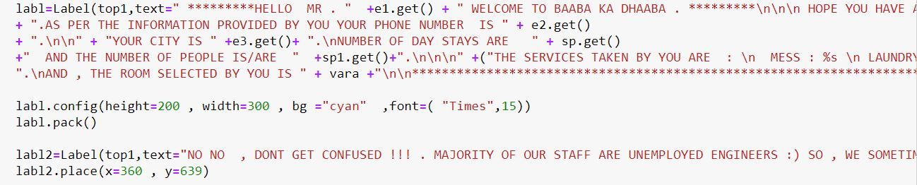

1. In the above code , we are label named as “labl” , which is displaying all the value which was entered by the user in the function CHECKINN() .
2. It includes user name which is fetched by e1.get()
3. Customer’s phone number which is fetched by e2.get()
4. Customer’s city name which is fetched by e3.get()
5. Total number of stays in the hotel fetched by sp1.get()
6. Total number of customers fetched by sp2.get()
7. We are also displaying the services selected by the user previously in the form of checkbuttons .
8. The room type specified by the user is also fetched by calling the variable vara which was used in step 15 using radiobutton.

1. Then we do some configurations with the label “labl” and assign the height and width to it and also set its background color using “bg” and also set its font size and style using font parameter.
2. Then we pack the label “labl” inside the window
3. After than we create a label labl2 with some information and place it on “top1” window.

**17.**

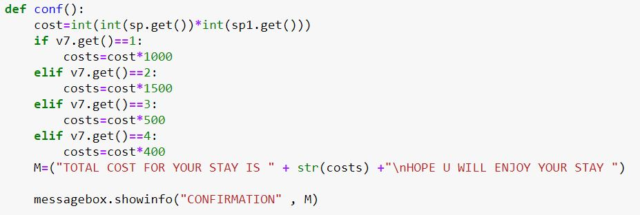

1. In the above code , we have created another function named conf using keyword def.
2. We have created a new variable which takes multipies the values of sp.get() and sp1.get(() , which were the two spin boxes taken earlier in the program to calculate the cost.Than we have used the if and elif statement:
3. When v7.get() (taken for radiobutton earlier in the code) function will give

value = 1 , than a new variable costs will get updated and will store the multiplication of cost and1000 to find total cost.

1. When v7.get() (taken for radiobutton earlier in the code) function will give

value = 2 , than the new variable costs will get updated and will store the multiplication of cost and 1500 to find total cost.

1. When v7.get() (taken for radiobutton earlier in the code) function will give

value = 3 , than the new variable costs will get updated and will store the multiplication of cost and 500 to find total cost.

1. When v7.get() (taken for radiobutton earlier in the code) function will give

value = 4 , than the new variable costs will get updated and will store the multiplication of cost and 400 to find total cost.

1. Than we have taken a variable M which will contain text and information about the total cost generated for customer.
2. Then using message box widget we would display the text M and with the help of showinfo() function.

**18.**

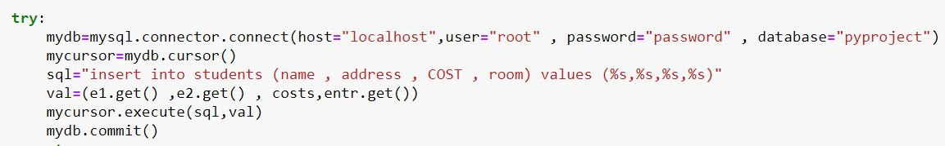

In the above code we have used the try block to check if any error comes or not.

1. Firstly , we have tried connecting to the mysql using variable mydb through mysql.connector.connect() method to the host “localhost” , with user name and

with password and we have also specified the database.

1. And we have created a cursor using mydb.cursor() command , named as mycurosr , which will handle all sessions and commands.
2. Than we try to insert values into the table students by using mysql queries .
3. Than we try to execute the command with the help of mycuror.execute() command
4. And then we commit the changes using mydb.commit.
5. But if the error comes in this code , which will have only one reason i.e , that if the database does not exists and also the table doesnot exists.
6. To handle this error and to make a new database and table we use the except block.

**19.**

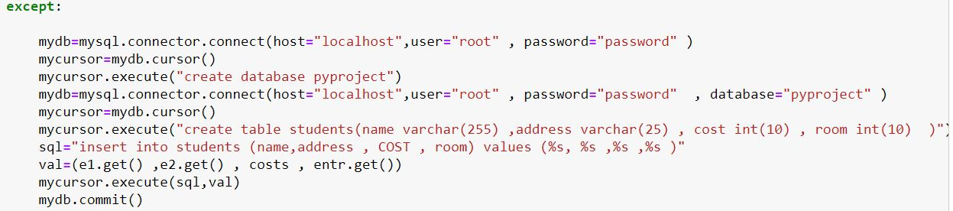

If the exception/error occurs in the previous step (18) , than the except block will handle that exception.

1. Firstly , we have tried connecting to the mysql using variable mydb through mysql.connector.connect() method to the host “localhost” , with user name and

with password but we have not specified the database because exception occurred because there as not database.

1. And we have created a cursor using mydb.cursor() command , named as

mycursor , which will handle all sessions and commands

1. Then we created a database using execute() method by passing the my sql query into execute function.
2. After that we re-established the connection with the mysql but this time we also specifies the database name.
3. Again we created the cursor mycursor using mydb.cursor() .
4. Now we executed the query to make a table named “students” and inserted 4 columns in the table to record customers information.
5. Than we passed the query to insert the data into a variable that we need to insert into the table by using mysql insert into query.
6. Than we executed the statement with execute() function.
7. Than finally we committed the changes to the database using commit() function.

**20.**



In the above code , we have just created a button using Button widget and have added some font style to it , changed its font size and passed the command as conf function (used earlier in the program).

**21.***END OF CONF() FUNCTION AND BEGINNING OF FUNC() FUNCITON\*\*\***

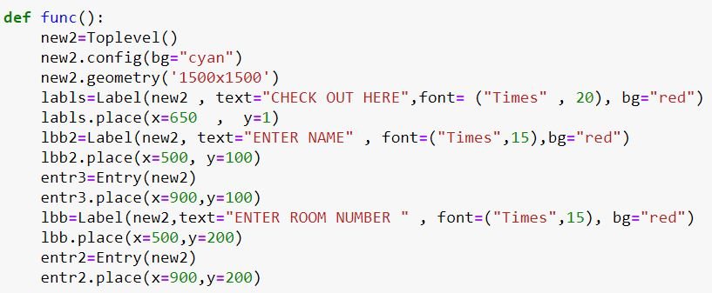

1. In the above code we created a new function named as func().

We create a new toplevel window using Toplevel widget and have applied some configurations to it , i.e , changed the background color to cyan using “bg”.

2.Next we changed the geometry of “new2” using geometry function for proper view.

Than we created a label named labls , changed its font size ,added some text , style and background color and finally place on new2 window.

3. Than we created a label named lbb2 , changed its font size ,added some text asking to enter customer name , changed its style and background color and finally placed on new2 window.

4.Then we created an entry “entr3” to take value from customer using Entry widget and placed it on the new2 window which will take customer’s name.

5.Than we created a label named lbb, added some text asking for customer’s room number , changed its font size and style and background color and finally placed on new2 window.

6.Then we created an entry “entr2” to take value from customer using Entry widget and placed it on the new2 window which will take customer’s room number.

**22.pysql() function starts**

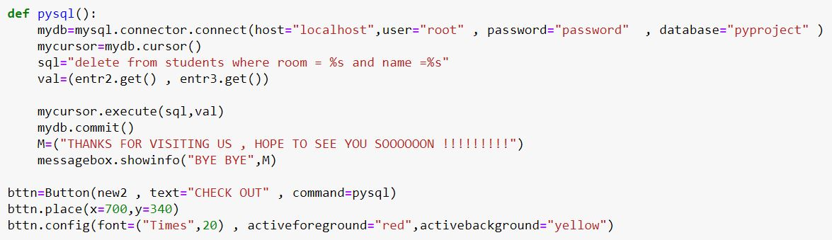

In this code we have created another function name as pysql which helps in deleting the record of the customer who leaves/check out of hotel.

1. Firstly , we have tried connecting to the mysql using variable mydb through mysql.connector.connect() method to the host “localhost” , with user name and

with password and we have also specified the database.

1. And we have created a cursor using mydb.cursor() command , named as mycurosr , which will handle all sessions and commands.
2. After that , we have passed a query used to delete the records using name and room number of customer into a variable .
3. Than we have taken another variable which consists of the two values i.e ,the name and room number of the customer who wants to checkout.
4. Than we have passed both the variables into the execute function to execute the query and then committed the changes.
5. Than we have taken another variable named ‘M’ in which we have passed some text.
6. Than we have used message box to show message M with the showinfo() function.

Pysql() function ends her

1. Then we have created the button named “bttn” and have configured its fore and back ground.
2. We also added pysql (function) command into the “bttn” .
3. Finally we have place it on the window.

**23.**

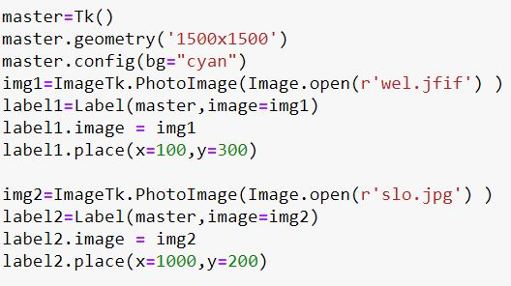

1. In the above code , we have created the main window , master which is the first window to appear after we open program.
2. We have assigned the Tk() function to it so as to create the window.
3. Than we have changed the geometry using geometry function.
4. After than we have configures master window and changed its background to “cyan”.
5. Than using ImageTk and Image module , we have opened an image and passed it into a variable img1.
6. After than we created a label named as label1 and assigned the image parameter as img1.
7. Than we created a reference to image and finally placed the image using place() method.
8. We have again inserted the image named as img2 on label named as label2 , using steps 6-7.

**24.**

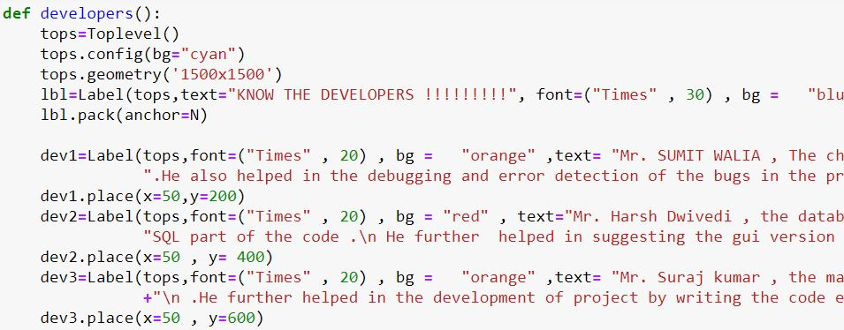

1. In the above code we have created a new function called as developers .We have added a new toplevel() window named as tops and configured it background color to cyan.
2. We have changed the geometry of tops to 1500x1500.
3. Than we have place a label named as lb1 and configured its text and background.
4. Then we have packed it using pack() function and gave its anchor parameter as ‘N’ to make it appear on the top center.
5. Then we created another label called dev1 which contains some text about developer 1 and we have also configured the text , background and style.
6. Then we have place it using place() function.
7. Again we created another label called dev2 which contains some text about developer 2 and we have also configured the text , background and style.
8. Then we have place it using place() function.
9. Then again , we created another label called dev3 which contains some text about developer 3 and we have also configured the text , background and style.
10. Then we have place it using place() function.

**25. developers() function ends here**

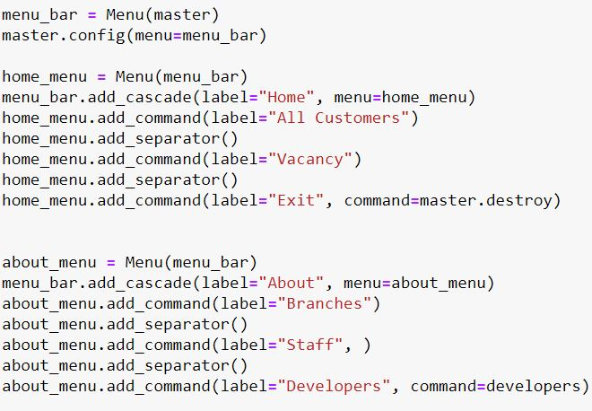

1. In the above code we have made a menu bar.
2. Firstly we have created a menubar using Menu widget on “master” window using menu_bar variable.
3. Than we have configured the master by config() method and applied the setting to make menu_bar variable appear like a real menu bar.
4. Then we created a home_menu on the menu_bar using Menu widget.
5. Than we added cascade menu inside the home_menu using add_cascade() method and labelled it as “home”.
6. Then we added a dummy selection menu to home_menu and labelled is as “all customers” .But this command is just a dummy.
7. Then we added separator.
8. And then again created a dummy clickable menu inside home menu named as “vacancy”
9. At last we again created a clickable menu inside home and labelled it as “exit” and gave the command to destroy the master window and close program.
10. Then we create another menu named as “about_menu” on menu_bar and added a cascade menu to it and named it as “about”.
11. Then we created other dummy menu commands inside the “about_menu”.
12. Then we created one clickable menu inside the “about_menu” named as “developers” and passed the command “developers ” to it which was created in step 24 , using add_command() function.

**26.**

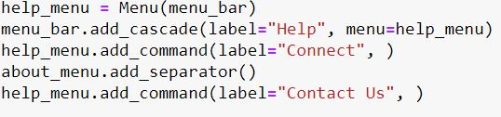

1. Then we create another menu named as “help_menu” on menu_bar and added a cascade menu to it and named it as “help”.
2. Then we created other dummy menu commands like “connect us” and “contact us” inside the “about_menu” , using add_command() function.

**27.**

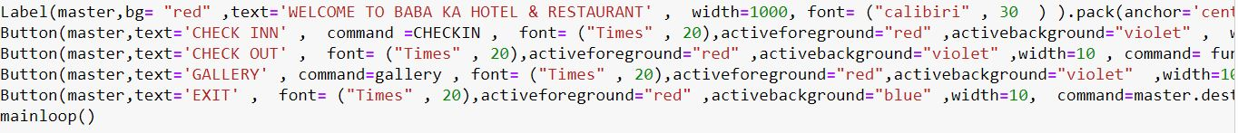

1. In this code , we created a label on master window and added some text to it .
2. We also added background color using “bg” attribute also changed the height and width of the label using height and width attributes. Than we also modified the font of the label using font attribute.
3. Than we finally packed it at “center” using anchor.
4. Than we added 4 buttons on the master window to which we passed the main 4 functions ie, checkin , checkout., gallery and exit.
5. We also changed font using font attribute and also used activebackground and active foreground attributes.We also changed the width and height of the buttons.
6. At last we created the mainloop() which is an infinite loop used to run the application, wait for an event to occur and process the event as long as the window is not closed.

**Description of Work Division in terms of Roles among Students**

**Sumit walia:** The coder and debugger , who played a major role in desiging the complete program with the help of Mr. Suraj kumar .He also helped in the debugging and error detection of the bugs in the program.

**Suraj kumar :** Error handler and efficient coder , Handle all sorts of problems and errors during code execution , played a major role in coding .He further helped in the development of project by writing the code efficiently.

**Harsh Dwivedi :** The database specialists who made sure that there was no stone unturned while coding the SQL part of the code . He further helped in suggesting the gui version of the program

**SWOT ANALYSIS**

STRENGTH :

* THE COMPLETE PROJECT IS VERY MUCH USER FRIENDLY
* A GREAT USE OF GUI AND IMAGES HAVE BEEN DONE
* ALL THE TOPLEVEL WINDOWS ARE WORKING PROPERLY AND ALL IMAGES ARE PLACED SYMMETRICALLY IN A DEFINITE POSITION
* CUSTOMERS WILL BE ABLE TO CHOOSE THE TYPES OF SERVICES THEY WANT TO OPT FOR

WEAKNESS:

* 3D EFFECTS HAVE NOT BEEN USED
* THE APP CANNOT PERFORM MORE ADVANCED PURPOSES.

OPPURTUNITY :

* THE PROJECT CAN BE USED IN DAILY LIFE WHERE THERE IS A NEED AN EFFICIENT BOOKING SYSTEM .

THREAT :

* NO SUCH THREAT OBSERVED.

REFERENCE FOR PERFORMING PROJECT :

* TEACHER’s NOTES
* GEEKSFORGEEKS.COM
* ONLINE HOTEL WEBITES
* TUTORIALSPOINT.COM

LEARNING OUTCOME :

* After completing this project we are able to understand the concepts of tkinter , MySQL and GUI and much more.
* We are able to understand the concept of combining python code with the database.
* Using tkinter we are now able to make the dynamic and and attractive GUI pages.
* We know how to connect database with python to store information at the back end.
* We are able to learn different ways of adding images in gui window using tkinter.
* This project helped understanding the development of an attractive and responsive hotel management website/app.
* The main motive of this project was to make a complete user friendly environment over internet so that the users may face no problems while using it and we achieve our motive.
* After the completion of this project , we are well familiar with the process of inserting images , creating events using buttons.
* We came to know how to perform queries on database without even opening the mysql compiler,
* Theory of GUI and MySQL became much clearer . We are able to learn the process of making a small app/website and understand the working of backend and frontend of any website.