SCREENSHOTS
1) Executing the python scripts

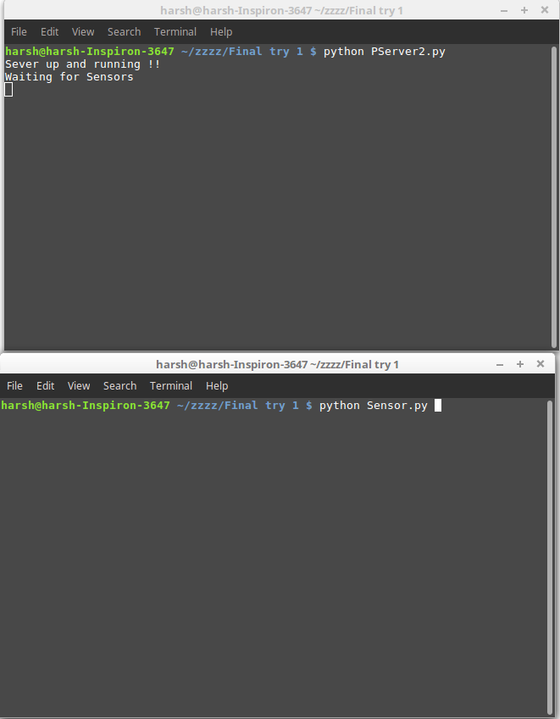

2) Screenshot 2
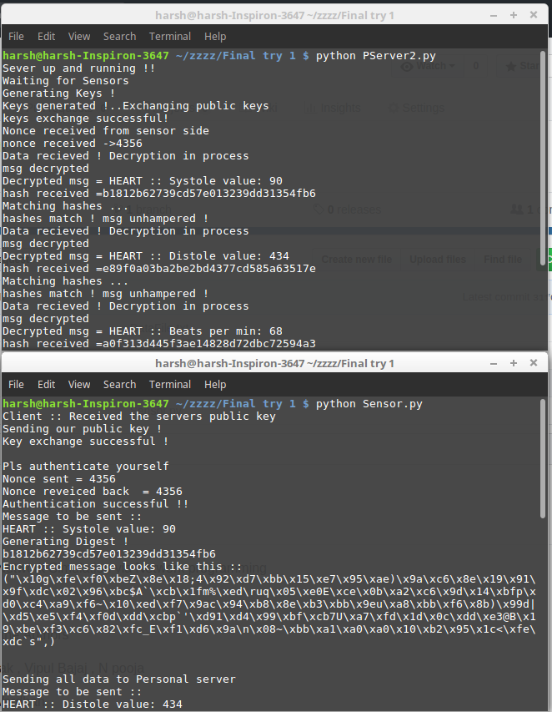

3) Screenshot 3
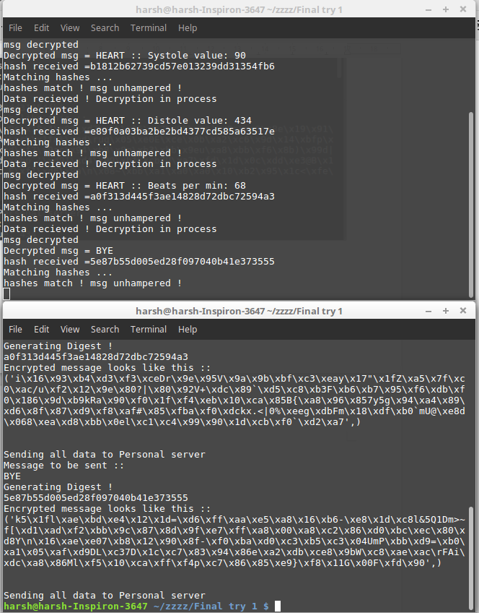

1) DO CHECK THE DataFile.txt file... It is the data base of all the data stored sent by sensor to the personel server , in an organised fashion ..

2) All the above screenshots are for communication between the Personal server and Sensor.
3) Also for inter communication between the Personal Server the hospital the code remains the same.

