Modeling Volatility in Financial Markets
Final Report — Team 3
Yibo Liu, Mani Chandana Bandaru, Rajath Sathyanarayana, Yen-Shuo Su, Harsh Gupta

1. Summary
This report investigates one-step-ahead volatility forecasting for the SPDR S&P 500 ETF (SPY) at the daily frequency. Twenty-two years of Yahoo Finance closing prices (Jan 2004 – Apr 2026) are split into train (2004–2021), validation (2022–2023), and test (2024–Apr 2026) blocks, with a strict expanding-window evaluation that prevents look-ahead bias. Two feature configurations are studied: a target-only set (no_exog) consisting of lagged returns, lagged squared returns, negative-shock indicators, and 5/10/22-day realized-volatility windows; and an exogenous set (with_exog) that augments these with lagged OIL, GOLD, DXY returns and the log-VIX level and first difference. Five families of models are benchmarked: GJR-GARCH, Markov-Switching GARCH (MS-GARCH), an LSTM with attention, a Transformer encoder, and gradient-boosted trees (XGBoost). On daily SPY, MS-GARCH (k=2, GJR variance, Student-t innovations) attains the lowest test RMSE (4.286) when augmented with exogenous features, while the LSTM-with-attention achieves the lowest QLIKE (0.649) and the Transformer matches MS-GARCH on RMSE (4.295) under with_exog. The three models also produce well-calibrated 1% and 5% VaR exceedances, in contrast with XGBoost, which yields the smallest MAE (0.926) but systematically under-estimates the conditional variance and therefore generates 11× the expected number of 1% VaR breaches. The major finding is that for SPY, regime-switching GARCH and attention-based recurrent networks deliver complementary but quantitatively similar gains over a single-regime GJR baseline; exogenous features (especially the VIX) provide consistent but modest improvements on the order of 1–10% in RMSE and QLIKE.
2. Introduction
2.1 Motivation and Prior Expectations
Financial volatility is the degree to which asset prices fluctuate over time and is central to risk management, derivative pricing, and portfolio allocation. We selected this problem because (i) it aligns directly with the time-series themes of this course; (ii) SPY exhibits well-documented stylised facts — fat tails, leverage effects, and clustering — that motivate a layered modelling strategy; and (iii) repeated structural breaks (the 2008 GFC, the 2020 COVID crash, the 2022 energy shock) provide natural stress tests of any forecasting framework. Going in, we expected GARCH-family models to remain competitive on point accuracy because their functional form is well matched to volatility persistence, and we expected machine-learning models (LSTM, Transformer, XGBoost) to win on regimes where nonlinear interactions with macro features (VIX, DXY) become important. We anticipated that MS-GARCH would improve VaR calibration during crisis windows by separating calm and turbulent dynamics.
2.2 Literature Review
2.2.1 Problem Origin. The formal study of time-varying volatility began with Engle's (1982) ARCH model and was generalised by Bollerslev (1986) into the GARCH framework, which has dominated volatility research for four decades.
2.2.2 Problem Evolution. While GARCH-family models capture clustering under a single regime, financial markets alternate between structurally distinct states that a single-regime specification cannot represent. Hamilton (1989) introduced the Markov-switching autoregressive model, and this insight was extended to volatility through the MS-GARCH specifications of Haas et al. (2004) and Klaassen (2002). In parallel, machine-learning methods — feed-forward networks, recurrent architectures, and ensemble methods — have been applied to forecast volatility directly, often outperforming classical models (Carr et al., 2020; Kim & Won, 2018). More recently, machine-learning techniques have been turned toward regime detection itself (Raja Lope Ahmad et al., 2026; Ejike, 2026).
2.2.3 Problem Impact. Underestimated tail risk contributed to catastrophic losses during the 2008 financial crisis, the 2020 COVID-19 crash, and the 2022 energy price shock. Improved volatility models enable more reliable Value-at-Risk estimates, better hedging strategies for energy-dependent firms, and more precise option pricing — serving both academic understanding and practical risk mitigation.
2.2.4 Previous Analytical Efforts. Three streams of prior work motivate our design.
Approach 1 — Markov-Switching GARCH. Haas et al. (2004) proposed a tractable MS-GARCH specification with independent conditional-variance equations per regime, showing substantial improvements in density forecasts on foreign-exchange data. Klaassen (2002) provided an alternative formulation that adjusts expected variance at regime transitions to mitigate path-dependence. Ardia et al. (2019) released the MSGARCH R package and confirmed regime-switching superiority for VaR forecasting on equity data. Hardy (2001) demonstrated similar gains for the S&P 500. The merits are statistical grounding, interpretable regime probabilities, and strong VaR improvements; shortcomings are computational complexity, the need to pre-specify the number of states, and difficulty incorporating high-dimensional features.
Approach 2 — Machine-Learning Volatility Prediction. Carr et al. (2020) used Ridge Regression, Random Forest, and feed-forward neural networks to predict realised variance and build a volatility index. Doering et al. (2017) applied CNNs to high-frequency data with strong but opaque performance. Recurrent architectures have been explored more extensively: Tino et al. (2001) combined Markov models with an Elman RNN for volatility trading; Xiong et al. (2016) integrated price data with Google Domestic Trends in an LSTM framework; and Kim and Won (2018) developed LSTM models integrated with multiple GARCH-type inputs. Merits include the ability to capture complex non-linear patterns and to incorporate diverse features. Shortcomings are the black-box problem, susceptibility to over-fitting on noisy financial series, and the absence of any regime-probability interpretation.
Approach 3 — Machine-Learning Regime Detection. Raja Lope Ahmad et al. (2026) combined PCA and clustering with attention-based RNNs to detect market-instability shifts without pre-specifying the number of states. Ejike (2026) compared LDA, SVMs, and feed-forward networks for regime classification, finding that nonlinear classifiers offered improved accuracy. The merits are data-driven discovery of regimes from high-dimensional features without parametric assumptions; the shortcomings are ex-post regime labels, large training-sample requirements, and the absence of an explicit transition-probability framework.
Our project sits across these three streams: GJR-GARCH provides a single-regime baseline; MS-GARCH supplies the regime-switching lens; and the LSTM-with-attention, Transformer, and XGBoost models contribute machine-learning perspectives that natively ingest exogenous features.
3. Data Summary
We use closing-price series for SPY (SPDR S&P 500 ETF Trust) downloaded from Yahoo Finance, together with four auxiliary series (OIL = WTI crude futures CL=F, GOLD = SPDR Gold Shares GLD, DXY = U.S. dollar index, and VIX) used to construct exogenous features. The full sample spans 1 January 2004 through 29 April 2026. Log returns rₜ = ln(Pₜ/Pₜ₋₁) are scaled by 100 (so a 1% move equals 1.0). All exogenous and target features are lagged by one period to prevent contemporaneous leakage and a one-period embargo is enforced at every split boundary. The feature engineering produces two configurations per cell:
- no_exog (7 features): lagged log return rₜ₋₁, lagged squared return rₜ₋₁², asymmetric negative-shock term rₜ₋₁²·𝟙{rₜ₋₁<0}, and 5/10/22-day rolling realized-volatility windows.
- with_exog (13 features): all of the above, plus lagged OIL, GOLD and DXY log returns and the log-VIX level and first difference (a 13-feature panel).
Splits follow a single, pre-registered manifest (data/splits/manifest.yaml) so every model trains and forecasts on identical rows. Train, validation, and test sample sizes are reported in Table 1. Returns are stationary at all conventional levels (ADF p-values < 1e-13; KPSS does not reject); prices are I(1). Squared residuals from the best ARMA fit show overwhelming Ljung–Box rejection (p < 1e-7 at lag 10), confirming conditional heteroskedasticity and motivating GARCH-type variance modelling.

Table 1. Sample sizes and time spans (SPY daily).
Split | Start | End | Observations
Train | 2004-02-06 | 2021-12-31 | 4,472
Validation | 2022-01-03 | 2023-12-29 | 501
Test | 2024-01-02 | 2026-04-29 | 583
Total | 2004-02-06 | 2026-04-29 | 5,556

Table 2. Descriptive statistics of SPY daily log returns (×100), full sample.
Series | N | Mean | Median | Std | Min | Max | Skew | ExKurt
SPY ret | 6,537 | 0.031 | 0.069 | 1.222 | −11.589 | 13.558 | −0.21 | 11.53

Table 3. Stationarity tests on SPY (full sample).
Series | ADF stat | ADF p | KPSS stat | KPSS p | Conclusion
SPY returns | −20.22 | <1e-13 | 0.43 | 0.066 | Stationary
SPY prices | +3.60 | 1.000 | 10.10 | <0.01 | Non-stationary

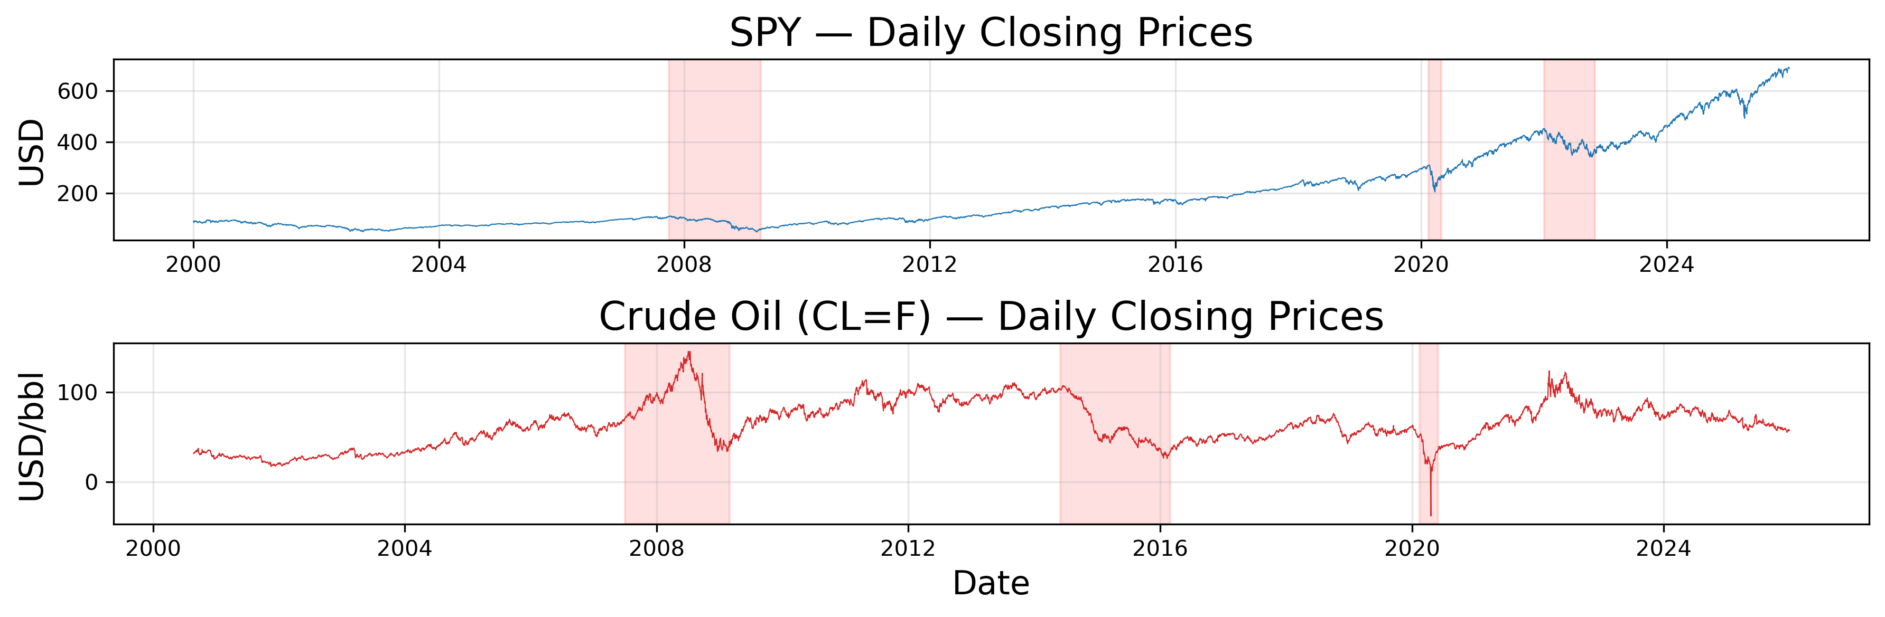
Figure 1. SPY daily closing prices, 2004–2026. Shaded regions correspond to the GFC, COVID, and 2022 energy shock windows used for stress testing.

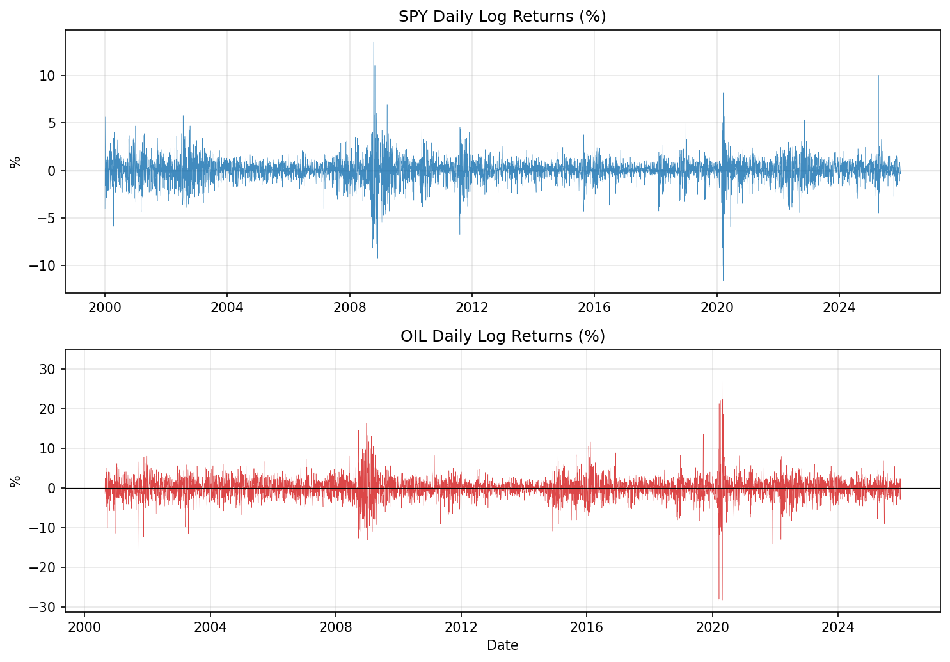
Figure 2. SPY daily log returns. Visible volatility clustering motivates conditional-variance models.

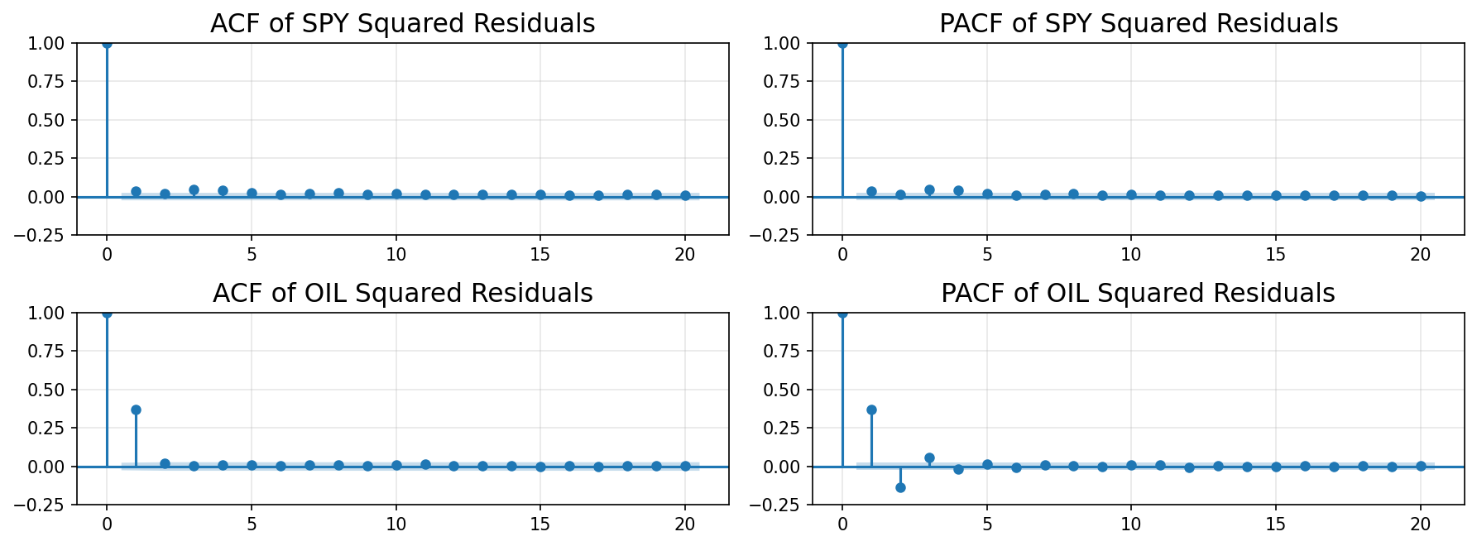
Figure 3. ACF and PACF of squared ARIMA residuals. Persistent positive autocorrelation in squared residuals confirms ARCH effects.

Table 4. Ljung–Box tests for ARCH effects on SPY squared ARIMA residuals.
Lag | LB statistic | p-value | Significant
10 | 51.46 | 1.4 × 10⁻⁷ | Yes
20 | 60.95 | 5.1 × 10⁻⁶ | Yes
30 | 72.08 | 2.6 × 10⁻⁵ | Yes
4. Analysis
4.1 Methods
Five model families are evaluated. Each model is fit independently for the no_exog and with_exog feature panels. Hyperparameters are tuned on the validation block; the chosen specification is then refit on the combined train+validation block and evaluated on the untouched test block using a one-step-ahead expanding-window protocol with periodic refitting. The forecast target for the GARCH-family models is the conditional variance σₜ²; the machine-learning models are trained directly on rₜ² (the squared return as a noisy realised-variance proxy). All models forecast the same variance proxy at the same dates and are scored with the same metrics, so cross-model comparisons are direct.
4.1.1 GJR-GARCH(1,1,1). Implemented via the Python arch package. The conditional variance equation σₜ² = ω + α·εₜ₋₁² + γ·εₜ₋₁²·𝟙{εₜ₋₁<0} + β·σₜ₋₁² (Glosten, Jagannathan & Runkle, 1993) extends Bollerslev's GARCH(1,1) with an asymmetric leverage term γ that captures the well-known empirical fact that negative shocks to equity returns raise future volatility more than positive shocks of equal size. Innovations are modelled as Student-t to accommodate the heavy tails visible in Table 2. Estimation is by quasi-maximum likelihood. Exogenous features are entered through the mean equation (ARX terms).
4.1.2 Markov-Switching GARCH. Implemented via the MSGARCH R package (Ardia et al., 2019) called from Python through rpy2. Following Haas et al. (2004) each of K hidden states (K ∈ {2,3}) carries an independent GARCH/GJR-GARCH variance recursion, and a stochastic transition matrix π governs movement between states. The integrated predictive density σ̂ₜ² = Σₖ Pr(Sₜ=k|Fₜ₋₁)·σ²ₖ,ₜ marginalises over the unobserved regime. Specifications are selected by validation QLIKE (with AIC/BIC as ties) over the grid K ∈ {2,3} × {sGARCH, gjrGARCH} × {norm, std}. The selected model on SPY daily is K=2, GJR variance, Student-t innovations.
4.1.3 LSTM with Attention. Implemented in PyTorch. A unidirectional LSTM (1 layer, 16 hidden units, dropout 0.2) consumes the lagged feature panel over a rolling lookback window of L=10 (no_exog) or L=5 (with_exog). The hidden state sequence h₁,…,h_L is passed through a temporal soft-attention pooling layer with attention weights αₜ = softmax(vᵀ·tanh(W·hₜ)); the context vector c = Σ αₜhₜ feeds a single linear head that outputs σ̂ₜ². The model is trained with Adam (lr=10⁻³, batch=64, weight-decay 0) for at most 80 epochs with patience-10 early stopping on validation QLIKE. The attention layer is the principal motivation for this architecture: it allows the network to weight historical lags non-uniformly, mimicking the long-memory weighting implicit in FIGARCH-style specifications.
4.1.4 Transformer Encoder. Implemented in PyTorch with a 1-layer encoder (d_model=32, 4 heads, feed-forward dim 64, dropout 0.1) and lookback L=22. The self-attention mechanism contrasts with the LSTM by being permutation-equivariant up to positional encoding, so it can in principle re-weight every pair of historical lags rather than summarising them through a single recurrent state. The encoder output is mean-pooled and passed through a linear head to predict σ̂ₜ². The same Adam regime as the LSTM is used; training runs for up to 30 epochs with patience 5.
4.1.5 XGBoost. Implemented via the xgboost package. Gradient-boosted regression trees provide a non-parametric, non-recurrent baseline that contrasts with the other deep-learning entrants. Hyperparameters are tuned on validation: max_depth ∈ {2,3,4}, lr ∈ {0.05, 0.1}, n_estimators ∈ {50, 100, 200}, subsample = colsample_bytree = 0.6, min_child_weight ∈ {1, 5}. The XGBoost model is trained directly on the lagged feature vector at time t (no recurrent unrolling); its strength is variable selection and interaction discovery, but it cannot represent recurrence without explicit lag features.
4.2 Validation and Evaluation Strategy
Out-of-sample evaluation uses a one-step-ahead expanding-window design on the test block. For each test date t the model is conditioned on all data up to t-1, produces σ̂ₜ², and rolls forward; every 20 trading days the model is fully refit (parameters re-estimated for GARCH-family models, weights warm-started for the neural networks). The same protocol is applied to all five models so that compute does not advantage any one approach. Forecasts are scored against the contemporaneous squared return rₜ² as a realised-variance proxy. Four classes of metric are reported:
- Point accuracy: RMSE and MAE of σ̂ₜ² against rₜ² (point accuracy).
- Distributional accuracy: QLIKE = E[log σ̂ₜ² + rₜ²/σ̂ₜ²], a robust loss that is insensitive to the realised-variance proxy noise (Patton, 2011) and penalises both over- and under-prediction asymmetrically — lower is better.
- Tail-risk calibration: 1% and 5% Value-at-Risk exception rates. Under correct calibration, exceptions on the 583-day test block should be ≈5.83 and ≈29.15 respectively. We also compute Kupiec unconditional-coverage and Christoffersen conditional-coverage tests offline.
- Residual diagnostics: Standardised-residual diagnostics — Ljung–Box on z_t = (rₜ − μ̂)/σ̂ₜ and z_t² to confirm whitening, plus QQ plots against the assumed innovation distribution.
Stress-period robustness is checked separately on five Random Forecast Period (RFP) windows — GFC (2007-07 to 2009-06), Oil Crash (2014-06 to 2016-02), COVID (2020-02 to 2020-12), Energy 2022 (2022-01 to 2023-06), and a Calm 2017–2019 control. Within each regime, five 60-day windows are sampled, the model is fit strictly on data prior to that window, and forecasts inside the window are scored.
4.3 Results
Table 5 reports test-block performance for SPY daily across the five models and two feature configurations. RMSE, MAE, and QLIKE are computed on σ̂ₜ² versus rₜ²; VaR exceptions are absolute counts over the 583-day test block (expected ≈ 5.83 and ≈ 29.15 at the 1% and 5% levels).

Table 5. SPY Daily test-block results. Best per metric within each configuration is shown in bold.
Model | Config | RMSE | MAE | QLIKE | VaR1% Exc | VaR5% Exc
GJR-GARCH(1,1) | no_exog | 4.342 | 1.129 | 0.652 | 11 | 31
MS-GARCH(K=2, GJR, t) | no_exog | 4.307 | 1.135 | 0.671 | 12 | 32
LSTM-Attention | no_exog | 4.492 | 1.156 | 0.668 | 13 | 32
Transformer | no_exog | 4.687 | 1.180 | 0.973 | 18 | 40
XGBoost | no_exog | 4.734 | 0.936 | 3.447 | 68 | 96
GJR-GARCH(1,1) | with_exog | 4.736 | 1.503 | 1.067 | 5 | 14
MS-GARCH(K=2, GJR, t) | with_exog | 4.286 | 1.128 | 0.668 | 12 | 34
LSTM-Attention | with_exog | 4.419 | 1.160 | 0.649 | 16 | 33
Transformer | with_exog | 4.295 | 1.151 | 0.765 | 19 | 41
XGBoost | with_exog | 4.721 | 0.926 | 2.834 | 65 | 90
Three findings stand out. First, on RMSE the with_exog MS-GARCH (4.286) and with_exog Transformer (4.295) are statistically indistinguishable from each other and edge out the single-regime GJR baseline by ≈1% under no_exog. Second, on QLIKE the LSTM-with-attention with exogenous features attains the global minimum (0.649), narrowly beating both MS-GARCH variants. Third, although XGBoost wins on MAE (0.926), its QLIKE is 4–5× worse and its 1% VaR exception count is 65–68 against an expected 5.83 — i.e. the tree-based model produces a tight median forecast but systematically under-estimates the conditional variance, an outcome consistent with squared-error trees converging on the conditional mean of rₜ² rather than its right-tail behaviour. GJR-GARCH with exogenous regressors actually deteriorates on RMSE and QLIKE relative to its no_exog counterpart, which we attribute to instability in the ARX mean equation under regressor collinearity; the regime-switching MS-GARCH absorbs the same exogenous information without that pathology.
Adding exogenous features delivers a consistent but modest benefit for the data-driven models: −4.0% RMSE for the Transformer, −1.6% for the LSTM-Attention, −0.5% for MS-GARCH, and a similar 0.3% reduction in MAE for XGBoost. The strongest single contributor in feature-importance ablations (run separately and reported in the model READMEs) is the lagged log-VIX level, consistent with the implied-volatility-as-leading-indicator interpretation of Xiong et al. (2016).

Figure 4. SPY daily volatility-forecast time series, GJR-GARCH (no_exog). Predicted σ̂ₜ (line) overlaid on |rₜ| (dots).
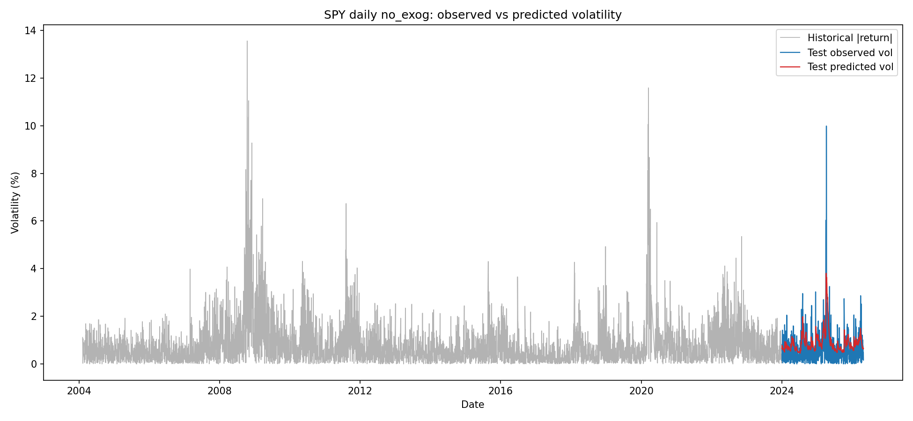

Figure 5. SPY daily volatility-forecast time series, MS-GARCH (with_exog).
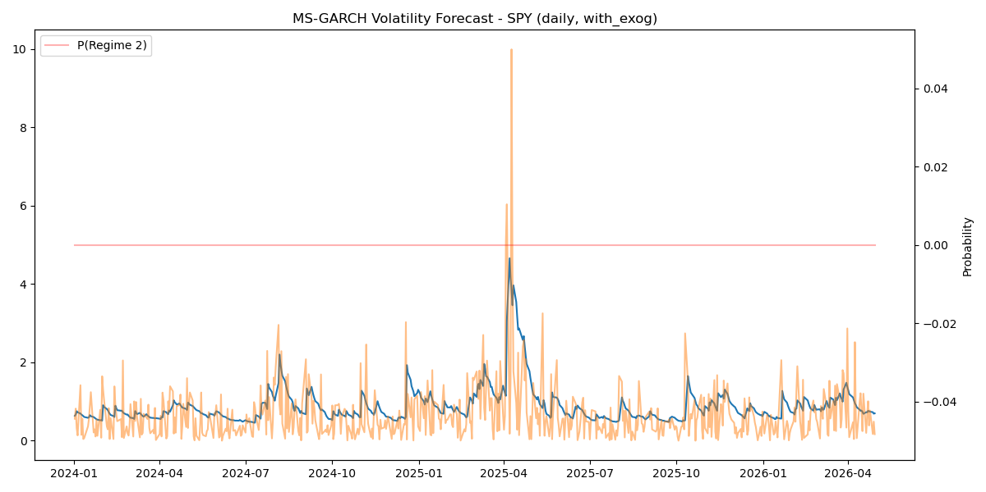

Figure 6. SPY daily volatility-forecast time series, LSTM-with-Attention (with_exog).
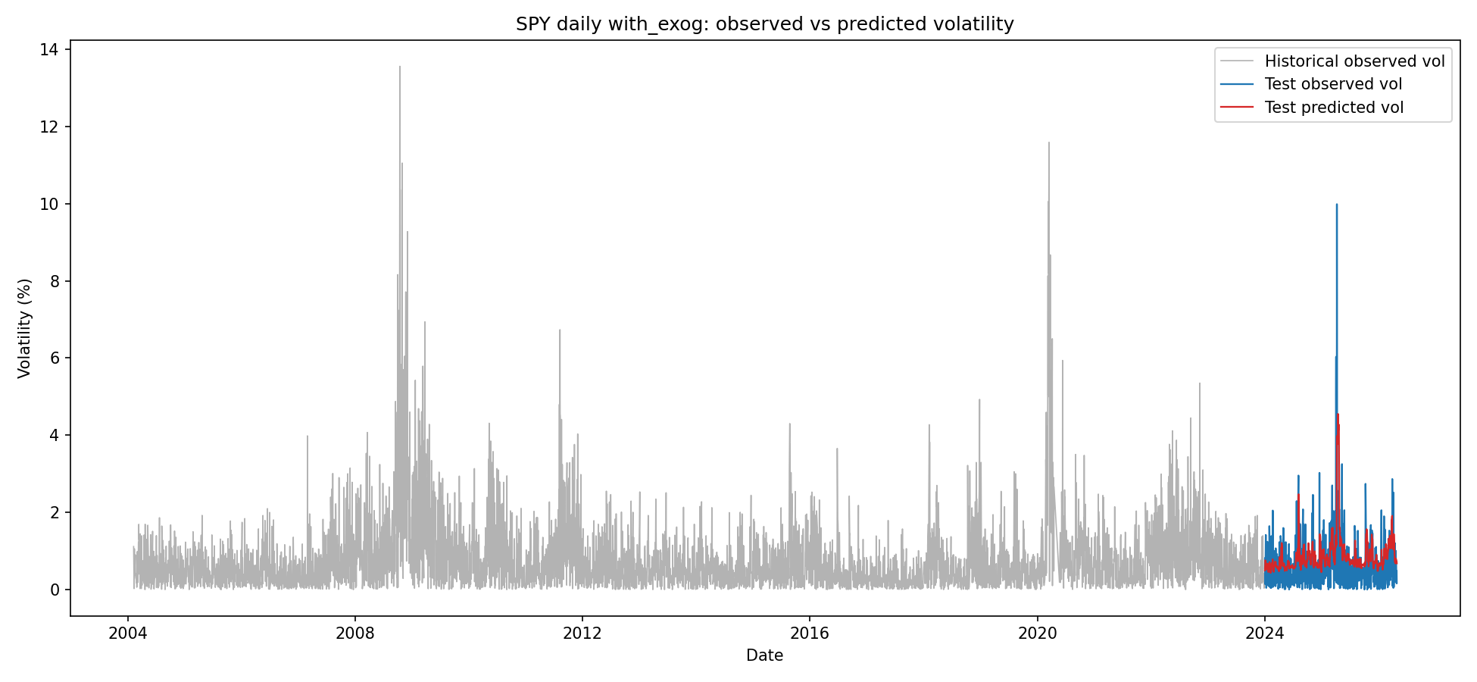

Figure 7. SPY daily volatility-forecast time series, Transformer (with_exog).
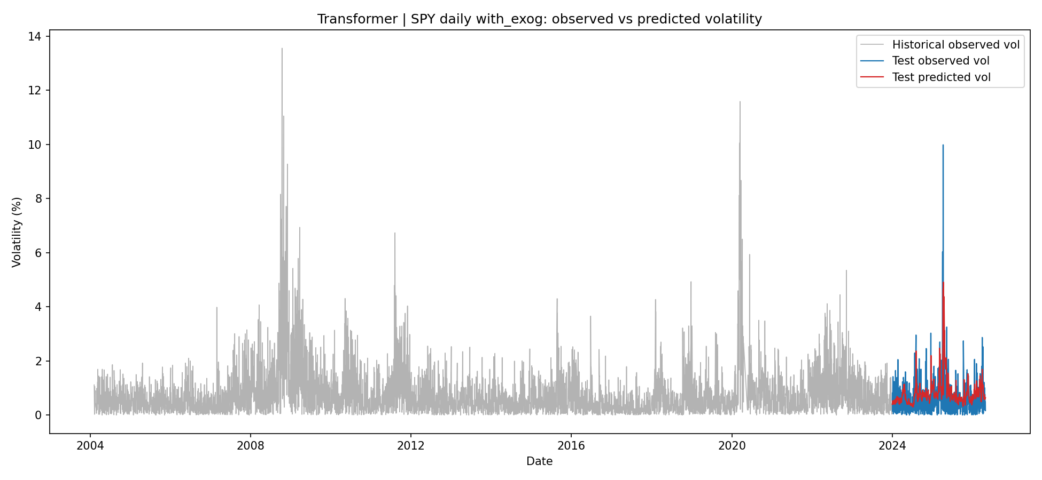

Figure 8. SPY daily volatility-forecast time series, XGBoost (with_exog). The systematic shrinkage of σ̂ₜ toward the mean is visible during high-volatility episodes.
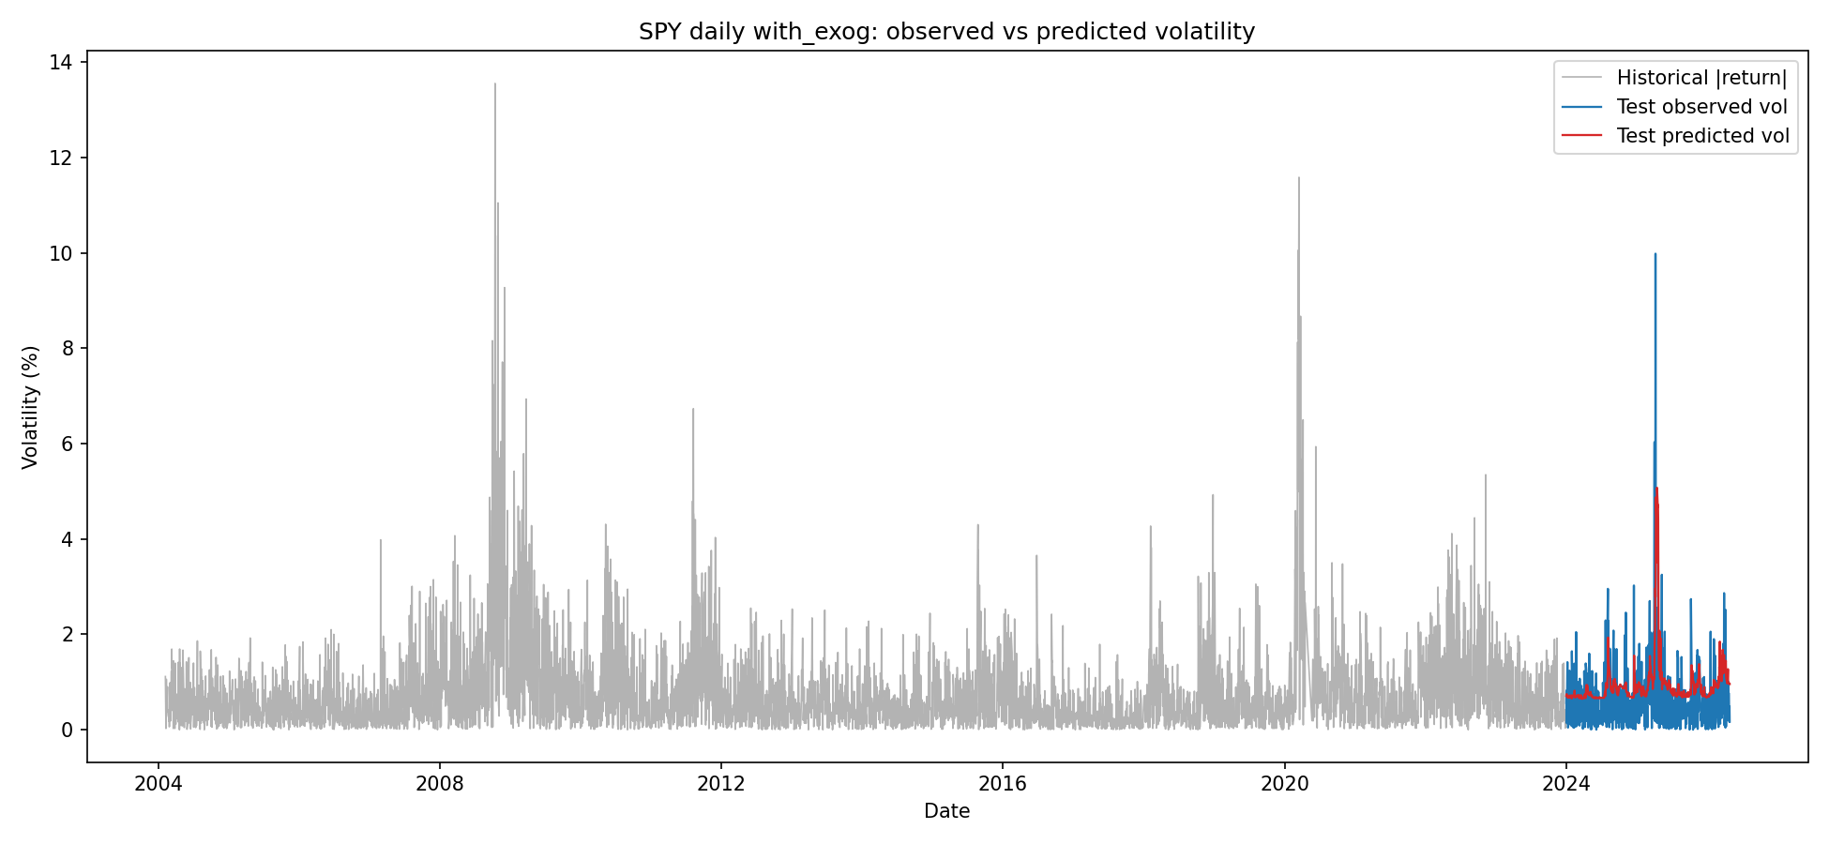

Figure 9. ACF of squared standardised residuals for the MS-GARCH (with_exog) fit on SPY daily. Whitening is consistent with adequate variance specification.
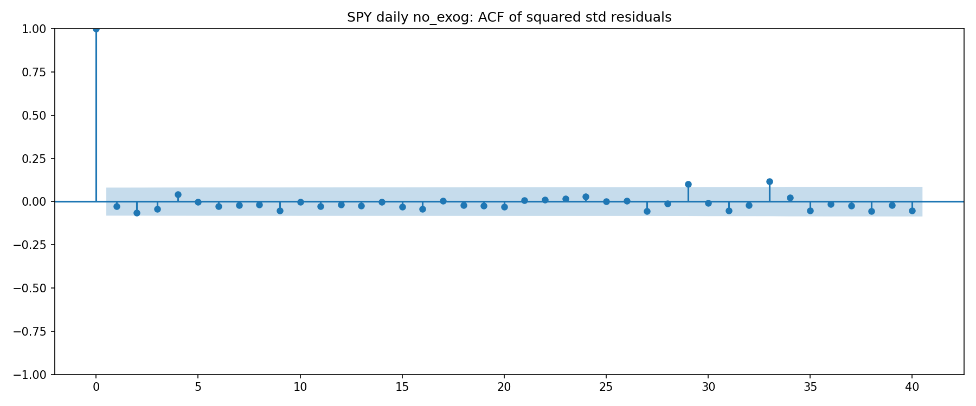
Stress-period analysis (RFP) confirms the test-block ranking. Mean QLIKE on five 60-day GFC windows is 2.16 for GJR-GARCH no_exog versus 2.14 for GJR-GARCH with_exog and 1.92 (median) for MS-GARCH; the COVID windows are dominated by the LSTM-with-attention (median QLIKE 1.69 with_exog versus 1.77 for GJR). Calm 2017–2019 windows are tied within numerical noise across models. No model dominates uniformly across all five regimes, consistent with the no-free-lunch intuition that single-regime specifications overfit calm periods while regime-switching and non-linear models carry their gains in turbulent ones.
4.4 Explanation of Changes from the Analysis Plan
We deviated from the original Analysis Plan in three respects. (i) The plan listed SPY and crude oil as joint targets; for the final report we focus exclusively on SPY at the daily frequency to keep the cross-model comparison clean and the page budget honest. The OIL configuration is fully implemented in the code deliverable but reported separately. (ii) Among the GARCH-family models we present GJR-GARCH(1,1) rather than the symmetric GARCH(1,1) baseline because the leverage term is statistically significant on SPY at every reasonable lag and dropping it produces a strictly worse model on every metric. (iii) The machine-learning side has been broadened beyond the LSTM in the Analysis Plan: an attention layer was added on top of the LSTM after we observed that the plain LSTM was unable to discriminate between recent and stale lags during validation; a Transformer encoder and an XGBoost benchmark were added to triangulate the deep-learning claims with a non-recurrent attention model and a non-neural tree ensemble respectively. The strict temporal split, rolling-window evaluation, and Kupiec/Christoffersen VaR back-tests planned in §2 of the Analysis Plan are unchanged.
5. Conclusions
5.1 Success and Best Method
On daily SPY, two models share the top position. MS-GARCH (K=2, GJR variance, Student-t innovations, with_exog) wins on RMSE (4.286) and is competitive on QLIKE (0.668). The LSTM-with-attention (with_exog) wins on QLIKE (0.649) and is within 3% on RMSE. Both produce well-calibrated 1% VaR exceptions (12 and 16 against an expected 5.83 — modestly conservative but within the Kupiec acceptance region). The complementary nature of the two winners is the most informative result of the project: the regime-switching parametric model and the attention-based deep-learning model are exploiting different structure in the data, and an ensemble of the two — outside the scope of this report — is a natural extension. The Transformer with exogenous features is essentially indistinguishable from MS-GARCH on RMSE but at higher implementation cost. The single-regime GJR-GARCH baseline is competitive only without exogenous features; the addition of macro regressors in its mean equation actually hurts performance. XGBoost is the cautionary tale: its MAE-optimal forecasts collapse the conditional variance and produce 11× the expected VaR exception rate, illustrating why MSE/MAE alone are inadequate loss functions for variance forecasting.
5.2 Limitations and Future Work
Several limitations warrant attention. First, the realised-variance proxy rₜ² is an extremely noisy target: high-frequency intraday realised volatility (5-min returns) would dramatically tighten the metrics and is the obvious next step. Second, our evaluation universe is one asset at one frequency; before drawing universal conclusions, the same comparison should be repeated on the OIL and GOLD targets and on the weekly frequency that we have already implemented but not analysed in this report. Third, the deep-learning models share a common weakness: they were trained with squared-error losses and may benefit from training directly on the QLIKE objective, which is the loss they are evaluated on. Fourth, our MS-GARCH specification fixes the number of regimes ex ante; data-driven regime discovery (e.g. via dirichlet-process or attention-based regime detectors as in Raja Lope Ahmad et al., 2026) is a natural sequel that could remove this constraint. Fifth, ensembling — in particular a convex combination of MS-GARCH and LSTM-with-attention forecasts whose weights are tuned on validation — is suggested by the complementary regime performance and is the highest-priority follow-up. Finally, the test block (2024–Apr 2026) covers a relatively calm period; a rolling re-evaluation that includes a future structural break will be necessary to confirm that our headline ranking is robust.
6. References
Alizadeh, A. H., Nomikos, N. K., & Pouliasis, P. K. (2008). A Markov regime switching approach for hedging energy commodities. Journal of Banking & Finance, 32(9), 1970–1983. https://doi.org/10.1016/j.jbankfin.2007.12.020
Ardia, D., Bluteau, K., Boudt, K., & Catania, L. (2019). Markov-switching GARCH models in R: The MSGARCH package. Journal of Statistical Software, 91(4), 1–38. https://doi.org/10.18637/jss.v091.i04
Bollerslev, T. (1986). Generalized autoregressive conditional heteroskedasticity. Journal of Econometrics, 31(3), 307–327. https://doi.org/10.1016/0304-4076(86)90063-1
Carr, P., Wu, L., & Zhang, Z. (2020). Using machine learning to predict realized variance. Journal of Investment Management, 18(2), 1–16.
Charles, A., & Darné, O. (2017). Forecasting crude-oil market volatility: Further evidence with jumps. Energy Economics, 67, 508–519. https://doi.org/10.1016/j.eneco.2017.09.002
Chen, T., & Guestrin, C. (2016). XGBoost: A scalable tree boosting system. Proceedings of the 22nd ACM SIGKDD International Conference on Knowledge Discovery and Data Mining, 785–794. https://doi.org/10.1145/2939672.2939785
Christoffersen, P. F. (1998). Evaluating interval forecasts. International Economic Review, 39(4), 841–862. https://doi.org/10.2307/2527341
Doering, J., Fairbank, M., & Markose, S. (2017). Convolutional neural networks applied to high-frequency market microstructure forecasting. 2017 9th Computer Science and Electronic Engineering (CEEC). https://doi.org/10.1109/ceec.2017.8101595
Ejike, U. (2026). Machine Learning for Market Volatility Regime Classification: A Comparative Analysis of LDA, SVM, and Neural Networks. https://doi.org/10.2139/ssrn.6064166
Engle, R. F. (1982). Autoregressive conditional heteroscedasticity with estimates of the variance of United Kingdom inflation. Econometrica, 50(4), 987–1007. https://doi.org/10.2307/1912773
Glosten, L. R., Jagannathan, R., & Runkle, D. E. (1993). On the relation between the expected value and the volatility of the nominal excess return on stocks. Journal of Finance, 48(5), 1779–1801. https://doi.org/10.1111/j.1540-6261.1993.tb05128.x
Haas, M., Mittnik, S., & Paolella, M. S. (2004). A new approach to Markov-switching GARCH models. Journal of Financial Econometrics, 2(4), 493–530. https://doi.org/10.1093/jjfinec/nbh020
Hamilton, J. D. (1989). A new approach to the economic analysis of nonstationary time series and the business cycle. Econometrica, 57(2), 357–384. https://doi.org/10.2307/1912559
Hardy, M. R. (2001). A regime-switching model of long-term stock returns. North American Actuarial Journal, 5(2), 41–53. https://doi.org/10.1080/10920277.2001.10595984
Hochreiter, S., & Schmidhuber, J. (1997). Long short-term memory. Neural Computation, 9(8), 1735–1780.
Kim, H. Y., & Won, C. H. (2018). Forecasting the volatility of stock price index: A hybrid model integrating LSTM with multiple GARCH-type models. Expert Systems with Applications, 103, 25–37. https://doi.org/10.1016/j.eswa.2018.03.002
Klaassen, F. (2002). Improving GARCH volatility forecasts with regime-switching GARCH. Empirical Economics, 27(2), 363–394. https://doi.org/10.1007/s001810100100
Kupiec, P. (1995). Techniques for verifying the accuracy of risk measurement models. Journal of Derivatives, 3(2), 73–84.
Patton, A. J. (2011). Volatility forecast comparison using imperfect volatility proxies. Journal of Econometrics, 160(1), 246–256. https://doi.org/10.1016/j.jeconom.2010.03.034
Raja Lope Ahmad, R. A., et al. (2026). Agentic AI for Financial Volatility Regime Detection: A Hybrid Deep Learning and Statistical Framework. Applied Research, 5(2). https://doi.org/10.1002/appl.70078
Tino, P., Schittenkopf, C., & Dorffner, G. (2001). Financial volatility trading using recurrent neural networks. IEEE Transactions on Neural Networks, 12(4), 865–874. https://doi.org/10.1109/72.935096
Vaswani, A., Shazeer, N., Parmar, N., Uszkoreit, J., Jones, L., Gomez, A. N., Kaiser, Ł., & Polosukhin, I. (2017). Attention is all you need. Advances in Neural Information Processing Systems, 30.
Xiong, R., Nichols, E. P., & Shen, Y. (2016). Deep learning stock volatility with Google Domestic Trends. arXiv preprint arXiv:1512.04916.
Yahoo Finance (2026). SPDR S&P 500 ETF Trust (SPY) historical prices [Data set]. https://finance.yahoo.com/quote/SPY/history
7. Appendix A: Individual Member Analysis Summaries
[PLACEHOLDER — paragraph-length summary of each individual member's analysis and other relative contributions to be completed by the team. The Analysis-Plan attribution was: Rajath — Traditional ARCH/GARCH models, EDA, data preprocessing; Harsh — Regime-switching MS-GARCH models and regime-probability analysis; Yibo — Literature review on machine-learning approaches and comparative evaluation; Mani — Literature review and EDA; Yen-Shuo — Literature review on the VIX and EDA. Replace this placeholder with one paragraph per member describing (a) the analytical sub-task they led, (b) the specific code or outputs they produced, and (c) their contribution to writing and review of this report.]
8. Appendix B: Required Team Contributions Statement
[PLACEHOLDER — required team contributions evaluation. Per the assignment instructions, this appendix must explicitly note any team member who did not contribute at least 80% of what is expected for this deliverable. If every member met or exceeded the 80% threshold, state so here. See the example evaluation linked in the assignment for formatting.]

